Supplementary Materials
Perceived racial discrimination, psychological distress, and suicidal behavior in adolescence: Secondary analysis of cross-sectional data from a statewide youth survey
Table S1. Comparison of Student Demographics: KIP 2021 and Kentucky Department of Education Enrollment 2020-2021
 |  | KIP 2021 |  | KY Total Enrollment  2020-2021^{b} |  | KY Enrollment w/o Jefferson County 2020-2021^{c}
Characteristics |  | n | (%) | n | (%) | n | (%)
Overall |  | 93,812 | (100) | 217,566 | (100) | 185,515 | (100)
School Grade
 | 6 | 25,552 | (27.2) | 54,479 | (25.0) | 46,490 | (25.1)
 | 8 | 26,712 | (28.5) | 56,558 | (26.0) | 48,281 | (26.0)
 | 10 | 23,632 | (25.2) | 56,352 | (25.9) | 47,633 | (25.7)
 | 12 | 17,916 | (19.1) | 50,177 | (23.1) | 43,111 | (23.2)
Gender Identityª
 | Female | 42,065 | (44.8) | 106,035 | (48.7) | 90,116 | (48.6)
 | Male | 46,052 | (49.1) | 111,531 | (51.3) | 95,399 | (51.4)
 | Questioning/unsure | 1,524 | (1.6)
 | Not listed | 2,103 | (2.2)
 | Prefer not to say | 1,756 | (1.9)
Race-Ethnicityª
 | Non-Hispanic White | 66,829 | (71.2) | 162,853 | (74.9) | 149,495 | (80.6)
 | Black | 5,920 | (6.3) | 24,480 | (11.3) | 12,356 | (6.7)
 | Hispanic or Latino | 8,265 | (8.8) | 16,650 | (7.7) | 12,898 | (7.0)
 | Asian | 1,227 | (1.4) | 3,867 | (1.8) | 2,599 | (1.4)
 | Native Hawaiian or Pacific Islander | 148 | (0.2) | 298 | (0.1) | 253 | (0.1)
 | American Indian or Alaska Native | 918 | (1.0) | 293 | (0.1) | 257 | (0.1)
 | Multiracial | 5,619 | (6.0) | 9,125 | (4.2) | 7,657 | (4.1)
 | Other | 1,743 | (1.9)
Rural
 | Yes | 52,087 | (55.5) | 107,506 | (49.4) | 107,506 | (58.0)
 | No | 41,725 | (44.5) | 110,060 | (50.6) | 77,895 | (42.0)
ªOverall characteristics may not add to 100% due to missingness; ^{b} Total enrollment for Grades 6, 8, 10, and 12 with Jefferson County School District; ^{c}Total enrollment for Grades 6, 8, 10, and 12 without Jefferson County School District.

Table S2. Characteristics of middle school students
 |  | Overall |  |  |  | SPD |  |  |  | Suicide Ideation |  |  |  | Suicide Attempt
Characteristics |  | n |  | (%) |  | n |  | (%) |  | n |  | (%) |  | n |  | (%)
Overall |  | 52,264 |  | (100) |  | 9,217 |  | (17.6) |  | 6,179 |  | (11.8) |  | 3,876 |  | (7.4)
School Grade
 | 6 |  | 25,552 |  | (48.9) |  | 3,823 |  | (15.0) |  | 2,443 |  | (9.6) |  | 1,669 |  | (6.5)
 | 8 |  | 26,712 |  | (51.1) |  | 5,394 |  | (20.2) |  | 3,736 |  | (14.0) |  | 2,207 |  | (8.3)
Gender Identityª
 | Female |  | 22,866 |  | (43.7) |  | 4,791 |  | (21.0) |  | 3,114 |  | (13.6) |  | 1,974 |  | (8.6)
 | Male |  | 25,821 |  | (49.4) |  | 2,729 |  | (10.6) |  | 1,733 |  | (6.7) |  | 1,101 |  | (4.3)
 | Questioning/unsure |  | 993 |  | (1.9) |  | 559 |  | (56.3) |  | 431 |  | (43.4) |  | 241 |  | (24.3)
 | Not listed |  | 1,220 |  | (2.3) |  | 714 |  | (58.5) |  | 595 |  | (48.8) |  | 353 |  | (28.9)
 | Prefer not to say |  | 1,181 |  | (2.3) |  | 401 |  | (34.0) |  | 290 |  | (24.6) |  | 195 |  | (16.5)
Sexual Orientationª
 | Heterosexual |  | 32,689 |  | (62.6) |  | 4,075 |  | (12.5) |  | 2,476 |  | (7.6) |  | 1,459 |  | (4.5)
 | Gay or lesbian |  | 2,893 |  | (5.5) |  | 1,464 |  | (50.6) |  | 1,218 |  | (42.1) |  | 763 |  | (26.4)
 | Questioning/unsure |  | 2,768 |  | (5.3) |  | 761 |  | (27.5) |  | 536 |  | (19.4) |  | 306 |  | (11.1)
 | Not listed |  | 3,717 |  | (7.1) |  | 1,437 |  | (38.7) |  | 1,151 |  | (31.0) |  | 682 |  | (18.4)
 | Prefer not to say |  | 4,861 |  | (9.3) |  | 834 |  | (17.2) |  | 421 |  | (8.7) |  | 322 |  | (6.6)
Race-Ethnicity^{ab}
 | NH White (White) |  | 35,439 |  | (67.8) |  | 6,126 |  | (17.3) |  | 3,992 |  | (11.3) |  | 2,290 |  | (6.5)
 | NH Black (Black) |  | 3,555 |  | (6.8) |  | 534 |  | (15.0) |  | 442 |  | (12.4) |  | 327 |  | (9.2)
 | Hispanic |  | 4,839 |  | (9.3) |  | 931 |  | (19.2) |  | 648 |  | (13.4) |  | 492 |  | (10.2)
 | NH Asian/NH/PI  (Asian/Pacific Islander) |  | 700 |  | (1.3) |  | 112 |  | (16.0) |  | 74 |  | (10.6) |  | 41 |  | (5.9)
 | NH AI/AN (Native American) |  | 650 |  | (1.2) |  | 137 |  | (21.1) |  | 85 |  | (13.1) |  | 70 |  | (10.8)
 | NH Other (Other) |  | 1,348 |  | (2.6) |  | 268 |  | (19.9) |  | 182 |  | (13.5) |  | 133 |  | (9.9)
 | NH Multiracial (Multiracial) |  | 3,242 |  | (6.2) |  | 799 |  | (24.7) |  | 572 |  | (17.6) |  | 378 |  | (11.7)
Rural
 | Yes |  | 28,925 |  | (55.3) |  | 5,322 |  | (18.4) |  | 3,541 |  | (12.2) |  | 2,233 |  | (7.7)
 | No |  | 23,339 |  | (44.7) |  | 3,895 |  | (16.7) |  | 2,638 |  | (11.3) |  | 1,643 |  | (7.0)
Perceived Racial Discriminationª
 | Yes |  | 2,557 |  | (4.9) |  | 1,018 |  | (39.8) |  | 763 |  | (29.8) |  | 529 |  | (20.7)
 | No/Not sure |  | 43,225 |  | (82.7) |  | 7,178 |  | (16.6) |  | 4,778 |  | (11.1) |  | 2,818 |  | (6.5)
ªOverall characteristics may not add to 100% due to missingness; ^{b}NH= Non-Hispanic; NH/PI=Native Hawaiian or Pacific Islander; AI/AN=American Indian or Alaska Native

Table S3. Characteristics of high school students
 |  | Overall |  | SPD |  | Suicide Ideation |  | Suicide Attempt
Characteristics |  | n | (%) | n | (%) | n | (%) | n | (%)
Overall |  | 41,548 | (100) | 10,093 | (24.3) | 6,345 | (15.3) | 3,048 | (7.3)
School Grade
 | 10 | 23,632 | (56.9) | 5,715 | (24.2) | 3,694 | (15.6) | 1,870 | (7.9)
 | 12 | 17,916 | (43.1) | 4,378 | (24.4) | 2,651 | (14.8) | 1,178 | (6.6)
Gender Identityª
 | Female | 19,199 | (46.2) | 5,792 | (30.2) | 3,354 | (17.5) | 1,618 | (8.4)
 | Male | 20,231 | (48.7) | 3,065 | (15.1) | 2,071 | (10.2) | 967 | (4.8)
 | Questioning/unsure | 531 | (1.3) | 330 | (62.2) | 253 | (47.7) | 112 | (21.1)
 | Not listed | 883 | (2.1) | 596 | (67.5) | 452 | (51.2) | 227 | (25.7)
 | Prefer not to say | 575 | (1.4) | 283 | (49.2)) | 196 | (34.1) | 109 | (19.0)
Sexual Orientationª
 | Heterosexual | 30,199 | (72.7) | 5,461 | (18.1) | 3,124 | (10.3) | 1,439 | (4.8)
 | Gay or lesbian | 2,551 | (6.1) | 1,375 | (53.9) | 1,029 | (40.3) | 512 | (20.1)
 | Questioning/unsure | 1,575 | (3.8) | 704 | (44.7) | 495 | (31.4) | 224 | (14.2)
 | Not listed | 2,879 | (6.9) | 1,527 | (53.0) | 1,122 | (39.0) | 514 | (17.9)
 | Prefer not to say | 1,686 | (4.1) | 471 | (27.9) | 255 | (15.1) | 136 | (8.1)
Race-Ethnicity^{ab}
 | NH White (White) | 31,390 | (75.6) | 7,637 | (24.3) | 4,726 | (15.1) | 2,140 | (6.8)
 | NH Black (Black) | 2,365 | (5.7) | 473 | (20.0) | 319 | (13.5) | 177 | (7.5)
 | Hispanic | 3,426 | (8.3) | 822 | (24.0) | 517 | (15.1) | 296 | (8.6)
 | NHAsian/NH/PI (Asian/Pacific Islander) | 675 | (1.6) | 139 | (20.6) | 88 | (13.0) | 40 | (5.9)
 | NH AI/AN (Native American) | 268 | (0.7) | 63 | (23.5) | 40 | (14.9) | 31 | (11.6)
 | NH Other (Other) | 395 | (1.0) | 104 | (26.3) | 67 | (17.0) | 44 | (11.1)
 | NH Multiracial (Multiracial) | 2,377 | (5.7) | 719 | (30.3) | 504 | (21.2) | 269 | (11.3)
Rural
 | Yes | 23,162 | (55.8) | 5,760 | (24.9) | 3,603 | (15.6) | 1,828 | (7.9)
 | No | 18,386 | (44.3) | 4,333 | (23.6) | 2,742 | (14.9) | 1,220 | (6.6)
Perceived Racial Discriminationª
 | Yes | 3,018 | (7.3) | 1,122 | (37.2) | 802 | (26.6) | 422 | (14.0)
 | No/Not sure | 34,581 | (83.2) | 8,084 | (23.4) | 4,992 | (14.4) | 2,259 | (6.5)
ªOverall characteristics may not add to 100% due to missingness; ^{b}NH= Non-Hispanic; NH/PI=Native Hawaiian or Pacific Islander; AI/AN=American Indian or Alaska Native

Figure S1. Prevalence of perceived racial discrimination among racial and ethnic minorities stratified by school level

Note: For all racial/ethnic groups besides Native Americans, high schoolers reported significantly higher rates of PRD than middle school students. The following are Cramer’s V for each racial/ethnic group with a significant relationship from left to right: 0.04, 0.10, 0.11, 0.14, -0.01, 0.11, 0.13.

Figure S2. Prevalence of SPD and suicidality among racial and ethnic minorities in middle school

Figure S3. Prevalence of SPD and suicidality among racial and ethnic minorities in high school

Figure S4. Adjusted odds of SPD and among racial and ethnic minorities stratified by school level
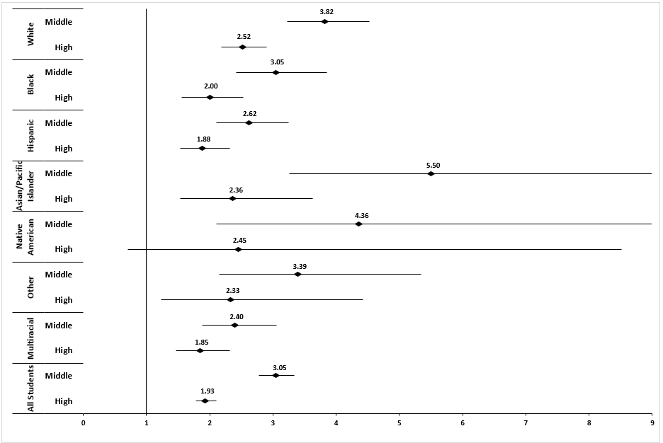

Figure S5. Adjusted odds of suicidal ideation among racial and ethnic minorities stratified by school level
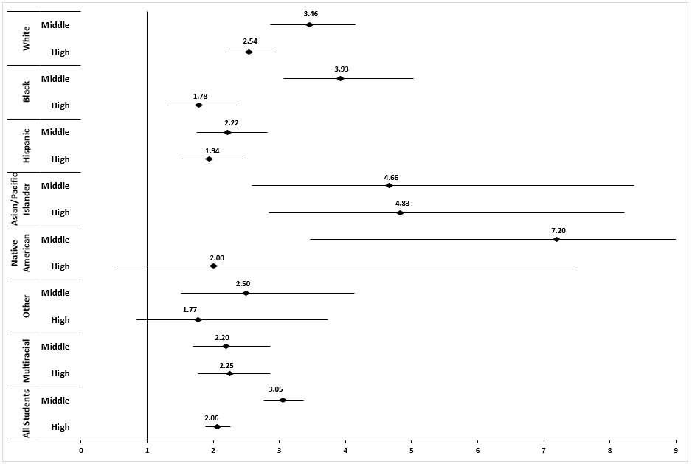

Figure S6. Adjusted odds of suicide attempt among racial and ethnic minorities stratified by school level
