Supplementary
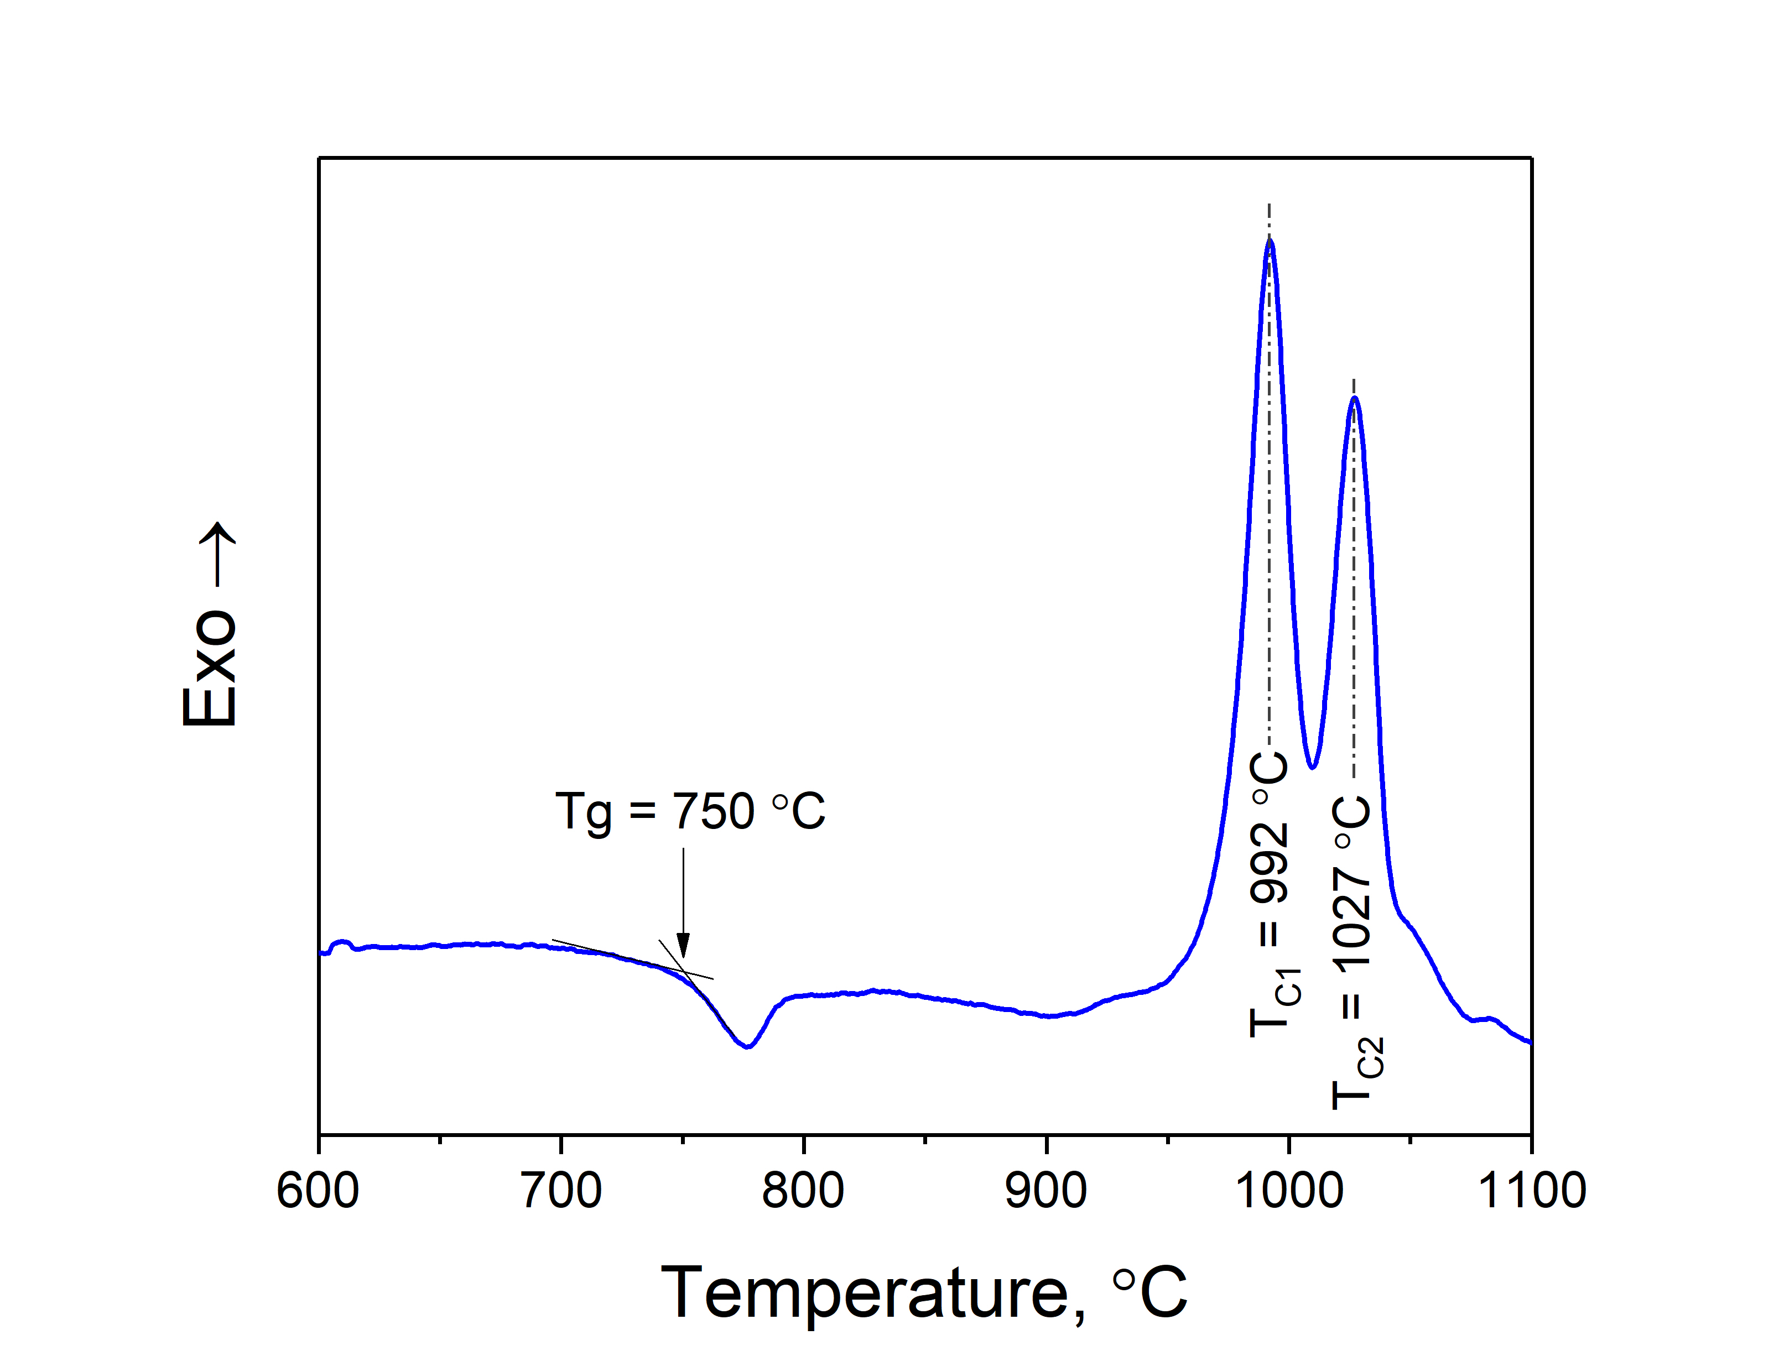
Figure S1. DSC curve of the synthetized glass.

