Supplementary Materials

Multi-elemental characterization of soils in the vicinity of siderurgical industry: levels, depth migration and toxic risk
Antoaneta Ene ^{1,}*, Florin Sloată ¹, Marina V. Frontasyeva ², Octavian G. Duliu ^{3,4},
Alina Sion ¹, Steluta Gosav ¹ and Diana Persa ³
¹Dunarea de Jos University of Galati, Faculty of Sciences and Environment, Department of Chemistry, Physics and Environment, INPOLDE research center, 47 Domneasca St., 800008 Galati, Romania
²Joint Institute for Nuclear Research, 6 Joliot Curie St., 141980 Dubna, Russian Federation
³Geological Institute of Romania, 1 Caransebes St., 012271 Bucharest, Romania
⁴University of Bucharest, Faculty of Physics, Department of Structure of Matter, Earth and Atmospheric Physics, Astrophysics, 405 Atomistilor St., 077125 Magurele, Ilfov, Romania

* Correspondence: antoaneta.ene@ugal.ro

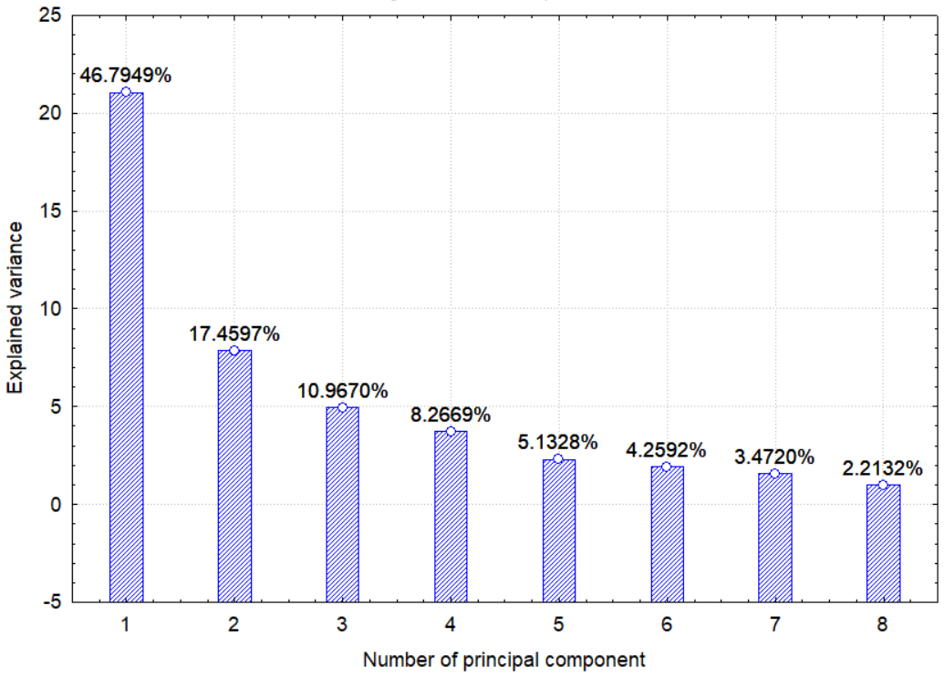
Principal Component Analysis (PCA)
0-5 cm depth
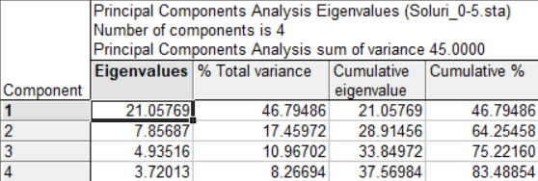

Loading of PC1 for each variable

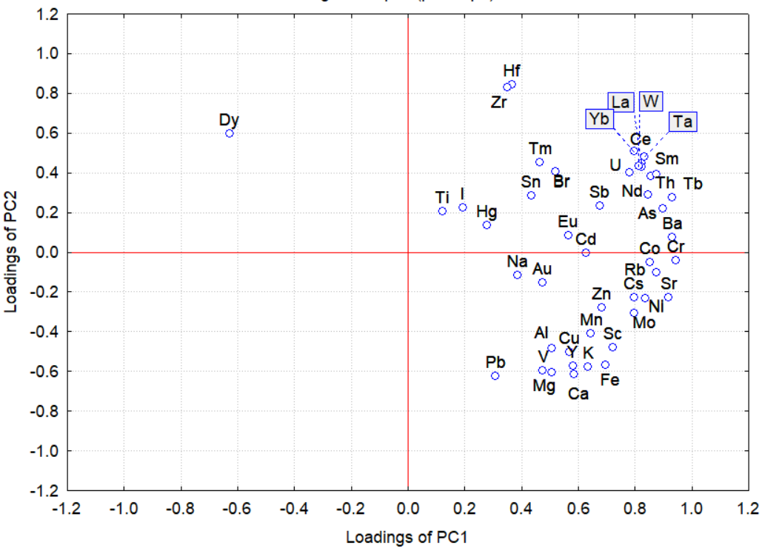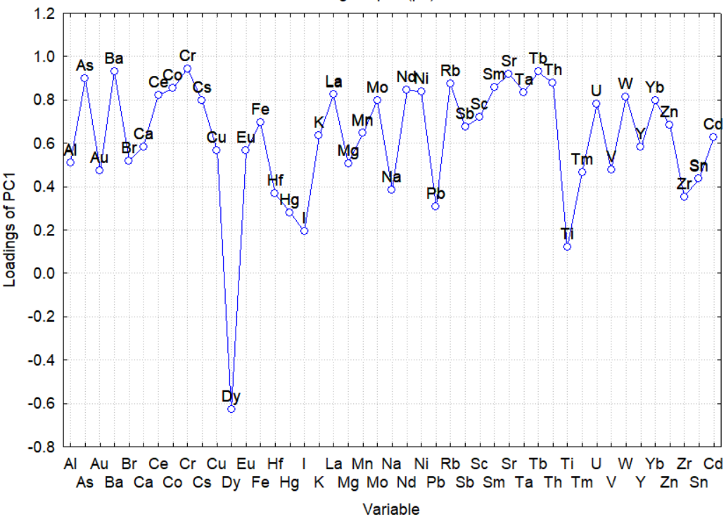
Figure S1. Explained variance for the principal components and plot of the PC2 loadings as a function of PC1 loadings.

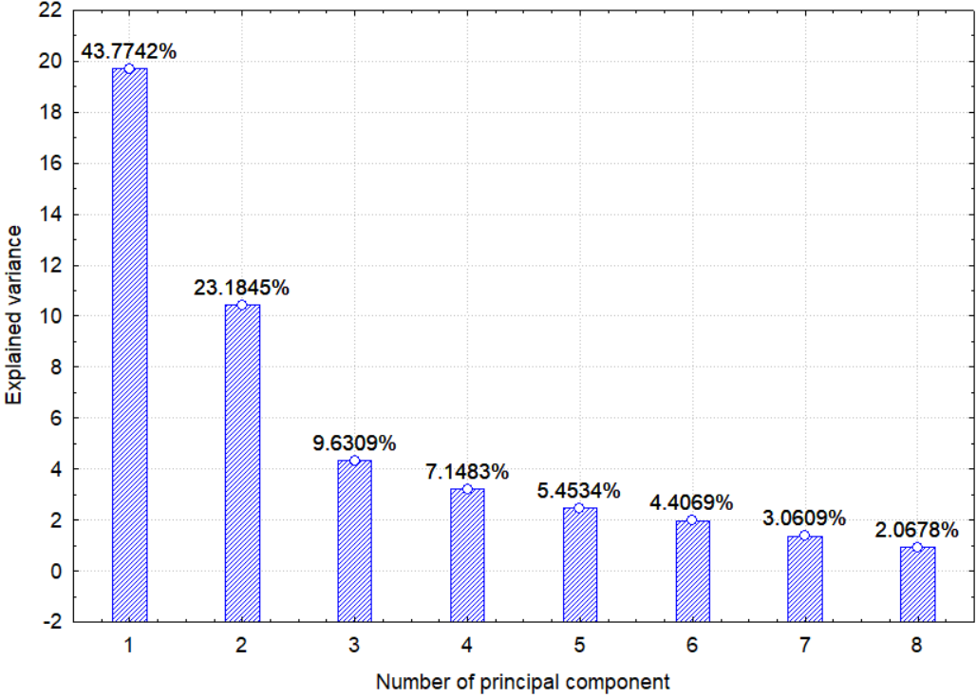
5-20 cm depth
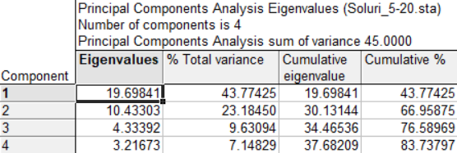

Loading of PC1 for each variable
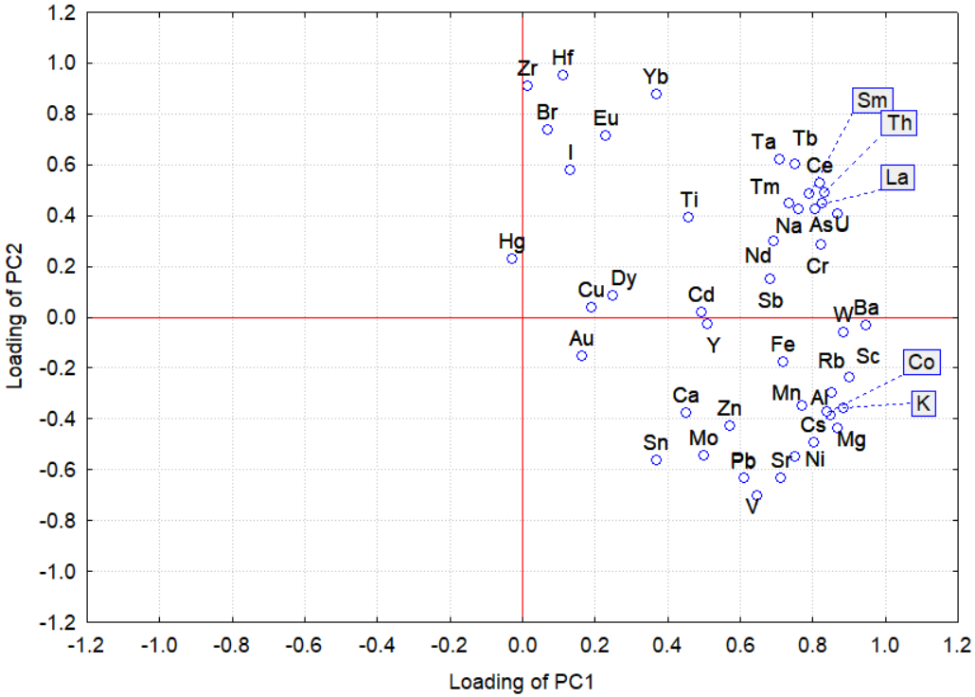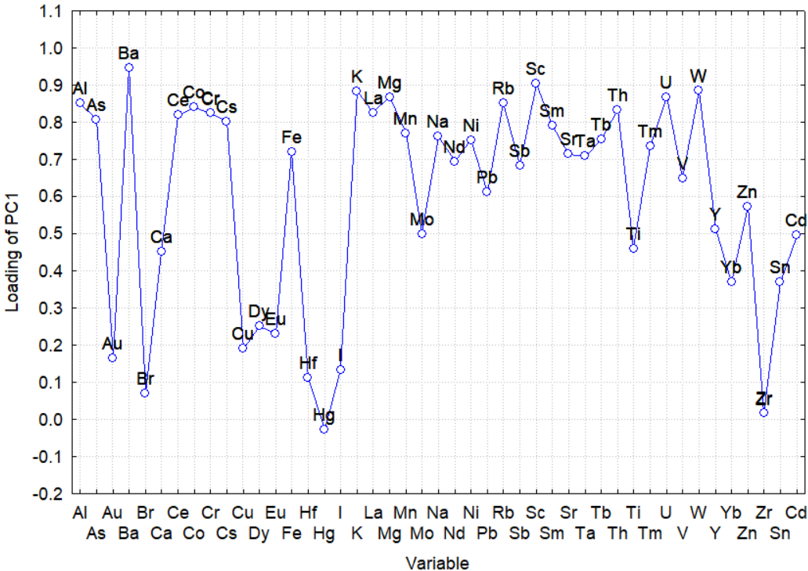

Figure S1. continued
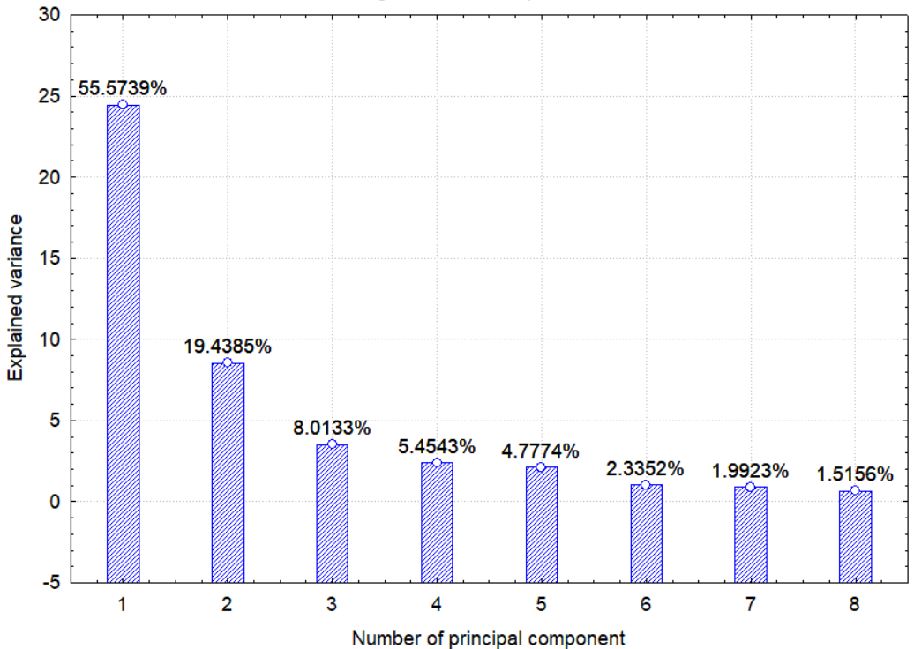
20-30 cm depth

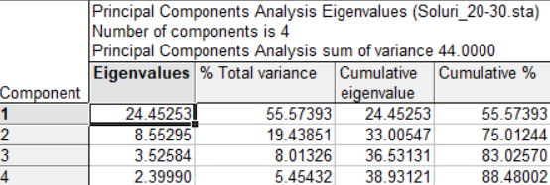

Loading of PC1 for each variable
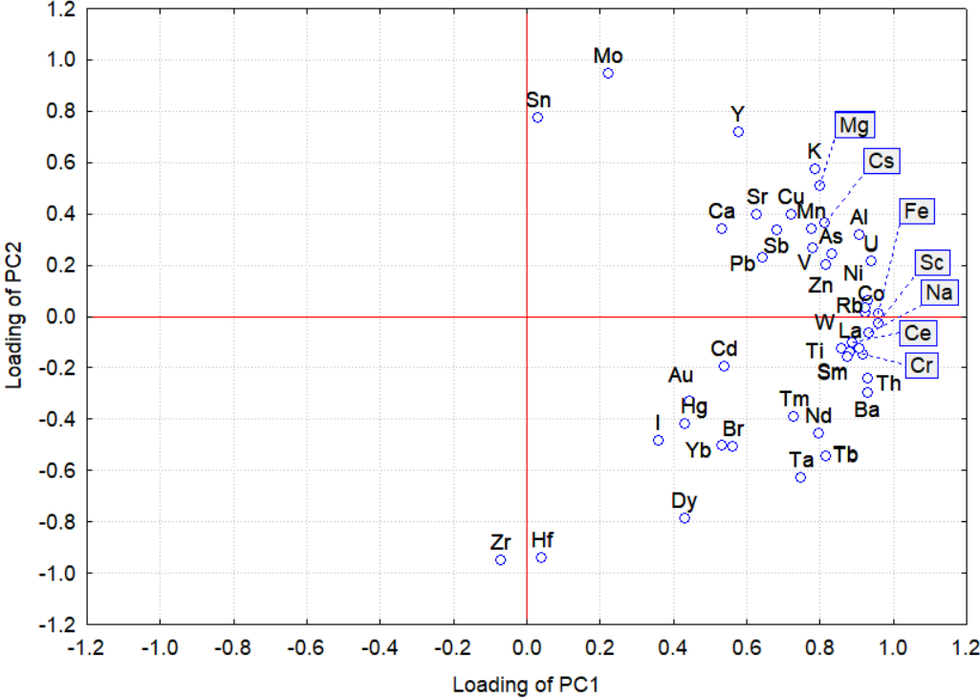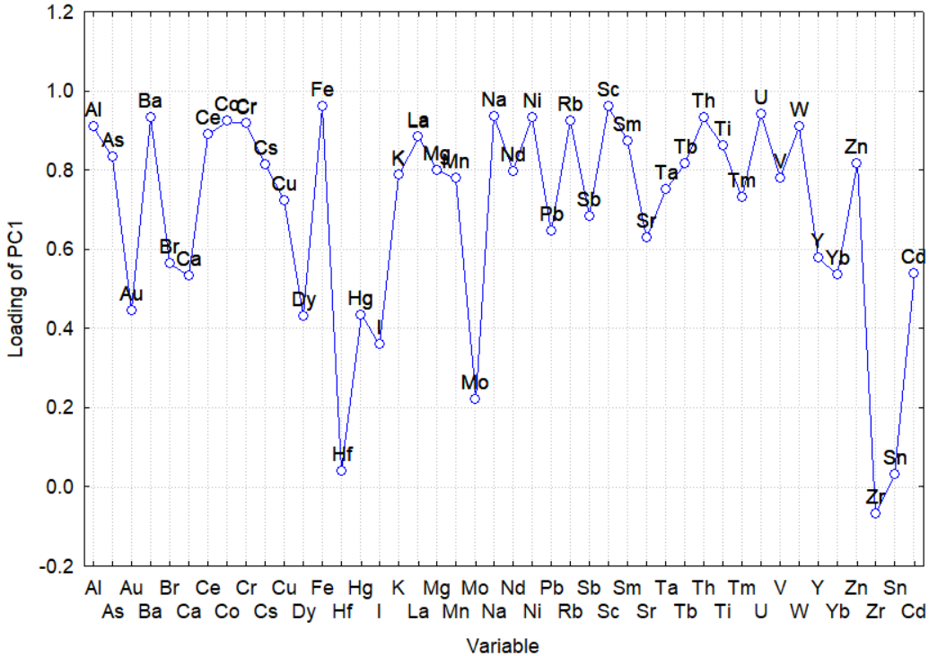
Figure S1. continued

Cluster Analysis (CA)
0-5 cm depth

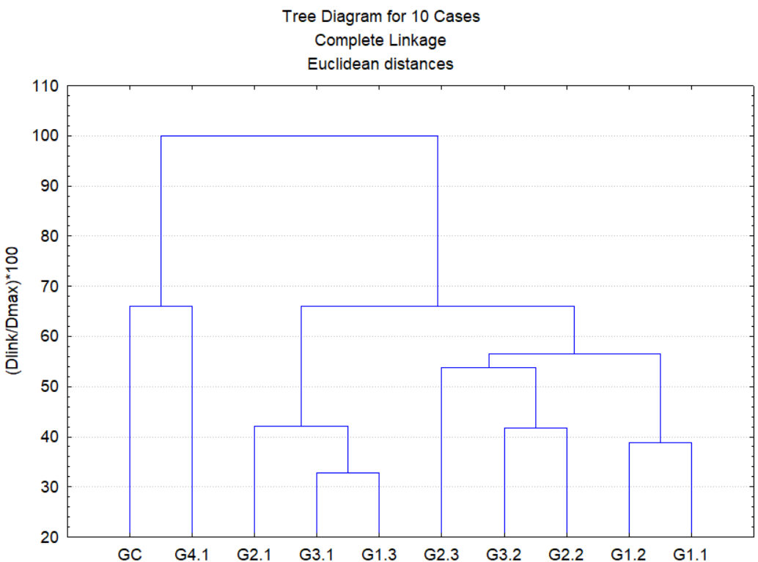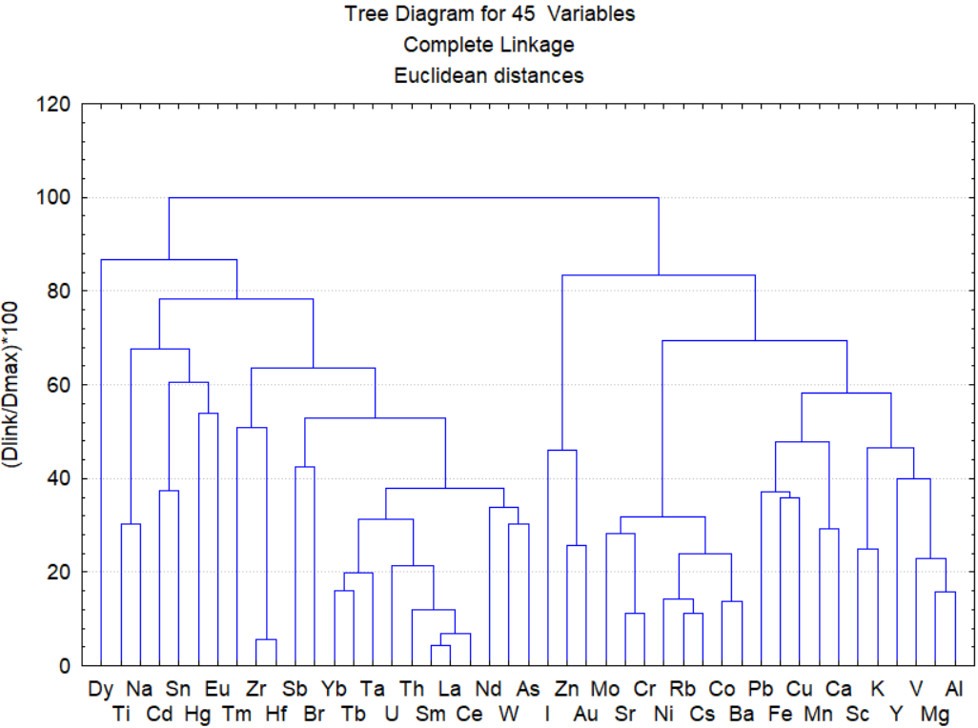

Figure S2. Dendrograms obtained with the Tree Clustering algorithm for the 10 soil samples and 45 variables in three soil layers.

5-20 cm depth
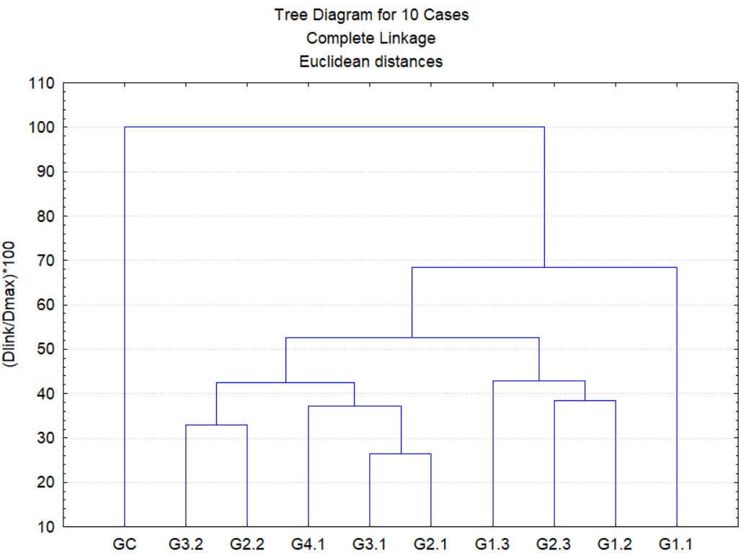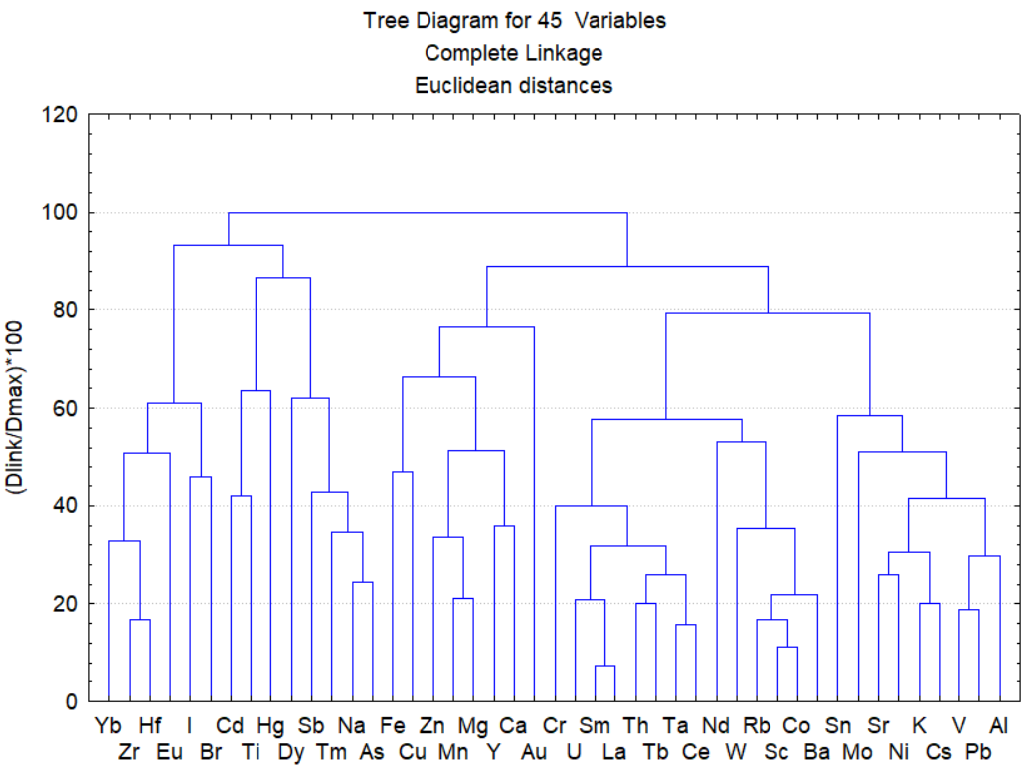

Figure S2. continued

20-30 cm depth

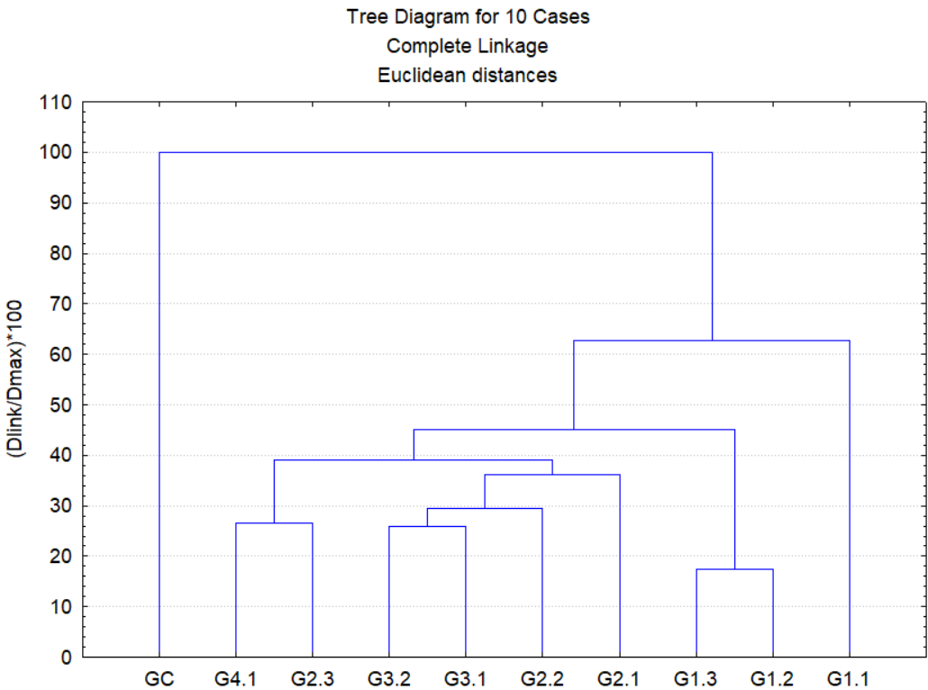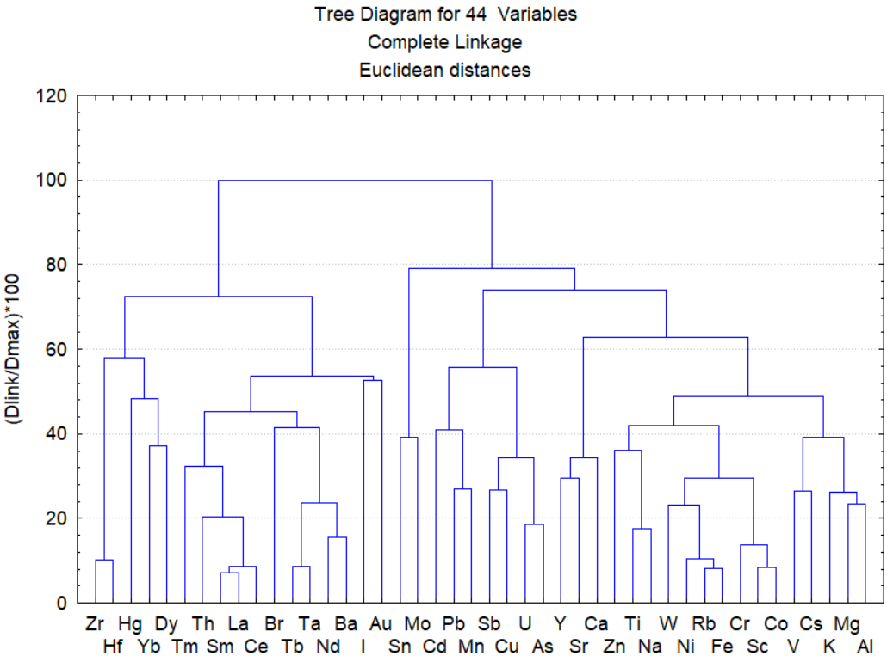

Figure S2. continued

