Acronyms and abbreviations:

F - frequency
FVC – Forced vital capacity
HFMSE - Hammersmith Function Motor Scale Expanded scale
lvl – level of the spinal cord
N-S – Non-sitters
Nus - Nusinersen
OA – Onasemnogene abeparvovec
Risd - Risdiplam
ROM – Range of Movements of joints with contracture
RULM - Revised Upper Limb Module scale
S – Sitters
Treatm - Treatment duration
tSCS - transcutaneous Spinal Cord Stimulation
W – Walkers

Table S1. Demographics and clinical parameters of SMA type 2 participants
Adult participant is marked in gray
Participants | Sex | Age,  years | Orphan drug |  |  |  | RULM,  score | HFMSE,  score | FVC,  % | Knee ROM,  deg |  | Functional  status
 |  |  | Nus | Risd | OA | Treatment,  months |  |  |  | Right | Left | N-S | S | W
21K53 | M | 3 | Y |  |  | 21 | 37 | 37 |  |  |  |  | Y
6K12 | M | 3 | Y |  |  | 24 | 16 |  |  |  |  | Y
8K18 | M | 5 | Y |  |  | --¹ | 21 | 30 |  |  |  |  | Y
15K49 | M | 5 |  |  | Y | 30 | 16 |  |  | 178 | 168 | Y
1K1 | M | 6 | Y |  |  | -- | 35 |  |  |  |  |  | Y
10K30 | F | 6 | Y |  |  | 31 | 24 |  | 74 | 145 | 128 | Y
5K10 | M | 6 |  | Y |  | 26 | 15 |  | 66 |  |  | Y
1K2 | F | 7 |  | Y |  | 8 | 17 | 4 | 47 |  |  | Y
15K47 | M | 7 | Y |  |  | 26 | 16 |  | 38 | 150 | 160 | Y
9K22 | F | 8 | Y |  |  | 34 | 35 | 49 | 113 |  |  |  | Y
16K50 | M | 8 | Y |  |  | 27 | 26 | 24 | 68 | 170 | 169 |  | Y
3K5 | F | 9 |  | Y |  | 17 | 24 | 17 | 66 | 122 | 130 |  | Y
6K11 | F | 9 | Y |  |  | 13 | 6 |  | 9 | 118 | 124 | Y
9K23 | M | 12 | Y |  |  | 19 | 22 | 11 | 94 | 125 | 127 | Y
5K8 | M | 12 |  | Y |  | 5 | 28 |  | 58 | 139 | 146 |  | Y
8K20 | F | 13 |  | Y |  | 34 | 30 |  | 71 |  |  | Y
9K24 | F | 13 | Y |  |  | 21 | 18 |  | 22 |  |  | Y
7K14 | F | 15 | Y |  |  | 16 | 0 |  | 42 | 169 | 153 | Y
8K19 | M | 16 |  | Y |  | 31 | 5 |  | 11 | 125 | 109 | Y
14K44 | F | 39 | Y |  |  | 36 | 13 |  |  | 165 | 170 |  | Y
¹ Medical records of initial treatment not provided

Table S2. Demographics and clinical parameters of SMA type 3 participants
Adult participants are marked in gray

Participants | Sex | Age,  years | Orphan drug |  |  |  | RULM,  score | HFMSE,  score | FVC,  % | Knee ROM,  deg |  | Functional  status
 |  |  | Nus | Risd | OA | Treatment,  months |  |  |  | Right | Left | N-S | S | W
11K34 | M | 7 | Y |  |  | 57 | 37 | 49 | 38 |  |  |  |  | Y
20K51 | M | 8 | Y |  |  | 47 | 37 | 37 | 106 |  |  |  | Y
12K43 | M | 9 | Y |  |  | 36 | 37 | 16 | 72 | 116 | 112 |  | Y
9K26 | M | 10 | Y |  |  | 22 | 35 | 40 | 97 | 150 |  |  | Y
12K42 | F | 10 | Y |  |  | 38 | 36 | 35 | 105 | 165 |  |  | Y
7K15 | F | 11 | Y |  |  | --¹ | 26 | 18 | 79 | 156 | 172 |  | Y
11K39 | F | 11 | Y |  |  | 23 | 20 |  | 42 |  |  | Y
9K27 | M | 12 | Y |  |  | 32 | 37 | 51 | 71 | 167 | 178 |  | Y
2K3 | M | 12 | Y |  |  | 22 | 37 | 59 | 111 |  |  |  | Y
11K35 | M | 13 | Y |  |  | 20 | 37 | 51 | 122 | 174 | 165 |  | Y
15K48 | F | 14 | Y |  |  | 35 | 31 | 57 | 103 |  |  |  |  | Y
9K28 | M | 20 | Y |  |  | 20 | 23 | 28 | 78 |  |  |  | Y
10K32 | F | 24 | Y |  |  | 16 | 34 | 40 | 61 | 171 | 154 |  | Y
4K7 | M | 24 | Y |  |  | 22 | 29 | 40 | 95 | 167 | 166 |  | Y
9K25 | F | 27 | Y |  |  | 13 | 37 | 41 | 74 |  |  |  | Y
11K37 | F | 36 | Y |  |  | 21 | 32 | 50 | 56 |  |  |  | Y
8K21 | M | 42 | Y |  |  | -- | 14 | 27 | 81 |  |  |  | Y
¹ Medical records of initial treatment not provided

Table S3. Spinal stimulation parameters of SMA type 2 participants
Adult participant is marked in gray

Participants | Cervical lvl |  | Thoracolumbar lvl |  | Sacral lvl |  | tSCS  duration²,  min | Therapy  duration,  days
 | Current¹,  mA | F,  Hz | Current¹,  mA | F,  Hz | Current¹,  mA | F,  Hz
21K53 | 10 | 20 | 10 | 20 |  |  | 20 | 12
6K12 | 22 | 30 | 22 | 30 | 22 | 30 | 30 | 12
8K18 | 18 | 30 |  |  |  |  | 40 | 12
15K49 | 12 | 30 | 12 | 30 |  |  | 40 | 12
1K1 |  |  | 30 | 20 | 30 | 20 | 20 | 12
10K30 |  |  | 18 | 30 | 18 | 35 | 35 | 12
5K10 | 20 | 30 | 20 | 30 |  |  | 20 | 10
1K2 | 7 | 30 | 7 | 30 |  |  | 45 | 12
15K47 | 45 | 30 |  |  | 39 | 30 | 40 | 10
9K22 | 25 | 30 |  |  |  |  | 20 | 12
16K50 | 30 | 30 | 30 | 30 |  |  | 20 | 12
3K5 | 10 | 30 |  |  |  |  | 20 | 12
6K11 | 45 | 30 | 27 | 30 |  |  | 10 | 12
9K23 | 20 | 30 |  |  |  |  | 20 | 12
5K8 | 30 | 30 | 30 | 30 |  |  | 50 | 10
8K20 | 25 | 30 | 25 | 30 |  |  | 35 | 12
9K24 | 12 | 30 |  |  |  |  | 20 | 10
7K14 | 30 | 30 | 30 | 30 |  |  | 15 | 12
8K19 | 30 | 30 | 30 | 30 |  |  | 50 | 12
14K44 | 12 | 20 | 12 | 20 |  |  | 15 | 12
¹ maximal current intensity during tSCS course; ² estimated duration per day excluding breaks to relax participants and change positions for the next therapeutic exercise.

Table S4. Spinal stimulation parameters of SMA type 3 participants
Adult participants are marked in gray
Participants | Cervical lvl |  | Thoracolumbar lvl |  | Sacral lvl |  | tSCS  duration²,  min | Therapy  duration,  days
 | Current¹,  mA | F,  Hz | Current¹,  mA | F,  Hz | Current¹,  mA | F,  Hz
11K34 | 15 | 30 | 15 | 30 |  |  | 30 | 12
20K51 | 20 | 20 | 20 | 20 |  |  | 50 | 12
12K43 | 23 | 30 | 18 | 30 |  |  | 50 | 10
9K26 | 32 | 30 | 42 | 30 |  |  | 30 | 12
12K42 | 65 | 30 |  |  | 65 | 30 | 35 | 12
7K15 | 60 | 30 |  |  |  |  | 20 | 12
11K36 | 30 | 30 | 30 | 30 |  |  | 45 | 8
9K27 | 40 | 30 | 40 | 30 |  |  | 30 | 12
2K3 | 30 | 30 |  |  |  |  | 30 | 12
11K35 | 40 | 30 | 40 | 30 |  |  | 20 | 12
15K48 | 15 | 30 | 49 | 30 |  |  | 40 | 12
9K28 | 15 | 30 | 20 | 30 |  |  | 30 | 12
10K32 |  |  | 55 | 30 |  |  | 35 | 13
4K7 | 45 | 30 | 27 | 30 | 20 | 20 | 40 | 12
9K25 | 20 | 30 | 20 | 30 |  |  | 30 | 12
11K37 | 15 | 30 | 25 | 30 |  |  | 20 | 12
8K21 | 30 | 30 | 30 | 30 |  |  | 50 | 10
lvl – level; ¹ maximal current intensity during tSCS course; ² estimated duration per day excluding breaks to relax participants and change positions for the next therapeutic exercise.

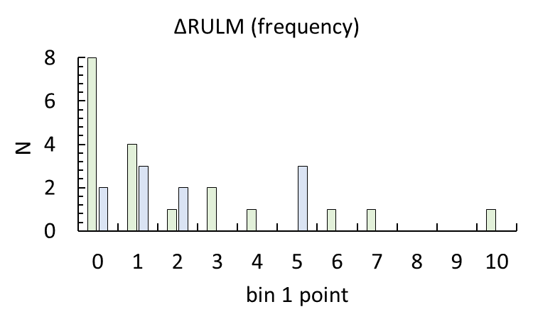 | 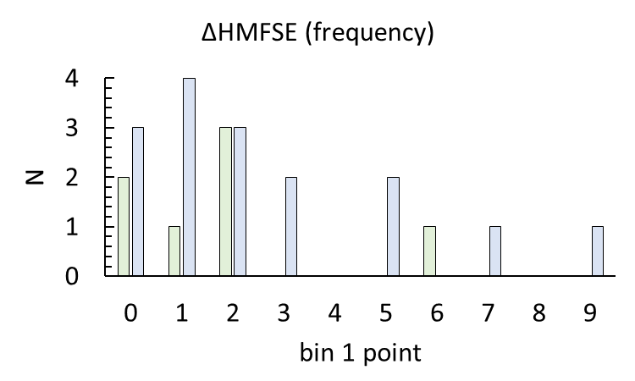
(a) | (b)
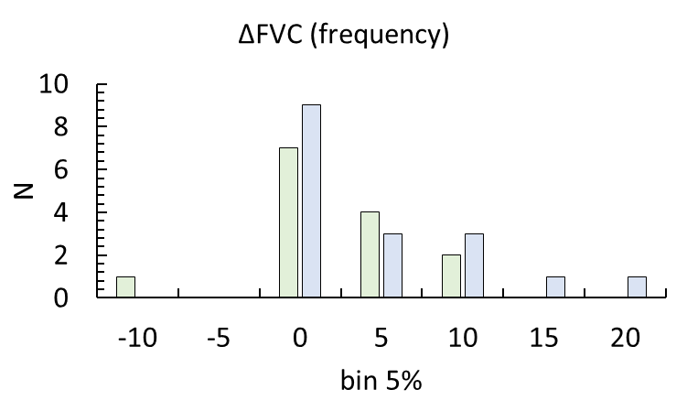 | 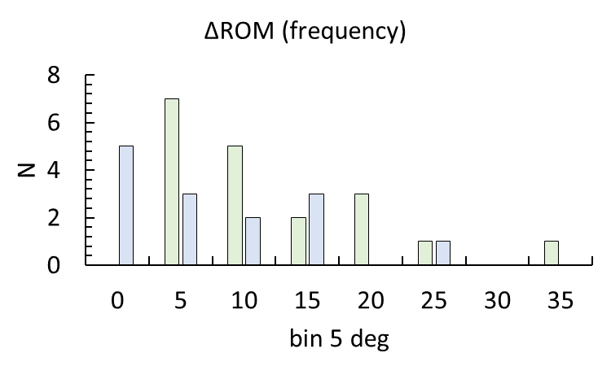
(c) | (d)

Figure S1. Frequency distribution of the difference in RULM (a), HFMSE (b), FVC (c), and ROM (d) before and after tSCS sessions in SMA type 2 and type 3 groups. Bin is 1 point in (a) and (b) and 5 percent and degrees in (c) and (d), respectively.

Table S5. New motor skills of participants with SMA type 2 after the tSCS training course
Adult participant is marked in gray

Participants | New motor skills
21K53 | Standing unsupported up to 1 minute
6K12 | Head elevation in prone position. Head elevation from pillow in supine position
8K18
15K49 | When eating, uses a spoon
1K1
10K30 | Moving from supine to sitting with hands
5K10
1K2 | Supine, legs vertical, up to 15 seconds
15K47
9K22 | Standing unsupported up to 2,5 minutes
16K50 | Moves from wheelchair to couch without support
3K5 | Sitting on the floor, moves forward 2-3 meters using hands and legs
6K11
9K23
5K8 | Moves from the floor to wheelchair without support
8K20
9K24
7K14 | Rolling from the supine to the lateral position
8K19 | Raises and holds knees in supine position
14K44

Table S6. New motor skills of participants with SMA type 3 after the tSCS training course
Adult participants are marked in gray
Participants | New motor skills
11K34 | Use one hand (instead of two) to walk up and down stairs
20K51
12K43
9K26 | Moves from all fours to wheelchair without support
12K42 | Standing unsupported and walking 2-3 meters supported
7K15 | Standing on all fours up to half a minute
11K39 | Movement from supine to right side position
9K27 | Pick up and move 100-gram weight
2K3
11K35 | Ability to extend from standing with hands on knees to standing upright
15K48
9K28 | Movements from supine to prone position and from prone position to supine position
10K32
4K7 | Transition from sitting on the floor to kneeling on the floor, kneeling on both knees
9K25
11K37
8K21 | The ability to wash the face with the right hand without supporting the forearm with the left hand has returned

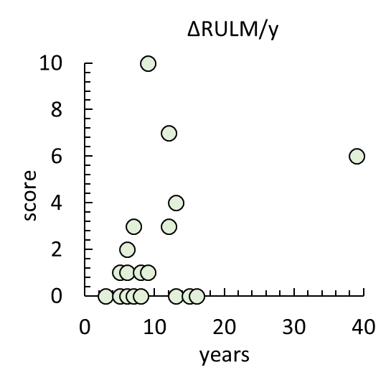 | 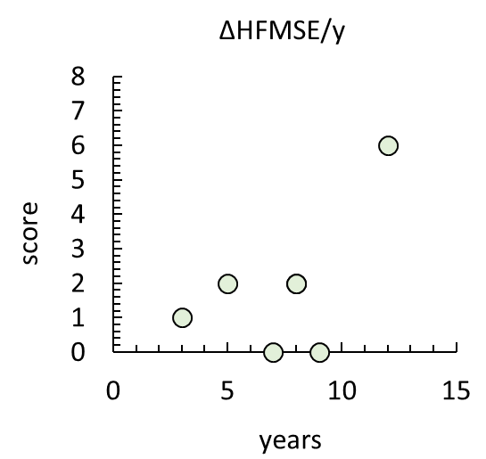 | 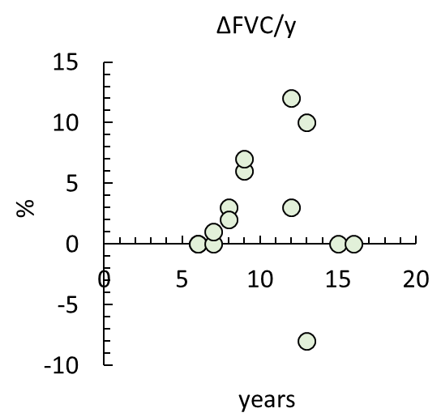
(a) | (b) | (c)
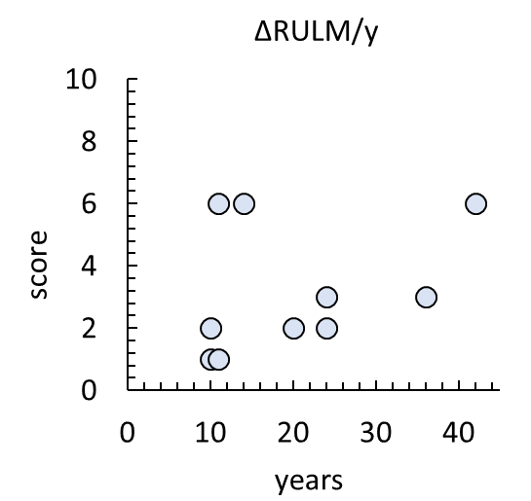 | 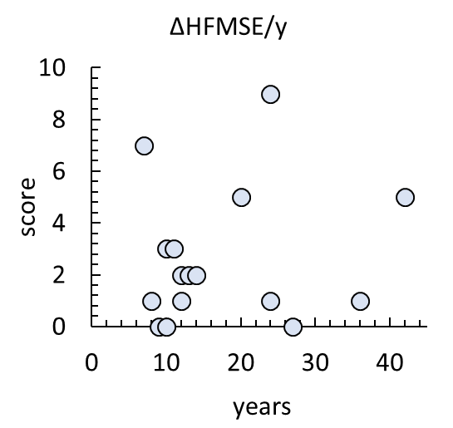 | 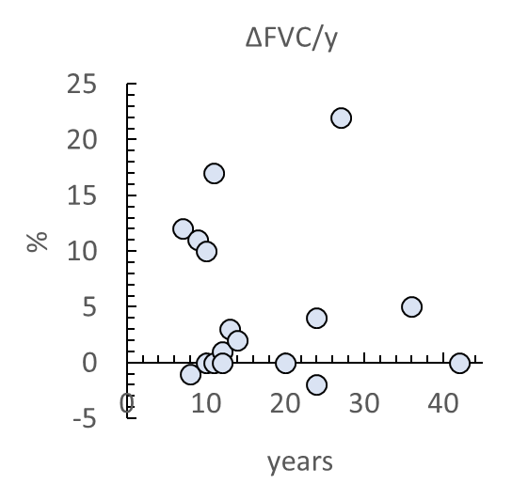
(d) | (e) | (f)
Figure S2. Difference in RULM, HFMSE and FVC before and after tSCS sessions versus age. (a) - (c) - SMA type 2 group; (d) - (f) - SMA type 3 group.

