**SUPPLEMENTARY MATERIAL**

**Suplementary information on SARS-CoV-2 genome sequencing of individual code N**

Illumina sequence raw data was processed using the COVID Lineage pipeline on the Dragen analysis platform. After quality control, the consensus sequence was assembly and mapped against the reference strain (NC_045512.2) to identity mutations, which are described below:

**Nucleotide substitutions**

C241T,T670G,C2790T,C3037T,G4184A,C4321T,C6354T,C9344T,A9424G,C9534T,C9866T,C10029T,C10198T,G10447A,C10449A,C12880T,C14408T,C15714T,C17410T,A18163G,C19955T,A20055G,C21618T,G21987A,T22200G,G22578A,C22674T,T22679C,C22686T,A22688G,G22775A,A22786C,G22813T,T22882G,G22992A,C22995A,A23013C,A23040G,A23055G,A23063T,T23075C,A23403G,C23525T,T23599G,C23604A,C23854A,G23948T,A24424T,T24469A,C25000T,C25584T,A26053G,C26060T,C26270T,G26709A,C26858T,A27259C,G27382C,A27383T,T27384C,C27807T,A28271T,C28311T,G28881A,G28882A,G28883C,A29510C,T29834A

**Amino acid substitutios**

E:T9I,M:A63T,N:P13L,N:R203K,N:G204R,N:S413R,ORF1a:S135R,ORF1a:T842I,ORF1a:G1307S,ORF1a:S2030L,ORF1a:L3027F,ORF1a:T3090I,ORF1a:L3201F,ORF1a:T3255I,ORF1a:P3395H,ORF1b:P314L,ORF1b:R1315C,ORF1b:I1566V,ORF1b:T2163I,ORF3a:T221A,ORF3a:T223I,ORF6:D61L,ORF9b:P10S,S:T19I,S:A27S,S:G142D,S:V213G,S:G339D,S:S371F,S:S373P,S:S375F,S:T376A,S:D405N,S:R408S,S:K417N,S:N440K,S:S477N,S:T478K,S:E484A,S:Q493R,S:Q498R,S:N501Y,S:Y505H,S:D614G,S:H655Y,S:N679K,S:P681H,S:N764K,S:D796Y,S:Q954H,S:N969K

**Amino acid deletion**

N:E31-,N:R32-,N:S33-,ORF1a:S3675-,ORF1a:G3676-,ORF1a:F3677-,ORF9b:E27-,ORF9b:N28-,ORF9b:A29-,S:L24-,S:P25-,S:P26-

**Table S1**

|  |  |  |  |  |  |  |  |  |  |  |  |  |  |  |  |  |
| --- | --- | --- | --- | --- | --- | --- | --- | --- | --- | --- | --- | --- | --- | --- | --- | --- |
| **INVESTIGATION FORM FOR CORONAVIRUS 2019** | | | | | | | | | | | | | | | | |
| **Notification State (UF):** | | **Notification Municipality:** | | | | | | | | | | | | | | |
| **Identification** | **Full name:** | | | | | | | | | | | | | | | |
| **Data of Birth:** | | | | | | | | **Coountry of Origin:** | | | | | | | |
| **Gender:**  | |Male  | |Female | | **Contact Phone:** | | | | | | | | | | | | | |
| **Clinical Data** | **Notification Date:** | | | | | | | | **Onset of Symptoms Date:** | | | | | | | |
| **Symptoms: (Mark X)**  | |Asymptomatic | |Fever | |Sore Throat | |Shortness of Breath | |Cough | | Runny Nose  | |Headache | | Taste Disorders | | Smell Disorders | |Others | | | | | | | | | | | | | | | |
| **Conditions: (Mark X)**  | |Uncontrolled chronic respiratory diseases | | Diabetes | | Obesity | |Advanced-stage chronic kidney diseases (Stages 3, 4, and 5) | | Immunocompromised | |Carrier of chromosomal diseases or immunological fragility state | | Pregnant | |Chronic heart diseases | | Postpartum (up to 45 days after delivery) | | | | | | | | | | | | | | | |
| **Symptoms** | **Symptoms intensity** | | | | | | | | | | | | | | |
| **1** | | **2** | | **3** | **4** | | | **5** | **6** | **7** | **8** | **9** | **10** | **Observations:** |
| **Fever or chills** |  | |  | |  |  | | |  |  |  |  |  |  |
| **Sore Throat** |  | |  | |  |  | | |  |  |  |  |  |  |
| **Shortness of Breath** |  | |  | |  |  | | |  |  |  |  |  |  |
| **Cough** |  | |  | |  |  | | |  |  |  |  |  |  |
| **Headache** |  | |  | |  |  | | |  |  |  |  |  |  |
| **Congestion or Runny Nose** |  | |  | |  |  | | |  |  |  |  |  |  |
| **Loss of Smell or Taste** |  | |  | |  |  | | |  |  |  |  |  |  |
| **Muscle or Body** |  | |  | |  |  | | |  |  |  |  |  |  |
| **Diarrhea** |  | |  | |  |  | | |  |  |  |  |  |  |
| **Others:** |  | |  | |  |  | | |  |  |  |  |  |  |
| **Positive teste for SARS-CoV-2?**  | | Yes | |No | | | | | | | **Type of test:** | | RT-PCR | | Rapid Antigen Test  | | Rapid Antibody Test | |ELISA | |ECLIA | |CLIA | | | | | | | | |
| **Collection Date:** | | | | | | **Test Result:**  | | Positive | |Negative | |Inconclusive | | | | | | | | | | | |

**Table S1:** COVID-19 technical data sheet: Symptoms, Tests, Monitoring and Identification of Risk Conditions.

**Table S2**



**Table S2:** General data record, indicating test records and onset of symptoms, intensity of COVID-19 symptoms (evaluated on a scale of 0 to 10) and the sum of symptoms. The vaccination scheme of participants is reported according to the initial letter of the vaccine's name (A, for AstraZeneca, C for CoronaVac, J for Janssen, P for Pfizer). The anti-N and anti-S IgG titers before and after the infection event are also listed.

**Table S3**

|  |  |  |  |  |  |  |  |  |  |  |  |  |
| --- | --- | --- | --- | --- | --- | --- | --- | --- | --- | --- | --- | --- |
| **Symptomatology** | **Mean ± SD** | **Frequency Distribution (%) - Degree of intensity of symptoms COVID-19**  **(from 0 to 10)** | | | | | | | | | | |
| **0** | **1** | **2** | **3** | **4** | **5** | **6** | **7** | **8** | **9** | **10** |
| **Fever or chills** | 7,9 ± 2,6 | 6% | 0% | 0% | 0% | 6% | 0% | 6% | 0% | 19% | 50% | 13% |
| **Sore throat** | 6,7 ± 3,9 | 19% | 0% | 6% | 0% | 0% | 6% | 0% | 0% | 13% | 38% | 19% |
| **Shortness of breath** | 2,8 ± 3,7 | 25% | 38% | 13% | 0% | 0% | 0% | 0% | 6% | 6% | 0% | 13% |
| **Cough** | 6,8 ± 3,1 | 6% | 0% | 0% | 13% | 6% | 13% | 6% | 0% | 0% | 44% | 13% |
| **Headache** | 3,1 ± 2,7 | 31% | 0% | 0% | 38% | 0% | 6% | 13% | 6% | 6% | 0% | 0% |
| **Congestion or runny nose** | 4,3 ± 3,4 | 6% | 13% | 13% | 31% | 0% | 13% | 0% | 0% | 0% | 13% | 13% |
| **Loss of taste or smell** | 4,8 ± 2,7 | 13% | 0% | 6% | 19% | 0% | 13% | 25% | 6% | 13% | 6% | 0% |
| **Muscle or body aches** | 4,9 ± 3,0 | 13% | 0% | 6% | 19% | 6% | 19% | 0% | 19% | 6% | 6% | 6% |
| **Diarrhea** | 0,9 ± 1,9 | 50% | 44% | 0% | 0% | 0% | 0% | 0% | 0% | 6% | 0% | 0% |

**Table S3:** Frequency distribution table associated with the degree of intensity of COVID-19 symptoms. Note: based on the latest update from the Ministry of Health (September 2021), primary symptoms of COVID-19 have been incorporated into the table. SD: Standard Deviation.

**Figure S1 pages 5 - 11**















**Figure S1:** Time course of IgG titers and relevant events in each individual. The x-axis indicates the temporal analysis of each individual, infection and vaccination events are indicated by vertical lines. Each vaccine dose and vaccination scheme are shown according to the initial letter of the vaccine's name (A, for AstraZeneca, C for CoronaVac, J for Janssen, P for Pfizer). The anti-N (green) and anti-S (red) IgG titers are reported on the left y-axis, with dashed lines indicating the positivity cutoff. The right y-axis corresponds to time in days after infection (gray) or administration of the last vaccine dose (blue), indicated by the vertical bars. Asymptomatic cases are indicated as “Possible Infections”. “Infection”, indicates individuals who declared a positive RT-qPCR or antigen SARS-CoV-2 test.

**Figure S2**

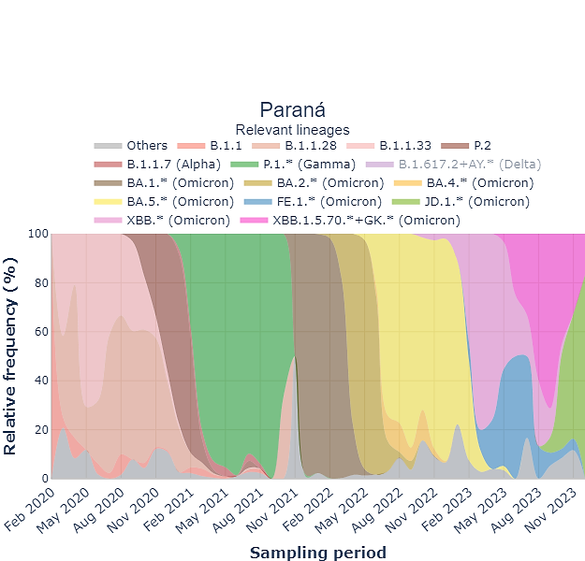

**Figure S2:** Relative frequency of SARS-CoV-2 variants circulating in the Paraná state in Brazil from 2020 to 2023. **Source:** <https://www.genomahcov.fiocruz.br/dashboard-pt/>

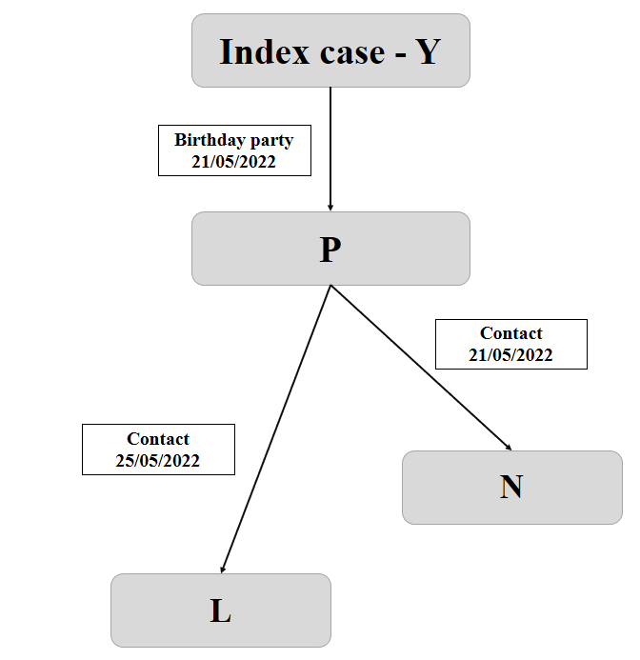

**Figure S3:** Descriptive flowchart of the clinical course of COVID-19 infection in cases related to individual N, representing the individuals' contact history. Description of cases: On 23/05/2022 the Index case (individual Y) test positive for SARS-CoV-2 (antigen test). Individuals code N and P had no negative symptoms and tested negative for SARS-CoV-2 antigen. On 25/05/2022 individual N has no symphotms and individual P reported fever and chills, sore throat and strong cough. On 26/05/2022 individual N and P tested positive for SARS-CoV-2 antigen; P reported sore throat, strong cough, congestion and running nose, while individual N reported a light sore throat. On 27/05/2022, individual N tested positive for SARS-CoV-2 based on RT-qPCR. This sample was subjected to SARS-CoV-2 genome sequencing. At this stage individual N reported fever and chills, while individual P had a sore throat, cough, congestion with running nose and loss of smell. On 28/05/2022 individual P again reported similar symptoms with cough, running nose and loss of smell. On this date, individual N, experienced a strong cough, with fever and chills. At this stage, individual L tested positive for SARS-CoV-2 antigen and reported fever and chills, with sore throat and a cough.. On 29/05/2022 individual P only reported loss of smell, individual N, reported cough and sore throat and individual L slightly recovered. On 30/05/2022 individuals P and L were fully recovered, and individual N reported cough, sore throat, loss of smell. On 31/05/2022 individual N fully recovered.