Table S1. Identification of RG/RGG repeat sequences within the protein sequences of the DEAD-box family using phase separation databases, including PhaSepDB, PhaSePro, LLPSDB v2.0, and DrLLPS.
Gene | Species | The number of RG/RGG
DDX3X | Human | RG*10 RGG*1
DDX4 | Human | RG*5 RGG*1
DDX5 | Human | RG*9 RGG*2
DDX6 | Human | RG*2
DDX17 | Human | RG*4 RGG*5
DDX21 | Human | RG*9
DBP1 | Yeast | RG*4 RGG*3
DBP2 | Yeast | RG*3 RGG*7
DED1 | Yeast | RG*4 RGG*4
DHH1 | Yeast | RG*1
LAF-1 | Caenorhabditis elegans | RG*11 RGG*8
RhlE | Escherichia coli | RG*4 RGG*2
DeaD | Escherichia coli | RG*8 RGG*1

Table S2. Plasmids used in this article
Plasmid | Characterization of plasmids
pET23a-sfGFP | sfGFP(Superfold Green Fluorescent Protein)
pET23a-DED1NC | DED1N-sfGFP-DED1C
pET23a-DED1N | DED1N-sfGFP-DED1N
pET23a-DED1C | DED1C-sfGFP-DED1C
pET23a-DDX3XNC | DDX3XN-sfGFP-DDX3XC
pET23a-DDX3XN | DDX3XN-sfGFP-DDX3XN
pET23a-DDX3XC | DDX3XC-sfGFP-DDX3XC
pET23a-DBP1NC | DBP1N-sfGFP-DBP1C
pET23a-DBP1N | DBP1N-sfGFP-DBP1N
pET23a-DBP1C | DBP1C-sfGFP-DBP1C
pET23a-DED1N-RGG*0 | DED1N(R51S/R62S)-sfGFP-DED1N(R51S/R62S)
pET23a-DED1N-RGG | DED1N(R51S)-sfGFP-DED1N(R51S)
pET23a-DED1N-GGRGGG | DED1N(R62S)-sfGFP-DED1N(R62S)
pET23a-DED1C-RGG*0 | DED1C(R545S/R578S)-sfGFP-DED1C(R545S/R578S)
pET23a-DED1C-RGG*3 | DED1C(A559R)-sfGFP-DED1C(A559R)
pET23a-DED1C-RGG*4 | DED1C(A559R /S595R)-sfGFP-DED1C(A559R/S595R)
pET23a-DED1C-R2RG4 | DED1C(S581G)-sfGFP-DED1C(S581G)
pET23a-DED1C-R3RG4 | DED1C(A559R/S581G)-sfGFP-DED1C(A559R/S581G)
pET23a-DED1C-R4RG4 | DED1C(A559R/S581G/S595R)-sfGFP-DED1C(A559R/S581G/S595R)
pET23a-DED1C-R2GGRGG | DED1C(S576G/F577G)-sfGFP-DED1C(S576G/F577G)
pET23a-DED1C-R3GGRGG | DED1C(A559R/S576G/F577G)-sfGFP-DED1C(A559R/S576G/F577G)
pET23a-DED1C-R4GGRGG | DED1C(A559R/S576G/F577G/S595R)-sfGFP-DED1C(A559R/S576G/F577G/S595R)
pET23a-DED1C-R2GGRG4 | DED1C(S576G/F577G/S581G)-sfGFP-DED1C(S576G/F577G/S581G)
pET23a-DED1C-R3GGRG4 | DED1C(A559R/S576G/F577G/S581G)-sfGFP-DED1C(A559R/S576G/F577G/S581G)
pET23a-DED1C-R4GGRG4 | DED1C(A559R/S576G/F577G/S581G/S595R)-sfGFP-DED1C(A559R/S576G/F577G/S581G/S595R)
pET23a-DBP1N-RGG*2 | DBP1N(N78R)-sfGFP-DBP1N(N78R)
pET23a-DBP1N-N18R | DBP1N(N18R)-sfGFP-DBP1N(N18R)
pET23a-DBP1N-N78R | DBP1N(N78R)-sfGFP-DBP1N(N78R)
pET23a-DBP1C-RGG*0 | DBP1C(R550S/R555S)-sfGFP-DBP1C(R550S/R555S)
pET23a-DDX3XN-RGG*2 | DDX3XN(S114G)-sfGFP-DDX3XN(S114G)
pET23a-DDX3XN-S28R | DDX3XN(S28R)-sfGFP-DDX3XN(S28R)
pET23a-DDX3XN-S114G | DDX3XN(S114G)-sfGFP-DDX3XN(S114G)
pET23a-DDX3XC-RGG*2 | DDX3XC(S622G/G624SR)-sfGFP-DDX3XC(S622G/G624SR)
pET23a-DDX3XC-22 | DDX3XC(S622G/G624SR)-sfGFP-DDX3XC(S622G/G624SR)
pET23a-DDX3XC-25 | DDX3XC(S622G/Y638YR)-sfGFP-DDX3XC(S622G/Y638YR)
pET23a-DDX3XC-56 | DDX3XC(S622G/F633G)-sfGFP-DDX3XC(S622G/F633G)
pET23a-DDX3XC-59 | DDX3XC(S622G/F633G/Y638G)-sfGFP-DDX3XC(S622G/F633G/Y638G)
pET23a-DDX3XC-RGG | DDX3XC(S622G/G624SR)-sfGFP-DDX3XC(S622G/G624SR)
pET23a-DDX3XC-GGRGG | DDX3XC(S622G/G624R/Y638R)-sfGFP-DDX3XC(S622G/G624R/Y638R)

Table S3. Primers associated with targeted mutations
Primers | Primer Sequences (5’-3’)
DED1-R51S-F | GCGGCTACAACGGTGGCAGTGGCGGTGGCAGCTTCTTTAG
DED1-R51S-R | GAAGCTGCCACCGCCACTGCCACCGTTGTAGCCGCCGTTG
DED1-R62S-F | CTTTAGCAACAACCGTAGTGGTGGTTACGGCAACGGTGG
DED1-R62S-R | CGTTGCCGTAACCACCACTACGGTTGTTGCTAAAGAAGC
DED1-R545S-F | CAGAAGCAACAGCCGTAGTGGCGGTTTCGGTCGCAACAAC
DED1-R545S-R | TTGCGACCGAAACCGCCACTACGGCTGTTGCTTCTGCTAC
DED1-R578S-F | GCAGAGATAACTCTTTCAGTGGCGGTAGTGGCTGGGGTAG
DED1-R578S-R | CCCCAGCCACTACCGCCACTGAAAGAGTTATCTCTGCTTC
DED1-A559R-F | ACAGAGATTACCGTAAGAGAGGAGGCGCTAGCGCAGGCGG
DED1-A559R-R | TGCGCTAGCGCCTCCTCTCTTACGGTAATCTCTGTTGTTG
DED1-S595R-F | CTTCTGGCTGGGGTAACAGAGGTGGTTCAAACAACTCTTC
DED1-S595R-R | GTTGTTTGAACCACCTCTGTTACCCCAGCCAGAAGACTTG
DED1-S581G-F | TCTTTCAGAGGCGGTGGTGGCTGGGGTAGCGATTCCAAG
DED1-S581G-R | TCGCTACCCCAGCCACCACCGCCTCTGAAAGAGTTATC
DED1-S576G/F577G-F | GAAGCAGAGATAACGGTGGCAGAGGCGGTAGTGGCTGGGG
DED1-S576G/F577G-R | CCACTACCGCCTCTGCCACCGTTATCTCTGCTTCTTGAAG
DBP1-N18R-F | CATCAACAACAAAGAGAGGGGTGGTGGTGGCGGCAAATC
DBP1-N18R-R | GCCGCCACCACCACCCCTCTCTTTGTTGTTGATGCTTAAATTAG
DBP1-N78R-F | TTTTCTAAGGAAAGAGGTGGAGGGACGAGTGCGAACTATAAC
DBP1-N78R-R | ATAGTTCGCACTCGTCCCTCCACCTCTTTCCTTAGAAAAGCC
DBP1-R550S-F | GTCAAGACAGAATTCAAGTGGTGGAAGAACTAGGGGAGG
DBP1-R550S-R | CCCCTAGTTCTTCCACCACTTGAATTCTGTCTTGACAGG
DBP1-R555S-F | TCAAGAGGTGGAAGAACTAGTGGAGGTCAAGAGGTGGAAGAACTAG
DBP1-R555S-R | GAAAAAACCTCCTCCTCCACTAGTTCTTCCACCTCTTGAATTC
DDX3X-S28R-F | CTTCAGATAATCAGCGTGGAGGAAGTACAGCCAGCAAAG
DDX3X-S28R-R | TGGCTGTACTTCCTCCACGCTGATTATCTGAAGAGTTCAG
DDX3X-S114G-F | CAGCCGTGGTGACAGAGGTGGCTTTGGCAAATTTGAACG
DDX3X-S114G-R | AATTTGCCAAAGCCACCTCTGTCACCACGGCTGCCAATG
DDX3X-S622G-F | CGCAAGCAGCAGCCGCGGTGGCGGAGGTGGCCACGGTAG
DDX3X-S622G-R | CGTGGCCACCTCCGCCACCGCGGCTGCTGCTTGCGCGGC
DDX3X-G624SR-F | CAGCAGCCGCAGTGGCAGTCGAGGTGGCCACGGTAGCAGCAG
DDX3X-G624SR-R | TGCTACCGTGGCCACCTCGACTGCCACTGCGGCTGCTGCTTG
DDX3X-G624R-F | CAGCAGCCGCAGTGGCCGAGGTGGCCACGGTAGCAGCAG
DDX3X-G624R-R | TGCTACCGTGGCCACCTCGGCCACTGCGGCTGCTGCTTG
DDX3X-F633G-F | CGGTAGCAGCAGAGGAGGTGGTGGAGGTGGCTATGGAGG
DDX3X-F633G-R | CATAGCCACCTCCACCACCTCCTCTGCTGCTACCGTGGC
DDX3X-Y638YR-F | ATTTGGTGGAGGTGGCTATCGTGGAGGCTTTTACAACAGTG
DDX3X-Y638YR-R | TGTTGTAAAAGCCTCCACGATAGCCACCTCCACCAAATCCTC
DDX3X-Y638R-F | ATTTGGTGGAGGTGGCCGTGGAGGCTTTTACAACAGTG
DDX3X-Y638R-R | TGTTGTAAAAGCCTCCACGGCCACCTCCACCAAATCCTC
DDX3X-Y638G-F | ATTTGGTGGAGGTGGCGGTGGAGGCTTTTACAACAGTG
DDX3X-Y638G-R | TGTTGTAAAAGCCTCCACCGCCACCTCCACCAAATCCTC

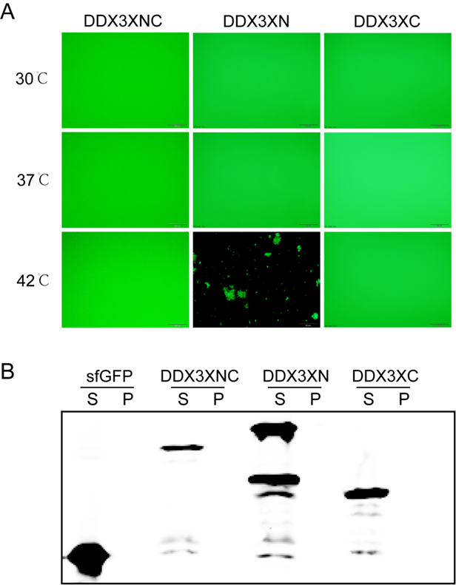
Supplemental Figure S1. A) Expression of DDX3XNC/ DDX3XN/ DDX3XC in a cell-free system (4 h at 30℃) followed by 30 min incubation at different temperatures (30, 37, and 42℃). Phase separation and aggregation were assessed by fluorescence microscopy. B) Solubility analysis using Western blot analysis of the supernatant (S) and pellet (P) fractions at 37℃.

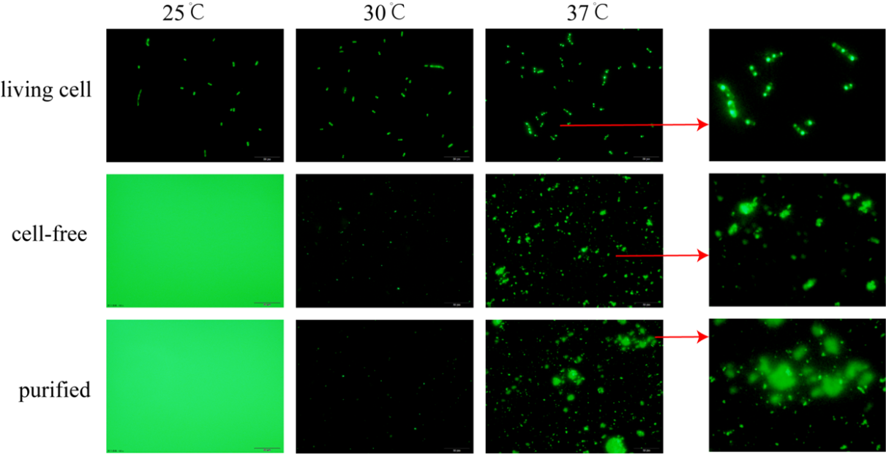
Supplemental Figure S2. Comparison of self-aggregation in living cells, cell-free protein synthesis (CFPS) systems, and purified proteins at different temperatures (25, 30, 37 ℃). Left panel: Fluorescence microscopy images with a Scale bar of 20 μm. Right panel: Enlarged fluorescence images highlighting the morphology of the aggregates (Scale bar, 2 μm).

Phase-separated protein expression purification
The pET28a-DED1NC plasmid was constructed and transformed into E. coli BL21 (DE3) for protein expression. The monoclonal strains were harvested and cultured in LB medium at 37°C with an oscillation frequency of 220 rpm until OD600 = 0.6-0.8. They were then induced with 1 mM isopropyl-β-D-thiogalactopyranoside (IPTG) (Cat. I1020, Solarbio) and cultured overnight at 18°C and 220 rpm for protein expression. Bacteria were resuspended in high salt lysis buffer (500 mM NaCl, 20 mM Tris, 20 mM imidazole, 1 mM PMSF, pH 7.5) and sonicated. It was then purified on a nickel column (Cat. P2011, Solarbio) and eluted in 8ULB buffer (200 mM NaCl, 20 mM Tris, 200 mM imidazole, 8 M urea, pH 7.5). Finally, 10 kDa ultrafiltration tubes (Cat. UFC801096, Solarbio) were used and the solvent was changed to high salt buffer (500 mM NaCl, 20 mM Tris, pH 7.5) to prevent phase separation. Quick freeze in liquid nitrogen and store at -80°C.

