Photochemical and oxidative degradation of chamazulene contained in Artemisia, Matricaria and Achillea essential oils and setup of protection strategies

Simone Gabbanini,*^{,1} Jerome Ngwa Neba,² Riccardo Matera,¹ Luca Valgimigli, *^{,2,3}
¹ R&D Department, BeC s.r.l., Via C. Monteverdi 49, 47122 Forlì, Italy; laboratorio@bec-natura.com
²Department of Chemistry “Ciamician”, University of Bologna, Via Gobetti 85, 40129 Bologna, Italy; luca.valgimigli@unibo.it
³ Tecnopolo di Rimini, Via D. Campana 71, 47922 Rimini, Italy.

APPENDIX
(Supplementary data)

Table of Contents
Figure S1. Spectral radiation power distribution of Ultra-Vitalux lamp | Page 2
Figure S2. Fragmentation of parent peak m/z 215, calculated by Mass Frontier software | Page 2
Figure S3. GC-MS calibration curve of CA in Total Ion Count (TIC) mode | Page 3
Figure S4. LC-PDA calibration curve of CA at 349 nm | Page 3
Figure S5. Example of HPLC-PDA chromatograms of mixtures of CA and antioxidants. | Page 4
Figure S6. Example of LC-PDA chromatograms of mixtures of CA (0.17 mM) with UV filters | Page 5
Figure S7.Spectrophotometric evaluation of CA photodegradation in the absence of oxygen | Page 6
Figure S8. Detail of chamazulene degradation with selected antioxidants, incubated at 50°C. | Page 6

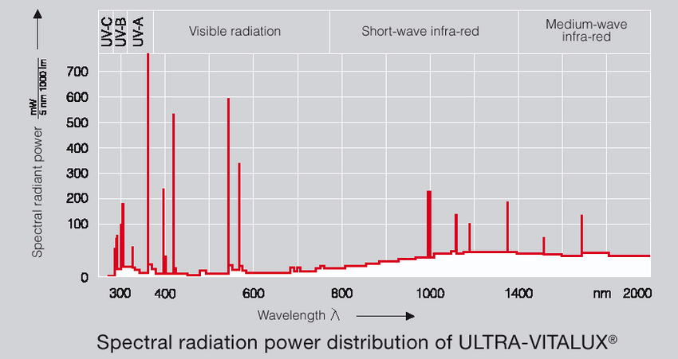
Figure S1. Spectral radiation power distribution of Osram Ultra-Vitalux® lamp at various wavelengths. Data provided by the lamp manufacturer, reported only as a reference.
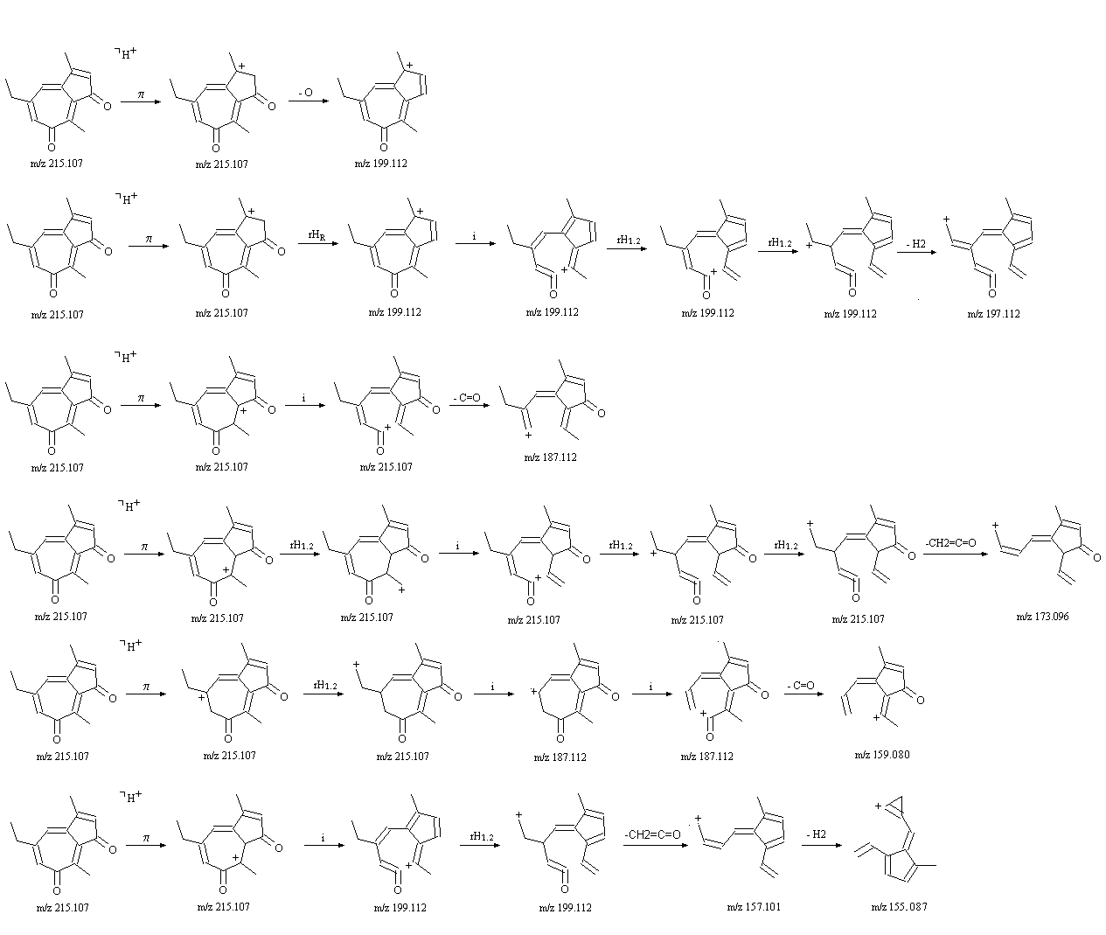

Figure S2. Fragmentation ions of parent peak m/z 215, in positive mode attributed to chamazulene quinone (6), calculated by Mass Frontier software. The fragmentation pattern explains ions with m/z 197, 187 and 159 shown in Figure 9.
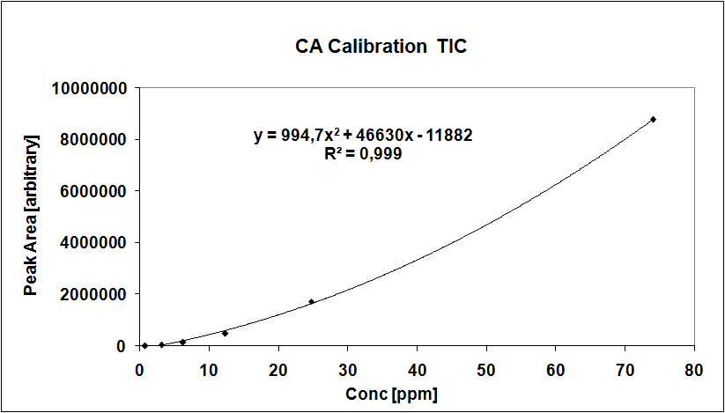

Figure S3. GC-MS calibration curve of CA in Total Ion Count (TIC) mode, used to evaluate the influence of solvent type and presence of oxygen on the photostability of CA alone.

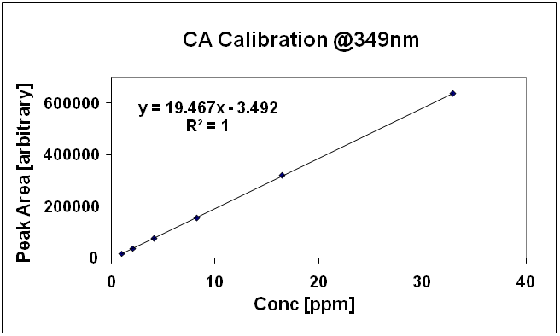

Figure S4. LC-PDA calibration curve of CA at 349 nm used for evaluation of photo and thermal stability experiments of CA in presence of antioxidants and sunscreens.

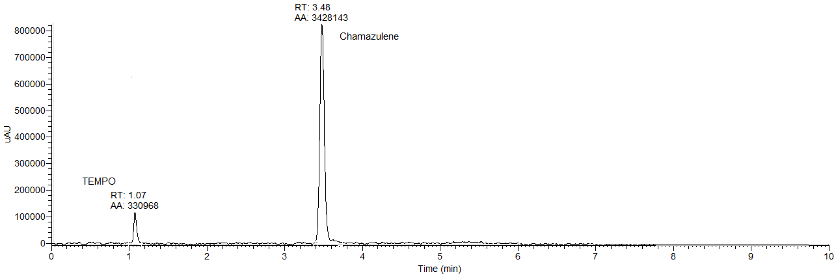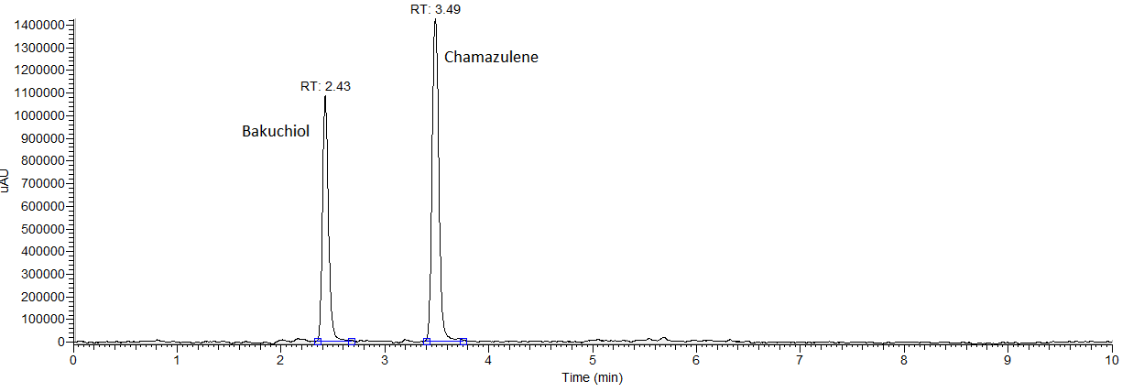
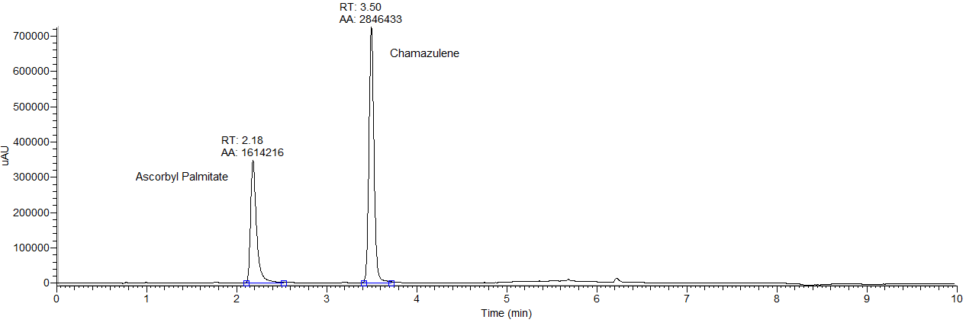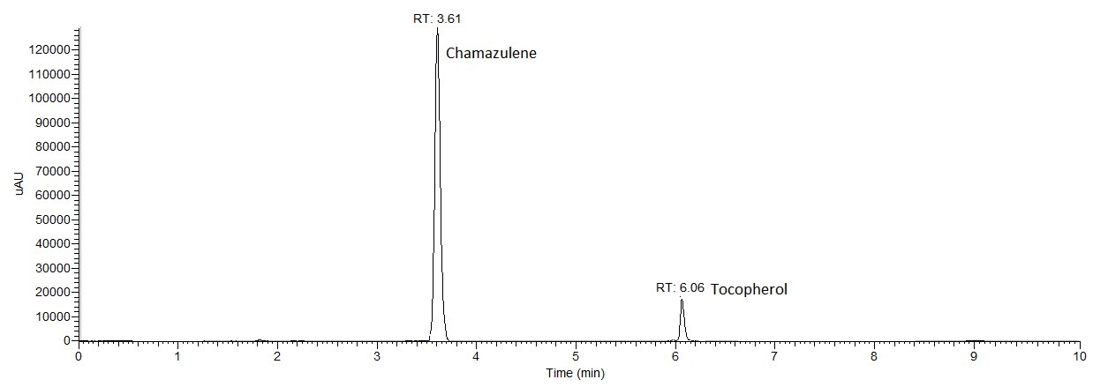
Figure S5. Example of HPLC-PDA chromatograms of mixtures of CA:antioxidants in molar ratio 1:10. From top to bottom: TEMPO, bakuchiol, ascorbyl palmitate, tocopherol.

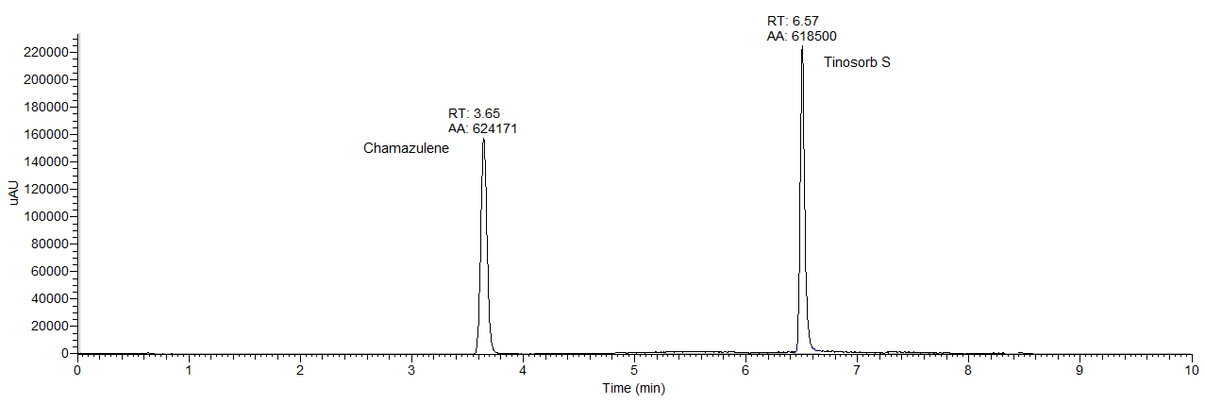

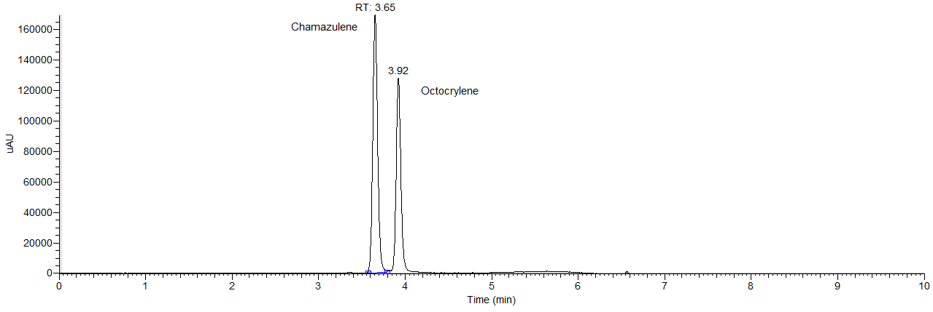
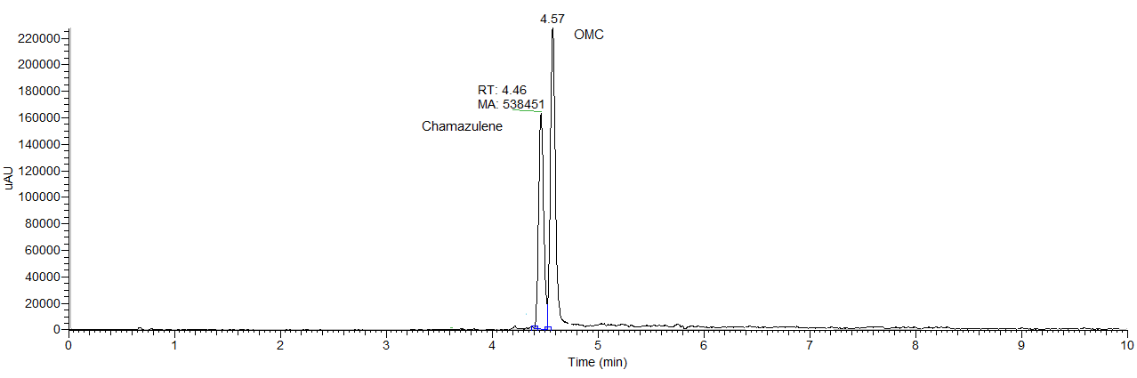

Figure S6. Example of LC-PDA chromatograms of mixtures of CA (0.17 mM) with UV filters at a concentration of 5% w/v (from top to bottom:, Tinosorb® S, octocrylene, octyl methoxycinnamate). The choormatographic conditions were slightly changed for octlyl methoxycinnamate to resolv coelution with chamazulene..

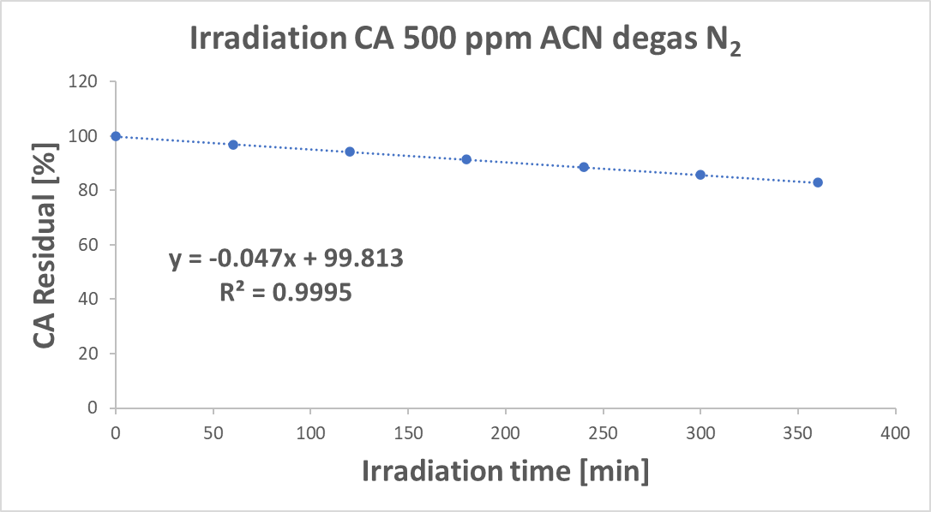

Figure S7.Spectrophotometric evaluation of CA photodegradation in the absence of oxygen. Measurments were perfomed in a sample of CA 500 ppm in acetonitrile in a 3.5 mL Teflon sealed quartz cu-vette and degassed for 5 minutes with an abundant N₂ stream. The cuvette was subjected to UVA-UVB radiation at100 mW/cm² (strong photooxidation conditions)for 6 hours. At regular time intervals a spectrophotometric reading was performed without opening the cuvette. The rate of the CA degradation is reported.

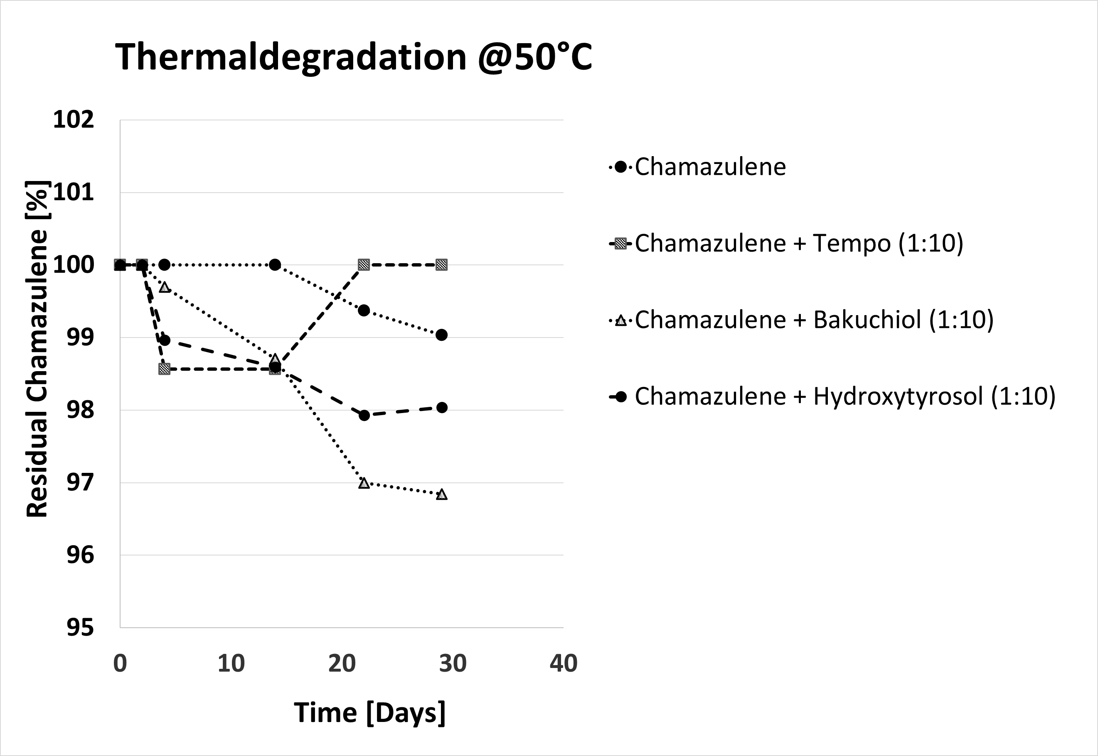

Figure S8. Detail of thermal degradation of chamazulene in solution, alone or in the presence of selected antioxidants, incubated at 50°C. This figure represents and expansion of Figure 12 in the manuscript.

