Article
Climate Effects on Ergot and Ergot Alkaloids Occurrence in Italian Wheat
Mariantonietta Peloso ¹, Gaetan Minkoumba Sonfack¹, Ilaria Prizio¹, Eleonora Baraldini Molgora¹, Guido Pedretti², Giorgio Fedrizzi¹ and Elisabetta Caprai ^{1,} *
¹Food Chemical Department, IZSLER, via Fiorini 5, Bologna, Italy;
²Agronomist Freelance, Como, Italy;

* Correspondence: elisabetta.caprai@izsler.it

- Supplementary Material

1.1 Tables
Table S1. LC conditions
LC conditions
LC-MS/MS equipment | XEVO TQ-Xs Acquity UPLC I Class Plus Waters
LC Column | UPLC BEH C18 1.7µm 100 mm x 2.1 mm Waters
Mobile Phase | A: 10 mM ammonium carbonate solution (pH 10)  B: acetonitrile
Flow | 0.4 mL/min
Injection volume | 5µL

 | Time  (min) | Mobile phase A  (%) | Mobile Phase B  (%)
0  8  8.5  11 |  | 80  30  80  80 | 20  70  20  20
Table S2. Gradient Elution Program

MS/MS parameters
Ionization mode  Capillary voltage | ESI+  0.50 kV
Source Temperature | 150°C
Cone voltage | 35 V
Desolvation Temperature | 600°C
Table S3. MS/MS parameters

Table S4. Total content of 12 ergot alkaloids in sclerotia samples and corresponding wet weight.
Samples number¹ | Wet Weight (g) |  | T-EAs² (µg/kg)
S1 |  | 0.24 | 1,158,760
S2 |  | 0.32 | 698,640
S3 |  | 0.20 | 819,530
S4 |  | 0.20 | 110,090
S5 |  | 0.36 | 639,100
S6 |  | 0.18 | 1,421,970
S7 |  | 0.08 | 147,050
S8 |  | 0.07 | 698,960
S9 |  | 0.07 | 337,720
S10 |  | 0.08 | 702,140
S11 |  | 0.06 | 4,951,190
S12 |  | 0.02 | 1,019,080
S13  S14 |  | 0.03  0.03 | 1,208,110  1,218,340
S15 |  | 0.01 | 2,590
WE1 |  | 1.00 | 2,300
WE2 |  | 0.52 | 70
WE3 |  | 0.23 | 120
WE4 |  | 0.47 | 50
WE5 |  | 0.49 | 60
WE6 |  | 0.14 | 30
WE7 |  | 0.36 | 10
WE8 |  | 0.76 | 20
WE9 |  | 0.63 | 1,450
WE10 |  | 0.36 | 33,110
WE11 |  | 0.66 | 40
WK1 |  | 10.00 | 1,150
¹ S= sclerotia; WE= wheat ear; WK= wheat kernels; ² Total content of ergot alkaloids (T-EAs)

Table S5. The concentrations of ergot alkaloids (-ine form) in analyzed samples
Samples number¹ | Ergocornine µg/kg | Ergocristine µg/kg | Ergocryptine µg/kg | Ergosine µg/kg | Ergometrine µg/kg | Ergotamine µg/kg
S1 | 10,872.0 | 187,479.0 | 136,652.0 | 259,960.0 | 102,561.0 | 56,559.0
S2 | < LOQ² | 210,342.0 | 1,859.0 | 97,553.0 | 167.0 | 133,249.0
S3 | < LOQ | 216,586.0 | 614.0 | 30,381.0 | 77,210.0 | 123,333.0
S4 | 1,207.0 | 64.0 | 23,074.0 | 25,161.0 | 2,965.0 | 92.0
S5 | 75,324.0 | 24,035.0 | 41,668.0 | 154,380.0 | 59,333.0 | 9,224.0
S6 | < LOQ | 440,337.1 | 3,317.1 | 337,221.6 | 124,045.8 | 220,254.2
S7 | < LOQ | 56,821.4 | 398.5 | 19,582.4 | 69.4 | 28,221.4
S8 | 142,094.4 | 13,137.1 | 88,984.2 | 174,590.5 | 38,327.0 | 9,275.7
S9 | 2,155.5 | 72,791.4 | 2,060.0 | 92,845.9 | 36,023.5 | 13,778.5
S10 | 203,251.3 | 984.2 | 107,525.7 | 143,216.2 | 29,852.9 | 1,244.2
S11 | 1,001,533.3 | 190.0 | 623,237.1 | 705,720.2 | 251,147.0 | 1,331.4
S12 | 45,901.3 | 124.2 | 331,617.1 | 16,454.0 | 111,205.8 | 34.2
S13 | 335,620.8 | 65.7 | 150,771.4 | 38,762.1 | 225,564.1 | 312.8
S14 | 121,872.0 | 39.0 | 175,879.0 | 86,869.0 | 355,865.0 | 422.0
S15 | 180.5 | 88.5 | 1,194.2 | 294.5 | 288.2 | 85.7
WE1 | 118.0 | 82.0 | 56.0 | 432.0 | 674.0 | 110.0
WE2 | 5.0 | < LOQ | < LOQ | 4.0 | 40.0 | < LOQ
WE3 | 9.0 | < LOQ | 4.0 | 10.0 | 55.0 | < LOQ
WE4 | 5.0 | < LOQ | < LOQ | 6.0 | 22.0 | < LOQ
WE5 | < LOQ | < LOQ | 5.0 | 4.0 | 33.0 | < LOQ
WE6 | < LOQ | < LOQ | < LOQ | < LOQ | 26.0 | < LOQ
WE7 | < LOQ | < LOQ | < LOQ | < LOQ | 8.0 | < LOQ
WE8 | < LOQ | < LOQ | < LOQ | < LOQ | 12.0 | < LOQ
WE9 | 3.00 | < LOQ | 18.0 | 947.0 | 30.0 | < LOQ
WE10 | 1,037.0 | 1,930.0 | 13,230.0 | 2,240.0 | 1,680.0 | 466.0
WE11 | 3.0 | < LOQ | 10.0 | 5.0 | 14.0 | < LOQ
WK1 | 3.0 | 350.0 | 24.0 | 181.0 | 148.0 | 68.0
¹ S= sclerotia; WE= wheat ear; WK= wheat kernels; ²LOQ= 2 µg/kg
Table S6. The concentrations of ergot alkaloids (-inine form) in analyzed samples
Samples  number¹ | Ergocorninine µg/kg | Ergocristinine µg/kg | Ergocryptinine µg/kg | Ergosinine µg/kg | Ergometrinine µg/kg | Ergotaminine µg/kg
S1 | 10,559.0 | 95,926.0 | 83,574.0 | 122,834.0 | 70,986.0 | 20,802.0
S2 | < LOQ² | 138,875.0 | 1,364.0 | 50,141.0 | 130.0 | 64,958.0
S3 | < LOQ | 216,664.0 | 641.0 | 17,975.0 | 62,254.0 | 73,870.0
S4 | 3,013.0 | 67.0 | 32,031.0 | 17,584.0 | 4,791.0 | 41.0
S5 | 86,187.0 | 18,347.0 | 35,447.0 | 87,265.0 | 44,131.0 | 3,758.0
S6 | 844.0 | 146,938.5 | 892.9 | 68,664.9 | 36,152.0 | 43,304.2
S7 | < LOQ | 24,827.7 | 192.9 | 7,414.9 | 20.0 | 9,504.2
S8 | 92,710.7 | 4,330.8 | 40,957.1 | 67,154.1 | 24,540.0 | 2,861.1
S9 | 2,028.0 | 40,096.9 | 1,501.4 | 43,527.0 | 25,221.3 | 5,688.9
S10 | 107,953.3 | 426.2 | 41,721.4 | 52,867.6 | 12,734.7 | 361.1
S11 | 114,2236.0 | 126.2 | 630,792.9 | 436,247.3 | 157,321.3 | 1,305.6
S12 | 65,685.3 | 133.8 | 303,358.6 | 57,189.2 | 87,372.0 | < LOQ
S13 | 211,729.3 | 23.1 | 74,328.6 | 34,589.2 | 136,224.0 | 122.2
S14 | 113,326.0 | 13.0 | 148,029.0 | 41,836.0 | 174,002.0 | 188.0
S15 | 108.0 | 36.9 | 85.7 | 97.3 | 129.3 | < LOQ
WE1 | 118.0 | 75.0 | 48.0 | 238.0 | 298.0 | 53.0
WE2 | 3.0 | < LOQ | < LOQ | < LOQ | 21.0 | < LOQ
WE3 | 8.0 | < LOQ | < LOQ | 5.0 | 33.0 | < LOQ
WE4 | < LOQ | < LOQ | < LOQ | 3.0 | 10.0 | < LOQ
WE5 | < LOQ | < LOQ | < LOQ | < LOQ | 17.0 | < LOQ
WE6 | < LOQ | < LOQ | < LOQ | < LOQ | 8.0 | < LOQ
WE7 | < LOQ | < LOQ | < LOQ | < LOQ | 4.0 | < LOQ
WE8 | < LOQ | < LOQ | < LOQ | < LOQ | 7.0 | < LOQ
WE9 | < LOQ | < LOQ | 15.0 | 421.0 | 18.0 | < LOQ
WE10 | 846.0 | 1,488.0 | 7,732.0 | 1,127.0 | 1,136.0 | 196.0
WE11 | < LOQ | < LOQ | < LOQ | < LOQ | 8.0 | < LOQ
WK1 | 3.0 | 181.0 | 13.0 | 83.0 | 75.0 | 25.0
¹ S= sclerotia; WE= wheat ear; WK= wheat kernels; ²LOQ= 2 µg/kg

Table S7. Validation Parameters for each EA -ine form at six spiking levels
Samples | Spiking Level  µg/kg | Mean Conc µg/kg | SD¹ | RSDr² | Mean Recovery %
Ergocornine | 2 | 1.5 | 0.16 | 10.79 | 79.3
 | 10 | 8.3 | 0.66 | 7.90
 | 50 | 43.2 | 4.32 | 9.99
 | 150 | 112.9 | 5.80 | 5.14
 | 250 | 213.0 | 17.42 | 8.18
 | 600 | 422.5 | 36.00 | 8.52
Ergocristine | 2 | 1.4 | 0.16 | 11.16 | 74.7
 | 10 | 7.4 | 0.78 | 10.44
 | 50 | 39.5 | 1.92 | 4.86
 | 150 | 107.2 | 2.59 | 2.41
 | 250 | 188.9 | 21.49 | 11.37
 | 600 | 444.1 | 28.40 | 6.39
Ergocryptine | 2 | 1.4 | 0.18 | 12.90 | 77.4
 | 10 | 7.7 | 0.69 | 8.87
 | 50 | 41.4 | 4.29 | 10.34
 | 150 | 105.1 | 8.29 | 7.89
 | 250 | 197.9 | 15.46 | 7.81
 | 600 | 504.7 | 55.71 | 11.04
Ergosine | 2 | 1.6 | 0.20 | 12.33 | 86.9
 | 10 | 8.8 | 0.68 | 7.77
 | 50 | 44.0 | 3.41 | 7.74
 | 150 | 120.6 | 6.29 | 5.22
 | 250 | 233.1 | 21.69 | 9.30
 | 600 | 548.4 | 62.44 | 11.38
Ergometrine | 2 | 1.6 | 0.12 | 7.41 | 90.7
 | 10 | 8.5 | 0.48 | 5.61
 | 50 | 38.1 | 2.56 | 6.69
 | 150 | 129.8 | 7.47 | 5.75
 | 250 | 231.5 | 13.82 | 5.97
 | 600 | 717.8 | 52.49 | 7.31
Ergotamine | 2 | 1.5 | 0.25 | 16.12 | 76.7
 | 10 | 7.8 | 0.82 | 10.47
 | 50 | 39.5 | 2.70 | 6.82
 | 150 | 107.7 | 10.31 | 9.57
 | 250 | 202.7 | 24.59 | 12.13
 | 600 | 439.2 | 77.67 | 17.68
¹ Standard Deviation; ²The Coefficient of Variation (CV%) of the repeatability was calculated by analyzing blank samples in six replicates at the six fortified levels.

Table S8. Validation Parameters for each EA -inine form at six spiking levels
Samples | Spiking Level  µg/kg | Mean conc µg/kg | Sd¹ | RSDr² | Mean Recovery  %
Ergocorninine | 2 | 1.6 | 0.19 | 11.50 | 88.9
 | 10 | 8.9 | 0.64 | 7.11
 | 50 | 47.6 | 6.41 | 13.46
 | 150 | 121.3 | 8.70 | 7.17
 | 250 | 230.5 | 30.00 | 13.01
 | 600 | 549.7 | 71.81 | 13.06
Ergocristinine | 2 | 1.5 | 0.18 | 11.69 | 80.7
 | 10 | 8.2 | 0.83 | 10.02
 | 50 | 43.9 | 3.78 | 8.60
 | 150 | 108.3 | 7.33 | 6.77
 | 250 | 199.5 | 19.41 | 9.73
 | 600 | 515.2 | 55.73 | 10.82
Ergocryptinine | 2 | 1.7 | 0.14 | 7.56 | 79.8
 | 10 | 8.0 | 0.61 | 7.53
 | 50 | 41.1 | 4.27 | 10.38
 | 150 | 105.0 | 4.91 | 4.67
 | 250 | 195.9 | 16.91 | 8.63
 | 600 | 466.6 | 50.25 | 10.77
Ergosinine | 2 | 1.7 | 0.13 | 7.62 | 91.2
 | 10 | 9.0 | 0.47 | 5.21
 | 50 | 46.4 | 3.96 | 8.53
 | 150 | 126.6 | 8.71 | 6.88
 | 250 | 237.2 | 22.02 | 9.28
 | 600 | 594.6 | 39.68 | 6.67
Ergometrinine | 2 | 1.6 | 0.12 | 7.01 | 91.1
 | 10 | 8.7 | 0.52 | 6.01
 | 50 | 41.4 | 2.92 | 7.04
 | 150 | 129.6 | 10.10 | 7.79
 | 250 | 231.5 | 14.91 | 6.52
 | 600 | 717.8 | 52.08 | 7.55
Ergotaminine | 2 | 1.6 | 0.14 | 8.54 | 87.2
 | 10 | 8.9 | 0.74 | 8.33
 | 50 | 45.1 | 3.56 | 7.89
 | 150 | 116.9 | 7.63 | 6.52
 | 250 | 214.2 | 14.81 | 6.91
 | 600 | 580.0 | 40.39 | 6.96
¹ Standard Deviation; ² The Coefficient of Variation (CV%) of the repeatability was calculated by analyzing blank samples in six replicates at the six fortified levels.

Table S9. Validation Parameters for EAs sum
Samples | Spiking Level  µg/kg | Mean conc µg/kg | Sd¹ | RSDr² | Mean Recovery %
EAs sum | 24 | 19 | 1.77 | 9.2 | 83.7
 | 120 | 101 | 7.35 | 7.3
 | 600 | 512 | 37.28 | 7.3
 | 1,800 | 1,392 | 72.85 | 5.2
 | 3,000 | 2,574 | 204.20 | 7.9
 | 7,200 | 6,473 | 388.05 | 6.0
¹ Standard Deviation; ² The Coefficient of Variation (CV%) of the repeatability was calculated by analyzing blank samples in six replicates at the six fortified levels.

  - Figures
Figure S1. Chromatograms of ergocristine, ergocryptine and corresponding epimers at 3 ng/mL
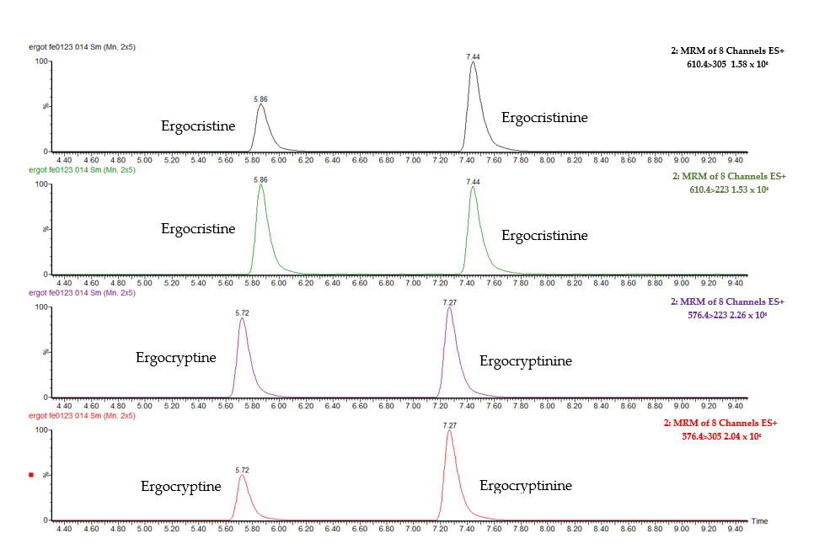
Figure S2. Chromatograms of ergosine, ergocornine and corresponding epimers at 3 ng/mL
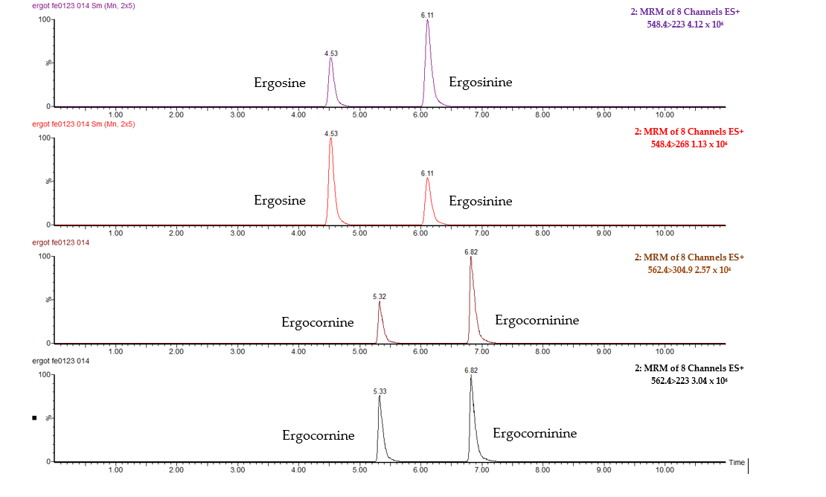
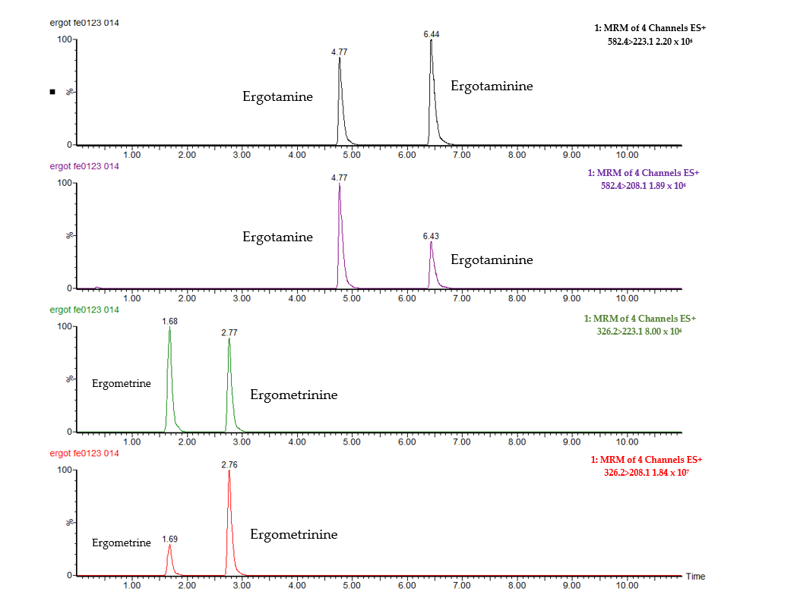
Figure S3. Chromatograms of ergotamine, ergometrine and corresponding epimers at 3 ng/mL

