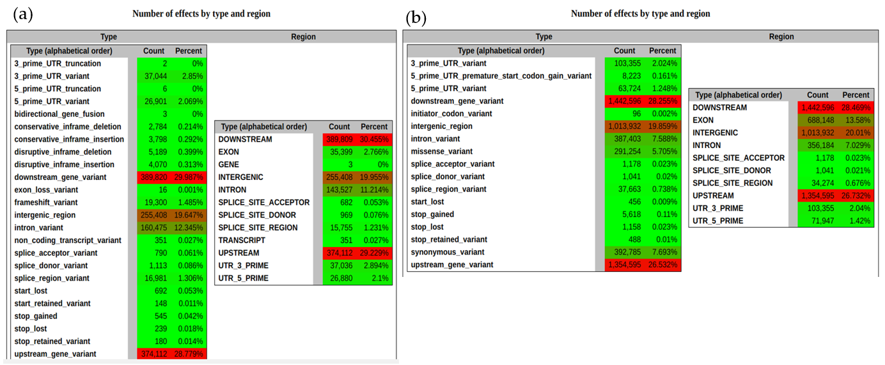
Suppl. Figure 1. Effects of different (a). InDels and (b). SNPs on gene structure ranged by type and region. Figure was generated by SnpEff programme.
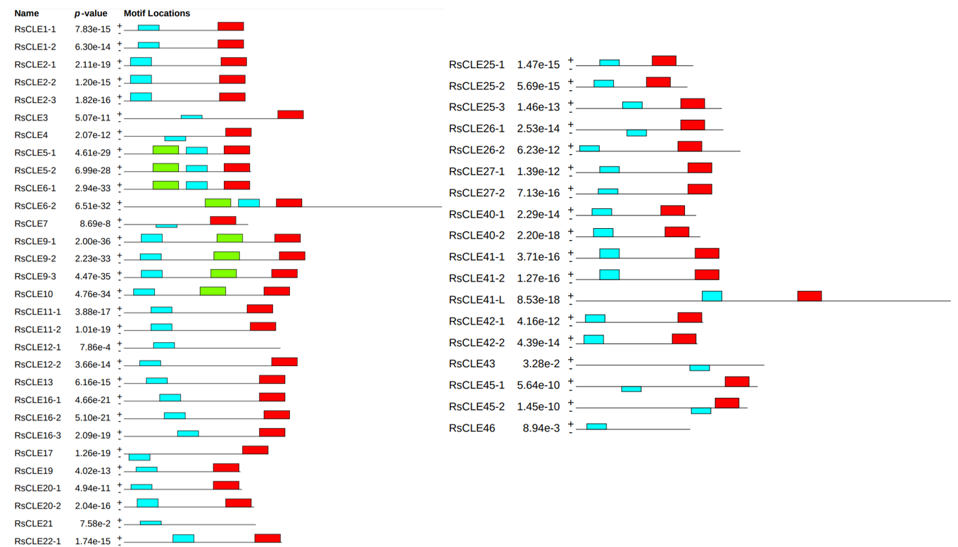
Suppl. Figure 2. Predicted domains in the structure of the CLE proteins of R.sativus line 19. Figure was generated by the MEME online tool (https://meme-suite.org/meme/tools/meme) available on 25.01.2024).

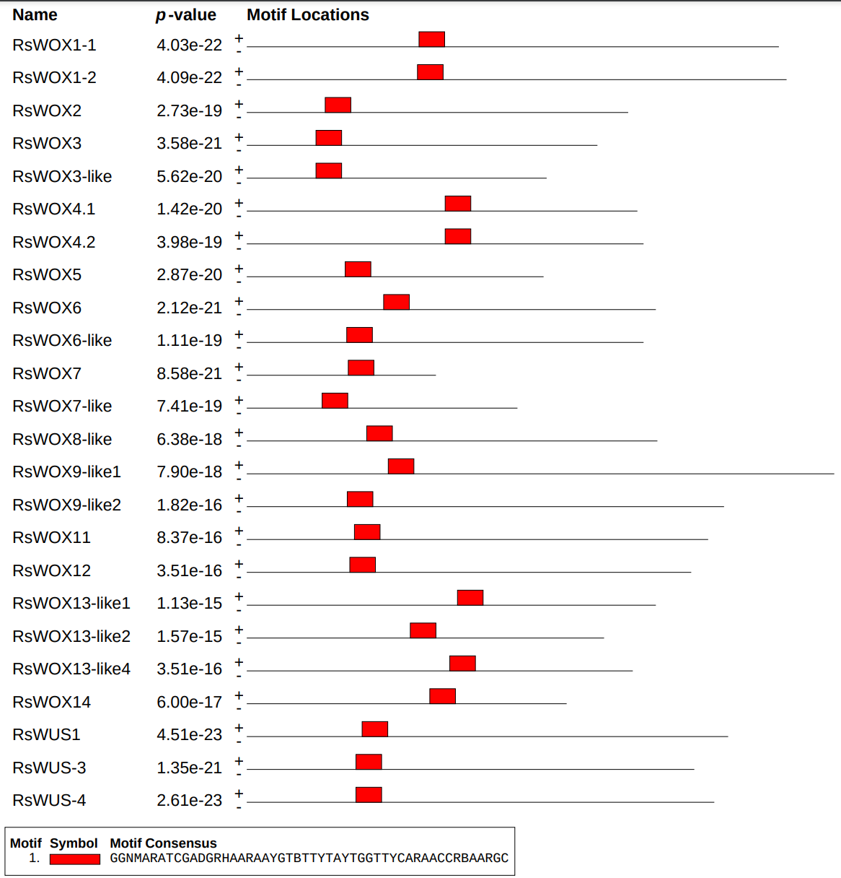
Suppl. Figure 3. Predicted domains in the structure of the WOX proteins of R. sativus line 19. The figure was generated by the MEME online tool ((https://meme-suite.org/meme/tools/meme) available on 25.01.2024).
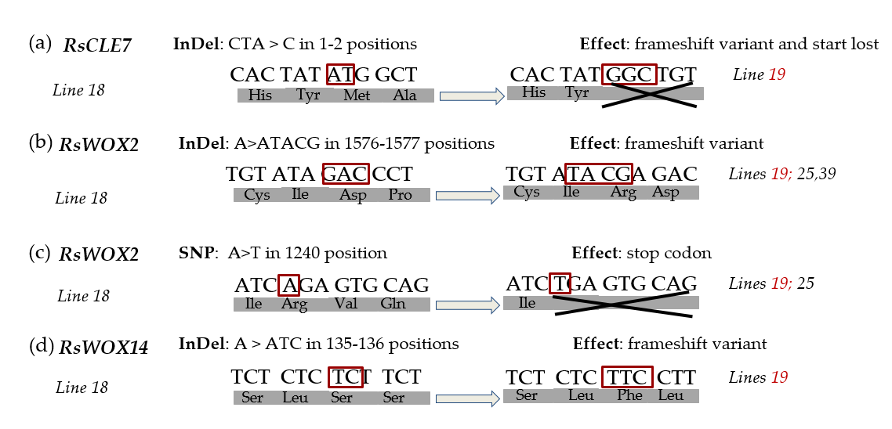
Suppl. Figure 4. Schematic representation of genes (a). RsCLE7, (b), (c). RsWOX2, (d). RsWOX14 without SNVs (left parts of the figure) with SNVs (right parts of the figure) and their likely products. For each SNV, its type and effect on the gene product are indicated. SNVs are highlighted in the red box. Radish tumour lines are highlighted in red.
Suppl. Table 1. Protein-coding genes with InDels causing disruption of the protein structure in radish tumour line.
№ | Gene | Chr | The radish homolog ID in the NCBI database | InDel | Function of Arabidopsis homolog | Number of homologs in radish | Reference
Cell cycle control, cell growth and division
1 | CFAT | 7 | LOC108815961 | c.868_871delAGGA|p.Arg290fs | Lignin biosynthesis. | 2 | [46]
2 | CYCD3;1L | 2 | LOC130508373 | c.967delC|  p.Arg323fs | Cell cycle control during the G1/S transition: activation in response to CK; proliferation of leaf epidermal cells and stomata density; regulation of secondary root growth. | 2 | [47]
3 | SGO2 | 7 | LOC108814355 | c.391_392insCT|p.Phe131 | Cohesion and segregation of sister chromatids in meiosis. | 1 | [48]
4 | CYCD4;1-L | 9 | LOC108828557 | c.591_592delCA|  p.Lys199fs | Activation of the G1/S transition in response to CK; mitotic cell division; cell cycle activation in RAM; germinal root promotion. | 3 | [49]
5 | KIN-7N | 6 | LOC108807218 | c.234_237delGATT|p.Ile79fs | ATP binding; motor function of microtubules. | 2 | [50]
6 | PDS5 | 3 | LOC108845796 | c.1delA|p.Met1fs | DNA repair; cohesion of sister chromatids in mitosis. | 1 | [51]
7 | EXPA7L | 6 | LOC108810873 | c.375_376insTAAT|p.Gly126fs | Weakening of cell walls due to disruption of the bond between cellulose microfibrils and matrix glucans; elongation of root hairs. | 3 | [52]
8 | EXPA4 | 6 | LOC108813883 | c.1delA|p.Met1fs | Weakening of cell walls due to disruption of the bond between cellulose microfibrils and matrix glucans; formation of syncytium. | 3 | [53]
9 | LTP1 | 4 | LOC108853879 | c.1dupA|p.Met1fs | Lipid transport across membranes; deposition of wax and cutin in cell walls and secretory tissues; binding of calmodulin. | 1 | [54]
10 | LOC108817684 | 7 | LOC108817684 | c.148dupT|p.Cys50fs | Biosynthesis of xyloglucans. | 1 | [55]
11 | PME60 | 9 | LOC108826705 | c.2861_2862insCCTC|p.Thr955fs | Modification of cell walls by demethylesterification of pectin. | 1 | [56]
12 | KIN-4A | 9 | LOC108827664 | c.61dupA|p.Ile21fs | Deposition of cellulose microfibrils; cell wall mechanics during cell elongation. | 2 | [57]
13 | LOC108859024 | 5 | LOC108859024 | c.2410delG|p.Glu804fs | A gene with unknown function - probably a cell cycle regulator | 1 | [58]
14 | FZR3 | 3 | LOC108844659 | c.353dupA|p.Gln119fs | Control of ubiquitinligase activity and substrate specificity of anaphase-stimulating complex. | 3 | [59]
15 | NET1A | 5 | LOC108862024 | c.1664_1665delTT|p.Val555fs | Association with F-actin at plasma membrane and plasmodesmata; response to pathogen-associated stress; inhibition of root growth. | 1 | [60]
16 | PCNA1 | 5 | LOC108832540 | c.154_155insGC|p.Leu52fs | Control of DNA replication by increasing polymerase processivity by leading chain elongation. | 3 | [61]
17 | WOX14 | 1 | LOC108853278 | c.135_136insTC|p.Phe46fs | Functions in the organising centre of the shoot meristem, maintaining stem cells in an undifferentiated state. Together with WOX4 act downstream of PXY, independently regulating plant vascular proliferation. | 1 | [37]
18 | HAG2 | 3 | LOC108847241 | c.909_910delGG|p.Ala304fs | Histone modification; control of cell cycle, flowering time, response to environmental conditions, hormone signalling and epigenetic processes. | 2 | [62]
19 | BIN4L | 9 | LOC130499962 | c.96_100delTTCAT|p.Cys32fs | Chromatin organisation and endoreduplication cycling. | 3 | [63]
20 | MYB65L | 5 | LOC108862100 | c.195_196insAGGCTGGGTGCCT|p.Leu66fs | Inhibition of tissue growth by reduced cell proliferation; programmed cell death of protein-storing vacuoles in the aleurone layer during seed germination; anther and tapetum development. | 1 | [64]
21 | DUF724 | 8 | LOC108820138 | c.25dupA|p.Thr9fs | Polar cell growth. | 2 | [65]
22 | AGP22 | 9 | LOC108826274 | c.1_1delGA|p.Met1fs | Differentiation, embryogenesis and programmed cell death. | 3 | [66]
23 | AGP27 | 6 | LOC108809107 | c.111_112delTC|  p.Pro38fs | Differentiation, embryogenesis and programmed cell death. | 1 | [66]
Control of meristem activity
24 | LBD4 | 5 | LOC108857433 | c.17dupG|p.Gly7fs | Phloem/xylem histogenesis; regulation of radial growth through control of cell size and cambium cell divisions. | 1 | [67]
25 | ASK1 | 9 | LOC108827710 | c.535_536dupTT|p.Leu179fs | Regulation of meristem development; response to osmotic stress. | 2 | [68]
26 | LOC130500851 | 4 | LOC130500851 | c.654delT|p.Ala219fs | Lateral root initiation and shoot regeneration. | 2 | [69]
27 | REM15 | 6 | LOC108808545 | c.2917dupT|p.Cys973fs | Flower development. | 1 | [70]
28 | PLT1 | 6 | LOC108829093 | c.177_178insTA  |p.Asp60fs | Specification of the resting root and columella centre; stem cell niche formation during embryogenesis; modulation of polar auxin transport through regulation of PIN gene distribution. A component of the ethylene-activated signalling pathway. Telomere maintenance. | 1 | [71]
Regulation of gene expression
29 | WOX2 | 2 | LOC108841333 | c.2593delG|  p.Glu865fs | Embryonic pattern formation. | 1 | [72]
30 | ERF121 | 8 | LOC108837093 | c.428_429delAG|  p.Lys143fs | Regulation of gene expression by stress factors and components of signal transduction pathways under stress. | 6 | [73]
31 | ARR21 | 7 | LOC108815221 | c.599delT|p.Leu200fs | B-type response regulator involved in the phosphorelay-type signal transduction system from His to Asp. Activates the A-type RR in response to CK. | 2 | [74]
32 | SCL23 | 4 | LOC108848776 | c.97delT|p.Ser33fs | Formation of vascular bundle sheath cells. | 1 | [75]
33 | ERF115-L | 3 | LOC108846562 | c.232_235delAGCT|p.Ser78fs | Activation of phytosulfokine; rate-limiting of quiescent centre cell division, active when surrounding stem cells are damaged. | 3 | [76]
34 | bHLH143 | 7 | LOC108817725 | c.182_183dupAA|p.Val62fs | Vascular development. | 1 | [77]
35 | MYR1 | 7 | LOC108815809 | c.291_294delCCCC|p.Pro98fs | Suppresses flowering and organ elongation when light intensity is reduced; affects gibberellin levels. | 1 | [78]
36 | PHR1-L1 | 9 | LOC108824019 | c.262_263insTG|  p.Ser88fs | Response to phosphorus deficiency; carbohydrate transport. | 1 | [79]
37 | CDF2 | 4 | LOC108849692 | c.378delA|p.Glu127fs | Control of photoperiodic flowering response through repression of CONSTANS. | 2 | [80]
38 | ARR10 | 4 | LOC108830348 | c.865_866delGC|  p.Ala289fs | Activation of RR A-type in response to CK. Callus formation, maintenance of SAM identity, primary root development, regulation of anthocyanin metabolism, chlorophyll biosynthesis, seed growth; response to water deficit. | 1 | [81]
39 | bZIP19 | 8 | LOC108818944 | c.763_764dupGA|p.Asp255fs | Promotes expression of the zinc transporters ZIP3, ZIP4, ZIP5 and ZIP9 during growth under zinc-deficient conditions. | 2 | [82]
40 | DIV | 2 | LOC108840441 | c.38_39dupTG  |p.Lys14fs | Suppression of ABA biosynthesis; response to gibberellins; response to salicylic acid; response to salinity. | 4 | [83]
41 | AGL61 | 6 | LOC108808389 | c.278_279delTG|p.Met93fs | Control of cell differentiation during female gametophyte development. | 2 | [84]
42 | AGL29 | 4 | LOC108850931 | c.1dupA|p.Met1fs | Pollen development. | 2 | [85]
43 | bHLH67 | 5 | LOC108860648 | c.632_633insT|  p.Thr212fs | Adaptation to cold. | 2 | [86]
44 | HDG4 | 8 | LOC108820851 | c.1189_1190delGC|p.Ala397fs | Identity of subepidermal cells during postembryonic development. | 2 | [87]
45 | SCL3 | 8 | LOC130499224 | c.100delA|p.Ile34fs | Response to gibberellins. | 1 | [88]
46 | AGL24 | 4 | LOC108852002 | c.246_247insC  |p.Tyr83fs | Transition to flowering in response to jarrowisation; determination of inflorescence fate in apical meristems; signal transduction via receptor-like kinases. Upon binding to SOC1, mediates the effect of gibberellins on flowering under short-day conditions and regulates LFY expression. | 1 | [89]
47 | bHLH74-L | 5 | LOC108856918 | c.1020delT|  p.Tyr340fs | Cell elongation; binds to the chromatin region of FT, which promotes its expression and flowering in response to blue light. A component of miR396a -bHLH74 module that regulates root formation in Arabidopsis seedlings. | 2 | [90]
48 | AIL1 | 2 | LOC130498742 | c.1039_1040insTT|p.Tyr347fs | Control of shoot and flower meristems; flowering initiation; seed pod development; flower organ identity; cell proliferation; regulation of gene expression by stress factors. | 4 | [91]
49 | ERF018 | 7 | LOC108835321 | c.-1_1insCAG | Cell division; response to insect exposure; ethylene-activated signalling pathway; phloem/xylem histogenesis; response to wounding; activation of jasmonate biosynthesis gene expression. | 3 | [19]
50 | DF1-L | 2 | LOC108848832 | c.709_710delCC|  p.Pro237fs | Suppression of root hair growth; mucilage synthesis in seed coat. | 4 | [92]
51 | LRL1 | 4 | LOC108852215 | c.206delG|p.Gly69fs | Lipid accumulation under nutrient-deficient conditions; elongation of root hairs. | 2 | [93]
52 | ERF019 | 6 | LOC108809887 | c.458_459delAA|  p.Lys153fs | Response to drought; ethylene-activated signalling pathway; response to fungal infection. | 2 | [94]
53 | bHLH111 | 1 | LOC108829884 | c.1delA|p.Met1fs | Anthocyanin biosynthesis; expressed in response to nitrogen deficiency | 1 | [95]
54 | CRF1 | 3 | LOC108846019 | c.252_253insG|  p.Thr85fs | Probable target of CLE41; component of CK signalling; seedling, leaf and embryo development; regulation of gene expression by stress factors and components of stress signalling pathways. | 1 | [96]
55 | CDC5 | 8 | LOC108830943 | c.1494_1495insTT|p.Ala499fs | Regulation of defence responses through control of transcription; mRNA splicing; cell cycle control; SAM development; control of plant innate immunity. | 4 | [97]
56 | PRHA-L | 8 | LOC108821801 | c.714dupG|p.Ser239fs | Response to auxin; response to pathogens. | 2 | [98]
57 | SUVH9-L | 6 | LOC108835120 | c.865delG|p.Glu289fs | Transposon silencing; RNA-directed DNA methylation. | 2 | [99]
58 | TOPII | 2 | LOC130508706 | c.1680delG|  p.Arg561fs | Control of DNA topological states by temporary breakage and subsequent reunion of DNA strands. | 1 | [100]
59 | BBX27 | 7 | LOC108816763 | c.690dupT|p.Ser231fs | Photoperiodic control of short-day flowering. | 1 | [101]
Organogenesis
60 | ARA2 | 4 | LOC108854961 | c.926_927insTG|  p.Arg310fs | Establishment and development of lateral roots independent of auxin and abscisic acid. | 1 | [102]
Metabolism and signalling of phytohormones
61 | CLE7 | 4 | LOC108853737 | c.1_2delAT|p.Met1fs | Signal peptide, synthesised in response to nitrogen deficiency. Expressed in the vascular network and pericycle, inhibits lateral root formation. | 1 | [103]
62 | SAUR15A-L | 3 | LOC108846677 | c.1dupA|p.Met1fs | Formation of lateral and adventitious roots in response to auxin. | 1 | [104]
63 | SAUR32 | 6 | LOC108809074 | c.365_366delAA|p.Lys122fs | Response to auxin; inhibits hypocotyl cell growth. | 2 | [105]
64 | SAUR40-L | 3 | LOC108846468 | c.543delA|p.Lys181fs | Response to auxin. | 1 | [106]
65 | GA2OX3 | 4 | LOC130510497 | c.827_834delCACCATTG|p.Ala276fs | A component of the GC signalling pathway. | 1 | [107]
66 | LOC108857184 | 5 | LOC108857184 | c.72dupT|p.Pro25fs | A gene of unknown function, probably CK-activated | 1
67 | HK5-L | 3 | LOC108844370 | c.2573delA|p.Asn858fs | Negative regulation of ETR1-dependent ABA and ethylene signalling pathway; inhibits root elongation; opening/closing of stomata in closing cells by ABA-independent pathway; control of AFC production in response to stress. | 3 | [108]
68 | ETR1 | 7 | LOC108817715 | c.77dupT|p.Leu26fs | A two-component negative regulator of ethylene signalling. Control of seed germination, control of RAM. | 1 | [109]
Other functions
69 | LOC108842019 | 2 | LOC108842019 | c.716_717insAT|p.Leu240fs | A putative receptor kinase. | 2 | [110]
70 | PNG1 | 6 | LOC108813526 | c.1773_1779delGCCGCCA|p.Pro592fs | Protein quality control. | 2 | [111]
71 | LOC108851456 | 4 | LOC108851456 | c.383_384delTT|p.Phe128fs | Binding of metal ions; DNA replication. | 1 | [112]
72 | ASP39 | 6 | LOC108812392 | c.387_388insC|  p.Lys130fs | Synthesis of phytochelatins and homophytochelatins that bind heavy metals. Degradation of glutathione conjugates. | 1 | [113]

Suppl. Table 2. Protein-coding genes with SNPs causing disruption of the protein structure in radish tumour line.
№ | Gene | Chr | The radish homolog ID in the NCBI database | SNP | Function in radish | Number of homologs in radish | Reference
Cell cycle control
1 | CYCJ18 | 4 | LOC108830438 | c.718T>C|  p.Ter240Argext* | Cell division; regulation of cyclin-dependent protein serine/threonine kinase activity; phase transition of the mitotic cell cycle. | 1 | [114]
2 | PS1L | 9 | LOC108861742 | c.1297G>T|  p.Glu433* | Orientation of the division spindle in the second division of meiosis, formation of microspore tetrads. | 1 | [115]
3 | AUR1 | 2 | LOC108819297 | c.1168C>T|  p.Arg390* | Cytokinesis; formation of microtubule organisation centres. | 2 | [116]
4 | bZIP1 | 5 | LOC108825955 | c.64C>T|p.Arg22* | Spatial control of cytokinesis by proper assembly of the phragmoplast. | 1 | [117]
5 | LRX1 | 5 | LOC108836486 | c.1638C>A|  p.Tyr546* | Cell morphogenesis, including root hairs, through cell wall formation and assembly and/or growth polarisation. | 3 | [118]
6 | AGP18 | 4 | LOC108807296 | c.578C>A|  p.Ser193* | Differentiation, embryogenesis, and programmed cell death. | 3 | [119]
7 | COBL11 | 2 | LOC108841217 | c.574A>T| p.Arg192* | Pollen tube formation and development. | 1 | [120]
Metabolism and signalling of phytohormones
8 | GRR1-L1 | 9 | LOC108825013 | c.665A>T|  p.Ter222Leuext* | Reception of auxin; response to auxin. | 3 | [121]
Regulation of gene expression
9 | CHR35 | 5 | LOC108862654 | c.2327T>A|  p.Leu776* | Epigenetic control of RNA-directed DNA methylation. | 1 | [122]
10 | CMT1 | 1 | LOC108807343 | c.902G>C|  p.Ter301Ser* | CpXpG methylation; gene silencing. | 1 | [123]
11 | WOX2 | 2 | LOC108841333 | c.1204A>T|  p.Arg402* | Embryonic pattern formation. | 1 | [72]
12 | bZIP44 | 7 | LOC108814136 | c.415T>C|  p.Ter139Glnext* | Regulation of seed germination by loosening of micropylar endosperm and seed coat rupture. | 2 | [124]
13 | ARF21 | 9 | LOC108822118 | c.487A>T|  p.Lys163* | Response to auxin. | 1 | [125]
14 | NAC017 | 5 | LOC108856330 | c.2T>C|p.Met1 | Response to stress. | 1 | [126]
15 | MYB104L | 6 | LOC108810575 | c.448C>T|  p.Gln150* | Microgametogenesis, development of polarised microspores. | 1 | [127]
16 | NF-YB8 | 3 | LOC108844481 | c.566A>T|  p.Ter189Leuext* | Control of flowering time; flavonoid biosynthesis. | 1 | [128]
17 | WRKY55L | 3 | LOC130509746 | c.363G>A|  p.Trp121* | Regulation of leaf senescence through control of salicylic acid and AFC accumulation. | 2 | [129]
18 | ERF119 | 4 | LOC108833429 | c.841T>G|  p.Ter281Gluext* | Regulation of gene expression by stress factors and components of stress-mediated signal transduction pathways; formation of secondary cell wall. | 3 | [130]
19 | ARR21 | 3 | LOC108846809 | c.1694C>G|  p.Ser565* | B-type response regulator involved in a phosphorelay-type signal transduction system from His to Asp. Activates A-type RR in response to CK. | 2 | [74]
20 | REM5 | 2 | LOC130494531 | c.392G>T|  p.Ter131Leut* | Vesicular transport. | 2 | [131]
21 | bHLH63 | 2 | LOC108824102 | c.487A>T|  p.Lys163* | Epigenetic regulation of flowering: activation of FT expression, flowering in response to blue light. Suppression of the innate immune response. | 2 | [132]
22 | AGL80 | 2 | LOC108815229 | c.432A>G|  p.Ter144Trp* | Endosperm cell proliferation. | 1 | [133]
23 | SHOC1 | 5 | LOC130500734 | c.20T>A|p.Leu7* | Biosynthesis of gibberellins; seed germination; differentiation of xylem elements, lignification of secondary cell wall. | 1 | [134]
24 | CDF3 | 6 | LOC108813543 | c.984G>A|  p.Trp328* | Photoperiodic control of flowering through suppression of CONSTANS; enhances nitrogen use efficiency; increases biomass production and yield under salinity stress. | 1 | [135]
25 | dZIP30 | 4 | LOC108848413 | c.240T>A|  p.Cys80* | TF, a repressor of reproductive development, meristem size and plant growth. Interacts with regulators of meristem and gynoecium development. | 1 | [136]
Control of meristem activity
26 | REM10L | 1 | LOC108857973 | c.604A>T|  p.Lys202* | Flower development. | 2 | [70]
27 | BRX | 5 | LOC108850063 | c.946T>A|  p.Ter316Arg* | Proliferation and elongation of root and shoot cells; control of the protofloem; interactions between ISC and brassinosteroid signalling; CK-mediated inhibition of lateral root initiation. | 1 | [137]
Other functions
28 | PER30 | 5 | LOC108862038 | c.2T>C|p.Met1 | Oxidation of toxic reducing agents; lignin biosynthesis and degradation, suberisation, auxin catabolism, response to exogenous stresses. | 1 | [138]
29 | CRWN | 1 | LOC108806851 | c.8G>A|p.Trp3* | Organisation of core structure. | 1 | [139]
30 | LRR-RK | 2 | LOC108842145 | c.1526T>A|p.Leu509* | Encodes protein with serine/threonine/tyrosine kinase activity. | 1 | [140]
31 | LecRLK | 9 | LOC108824077 | c.107G>Tp.Ter36Leuext | Plant development; response to stress. | 1 | [141]
32 | SBT2.6 | 4 | LOC108849971 | c.2442C>G|p.Tyr814* | Proteolysis; activated in response to eoCLE40. | 1 | [142]
33 | LOC108853023 | 4 | LOC108853023 | c.87T>A|p.Tyr29* | Participant in ubiquitin-dependent catabolic processes. | 2 | [143]
34 | VLG | 6 | LOC130496156 | c.309C>G|p.Tyr103* | Gametogenesis | 1 | [144]
35 | LOC108856505 | 5 | LOC108856505 | c.1354C>T|p.Arg452* | Response to hypoxia. | 1 | [145]
36 | LOC108854537 | 1 | LOC108854537 | c.3G>A|p.Met1 | No data | 1

