Supplemental Table 1. Compounds identified in GC/-MS analysis of hemp leaf dried extract and its hexane and methanol fractions. The retention time (R.T.) indicates the minutes at which compounds were detected. All listed compounds were present in the dried hemp leaf extract (+). The values for the hexane and methanol fractions represent the percentage (%) of each compound relative to its total amount in the dried leaf extract.
Compound | R.T. (min) |  | Percentage (%)
 |  | Hemp leaf dried extract | Hexane fraction | Methanol Fraction
β-Caryophellene | 13.65 | + | 100 | 0
α-Caryophellene | 13.81 | + | 100 | 0
Bisabolol | 15.06 | + | 90 | 10
CBD | 17.98 | + | 20 | 80

Supplemental Figure 1. Concentration-response curves for 48 h larvicidal activity of cypermethrin against pyrethroid-susceptible Ae. aegypti of (PS, blue) and pyrethroid-resistant (PR, red) strains of Ae. aegypti. Values are means ± SEM based on 8 replicates of 6 larvae per concentration (0.001, 0.01, 1, and 100 ppm).

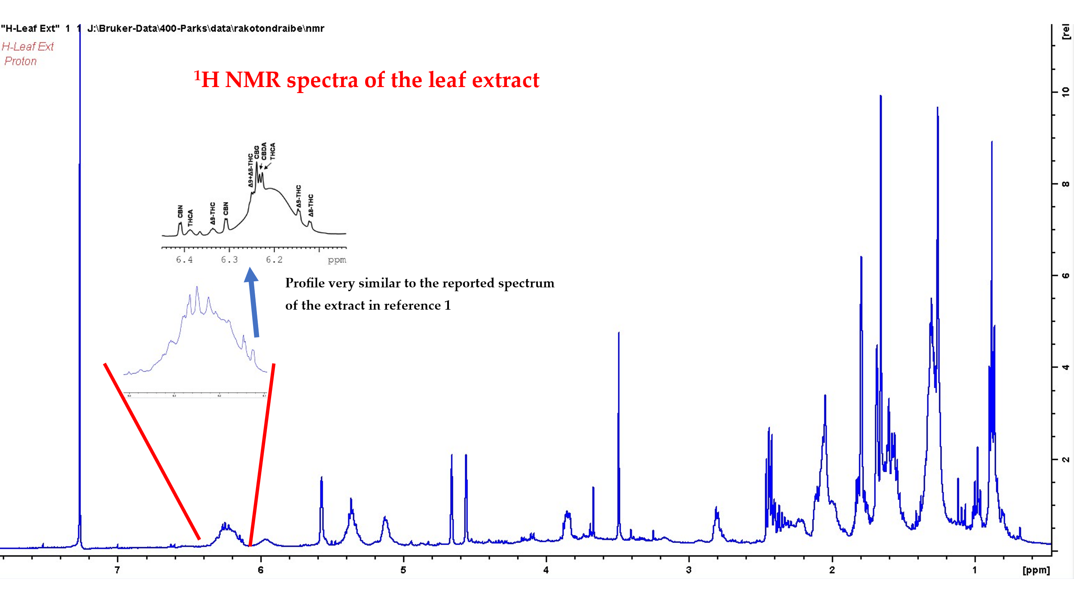
Supplemental Figure 2. ¹H NMR spectra of dried hemp leaf extract

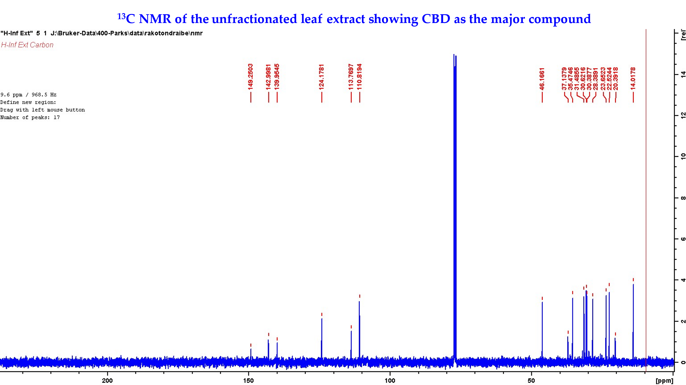
Supplemental Figure 3. ¹³C NMR of dried leaf/unfractionated leaf extract.
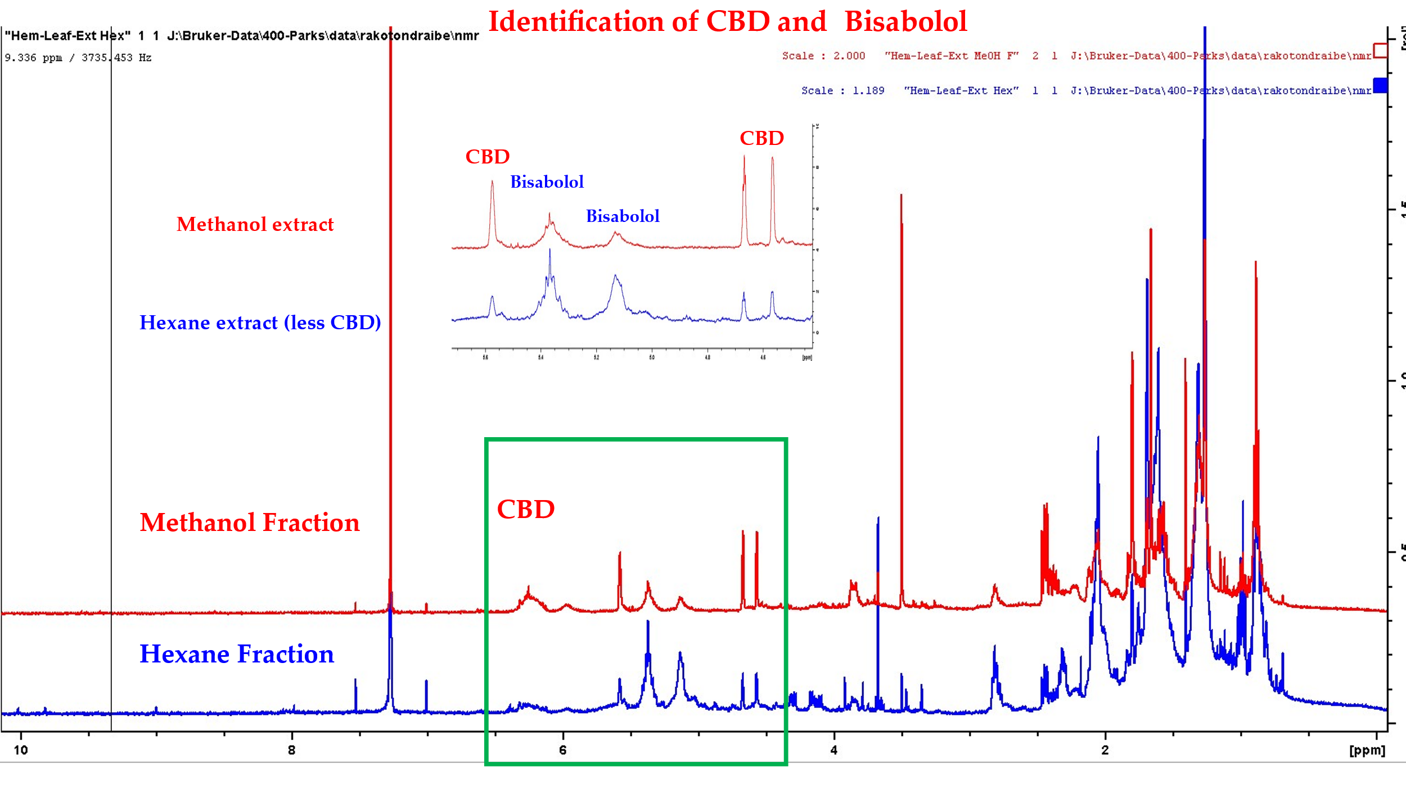
Supplemental Figure 4. NMR analysis of CBD and bisabolol found in methanol and hexane fractions of unfractionated dried hemp leaf extract.

