**Supplementary**

**A**

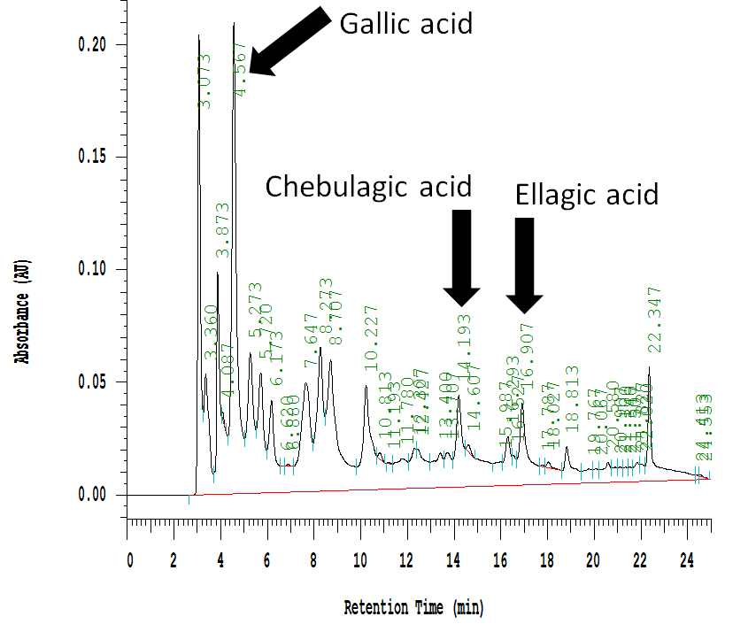

**B**



**C**

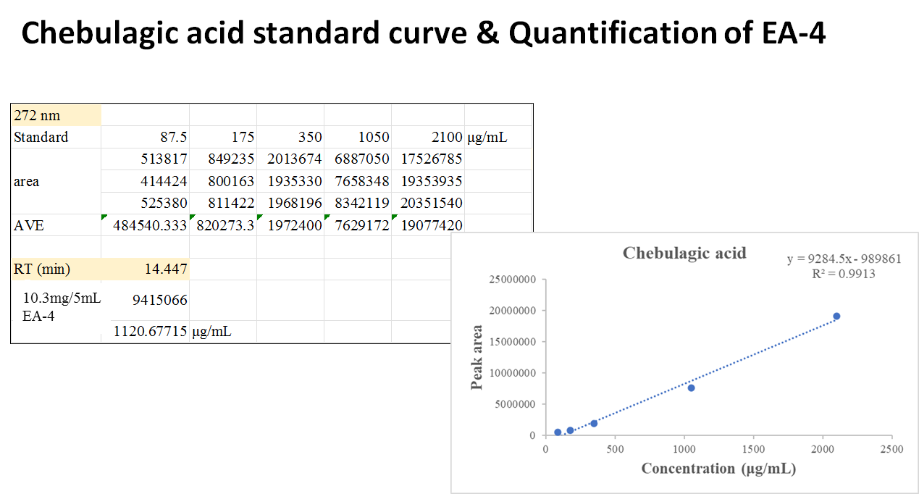

**Figure supplementary.** (**A**)~(**C**) High-performance liquid chromatography analysis of(**A**) 2500 ppm ethyl acetate of *Phyllanthus emblica* L. (EPE),(**B**)10.3 mg/5mL EA-4 of ethyl acetate of *Phyllanthus emblica* L. **(C)** Chebulagic acid standard curve and Quantification of EA-4.