SUPPLEMENTARY MATERIAL

Supplementary Figure S1. Anatomical dissection of the Pterygopalatine fossa.
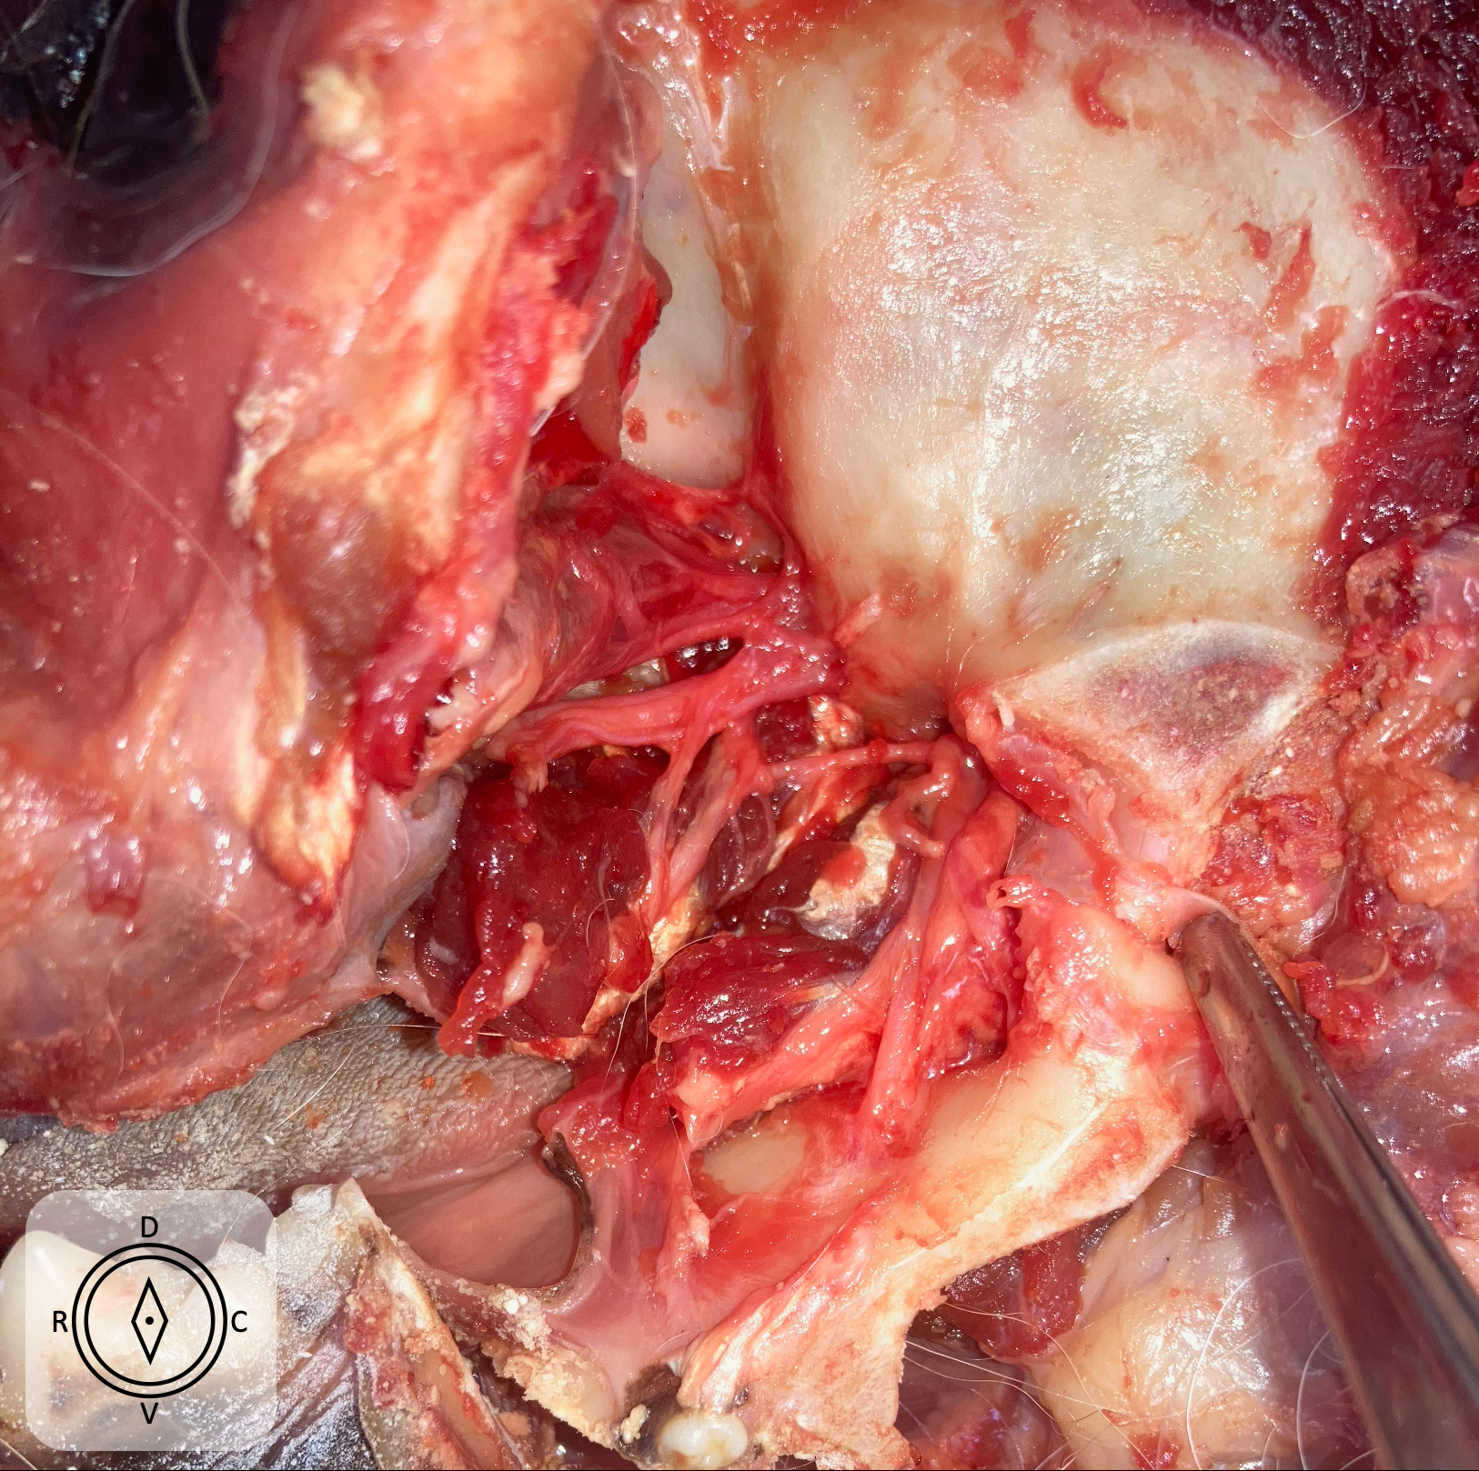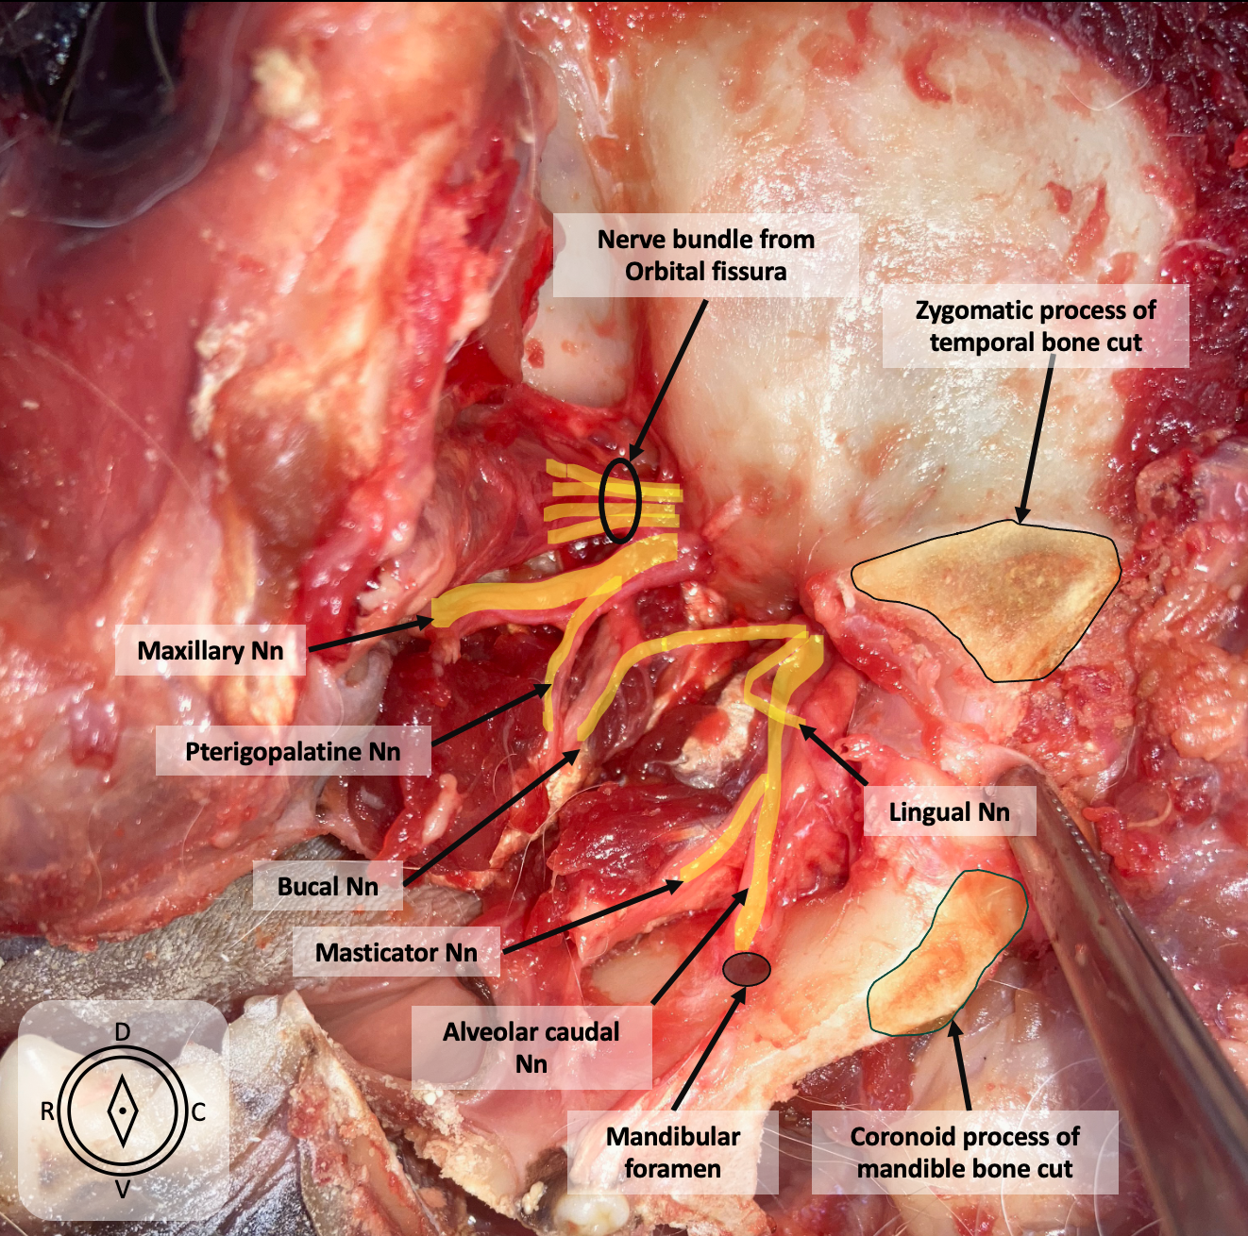

Supplementary Figure S2. Craneal length (CrL)
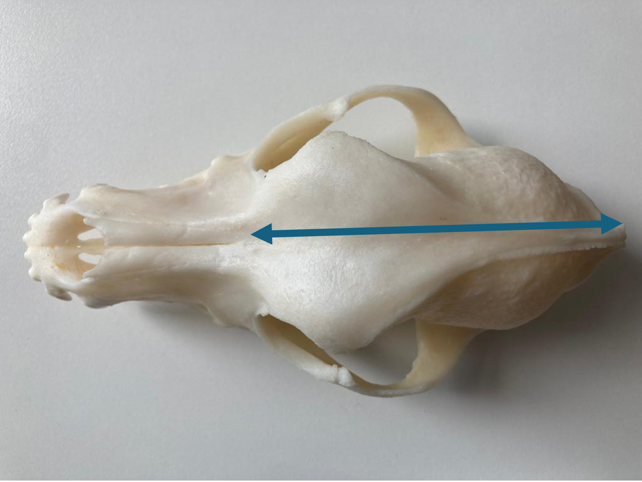

Figure 1. Position of the probe and needle. Ultrasound image of the temporal approach, where the anatomic landmarks can be identified. The microconvex ultrasound probe is placed on the temporal region, caudally to the orbital ligament, in a transversal position, with the mouth of the dog opened.
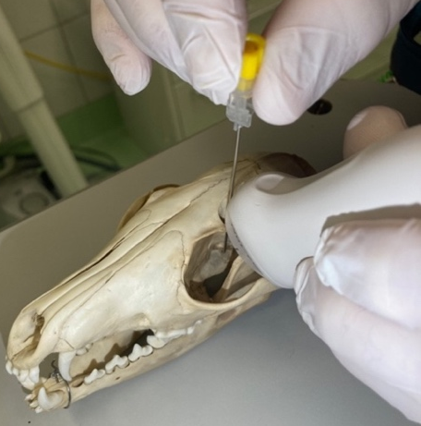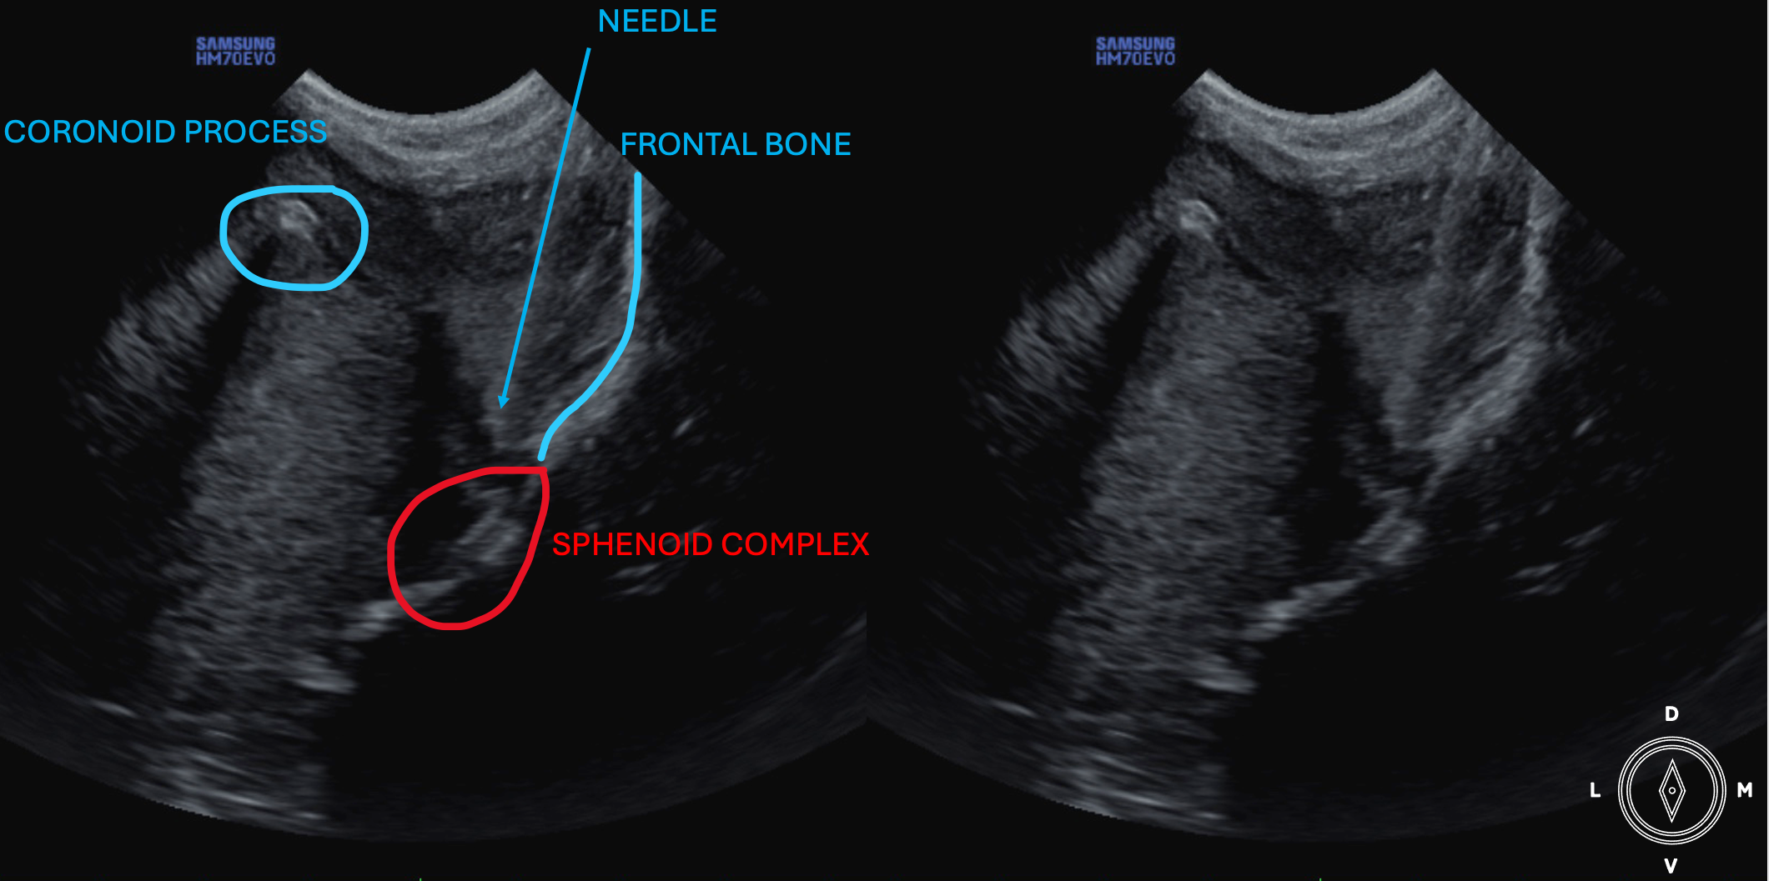

Figure 2. Position of the probe and needle. Ultrasound image of coronoid approach
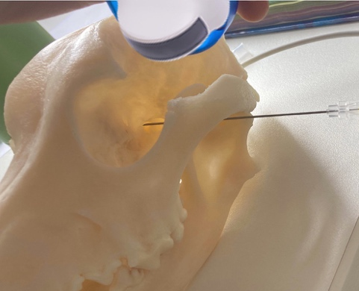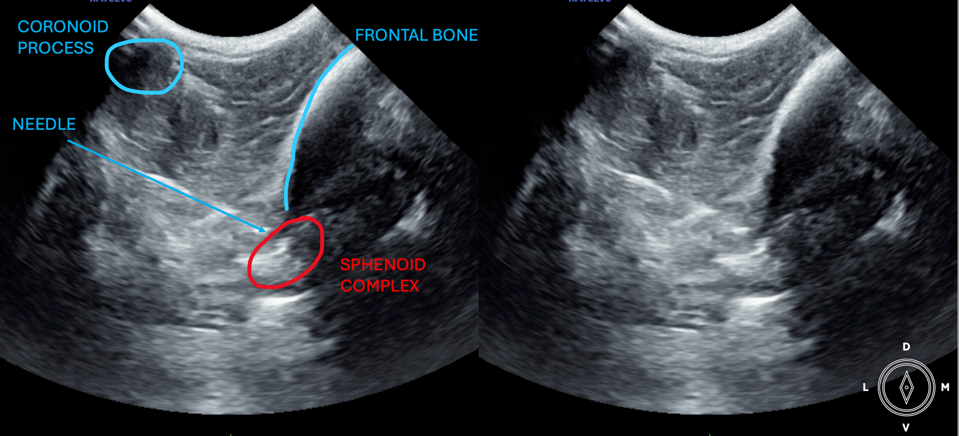

Figure 3. Violin plot of the distance distribution (mm) in the two approaches. The plot represents the distribution of the distances from tip of the needle to the target point in millimetres in both approaches.
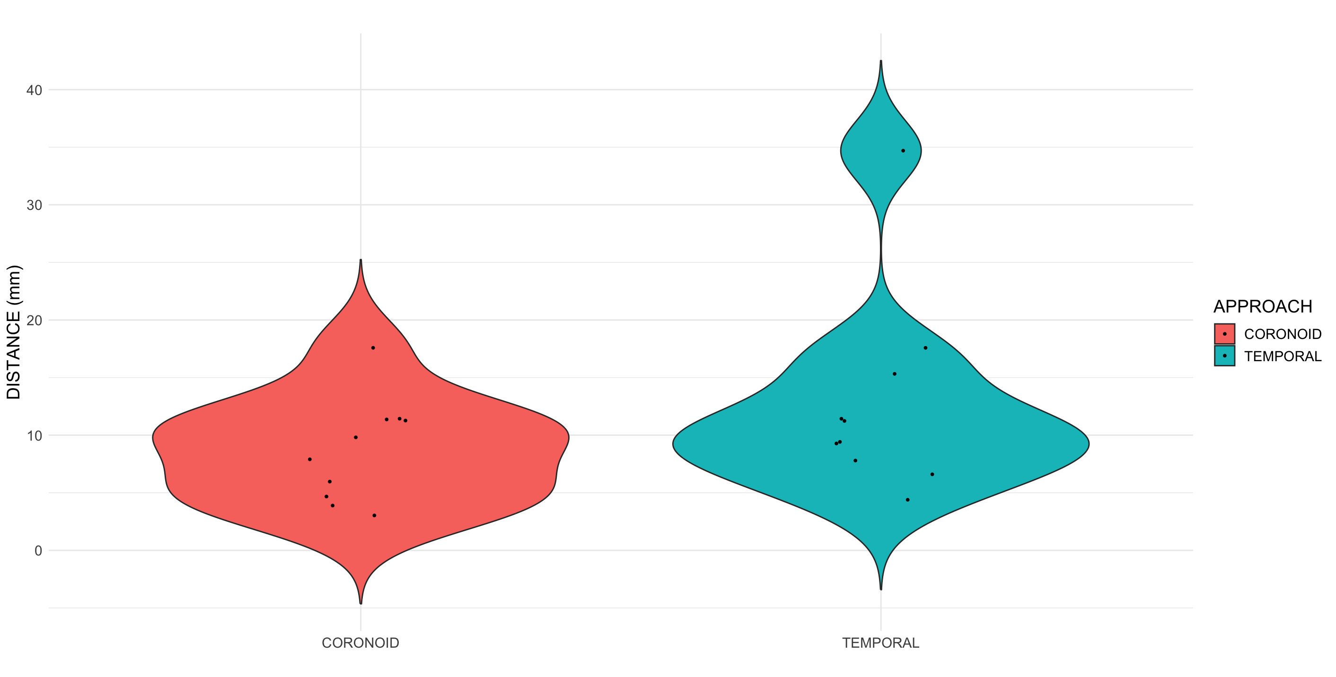

Figure 4. CT study in ten specimens. Blue colour indicates presence of the contrast withing the structure of interest (carium, retrobulbar conus, muscle, interfascial) or in contact with it (optic canal, orbital fissure, rostral alar canal, foramen ovale). Red colour indicates absence withing or non contact with it..

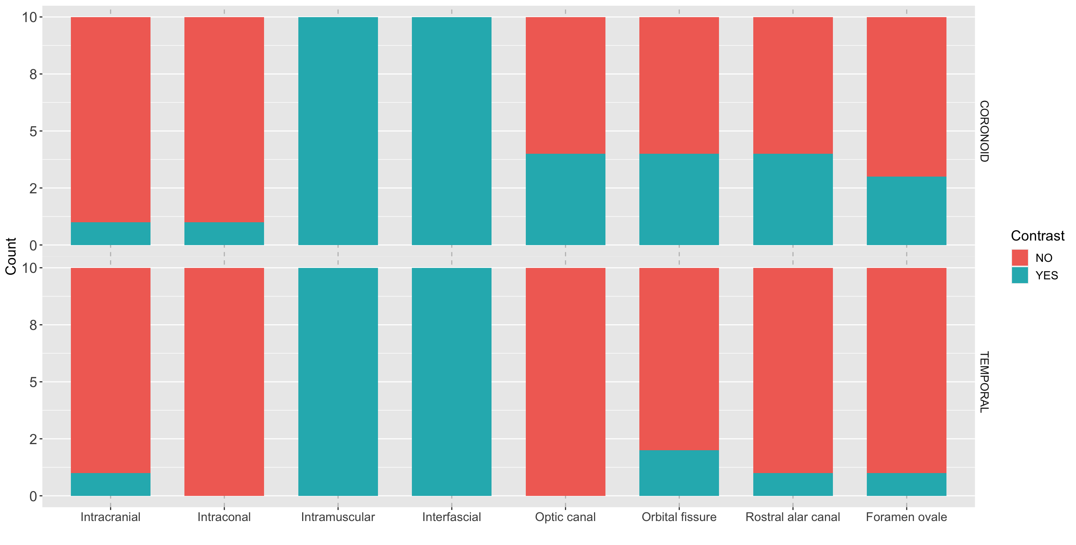

Figure 5. Dissection study in ten specimens. Blue colour indicates presence of dye withing the structure of interest (retrobulbar conus, muscle, intesfascial) or staining of the nerve (mandibular, maxillary, optic nerves and orbital fissure complex).

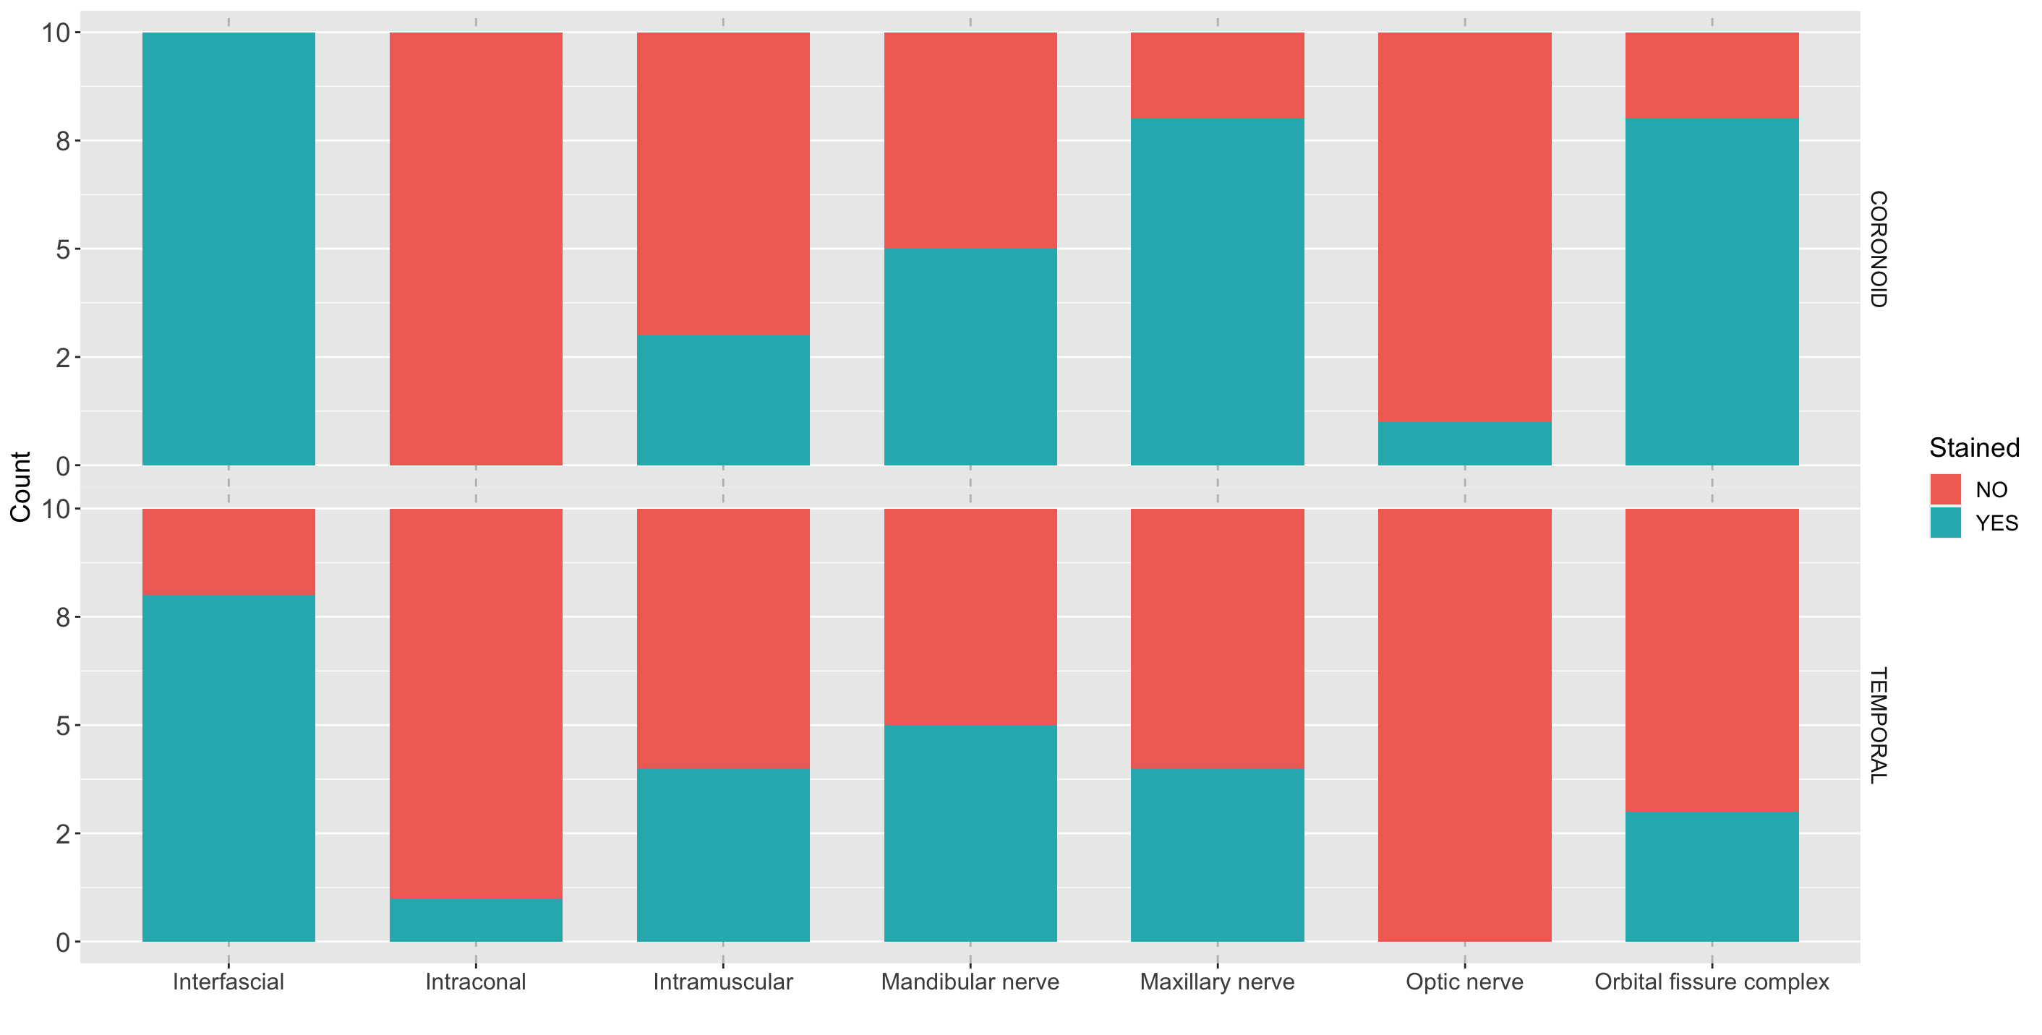

Supplementary Figure S3. Transverse CT image displayed in bone window and mildly angulated to the needle plane, with the needle in the coronoid approach (Left side of the screen). Note the position of the tip of the needle in the proximity of the orbital fissure and rostral alar foramen
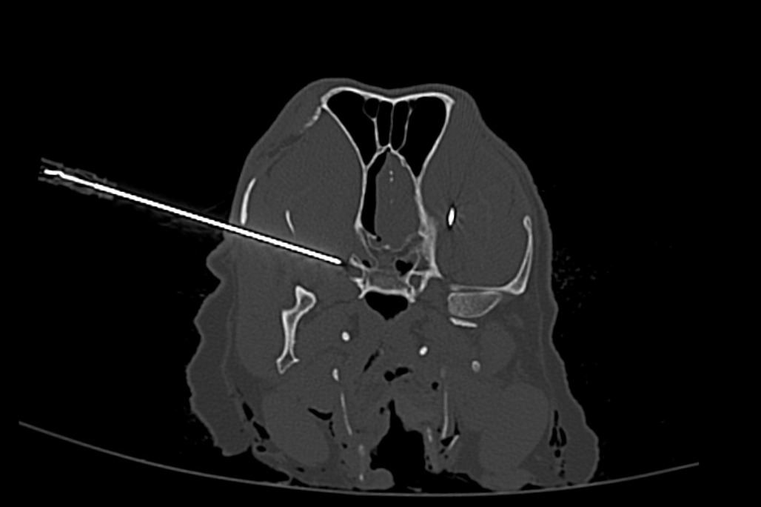

Supplementary figure S4. Transverse CT image displayed in bone window and mildly angulated to the needle plane at the level of the orbital fissure, with the needle in place in the temporal approach (right side of the screen)
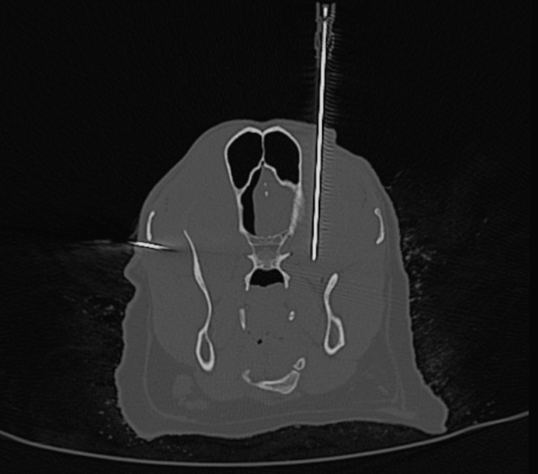

Supplementary Figure S5. Transverse CT image of the head of a dog at the level of the alar canal and orbital fissure, displayed in bone window, where contrast media can be observed over the surface of the frontal and sphenoid bones, and inside the orbital fissure after an injection using a coronoid approach (left side of the screen).

Supplementary Figure S6. 3D reconstruction of the head of a dog after placement of the needle with temporal approach.
.

Supplementary figure S7. 3D reconstruction of the head of a dog after placement of the needle with coronoid approach.

