Supplementary information
Effect of Solvent Properties on the Critical Solution Temperature of Thermoresponsive Polymers
Konstantin Nikolaus Beitl¹ and Erik Reimhult^{1,}*
¹Institute of Colloid and Biointerface Science, Department of Bionanosciences, BOKU University, Muthgasse 11, A-1190 Vienna, Austria
*Correspondence: erik.reimhult@boku.ac.at

Table S1. Critical solution temperatures of differently concentrated PNiPAm and PiPOx (21 kDa) dispersions prepared in H₂O and D₂O measured with DLS and DSC, respectively.
PNiPAm (DLS) | H₂O | D₂O | PNiPAm (DSC) | H₂O | D₂O
ρ [mg ml⁻¹] | T [°C] |  | ρ [mg ml⁻¹] | T [°C]
10⁻¹ | 45.0 | 43.4 | 10⁻¹ | 46.49 | 44.52
10⁰ | 40.0 | 41.0 | 10⁰ | 43.54 | 42.32
10¹ | 35.4 | 36.6 | 10¹ | 39.94 | 38.67
PiPOx (DLS) | H₂O | D₂O | PiPOx (DSC) | H₂O | D₂O
ρ [mg ml⁻¹] | T [°C] |  | ρ [mg ml⁻¹] | T [°C]
10⁻¹ | 45.0 | 43.8 | 10⁻¹ | 46.39 | 45.27
10⁰ | 42.0 | 40.6 | 10⁰ | 43.29 | 42.57
10¹ | 38.6 | 37.8 | 10¹ | 40.27 | 39.55

Table S2. Comparison of onset and peak temperature values [°C] in DSC thermograms of PNiPAm and PiPOx dispersions (21 kDa polymers; 10⁻¹ mg ml⁻¹, 10⁰ mg ml⁻¹ and 10¹ mg ml⁻¹) in H₂O and D₂O.
PNiPAm | H₂O |  |  | D₂O
ρ [mg ml⁻¹] | T_{onset} | T_{peak} | ΔT | T_{onset} | T_{peak} | ΔT
10⁻¹ | 43.94 | 46.49 | 2.55 | 39.27 | 44.52 | 5.25
10⁰ | 41.34 | 43.54 | 2.20 | 40.04 | 42.32 | 2.28
10¹ | 37.83 | 39.94 | 2.11 | 38.11 | 38.67 | 0.56
PiPOx | H₂O |  |  | D₂O
ρ [mg ml⁻¹] | T_{onset} | T_{peak} | ΔT | T_{onset} | T_{peak} | ΔT
10⁻¹ | 43.08 | 46.39 | 3.31 | 40.58 | 45.27 | 4.69
10⁰ | 41.3 | 43.29 | 1.99 | 40.63 | 42.57 | 1.94
10¹ | 39.19 | 40.27 | 1.08 | 38.58 | 39.55 | 0.97

Table S3. Critical solution temperatures of PNiPAm and PiPOx (21 kDa; 1 mg ml⁻¹) in Hofmeister series salt solutions prepared in H₂O and D₂O from 1 mM to physiological ionic strength measured with DLS and DSC, respectively.
PNiPAm | 1 mM salts |  | 10 mM salts |  | 160 mM salts
DLS | T_{H2O} | T_{D2O} | T_{H2O} | T_{D2O} | T_{H2O} | T_{D2O}
No salt | 40.2 (0 mM) | 41.0 (0 mM) | - | - | - | -
K₂SO₄ | 40.4 | 40.2 | 39.4 | 39.4 | 31.2 | 32.0
K₂HPO₄ | 40.6 | 40.4 | 39.8 | 39.8 | 28.8 | 31.8
KCl | 40.4 | 40.4 | 40.2 | 40.2 | 37.0 | 36.8
KSCN | 40.4 | 40.4 | 40.4 | 40.4 | 39.2 | 42.6
PNiPAm | 1 mM salts |  | 10 mM salts |  | 160 mM salts
DSC | T_{H2O} | T_{D2O} | T_{H2O} | T_{D2O} | T_{H2O} | T_{D2O}
No salt | 43.54 (0 mM) | 42.32 (0 mM) | - | - | - | -
K₂SO₄ | 43.1 | 43.61 | 42.11 | 42.01 | 34.42 | 35.16
K₂HPO₄ | 43.9 | 44.08 | 43.75 | 43.71 | 34.57 | 35.73
KCl | 42.83 | 43.6 | 42.68 | 42.32 | 39.84 | 40.45
KSCN | 43.00 | 43.73 | 42.73 | 42.93 | 44.29 | 44.87
PiPOx | 1 mM salts |  | 10 mM salts |  | 160 mM salts
DLS | T_{H2O} | T_{D2O} | T_{H2O} | T_{D2O} | T_{H2O} | T_{D2O}
No salt | 42.2 (0 mM) | 40.2 (0 mM) | - | - | - | -
K₂SO₄ | 41.8 | 40.8 | 40.6 | 39.8 | 32.0 | 31.4
K₂HPO₄ | 41.2 | 40.2 | 40.4 | 39.4 | 31.4 | 31.2
KCl | 41.4 | 40.6 | 41.2 | 39.6 | 39.2 | 35.6
KSCN | 41.2 | 40.0 | 40.8 | 41.2 | 52.8 | 51.8
PiPOx | 1 mM salts |  | 10 mM salts |  | 160 mM salts
DSC | T_{H2O} | T_{D2O} | T_{H2O} | T_{D2O} | T_{H2O} | T_{D2O}
No salt | 43.29 (0 mM) | 42.57 (0 mM) | - | - | - | -
K₂SO₄ | 43.45 | 42.61 | 43.22 | 42.09 | 35.39 | 35.41
K₂HPO₄ | 43.12 | 42.36 | 42.32 | 41.1 | 34.35 | 34.23
KCl | 43.51 | 42.65 | 43.53 | 42.06 | 41.9 | 41.69
KSCN | 43.03 | 42.15 | 43.07 | 42.98 | 52.75 | 53.35

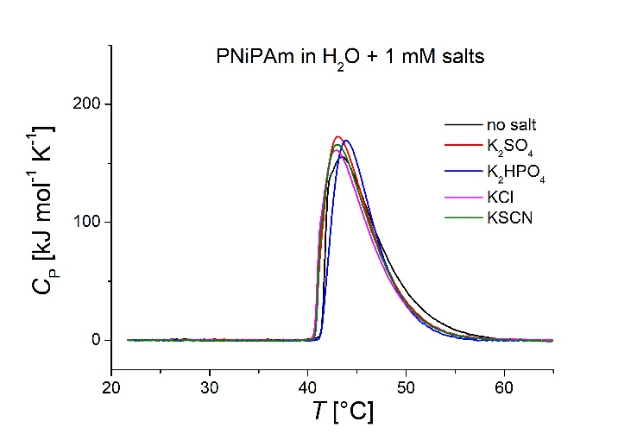 | 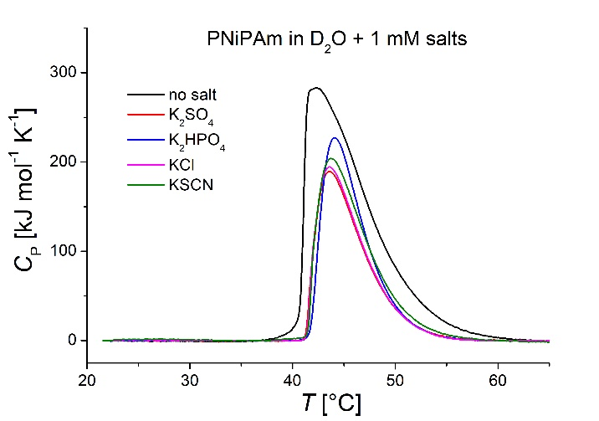
(a) | (b)
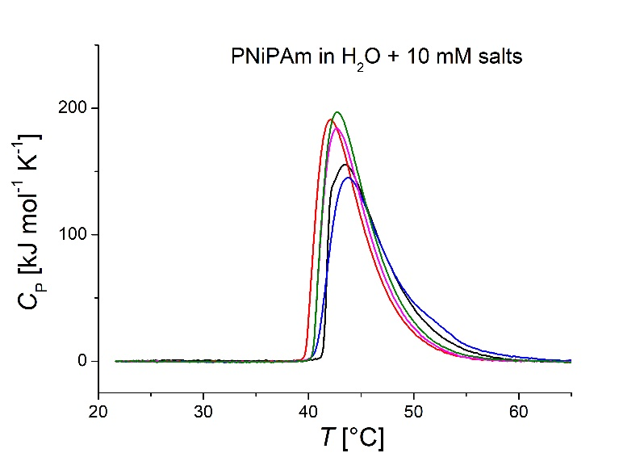 | 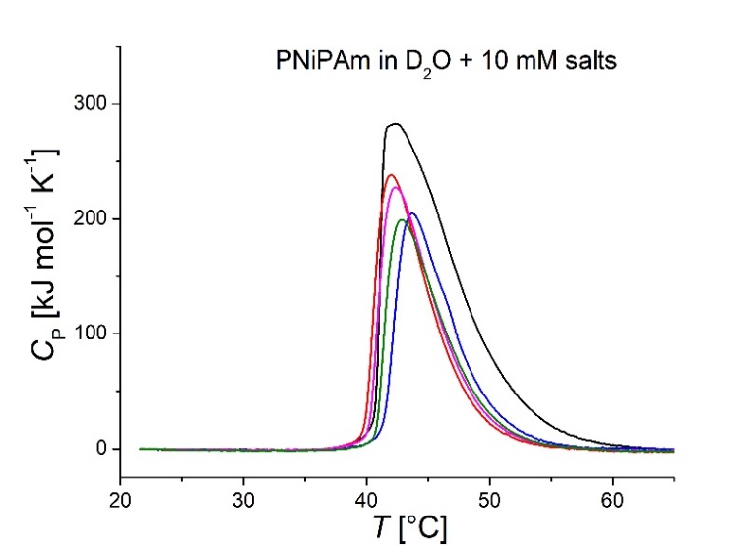
(c) | (d)
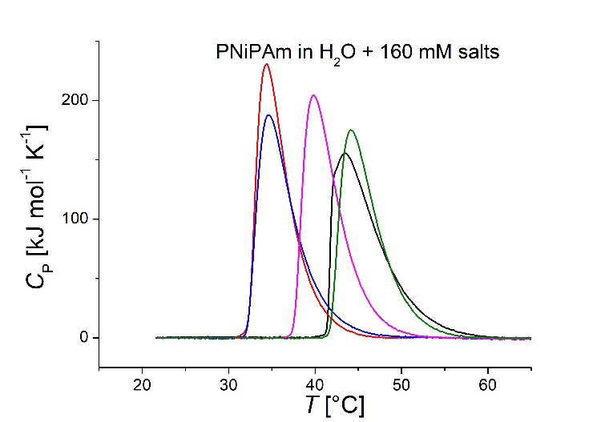 | 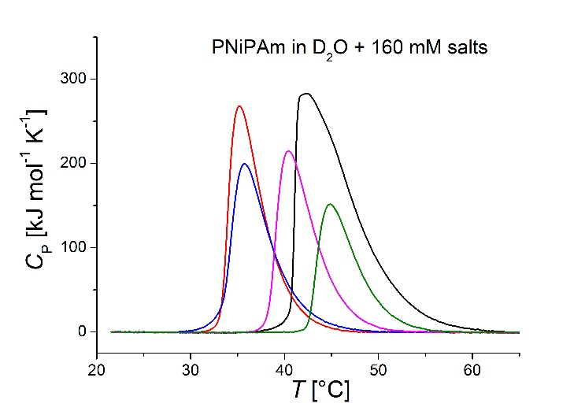
(e) | (f)
Figure S1. DSC-recorded thermograms of PNiPAm (21 kDa; 1 mg ml⁻¹) in H₂O and D₂O. Red: K₂SO₄, blue: K₂HPO₄, pink: KCl, green: KSCN; polymer dispersed in solutions of (a) 1 mM salts in H₂O; (b) 1 mM salts in D₂O; (c) 10 mM salts in H₂O; (d) 10 mM salts in D₂O; (e) 160 mM salts in H₂O and (f) 160 mM salts in D₂O.

Table S4. DSC-derived transition enthalpies per monomer unit of PNiPAm and PiPOx (21kDa) in differently concentrated salt solutions prepared in H₂O and D₂O.
PNiPAm | ΔH_{monomer} [J mol⁻¹]
H₂O | 1 mM salt | 10 mM salt | 160 mM salt | D₂O | 1 mM salt | 10 mM salt | 160 mM salt
No salt | 5568 (0 mM) | - | - | No salt | 11459 (0 mM) | - | -
K₂SO₄ | 5676 | 5946 | 5838 | K₂SO₄ | 5892 | 7135 | 6703
K₂HPO₄ | 4968 | 5730 | 5514 | K₂HPO₄ | 6432 | 6324 | 5838
KCl | 5375 | 5676 | 5730 | KCl | 5946 | 6973 | 5892
KSCN | 5514 | 6270 | 5195 | KSCN | 6649 | 6162 | 4243
PiPOx | ΔH_{monomer} [J mol⁻¹]
H₂O | 1 mM salts | 10 mM salts | 160 mM salts | D₂O | 1 mM salts | 10 mM salts | 160 mM salts
No salt | 4719 (0 mM) | - | - | No salt | 4470 (0 mM) | - | -
K₂SO₄ | 5189 | 4227 | 5568 | K₂SO₄ | 5368 | 4222 | 6703
K₂HPO₄ | 5286 | 3357 | 5027 | K₂HPO₄ | 5011 | 5514 | 6162
KCl | 4859 | 4541 | 9135 | KCl | 5676 | 5459 | 9514
KSCN | 4730 | 7838 | 15459 | KSCN | 5784 | 12865 | 18000

Figure S2. ¹H NMR spectrum for PNiPAm in CDCl₃ at 300 MHz. Normalised intensity is plotted against chemical shifts relative to TMS (0 ppm). Structural components and corresponding peaks are marked with letters a to d. PNiPAm: δH(300 MHz, CDCl3, ppm) 4.02 (s, 1H), 2.14 (s, 1H), 1.66 (d, 2H), 1.15 (d, 6H)
Figure S3. ¹H NMR spectrum for PiPOx in CDCl₃ at 300 MHz. Normalised intensity is plotted against chemical shifts relative to TMS (0 ppm). Structural components and corresponding peaks are marked with letters a to d. PiPOx: δ_{H}(300 MHz, CDCl3, ppm) 3.46 (d, 2H), 3.00 (s, 3H), 2.77 (d, 1H), 1.10 (s, 6H).

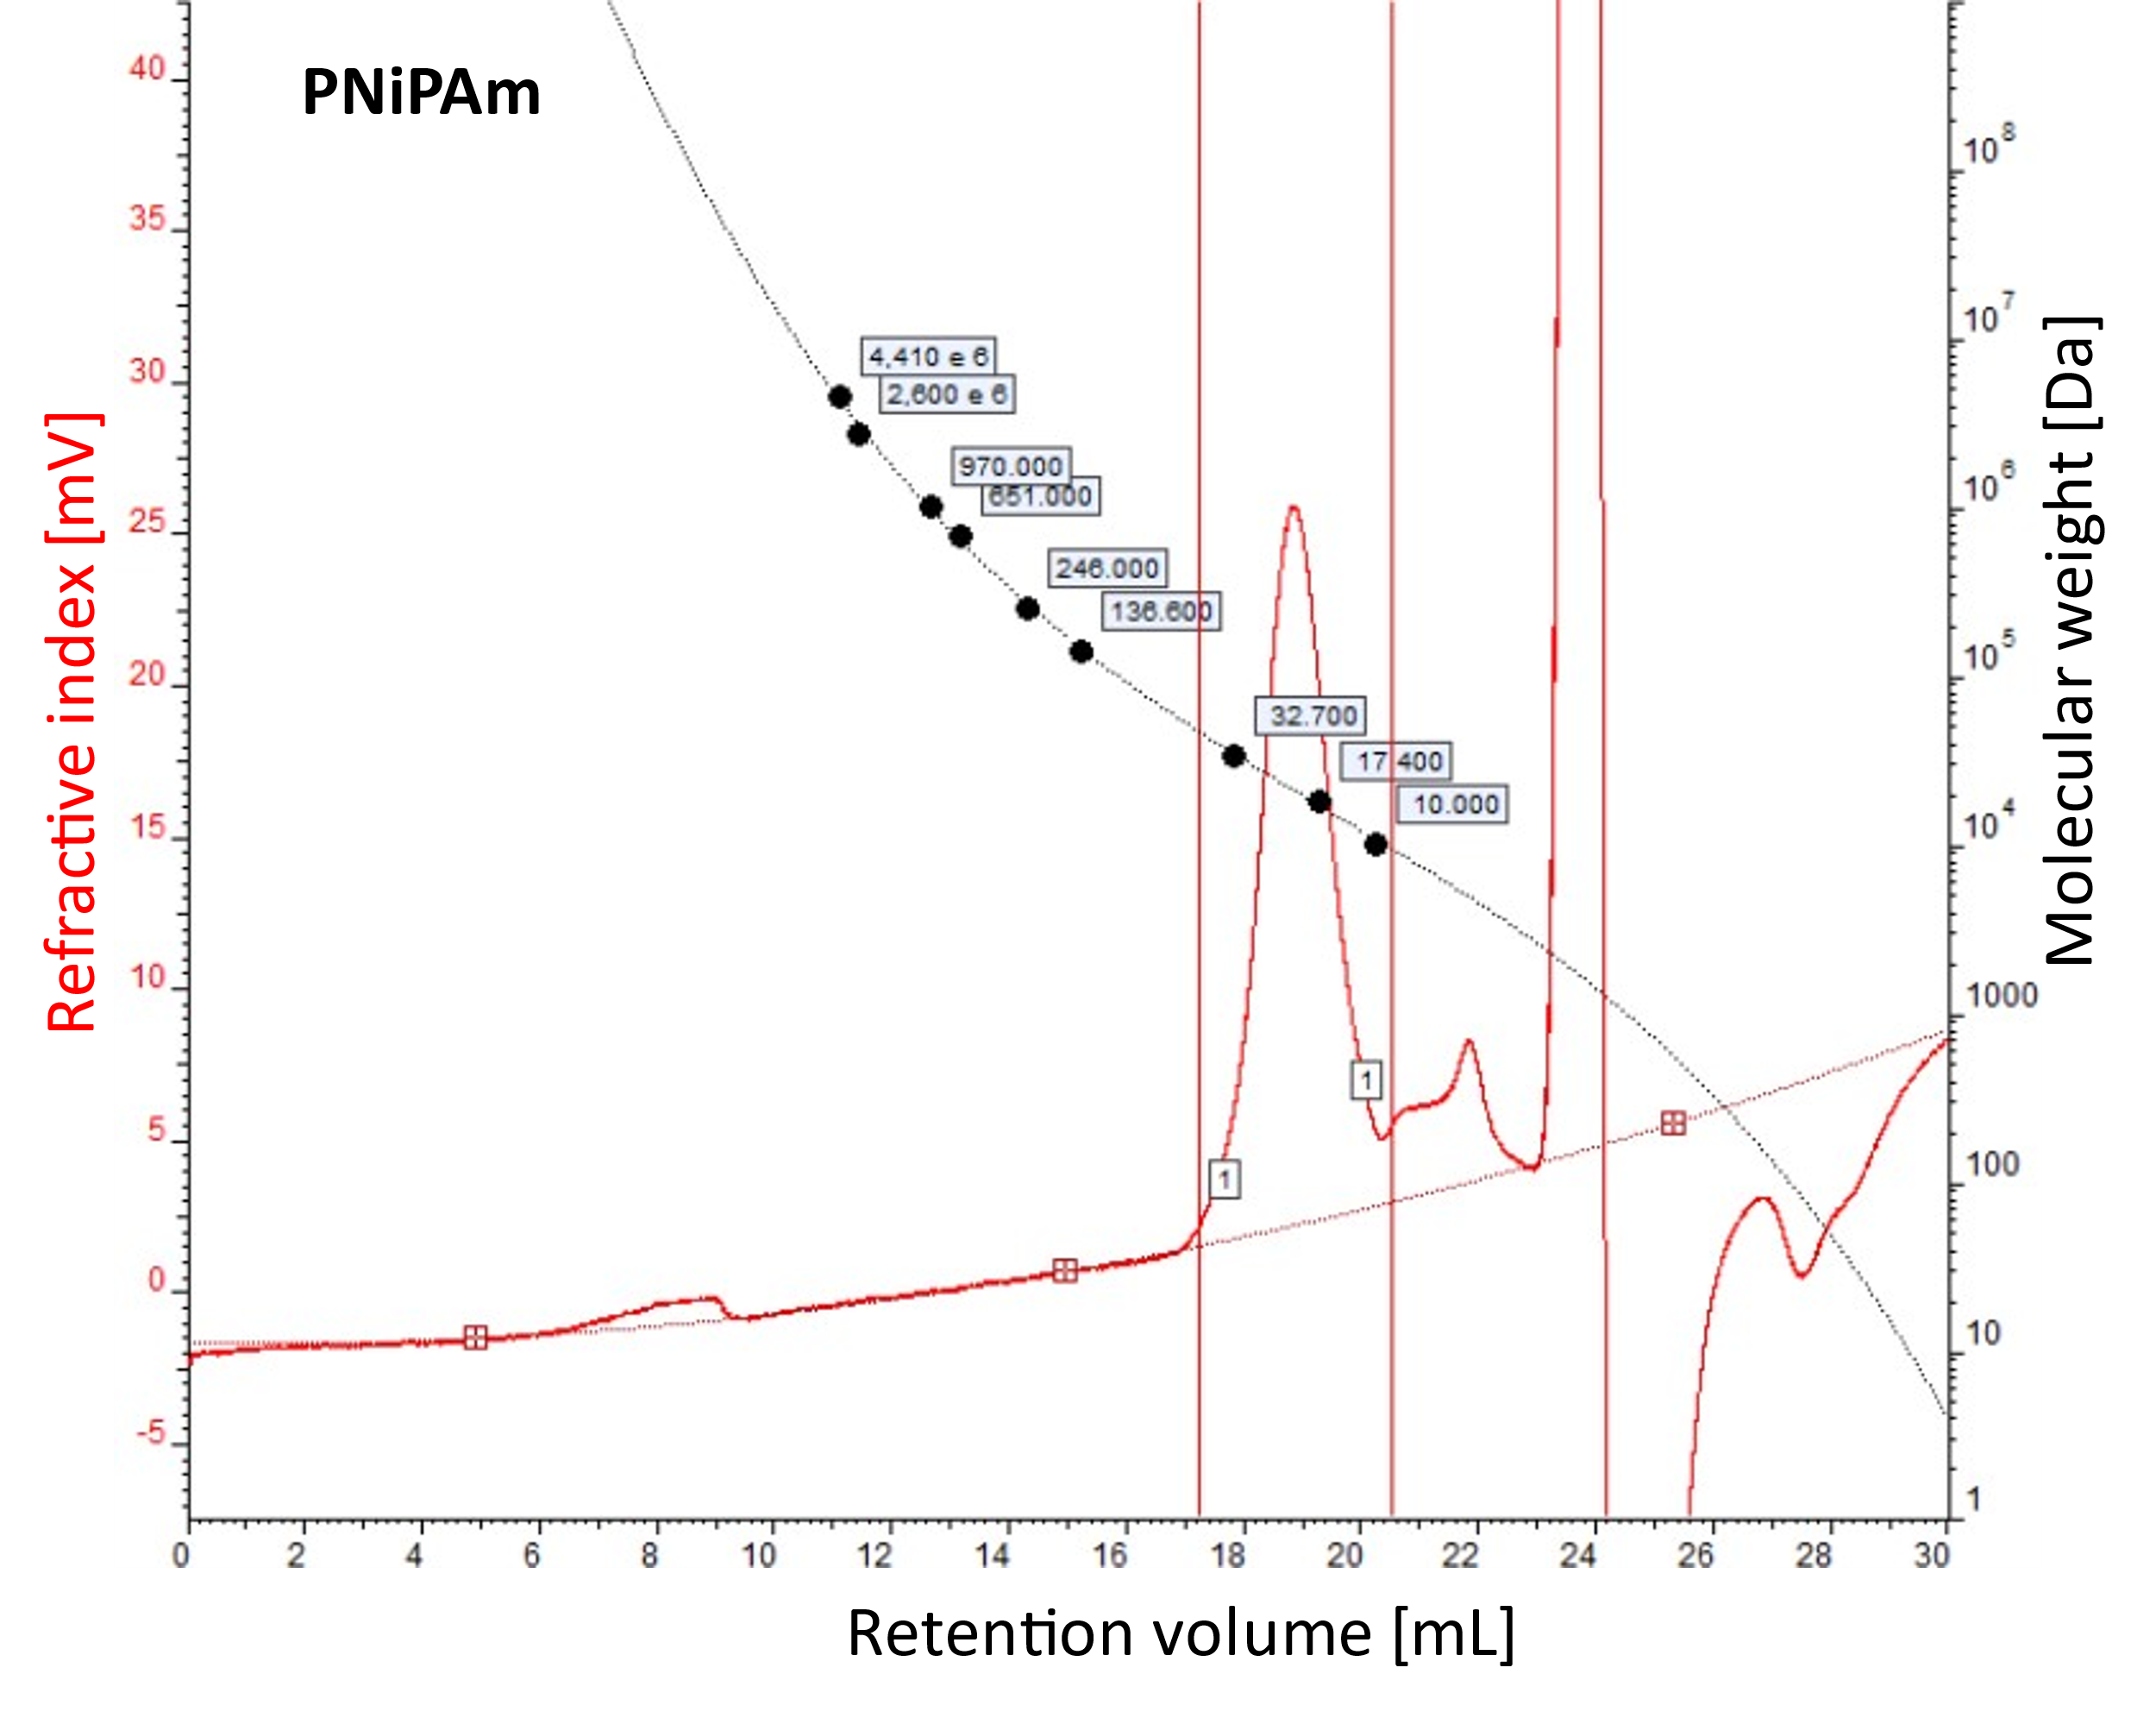
Figure S4. Gel permeation chromatography of PNiPAm based on its R_{G} against a standard of polystyrene in N,N-dimethylformamide (DMF). 3.5 mg polymer were dissolved in 1 ml DMF containing 0.05 mol l⁻¹ lithium bromide. 50 µl of sample were measured at a flow rate of 9.5 ml min⁻¹ at 60 °C.

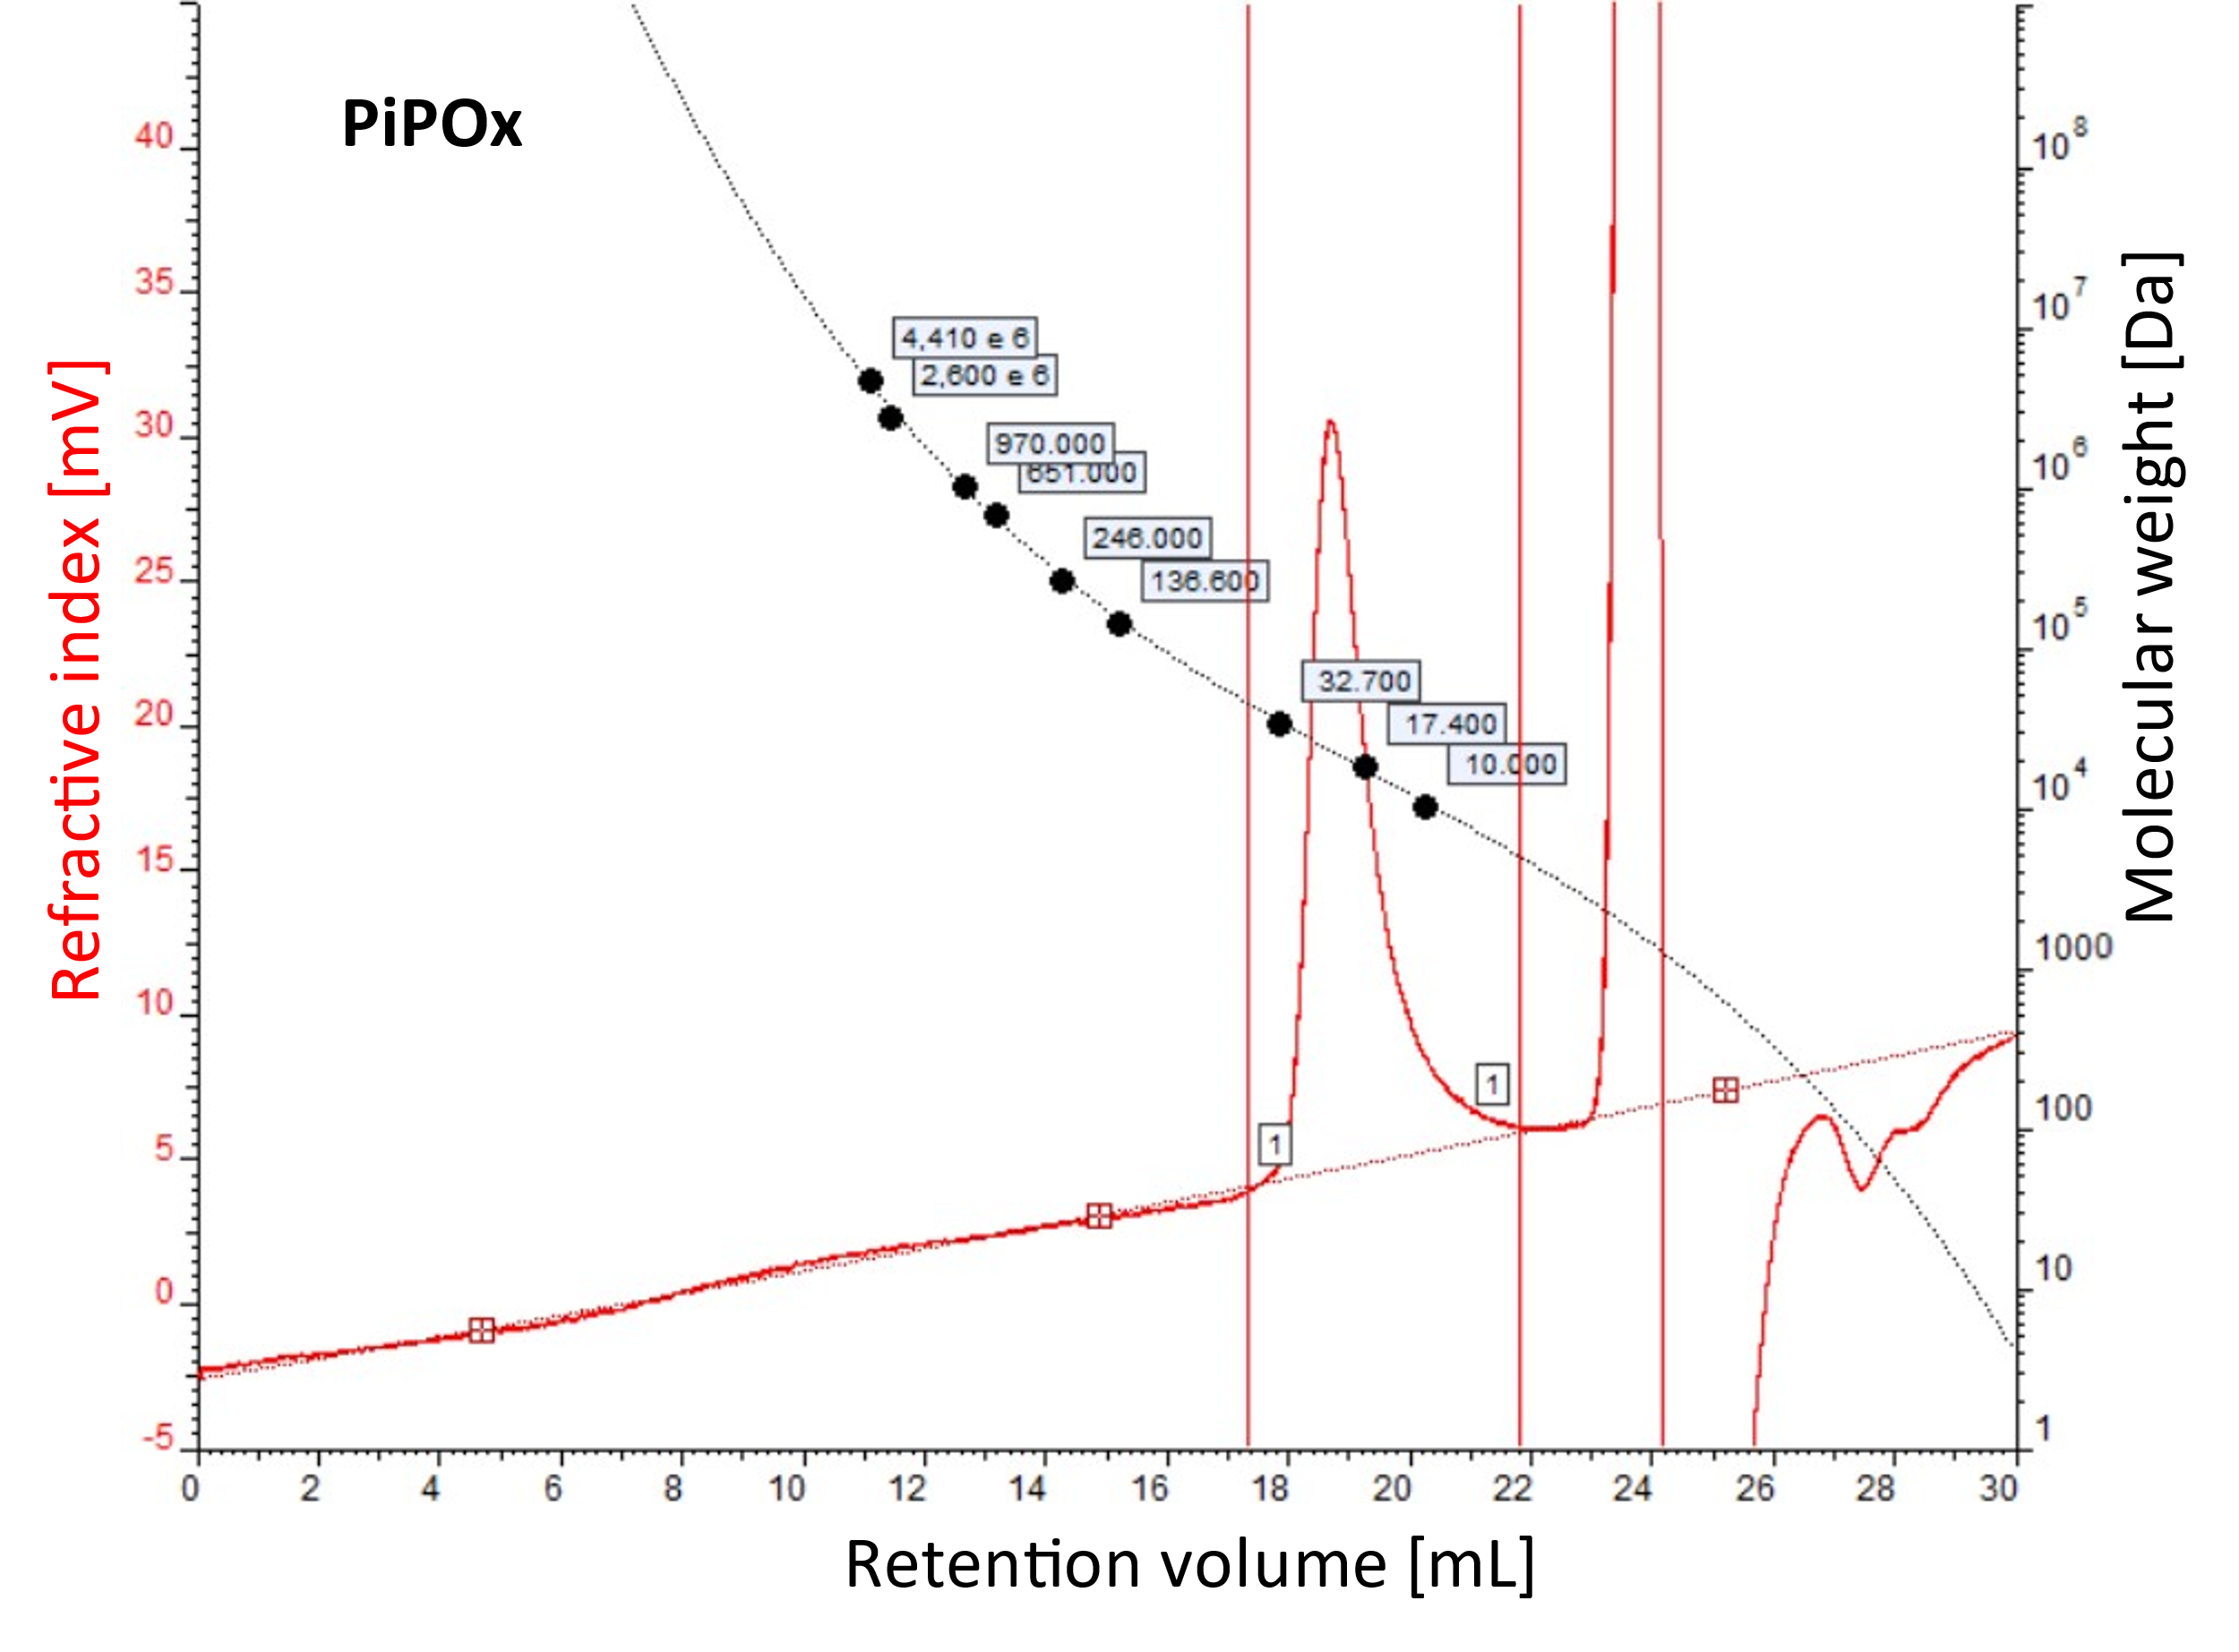
Figure S5. Gel permeation chromatography of PiPOx based on its R_{G} against a standard of polystyrene in N,N-dimethylformamide (DMF). 3.5 mg polymer were dissolved in 1 ml DMF containing 0.05 mol l⁻¹ lithium bromide. 50 µl of sample were measured at a flow rate of 9.5 ml min⁻¹ at 60 °C.

Table S5. Polymer weight and polydispersity derived from GPC.
Polymer | PNiPAm | PiPOx
Linear Formula | CH₃(C₆H₁₁NO)_{n}OH | CH₃(C₆H₁₁NO)_{n}OH
M_{w} [kDa] | 21.368 | 21.119
M_{n} [kDa] | 20.379 | 20.341
PDI | 1.049 | 1.038

$$PDI=\frac{M_{w}}{M_{n}}$$ | Eq. S1

