Supplementary Materials:
Figure S1: Figure showing the viruses included in the enrichment workflow of the Viral Surveillance Panel – VSP (Illumina).
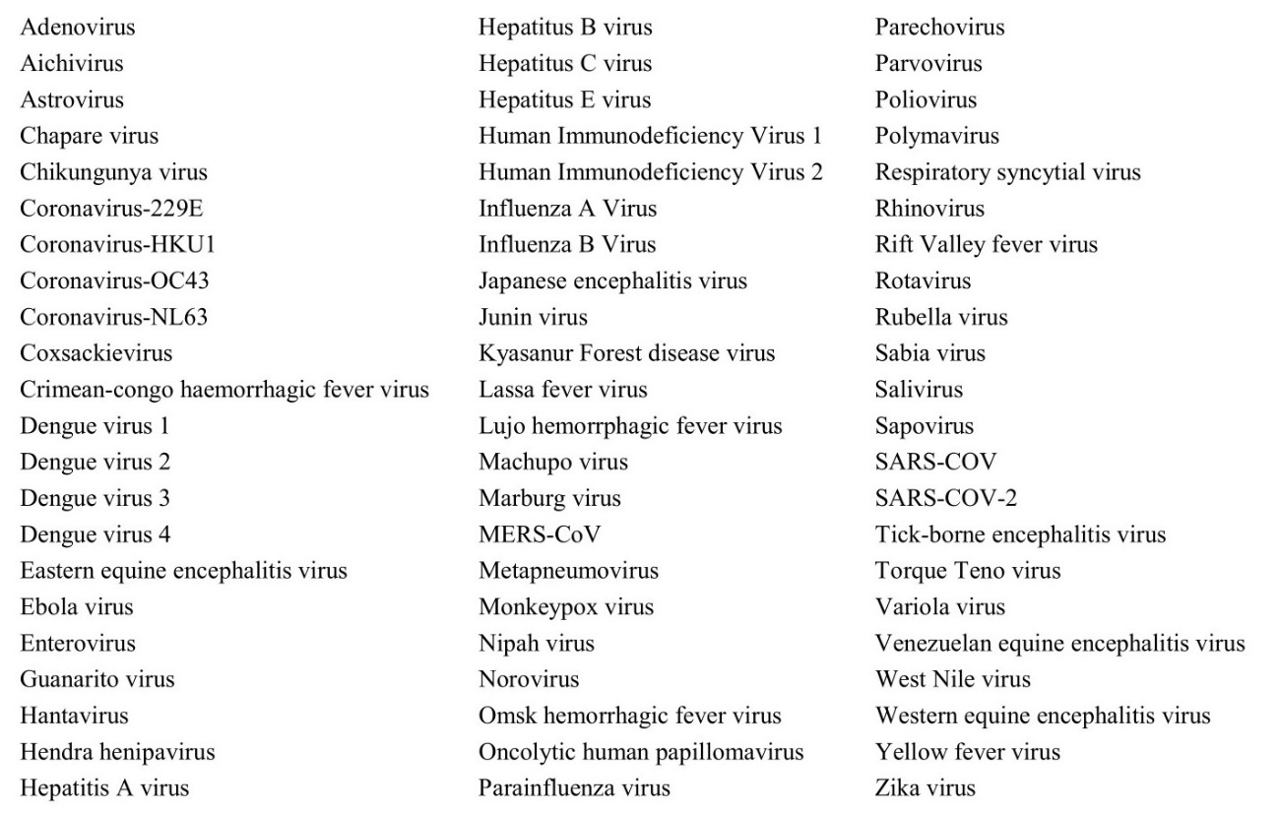

Table S1: Detection of SARS-CoV-2, Influenza A, Influenza B in sewage samples from hospitals and WWTPs by applying hybrid capture-WGS with VSP and RT-PCR using BioManguinhos Kit*.
Sample/date | WGS/SARS-CoV-2 | SARS-CoV-2 | Influenza A | Influenza B
Hospital A (07/23/2022) | 1013 reads | + (32.0) | n.d. | n.d.
Hospital A (08/12/2022) | n.d. | n.d. | n.d. | n.d.
Hospital A (09/01/2022) | n.d. | n.d. | n.d. | n.d.
Hospital A (09/21/2022) | n.d. | + (31.9) | n.d. | n.d.
Hospital A (10/05/2022) | n.d. | + (31.0) | + (29.7) | n.d.
Hospital A (10/19/2022) | n.s. | n.d. | n.d. | n.d.
Hospital A (11/18/2022) | 901 reads | + (28.3) | + (36.1) | n.d.
Hospital A (11/30/2022) | n.d. | + (28.0) | n.d. | n.d.
Hospital A (12/14/2022) | n.d. | n.d. | n.d. | n.d.
Hospital A (01/11/2023) | n.d. | + (33.4) | n.d. | n.d.
Hospital A (01/25/2023) | n.d. | n.d. | + (30.9) | n.d.
Hospital A (02/08/2023) | 537 reads | n.d. | n.d. | n.d.
Hospital A (02/24/2023) | 18 reads | + (30.9) | + (31.3) | n.d.
Hospital A (03/01/2023) | 632 reads | + (31.9) | n.d. | n.d.
Hospital A (03/15/2023) | n.s. | + (32.3) | n.d. | n.d.
Hospital B (09/01/2022) | 555 reads | n.d. | n.d. | n.d.
Hospital B(12/01/2022) | 1261 reads | +(34.1) | n.d. | n.d.
Hospital B (02/07/2023) | 381 reads | n.d. | n.d. | n.d.
Hospital B (02/23/2023) | 1156 reads | +(33.6) | n.d. | n.d.
Hospital B (03/01/2023) | 735 reads | n.d. | n.d. | n.d.
Hospital B (03/15/2023) | n.s. | +(30.6) | n.d. | n.d.
WWTP-A (02/08/2023) | 433 reads | n.d. | + (31.6) | n.d.
WWTP-A (02/23/2023) | 780 reads | +(35.3) | +(33.6) | n.d.
WWTP-A (03/01/2023) | 94 reads | n.d. | n.d. | n.d.
WWTP-A (03/15/2023) | 401 reads | +(34.8) | n.d. | n.d.
WWTP-B (02/23/2023) | 1014 reads | +(34.7) | n.d. | n.d.
WWTP-B (03/01/2023) | 1373 reads | n.d. | n.d. | n.d.
WWTP-B (03/15/2023) | 50 reads | n.d. | n.d. | n.d.
Detection | 17/25= 68% | 15/28=53.6% | 6/28=21.4% | 0%
* RT-qPCR assays for the detection of INFA/INFB/SC2 were performed according to the protocol developed by the Bio-Manguinhos Molecular Kit and to instructions provided by the manufacturer in a QuantStudio®5 Real-time PCR System (Thermo Fisher). n.d. not detected. n.s. not sequenced. Influenza A and Influenza B genomes were not detected by hybrid capture-WGS and results are not shown in this table.

