Nitrogen-rich Carbon Nanotube Supported Palladium as a Catalyst for Desulfurization of Dibenzothiophene and Reduction of Nitroarenes

Mohammad Gholinejad,*^{a,b} Zeinab Elkhani,ª Sara Nayeri,ª José, M. Sansano^{c}*
ªDepartment of Chemistry, Institute for Advanced Studies in Basic Sciences (IASBS), P. O. Box 45195-1159, Gavazang, Zanjan 45137-66731, Iran, E-mail: gholinejad@iasbs.ac.ir.
^{b}Research Center for Basic Sciences & Modern Technologies (RBST), Institute for Advanced Studies in Basic Sciences (IASBS), Zanjan 45137-66731, Iran.
c Departamento de Química Orgánica, Instituto de Síntesis Orgánica, and Centro de Innovación en Química Avanzada (ORFEO-CINQA), Universidad de Alicante, 03690-Alicante, Spain.

Procedure for the synthesis of 1-(prop-2-yn-1-yl)-1H-imidazole (compound A)

In a 25 ml flask, acetonitrile (10 ml), imidazole (4.4 mmol, 0.3 g), and K₂CO₃ (8 mmol, 1.1 g) were added. Then propargyl bromide (4 mmol, 0.3 ml) was added to the solution and stirred for 48 hours at room temperature. After the completion of the reaction, the acetonitrile solvent was dried by a rotary evaporator and the product was washed with water (15 ml) and ethyl acetate (20 ml), and the product was extracted into the organic phase. The pure product 1-(prop-2-yn-1-yl)-1H-imidazole (A) was obtained with 70% yield and was characterized by ¹H NMR and ¹³C NMR.
Procedure for the synthesis of 3-(2-bromoethyl)-1-(prop-2-yn-1-yl)-1H-imidazol-3-ium (ILB)
In a 5 ml flask 1-(prop-2-yn-1-yl)-1H-imidazole (A) (2.8 mmol, 0.3 g) and 1,2-dibromoethane (35 mmol, 3 ml) was added mixture stirred for 48 hours at room temperature. Then, the reaction was washed with hexane (2 x 10 ml) and ethyl acetate (1 ml) to remove unreacted 1,2-dibromoethane. After drying final ionic liquid was obtained in 76% yield and was characterized by ¹H NMR and ¹³C NMR.
Procedure for the epoxidation of carbon nanotube (1)
A 250 ml flask containing carbon nanotubes (1 g) and dry CH₂Cl₂ (50 ml) was sonicated for 10 min. Then, metachloroperbenzoic acid (5.8 mmol, 1 g) was dissolved in CH₂Cl₂ (50 ml) and the solution was added to a flask containing CNT, and the resulting mixture was stirred at 40°C for 48 hours under reflux condition. afterward, the solid was separated by centrifugation and was washed with distilled water (3×10 mL) and ethanol (2×10 mL). The final epoxy functionalized CNT was dried in an oven at 70 °C.
Procedure for the azidation of carbon nanotube (2):
Epoxidized carbon nanotubes (1 g) and distilled water (40 ml) were added to a 100 mL flask, and the mixture was sonicated for 10 min. Then, sodium azide (57 mmol, 3.7 g) was added to the solution, and the mixture was stirred under reflux at 90°C for 48 hours. After 48 hours, the mixture was centrifuged and the remaining precipitate was washed with distilled water (10 x 3 ml) and ethanol (10 x 2 ml). Afterward, the sediment was placed in an oven at 70 degrees Celsius for 24 hours to dry.
Procedure for functionalization of carbon nanotube with IL(B) (3):
Azido carbon nanotube (1 g) was added to a flask containing 30 mL H₂O and the resulting mixture was sonicated for 10 minutes. At the same time, to a 10 mL flask containing distilled water (2 ml), CuSO₄. 5H₂O (0.09 mmol, 0.15 g) and ascorbic acid (0.17 mmol, 30 mg) were added and after 5 min stirring, solution along with ionic liquid (B) was added to a flask containing azido carbon nanotube. The resulting mixture was stirred under reflux at 80°C for 48 hours. Then, the mixture was centrifuged and the remaining precipitate was washed with distilled water (3×10 mL) and ethanol (3×10 mL) and dried in an oven at 70°C for 24 h.
Procedure for the functionalization of carbon nanotube with A (5):
carbon nanotube functionalized with ionic liquid (B) was reacted with sodium azide using reported above mentioned procedure to produce (4). To 1g of (4), a solution containing CuSO₄. 5H₂O (0.09 mmol, 0.15 g) and ascorbic acid (0.17 mmol, 30 mg) in distilled water (2 ml), were added and the mixture was stirred under reflux at 80 °C for 48 hours. Then, the mixture was centrifuged, and the obtained solid was washed with distilled water (3×10 mL) and ethanol (3×10 mL) and dried in an oven at 70°C for 24 hours to dry.
Procedure for the stabilization of palladium (6)
Distilled water (10 mL) and a modified carbon nanotube (0.5 g) were added to a 25 mL flask and the mixture stirred for 10 minutes at room temperature. Then, Na₂PdCl₄ (0.023 mmol, 7 mg) was dissolved in 2 ml of distilled water added dropwise to the reaction mixture under argon, and stirred for 24 hours. Next, the mixture was centrifuged and washed with distilled water (3×10 mL) to remove unreacted Pd salt, and the resulting solid was dried in an oven.
General procedure for the reductions of nitroarenes
In a 10 mL flask, CNT-TZ-IL@Pd catalyst (7 mg, containing 0.005 mol% Pd), nitroarene (0.4 mmol), NaBH₄ (0.4 mmol, 15 mg), water (1.5 mL) were added and the mixture was stirred at room temperature for appropriate reaction time. The progress of the reaction was evaluated using thin-layer chromatography and gas chromatography. Then, the product was extracted with ethyl acetate (3× 5mL) and purified by column or plate chromatography.
A typical procedure for the CNT-TZ-IL@Pd catalyzed hydro-desulfurization of DBT using tetralin
To a 10 mL flask, 0.2 mmol of DBT (36.8 mg), tetralin (1 mL), and 10 mg CNT-TZ-IL@Pd were added and the reaction was stirred in an oil bath at 130°C for 5 h. Progress of the reaction was monitored by gas chromatography.

NMRs of compounds A, ionic liquid (B) and some amine products

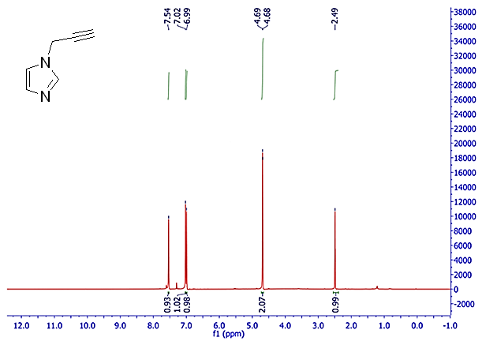
¹H NMR of compound A
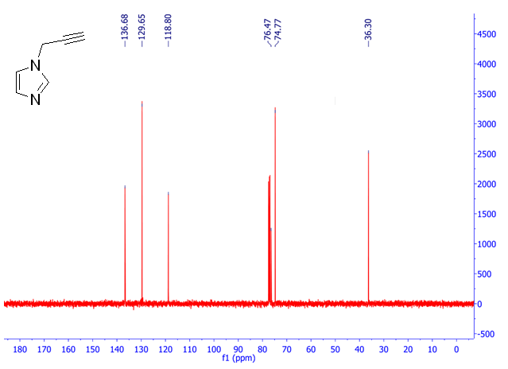
¹³C NMR of compound A

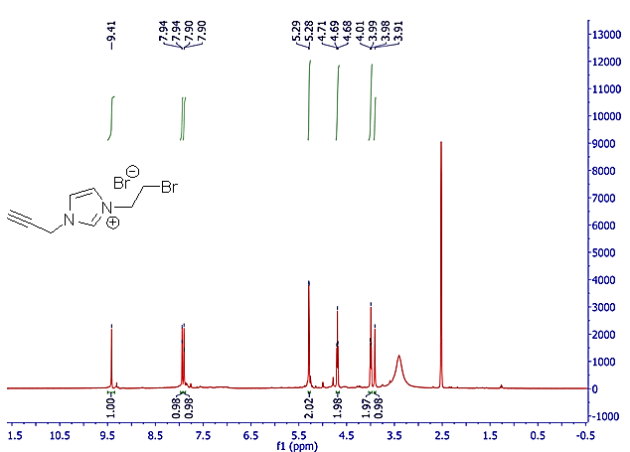
¹H NMR of ionic liquid (B)

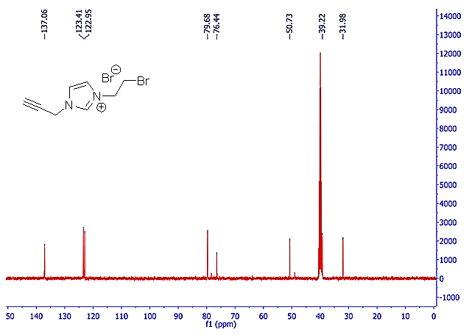
¹³C NMR of ionic liquid (B)

