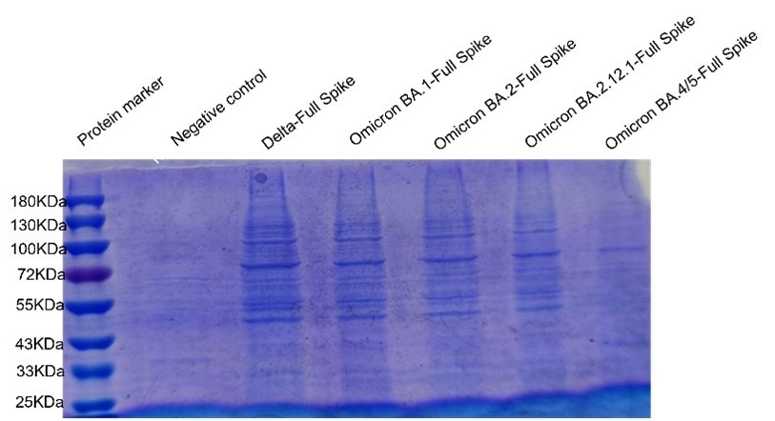

S1A
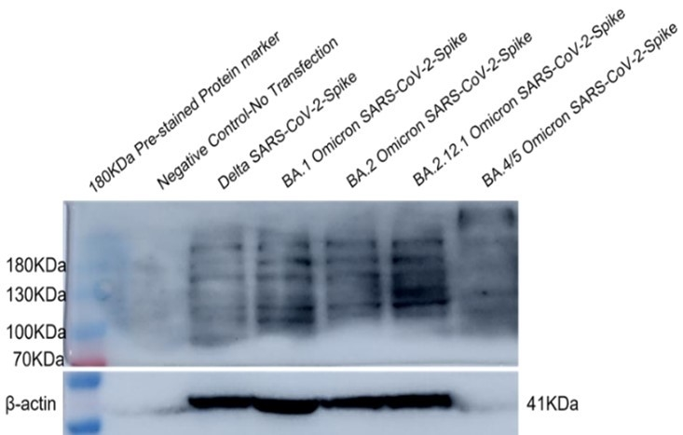

S1B
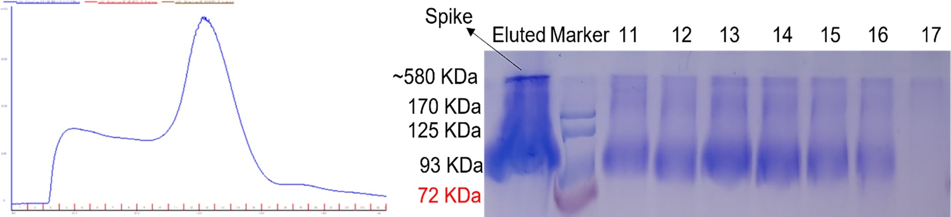

S1C

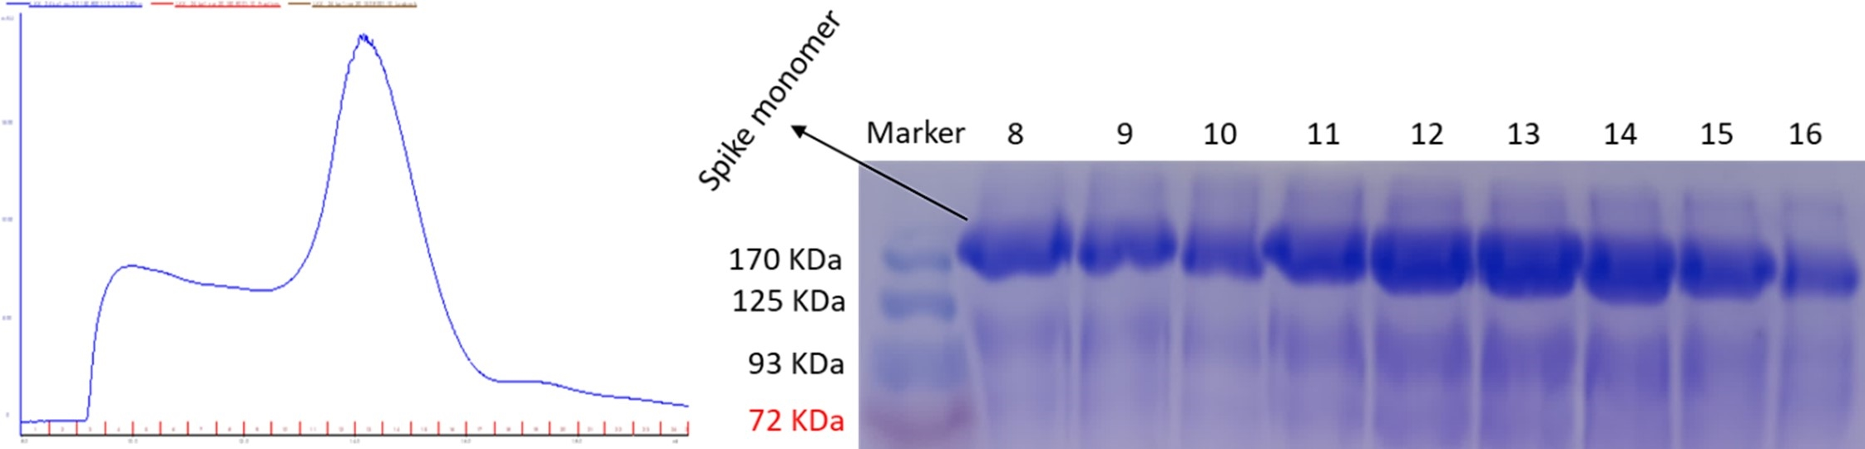

S1D

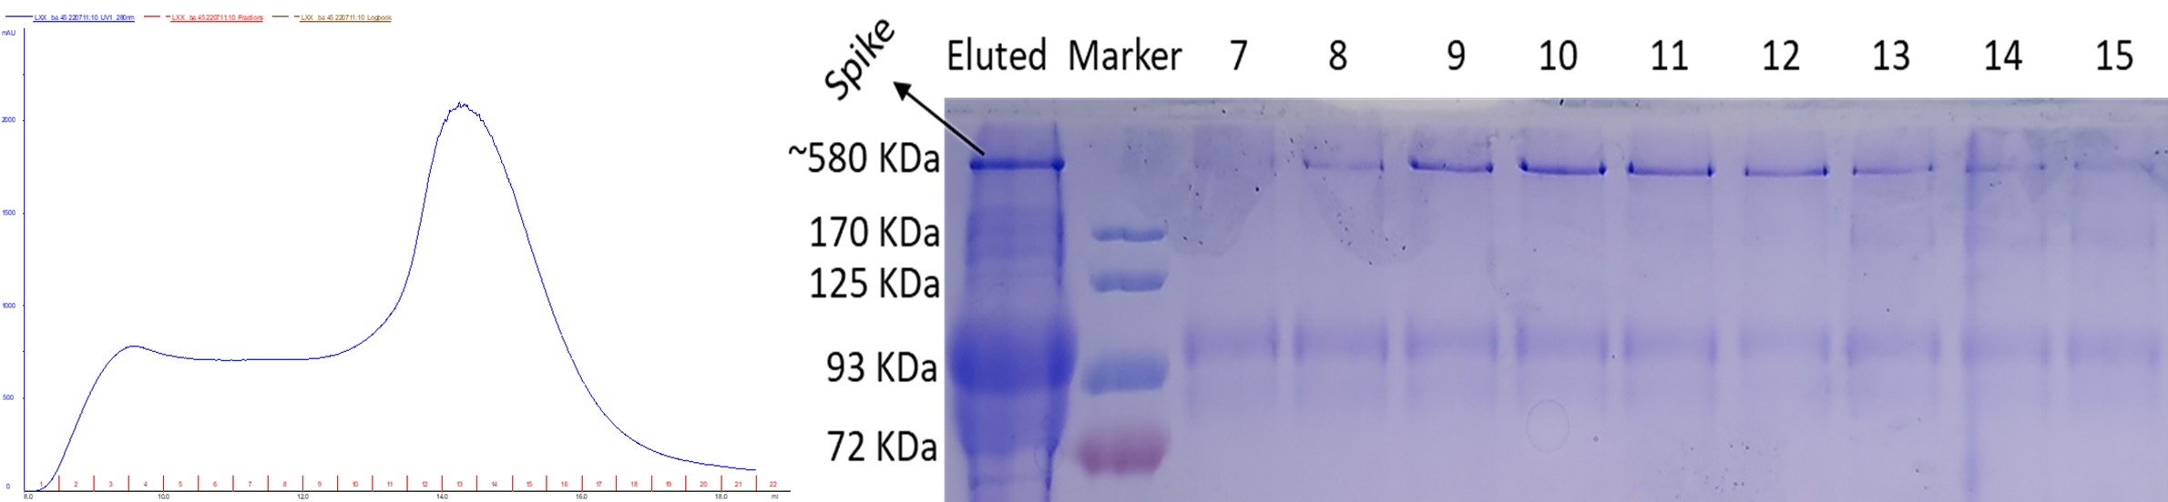

S1E
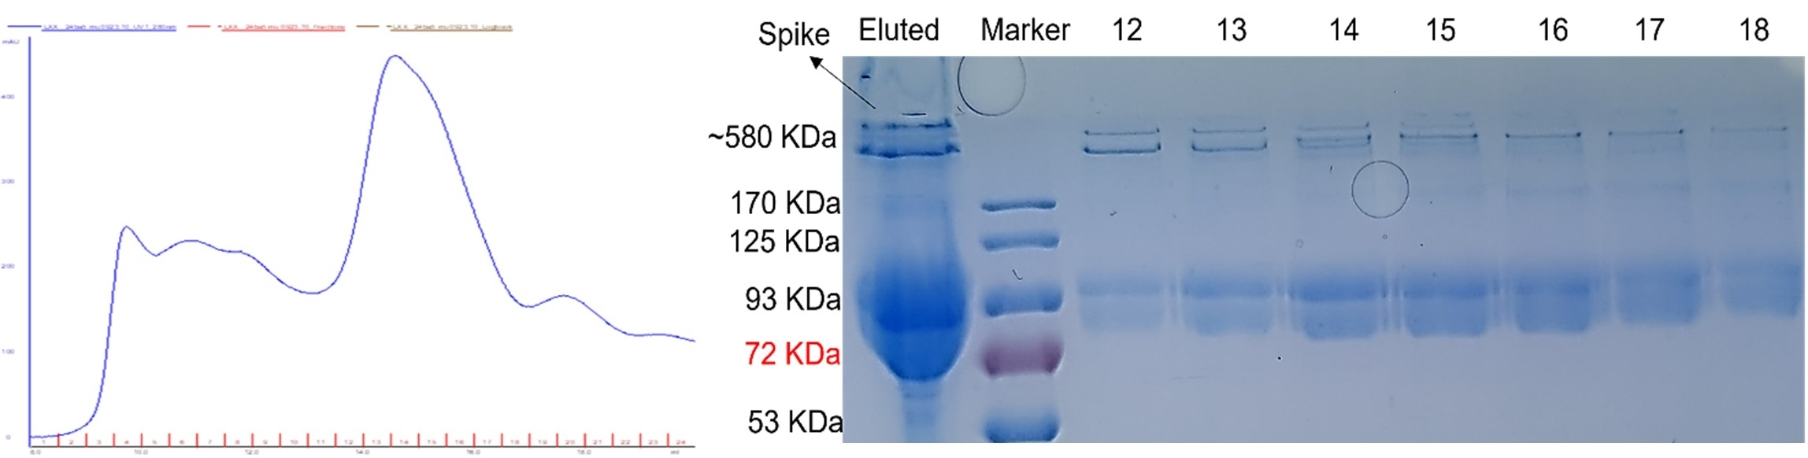

S1F
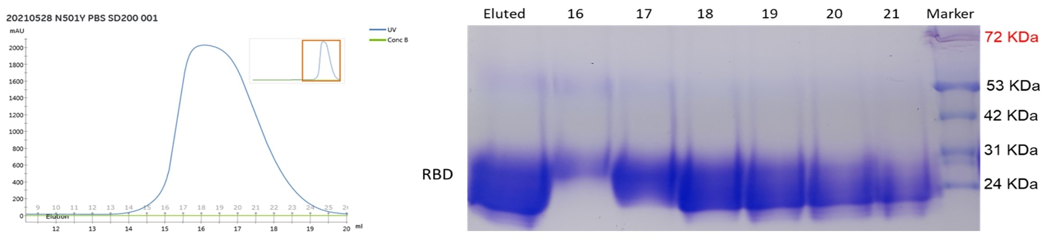

S1G
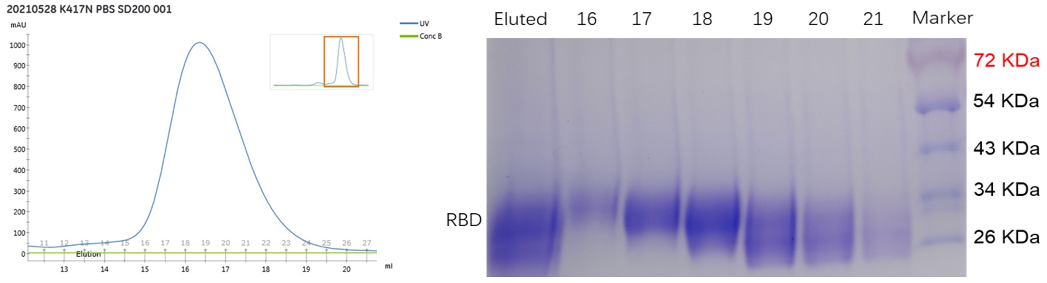

S1H

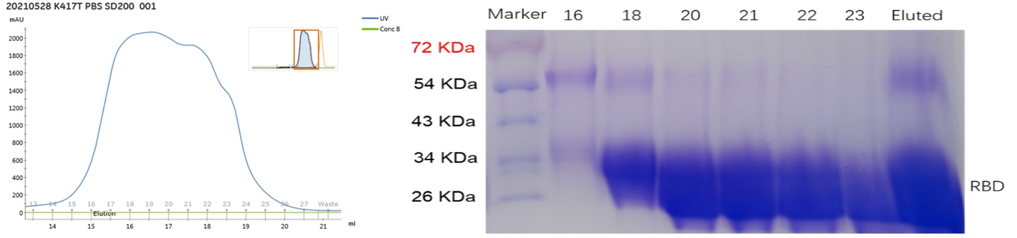

S1I

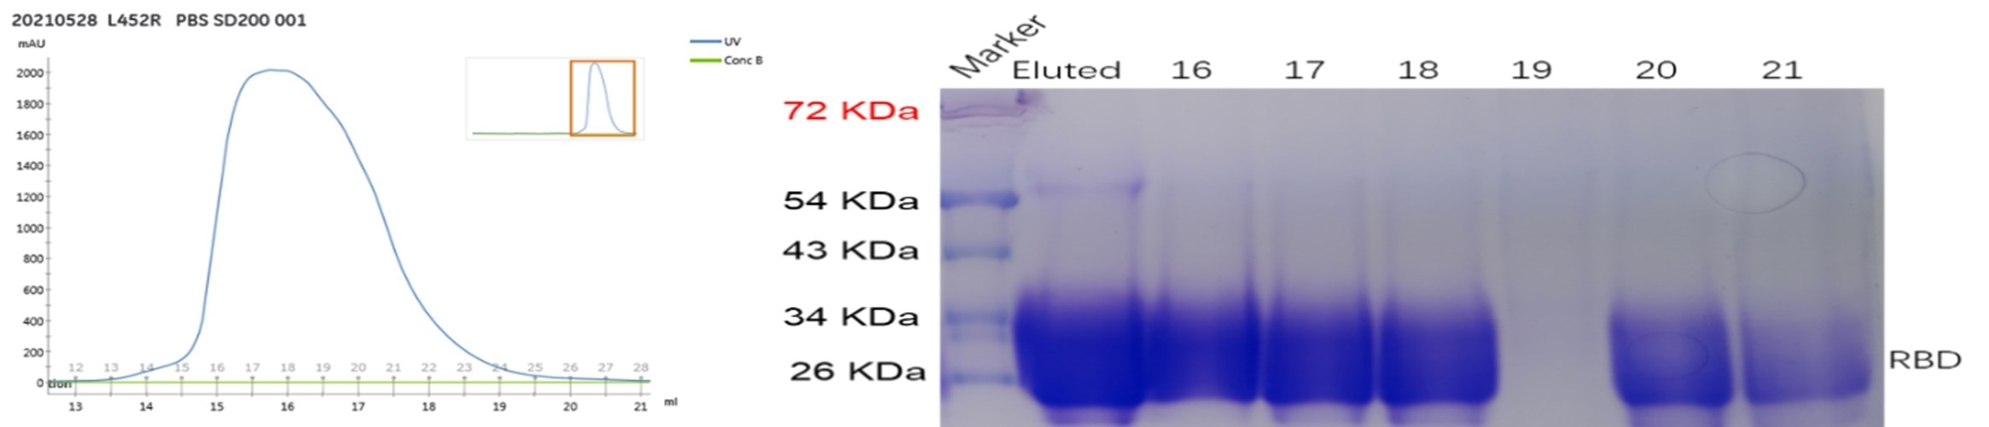

S1J

Supplementary Figure S1A-J: RBD and full-length spike protein production. Supplementary Figure 1S (A) shows the SDS-PAGE gel stained with CBB stain. The first lane is of 180KDa pre-stained protein marker, the second lane is negative control without the transfection of any plasmid, the subsequent lanes correspond to the plasmids carrying full-length spike sequence of respective variant of SARS-CoV-2. Absence of any band at the negative control lane indicates that the cellular system for the expression of the protein is validated. The three bands of about 180KDa are not very clearly shown on the gel picture. Some variants are not shown on the figure.

Supplementary Figure S1 (B) shows the Western blot using anti-His antibodies. The three bands of larger than 180KDa size (i.e., three monomers of full-length spike with His-tag can be shown for each respective variant’s full-length spike.

Supplementary Figure S1 C-J: show the purification of the proteins of SARS-CoV-2. The left side of the figures show the peak of absorbance at 280nm wavelength indicating that the target protein has been starting eluting from the retention volume as purified by the SEC purification. The right side of the figures indicate the SDS-PAGE gel stained with CBB stain. Almost all the proteins were shown to be approximately 90% pure. Supplementary Figures S1 (C), S1 (D), S1 (E) and S1 (F) show the purification of spike of wild-type, Omicron BA.1, BA.4/5, BA.5 respectively and Supplementary Figures S1 (G), S1 (H), S1 (I) and S1 (J) show the purification of RBD of alpha, beta, gamma and kappa respectively with retention volumes of 11-17, 8-16, 7-15, 12-18, 16-21, 16-21, 16-21 and 16-23 ml respectively in SEC purification. In Supplementary Figures S1 (C), S1 (E) and S1 (F), the first lane is of the eluted fraction after SEC and it indicates a single band of about 580KDa size which is the trimeric form of spike, the second lane is of 180KDa pre-stained protein marker. The subsequent lanes correspond to the indicated fractions after the SEC purification as indicated by the peak. In Figure S1 (C), only the eluted lane showed purified protein band while in Figure S1 (E) and S1 (F), fractions 7,8,14 and 15; and fractions 17 and 18 showed light bands respectively. In Supplementary Figure S1 (D), the first lane is of 180KDa pre-stained protein marker, and the subsequent lanes correspond to the indicated fractions after the SEC purification as indicated by the peak. All the indicated protein fractions showed a band of about 180KDa size which is the monomeric form of full-length spike.

In Supplementary Figures S1 (G) and S1 (H), the first lane is of the eluted protein indicating a band of about 25KDa size, the subsequent lanes correspond to the indicated fractions after the SEC purification as indicated by the peak and the last lane is of 180KDa pre-stained protein marker. All the fractions showed bands of about 25KDa size except fraction 16 showing lighter band.

In Supplementary Figures S1 (I), the first lane is of 180KDa pre-stained protein marker, the subsequent lanes correspond to the indicated fractions after the SEC purification as indicated by the peak and the last lane is of the eluted protein all indicating a band of about 25KDa size. All the fractions showed bands of about 25KDa size except fraction 16 showing lighter band.

In Supplementary Figure S1 (J), the first lane is of 180KDa pre-stained protein marker, the second lane is of the eluted protein and the subsequent lanes correspond to the indicated fractions after the SEC purification as indicated by the peak all showing band of about 25KDa size. All the fractions showed bands of about 25KDa size except fraction 19.

