Supporting information for

# An improved method of mitigating orbital errors in multiple SAR interferometric pairs analysis for interseismic deformation measurement: Application to the Tuosuo Lake segment of the Kunlun fault

Qian Xu1, Ying-Hui Yang2, Qiang Chen1, De-Chao Wang1, Su Liu1, Yu-Cong He1, Lang Xu3

Chengdai Zi3

# College of Air Traffic Management, Civil Aviation Flight University of China, Deyang, Sichuan, China

# State Key Laboratory of Geohazard Prevention and Geoenvironment Protection, Chengdu University of Technology, Chengdu, Sichuan, China.

# Department of Remote Sensing and Geoinformation Engineering, Southwest Jiaotong University, Chengdu, Sichuan, China

**Contents of this file**

Figures S1 to S4

Text S1

Table S1 to S2

**Introduction**

Figure S1 shows the diagram of the SAR image partition.

Figure S2 shows the different solutions of crustal deformation velocity with variable *N*.

Figure S3 shows the uncertainty distributions of the derived velocity maps.

Figure S4 shows the InSAR LOS velocity fields with orbital error correction using the traditional quadratic approximation.

Text S1 describes the uncertainty quantification of the derived velocity fields.

Table S1 shows the SAR images and interferograms used in this study.

Table S2 shows the criteria of the interferogram selection.

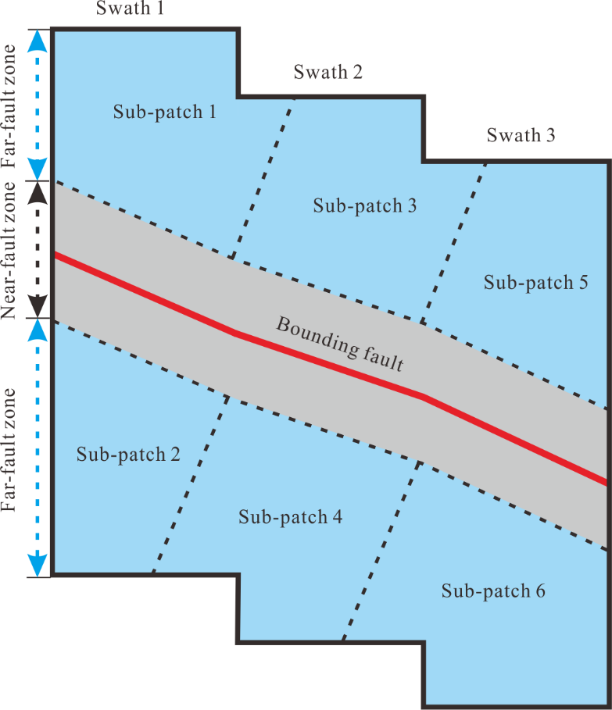

Figure S1 Diagram of the Sentinel-1 SAR image partition with 6 sub-patches.

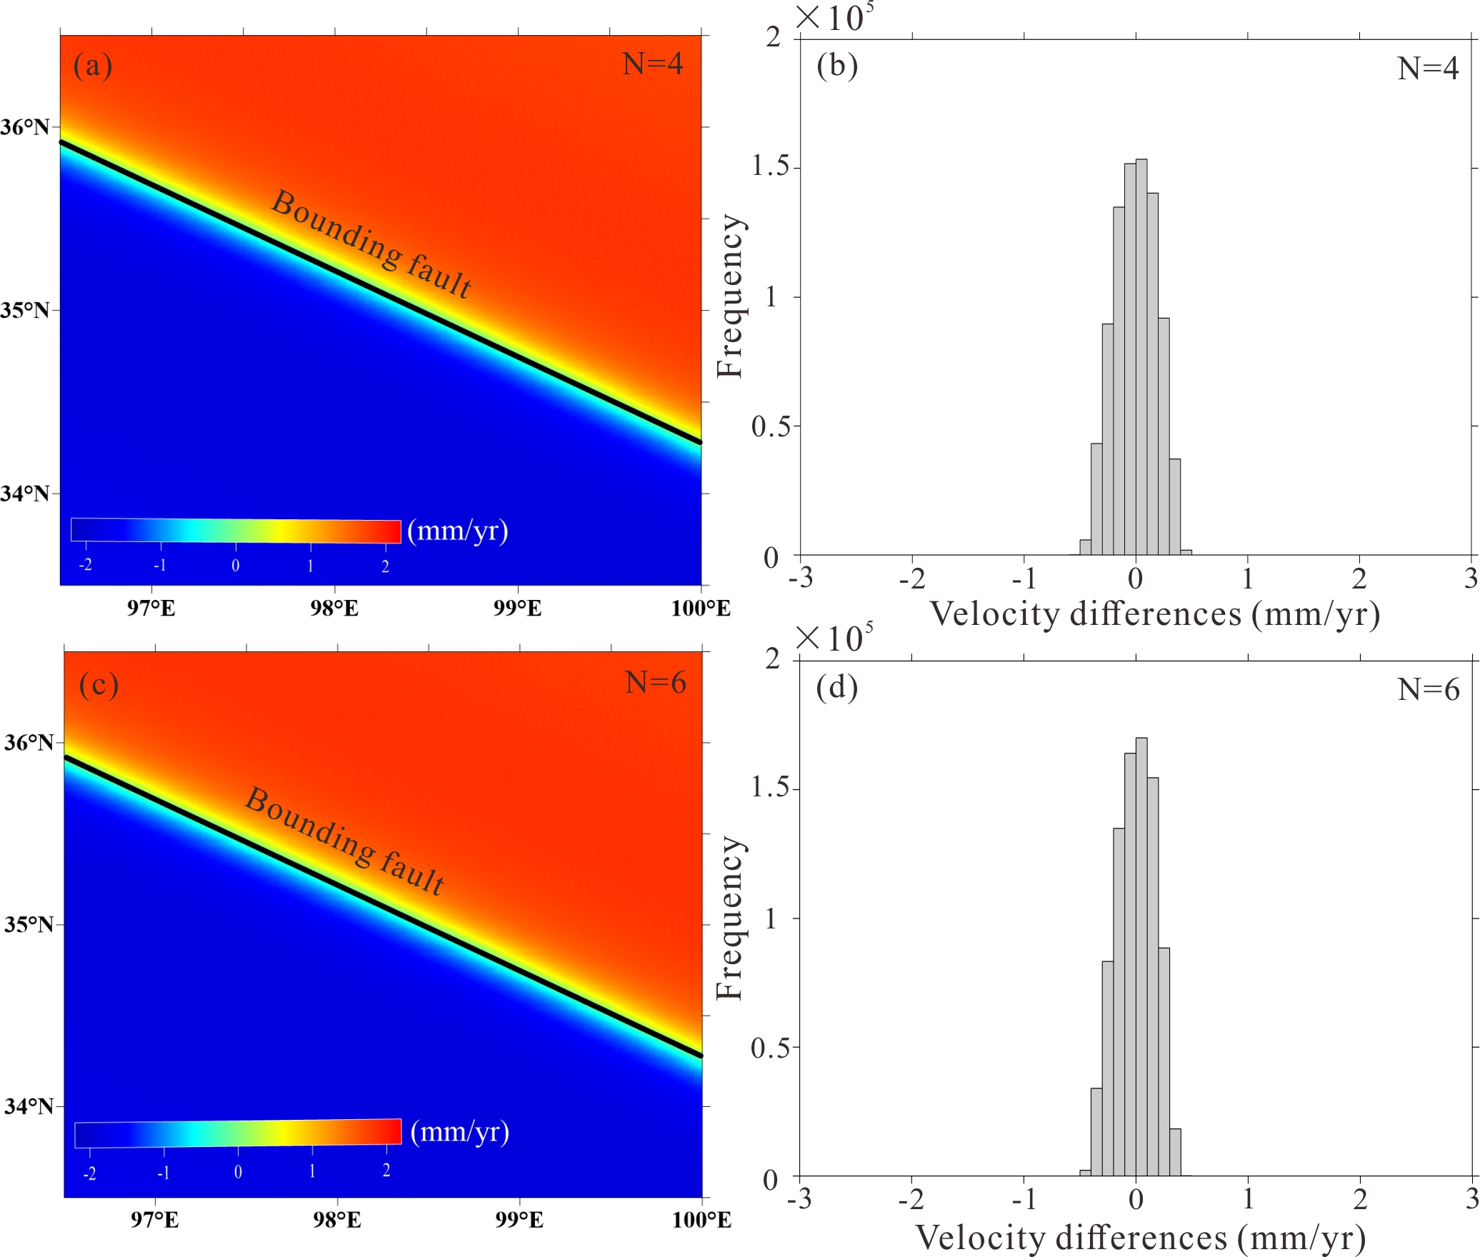

Figure S2 Different solutions of crustal deformation velocity with variable *N*. LOS rate (a) calculated with *N*=4, the corresponding histogram (b) of the velocity differences between the true (Fig 1a) and estimated values. (c) Velocity and (d) histogram of velocity differences solved with *N*=6.

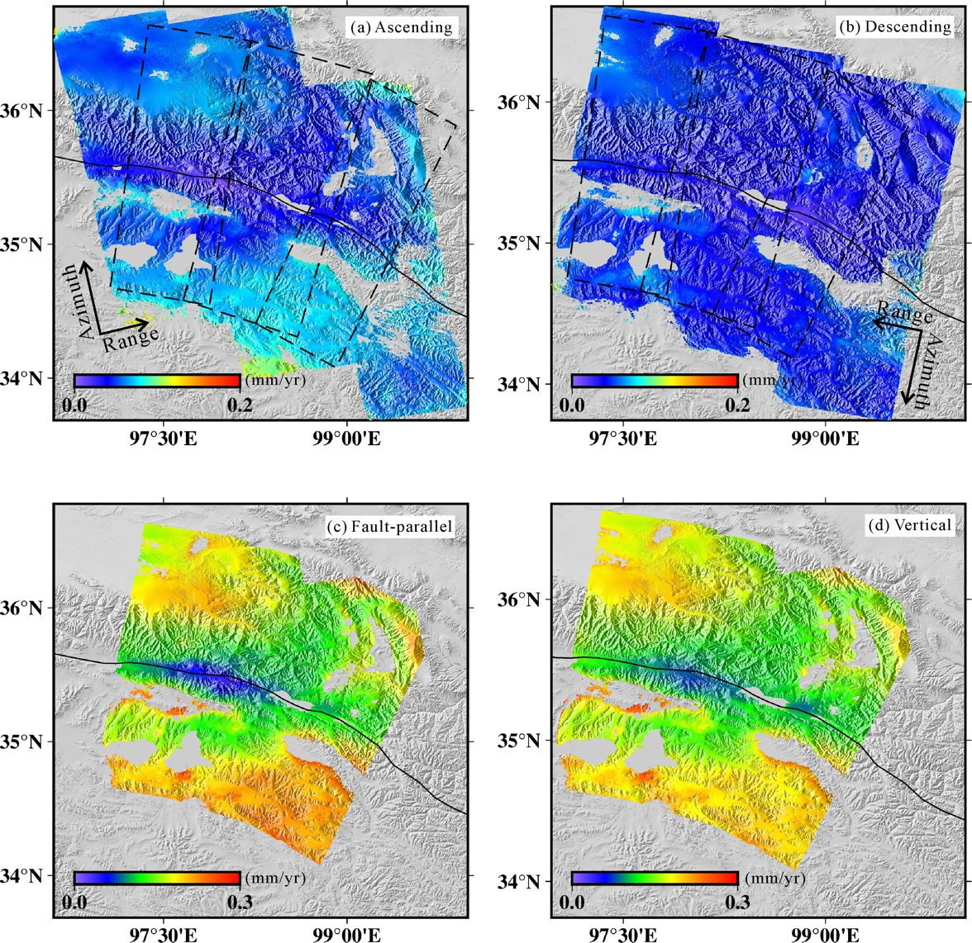

Figure S3 Estimated uncertainties of the velocities for (a) ascending track, (b) descending track, (c) fault-parallel component, and (d) vertical component. Black dashed rectangles are the same as Figure 5.

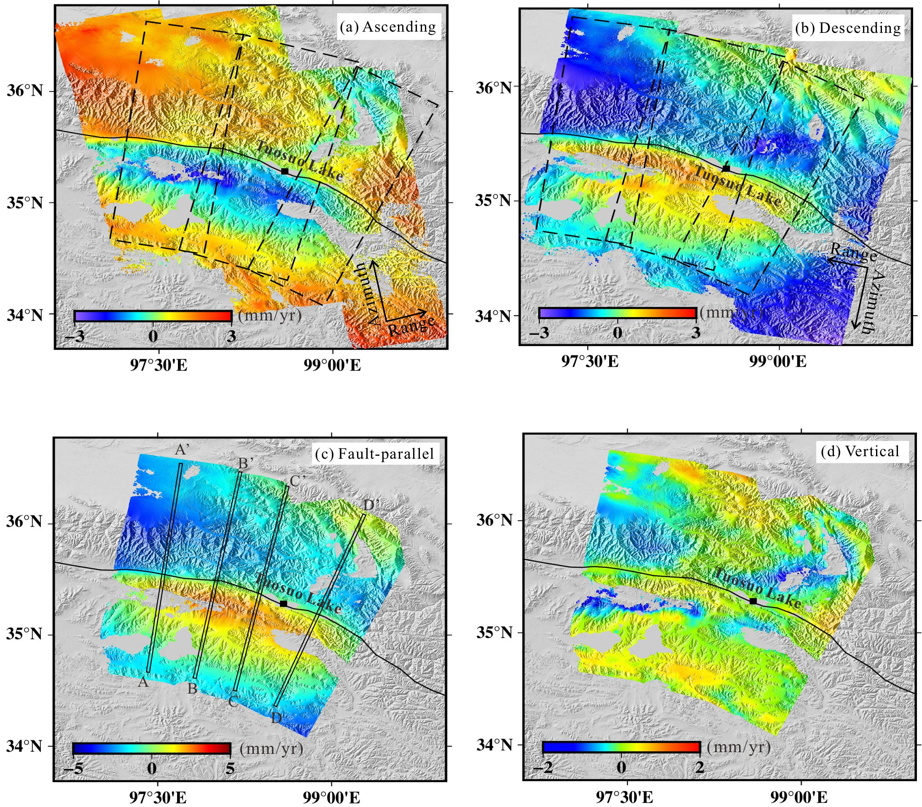

Figure S4 Ascending(a) and descending (b) InSAR LOS velocity fields with orbital error correction using the traditional quadratic approximation, related fault-parallel (c) and vertical (d) components of the InSAR- velocities.

**Text S1. Quantifying the uncertainties of the derived velocity fields**

We quantify the uncertainties of the stacked velocity fields using bootstrapping. On each iteration of bootstrapping, a random subset of 80 per cent of the selected interferograms is used in the stacking, and then the velocity is formed by summing the LOS slant change and dividing by the total time duration. We conduct the bootstrapping for 100 times, and take the standard deviation of the estimated velocities as the uncertainties of the derived velocity fields.

The uncertainties of the ascending/descending (/) LOS velocity maps can be further utilized to express the uncertainties of fault-paralleland verticalvelocity fields, as writing as:



with, , ,

, 

Table S1. SAR images and interferograms used in this study.

|  |  |  |  |  |  |
| --- | --- | --- | --- | --- | --- |
| Tracks | Flight  Direction | scenes | Total number of generated interferograms | Time span | Number of interferograms used to form velocity map |
| T99 | Ascending | 91 | 786 | 20141012 -20210520 | 210 |
| T106 | Descending | 83 | 663 | 20141024 -20210520 | 274 |

Table S2. Criteria of the interferogram selection.

|  |  |  |
| --- | --- | --- |
| No. | Perpendicular baseline (m) | Temporal baseline (days) |
| 1 | < 10 | 200-500 |
| 2 | <20 | 500-1200 |
| 3 | < 60 | >1200 |