Supporting information for:
Flexible asymmetric supercapacitors constructed by reduced graphene oxide/MoO₃ and MnO₂ electrochemically deposited on carbon cloth
The specific capacitance in geometric area (C_{a}) and in mass (C_{m}) for the electrodes tested by employing three-electrode system could be calculated based on the formulae (1) and (2):
$Ca=\frac{\int{\text{IdV}}}{2⋅v⋅S⋅ΔV}$ (1)
$C_{m}=\frac{\int{\text{IdV}}}{2⋅v⋅m⋅ΔV}$ (2)
where C_{a} is in term of mF cm⁻², C_{m} in F g⁻¹; $\int{\text{IdV}}$is the integrated areas surrounded by CV curves, S the geometric area of the electrode calculated by length × width (cm²), ∆V the voltage difference during the CV tests (V) and v the potential scan rate (V s⁻¹), m the loading mass of the active materials (g).
Moreover, the C_{a} and C_{m} of the single electrode could also be obtained from the GCD curves using formulae (3) and (4):
$Ca=\frac{I⋅t}{S⋅ΔV}$ (3)
$Cm=\frac{I⋅t}{m⋅ΔV}$ (4)
where I is the constant discharge current (A), t the discharging time (s), and other parameters are as same as formula (1) and (2).
In order to evaluate the performances of the ASCs, the C_{m} for the cells tested by two-electrode system could be calculated based on the formulae (5) and (6):
$Cm=\frac{\int{\text{IdV}}}{2⋅v⋅m⋅ΔV}$ (5)
Where m is the active substance mass of the positive and negative in the asymmetric capacitor (g), and other parameters are as same as formula (1) and (2).
The C_{a} could also be obtained from the GCD curves using formula (6):
$Cm=\frac{I⋅t}{m⋅ΔV}$ (6)
To further determine the properties of the materials, the energy density and power density [51] of the ASCs depicted in the Ragone plot were required, which could be calculated by using formula (7) and (8) according to the ASC’s GCD curves, respectively.
$E=\frac{1}{2}⋅\frac{Cm{ΔV}^{2}}{\text{3600}}$ (7)
$P=\frac{\text{3600}E}{t}$ (8)
where E is the mass energy density in Wh kg⁻¹, P the mass power density in W kg⁻¹, C_{m} the specific capacitance in F g⁻¹, V the voltage window (excluding iR drop at the beginning of the discharge) in V and t the discharge time in s.

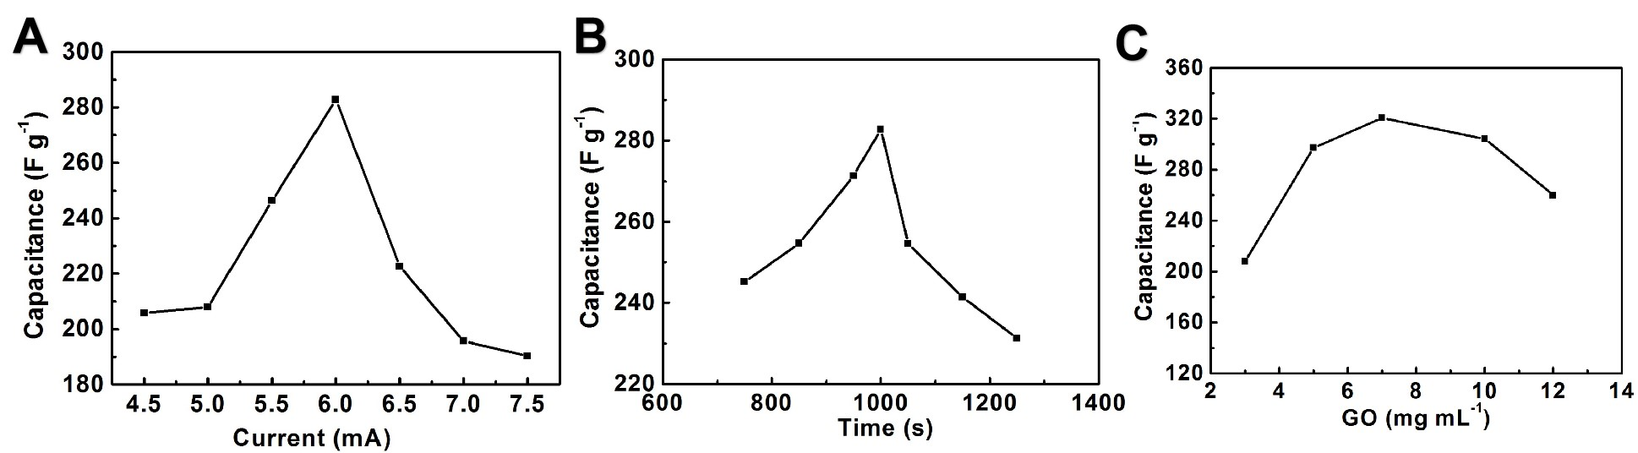
Fig. S1. Specific capacitance variations of MoO₃/CC versus deposition currents, time and concentrations of GO.

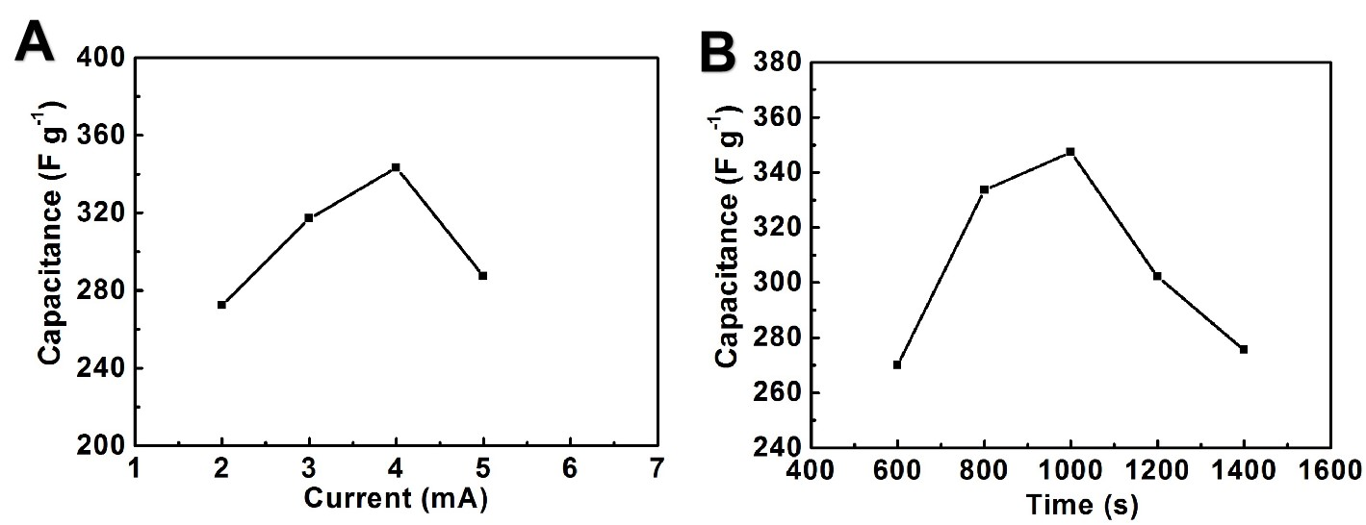
Fig. S2. The plots of specific capacitance of MnO₂/CC versus depositing currents and times.

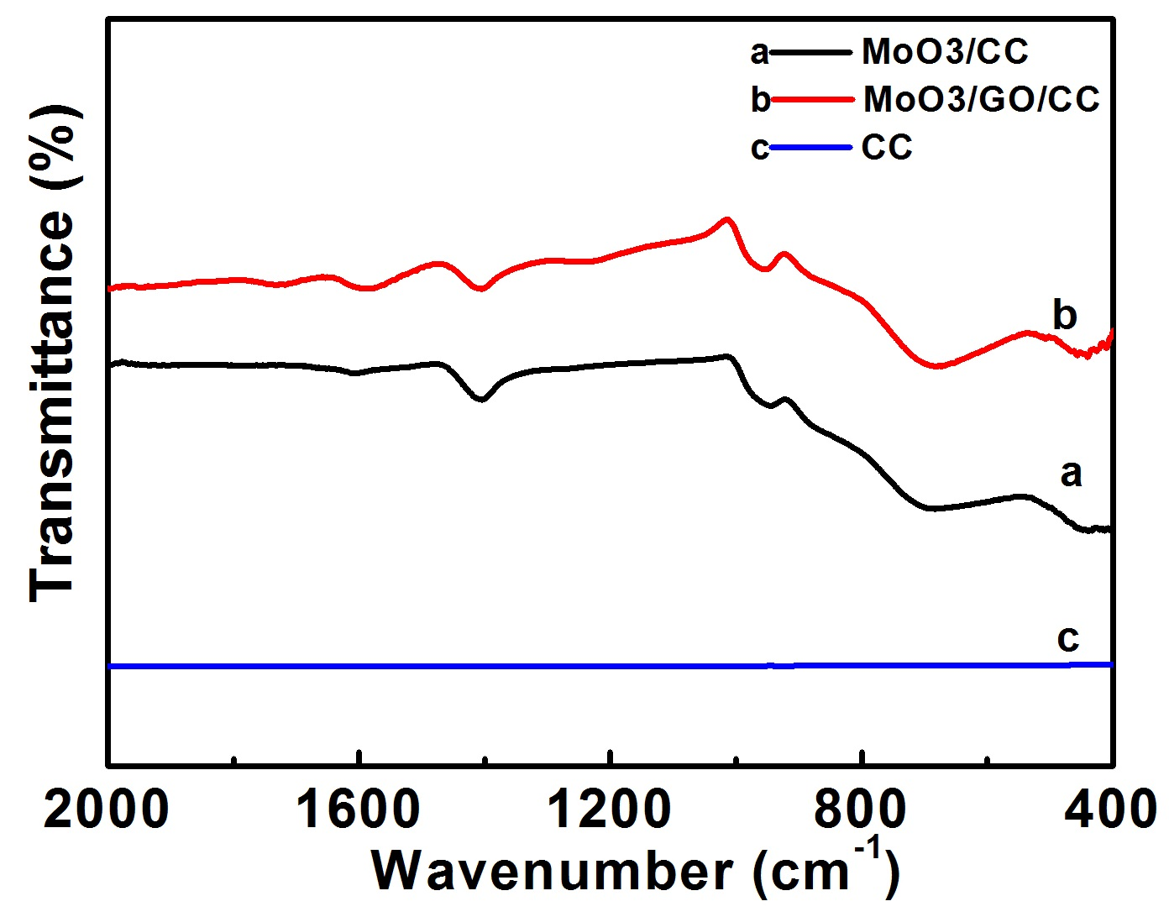
Fig. S3. The FTIR spectra of CC, MoO₃/CC and MoO₃/rGO/CC.

