***Supplementary material for:***

**Νovel poly-lactide acid/tetraethyl citrate / carvacrol@natural zeolite self-healable active packaging films for minced pork meat shelf life extension**

**Vassilios K. Karabagias1, Aris E. Giannakas1,*, Nikolaos D. Andritsos1, Dimitrios Moschovas2, Andreas Karydis-Messinis2, Areti Leontiou1, Apostolos Avgeropoulos2, Nikolaos E. Zafeiropoulos2, Charalampos Proestos3 and Constatninos E. Salmas 2,\***

1. Department of Food Science and Technology, University of Patras, 30100 Agrinio, Greece; [vkarampagias@upatras.gr](mailto:vkarampagias@upatras.gr) (V.K.K.); [agiannakas@upatras.gr](mailto:agiannakas@upatras.gr) (A.E.G.); [nandritsos@upatras.gr](mailto:nandritsos@upatras.gr) (N.D.A.) [aleontiu@upatras.gr](mailto:aleontiu@upatras.gr) (A.L.);
2. Department of Material Science and Engineering, University of Ioannina, 45110 Ioannina, Greece; [karydis.and@gmail.com](mailto:karydis.and@gmail.com) (A.K.-M.) ; [nzafirop@uoi.gr](mailto:nzafirop@uoi.gr) (N.E.Z.) ; [dmoschov@uoi.gr](mailto:dmoschov@uoi.gr) (D.M.); [aavger@uoi.gr](mailto:aavger@uoi.gr) (A.A); [ksalmas@uoi.gr](mailto:ksalmas@uoi.gr) (C.E.S.);
3. Laboratory of Food Chemistry, Department of Chemistry, National and Kapodistrian University of Athens Zografou, 15771 Athens, Greece; [harpro@chem.uoa.gr](mailto:harpro@chem.uoa.gr) (C.P.)

**\***Correspondence: [ksalmas@uoi.gr](mailto:ksalmas@uoi.gr)(C.E.S.); [agiannakas@upatras.gr](mailto:agiannakas@upatras.gr) (A.E.G.)

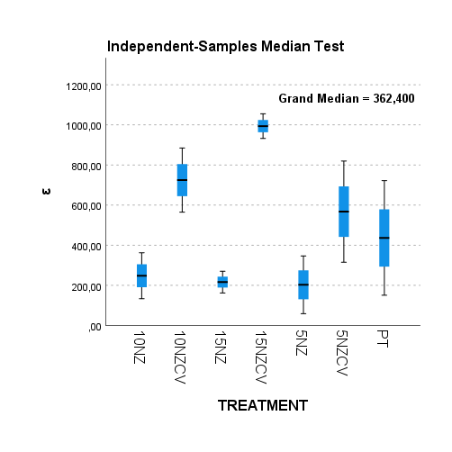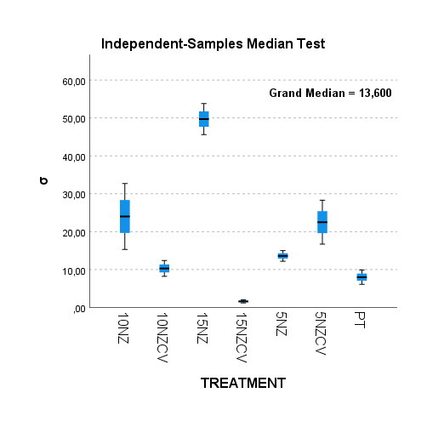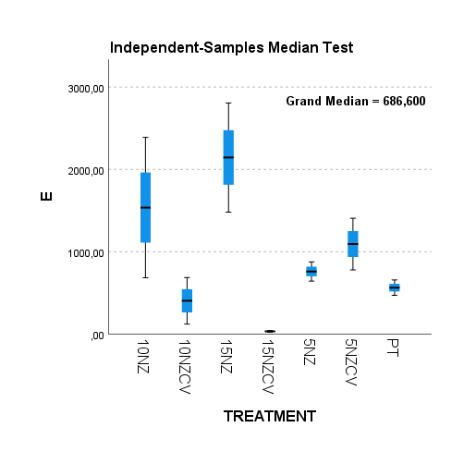

Table S? :

**Figure S1** :Independent-Samples Median Test for E, σ, %ε.

**Table S1** : Pairwise Comparisons of the different treatments according to the mean values of E, σ, %ε.

|  |  |  |  |  |  |  |  |  |  |  |  |
| --- | --- | --- | --- | --- | --- | --- | --- | --- | --- | --- | --- |
| E | | | | σ | | | | %ε | | | |
| **Pairwise Comparisons of TREATMENTS** | | | | **Pairwise Comparisons of TREATMENTS** | | | | **Pairwise Comparisons of TREATMENTS** | | | |
| Sample 1-Sample 2 | Test Statistic | Sig. | Adj. Sig.a | Sample 1-Sample 2 | Test Statistic | Sig. | Adj. Sig.a | Sample 1-Sample 2 | Test Statistic | Sig. | Adj. Sig.a |
| 15NZCV-10NZCV | 6,000 | 0,014 | 0,300 | 15NZCV-PT | 6,000 | 0,014 | 0,300 | 5NZ-15NZ | 0,667 | 0,414 | 1,000 |
| 15NZCV-PT | 6,000 | 0,014 | 0,300 | 15NZCV-10NZCV | 6,000 | 0,014 | 0,300 | 5NZ-10NZ | 0,667 | 0,414 | 1,000 |
| 15NZCV-5NZ | 6,000 | 0,014 | 0,300 | 15NZCV-5NZ | 6,000 | 0,014 | 0,300 | 5NZ-PT | 0,667 | 0,414 | 1,000 |
| 15NZCV-5NZCV | 6,000 | 0,014 | 0,300 | 15NZCV-5NZCV | 6,000 | 0,014 | 0,300 | 5NZ-5NZCV | 0,667 | 0,414 | 1,000 |
| 15NZCV-10NZ | 6,000 | 0,014 | 0,300 | 15NZCV-10NZ | 6,000 | 0,014 | 0,300 | 5NZ-10NZCV | 6,000 | 0,014 | 0,300 |
| 15NZCV-15NZ | 6,000 | 0,014 | 0,300 | 15NZCV-15NZ | 6,000 | 0,014 | 0,300 | 5NZ-15NZCV | 6,000 | 0,014 | 0,300 |
| 10NZCV-PT | 0,667 | 0,414 | 1,000 | PT-10NZCV | 0,667 | 0,414 | 1,000 | 15NZ-10NZ | 0,667 | 0,414 | 1,000 |
| 10NZCV-5NZ | 0,667 | 0,414 | 1,000 | PT-5NZ | 6,000 | 0,014 | 0,300 | 15NZ-PT | 0,667 | 0,414 | 1,000 |
| 10NZCV-5NZCV | 6,000 | 0,014 | 0,300 | PT-5NZCV | 6,000 | 0,014 | 0,300 | 15NZ-5NZCV | 6,000 | 0,014 | 0,300 |
| 10NZCV-10NZ | 0,667 | 0,414 | 1,000 | PT-10NZ | 6,000 | 0,014 | 0,300 | 15NZ-10NZCV | 6,000 | 0,014 | 0,300 |
| 10NZCV-15NZ | 6,000 | 0,014 | 0,300 | PT-15NZ | 6,000 | 0,014 | 0,300 | 15NZ-15NZCV | 6,000 | 0,014 | 0,300 |
| PT-5NZ | 0,667 | 0,414 | 1,000 | 10NZCV-5NZ | 0,667 | 0,414 | 1,000 | 10NZ-PT | 0,667 | 0,414 | 1,000 |
| PT-5NZCV | 6,000 | 0,014 | 0,300 | 10NZCV-5NZCV | 6,000 | 0,014 | 0,300 | 10NZ-5NZCV | 0,667 | 0,414 | 1,000 |
| PT-10NZ | 6,000 | 0,014 | 0,300 | 10NZCV-10NZ | 6,000 | 0,014 | 0,300 | 10NZ-10NZCV | 6,000 | 0,014 | 0,300 |
| PT-15NZ | 6,000 | 0,014 | 0,300 | 10NZCV-15NZ | 6,000 | 0,014 | 0,300 | 10NZ-15NZCV | 6,000 | 0,014 | 0,300 |
| 5NZ-5NZCV | 0,667 | 0,414 | 1,000 | 5NZ-5NZCV | 6,000 | 0,014 | 0,300 | PT-5NZCV | 0,667 | 0,414 | 1,000 |
| 5NZ-10NZ | 0,667 | 0,414 | 1,000 | 5NZ-10NZ | 6,000 | 0,014 | 0,300 | PT-10NZCV | 0,667 | 0,414 | 1,000 |
| 5NZ-15NZ | 6,000 | 0,014 | 0,300 | 5NZ-15NZ | 6,000 | 0,014 | 0,300 | PT-15NZCV | 6,000 | 0,014 | 0,300 |
| 5NZCV-10NZ | 0,667 | 0,414 | 1,000 | 5NZCV-10NZ | 0,667 | 0,414 | 1,000 | 5NZCV-10NZCV | 0,667 | 0,414 | 1,000 |
| 5NZCV-15NZ | 6,000 | 0,014 | 0,300 | 5NZCV-15NZ | 6,000 | 0,014 | 0,300 | 5NZCV-15NZCV | 6,000 | 0,014 | 0,300 |
| 10NZ-15NZ | 0,667 | 0,414 | 1,000 | 10NZ-15NZ | 6,000 | 0,014 | 0,300 | 10NZCV-15NZCV | 6,000 | 0,014 | 0,300 |
| Each row tests the null hypothesis that the Sample 1 and Sample 2 distributions are the same.  Asymptotic significances (2-sided tests) are displayed. The significance level is ,050. | | | | Each row tests the null hypothesis that the Sample 1 and Sample 2 distributions are the same.  Asymptotic significances (2-sided tests) are displayed. The significance level is ,050. | | | | Each row tests the null hypothesis that the Sample 1 and Sample 2 distributions are the same.  Asymptotic significances (2-sided tests) are displayed. The significance level is ,050. | | | |
|

**Table S2**: WVTR, Dwv, O.T.R. and PeO2 values for all PLA/TEC/xNZ and PLA/TEC/xCV@NZ films as well as for pure PLA/TEC films.

*Different letters in each column indicate statistically significant differences at the confidence level p < 0.05.*

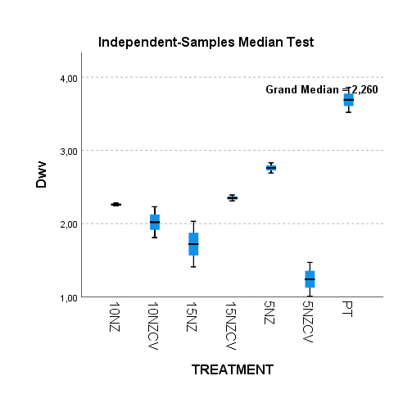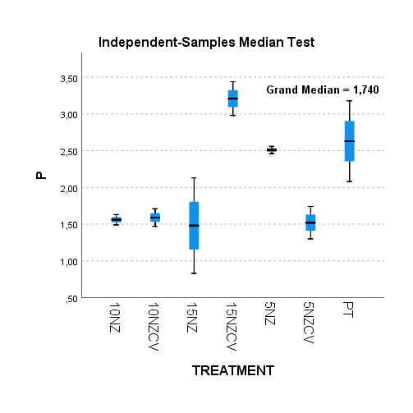

**Figure S2** : Independent-Samples Median Test for Dwv,Peo2.

|  |  |  |  |  |  |  |  |  |
| --- | --- | --- | --- | --- | --- | --- | --- | --- |
|  | **Film thickness (mm)** | **WVTR**  **(10-7 gr.cm-2. s1)** | **Dwv**  **(10-4 cm2/s)** | **Film thickness (mm)** | | **OTR**  **(ml.m-2.day-1)** | | **PeO2**  **(10-9cm2/s)** |
| PLA/TEC | 0.140±0.026 | 18.8573±6.65 | 3.69±0.17a | | 0.08±0.01 | 284.6±56.2 | 2.63±0.55a | | |
| PLA/TEC/5NZ | 0.063±0.025 | 8.94097±0.73 | 2.76±0.07b | | 0.08±0.02 | 271.0±76.2 | 2.51±0.05a | | |
| PLA/TEC/10NZ | 0.096±0.015 | 8.65331±0.34 | 2.26±0.02c | | 0.09±0.02 | 159.7±66.2 | 1.56±0.07b | | |
| PLA/TEC/15NZ | 0.090±0.010 | 6.20586±0.29 | 1.72±0.31d | | 0.08±0.01 | 164.7±54.3 | 1.48±0.65a,b | | |
| PLA/TEC/5CV@NZ | 0.116±0.005 | 6.48645±0.15 | 1.24±0.23d,e | | 0.12±0.01 | 105.4±15.7 | 1.52±0.22b | | |
| PLA/TEC/10CV@NZ | 0.060±0.020 | 7.65358±0.20 | 2.02±0.21f,d | | 0.07±0.01 | 187.3±36.4 | 1.59±0.12b | | |
| PLA/TEC/15CV@NZ | 0.096±0.020 | 9.34063±0.30 | 2.35±0.04g | | 0.08±0.02 | 388.5±68.6 | 3.21±0.23a | | |

**Table S3** : Pairwise Comparisons of the different treatments according to the mean values of Dwv,Peo2.

|  |  |  |  |  |  |  |  |
| --- | --- | --- | --- | --- | --- | --- | --- |
| Dwv | | | | Peo2 | | | |
| **Pairwise Comparisons of TREATMENTS** | | | | **Pairwise Comparisons of TREATMENTS** | | | |
| Sample 1-Sample 2 | Test Statistic | Sig. | Adj. Sig.a | Sample 1-Sample 2 | Test Statistic | Sig. | Adj. Sig.a |
| 5NZCV-15NZ | 0,667 | 0,414 | 1,000 | 15NZ-5NZCV | 0,667 | 0,414 | 1,000 |
| 5NZCV-10NZCV | 6,000 | 0,014 | 0,300 | 15NZ-10NZ | 0,667 | 0,414 | 1,000 |
| 5NZCV-10NZ | 6,000 | 0,014 | 0,300 | 15NZ-10NZCV | 0,667 | 0,414 | 1,000 |
| 5NZCV-15NZCV | 6,000 | 0,014 | 0,300 | 15NZ-5NZ | 6,000 | 0,014 | 0,300 |
| 5NZCV-5NZ | 6,000 | 0,014 | 0,300 | 15NZ-PT | 0,667 | 0,414 | 1,000 |
| 5NZCV-PT | 6,000 | 0,014 | 0,300 | 15NZ-15NZCV | 6,000 | 0,014 | 0,300 |
| 15NZ-10NZCV | 0,667 | 0,414 | 1,000 | 5NZCV-10NZ | 0,667 | 0,414 | 1,000 |
| 15NZ-10NZ | 6,000 | 0,014 | 0,300 | 5NZCV-10NZCV | 0,667 | 0,414 | 1,000 |
| 15NZ-15NZCV | 6,000 | 0,014 | 0,300 | 5NZCV-5NZ | 6,000 | 0,014 | 0,300 |
| 15NZ-5NZ | 6,000 | 0,014 | 0,300 | 5NZCV-PT | 6,000 | 0,014 | 0,300 |
| 15NZ-PT | 6,000 | 0,014 | 0,300 | 5NZCV-15NZCV | 6,000 | 0,014 | 0,300 |
| 10NZCV-10NZ | 6,000 | 0,014 | 0,300 | 10NZ-10NZCV | 0,667 | 0,414 | 1,000 |
| 10NZCV-15NZCV | 6,000 | 0,014 | 0,300 | 10NZ-5NZ | 6,000 | 0,014 | 0,300 |
| 10NZCV-5NZ | 6,000 | 0,014 | 0,300 | 10NZ-PT | 6,000 | 0,014 | 0,300 |
| 10NZCV-PT | 6,000 | 0,014 | 0,300 | 10NZ-15NZCV | 6,000 | 0,014 | 0,300 |
| 10NZ-15NZCV | 6,000 | 0,014 | 0,300 | 10NZCV-5NZ | 6,000 | 0,014 | 0,300 |
| 10NZ-5NZ | 6,000 | 0,014 | 0,300 | 10NZCV-PT | 6,000 | 0,014 | 0,300 |
| 10NZ-PT | 6,000 | 0,014 | 0,300 | 10NZCV-15NZCV | 6,000 | 0,014 | 0,300 |
| 15NZCV-5NZ | 6,000 | 0,014 | 0,300 | 5NZ-PT | 0,667 | 0,414 | 1,000 |
| 15NZCV-PT | 6,000 | 0,014 | 0,300 | 5NZ-15NZCV | 6,000 | 0,014 | 0,300 |
| 5NZ-PT | 6,000 | 0,014 | 0,300 | PT-15NZCV | 0,667 | 0,414 | 1,000 |
| Each row tests the null hypothesis that the Sample 1 and Sample 2 distributions are the same.  Asymptotic significances (2-sided tests) are displayed. The significance level is ,050. | | | | Each row tests the null hypothesis that the Sample 1 and Sample 2 distributions are the same.  Asymptotic significances (2-sided tests) are displayed. The significance level is ,050. | | | |



**Figure S3**: Plots of (1-mt/m0) as a function of time for all PLA/TEC/xCV@NZ samples (in triplicate) simulated with the pseudo second order kinetic equation to obtain k2, and qe mean values.

**Figure S4**: Equations for the determination of EC50 in PLA/TEC/5CV@NZ films.

**Figure S5**: Equations for the determination of EC50 in PLA/TEC/10CV@NZ films.

**Figure S6**: Equations for the determination of EC50 in PLA/TEC/15CV@NZ films.

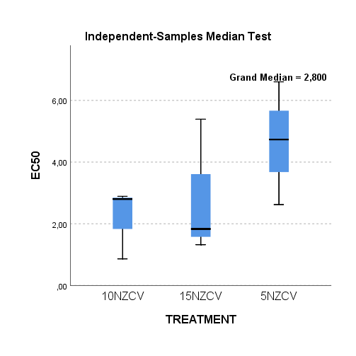

**Figure S7** : Independent-Samples Median Test of EC50 values.

**Table S4** : Independent-Samples Median Test Summary of the different treatments according to the mean values of EC50.

|  |  |
| --- | --- |
| **Independent-Samples Median Test Summary** | |
| Total N | 9 |
| Median | 2,800 |
| Test Statistic | ,900a,b |
| Degree Of Freedom | 2 |
| Asymptotic Sig.(2-sided test) | ,638 |
| a. More than 20% of the cells have expected values less than five. | |
| b. Multiple comparisons are not performed because the overall test does not show significant differences across samples. | |

|  |  |  |  |  |  |  |
| --- | --- | --- | --- | --- | --- | --- |
| **Sample name** | **Day 0** | **Day 2** | **Day 4** | **Day 6** | **Day 8** | **Day 10** |
|  | logCFU/g (Avg ± SD) | | | |  |  |
| **CONTROL** | 3.79±0.03a | 5.56±0.13b | 6.84±0.06e | 7.28±0.19h | 8.53±0.07k | 9.33±0.08n |
| **PLA/TEC** | 3.79±0.03a | 4.84±0.04c | 5.59±0.01f | 6.56±0.07i | 7.66±0.03l | 8.74±0.01o |
| **PLA/TEC/10NZ@CV** | 3.79±0.03a | 4.13±0.03d | 4.69±0.06g | 5.43±0.04j | 6.88±0.03m | 7.45±0.21p |

**Table S5**:TVC of Pork Minced Meat in Different Packaging Systems with Respect to Storage Time.

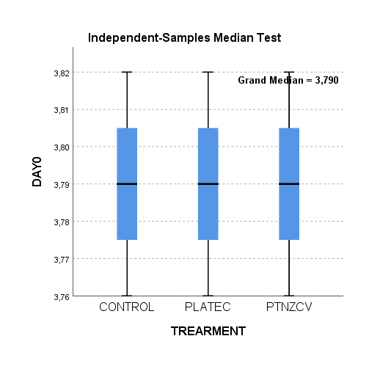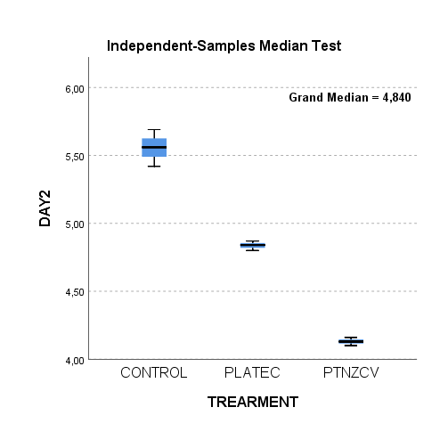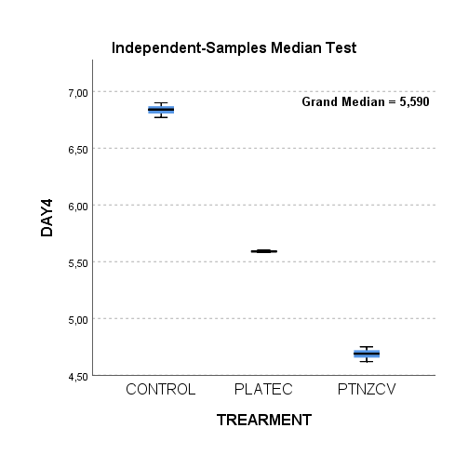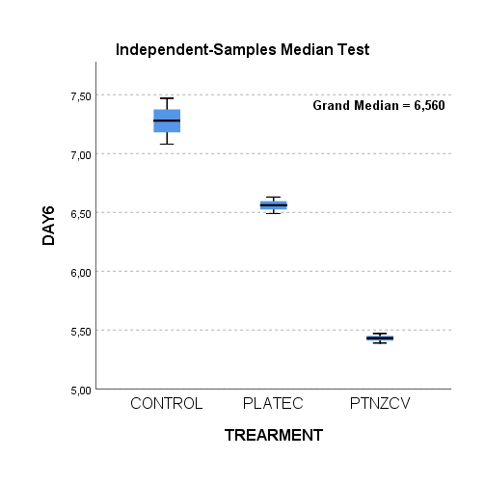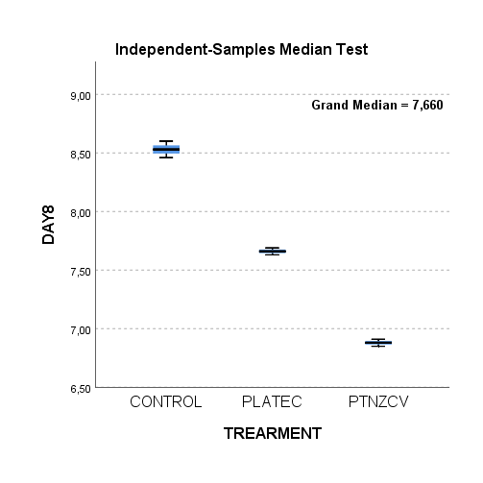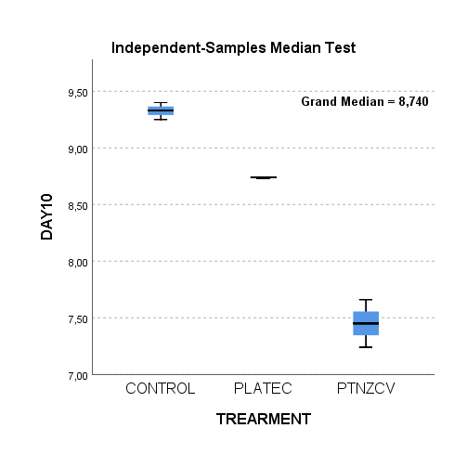

**Figure S8**: Independent-Samples Median Test of TVC durring storage time.

**Table S6**: Pairwise Comparisons of the different treatments according to the mean values of TVC during storage time.

|  |  |  |  |  |  |  |  |  |  |  |  |
| --- | --- | --- | --- | --- | --- | --- | --- | --- | --- | --- | --- |
| DAY 2 | | | | DAY4 | | | | DAY6 | | | |
| **Pairwise Comparisons of TREATMENTS** | | | | **Pairwise Comparisons of TREATMENTS** | | | | **Pairwise Comparisons of TREATMENTS** | | | |
| Sample 1-Sample 2 | Test Statistic | Sig. | Adj. Sig.a | Sample 1-Sample 2 | Test Statistic | Sig. | Adj. Sig.a | Sample 1-Sample 2 | Test Statistic | Sig. | Adj. Sig.a |
| PTNZCV-PLATEC | 6,000 | 0,014 | 0,043 | PTNZCV-PLATEC | 6,000 | 0,014 | 0,043 | PTNZCV-PLATEC | 6,000 | 0,014 | 0,043 |
| PTNZCV-CONTROL | 6,000 | 0,014 | 0,043 | PTNZCV-CONTROL | 6,000 | 0,014 | 0,043 | PTNZCV-CONTROL | 6,000 | 0,014 | 0,043 |
| PLATEC-CONTROL | 6,000 | 0,014 | 0,043 | PLATEC-CONTROL | 6,000 | 0,014 | 0,043 | PLATEC-CONTROL | 6,000 | 0,014 | 0,043 |
| Each row tests the null hypothesis that the Sample 1 and Sample 2 distributions are the same.  Asymptotic significances (2-sided tests) are displayed. The significance level is ,05. | | | | Each row tests the null hypothesis that the Sample 1 and Sample 2 distributions are the same.  Asymptotic significances (2-sided tests) are displayed. The significance level is ,05. | | | | Each row tests the null hypothesis that the Sample 1 and Sample 2 distributions are the same.  Asymptotic significances (2-sided tests) are displayed. The significance level is ,05. | | | |
| a. Significance values have been adjusted by the Bonferroni correction for multiple tests. | | | | a. Significance values have been adjusted by the Bonferroni correction for multiple tests. | | | | a. Significance values have been adjusted by the Bonferroni correction for multiple tests. | | | |
| DAY8 | | | | DAY10 | | | |  |  |  |  |
| **Pairwise Comparisons of TREATMENTS** | | | | **Pairwise Comparisons of TREATMENTS** | | | |  |  |  |  |
| Sample 1-Sample 2 | Test Statistic | Sig. | Adj. Sig.a | Sample 1-Sample 2 | Test Statistic | Sig. | Adj. Sig.a |  |  |  |  |
| PTNZCV-PLATEC | 6,000 | 0,014 | 0,043 | PTNZCV-PLATEC | 6,000 | 0,014 | 0,043 |  |  |  |  |
| PTNZCV-CONTROL | 6,000 | 0,014 | 0,043 | PTNZCV-CONTROL | 6,000 | 0,014 | 0,043 |  |  |  |  |
| PLATEC-CONTROL | 6,000 | 0,014 | 0,043 | PLATEC-CONTROL | 6,000 | 0,014 | 0,043 |  |  |  |  |
| Each row tests the null hypothesis that the Sample 1 and Sample 2 distributions are the same.  Asymptotic significances (2-sided tests) are displayed. The significance level is ,05. | | | | Each row tests the null hypothesis that the Sample 1 and Sample 2 distributions are the same.  Asymptotic significances (2-sided tests) are displayed. The significance level is ,05. | | | |  |  |  |  |
| a. Significance values have been adjusted by the Bonferroni correction for multiple tests. | | | | a. Significance values have been adjusted by the Bonferroni correction for multiple tests. | | | |  |  |  |  |

**Table S7:** TBARS and Heme-Iron Content of Pork Minced Meat in Different Packaging Systems with Respect to Storage Time.

|  |  |  |  |  |  |  |
| --- | --- | --- | --- | --- | --- | --- |
| **TBARS** | ***Day 0*** | ***Day 2*** | ***Day 4*** | ***Day 6*** | ***Day 8*** | ***Day 10*** |
| **AVG ± SD** | | | | | |
| **(mg/kg)** | | | | | |
| Control | 0.29 ± 0.02a | 0.43 ± 0.01b | 0.55± 0.02e | 0.65 ± 0.02h | 0.77 ± 0.03k | 0.93 ± 0.01m |
| PLA/TEC | - | 0.40 ± 0.01c | 0.51 ± 0.01f | 0.60± 0.02i | 0.73 ± 0.01k | 0.87 ± 0.01n |
| PLA/TEC/0.6/NZCV | - | 0.36 ± 0.01d | 0.43 ± 0.01g | 0.54 ± 0.01j | 0.67 ± 0.01l | 0.78± 0.01o |
| **Fe** | ***Day 0*** | ***Day 2*** | ***Day 4*** | ***Day 6*** | ***Day 8*** | ***Day 10*** |
| **AVG ± SD** | | | | | |
| **(μg/g)** | | | | | |
| Control | 11.12 ± 0.15a | 9.30 ± 0.18b | 8.18 ± 0.12d | 6.76 ± 0.21g | 4.90± 0.18j | 3.48 ± 0.36m |
| PLA/TEC | - | 9.48 ± 0.22b | 8.56 ± 0.28e | 7.24 ± 0.23h | 5.64 ± 0.22k | 3.92 ± 0.27m |
| PLA/TEC/0.6/NZCV | - | 10.02 ± 0.22c | 9.30 ± 0.22f | 7.98 ± 0.27i | 7.18 ± 0.09l | 4.42 ± 0.12n |

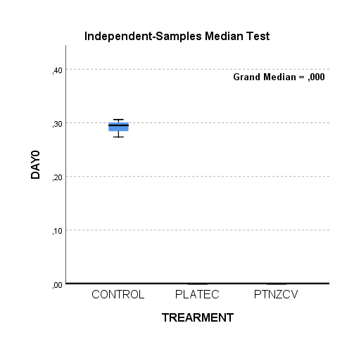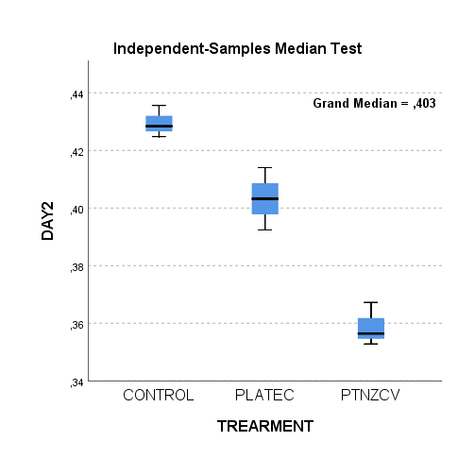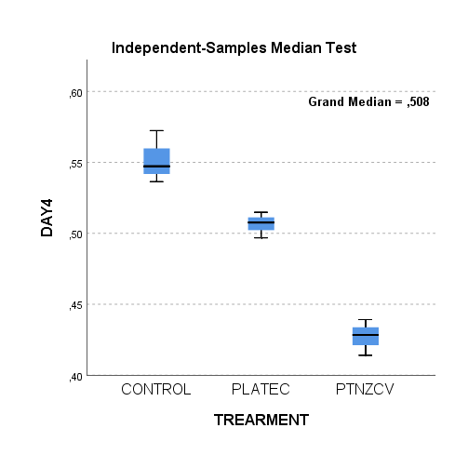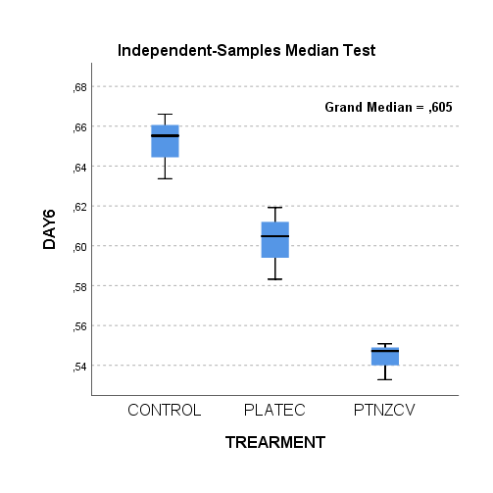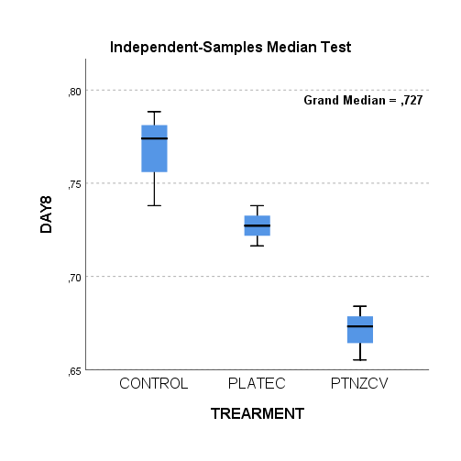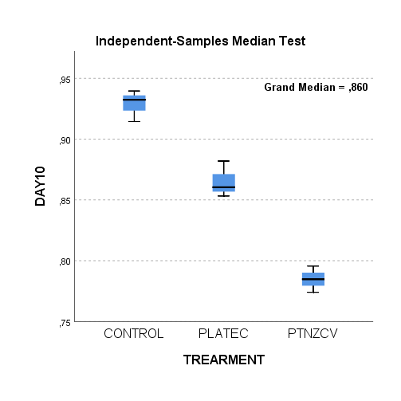

**Figure S9**: Independent-Samples Median Test of TBARS durring storage time.

**Table S8**: Pairwise Comparisons of the different treatments according to the mean values of TBARS during storage time.

|  |  |  |  |  |  |  |  |  |  |  |  |
| --- | --- | --- | --- | --- | --- | --- | --- | --- | --- | --- | --- |
| DAY2 | | | | DAY4 | | | | DAY6 | | | |
| **Pairwise Comparisons of TREATMENTS** | | | | **Pairwise Comparisons of TREATMENTS** | | | | **Pairwise Comparisons of TREATMENTS** | | | |
| Sample 1-Sample 2 | Test Statistic | Sig. | Adj. Sig.a | Sample 1-Sample 2 | Test Statistic | Sig. | Adj. Sig.a | Sample 1-Sample 2 | Test Statistic | Sig. | Adj. Sig.a |
| PTNZCV-PLATEC | 6,000 | 0,014 | 0,043 | PTNZCV-PLATEC | 6,000 | 0,014 | 0,043 | PTNZCV-PLATEC | 6,000 | 0,014 | 0,043 |
| PTNZCV-CONTROL | 6,000 | 0,014 | 0,043 | PTNZCV-CONTROL | 6,000 | 0,014 | 0,043 | PTNZCV-CONTROL | 6,000 | 0,014 | 0,043 |
| PLATEC-CONTROL | 6,000 | 0,014 | 0,043 | PLATEC-CONTROL | 6,000 | 0,014 | 0,043 | PLATEC-CONTROL | 6,000 | 0,014 | 0,043 |
| Each row tests the null hypothesis that the Sample 1 and Sample 2 distributions are the same.  Asymptotic significances (2-sided tests) are displayed. The significance level is ,05. | | | | Each row tests the null hypothesis that the Sample 1 and Sample 2 distributions are the same.  Asymptotic significances (2-sided tests) are displayed. The significance level is ,05. | | | | Each row tests the null hypothesis that the Sample 1 and Sample 2 distributions are the same.  Asymptotic significances (2-sided tests) are displayed. The significance level is ,05. | | | |
| a. Significance values have been adjusted by the Bonferroni correction for multiple tests. | | | | a. Significance values have been adjusted by the Bonferroni correction for multiple tests. | | | | a. Significance values have been adjusted by the Bonferroni correction for multiple tests. | | | |
| DAY8 | | | | DAY10 | | | |  |  |  |  |
| **Pairwise Comparisons of TREATMENTS** | | | | **Pairwise Comparisons of TREATMENTS** | | | |  |  |  |  |
| Sample 1-Sample 2 | Test Statistic | Sig. | Adj. Sig.a | Sample 1-Sample 2 | Test Statistic | Sig. | Adj. Sig.a |  |  |  |  |
| PTNZCV-PLATEC | 6,000 | 0,014 | 0,043 | PTNZCV-PLATEC | 6,000 | 0,014 | 0,043 |  |  |  |  |
| PTNZCV-CONTROL | 6,000 | 0,014 | 0,043 | PTNZCV-CONTROL | 6,000 | 0,014 | 0,043 |  |  |  |  |
| PLATEC-CONTROL | 3,000 | 0,083 | 0,250 | PLATEC-CONTROL | 6,000 | 0,014 | 0,043 |  |  |  |  |
| Each row tests the null hypothesis that the Sample 1 and Sample 2 distributions are the same.  Asymptotic significances (2-sided tests) are displayed. The significance level is ,05. | | | | Each row tests the null hypothesis that the Sample 1 and Sample 2 distributions are the same.  Asymptotic significances (2-sided tests) are displayed. The significance level is ,05. | | | |  |  |  |  |
| a. Significance values have been adjusted by the Bonferroni correction for multiple tests. | | | | a. Significance values have been adjusted by the Bonferroni correction for multiple tests. | | | |  |  |  |  |

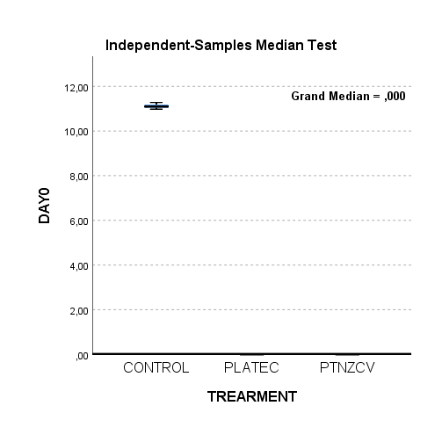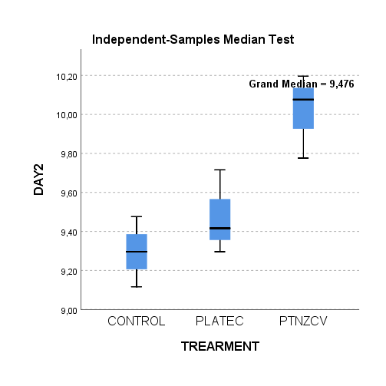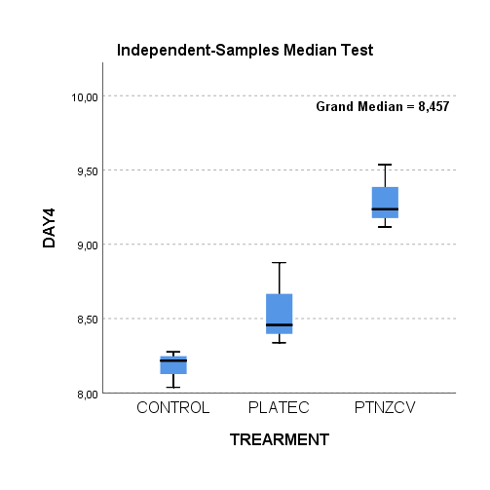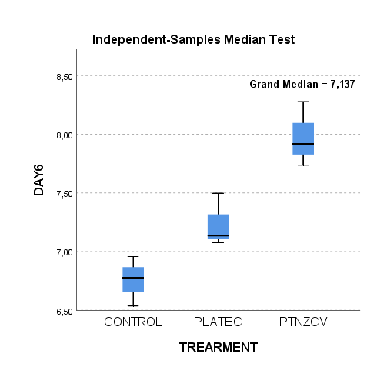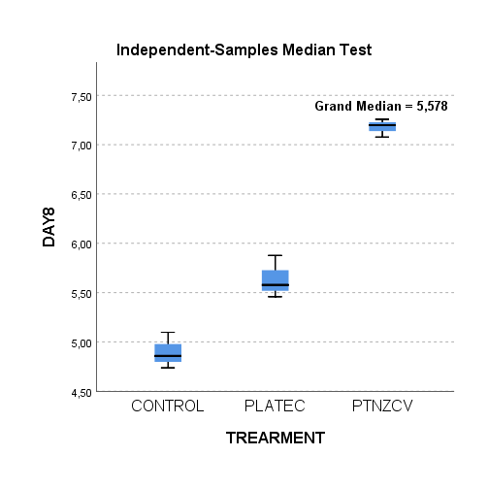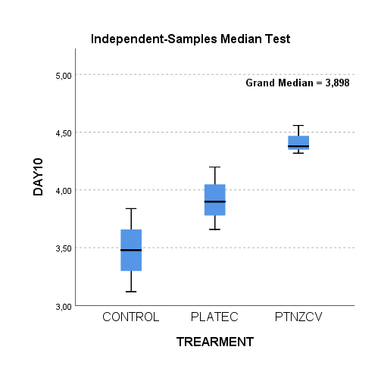

**Figure S10** : Independent-Samples Median Test of Heme-iron content durring storage time.

**Table S9**: Pairwise Comparisons of the different treatments according to the mean values of Heme-iron content during storage time.

|  |  |  |  |  |  |  |  |  |  |  |  |
| --- | --- | --- | --- | --- | --- | --- | --- | --- | --- | --- | --- |
| DAY2 | | | | DAY4 | | | | DAY6 | | | |
| **Pairwise Comparisons of TREATMENTS** | | | | **Pairwise Comparisons of TREATMENTS** | | | | **Pairwise Comparisons of TREATMENTS** | | | |
| Sample 1-Sample 2 | Test Statistic | Sig. | Adj. Sig.a | Sample 1-Sample 2 | Test Statistic | Sig. | Adj. Sig.a | Sample 1-Sample 2 | Test Statistic | Sig. | Adj. Sig.a |
| CONTROL-PLATEC | 0,667 | 0,414 | 1,000 | CONTROL-PLATEC | 6,000 | 0,014 | 0,043 | CONTROL-PLATEC | 6,000 | 0,014 | 0,043 |
| CONTROL-PTNZCV | 6,000 | 0,014 | 0,043 | CONTROL-PTNZCV | 6,000 | 0,014 | 0,043 | CONTROL-PTNZCV | 6,000 | 0,014 | 0,043 |
| PLATEC-PTNZCV | 6,000 | 0,014 | 0,043 | PLATEC-PTNZCV | 6,000 | 0,014 | 0,043 | PLATEC-PTNZCV | 6,000 | 0,014 | 0,043 |
| Each row tests the null hypothesis that the Sample 1 and Sample 2 distributions are the same.  Asymptotic significances (2-sided tests) are displayed. The significance level is ,05. | | | | Each row tests the null hypothesis that the Sample 1 and Sample 2 distributions are the same.  Asymptotic significances (2-sided tests) are displayed. The significance level is ,05. | | | | Each row tests the null hypothesis that the Sample 1 and Sample 2 distributions are the same.  Asymptotic significances (2-sided tests) are displayed. The significance level is ,05. | | | |
| a. Significance values have been adjusted by the Bonferroni correction for multiple tests. | | | | a. Significance values have been adjusted by the Bonferroni correction for multiple tests. | | | | a. Significance values have been adjusted by the Bonferroni correction for multiple tests. | | | |
| DAY8 | | | | DAY10 | | | |  |  |  |  |
| **Pairwise Comparisons of TREATMENTS** | | | | **Pairwise Comparisons of TREATMENTS** | | | |  |  |  |  |
| Sample 1-Sample 2 | Test Statistic | Sig. | Adj. Sig.a | Sample 1-Sample 2 | Test Statistic | Sig. | Adj. Sig.a |  |  |  |  |
| CONTROL-PLATEC | 6,000 | 0,014 | 0,043 | CONTROL-PLATEC | 0,667 | 0,414 | 1,000 |  |  |  |  |
| CONTROL-PTNZCV | 6,000 | 0,014 | 0,043 | CONTROL-PTNZCV | 6,000 | 0,014 | 0,043 |  |  |  |  |
| PLATEC-PTNZCV | 6,000 | 0,014 | 0,043 | PLATEC-PTNZCV | 6,000 | 0,014 | 0,043 |  |  |  |  |
| Each row tests the null hypothesis that the Sample 1 and Sample 2 distributions are the same.  Asymptotic significances (2-sided tests) are displayed. The significance level is ,05. | | | | Each row tests the null hypothesis that the Sample 1 and Sample 2 distributions are the same.  Asymptotic significances (2-sided tests) are displayed. The significance level is ,05. | | | |  |  |  |  |
| a. Significance values have been adjusted by the Bonferroni correction for multiple tests. | | | | a. Significance values have been adjusted by the Bonferroni correction for multiple tests. | | | |  |  |  |  |

**Table S10** : Pearson’s Correlation between TBARS and Heme-iron content during storage time.

|  |  |  |  |  |  |  |  |
| --- | --- | --- | --- | --- | --- | --- | --- |
| **Correlations** | | | | | | | |
|  | | DAY0 | DAY2 | DAY4 | DAY6 | DAY8 | DAY10 |
| DAY0 | Pearson Correlation | 1 | ,408 | ,381 | ,360 | ,255 | ,298 |
| Sig. (2-tailed) |  | ,093 | ,118 | ,142 | ,307 | ,229 |
| N | 18 | 18 | 18 | 18 | 18 | 18 |
| DAY2 | Pearson Correlation | ,408 | 1 | ,999** | ,997** | ,978** | ,988** |
| Sig. (2-tailed) | ,093 |  | ,000 | ,000 | ,000 | ,000 |
| N | 18 | 18 | 18 | 18 | 18 | 18 |
| DAY4 | Pearson Correlation | ,381 | ,999** | 1 | ,998** | ,984** | ,992** |
| Sig. (2-tailed) | ,118 | ,000 |  | ,000 | ,000 | ,000 |
| N | 18 | 18 | 18 | 18 | 18 | 18 |
| DAY6 | Pearson Correlation | ,360 | ,997** | ,998** | 1 | ,988** | ,991** |
| Sig. (2-tailed) | ,142 | ,000 | ,000 |  | ,000 | ,000 |
| N | 18 | 18 | 18 | 18 | 18 | 18 |
| DAY8 | Pearson Correlation | ,255 | ,978** | ,984** | ,988** | 1 | ,993** |
| Sig. (2-tailed) | ,307 | ,000 | ,000 | ,000 |  | ,000 |
| N | 18 | 18 | 18 | 18 | 18 | 18 |
| DAY10 | Pearson Correlation | ,298 | ,988** | ,992** | ,991** | ,993** | 1 |
| Sig. (2-tailed) | ,229 | ,000 | ,000 | ,000 | ,000 |  |
| N | 18 | 18 | 18 | 18 | 18 | 18 |
| **. Correlation is significant at the 0.01 level (2-tailed). | | | | | | | |

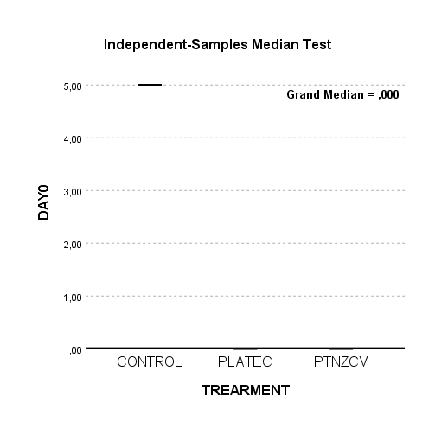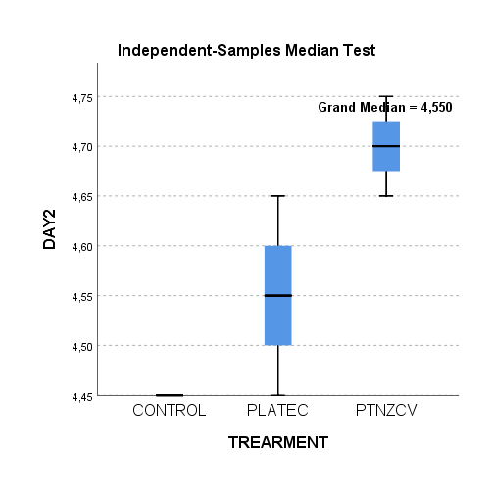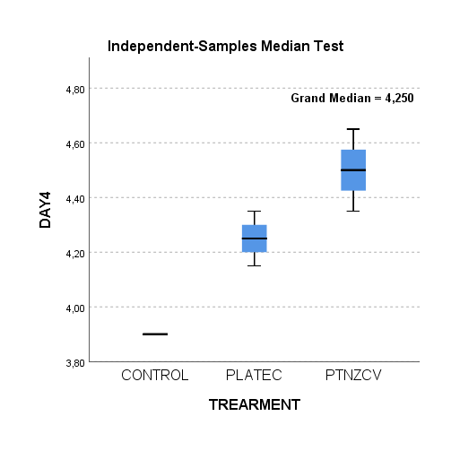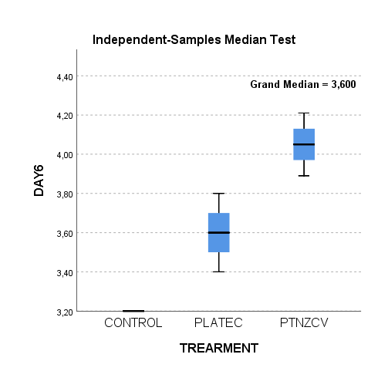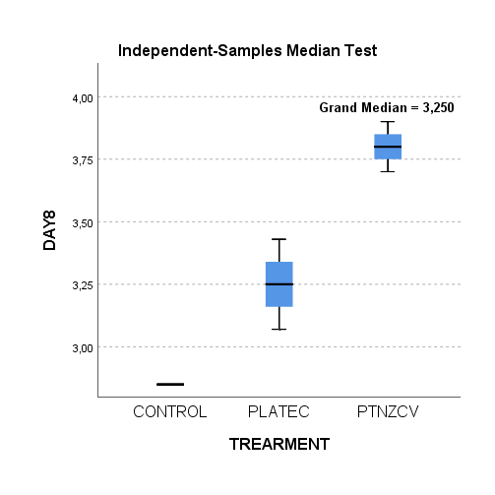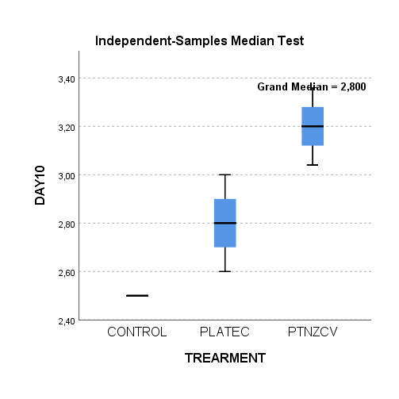

**Figure S11** : Independent-Samples Median Test of Odor durring storage time.

**Table S11**: Pairwise Comparisons of the different treatments according to the mean values of Odor during storage time.

|  |  |  |  |  |  |  |  |  |  |  |  |
| --- | --- | --- | --- | --- | --- | --- | --- | --- | --- | --- | --- |
| DAY2 | | | | DAY4 | | | | DAY6 | | | |
| **Pairwise Comparisons of TREATMENTS** | | | | **Pairwise Comparisons of TREATMENTS** | | | | **Pairwise Comparisons of TREATMENTS** | | | |
| Sample 1-Sample 2 | Test Statistic | Sig. | Adj. Sig.a | Sample 1-Sample 2 | Test Statistic | Sig. | Adj. Sig.a | Sample 1-Sample 2 | Test Statistic | Sig. | Adj. Sig.a |
| CONTROL-PLATEC | 3,000 | 0,083 | 0,250 | CONTROL-PLATEC | 6,000 | 0,014 | 0,043 | CONTROL-PLATEC | 6,000 | 0,014 | 0,043 |
| CONTROL-PTNZCV | 6,000 | 0,014 | 0,043 | CONTROL-PTNZCV | 6,000 | 0,014 | 0,043 | CONTROL-PTNZCV | 6,000 | 0,014 | 0,043 |
| PLATEC-PTNZCV | 3,000 | 0,083 | 0,250 | PLATEC-PTNZCV | 3,000 | 0,083 | 0,250 | PLATEC-PTNZCV | 6,000 | 0,014 | 0,043 |
| Each row tests the null hypothesis that the Sample 1 and Sample 2 distributions are the same.  Asymptotic significances (2-sided tests) are displayed. The significance level is ,05. | | | | Each row tests the null hypothesis that the Sample 1 and Sample 2 distributions are the same.  Asymptotic significances (2-sided tests) are displayed. The significance level is ,05. | | | | Each row tests the null hypothesis that the Sample 1 and Sample 2 distributions are the same.  Asymptotic significances (2-sided tests) are displayed. The significance level is ,05. | | | |
| a. Significance values have been adjusted by the Bonferroni correction for multiple tests. | | | | a. Significance values have been adjusted by the Bonferroni correction for multiple tests. | | | | a. Significance values have been adjusted by the Bonferroni correction for multiple tests. | | | |
| DAY8 | | | | DAY10 | | | |  |  |  |  |
| **Pairwise Comparisons of TREATMENTS** | | | | **Pairwise Comparisons of TREATMENTS** | | | |  |  |  |  |
| Sample 1-Sample 2 | Test Statistic | Sig. | Adj. Sig.a | Sample 1-Sample 2 | Test Statistic | Sig. | Adj. Sig.a |  |  |  |  |
| CONTROL-PLATEC | 6,000 | 0,014 | 0,043 | CONTROL-PLATEC | 6,000 | 0,014 | 0,043 |  |  |  |  |
| CONTROL-PTNZCV | 6,000 | 0,014 | 0,043 | CONTROL-PTNZCV | 6,000 | 0,014 | 0,043 |  |  |  |  |
| PLATEC-PTNZCV | 6,000 | 0,014 | 0,043 | PLATEC-PTNZCV | 6,000 | 0,014 | 0,043 |  |  |  |  |
| Each row tests the null hypothesis that the Sample 1 and Sample 2 distributions are the same.  Asymptotic significances (2-sided tests) are displayed. The significance level is ,05. | | | | Each row tests the null hypothesis that the Sample 1 and Sample 2 distributions are the same.  Asymptotic significances (2-sided tests) are displayed. The significance level is ,05. | | | |  |  |  |  |
| a. Significance values have been adjusted by the Bonferroni correction for multiple tests. | | | | a. Significance values have been adjusted by the Bonferroni correction for multiple tests. | | | |  |  |  |  |

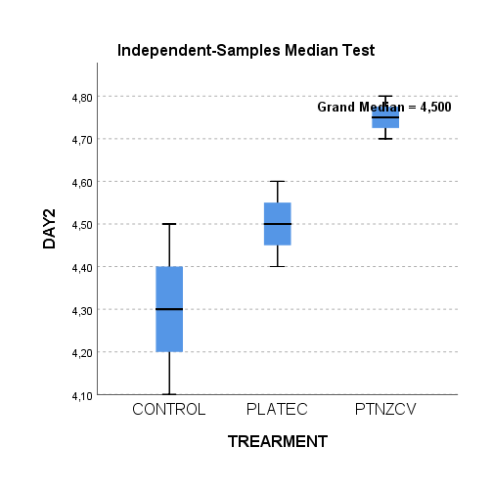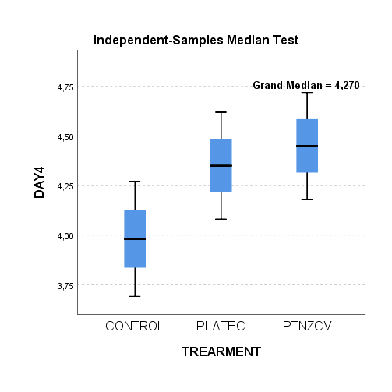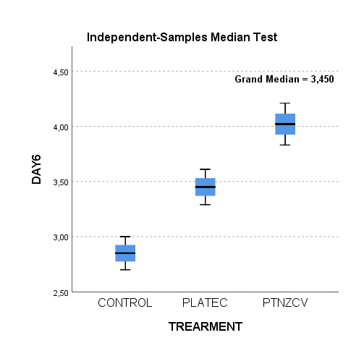

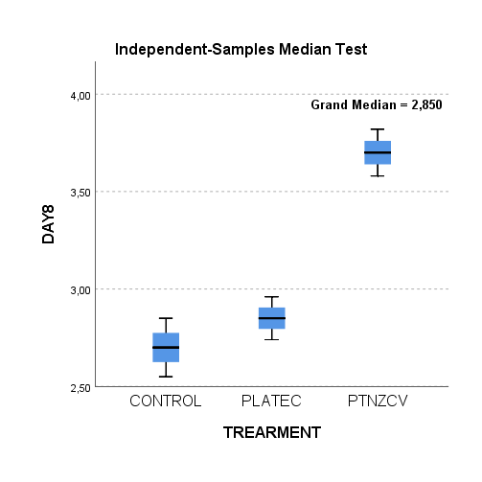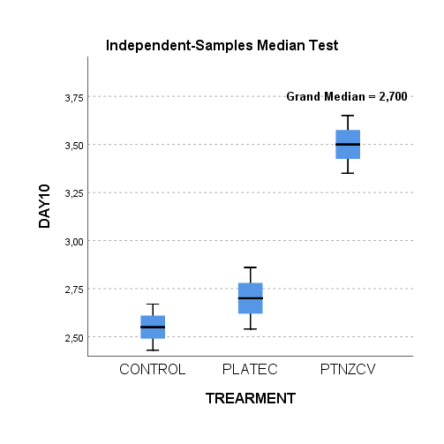

**Figure S12**: Independent-Samples Median Test of Color durring storage time.

**Table S12**: Pairwise Comparisons of the different treatments according to the mean values of Color during storage time.

|  |  |  |  |  |  |  |  |  |  |
| --- | --- | --- | --- | --- | --- | --- | --- | --- | --- |
| DAY2 | | | | DAY4 | | DAY6 | | | |
| **Pairwise Comparisons of TREATMENTS** | | | | **Independent-Samples Median Test Summary** | | **Pairwise Comparisons of TREATMENTS** | | | |
| Sample 1-Sample 2 | Test Statistic | Sig. | Adj. Sig.a | Total N | 9 | Sample 1-Sample 2 | Test Statistic | Sig. | Adj. Sig.a |
| CONTROL-PLATEC | 0,667 | 0,414 | 1,000 | Median | 4,270 | CONTROL-PLATEC | 6,000 | 0,014 | 0,043 |
| CONTROL-PTNZCV | 6,000 | 0,014 | 0,043 | Test Statistic | 3,600a,b | CONTROL-PTNZCV | 6,000 | 0,014 | 0,043 |
| PLATEC-PTNZCV | 6,000 | 0,014 | 0,043 | Degree Of Freedom | 2 | PLATEC-PTNZCV | 6,000 | 0,014 | 0,043 |
| Each row tests the null hypothesis that the Sample 1 and Sample 2 distributions are the same.  Asymptotic significances (2-sided tests) are displayed. The significance level is ,05. | | | | Asymptotic Sig.(2-sided test) | | Each row tests the null hypothesis that the Sample 1 and Sample 2 distributions are the same.  Asymptotic significances (2-sided tests) are displayed. The significance level is ,05. | | | |
| a. Significance values have been adjusted by the Bonferroni correction for multiple tests. | | | | a. More than 20% of the cells have expected values less than five. | | a. Significance values have been adjusted by the Bonferroni correction for multiple tests. | | | |
|  |  |  |  | b. Multiple comparisons are not performed because the overall test does not show significant differences across samples. | |  |  |  |  |
| DAY8 | | | | DAY10 | | | |  |  |
| **Pairwise Comparisons of TREATMENTS** | | | | **Pairwise Comparisons of TREATMENTS** | | | |  |  |
| Sample 1-Sample 2 | Test Statistic | Sig. | Adj. Sig.a | Sample 1-Sample 2 | Test Statistic | Sig. | Adj. Sig.a |  |  |
| CONTROL-PLATEC | 0,667 | 0,414 | 1,000 | CONTROL-PLATEC | 0,667 | 0,414 | 1,000 |  |  |
| CONTROL-PTNZCV | 6,000 | 0,014 | 0,043 | CONTROL-PTNZCV | 6,000 | 0,014 | 0,043 |  |  |
| PLATEC-PTNZCV | 6,000 | 0,014 | 0,043 | PLATEC-PTNZCV | 6,000 | 0,014 | 0,043 |  |  |
| Each row tests the null hypothesis that the Sample 1 and Sample 2 distributions are the same.  Asymptotic significances (2-sided tests) are displayed. The significance level is ,05. | | | | Each row tests the null hypothesis that the Sample 1 and Sample 2 distributions are the same.  Asymptotic significances (2-sided tests) are displayed. The significance level is ,05. | | | |  |  |
| a. Significance values have been adjusted by the Bonferroni correction for multiple tests. | | | | a. Significance values have been adjusted by the Bonferroni correction for multiple tests. | | | |  |  |

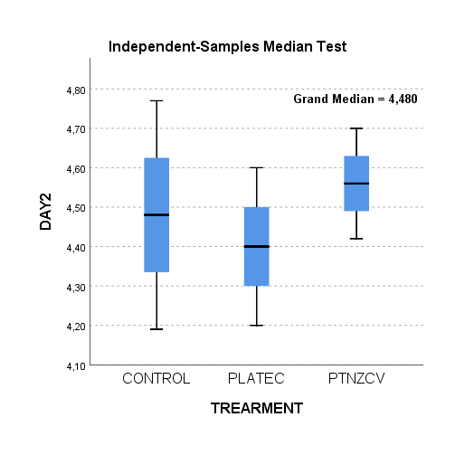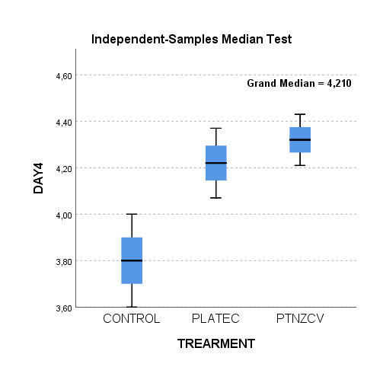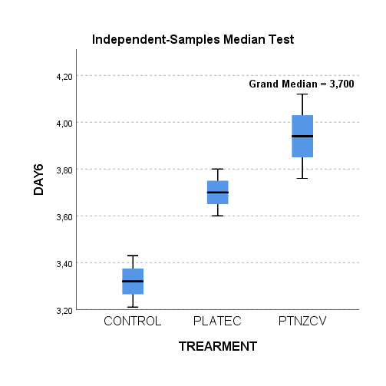

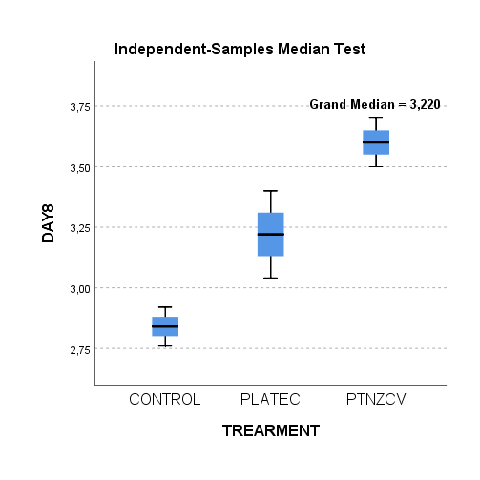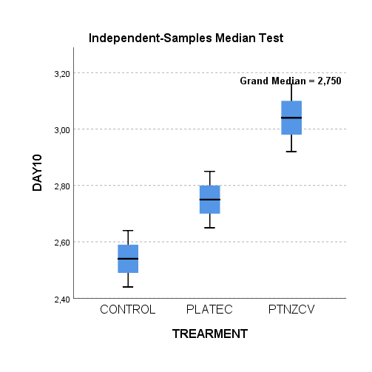

**Figure S13**: Independent-Samples Median Test of Texture durring storage time.

**Table S13**: Pairwise Comparisons of the different treatments according to the mean values of Texture during storage time.

|  |  |  |  |  |  |  |  |
| --- | --- | --- | --- | --- | --- | --- | --- |
| DAY2 | | DAY4 | | DAY6 | | | |
| **Independent-Samples Median Test Summary** | | **Independent-Samples Median Test Summary** | | **Pairwise Comparisons of TREATMENTS** | | | |
| Total N | 9 | Total N | 9 | Sample 1-Sample 2 | Test Statistic | Sig. | Adj. Sig.a |
| Median | 4,480 | Median | 4,210 | CONTROL-PLATEC | 6,000 | 0,014 | 0,043 |
| Test Statistic | ,900a,b | Test Statistic | 3,600a,b | CONTROL-PTNZCV | 6,000 | 0,014 | 0,043 |
| Degree Of Freedom | 2 | Degree Of Freedom | 2 | PLATEC-PTNZCV | 0,667 | 0,414 | 1,000 |
| Asymptotic Sig.(2-sided test) | 0,638 | Asymptotic Sig.(2-sided test) | 0,165 | Each row tests the null hypothesis that the Sample 1 and Sample 2 distributions are the same.  Asymptotic significances (2-sided tests) are displayed. The significance level is ,05. | | | |
| a. More than 20% of the cells have expected values less than five. | | a. More than 20% of the cells have expected values less than five. | | a. Significance values have been adjusted by the Bonferroni correction for multiple tests. | | | |
| b. Multiple comparisons are not performed because the overall test does not show significant differences across samples. | | b. Multiple comparisons are not performed because the overall test does not show significant differences across samples. | |  |  |  |  |
| DAY8 | | | | DAY10 | | | |
| **Pairwise Comparisons of TREATMENTS** | | | | **Pairwise Comparisons of TREATMENTS** | | | |
| Sample 1-Sample 2 | Test Statistic | Sig. | Adj. Sig.a | Sample 1-Sample 2 | Test Statistic | Sig. | Adj. Sig.a |
| CONTROL-PLATEC | 6,000 | 0,014 | 0,043 | CONTROL-PLATEC | 6,000 | 0,014 | 0,043 |
| CONTROL-PTNZCV | 6,000 | 0,014 | 0,043 | CONTROL-PTNZCV | 6,000 | 0,014 | 0,043 |
| PLATEC-PTNZCV | 6,000 | 0,014 | 0,043 | PLATEC-PTNZCV | 6,000 | 0,014 | 0,043 |
| Each row tests the null hypothesis that the Sample 1 and Sample 2 distributions are the same.  Asymptotic significances (2-sided tests) are displayed. The significance level is ,05. | | | | Each row tests the null hypothesis that the Sample 1 and Sample 2 distributions are the same.  Asymptotic significances (2-sided tests) are displayed. The significance level is ,05. | | | |
| a. Significance values have been adjusted by the Bonferroni correction for multiple tests. | | | | a. Significance values have been adjusted by the Bonferroni correction for multiple tests. | | | |