Article
Effects of Mint Oils on the Human Oral Microbiome: A Pilot Study

Supplementary figures

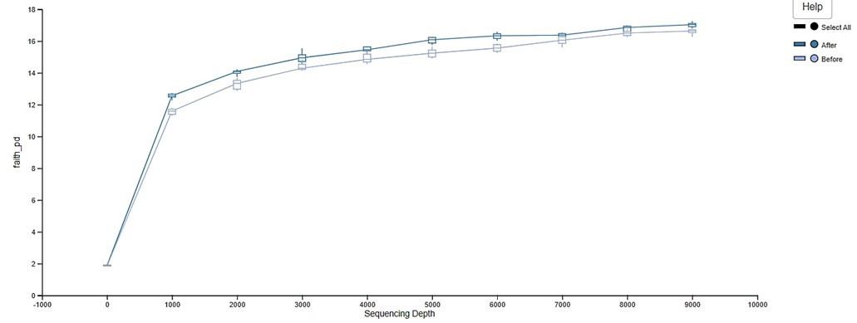
Figure S1. Alpha-rarefaction curve.

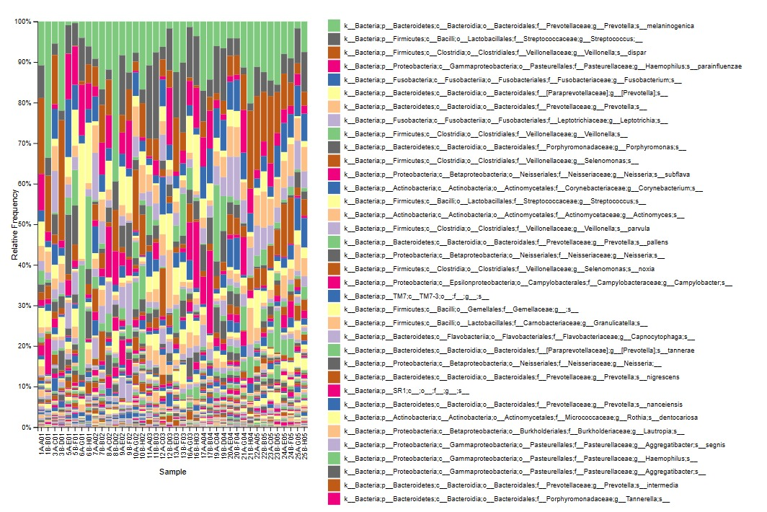 Figure S2. Taxonomic composition of oral microbiome.

