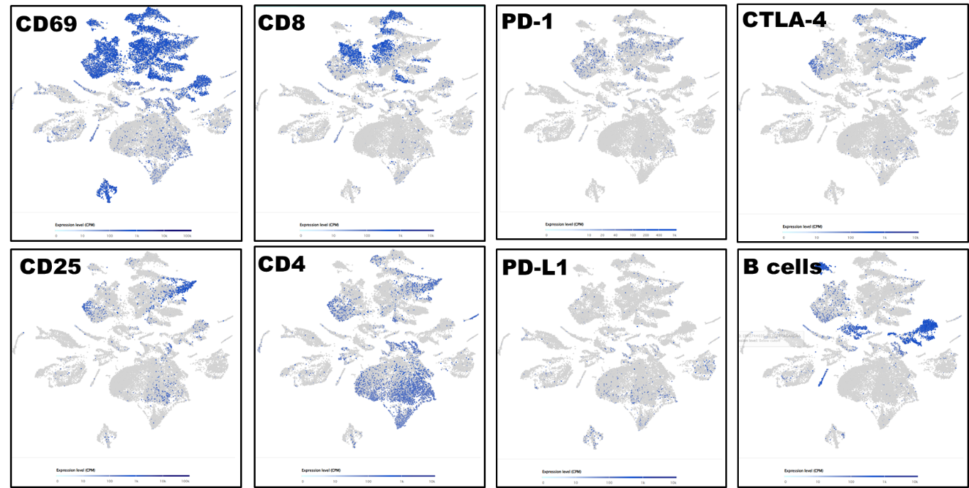

Figure S1. Distinct immune cell clusters in tumor microenvironment by single cell RNA-Seq spatial transcriptomic analysis in lung carcinoma tissues (32,341 cells).

