**Supplementary Materials**

**Development of foam composites from flax gum-filled epoxy resin**

C. Musa 1, M. Zaidi 1, M. Depriester 2, Y. Allouche 1, N. Naouar 3, A. Bourmaud 4, D. Baillis 3, F. Delattre [1]*

1 UCEIV, UR 4492, Université du Littoral-Côte d’Opale, 59140 Dunkerque, France

2 UDSMM, UR 4476, Université du Littoral-Côte d'Opale, 59140 Dunkerque, France

3 LaMCoS, INSA-Lyon, CNRS UMR 5259, F69621 Villeurbanne, France

4 IRDL, UMR 6027, Université de Bretagne-Sud, 56321 Lorient Cedex, France

**Materials**

Flax fibers (Aramis variety) were supplied by Van Robaeys Frère (Killem, France) and were cut and sieved to obtain fibers smaller than 1 mm. From the seeds, the flax gum was extracted according to Dubois et al.[X]. In summary, 10%w/v of flax seeds were suspended in tap water one hour before the extraction. Then, the extraction temperature was set to 40°C with a stirrer speed of 400 rpm for 6 hours. After the filtration of seeds, the flax gum was recovered by precipitation in ethanol. Diglycidyl ether of bisphenol A (Epolam 2020) and isophorone diamine (IPD) (curing agent) were purchased from Sigma Aldrich (Saint-Louis, MO, United States).

[X] Dubois F, Musa C, Duponchel B, Tidahy L, Sécordel X, Mallard I, Delattre F. Nuclear magnetic resonance and calorimetric investigations of extraction mode on flaxseed gum composition.

Polymers 2020;12(11);2654. <https://doi.org/10.3390/polym12112654>.

**Determination of aldehyde and carboxylic contents**

The monitoring of the oxidation of flax gum and fibers was carried out by determining the aldehyde and carboxylic acid functions on the native and oxidized materials. The determination of carboxylic acids by conductimetry measurement was carried out according to a protocol that allows the determination of the level of acid groups on cellulosic fibers [Y]. The sample (40-50 mg) was first acidified for 15 minutes in 25 ml of 0.01 M hydrochloric acid solution and then the solution was titrated with NaOH solution. The determination is followed by conductimetry (mS.cm-1) with the addition of 0.05 M NaOH. The equivalent volume is determined by the tangent method. In order to compare the treated and not treated materials, we have determined a ratio Rox = [oxidized product]/[native product].

[Y] Da Silva Perez D, Montanari S, Vignon MR. TEMPO-mediated oxidation of cellulose III Biomacromol 2003;4:1417–1425.

**Fig. S1.** FTIR spectra of (A) native and oxidized Flax gum; (B) Flax fibres (F1 and F1ox).

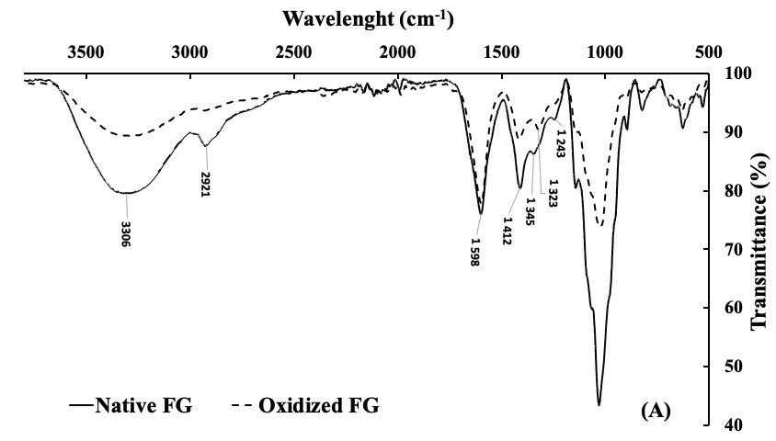



**(B)**

**Fig. S2.** FTIR spectra of (A) Oxidized Flax gum filled epoxy filled foams (FGox-80 and FGox-20); (B) composites FG-Comp and FGox-Comp.

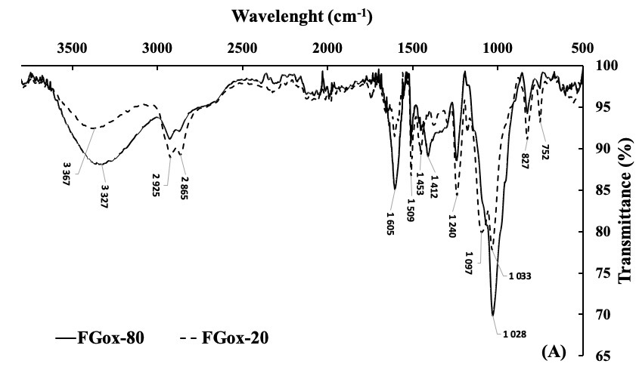

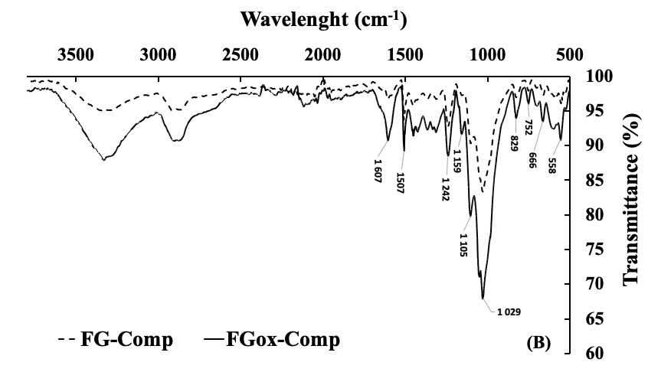

**Fig. S3.** SEM images of the cross-section morphology of composites.



1. Corresponding author.

   *E-mail address :* delattre@univ-littoral.fr (F. Delattre).