Figures – Supplementary Information
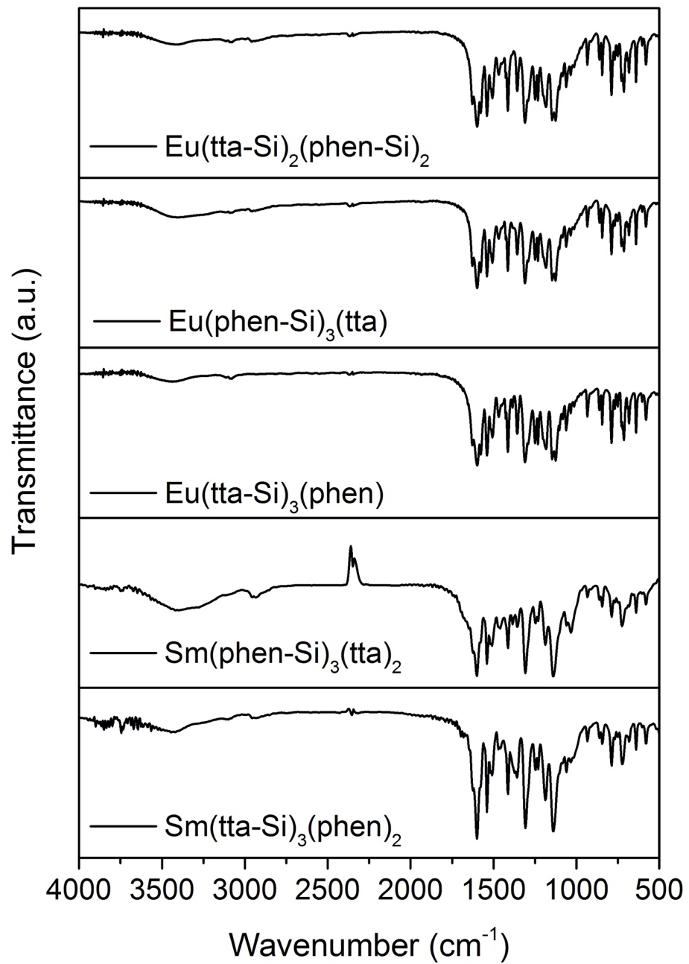
Figure S1. FTIR spectra of the complexes.

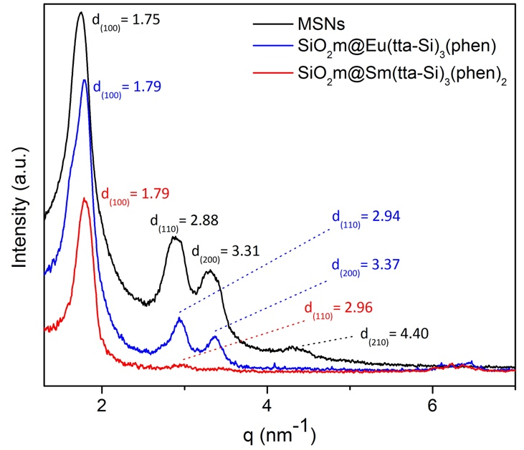
Figure S2. SAXS curves for MSNs, SiO₂m@Sm(tta-Si)₃(phen)₂, and SiO₂m@Eu(tta-Si)₃(phen).

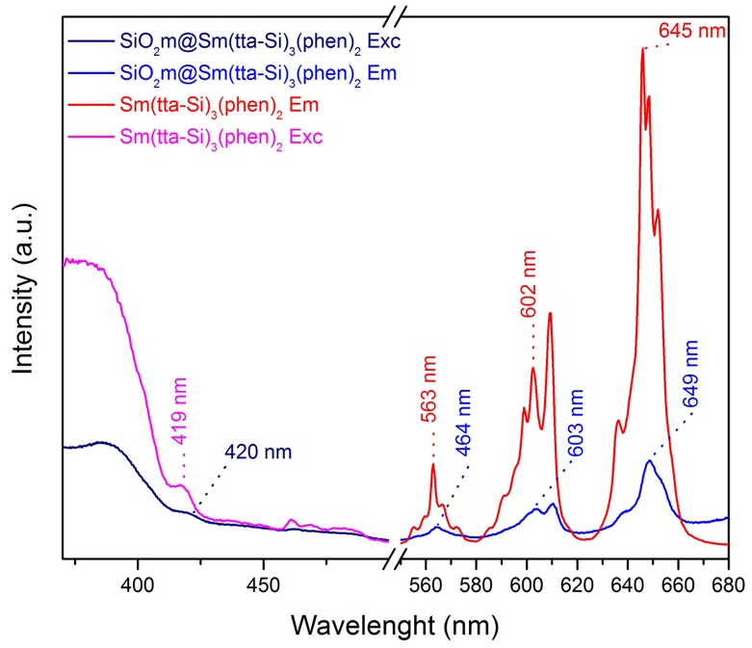
Figures S3. LS spectra of the Sm(tta-Si)₃(phen)₂ complex, acquired with: λ_{em}= 650 nm and λ_{exc}= 375.5 nm; excitation/emission slits = 2/2 mm; increment = 0.5 nm; and speed = 0.1 s; and of the SiO₂m@Sm(tta-Si)₃(phen)₂, acquired with: λ_{em}= 650 nm and λ_{exc}= 384 nm; excitation/emission slits = 2/2 mm; increment = 1 nm; and speed = 0.1 s.
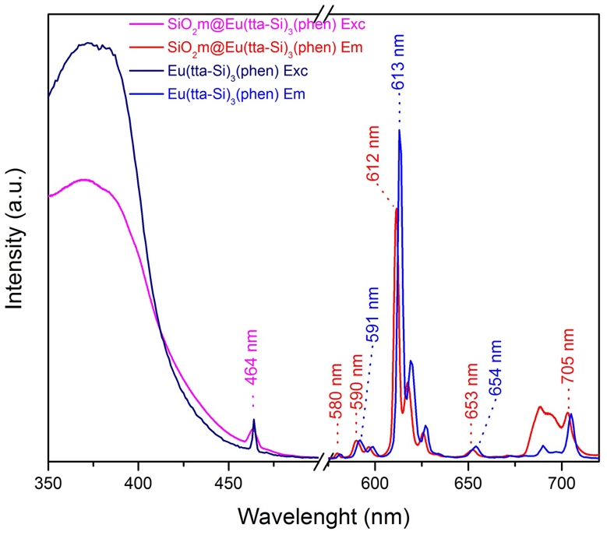
Figures S4. LS spectra of the Eu(tta-Si)₃(phen) complex, acquired with: λ_{em}= 613.5 nm and λ_{exc}= 381.5 nm; excitation/emission slits = 2/2 mm; increment = 0.5 nm; and speed = 0.1 s; and of the SiO₂m@Eu(tta-Si)₃(phen), acquired with: λ_{em}= 611 nm and λ_{exc}= 374 nm; excitation/emission slits = 2/2 mm; increment = 1 nm; and speed = 0.1 s.

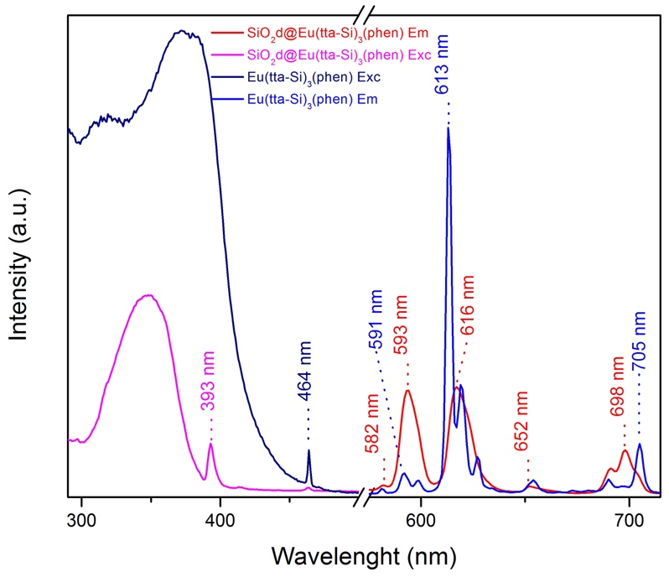
Figures S5. LS spectra of the Eu(tta-Si)₃(phen) complex, acquired with: λ_{em}= 613.5 nm and λ_{exc}= 381.5 nm; excitation/emission slits = 2/2 mm; increment = 0.5 nm; and speed = 0.1 s; and of the SiO₂d@Eu(tta-Si)₃(phen), acquired with: λ_{em}= 612 nm and λ_{exc}= 348 nm; excitation/emission slits = 2/2 mm; increment = 1 nm; and speed = 0.1 s.

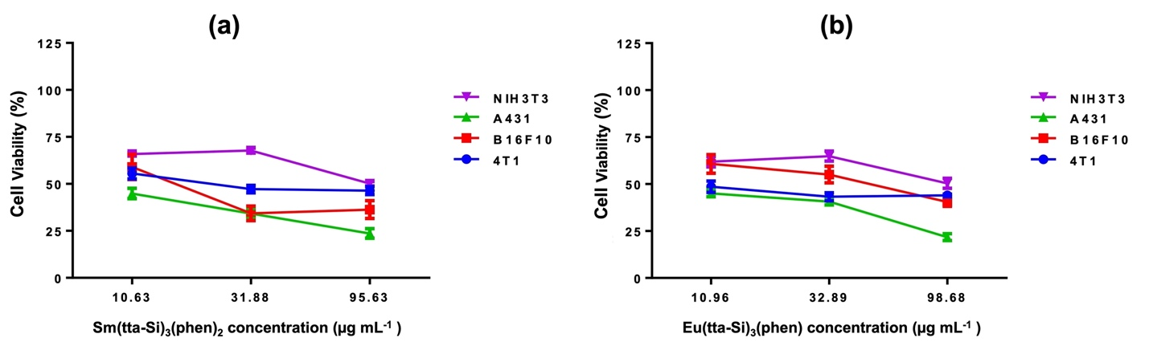
Figure S6. Cell viability percentage as a function of varying Sm(tta-Si)₃(phen)₂ (a) and Eu(tta-Si)₃(phen) (b) from 10 to 100 µg mL⁻¹ concentration.

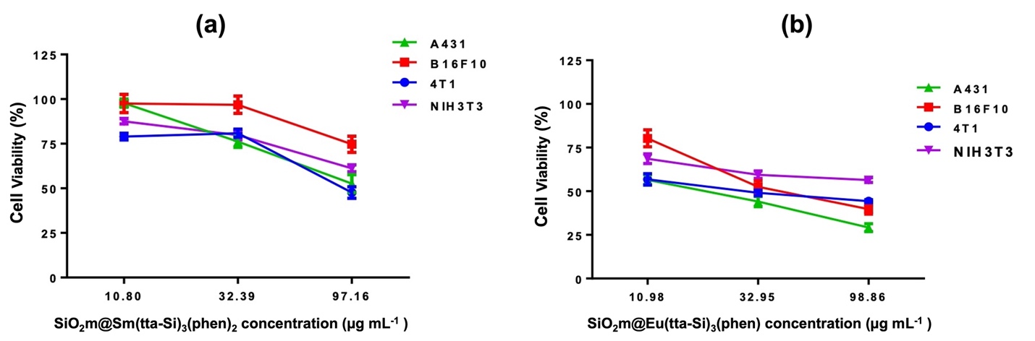
Figure S7. Cell viability percentage as a function of varying SiO₂m@Sm(tta-Si)₃(phen)₂ (a) and SiO₂m@Eu(tta-Si)₃(phen) (b) from 10 to 100 µg mL⁻¹ concentration.

