Table S1: Molecular identification of LAB isolates based on the 16S rRNA and phes gene sequencing.
Strain | NCBI accession number | 16S rRNA | phes Gene | Source
^{D12} | ^{MG996515.1} | ^{Lactobacillus amylolyticus} | ^{Lactobacillus amylolyticus} | ^{Ting Slurry}
^{D7} | ^{MG996514.1} | ^{Lactobacillus helveticus} | ^{Lactobacillus helveticus} | ^{Ting Slurry}
^{T12} | ^{MN068415.1} | ^{Lactiplantibacillus plantarum} | ^{Lactiplantibacillus plantarum} | ^{Ting Slurry}
^{K20} | ^{MG996453.1} | ^{Lacticaseibacillus paracasei} | ^{Lacticaseibacillus paracasei} | ^{Ting Slurry}

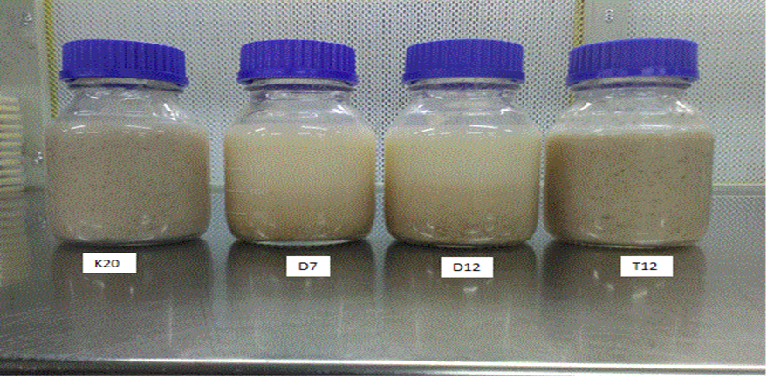
Figure S1: Fermentation products showing the effect of amylase positive strains D7 and D12 on sorghum gruel.

Table S2: Amylase assay of the 4 probiotic strains.
LAB strains | Amylase
K20 | Absent
T12 | Absent
D12 | Present
D7 | Present

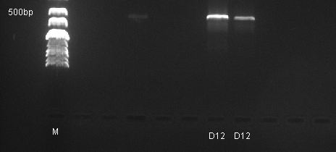
Figure S2: Agarose gel electrophoresis showing positive results for PCR amplification of amylase gene in strains D7 and D12.
Table S3: Colony counts of LAB strains used for fermentation over period of 24hours supplemented with 10% glucose.
Strains | Log cfu/mL
 | 0 hour | 4 hours | 8 hours | 16 hours | 24 hours
Lacticaseibacillus paracasei K20 | 7,98(±0.04)^{cd} | 8,3(±0.03)^{de} | 8,195(±0.06)^{de} | 8,83(±0.09)^{d} | 8,585(±0.06)^{cd}
Lactiplantibacillus plantarum T12 | 8,285(±0.01)^{e} | 8,38(±0.05)^{e} | 7,505(±0.05)ª | 8,805(±0.10)^{d} | 8,8(±0.08)^{d}
Lactobacillus amylolyticus D12 | 7,285(±0.15)^{b} | 7,39(±0.05)ª | 7,6(±0.05)^{ab} | 7,885(±0.02)^{abc} | 7,815(±0.02)ª
Lactobacillus helveticus D7 | 7,93(±0.04)^{cd} | 8,09(±0.01)^{c} | 8,01(±0.01)^{cd} | 8,4(±0.01)^{bcd} | 8,285(±0.02)^{bc}
Log mean values with different letters in each column are significantly different at p<0.05
Values reported are means of at least three independent measurements.

Table S4: Mean log colony counts of LAB strains used for fermentation over period of 24hours without added glucose.
Strains | log10 cfu/mL
 | 0 hour | 4 hours | 8 hours | 16 hours | 24 hours
Lacticaseibacillus paracasei K20 | 7,74 (±0.048^{)cd} | 8,18 (±0.057)^{e} | 8,535 (±0.028)^{ef} | 8,39 (±0)^{ef} | 8,29 (±0.097)^{cd}
Lactiplantibacillus plantarum T12 | 8,375 (±0.012)^{e} | 8,445 (±0.053)^{f} | 8,66 (±0.032)^{d} | 8,58 (±0.04)^{d} | 8,24 (±0.138)^{f}
Lactobacillus amylolyticus D12 | 7,09 (±0.016)^{b} | 7,52 (±0.024)^{b} | 7,495 (±0.085)^{d} | 8,03 (±0.024)^{d} | 8,49 (±0.065)^{b}
Lactobacillus helveticus D7 | 7,32 (±0.073)^{bc} | 7,535 (±0.028)^{c} | 7,22 (±0.04)^{b} | 7,76 (±0.008)^{c} | 8,59 (±0.024)^{ef}
Log mean values with different letters in each column are significantly different at p<0.05
Values reported are means of at least three independent measurements.

Table S5: Lactic acid composition data for fermented sorghum gruels. Percentage lactic acid levels were monitored hourly throughout the fermentation processes. The results were recorded as mean values.
Sample |  | F1- without %10 glucose |  |  |  | F2- 10% glucose
 |  | 0 hour | 24 hours | Percentage difference% |  | 0 hour | 24 hours | Percentage difference %
Lacticaseibacillus paracasei K20 |  | 0,14 (±0.07) | 0,18 (±0.02) | 0,04 |  | 0,25 (±0.07) | 0,44 (±0.25) | 0,19
Lactiplantibacillus plantarum T12 |  | 0,16 (±0.03) | 0,24 (±0.11) | 0,08 |  | 0,24 (±0.03) | 0,67 (±0.11) | 0,43
Lactobacillus amylolyticus D12 |  | 0,19 (±0.03) | 0,48 (±0.21) | 0,29 |  | 0,23 (±0.03) | 0,55 (±0.21) | 0,32
Lactobacillus helveticus D7 |  | 0,15 (±0.1) | 0,42 (±0.14) | 0,27 |  | 0,24 (±0.06) | 0,68 (±0.14) | 0,44

± SD of lactic acid value of LAB strains for each column
Values reported are means of at least three independent measurements.

