**SUPPLEMENTARY DATA**

**Phenolic Acid – β-cyclodextrin Complexation Study to Mask Bitterness in Wheat Bran: A Machine-Learning-based QSAR Study**

Kweeni Iduoku1,2, Marvellous Ngongang1, Jayani Kulathunga3, Amir Daghighi1,2, Gerardo M. Casanola-Martin1, Senay Simsek3,4, Bakhtiyor Rasulev1,2*

*1Department of Coatings and Polymeric Materials, North Dakota State University, Fargo, ND 58102, USA*

*2Biomedical Engineering Program, North Dakota State University, Fargo, ND 58102, USA*

*3Cereal Science Graduate Program, Department of Plant Sciences, North Dakota State University, Fargo, ND 58102, USA*

*4Whistler Center for Carbohydrate Research, Department of Food Science, Purdue University, West Lafayette, IN 47907, USA*

**Table of Contents**

**Fig S1.** Electronic orbitals of BCD-complexed molecules, showing the location of their HOMO-LUMO orbitals.

**Fig S2.** Electrostatic potential graph showing the saturation patterns of polar and non-polar groups in molecules

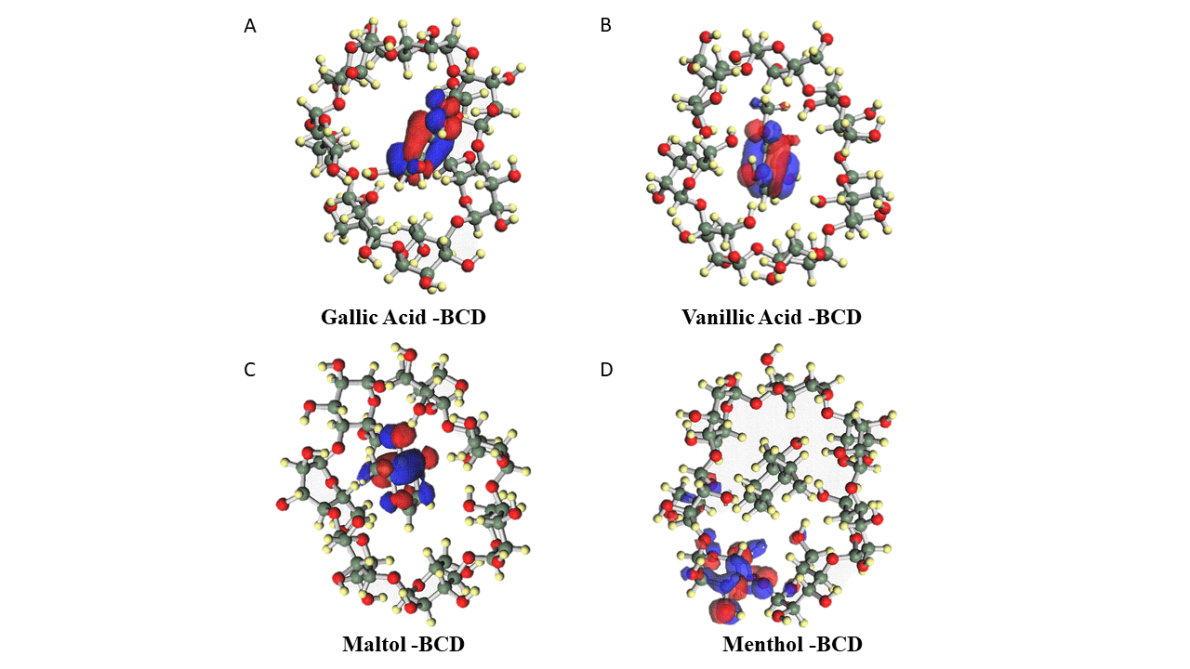**Figure S1**: Electronic orbitals of BCD-complexed molecules, showing the location of their HOMO-LUMO orbitals.

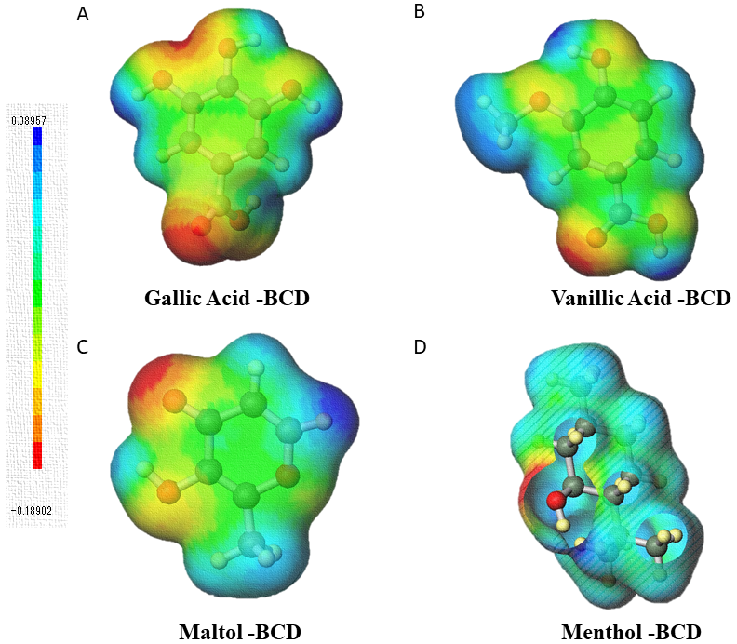

**Figure S2**: Electrostatic potential graph showing the saturation patterns of polar and non-polar groups in molecules