**Supplementary material**

**Supplementary methods**

**INFLA-score computation.** The INFLA-score was computed by creating 10-tiles for CRP, leukocyte count, platelet count, and NLR values. To generate the 10-tiles, the data for each biomarker were divided into ten groups based on their values, such that the first 10-tile contained the lowest values, the second contained slightly higher values, and so on, until reaching the tenth 10-tile containing the highest values. These biomarker 10-tiles were assigned scores ranging from lower levels (from -4 to -1) to higher levels (from +4 to +1), with intermediate values receiving a score of 0. Summing the scores of the four components results in the INFLA-score, which ranges between -16 and +16.

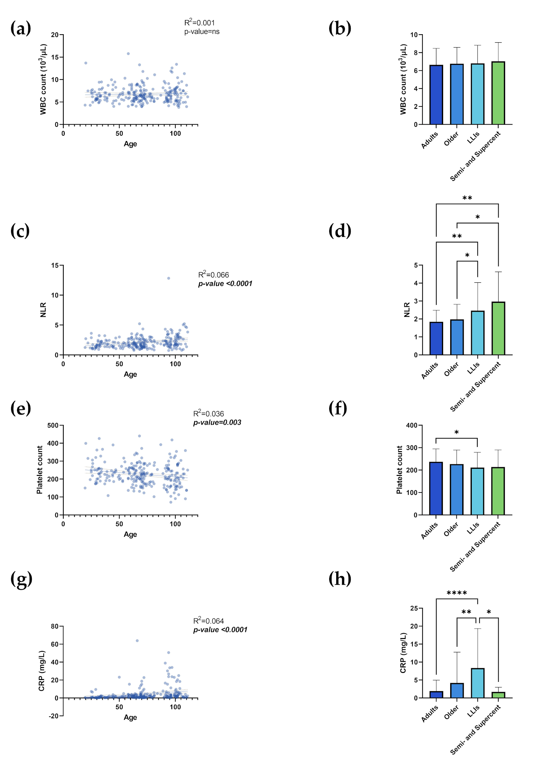

**Figure S1. The parameters of the INFLA-score**. Linear regression analysis shows the relationship between WBC count (a), NLR (c), Platelet count (e), CRP (g) and age in N= 247 individuals. Each point represents data from a healthy donor. Column bar graphs show differences between the mean of the values of WBC count (b), NLR (d), Platelet count (f), and CRP (h) from each aged group obtained by one-way ANOVA test. The coefficient of determination and *p*-values are shown on the graphs. \**p*-value ≤0.05; \*\**p*-value ≤0.01; \*\*\**p*-value ≤0.001; \*\*\*\**p*-value ≤0.0001; WBC= White Blood Cells; NLR= Neutrophil-to-Lymphocyte ratio; CRP= C-Reactive Protein; LLIs= Long-Lived Individuals; Semi and Supercent= Semi- and Supercentenarians; R2= R squared; ns= not significant. ***p-value*** (bold and italic)= statistically significant.

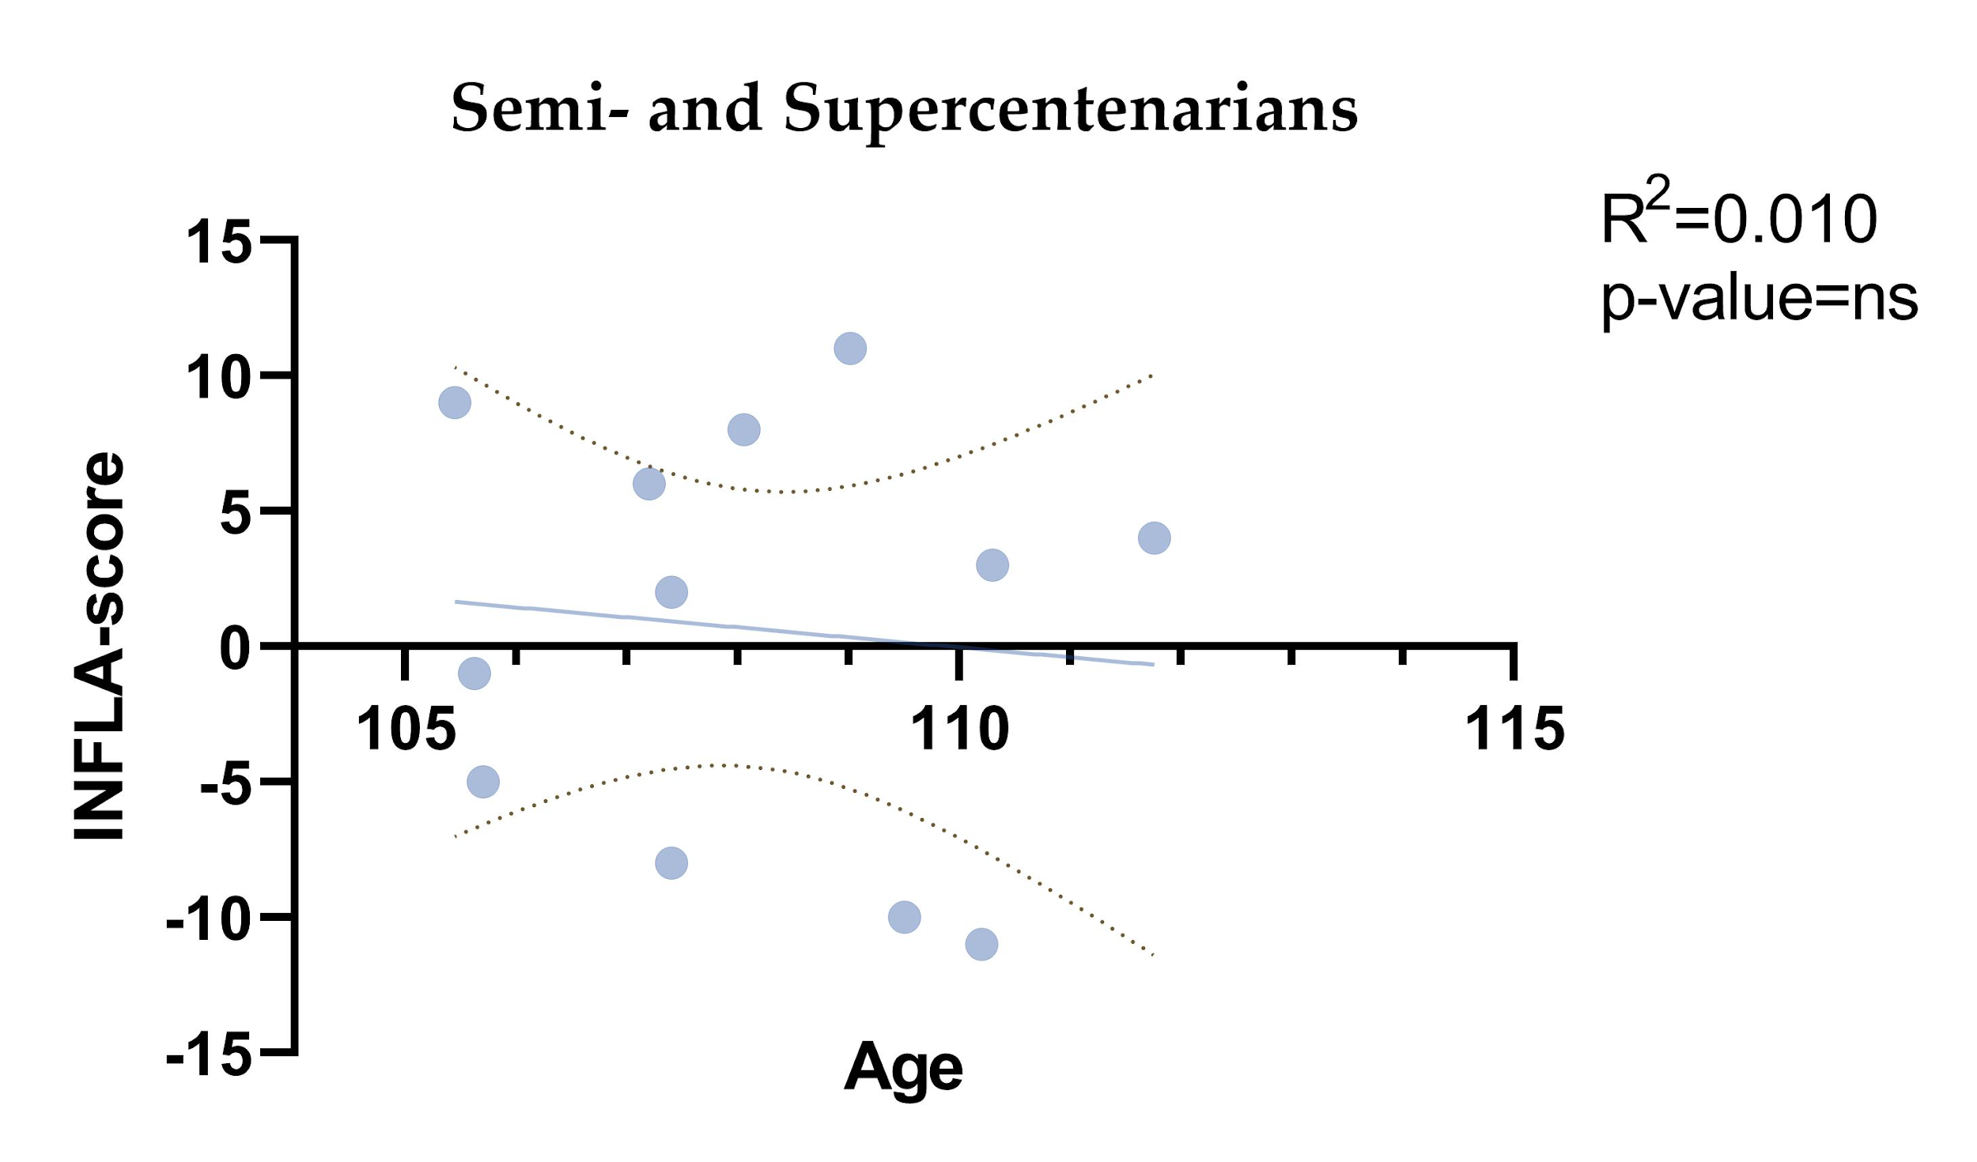

**Figure S2. Semi- and Supercentenarians INFLA-score**. Linear regression analysis shows the relationship between INFLA-score and age in the age group of semi- and supercentenarians (N= 12). The coefficient of determination and p-values are shown on the graphs. R2 = R squared; ns = not significant. ***p-value*** (bold and italic)= statistically significant.

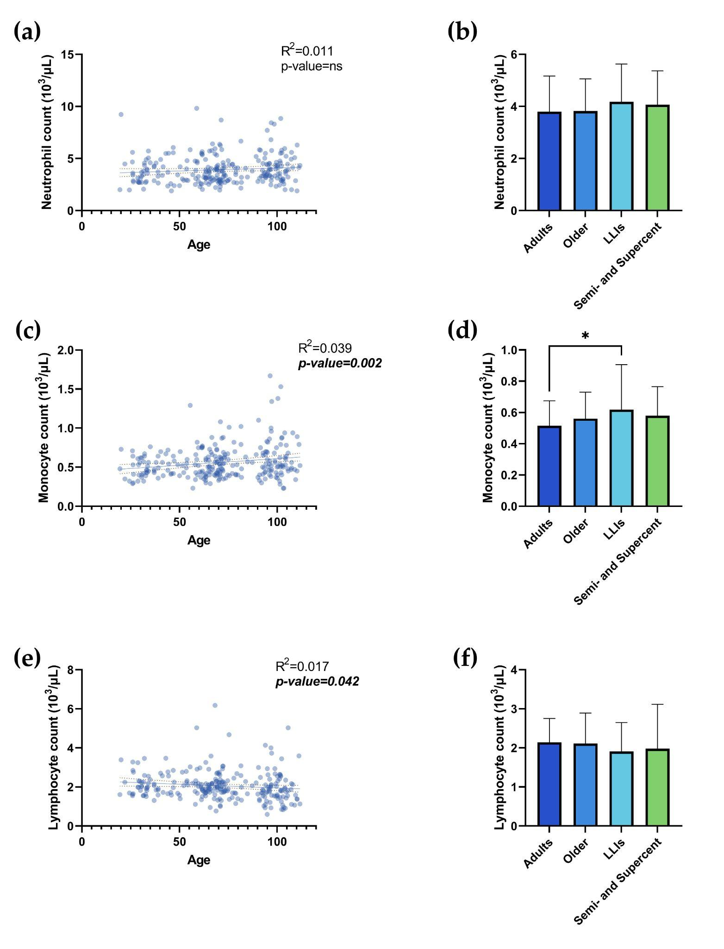

**Figure S3.** **The parameters of SIRI analysis**. Linear regression analysis shows the relationship between Neutrophil count (a), Monocyte count (c), Lymphocyte count (e), and age in N= 249 individuals. Each point represents data from an individual healthy donor. Column bar graphs show differences between the mean of the values of Neutrophil count (b), Monocyte count (d), and Lymphocyte count (f), from each aged group obtained by one-way ANOVA test. The coefficient of determination and *p*-values are shown on the graphs. *p-value ≤0.05; \*\**p*-value ≤0.01; \*\*\**p*-value ≤0.001; \*\*\*\**p*-value ≤ 0.0001; SIRI= Systemic Inflammation Response Index; LLIs= Long-Lived Individuals; Semi and Supercent= Semi- and Supercentenarians; R2= R squared; ns= not significant. ***p-value*** (bold and italic)= statistically significant.

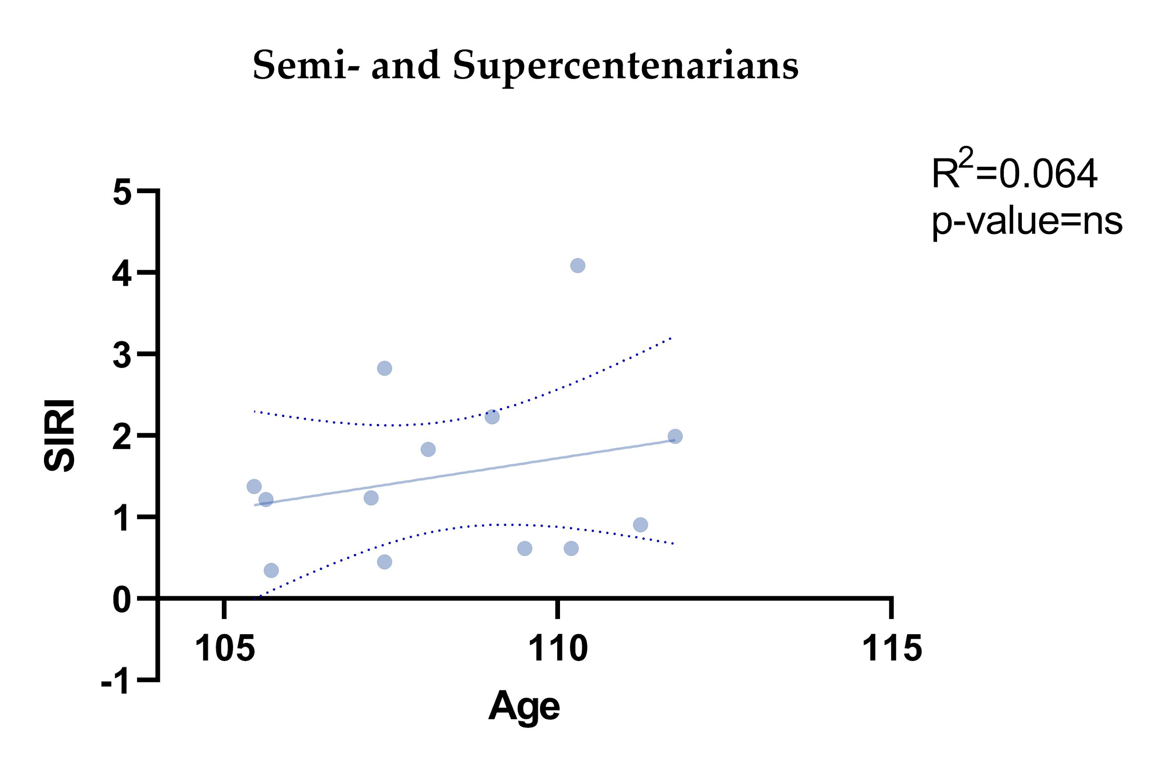

**Figure S4.** **Semi- and Supercentenarians SIRI**. Linear regression analysis shows the relationship between SIRI and age in the age group of semi- and supercentenarians (N= 13). The coefficient of determination and p-values are shown on the graphs. SIRI= Systemic Inflammation Response Index; R2 = R squared; ns = not significant. ***p-value*** (bold and italic)= statistically significant.

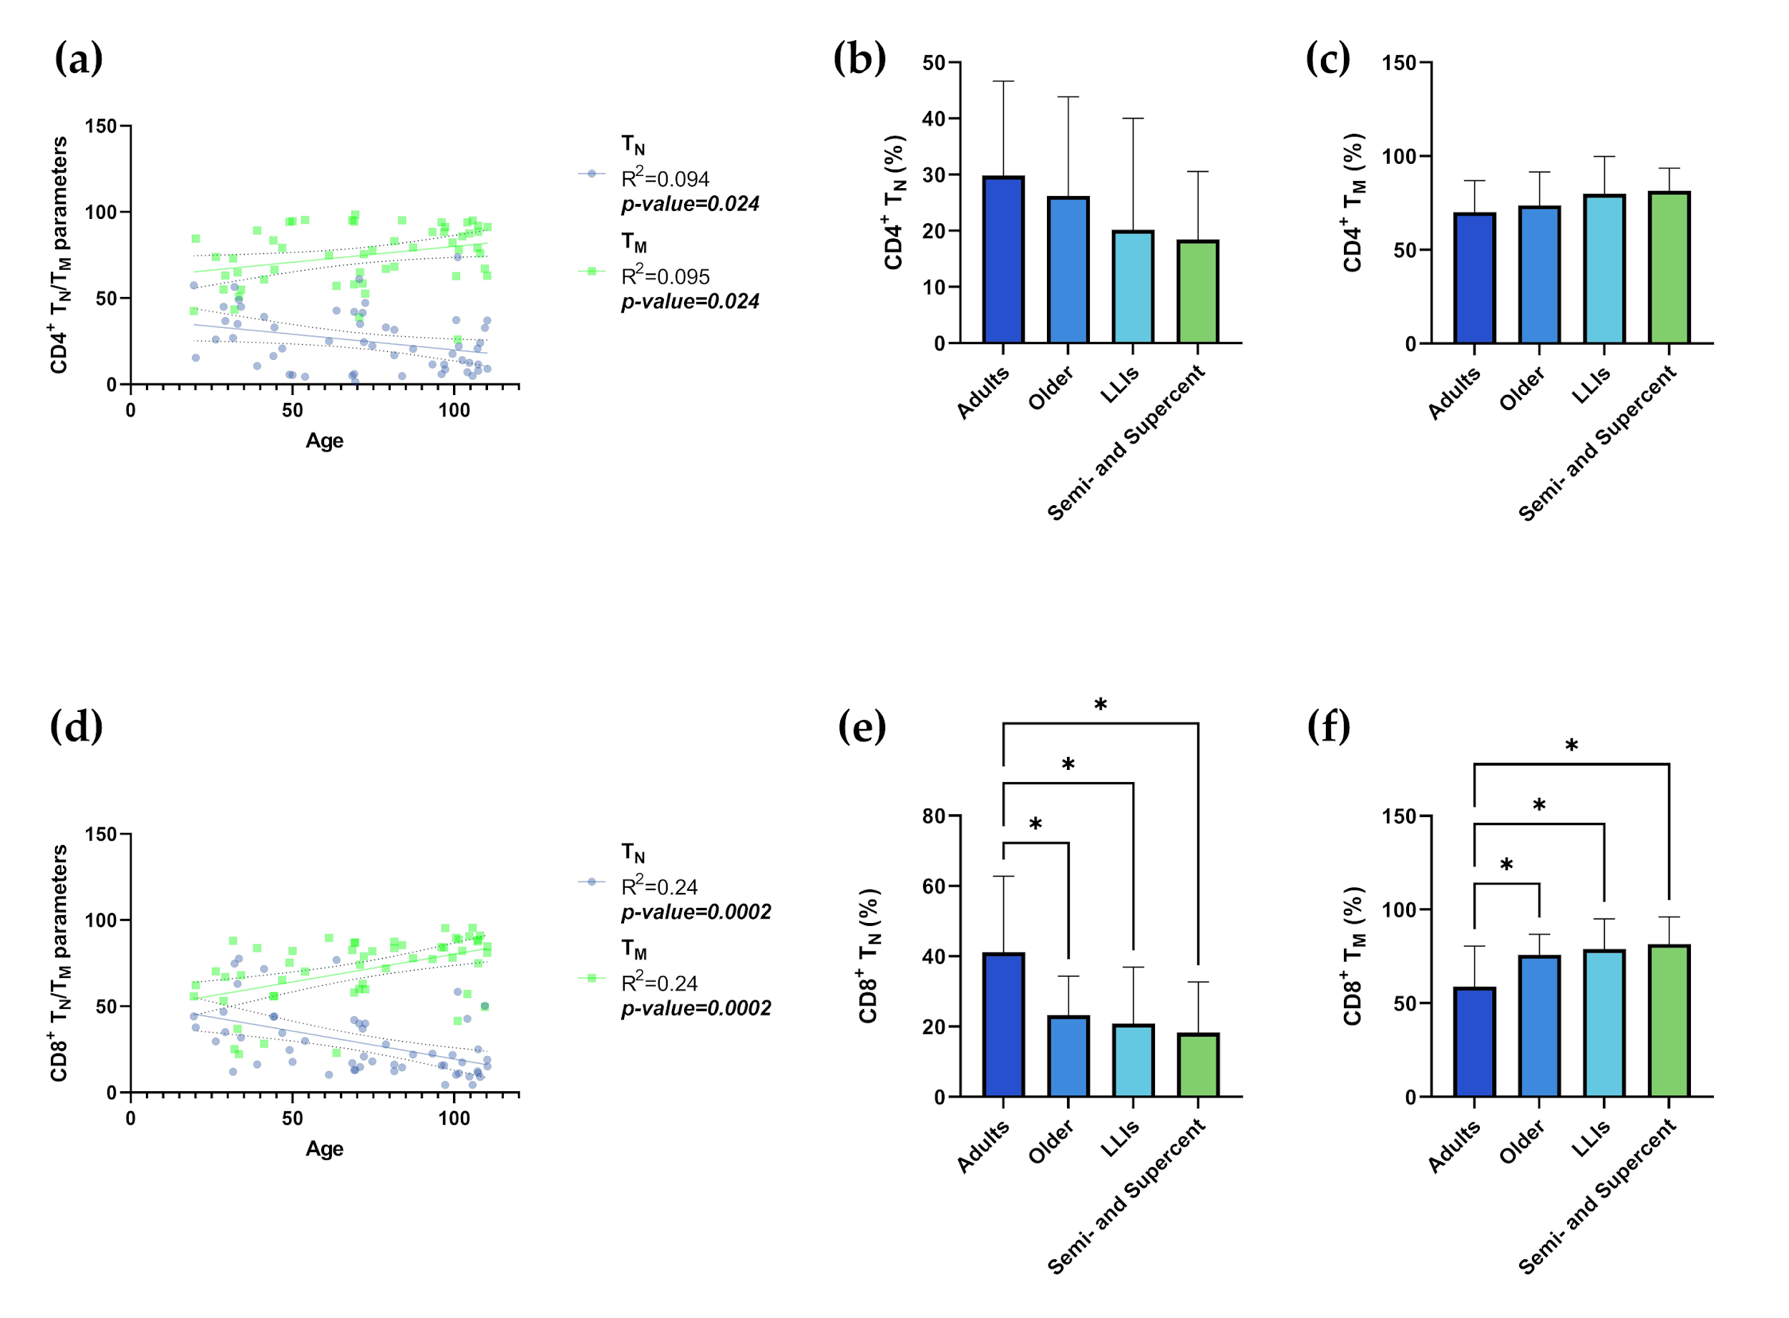**Figure S5.** **The parameters of** **TN/TM**. Linear regression analysis shows the relationship between CD4+ TN (blue line), CD4+ TM (green line) (a) and CD8+ TN (blue line), CD8+ TM (green line) (d) and age in N= 54 individuals. Each point represents data from a healthy donor. Column bar graphs show differences between the mean of the values of CD4+ TN (b), CD4+ TM (c), CD8+ TN (e), CD8+ TM (f) from each aged group obtained by one-way ANOVA test. The coefficient of determination and p-values are shown on the graphs. \**p*-value ≤0.05; \*\**p*-value ≤0.01; \*\*\**p*-value ≤0.001; \*\*\*\**p*-value ≤0.0001; TN: T Naïve (CD45RA+CD27+); TM: TCM (CD45RA-CD27+) + TEM (CD45RA-CD27-) + TEMRA (CD45RA+CD27-); LLIs= Long-Lived Individuals; Semi and Supercent= Semi- and Supercentenarians; R2= R squared; ns= not significant; ***p-value*** (bold and italic)= statistically significant.

**Table S1. INFLA-score parameters.** Mean±SD of INFLA-score parameters according to age groups.

|  |  |  |  |  |  |  |
| --- | --- | --- | --- | --- | --- | --- |
| **Variable** | **Adults**  **(N= 91)** | **Older**  **(N= 76)** | **LLIs**  **(N= 68)** | **Semi- and Supercentenarians**  **(N= 12)** | **Significant comparisons** | **p-value** |
| **WBC count (103/μL)** | 6.65±1.83 | 6.77±1.82 | 6.81±2.02 | 7.03±2.10 | None | ns |
| **NLR** | 1.85±0.64 | 1.98±0.84 | 2.47±1.56 | 2.97±1.66 | Adults vs LLIs | 0.002 |
| Adults vs Semi- and Supercentenarians | 0.004 |
| Older vs LLIs | 0.043 |
| Older vs Semi- and Supercentenarians | 0.019 |
| **Platelet count** | 237.4±57.26 | 227±62.33 | 211.4±67.62 | 214.1±75.68 | Adults vs LLIs | 0.044 |
| **CRP (mg/L)** | 1.94±3.03 | 4.23±8.53 | 8.36±10.96 | 1.69±1.31 | Adults vs LLIs | <0.0001 |
| Older vs LLIs | 0.009 |
| LLIs vs Semi- and Supercentenarians | 0.026 |

*SD: Standard Deviation; ns: not significant; LLIs: Long-Lived Individuals; WBC: White Blood Cells; NLR: Neutrophil-to-Lymphocyte Ratio; CRP: C-Reactive Protein. p-values obtained from the one-way ANOVA test are reported. p-values >0.05 is not significant.

**Table S2**. **SIRI parameters**. Mean±SD of SIRI parameters according to age groups.

|  |  |  |  |  |  |  |
| --- | --- | --- | --- | --- | --- | --- |
| **Variable** | **Adults**  **(N= 91)** | **Older**  **(N= 76)** | **LLIs**  **(N= 69)** | **Semi- and Supercentenarians**  **(N= 13)** | **Significant comparisons** | **p-value** |
| **Neutrophil count (103/μL)** | 3.8±1.37 | 3.82±1.24 | 4.18±1.45 | 4.07±1.30 | None | ns |
| **Monocyte count (103/μL)** | 0.52±0.16 | 0.56±0.17 | 0.62±0.29 | 0.58±0.19 | Adults vs LLIs | 0.011 |
| **Lymphocyte count (103/μL)** | 2.14±0.61 | 2.11±0.78 | 1.91±0.74 | 1.98±1.13 | None | ns |

*SIRI: Systemic Inflammation Response Index; SD: Standard Deviation; ns: not significant; LLIs: Long-Lived Individuals. p-values obtained from the one-way ANOVA test are reported. p-values >0.05 is not significant.

**Table S3.** **TN-TM parameters**. Mean±SD of CD4+ and CD8+ TN-TM according to age groups.

|  |  |  |  |  |  |  |
| --- | --- | --- | --- | --- | --- | --- |
| **Variable** | **Adults**  **(N= 20)** | **Older**  **(N= 15)** | **LLIs**  **(N= 11)** | **Semi- and Supercentenarians**  **(N= 8)** | **Significant comparisons** | **p-value** |
| **CD4+ TN-TM parameters** | | | | | | |
| **CD4+ TN** | 29.83±16.79 | 26.21±17.66 | 20.21±19.82 | 19.49±12.6 | None | ns |
| **CD4+ TM** | 70.14±16.80 | 73.85±17.70 | 79.90±81.53 | 81.53±12.09 | None | ns |
| **CD8+ TN-TM parameters** | | | | | | |
| **CD8+ TN** | 41.16±21.62 | 23.28±11.09 | 20.91±16.01 | 18.31±14.36 | Adults vs Older | 0.018 |
| Adults vs LLIs | 0.014 |
| Adults vs Semi- and Supercentenarians | 0.013 |
| **CD8+ TM** | 58.95±21.67 | 75.97±10.83 | 79.07±16 | 81.70±14.36 | Adults vs Older | 0.026 |
| Adults vs LLIs | 0.015 |
| Adults vs Semi- and Supercentenarians | 0.013 |

*SD: Standard Deviation; ns: not significative; LLIs: Long-Lived Individuals; TN: T Naïve (CD45RA+CD27+); TM: TCM (CD45RA-CD27+) + TEM (CD45RA-CD27-) + TEMRA (CD45RA+CD27-). p-values obtained from the one-way ANOVA test are reported. p-values >0.05 is not significant.