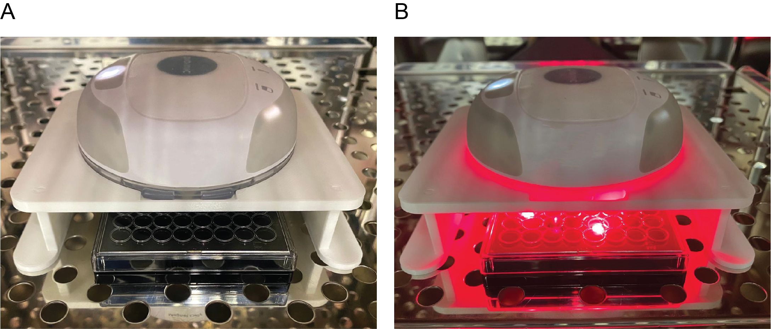

Figure S1. Plated cells subjected to light, magnetic fields, or both in a tissue culture incubator. (A) A typical COMS setup for magnetic fields alone or as a sham; (B) A typical COMS setup for light alone or in combination with magnetic fields.

