**Supporting Information**

**A mitochondria-targeting fluorescent probe for the dual sensing of hypochloriteandviscosity without signal crosstalk in living cells and zebrafish**

Chao Gao, Dandan Chen, Lin Zhang, Minglan Ma,

Hu-Wei Liu, Hai-Rong Cui*

Synergy Innovation Centre of Biological Peptide Antidiabetics of Hubei Province, College of Life Science, Wuchang University of Technology, Wuhan, P. R. 430223, P. R. China

*\* Correspondence: E-mail:* chr@wut.edu.cn

**Table S1 Summary of the recent single detection probes for ClO−**

|  |  |  |  |  |  |  |
| --- | --- | --- | --- | --- | --- | --- |
| **Probe’ Structure** | **Cell**  **Targeting** | **Response Time** | **Detection Limits** | **Detection**  **Medium** | **Application** | **Reference** |
|  | No | 5 min | 49 nM | CH3CN/PBS  buffer  (1:1, v/v) | HeLa cells,  Mice | **Ref. 10**  Talanta  268 (2024) 125298 |
|  | No | 10 s | 97 nM | PBS buffer with 20% EtOH | PLC cells,  HuH-7 cells,  HepG2 cells,  Mice. | **Ref. 11**  Sens. Actuators B  378  (2023) 133219 |
|  | No | 40 min | 35.2 nM | Tris-HCl buffer  (with 1% DMSO) | HeLa cells,  zebrafish | **Ref. 12**  Sens. Actuators B  392 (2023) 134041 |
|  | No | 35 s | 230 nM | PBS buffer with 20% EtOH | HeLa cells,  RAW264.7 cells,  Mice. | **Ref. 13**  Chem. Commun  59 (2023)  1357 |
|  | Mitochondria | 20 s | 89.7 nM | PBS buffer with 10% EtOH | MCF-7 cells,  Mice. | **Ref. 14**  Anal. Chem.  94 (2022) 17904−17912 |
|  | Mitochondria | 2.5 min | 7.4 nM | PBS buffer | 293T cells,  Liver tissue slices. | **Ref. 15**  Anal. Chem.  94 (2022)  11881−11888 |
|  | No | 5 min | 16.1 nM | PBS buffer with 20% DMF | RAW264.7 cells,  Mice. | **Ref. 16**  ACS Sens.  6 (2021) 3253–3261 |
|  | No | 5 min | 87 nM | PBS buffer with 10% CH3OH | RAW264.7 cells. | **Ref. 17**  J. Hazard. Mater. 418 (2021) 126243 |
|  | Mitochondria | 12 s | 18 nM | PBS buffer | HeLa cells,  Zebrafish, | **This work** |

**Table S2 Summary of the recent single detection probes for viscosity**

|  |  |  |  |  |
| --- | --- | --- | --- | --- |
| **Probe’ Structure** | **Cell**  **Targeting** | **Emission wavelength** | **Application** | **Reference** |
|  | No | 600 nm | Vesicle Shell | **Ref. 18**  J. Am. Chem. Soc. 145 (2023)  26494−26503 |
|  | No | 911 nm | HeLa cells,  Mice | **Ref. 19**  Biomaterials  300 (2023) 122190 |
|  | Mitochondria | 665 nm | HeLa cells | **Ref. 20**  Anal. Chem.  95 (2023)  5687−5694 |
|  | No | 702 nm | SH-SY5Y cells,  Mice | **Ref. 21**  Sens. Actuators B372 (2022) 132648 |
|  | Mitochondrial | 722 nm | HeLa cells,  Mice | **Ref. 22**  Anal. Chem.  94 (2022) 5069−5074 |
|  | No | 795 nm | HeLa cells  Mice | **Ref. 23**  Anal. Chem.  94 (2022) 13556−13565 |
|  | Mitochondria | 739 nm | HL-7702 cells,  Mice | **Ref. 24**  Chem. Eng. J.  445 (2022) 136448 |
|  | Mitochondria | 765 nm | HeLa cells,  Zebrafish | **This work** |

**Table S3 Summary of the recent difunctional probes for ClO− and****viscosity**

|  |  |  |  |  |  |  |
| --- | --- | --- | --- | --- | --- | --- |
| **Probe’ Structure** | **Cell**  **Targeting** | **For ClO−**  **(λem)** | **For Viscosity**  **(λem)** | **Emission wavelength difference**  **(Δ*λ* nm)** | **Application** | **Reference** |
|  | Mitochondria | 493 nm | 628 nm | **135 nm** | C6 cells,  Zebrafish | **Ref. 25**  Sens. Actuators B  383 (2023) 133510 |
|  | No | 520 nm | 620 nm | **100 nm** | HeLa cells,  HepG2 cells,  Mice | **Ref. 26**  Sens. Actuators B  393 (2023) 134345 |
|  | Mitochondria | 414 nm | 600 nm | **186 nm** | HeLa cells, | **Ref. 27**  Talanta  241 (2022) 123235 |
|  | No | 510 nm | 600 nm | **90 nm** | INS-1 cells | **Ref. 28**   1. Mol. Struct.   1227 (2021) 129523 |
|  | Mitochondria | 558 nm | 765 nm | **207 nm** | HeLa cells,  Zebrafish | **This work** |

**Table S4:** **DFT results for XTAP**−**Bn and XT−CHOa**

|  |  |  |  |  |  |
| --- | --- | --- | --- | --- | --- |
| **Compounds** | **HOMOb (eV)** | **LUMOb (eV)** | **Egb (eV)** | **λemb/nm** | **λemc/nm** |
| XTAP−Bn | -5.369 | -3.142 | 2.227 | 746 nm | 765 nm |
| XT−CHO | - 5.239 | - 2.181 | 3.058 | 574 nm | 558 nm |

a DFT calculation is performed with Gaussian 09 programs at B3LYP/6-31G(d) basis set.

b The calculation result was obtained using H2O as the solvent.

c Emission maximum (λem) measured in PBS buffer.

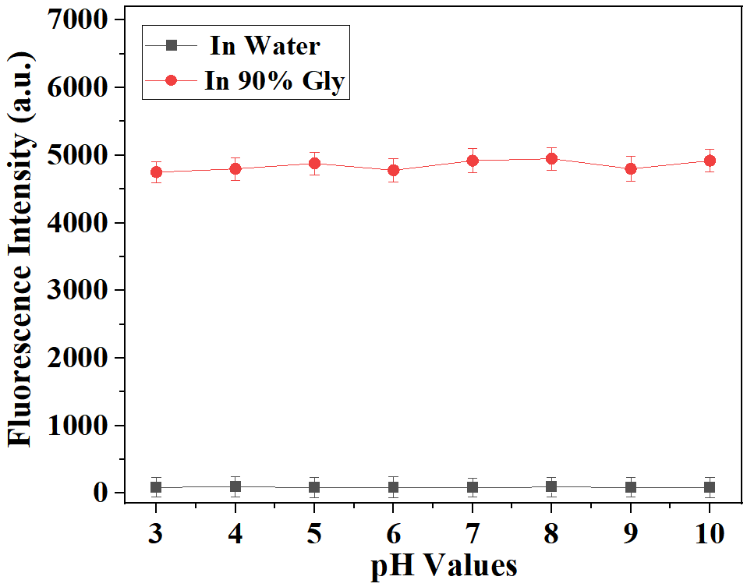

**Figure S1.** pH effect on the fluorescence intensity of probe **XTAP**−**Bn** (5 μM) at 765 nm in water and glycerol (with 10 % water). λex = 620 nm.

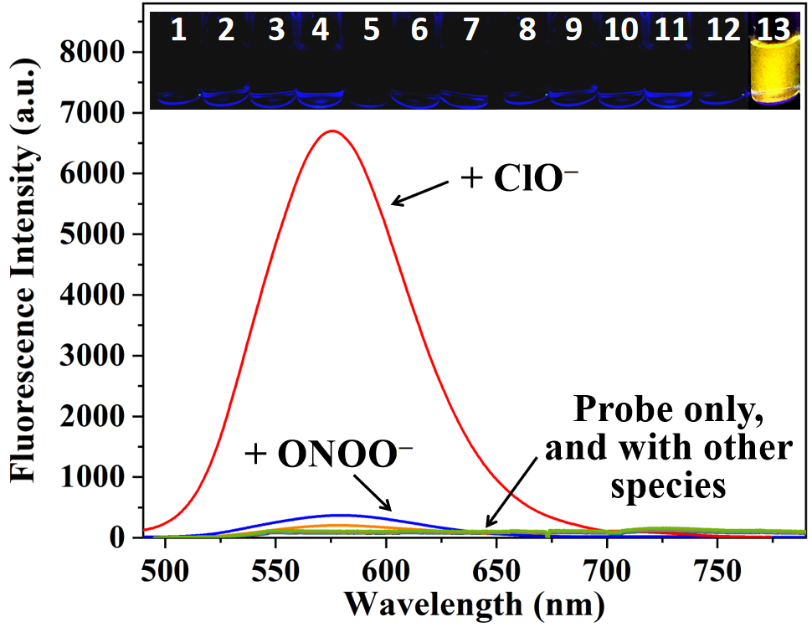

**Figure S2.** Fluorescence spectra of probe **XTAP**−**Bn** (5 μM) with ClO− (50 μM) and various other species (100 μM) in PBS buffer (10 mM, pH 7.4). Insert: the corresponding photos taken under 365 nm light irradiation. 1: Blank; 2: ONOO–; 3:•OH; 4: 1O2; 5: H2O2; 6: Cys; 7: Hcy; 8: GSH; 9: CO32−; 10: H2PO4−; 11: S2−; 12: SO32; 13: ClO−. λex = 482 nm.

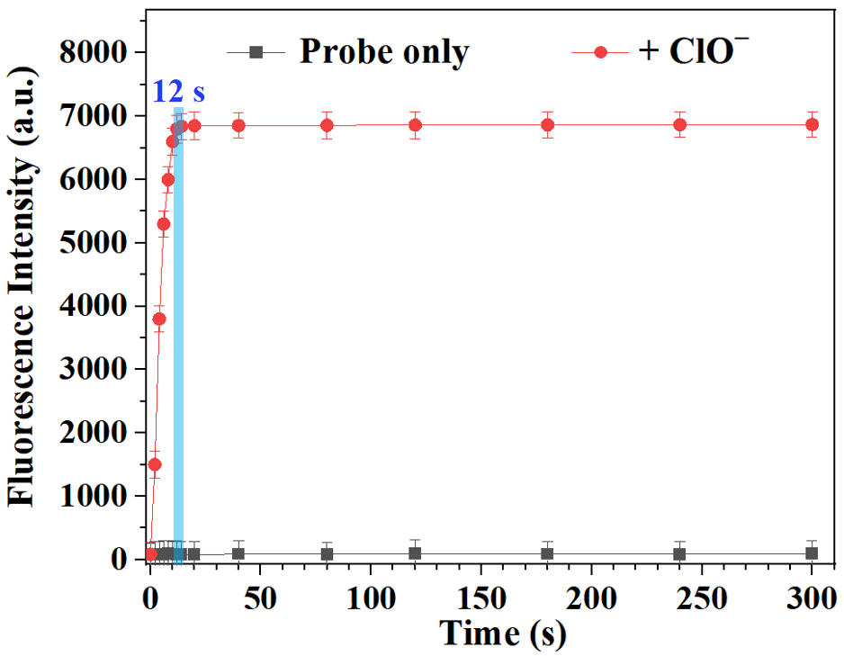

**Figure S3.** Thetime-dependent experiments of probe **XTAP**−**Bn** (5 μM) without and with ClO− (50 μM). For probe **XTAP**−**Bn** only: λex = 620 nm; λem =765 nm; For **XTAP**−**Bn** with ClO−:λex = 482 nm; λem = 558 nm. Error bars are ± SD (n = 3).

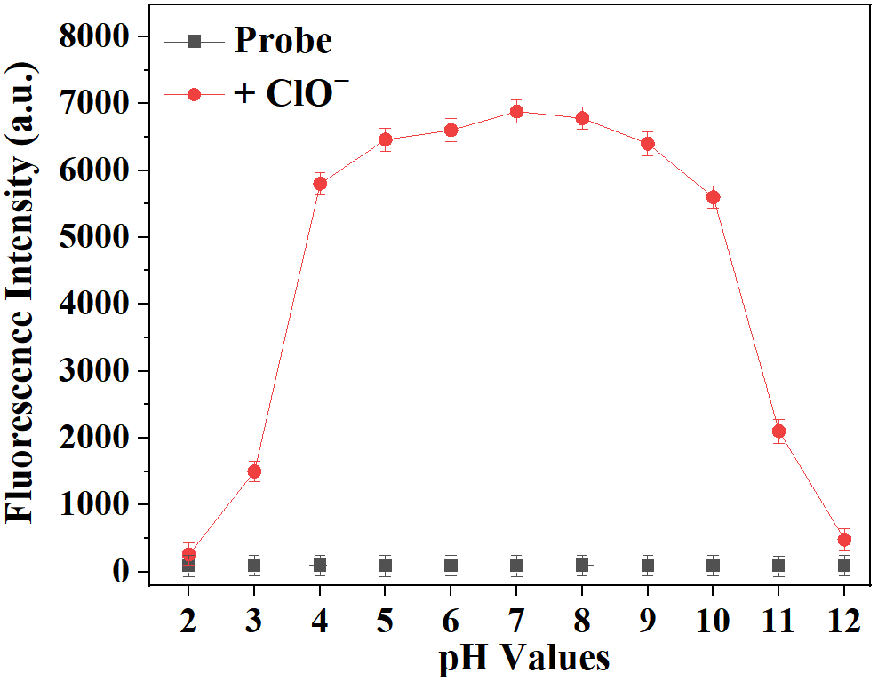

**Figure S4.** Fluorescence intensity changes of **XTAP**−**Bn** (5 μM) without and with ClO− (50 μM) under different pH conditions. For probe **XTAP**−**Bn** only: λex = 620 nm; λem =765 nm; For **XTAP**−**Bn** with ClO−:λex = 482 nm; λem = 558 nm. Error bars are ± SD (n = 3).

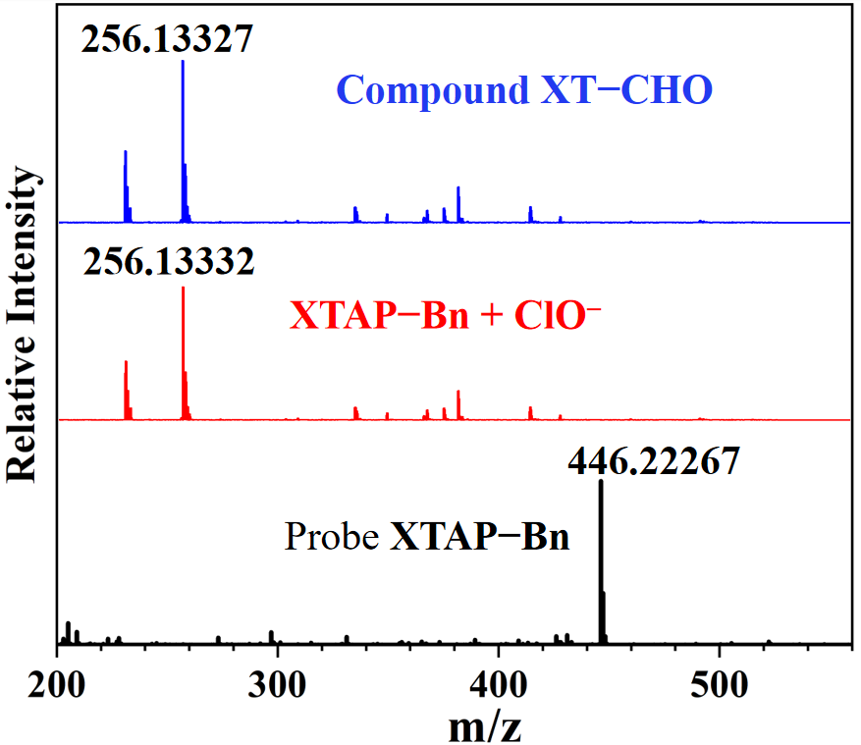

**Figure S5.** The HRMS data of **XTAP**−**Bn** without and withClO−, as well as compound **XT**−**CHO**.

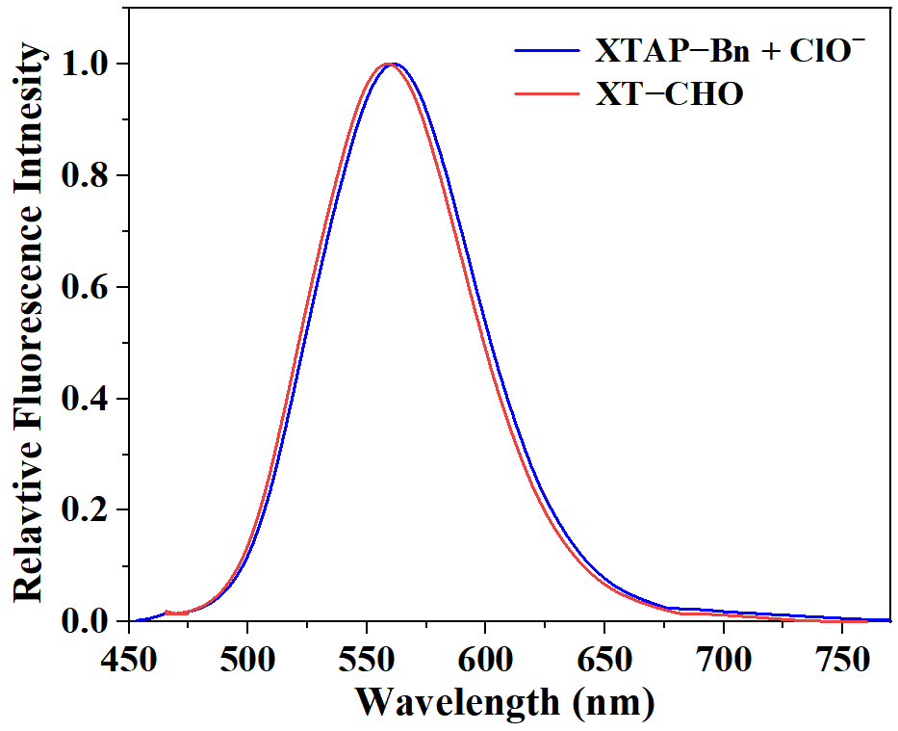

**Figure S6.** The fluorescence spectra of **XTAP**−**Bn** (5 μM) with ClO− (50 μM)and **XT**−**CHO** (5μM**)** in PBS buffer.

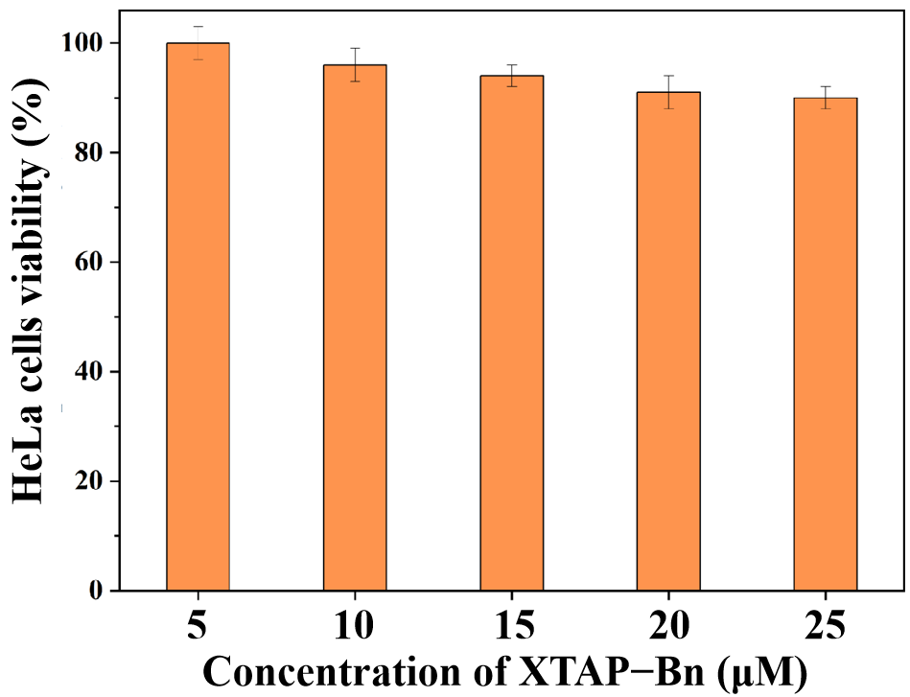

**Figure S7.** Viability of HeLa cells after the incubation with different concentrations of probe **XTAP**−**Bn**.

**1**

**Figure S8.** 1H NMR (400 MHz, DMSO-*d*6) spectrum of **XTAP.**

**图片2**

**Figure S9.** 13C NMR (100 MHz, DMSO-*d*6) spectrum of **XTAP.**

图片3

**Figure S10.** 1H NMR (400 MHz, DMSO-*d*6) spectrum of **XTAP**−**Bn.**

图片5

**Figure S11.** 13C NMR (100 MHz, DMSO-*d*6) spectrum of **XTAP**−**Bn.**

图片3

**Figure S12.** HRMS spectrum of **XTAP.**

图片4

**Figure S13.** HRMS spectrum of **XTAP**−**Bn.**