Supplementary Material for
Early-season mapping of winter canola by combining Sentinel-1 and Sentinel-2 data
Tingting Liu¹, Peipei Li ² , Feng Zhao ³ , Jie Liu¹ and Ran Meng^{1,4*}
¹ Artificial Intelligence Research Institute Co., Ltd, School of Computer Science and Technology, Harbin Institute of Technology, Harbin 150000, China; hzauliutingting@gmail.com
² College of Resources and Environment, Huazhong Agricultural University, Wuhan 430070, China; 18229880838@163.com
³ Key Laboratory of Sustainable Forest Ecosystem Management-Ministry of Education/College of Forestry, Northeast Forestry University, Harbin 150040, China; peakzhao424@hotmail.com
⁴ National Key Laboratory of Smart Farm Technologies and Systems, Harbin 150000, China;
* Correspondence: mengran@hit.edu.cn;
Table of contents
Table S1. 1
Table S2.. 2
Table S3 2
Figure of contents
Figure S1. 3
Figure S2.. 3
Figure S3.. 4
Figure S4. 4
Figure S5. 4

Table S1. Description of the number of Sentinel-1 satellite images used in the study.
Satellite platform | Image date | Image numbers | phenological stage
Sentinel-1 | 2016.12.01-2016.12.09 | 5 | Seeding
Sentinel-1 | 2016.12.20-2016.12.31 | 5 | Overwinter
Sentinel-1 | 2017.01.20-2017.01.31 | 5 | Early-bolting
Sentinel-1 | 2017.02.11-2017.02.20 | 5 | Later-bolting
Sentinel-1 | 2017.03.19-2017.03.30 | 6 | Flowering
Sentinel-1 | 2017.12.20-2017.12.31 | 6 | Overwinter
Sentinel-1 | 2019.1.20-2019.1.31 | 6 | Early-bolting
Sentinel-1 | 2019.12.20-2019.12.31 | 6 | Overwinter
Sentinel-1 | 2020.12.20-2020.12.31 | 5 | Overwinter
Sentinel-1 | 2021.12.20-2021.12.31 | 6 | Overwinter

Table S2. Description of the number of Sentinel-2 satellite images used in the study.
Satellite platform | Image date | Number of images (Before selecting) | Number of images  (After selecting)
Sentinel-2 | 2016.12.01-2016.12.09 | 28 | 22
Sentinel-2 | 2016.12.20-2016.12.31 | 13 | 11
Sentinel-2 | 2017.02.20-2017.02.28 | 18 | 13
Sentinel-2 | 2017.12.20-2017.12.31 | 31 | 20
Sentinel-2 | 2019.12.04-2019.12.31 | 135 | 42
Sentinel-2 | 2020.12.20-2021.1.12 | 102 | 58
Sentinel-2 | 2021.12.20-2021.12.31 | 60 | 42

Table S3 Spectral indexes
Spectral indexes | Formula | Citation
ARVI | (N-(2*R)+B)/(N+(2*R)+B) | (Pen Uelas et al. 1995)
DVI | N-R | (Jordan 1969)
GARI | (N-(G-1.7*(B-R)))/(N+(G-1.7*(B-R))) | (Gitelson et al. 1996)
GCI | N/G-1 | (Gitelson et al. 2002)
GLI | ((G-R)+(G-B))/((2*G)+R+B) | (Eng et al. 2019)
GNDVI | (N-G)/(N+G) | (Sripada 2005)
GOSAVI | (N-G)/(N+G+0.16) | (Tucker 1979)
GRVI | N/G | (Pearson and Miller 1972)
GSAVI | 1.5*(N-G)/(N+G+0.5) | (Crippen 1990)
IPVI | N/(N+R) | (Ruimy et al. 1994)
NDWI | (G-N)/(G+N) | (Broge and Leblanc 2001)
NDYI | (G-B)/(G+B) | (Sulik and Long 2015)
RVI | N/R | (Gao 1996)
SAVI | (1.5*(N-R))/(N+R+0.5) | (Bannari et al. 2002)
SIPI | (N-B)/(N-R) | (Vapnik 1999)
Canola Index (CI) | N * (R + G) | (Ashourloo et al. 2019)
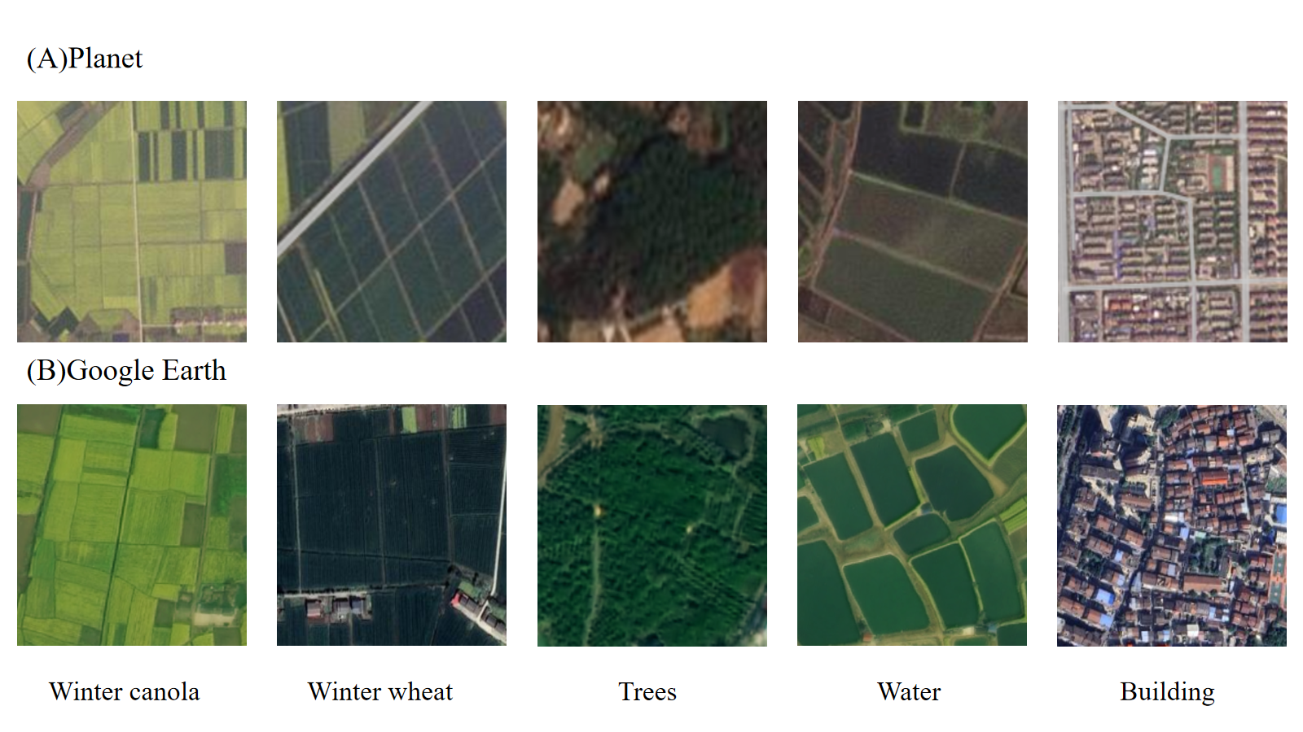
Figure S1. Five sample images from Planet and Google Earth
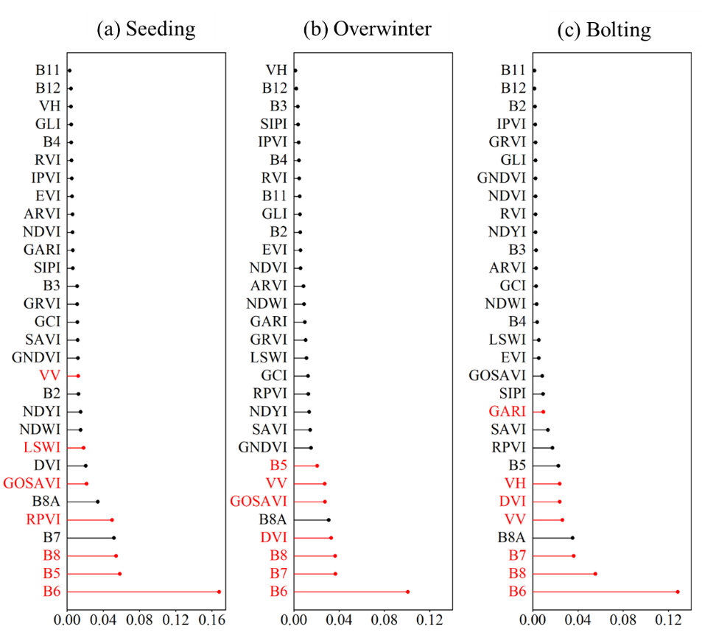
Figure S2. Importance of features at different winter canola phenological stages based on Sentinel-2 and Sentinel-1.
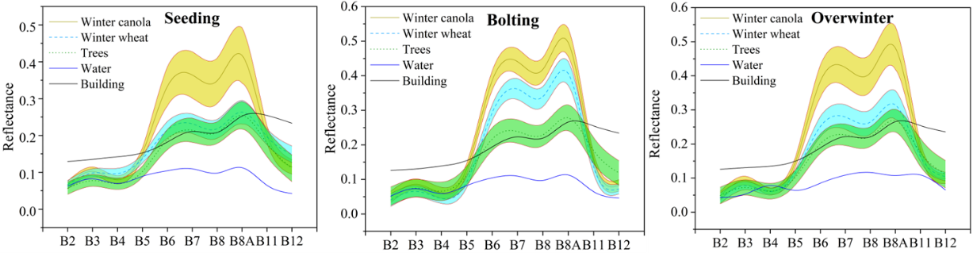
Figure S3. Spectral curves of different land types at different phenological stages.
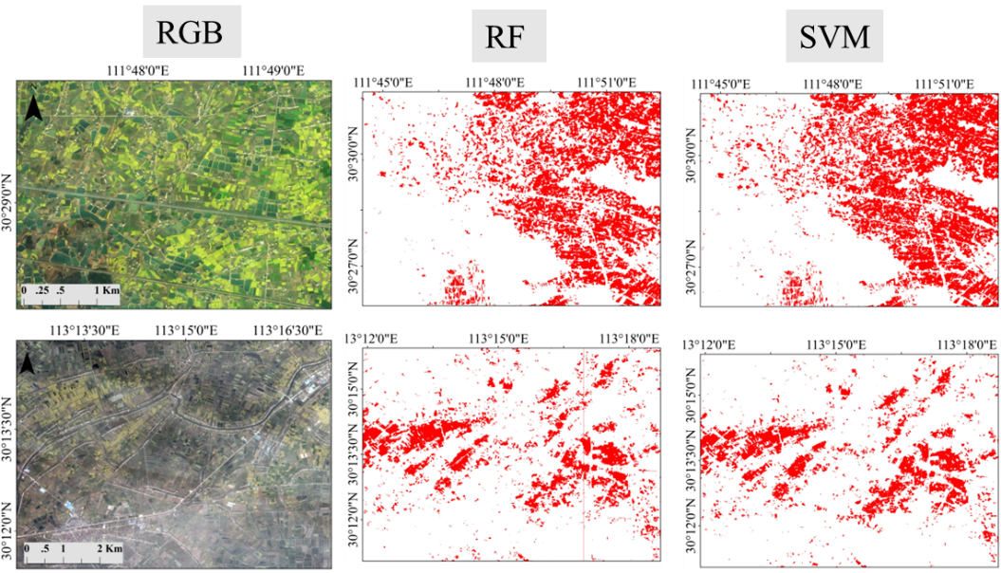
Figure S4. The spatial details of the winter canola map at the overwinter stage in 2017
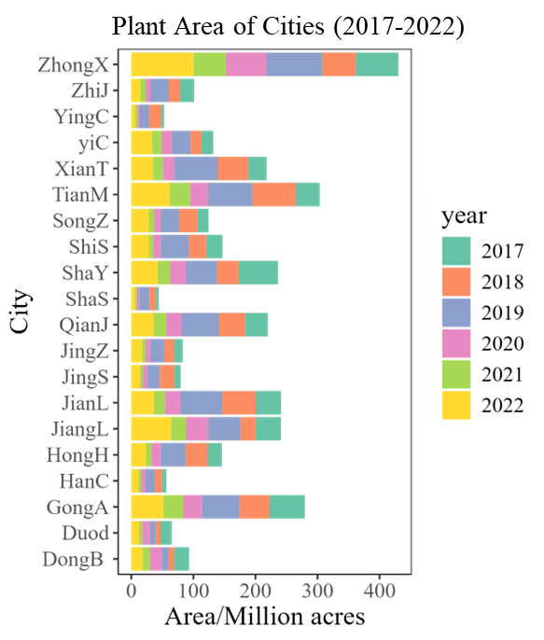
Figure S5. Winter canola area in each city of Jianghan Plain in 2017–2022.
References
- Ashourloo, D., Shahrabi, H.S., Azadbakht, M., Aghighi, H., Nematollahi, H., Alimohammadi, A., & Matkan, A.A. (2019). Automatic canola mapping using time series of sentinel 2 images. ISPRS Journal of Photogrammetry and Remote Sensing, 156, 63-76
- Bannari, A., Asalhi, H., & Teillet, P.M. (2002). Transformed difference vegetation index (TDVI) for vegetation cover mapping. In, IEEE International geoscience and remote sensing symposium (pp. 3053-3055). Toronto, ON, Canada: IEEE
- Broge, N.H., & Leblanc, E. (2001). Comparing prediction power and stability of broadband and hyperspectral vegetation indices for estimation of green leaf area index and canopy chlorophyll density. Remote sensing of environment, 76, 156-172
- Crippen, R.E. (1990). Calculating the vegetation index faster. Remote sensing of environment, 34, 71-73
- Eng, L.S., Ismail, R., Hashim, W., & Baharum, A. (2019). The use of VARI, GLI, and VIgreen formulas in detecting vegetation in aerial images. International Journal of Technology, 10, 1385-1394
- Gao, B.C. (1996). NDWI—A normalized difference water index for remote sensing of vegetation liquid water from space. Remote sensing of environment, 58, 257-266
- Gitelson, A.A., Kaufman, Y.J., & Merzlyak, M.N. (1996). Use of a green channel in remote sensing of global vegetation from EOS-MODIS. Remote sensing of environment, 58, 289-298
- Gitelson, A.A., Kaufman, Y.J., Stark, R., & Rundquist, D. (2002). Novel algorithms for remote estimation of vegetation fraction. Remote sensing of environment, 80, 76-87
- Jordan, C.F. (1969). Derivation of leaf‐area index from quality of light on the forest floor. Ecology, 50, 663-666
- Pearson, R.L., & Miller, L.D. (1972). Remote mapping of standing crop biomass for estimation of the productivity of the shortgrass prairie. Remote sensing of environment, 1355
- Pen Uelas, J., Filella, I., Lloret, P., Mun Oz, F., & Vilajeliu, M. (1995). Reflectance assessment of mite effects on apple trees. International Journal of Remote Sensing, 16, 2727-2733
- Ruimy, A., Saugier, B., & Dedieu, G. (1994). Methodology for the estimation of terrestrial net primary production from remotely sensed data. Journal of Geophysical Research: Atmospheres, 99, 5263-5283
- Sripada, R.P. (2005). Determining in-season nitrogen requirements for corn using aerial color-infrared photography. North Carolina State University
- Sulik, J.J., & Long, D.S. (2015). Spectral indices for yellow canola flowers. International Journal of Remote Sensing, 36, 2751-2765
- Tucker, C.J. (1979). Red and photographic infrared linear combinations for monitoring vegetation. Remote sensing of environment, 8, 127-150
- Vapnik, V.N. (1999). An overview of statistical learning theory. IEEE transactions on neural networks, 10, 988-999

