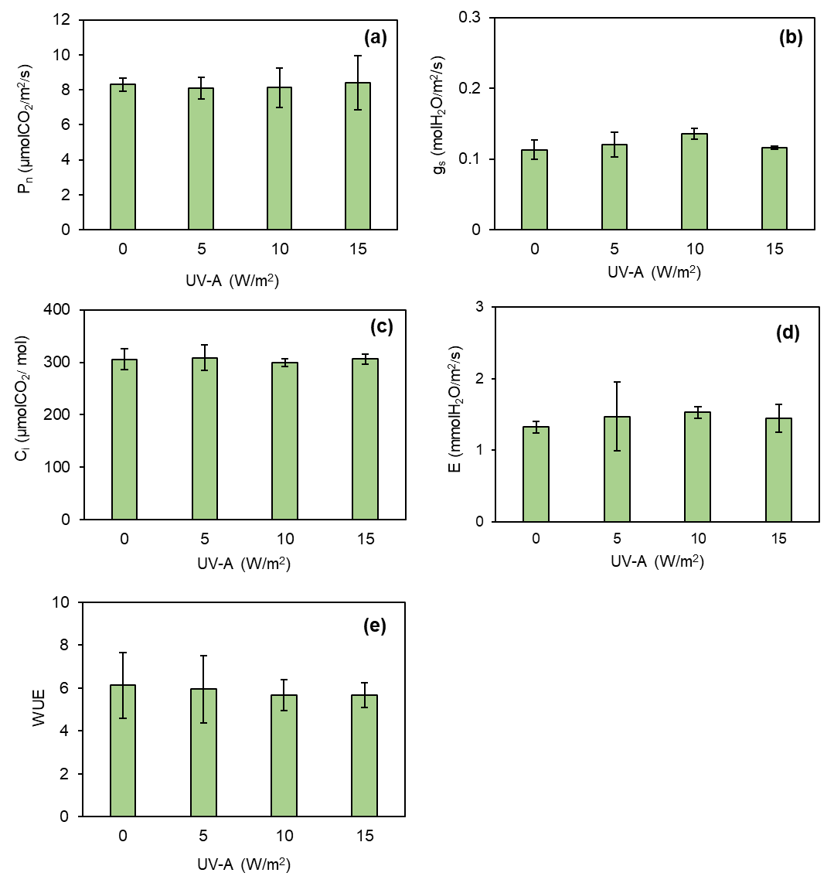
Figure S1. Changes in the gas exchange parameters; net photosynthetic rate (P_{n}) (a), stomatal conductance (g_{s}) (b), intercellular CO₂ concentration (C_{i}) (c), transpiration rate (E) (d), and water use efficiency (WUE) (e) of kale before treating with different levels of UV-A. Means with the same letter are not significantly different according to Tukey's HSD test at p < 0.05. Data are means ± SD shown by vertical error bars.

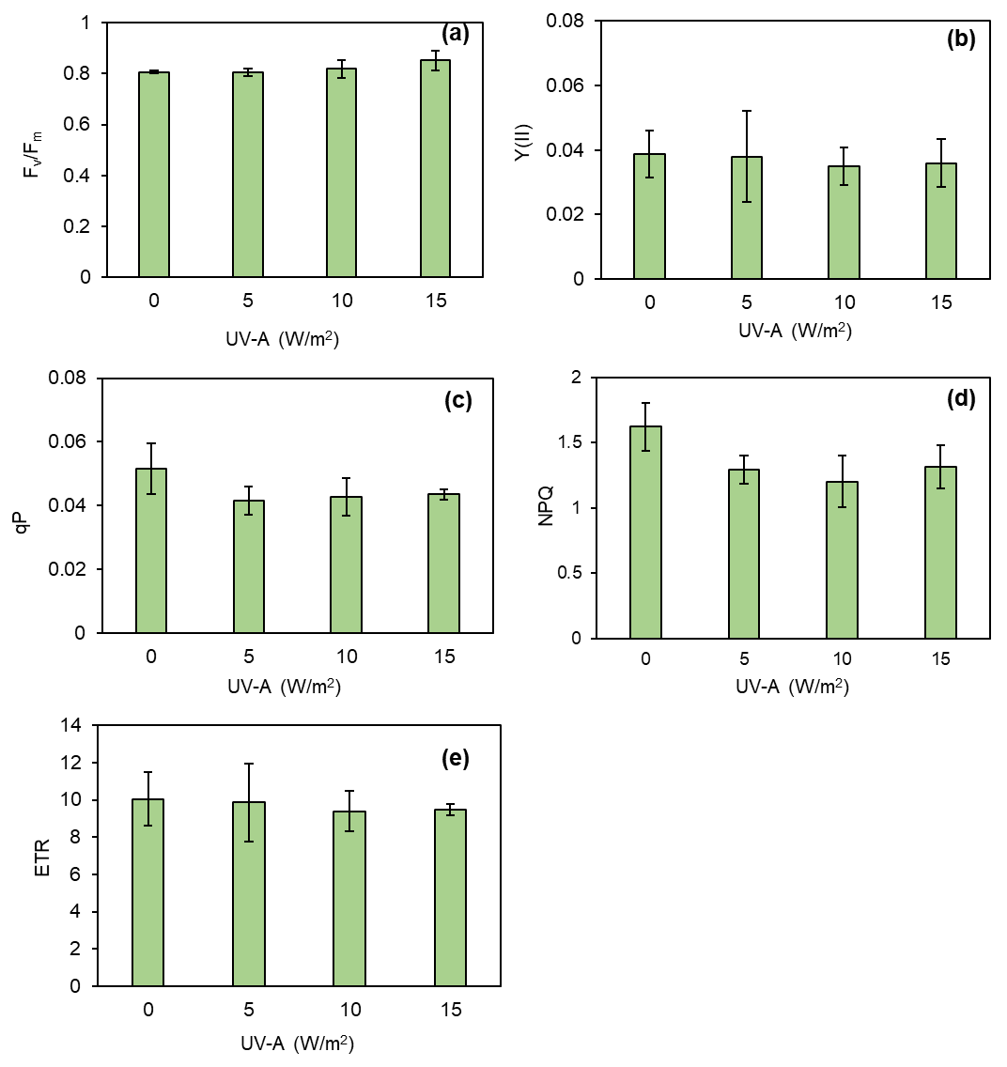
Figure S2. Changes in the quantum efficiency parameters; maximum quantum yield of PSII (F_{v} /F_{m}) (a), quantum efficiency of photosystem II (Y(II)) (b), photochemical quenching (qP) (c), non-photochemical quenching (NPQ) (d), and electron transport rate (e) of kale before treating with different levels of UV-A. Means with the same letter are not significantly different according to Tukey's HSD test at p < 0.05. Data are means ± SD shown by vertical error bars.

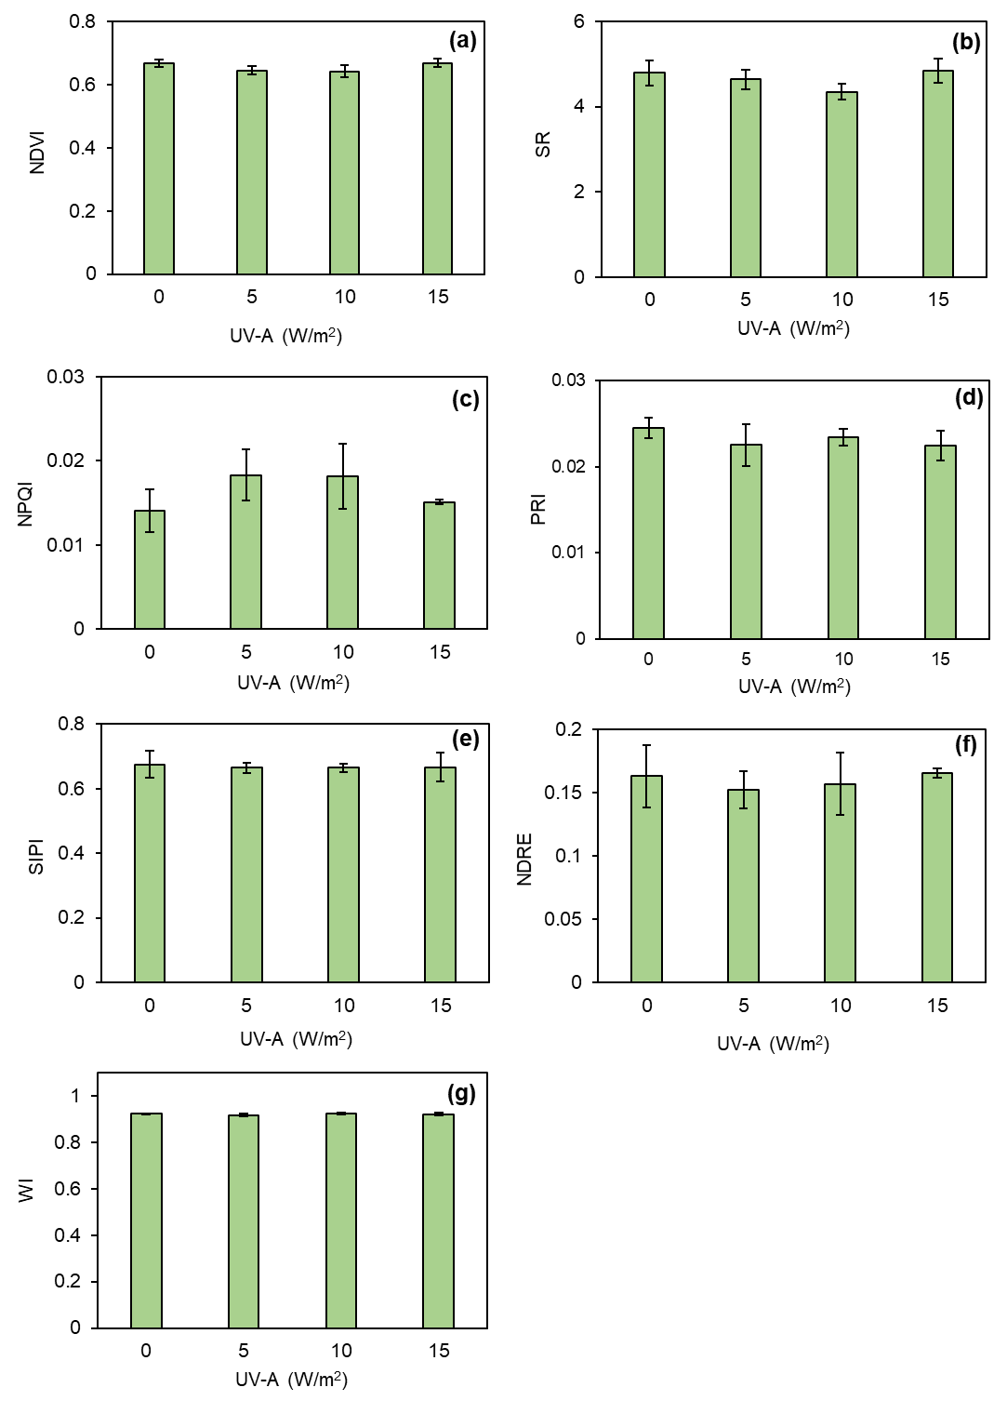
Figure S3. Changes in spectral indices; normalized difference vegetation index (NDVI) (a), simple ratio index (SR)) (b), normalized phaeophytinization index (NPQI) (c), photochemical reflectance index (PRI) (d), structure insensitive pigment index (SIPI) (e), normalized difference red edge index (NDRE) (f), and water index (WI) (g) of kale before treating with different levels of UV-A. Means with the same letter are not significantly different according to Tukey's HSD test at p < 0.05. Data are means ± SD shown by vertical error bars.
Table S1. Agronomic traits of kale at 14 days before treating with different levels of UV-A
UV-A (w/m²) | Fresh weight (g) | Stem height (cm) | Canopy width (cm) | Stem diameter (mm) | Number of leaves | Leaf greenness index (SPAD unit)
0 | 40.22 ± 7.41 | 26.17 ± 2.48 b | 30.10 ± 2.60 | 7.68 ± 1.08 | 9.83 ± 0.41 | 47.45 ± 1.87
5 | 46.79 ± 6.13 | 31.20 ± 2.04 a | 33.70 ± 3.19 | 9.12 ± 1.43 | 9.67 ± 1.21 | 44.55 ± 2.11
10 | 40.84 ± 7.17 | 28.33 ± 3.14 ab | 30.42 ± 2.44 | 7.66 ± 1.37 | 8.33 ± 0.52 | 46.65 ± 5.13
15 | 45.32 ± 5.98 | 31.33 ± 2.07 a | 32.79 ± 3.99 | 9.46 ± 1.34 | 9.40 ± 1.20 | 45.67 ± 2.85
Sig. | ns | ** | ns | ns | ns | ns
Data are means ± SD. Means with same lowercase letter are not significantly different according to Tukey’s HSD test. ns and ** indicate not significantly different at p < 0.05 and significantly different at p < 0.01, respectively.

