Impact of Hydroxyapatite on Gelatin/Oxidized Alginate 3D-Printed Cryogel Scaffolds
Supporting Information
Ainur Zhanbassynova¹, Fariza Mukasheva¹, Madi Abilev¹, Dmitriy Berillo², Alexander Trifonov¹, and Dana Akilbekova¹*

¹Department of Chemical and Materials Engineering, School of Engineering and Digital Sciences, Nazarba-yev University, 010000 Astana, Kazakhstan.
²Department of Chemistry and Biochemical Engineering, Satbayev University, 050013 Almaty, Kazakhstan.

*Corresponding author, email: dana.akilbekova@nu.edu.kz

Keywords: 3D printing, cryogelation, hydroxyapatite, stem cells, bone tissue engineering.

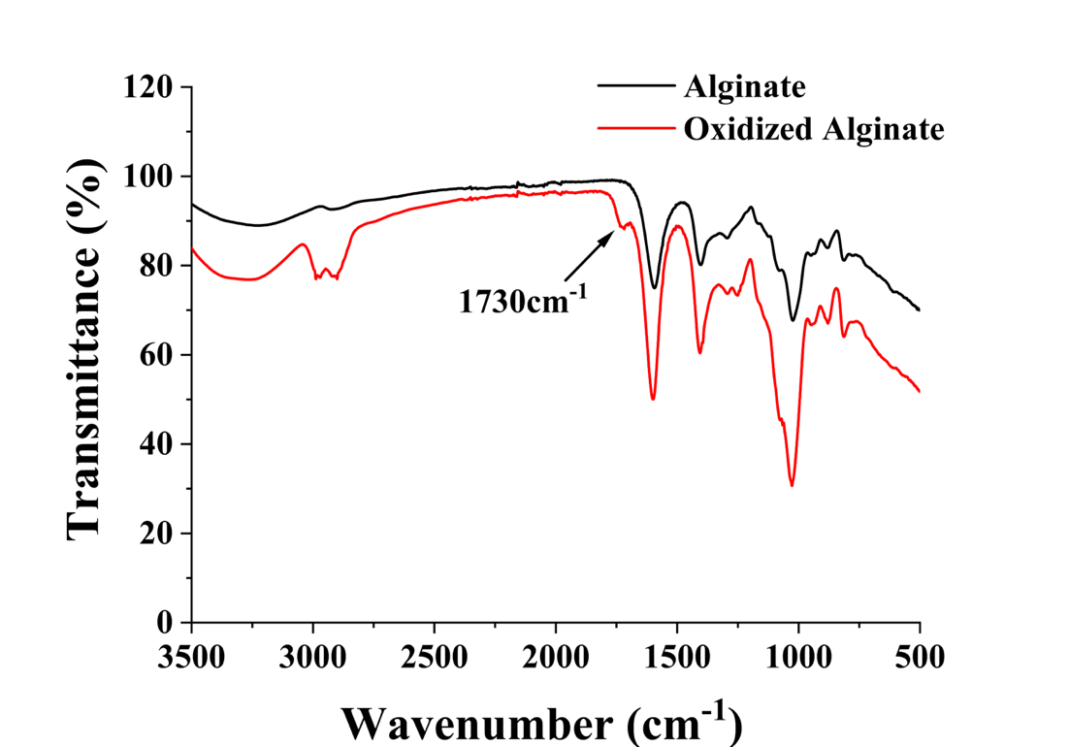

Figure S1: FTIR spectra of both oxidized and untreated alginate are shown. The arrow points to the 1730 cm⁻¹ region, which corresponds to the C=O bond stretching in the aldehyde group, signifying the successful synthesis of oxidized alginate.

