**Table S1.** LC-ESI-Q-IMS-qToF based identification of organosulfur compounds on red onion variety.

|  |  |  |  |  |  |  |
| --- | --- | --- | --- | --- | --- | --- |
| **N°** | **Compounds** | **Retention time (min)** | **Ion formulae** | **Measured *m/z*** | **Calculated *m/z*** | **Absolute error δ (ppm)** |
| 1 | Propiin | 2.942 | C6H14NO3S+ | 180.0681 | 180.0694 | 7.2 |
| 2 | Methiin | - | C4H10NO3S+ | - | 152.0381 | - |
| 3 | S-Methyl cysteine | 3.465 | C4H10NO2S+ | 136.0432 | 136.0432 | 0.0 |
| 4 | γ-Glutamyl-S-methyl cysteine | 3.465 | C9H17N2O5S+ | 265.0851 | 265.0858 | 2.6 |
| 5 | Isoaliin | 3.840 | C6H12NO3S+ | 178.0529 | 178.0538 | 5.1 |
| 6 | γ-Glutamyl-S-(1-propenyl) cysteine sulfoxide | 3.803 | C11H19N2O6S+ | 307.0946 | 307.0964 | 5.9 |
| 7 | S-(2-carboxypropil) cysteine-glycine | - | C9H17N2O5S+ | - | 265.0858 | - |
| 8 | γ-Glutamyl-S-propyl cysteine sulfoxide | 4.006 | C11H21N2O6S+ | 309.1130 | 309.1120 | 3.2 |
| 9 | γ–Glutamyl-S-(2-carboxypropyl) cysteine glycine | 3.580 | C14H24N3O8S+ | 394.1268 | 394.1284 | 4.1 |
| 10 | γ–Glutamyl-S-(2-carboxypropyl) cysteine glycine hexoside | 3.790 | C20H34N3O13S+ | 556.1804 | 556.1812 | 1.4 |
| 11 | γ–Glutamyl-S-(2-carboxypropyl) cysteine | 3.940 | C12H21N2O7S+ | 337.1050 | 337.1069 | 5.9 |
| 12 | S-(2-carboxypropyl) cysteine | 3.940 | C7H14NO4S+ | 208.0641 | 208.0643 | 1.0 |
| 13 | S-Propyl cysteine | 4.006 | C6H14NO2S+ | 164.0731 | 164.0745 | 8.5 |
| 14 | γ-Glutamyl-S-propyl cysteine | 4.006 | C11H21N2O5S+ | 293.1157 | 293.1171 | 4.8 |
| 15 | S-(1-Propenyl) cysteine | 5.359 | C6H12NO2S+ | 162.0580 | 162.0589 | 5.5 |
| 16 | γ-Glutamyl-S-(1-propenyl) cysteine | 5.359 | C11H19N2O5S+ | 291.1004 | 291.1015 | 3.8 |
| 17 | γ–Glutamyl-S-(S-1-propenyl)cysteine glycine | 7.880 | C13H22N3O6S2+ | 380.0938 | 380.0950 | 3.2 |
| 18 | γ–Glutamyl-S-(S-propyl)cysteine-glycine | 8.960 | C13H24N3O6S2+ | 382.1081 | 382.1107 | 6.8 |

**Table S2.** LC-ESI-Q-IMS-qToF based identification of organosulfur compounds on shallot sample.

|  |  |  |  |  |  |  |
| --- | --- | --- | --- | --- | --- | --- |
| **N°** | **Compounds** | **Retention time (min)** | **Ion formulae** | **Measured *m/z*** | **Calculated *m/z*** | **Absolute error δ (ppm)** |
| 1 | Propiin | 2.908 | C6H14NO3S+ | 180.0694 | 180.0694 | 0.0 |
| 2 | Methiin | - | C4H10NO3S+ | - | 152.0381 | - |
| 3 | S-Methyl cysteine | - | C4H10NO2S+ | - | 136.0432 | - |
| 4 | γ-Glutamyl-S-methyl cysteine | - | C9H17N2O5S+ | - | 265.0858 | - |
| 5 | Isoaliin | - | C6H12NO3S+ | - | 178.0538 | - |
| 6 | γ-Glutamyl-S-(1-propenyl) cysteine sulfoxide | - | C11H19N2O6S+ | - | 307.0964 | - |
| 7 | S-(2-carboxypropil) cysteine-glycine | - | C9H17N2O5S+ | - | 265.0858 | - |
| 8 | γ-Glutamyl-S-propyl cysteine sulfoxide | - | C11H21N2O6S+ | - | 309.1120 | - |
| 9 | γ–Glutamyl-S-(2-carboxypropyl) cysteine glycine | - | C14H24N3O8S+ | - | 394.1284 | - |
| 10 | γ–Glutamyl-S-(2-carboxypropyl) cysteine glycine hexoside | - | C20H34N3O13S+ | - | 556.1812 | - |
| 11 | S-(2-carboxypropyl) cysteine | - | C7H14NO4S+ | - | 208.0643 | - |
| 12 | γ–Glutamyl-S-(2-carboxypropyl) cysteine | - | C12H21N2O7S+ | - | 337.1069 | - |
| 13 | S-Propyl cysteine | 3.821 | C6H14NO2S+ | 164.0740 | 164.0745 | 3.0 |
| 14 | γ-Glutamyl-S-propyl cysteine | 3.973 | C11H21N2O5S+ | 293.1161 | 293.1171 | 3.4 |
| 15 | S-(1-Propenyl) cysteine | - | C6H12NO2S+ | - | 162.0589 | - |
| 16 | γ-Glutamyl-S-(1-propenyl) cysteine | - | C11H19N2O5S+ | - | 291.1015 | - |
| 17 | γ–Glutamyl-S-(S-1-propenyl)cysteine glycine | - | C13H22N3O6S2+ | - | 380.0950 | - |
| 18 | γ–Glutamyl-S-(S-propyl)cysteine-glycine | - | C13H24N3O6S2+ | - | 382.1107 | - |

**Table S3.** LC-ESI-Q-IMS-qToF based identification of organosulfur compounds on red label onion variety.

|  |  |  |  |  |  |  |
| --- | --- | --- | --- | --- | --- | --- |
| **N°** | **Compounds** | **Retention time (min)** | **Ion formulae** | **Measured *m/z*** | **Calculated *m/z*** | **Absolute error δ (ppm)** |
| 1 | Propiin | 2.941 | C6H14NO3S+ | 180.0694 | 180.0694 | 0.9 |
| 2 | Methiin | - | C4H10NO3S+ | - | 152.0381 | - |
| 3 | S-Methyl cysteine | - | C4H10NO2S+ | - | 136.0432 | - |
| 4 | γ-Glutamyl-S-methyl cysteine | - | C9H17N2O5S+ | - | 265.0858 | - |
| 5 | Isoaliin | - | C6H12NO3S+ | - | 178.0538 | - |
| 6 | γ-Glutamyl-S-(1-propenyl) cysteine sulfoxide | - | C11H19N2O6S+ | - | 307.0964 | - |
| 7 | S-(2-carboxypropil) cysteine-glycine | - | C9H17N2O5S+ | - | 265.0858 | - |
| 8 | γ-Glutamyl-S-propyl cysteine sulfoxide | - | C11H21N2O6S+ | - | 309.1120 | - |
| 9 | γ–Glutamyl-S-(2-carboxypropyl) cysteine glycine | - | C14H24N3O8S+ | - | 394.1284 | - |
| 10 | γ–Glutamyl-S-(2-carboxypropyl) cysteine glycine hexoside | - | C20H34N3O13S+ | - | 556.1812 | - |
| 11 | S-(2-carboxypropyl) cysteine | - | C7H14NO4S+ | - | 208.0643 | - |
| 12 | γ–Glutamyl-S-(2-carboxypropyl) cysteine | - | C12H21N2O7S+ | - | 337.1069 | - |
| 13 | S-Propyl cysteine | 3.854 | C6H14NO2S+ | 164.0740 | 164.0745 | 3.0 |
| 14 | γ-Glutamyl-S-propyl cysteine | 3.904 | C11H21N2O5S+ | 293.1175 | 293.1171 | 2.4 |
| 15 | S-(1-Propenyl) cysteine | - | C6H12NO2S+ | - | 162.0589 | - |
| 16 | γ-Glutamyl-S-(1-propenyl) cysteine | - | C11H19N2O5S+ | - | 291.1015 | - |
| 17 | γ–Glutamyl-S-(S-1-propenyl)cysteine glycine | - | C13H22N3O6S2+ | - | 380.0950 | - |
| 18 | γ–Glutamyl-S-(S-propyl)cysteine-glycine | - | C13H24N3O6S2+ | - | 382.1107 | - |

**Table S4.** LC-ESI-Q-IMS-qToF based identification of organosulfur compounds on yellow onion variety.

|  |  |  |  |  |  |  |
| --- | --- | --- | --- | --- | --- | --- |
| **N°** | **Compounds** | **Retention time (min)** | **Ion formulae** | **Measured *m/z*** | **Calculated *m/z*** | **Absolute error δ (ppm)** |
| 1 | Propiin | 2.992 | C6H14NO3S+ | 180.0694 | 180.0694 | 0.0 |
| 2 | Methiin | 3.161 | C4H10NO3S+ | 152.0382 | 152.0381 | 0.7 |
| 3 | S-Methyl cysteine | 3.482 | C4H10NO2S+ | 136.0434 | 136.0432 | 1.5 |
| 4 | γ-Glutamyl-S-methyl cysteine | 3.431 | C9H17N2O5S+ | 265.0862 | 265.0858 | 1.5 |
| 5 | γ-Glutamyl-S-propyl cysteine sulfoxide | 3.533 | C11H21N2O6S+ | 309.1131 | 309.1120 | 3.6 |
| 6 | Isoaliin | 3.499 | C6H12NO3S+ | 178.0542 | 178.0538 | 2.2 |
| 7 | S-(2-carboxypropil) cysteine-glycine | 3.533 | C9H17N2O5S+ | 265.0862 | 265.0858 | 1.5 |
| 8 | γ-Glutamyl-S-(1-propenyl) cysteine sulfoxide | 3.499 | C11H19N2O6S+ | 307.0967 | 307.0964 | 1.0 |
| 9 | γ–Glutamyl-S-(2-carboxypropyl) cysteine glycine | 3.530 | C14H24N3O8S+ | 394.1297 | 394.1284 | 3.3 |
| 10 | γ–Glutamyl-S-(2-carboxypropyl) cysteine glycine hexoside | 3.620 | C20H34N3O13S+ | 556.1819 | 556.1812 | 1.3 |
| 11 | S-(2-carboxypropyl) cysteine | 3.680 | C7H14NO4S+ | 208.0639 | 208.0643 | 1.9 |
| 12 | γ–Glutamyl-S-(2-carboxypropyl) cysteine | 3.680 | C12H21N2O7S+ | 337.1080 | 337.1069 | 2.7 |
| 13 | S-Propyl cysteine | 4.395 | C6H14NO2S+ | 164.0740 | 164.0745 | 3.0 |
| 14 | γ-Glutamyl-S-propyl cysteine | 4.344 | C11H21N2O5S+ | 293.1175 | 293.1171 | 1.4 |
| 15 | S-(1-Propenyl) cysteine | 5.054 | C6H12NO2S+ | 162.0589 | 162.0589 | 0.0 |
| 16 | γ-Glutamyl-S-(1-propenyl) cysteine | 5.223 | C11H19N2O5S+ | 291.1021 | 291.1015 | 2.1 |
| 17 | γ–Glutamyl-S-(S-1-propenyl)cysteine glycine | 8.270 | C13H22N3O6S2+ | 380.0949 | 380.0950 | 0.3 |
| 18 | γ–Glutamyl-S-(S-propyl)cysteine-glycine | 9.095 | C13H24N3O6S2+ | 382.1122 | 382.1107 | 6.8 |

**Table S5.** LC-ESI-Q-IMS-qToF based identification of organosulfur compounds on white onion variety.

|  |  |  |  |  |  |  |
| --- | --- | --- | --- | --- | --- | --- |
| **N°** | **Compounds** | **Retention time (min)** | **Ion formulae** | **Measured *m/z*** | **Calculated *m/z*** | **Absolute error δ (ppm)** |
| 1 | Propiin | 2.873 | C6H14NO3S+ | 180.0694 | 180.0694 | 0.0 |
| 2 | Methiin | 2.431 | C4H10NO3S+ | 152.0372 | 152.0381 | 5.9 |
| 3 | S-Methyl cysteine | - | C4H10NO2S+ | - | 136.0432 | - |
| 4 | γ-Glutamyl-S-methyl cysteine | - | C9H17N2O5S+ | - | 265.0858 | - |
| 5 | Isoaliin | - | C6H12NO3S+ | - | 178.0538 | - |
| 6 | γ-Glutamyl-S-(1-propenyl) cysteine sulfoxide | - | C11H19N2O6S+ | - | 307.0964 | - |
| 7 | S-(2-carboxypropil) cysteine-glycine | - | C9H17N2O5S+ | - | 265.0858 | - |
| 8 | γ-Glutamyl-S-propyl cysteine sulfoxide | - | C11H21N2O6S+ | - | 309.1120 | - |
| 9 | γ–Glutamyl-S-(2-carboxypropyl) cysteine glycine | - | C14H24N3O8S+ | - | 394.1284 | - |
| 10 | γ–Glutamyl-S-(2-carboxypropyl) cysteine glycine hexoside | - | C20H34N3O13S+ | - | 556.1812 | - |
| 11 | S-(2-carboxypropyl) cysteine | - | C7H14NO4S+ | - | 208.0643 | - |
| 12 | γ–Glutamyl-S-(2-carboxypropyl) cysteine | 3.670 | C12H21N2O7S+ | 337.1080 | 337.1069 | 2.7 |
| 13 | S-Propyl cysteine | 3.736 | C6H14NO2S+ | 164.0740 | 164.0745 | 3.0 |
| 14 | γ-Glutamyl-S-propyl cysteine | 3.769 | C11H21N2O5S+ | 293.1175 | 293.1171 | 1.4 |
| 15 | S-(1-Propenyl) cysteine | - | C6H12NO2S+ | - | 162.0589 | - |
| 16 | γ-Glutamyl-S-(1-propenyl) cysteine | - | C11H19N2O5S+ | - | 291.1015 | - |
| 17 | γ–Glutamyl-S-(S-1-propenyl)cysteine glycine | - | C13H22N3O6S2+ | - | 380.0950 | - |
| 18 | γ–Glutamyl-S-(S-propyl)cysteine-glycine | - | C13H24N3O6S2+ | - | 382.1107 | - |

**Table S6.** LC-ESI-Q-IMS-qToF based identification of organosulfur compounds on sweet onion variety.

|  |  |  |  |  |  |  |
| --- | --- | --- | --- | --- | --- | --- |
| **N°** | **Compounds** | **Retention time (min)** | **Ion formulae** | **Measured *m/z*** | **Calculated *m/z*** | **Absolute error δ (ppm)** |
| 1 | Propiin | 2.908 | C6H14NO3S+ | 180.0694 | 180.0694 | 0.0 |
| 2 | Methiin | 2.282 | C4H10NO3S+ | 152.0391 | 152.0381 | 6.6 |
| 3 | S-Methyl cysteine | 3.415 | C4H10NO2S+ | 136.0434 | 136.0432 | 1.5 |
| 4 | γ-Glutamyl-S-methyl cysteine | 3.381 | C9H17N2O5S+ | 265.0863 | 265.0858 | 1.9 |
| 5 | Isoaliin | 3.466 | C6H12NO3S+ | 178.0541 | 178.0538 | 1.7 |
| 6 | γ-Glutamyl-S-(1-propenyl) cysteine sulfoxide | 3.466 | C11H19N2O6S+ | 307.0981 | 307.0964 | 5.5 |
| 7 | S-(2-carboxypropil) cysteine-glycine | 3.466 | C9H17N2O5S+ | 265.0863 | 265.0858 | 1.9 |
| 8 | γ-Glutamyl-S-propyl cysteine sulfoxide | 3.466 | C11H21N2O6S+ | 309.1131 | 309.1120 | 3.6 |
| 9 | γ–Glutamyl-S-(2-carboxypropyl) cysteine glycine | 3.480 | C14H24N3O8S+ | 394.1312 | 394.1284 | 7.1 |
| 10 | γ–Glutamyl-S-(2-carboxypropyl) cysteine glycine hexoside | 3.580 | C20H34N3O13S+ | 556.1816 | 556.1812 | 0.7 |
| 11 | S-(2-carboxypropyl) cysteine | 3.650 | C7H14NO4S+ | 208.0651 | 208.0643 | 3.8 |
| 12 | γ–Glutamyl-S-(2-carboxypropyl) cysteine | 3.670 | C12H21N2O7S+ | 337.1080 | 337.1069 | 2.7 |
| 13 | S-Propyl cysteine | 4.328 | C6H14NO2S+ | 164.0750 | 164.0745 | 3.0 |
| 14 | γ-Glutamyl-S-propyl cysteine | 4.277 | C11H21N2O5S+ | 293.1175 | 293.1171 | 1.4 |
| 15 | S-(1-Propenyl) cysteine | 5.207 | C6H12NO2S+ | 162.0588 | 162.0589 | 0.6 |
| 16 | γ-Glutamyl-S-(1-propenyl) cysteine | 5.004 | C11H19N2O5S+ | 291.1021 | 291.1015 | 2.1 |
| 17 | γ–Glutamyl-S-(S-1-propenyl)cysteine glycine | 8.250 | C13H22N3O6S2+ | 380.0948 | 380.0950 | 0.5 |
| 18 | γ–Glutamyl-S-(S-propyl)cysteine-glycine | 9.095 | C13H24N3O6S2+ | 382.1122 | 382.1107 | 3.9 |

|  |  |  |  |  |  |  |  |
| --- | --- | --- | --- | --- | --- | --- | --- |
| **N°** | **Compounds** | **Retention time (min)** |  | **Ion formulae** | **Measured *m/z*** | **Calculated *m/z*** | **Absolute error δ (ppm)** |
| 1 | Propiin | 2.976 |  | C6H14NO3S+ | 180.0704 | 180.0694 | 5.6 |
| 2 | Methiin | 2.265 |  | C4H10NO3S+ | 152.0391 | 152.0381 | 6.6 |
| 3 | S-Methyl cysteine | 3.466 |  | C4H10NO2S+ | 136.0434 | 136.0432 | 1.5 |
| 4 | γ-Glutamyl-S-methyl cysteine | 3.398 |  | C9H17N2O5S+ | 265.0876 | 265.0858 | 6.8 |
| 5 | Isoaliin | 3.466 |  | C6H12NO3S+ | 178.0552 | 178.0538 | 7.9 |
| 6 | γ-Glutamyl-S-(1-propenyl) cysteine sulfoxide | 3.466 |  | C11H19N2O6S+ | 307.0981 | 307.0964 | 5.5 |
| 7 | S-(2-carboxypropil) cysteine-glycine | 3.466 |  | C9H17N2O5S+ | 265.0876 | 265.0858 | 6.8 |
| 8 | γ-Glutamyl-S-propyl cysteine sulfoxide | 3.466 |  | C11H21N2O6S+ | 309.1131 | 309.1120 | 3.6 |
| 9 | γ–Glutamyl-S-(2-carboxypropyl) cysteine glycine | 3.500 |  | C14H24N3O8S+ | 394.1297 | 394.1284 | 7.1 |
| 10 | γ–Glutamyl-S-(2-carboxypropyl) cysteine glycine hexoside | 3.600 |  | C20H34N3O13S+ | 556.1854 | 556.1812 | 7.6 |
| 11 | S-(2-carboxypropyl) cysteine | 3.650 |  | C7H14NO4S+ | 208.0662 | 208.0643 | 9.1 |
| 12 | γ–Glutamyl-S-(2-carboxypropyl) cysteine | 3.670 |  | C12H21N2O7S+ | 337.1080 | 337.1069 | 2.7 |
| 13 | S-Propyl cysteine | 4.261 |  | C6H14NO2S+ | 164.0760 | 164.0745 | 9.1 |
| 14 | γ-Glutamyl-S-propyl cysteine | 4.261 |  | C11H21N2O5S+ | 293.1175 | 293.1171 | 1.4 |
| 15 | S-(1-Propenyl) cysteine | 5.207 |  | C6H12NO2S+ | 162.0598 | 162.0589 | 5.6 |
| 16 | γ-Glutamyl-S-(1-propenyl) cysteine | 5.055 |  | C11H19N2O5S+ | 291.1035 | 291.1015 | 6.9 |
| 17 | γ–Glutamyl-S-(S-1-propenyl)cysteine glycine | 8.300 |  | C13H22N3O6S2+ | 380.0979 | 380.0950 | 7.6 |
| 18 | γ–Glutamyl-S-(S-propyl)cysteine-glycine | 9.214 |  | C13H24N3O6S2+ | 382.1122 | 382.1107 | 3.9 |

**Table S7.** LC-ESI-Q-IMS-qToF based identification of organosulfur compounds on spring onion variety.

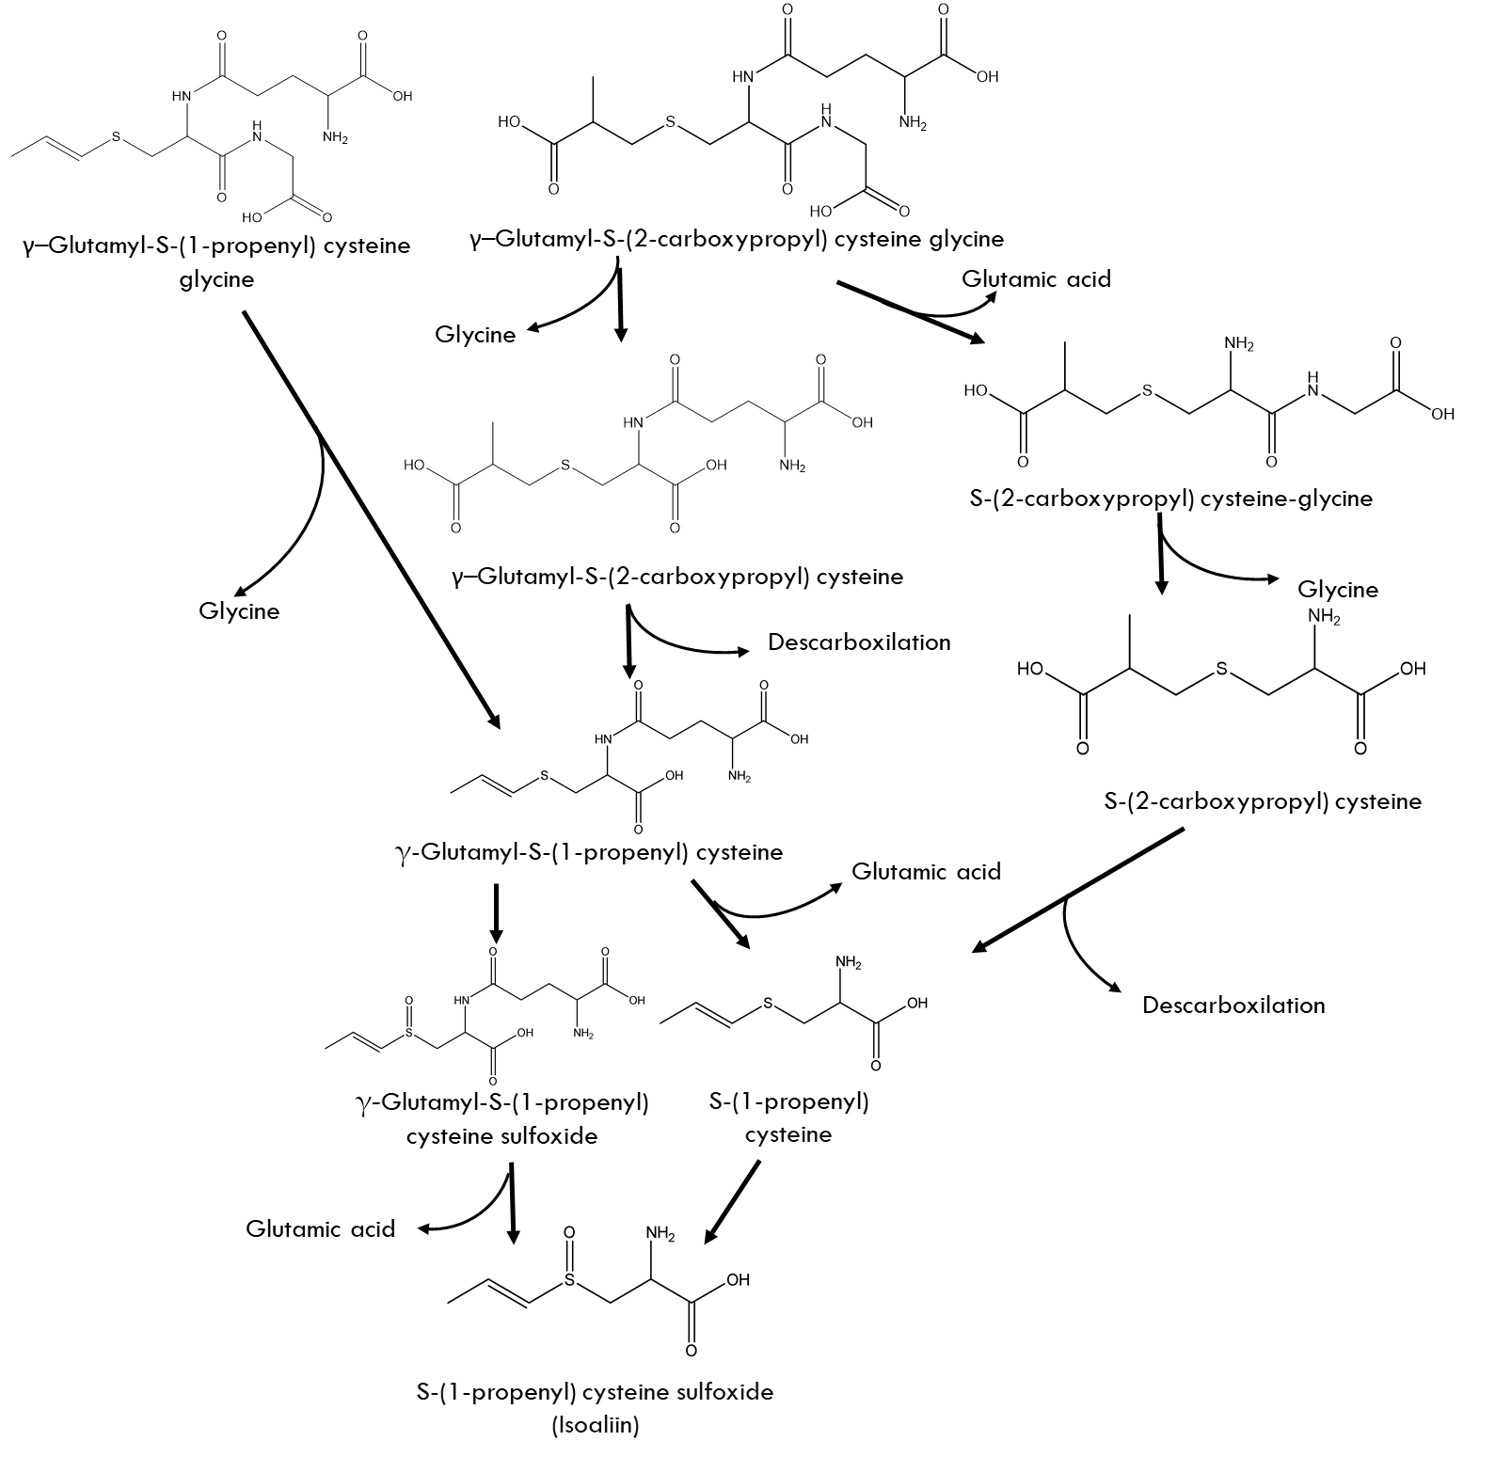**Figure S1.** Metabolic pathways for the synthesis of the isoaliin.