**Supplementary Table 1:** Calibration curve concentrations (9 point excluding the blank for initial assessment and 5 point highlighted in yellow) for the Geneva phenotyping cocktail probe drugs and metabolites after spiking plasma, whole blood or solvent before extraction and IS concentrations.

|  |  |  |  |  |  |  |  |  |  |  |  |  |  |  |  |
| --- | --- | --- | --- | --- | --- | --- | --- | --- | --- | --- | --- | --- | --- | --- | --- |
| **Analyte** | **Working std (µg.mL-1)** | **Concentrations (ng.mL-1) prepared from low concentration working standard solution** | | | | | **Calibration concentrations (ng.mL-1) prepared from high concentration working std. (specific volumes evaporated and reconstituted given in blue)** | | | | | | | | |
| **3.0 µL** | **7.5 µL** | | **15 µL** | | **3.0 µL** | **7.5 µL** | | **15 µL** | | **30 µL** | | **45 µL** | |
| **Caffeine** | 2; 20 | 60 | 150 | | 300 | | 600 | 1500 | | 3000 | | 6000 | | 9000 | |
| **Paraxanthine** | 1; 10 | 30 | 75 | | 150 | | 300 | 750 | | 1500 | | 3000 | | 4500 | |
| **Bupropion** | 1; 10 | 30 | 75 | | 150 | | 300 | 750 | | 1500 | | 3000 | | 4500 | |
| **OH-Bupropion** | 1; 10 | 30 | 75 | | 150 | | 300 | 750 | | 1500 | | 3000 | | 4500 | |
| **Flurbiprofen** | 2; 20 | 60 | 150 | | 300 | | 600 | 1500 | | 3000 | | 6000 | | 9000 | |
| **OH- Flurbiprofen** | 1; 10 | 30 | 75 | | 150 | | 300 | 750 | | 1500 | | 3000 | | 4500 | |
| **Omeprazole** | 1; 10 | 30 | 75 | | 150 | | 300 | 750 | | 1500 | | 3000 | | 4500 | |
| **OH- Omeprazole** | 1; 10 | 30 | 75 | | 150 | | 300 | 750 | | 1500 | | 3000 | | 4500 | |
| **Dextromethorphan** | 1; 10 | 30 | 75 | | 150 | | 300 | 750 | | 1500 | | 3000 | | 4500 | |
| **Dextrorphan** | 1; 10 | 30 | 75 | | 150 | | 300 | 750 | | 1500 | | 3000 | | 4500 | |
| **Midazolam** | 0.4; 4 | 12 | 30 | | 60 | | 120 | 300 | | 600 | | 1200 | | 1800 | |
| **OH- Midazolam** | 0.4; 4 | 12 | 30 | | 60 | | 120 | 300 | | 600 | | 1200 | | 1800 | |
| **Fexofenadine** | 1; 10 | 30 | 75 | | 150 | | 300 | 750 | | 1500 | | 3000 | | 4500 | |
| **Internal standards** | | | | | | | | | | | | | | | |
| **Imipramine** | 0.5 |  | |  | |  |  | |  | |  | |  | |  |
| **Probenecid** | 0.25 |  | |  | |  |  | |  | |  | |  | |  |

**Supplementary Table 2:** Concentration levels for the Geneva phenotyping cocktail probe drugs and metabolites in plasma, whole blood or solvent spiked after extraction.

|  |  |  |  |  |  |  |
| --- | --- | --- | --- | --- | --- | --- |
| **Analyte** | **Concentrations (ng.mL-1) for matrix effect assessment prepared from working standard solutions given in Table 3.2** | | | | | |
| **Plasma** | | | **DBS** | | |
| Low | Medium | High | Low | Medium | High |
| **Caffeine** | 37.50 | 187.50 | 375.00 | 15.00 | 75.00 | 150.00 |
| **Paraxanthine** | 18.75 | 93.75 | 187.50 | 7.50 | 37.50 | 75.00 |
| **Bupropion** | 18.75 | 93.75 | 187.50 | 7.50 | 37.50 | 75.00 |
| **OH-Bupropion** | 18.75 | 93.75 | 187.50 | 7.50 | 37.50 | 75.00 |
| **Flurbiprofen** | 18.75 | 93.75 | 187.50 | 7.50 | 37.50 | 75.00 |
| **OH- Flurbiprofen** | 18.75 | 93.75 | 187.50 | 7.50 | 37.50 | 75.00 |
| **Omeprazole** | 18.75 | 93.75 | 187.50 | 7.50 | 37.50 | 75.00 |
| **OH- Omeprazole** | 18.75 | 93.75 | 187.50 | 7.50 | 37.50 | 75.00 |
| **Dextromethorphan** | 18.75 | 93.75 | 187.50 | 7.50 | 37.50 | 75.00 |
| **Dextrorphan** | 18.75 | 93.75 | 187.50 | 7.50 | 37.50 | 75.00 |
| **Midazolam** | 7.50 | 37.50 | 75.00 | 3.00 | 15.00 | 30.00 |
| **OH- Midazolam** | 7.50 | 37.50 | 75.00 | 3.00 | 15.00 | 30.00 |
| **Fexofenadine** | 18.75 | 93.75 | 187.50 | 7.50 | 37.50 | 75.00 |

**Supplementary Table 3:** Relative mean matrix effects (%) in plasma and DBS (n=9) with precision (% CV).

|  |  |  |  |  |  |  |
| --- | --- | --- | --- | --- | --- | --- |
|  | **Plasma** | | | **DBS** | | |
| **Analyte** | **Conc. (ng.mL-1)** | **Mean matrix effect (%)** | **CV (%)** | **Conc. (ng.mL-1)** | **Mean matrix effect (%)** | **CV (%)** |
| **CAF** | 37.50 | 100.79 | 6.98 | 15.00 | 92.01 | 2.74 |
|  | 187.50 | 95.95 | 3.91 | 75.00 | 104.55 | 10.68 |
|  | 375.00 | 107.70 | 8.02 | 150.00 | 102.60 | 12.88 |
| **PAR** | 18.75 | 98.58 | 6.14 | 7.50 | 106.00 | 11.96 |
|  | 93.75 | 96.44 | 0.43 | 37.50 | 102.22 | 5.67 |
|  | 187.50 | 108.45 | 10.35 | 75.00 | 103.67 | 13.82 |
| **BUP** | 18.75 | 89.46 | 14.01 | 7.50 | 77.11 | 23.66 |
|  | 93.75 | 88.10 | 14.34 | 37.50 | 92.61 | 17.25 |
|  | 187.50 | 96.46 | 17.78 | 75.00 | 98.90 | 11.08 |
| **OH-BUP** | 18.75 | 102.56 | 9.48 | 7.50 | 81.53 | 10.84 |
| 93.75 | 98.01 | 7.62 | 37.50 | 96.81 | 3.25 |
|  | 187.50 | 105.20 | 16.97 | 75.00 | 99.72 | 10.55 |
| **FLB** | 18.75 | 64.32 | 23.75 | 7.50 | 101.36 | 0.89 |
|  | 93.75 | 82.54 | 12.66 | 37.50 | 101.66 | 0.88 |
|  | 187.50 | 98.41 | 11.09 | 75.00 | 96.62 | 9.24 |
| **OH-FLB** | 18.75 | 71.12 | 14.24 | 7.50 | 99.51 | 14.85 |
| 93.75 | 90.98 | 2.83 | 37.50 | 103.28 | 2.81 |
|  | 187.50 | 98.94 | 5.97 | 75.00 | 96.96 | 9.48 |
| **OPZ** | 18.75 | 105.29 | 13.07 | 7.50 | 98.83 | 16.23 |
|  | 93.75 | 98.17 | 3.07 | 37.50 | 96.36 | 1.02 |
|  | 187.50 | 109.90 | 12.90 | 75.00 | 99.67 | 10.12 |
| **OH-OPZ** | 18.75 | 99.47 | 4.12 | 7.50 | 100.20 | 16.90 |
| 93.75 | 97.84 | 2.20 | 37.50 | 98.73 | 1.74 |
|  | 187.50 | 107.42 | 11.72 | 75.00 | 97.23 | 10.00 |
| **DEX** | 18.75 | 101.11 | 10.98 | 7.50 | 100.06 | 18.36 |
|  | 93.75 | 99.49 | 3.02 | 37.50 | 93.53 | 2.98 |
|  | 187.50 | 105.92 | 17.47 | 75.00 | 103.90 | 12.23 |
| **DTP** | 18.75 | 98.34 | 6.28 | 7.50 | 95.63 | 18.31 |
|  | 93.75 | 100.47 | 4.48 | 37.50 | 98.33 | 2.19 |
|  | 187.50 | 108.05 | 17.06 | 75.00 | 101.97 | 9.33 |
| **MDZ** | 7.50 | 105.00 | 14.50 | 3.00 | 108.47 | 15.60 |
|  | 37.50 | 95.57 | 5.72 | 15.00 | 103.67 | 19.93 |
|  | 75.00 | 104.66 | 14.40 | 30.00 | 101.33 | 12.93 |
| **OH-MDZ** | 7.50 | 107.66 | 12.95 | 3.00 | 104.91 | 16.26 |
| 37.50 | 97.58 | 2.10 | 15.00 | 95.32 | 4.52 |
|  | 75.00 | 104.99 | 14.38 | 30.00 | 97.89 | 9.47 |
| **FEX** | 18.75 | 98.17 | 9.81 | 7.50 | 106.34 | 15.37 |
|  | 93.75 | 98.68 | 1.97 | 37.50 | 98.84 | 3.50 |
|  | 187.50 | 108.35 | 14.42 | 75.00 | 102.03 | 9.04 |

**Peak Intensity (cps)**

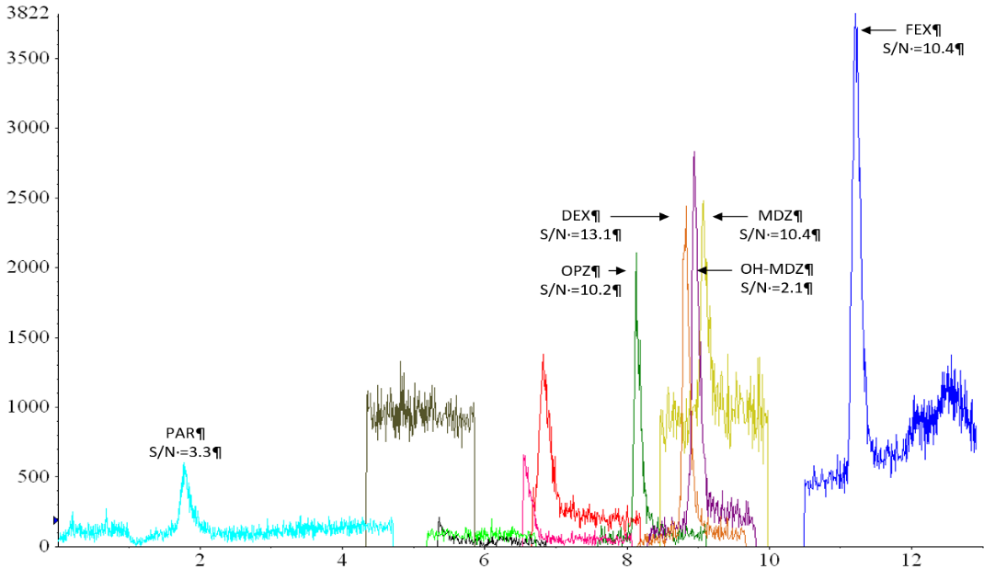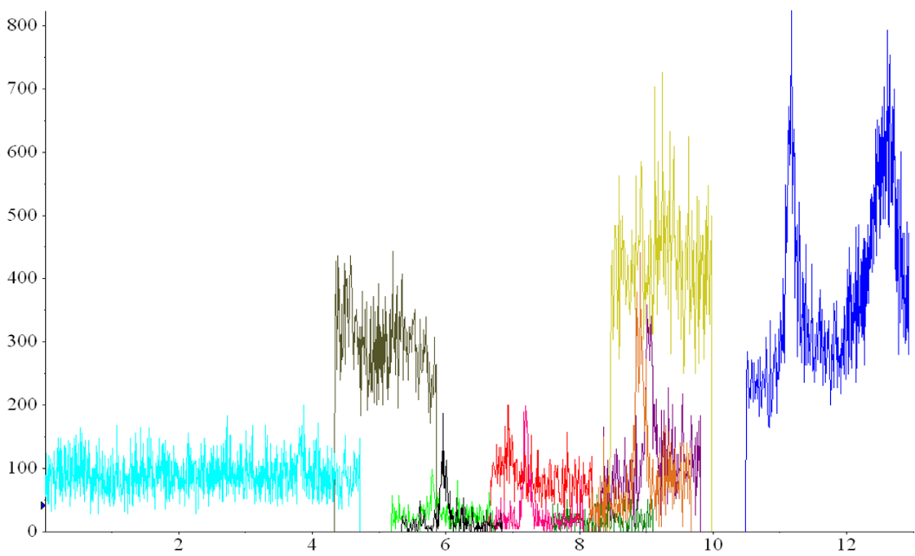

**Peak Intensity (cps)**

**Time (min)**

**A**

**B**

**Supplementary Figure 1:** Carry over of analytes acquired in ESI+ mode after injection of the first blank after the highest calibrant (A) and after second double blank injection (B).

**Supplementary Table 4:** Intra-day accuracy (%) and precision (%) in human plasma (n=3) spiked at 5 different concentration on three separate days from separately made up working standard solutions.

|  |  |  |  |  |  |  |  |  |  |  |  |  |  |  |  |  |
| --- | --- | --- | --- | --- | --- | --- | --- | --- | --- | --- | --- | --- | --- | --- | --- | --- |
| **Analyte in plasma** | **Spiked conc. (ng.mL-1)** | **Intra-day (n=3) Day 1** | | | | | **Intra-day (n=3) Day 2** | | | | | **Intra-day (n=3) Day 3** | | | | |
| **Found (mean ± SD in ng.mL-1)** | | | **Accuracy (%)** | **Precision (%)** | **Found (mean ± SD in ng.mL-1)** | | | **Accuracy (%)** | **Precision (%)** | **Found (mean ± SD in ng.mL-1)** | | | **Accuracy (%)** | **Precision (%)** |
| **FEX** | 75.00 | 74.87 | ± | 2.14 | 99.77 | 2.86 | 73.82 | ± | 5.48 | 98.42 | 7.43 | 70.57 | ± | 3.30 | 94.09 | 4.68 |
|  | 150.00 | 158.95 | ± | 2.25 | 105.68 | 1.42 | 147.30 | ± | 2.16 | 98.20 | 1.47 | 154.49 | ± | 4.49 | 102.99 | 2.90 |
|  | 750.00 | 781.52 | ± | 68.87 | 104.15 | 8.81 | 782.45 | ± | 37.52 | 104.33 | 4.79 | 791.94 | ± | 10.57 | 105.59 | 1.33 |
|  | 1500.00 | 1523.63 | ± | 168.28 | 101.30 | 11.04 | 1504.45 | ± | 25.06 | 100.30 | 1.67 | 1539.07 | ± | 9.19 | 102.60 | 0.60 |
|  | 4500.00 | 4433.17 | ± | 492.42 | 97.56 | 11.11 | 4475.81 | ± | 44.30 | 99.46 | 0.99 | 4430.01 | ± | 158.55 | 98.44 | 3.58 |
|  |  |  |  |  |  |  |  |  |  |  |  |  |  |  |  |  |
| **CAF** | 150.00 | 160.62 | ± | 17.84 | 106.79 | 11.11 | 153.62 | ± | 8.96 | 102.41 | 5.83 | 137.77 | ± | 27.55 | 91.85 | 19.99 |
|  | 300.00 | 294.22 | ± | 36.58 | 98.07 | 12.43 | 295.77 | ± | 13.80 | 98.59 | 4.67 | 308.98 | ± | 45.31 | 102.99 | 14.67 |
|  | 1500.00 | 1558.30 | ± | 58.00 | 103.61 | 3.72 | 1500.07 | ± | 4.25 | 100.00 | 0.28 | 1587.29 | ± | 107.18 | 105.82 | 6.75 |
|  | 3000.00 | 2857.16 | ± | 147.98 | 95.24 | 5.18 | 3007.06 | ± | 97.55 | 100.24 | 3.24 | 3076.72 | ± | 271.13 | 102.56 | 8.81 |
|  | 9000.00 | 8745.73 | ± | 702.36 | 96.74 | 8.03 | 9020.00 | ± | 143.49 | 100.22 | 1.59 | 8886.63 | ± | 911.67 | 98.74 | 10.26 |
|  |  |  |  |  |  |  |  |  |  |  |  |  |  |  |  |  |
| **PAR** | 75.00 | 79.47 | ± | 14.69 | 105.90 | 18.48 | 76.98 | ± | 4.58 | 102.64 | 5.95 | 69.62 | ± | 8.40 | 92.83 | 12.06 |
|  | 150.00 | 138.04 | ± | 26.47 | 91.78 | 19.18 | 147.53 | ± | 6.70 | 98.35 | 4.54 | 147.85 | ± | 18.62 | 98.57 | 12.60 |
|  | 750.00 | 804.85 | ± | 17.27 | 107.26 | 2.15 | 745.49 | ± | 4.47 | 99.40 | 0.60 | 803.85 | ± | 57.46 | 107.18 | 7.15 |
|  | 1500.00 | 1502.39 | ± | 26.65 | 99.89 | 1.77 | 1494.28 | ± | 54.49 | 99.62 | 3.65 | 1554.91 | ± | 106.41 | 103.66 | 6.84 |
|  | 4500.00 | 4386.53 | ± | 328.73 | 96.53 | 7.49 | 4515.13 | ± | 25.90 | 100.34 | 0.57 | 4406.75 | ± | 315.31 | 97.93 | 7.16 |
|  |  |  |  |  |  |  |  |  |  |  |  |  |  |  |  |  |
| **BUP** | 75.00 | 78.27 | ± | 0.90 | 104.31 | 1.16 | 80.71 | ± | 1.15 | 107.61 | 1.42 | - | ± | - | - | - |
|  | 150.00 | 141.06 | ± | 9.88 | 93.79 | 7.01 | 140.75 | ± | 9.49 | 93.83 | 6.74 | 131.80 | ± | 14.99 | 87.87 | 11.38 |
|  | 750.00 | 831.70 | ± | 65.10 | 110.83 | 7.83 | 759.86 | ± | 21.60 | 101.31 | 2.84 | 789.75 | ± | 5.38 | 105.30 | 0.68 |
|  | 1500.00 | 1546.17 | ± | 132.17 | 102.80 | 8.55 | 1507.04 | ± | 81.40 | 100.47 | 5.40 | 1575.00 | ± | 30.21 | 105.00 | 1.92 |
|  | 4500.00 | 4309.07 | ± | 261.34 | 94.83 | 6.07 | 4496.04 | ± | 162.88 | 99.91 | 3.62 | 4410.91 | ± | 85.12 | 98.02 | 1.93 |
| **Analyte in plasma** | | **Spiked conc. (ng.mL-1)** | **Intra-day (n=3) Day 1** | | | | | **Intra-day (n=3) Day 2** | | | | | **Intra-day (n=3) Day 3** | | | | |
| **Found (mean ± SD in ng.mL-1)** | | | **Accuracy (%)** | **Precision (%)** | **Found (mean ± SD in ng.mL-1)** | | | **Accuracy (%)** | **Precision (%)** | **Found (mean ± SD in ng.mL-1)** | | | **Accuracy (%)** | **Precision (%)** |
| **OH-BUP** | | 30.00 | 26.32 | ± | 2.04 | 87.74 | 7.77 | 31.01 | ± | 1.45 | 103.37 | 4.69 | 33.53 | ± | 4.08 | 111.76 | 12.16 |
|  | | 150.00 | - | ± | - | - | - | 147.61 | ± | 11.90 | 98.41 | 8.06 | 136.75 | ± | 5.19 | 91.16 | 3.79 |
|  | | 750.00 | 790.61 | ± | 1.75 | 105.41 | 0.22 | 749.04 | ± | 13.20 | 99.87 | 1.76 | 759.04 | ± | 23.03 | 101.21 | 3.03 |
|  | | 1500.00 | 1558.12 | ± | 21.39 | 103.87 | 1.37 | 1471.02 | ± | 44.54 | 98.07 | 3.03 | 1504.62 | ± | 70.45 | 100.31 | 4.68 |
|  | | 4500.00 | 4332.48 | ± | 349.79 | 96.28 | 8.07 | 4538.78 | ± | 59.65 | 100.86 | 1.31 | 4506.04 | ± | 108.02 | 100.13 | 2.40 |
|  | |  |  |  |  |  |  |  |  |  |  |  |  |  |  |  |  |
| **FLB** | | 150.00 | 145.65 | ± | 15.85 | 97.10 | 10.88 | 146.49 | ± | 26.36 | 97.66 | 17.99 | 135.15 | ± | 0.09 | 90.10 | 0.06 |
|  | | 300.00 | 295.31 | ± | 32.59 | 98.44 | 11.04 | 304.08 | ± | 39.91 | 101.36 | 13.13 | 312.15 | ± | 22.81 | 104.05 | 7.31 |
|  | | 1500.00 | 1525.12 | ± | 16.76 | 101.67 | 1.10 | 1560.32 | ± | 190.49 | 104.02 | 12.21 | 1548.10 | ± | 37.39 | 103.21 | 2.42 |
|  | | 3000.00 | 3212.95 | ± | 83.98 | 107.10 | 2.61 | 2910.61 | ± | 228.60 | 97.02 | 7.85 | 3049.52 | ± | 38.14 | 101.65 | 1.25 |
|  | | 9000.00 | 8817.35 | ± | 416.46 | 97.97 | 4.72 | 9072.70 | ± | 398.99 | 100.81 | 4.40 | 8918.65 | ± | 365.28 | 99.10 | 4.10 |
| **OH-FLB** | | 75.00 | 70.83 | ± | 5.07 | 94.43 | 7.15 | 74.01 | ± | 4.36 | 98.69 | 5.89 | 69.84 | ± | 2.61 | 93.11 | 3.74 |
|  | | 150.00 | 152.88 | ± | 7.72 | 101.92 | 5.05 | 146.52 | ± | 33.46 | 97.68 | 22.83 | 149.93 | ± | 5.70 | 99.95 | 3.80 |
|  | | 750.00 | 761.24 | ± | 5.12 | 101.50 | 0.67 | 801.82 | ± | 189.54 | 106.91 | 23.64 | 788.61 | ± | 12.57 | 105.15 | 1.59 |
|  | | 1500.00 | 1529.83 | ± | 19.88 | 101.99 | 1.30 | 1461.66 | ± | 258.42 | 97.44 | 17.68 | 1569.02 | ± | 46.12 | 104.60 | 2.94 |
|  | | 4500.00 | 4468.48 | ± | 113.83 | 99.30 | 2.55 | 4499.82 | ± | 389.41 | 100.00 | 8.65 | 4406.45 | ± | 126.30 | 97.92 | 2.87 |
|  | |  |  |  |  |  |  |  |  |  |  |  |  |  |  |  |  |
| **OPZ** | | 30.00 | 26.80 | ± | 11.97 | 89.34 | 44.67 | - | ± | - | - | - | 28.63 | ± | 1.29 | 95.44 | 4.52 |
|  | | 150.00 | 167.53 | ± | 11.50 | 111.69 | 6.87 | 150.73 | ± | 11.02 | 100.49 | 7.31 | 148.68 | ± | 10.78 | 99.12 | 7.25 |
|  | | 750.00 | 791.43 | ± | 16.87 | 105.52 | 2.13 | 786.89 | ± | 40.69 | 104.92 | 5.17 | 778.23 | ± | 10.34 | 103.76 | 1.33 |
|  | | 1500.00 | 1575.00 | ± | 73.61 | 105.00 | 4.67 | 1535.00 | ± | 35.08 | 102.33 | 2.29 | 1584.62 | ± | 120.29 | 105.64 | 7.59 |
|  | | 4500.00 | - | ± | - | - | - | 4439.20 | ± | 190.45 | 98.65 | 4.29 | 4407.91 | ± | 412.69 | 97.95 | 9.36 |
| **OH-OPZ** | | 75.00 | 76.83 | ± | 18.40 | 102.44 | 23.94 | 75.60 | ± | 3.03 | 100.80 | 4.01 | 71.35 | ± | 3.01 | 95.14 | 4.22 |
|  | | 150.00 | 177.20 | ± | 9.45 | 118.13 | 5.33 | 150.05 | ± | 11.63 | 100.03 | 7.75 | 157.11 | ± | 15.88 | 104.74 | 10.11 |
|  | | 750.00 | 849.78 | ± | 68.09 | 113.30 | 8.01 | 743.90 | ± | 20.67 | 99.19 | 2.78 | 760.22 | ± | 22.70 | 101.36 | 2.99 |
|  | | 1500.00 | 1519.02 | ± | 160.22 | 101.27 | 10.55 | 1507.06 | ± | 59.78 | 100.47 | 3.97 | 1491.16 | ± | 78.53 | 99.41 | 5.27 |
|  | | 4500.00 | 3875.23 | ± | 97.93 | 86.12 | 2.53 | 4505.89 | ± | 24.25 | 100.13 | 0.54 | 3914.82 | ± | 241.70 | 87.00 | 6.17 |
| **Analyte in plasma** | | **Spiked conc. (ng.mL-1)** | **Intra-day (n=3) Day 1** | | | | | **Intra-day (n=3) Day 2** | | | | | **Intra-day (n=3) Day 3** | | | | |
| **Found (mean ± SD in ng.mL-1)** | | | **Accuracy (%)** | **Precision (%)** | **Found (mean ± SD in ng.mL-1)** | | | **Accuracy (%)** | **Precision (%)** | **Found (mean ± SD in ng.mL-1)** | | | **Accuracy (%)** | **Precision (%)** |
| **DEX** | | 75.00 | 71.65 | ± | 3.91 | 95.53 | 5.46 | 77.74 | ± | 2.05 | 103.65 | 2.63 | 68.73 | ± | 3.51 | 91.64 | 5.10 |
|  | | 150.00 | 142.78 | ± | 16.65 | 95.19 | 11.66 | 144.85 | ± | 4.22 | 96.57 | 2.91 | 154.13 | ± | 9.61 | 102.75 | 6.24 |
|  | | 750.00 | 842.97 | ± | 28.20 | 112.40 | 3.35 | 763.20 | ± | 11.11 | 101.76 | 1.46 | 769.19 | ± | 15.21 | 102.56 | 1.98 |
|  | | 1500.00 | 1602.97 | ± | 21.01 | 106.86 | 1.31 | 1470.19 | ± | 16.72 | 98.01 | 1.14 | 1589.48 | ± | 122.16 | 105.97 | 7.69 |
|  | | 4500.00 | 4162.87 | ± | 140.75 | 92.51 | 3.38 | 4519.51 | ± | 29.48 | 100.43 | 0.65 | 4402.31 | ± | 147.39 | 97.83 | 3.35 |
|  | |  |  |  |  |  |  |  |  |  |  |  |  |  |  |  |  |
| **DTP** | | 75.00 | 70.89 | ± | 3.14 | 94.52 | 4.42 | 73.60 | ± | 3.24 | 98.13 | 4.40 | 70.59 | ± | 4.32 | 94.12 | 6.11 |
|  | | 150.00 | 155.12 | ± | 5.59 | 103.42 | 3.60 | 151.27 | ± | 5.40 | 100.85 | 3.57 | 148.65 | ± | 7.95 | 99.10 | 5.35 |
|  | | 750.00 | - | ± | - | - | - | 764.85 | ± | 21.29 | 101.98 | 2.78 | 809.27 | ± | 40.77 | 107.90 | 5.04 |
|  | | 1500.00 | 1637.47 | ± | 57.91 | 109.16 | 3.54 | 1496.05 | ± | 12.66 | 99.74 | 0.85 | 1513.34 | ± | 39.69 | 100.89 | 2.62 |
|  | | 4500.00 | 4270.30 | ± | 261.71 | 94.90 | 6.13 | 4496.72 | ± | 6.94 | 99.93 | 0.15 | 4441.98 | ± | 119.50 | 98.71 | 2.69 |
|  | |  |  |  |  |  |  |  |  |  |  |  |  |  |  |  |  |
| **MDZ** | | 30.00 | 28.81 | ± | 3.98 | 96.03 | 13.80 | 31.66 | ± | 5.83 | 105.54 | 18.41 | 27.79 | ± | 1.31 | 92.64 | 4.72 |
|  | | 60.00 | 59.25 | ± | 3.96 | 98.75 | 6.69 | 56.44 | ± | 8.05 | 94.07 | 14.26 | 63.02 | ± | 10.03 | 105.03 | 15.92 |
|  | | 300.00 | 310.29 | ± | 13.63 | 103.43 | 4.39 | 300.36 | ± | 5.08 | 100.12 | 1.69 | 308.17 | ± | 38.74 | 102.72 | 12.57 |
|  | | 600.00 | 596.71 | ± | 12.39 | 99.45 | 2.08 | 600.84 | ± | 4.97 | 100.14 | 0.83 | 600.99 | ± | 48.47 | 100.16 | 8.07 |
|  | | 1800.00 | - | ± | - | - | - | 1800.06 | ± | 38.40 | 100.00 | 2.13 | 1790.03 | ± | 100.03 | 99.45 | 5.59 |
|  | |  |  |  |  |  |  |  |  |  |  |  |  |  |  |  |  |
| **OH-MDZ** | | 30.00 | 28.62 | ± | 2.26 | 95.38 | 7.90 | 29.22 | ± | 2.23 | 97.41 | 7.62 | 28.78 | ± | 1.54 | 95.95 | 5.35 |
|  | | 60.00 | 58.85 | ± | 3.11 | 98.08 | 5.29 | 60.04 | ± | 2.70 | 100.06 | 4.50 | 59.31 | ± | 3.88 | 98.86 | 6.54 |
|  | | 300.00 | 312.00 | ± | 2.44 | 104.00 | 0.78 | 308.71 | ± | 17.60 | 102.90 | 5.70 | 312.04 | ± | 12.08 | 104.01 | 3.87 |
|  | | 600.00 | 602.81 | ± | 12.40 | 100.47 | 2.06 | 600.61 | ± | 14.90 | 100.10 | 2.48 | 625.74 | ± | 62.00 | 104.29 | 9.91 |
|  | | 1800.00 | 1788.10 | ± | 54.20 | 99.34 | 3.03 | 1791.42 | ± | 62.20 | 99.52 | 3.47 | 1768.14 | ± | 95.48 | 98.23 | 5.40 |
| FEX – fexofenadine; CAF – caffeine; PAR – paraxanthine; BUP – bupropion; OH-BUP – hydroxy-bupropion; FLB – flurbiprofen; OH-FLB – hydroxyflurbiprofen; OPZ – omeprazole; OH-OPZ – hydroxy-omeprazole; DEX – dextromethorphan; DTP – dextrorphan; MDZ – midazolam; OH-MDZ – hydroxymidazolam. | | | | | | | | | | | | | | | | | |

**Supplementary Table 5:** Intra-day accuracy (%) and precision (%) in human DBS (n=3) using a Mitra™ device, spiked at 5 different concentration on three separate days from separately made up working standard solutions.

|  |  |  |  |  |  |  |  |  |  |  |  |  |  |  |  |  |
| --- | --- | --- | --- | --- | --- | --- | --- | --- | --- | --- | --- | --- | --- | --- | --- | --- |
| **Analyte in plasma** | **Spiked conc. (ng.mL-1)** | **Intra-day (n=3) Day 1** | | | | | **Intra-day (n=3) Day 2** | | | | | **Intra-day (n=3) Day 3** | | | | |
| **Found (mean ± SD in ng.mL-1)** | | | **Accuracy (%)** | **Precision (%)** | **Found (mean ± SD in ng.mL-1)** | | | **Accuracy (%)** | **Precision (%)** | **Found (mean ± SD in ng.mL-1)** | | | **Accuracy (%)** | **Precision (%)** |
| **FEX** | 75.00 | 70.83 | ± | 5.18 | 94.44 | 7.32 | 73.25 | ± | 1.81 | 97.67 | 2.48 | 65.52 | ± | 2.15 | 87.36 | 3.29 |
|  | 150.00 | 146.17 | ± | 8.77 | 97.45 | 6.00 | 148.77 | ± | 4.26 | 99.18 | 2.86 | 151.43 | ± | 11.74 | 100.95 | 7.75 |
|  | 750.00 | 633.29 | ± | 45.58 | 84.44 | 7.20 | 765.52 | ± | 26.56 | 102.07 | 3.47 | 820.87 | ± | 26.03 | 109.45 | 3.17 |
|  | 1500.00 | 1558.49 | ± | 156.33 | 103.90 | 10.03 | 1530.68 | ± | 84.79 | 102.05 | 5.54 | 1581.73 | ± | 92.99 | 105.45 | 5.88 |
|  | 4500.00 | 4402.68 | ± | 538.37 | 97.84 | 12.23 | 4456.79 | ± | 343.59 | 99.04 | 7.71 | 4355.45 | ± | 294.41 | 96.79 | 6.76 |
|  |  |  |  |  |  |  |  |  |  |  |  |  |  |  |  |  |
| **CAF** | 150.00 | 138.25 | ± | 7.47 | 92.17 | 5.40 | 152.62 | ± | 9.76 | 101.75 | 6.40 | 140.47 | ± | 7.46 | 93.65 | 5.31 |
|  | 300.00 | 281.83 | ± | 20.90 | 93.94 | 7.41 | 294.20 | ± | 18.93 | 98.07 | 6.44 | 305.98 | ± | 3.02 | 101.99 | 0.99 |
|  | 1500.00 | 1275.15 | ± | 182.62 | 85.01 | 14.32 | 1507.50 | ± | 112.98 | 100.50 | 7.49 | 1572.50 | ± | 63.89 | 104.83 | 4.06 |
|  | 3000.00 | 2971.97 | ± | 175.08 | 99.07 | 5.89 | 2991.45 | ± | 182.10 | 99.71 | 6.09 | 3073.58 | ± | 332.58 | 102.45 | 10.82 |
|  | 9000.00 | 8907.00 | ± | 113.43 | 98.97 | 1.27 | 9005.82 | ± | 290.27 | 100.06 | 3.22 | 8881.63 | ± | 583.57 | 98.68 | 6.57 |
|  |  |  |  |  |  |  |  |  |  |  |  |  |  |  |  |  |
| **PAR** | 75.00 | 76.68 | ± | 8.02 | 102.24 | 10.46 | 75.08 | ± | 3.97 | 100.11 | 5.29 | 70.12 | ± | 4.12 | 93.49 | 5.88 |
|  | 150.00 | 150.41 | ± | 20.40 | 100.27 | 13.57 | 154.55 | ± | 2.05 | 103.03 | 1.32 | 141.15 | ± | 13.24 | 94.10 | 9.38 |
|  | 750.00 | 747.36 | ± | 154.13 | 99.65 | 20.62 | 742.63 | ± | 51.68 | 99.02 | 6.96 | 827.02 | ± | 56.15 | 110.27 | 6.79 |
|  | 1500.00 | 1485.35 | ± | 124.97 | 99.02 | 8.41 | 1456.69 | ± | 115.78 | 97.11 | 7.95 | 1619.78 | ± | 52.62 | 107.99 | 3.25 |
|  | 4500.00 | 3115.53 | ± | 448.54 | 103.85 | 14.40 | 4549.65 | ± | 177.64 | 101.10 | 3.90 | 4356.86 | ± | 438.60 | 96.82 | 10.07 |
|  |  |  |  |  |  |  |  |  |  |  |  |  |  |  |  |  |
| **BUP** | 75.00 | 84.24 | ± | 1.22 | 112.32 | 1.44 | 77.79 | ± | 4.55 | 103.72 | 5.85 | 78.09 | ± | 2.68 | 104.12 | 3.43 |
|  | 750.00 | 623.89 | ± | 38.85 | 83.18 | 6.23 | 144.20 | ± | 7.52 | 96.14 | 5.21 | 147.83 | ± | 3.05 | 98.56 | 2.07 |
|  | 1500.00 | 1444.15 | ± | 56.08 | 96.28 | 3.88 | 768.83 | ± | 83.38 | 102.51 | 10.84 | 742.20 | ± | 44.86 | 98.96 | 6.04 |
|  | 3000.00 | 3394.14 | ± | 35.33 | 113.14 | 1.04 | 1454.60 | ± | 84.53 | 96.97 | 5.81 | 1459.86 | ± | 20.61 | 97.32 | 1.41 |
|  | 4500.00 | 4278.59 | ± | 155.79 | 95.08 | 3.64 | 4544.36 | ± | 228.39 | 100.99 | 5.03 | 4547.02 | ± | 332.82 | 101.04 | 7.32 |
| **Analyte** | | **Spiked conc. (ng.mL-1)** | **Intra-day (n=3) Day 1** | | | | | **Intra-day (n=3) Day 2** | | | | | **Intra-day (n=3) Day 3** | | | | |
| **Found (mean ± SD in ng.mL-1)** | | | **Accuracy (%)** | **Precision (%)** | **Found (mean ± SD in ng.mL-1)** | | | **Accuracy (%)** | **Precision (%)** | **Found (mean ± SD in ng.mL-1)** | | | **Accuracy (%)** | **Precision (%)** |
| **OH-BUP** | | 75.00 | 72.22 | ± | 6.21 | 96.30 | 8.60 | 73.95 | ± | 2.91 | 98.60 | 3.94 | 70.56 | ± | 2.01 | 94.08 | 2.84 |
|  | | 150.00 | 137.82 | ± | 9.16 | 91.88 | 6.65 | 151.41 | ± | 4.53 | 100.94 | 2.99 | 148.99 | ± | 6.27 | 99.32 | 4.21 |
|  | | 750.00 | 734.15 | ± | 47.46 | 97.89 | 6.46 | 754.65 | ± | 15.45 | 100.62 | 2.05 | 800.49 | ± | 37.53 | 106.73 | 4.69 |
|  | | 1500.00 | 1524.50 | ± | 203.46 | 101.63 | 13.35 | 1505.65 | ± | 63.05 | 100.38 | 4.19 | 1519.54 | ± | 108.63 | 101.30 | 7.15 |
|  | | 4500.00 | 4278.27 | ± | 370.45 | 95.07 | 8.66 | 4489.81 | ± | 159.39 | 99.77 | 3.55 | 4435.43 | ± | 48.05 | 98.57 | 1.08 |
|  | |  |  |  |  |  |  |  |  |  |  |  |  |  |  |  |  |
| **FLB** | | 150.00 | 147.24 | ± | 6.75 | 98.16 | 4.58 | 159.27 | ± | 27.00 | 106.18 | 16.95 | 148.54 | ± | 11.50 | 99.03 | 7.74 |
|  | | 300.00 | 301.20 | ± | 19.35 | 100.40 | 6.43 | 333.42 | ± | 23.53 | 111.14 | 7.06 | 320.01 | ± | 20.94 | 106.67 | 6.54 |
|  | | 1500.00 | 1456.76 | ± | 143.07 | 97.12 | 9.82 | 1287.19 | ± | 90.02 | 85.81 | 6.99 | 1428.22 | ± | 123.83 | 95.21 | 8.67 |
|  | | 3000.00 | 3163.37 | ± | 202.27 | 105.45 | 6.39 | 2849.32 | ± | 271.67 | 94.98 | 9.53 | 2969.15 | ± | 81.36 | 98.97 | 2.74 |
|  | | 9000.00 | 8761.66 | ± | - | 97.35 | - | 9792.27 | ± | - | 108.80 | - | 9066.82 | ± | 183.28 | 100.74 | 2.02 |
| **OH-FLB** | | 75.00 | 77.48 | ± | 5.08 | 103.30 | 6.56 | 71.91 | ± | 10.07 | 95.88 | 14.00 | 74.47 | ± | 1.98 | 99.29 | 2.66 |
|  | | 150.00 | 144.11 | ± | 12.97 | 96.07 | 9.00 | 147.81 | ± | 7.79 | 98.54 | 5.27 | 156.49 | ± | 1.55 | 104.33 | 0.99 |
|  | | 750.00 | 747.60 | ± | 115.90 | 99.68 | 15.50 | 742.21 | ± | 26.55 | 98.96 | 3.58 | 704.52 | ± | 14.84 | 93.94 | 2.11 |
|  | | 1500.00 | 1540.75 | ± | 177.62 | 102.72 | 11.53 | 1611.94 | ± | 64.15 | 107.46 | 3.98 | 1497.35 | ± | 48.44 | 99.82 | 3.24 |
|  | | 4500.00 | 4395.27 | ± | - | 97.67 | - | 4350.15 | ± | 24.09 | 96.67 | 0.55 | 4527.01 | ± | 129.87 | 100.60 | 2.87 |
|  | |  |  |  |  |  |  |  |  |  |  |  |  |  |  |  |  |
| **OPZ** | | 75.00 | 63.83 | ± | 3.99 | 85.11 | 6.25 | 73.80 | ± | 7.41 | 98.39 | 10.04 | 67.67 | ± | 4.44 | 90.23 | 6.55 |
|  | | 150.00 | - | ± | - | - | - | 145.60 | ± | 3.64 | 97.07 | 2.50 | 153.92 | ± | 1.54 | 102.62 | 1.00 |
|  | | 750.00 | 812.26 | ± | 88.48 | 108.30 | 10.89 | 754.74 | ± | 4.83 | 100.63 | 0.64 | 805.24 | ± | 54.95 | 107.37 | 6.82 |
|  | | 1500.00 | 1544.86 | ± | 115.67 | 102.99 | 7.49 | 1566.20 | ± | 7.75 | 104.41 | 0.49 | 1567.29 | ± | 79.95 | 104.49 | 5.10 |
|  | | 3000.00 | 2890.15 | ± | 122.86 | 96.34 | 4.25 | 4433.20 | ± | 211.01 | 98.52 | 4.76 | 4399.29 | ± | 151.33 | 97.76 | 3.44 |
| **OH-OPZ** | | 30.00 | 33.67 | ± | 0.40 | 112.23 | 1.18 | 71.34 | ± | 0.82 | 95.12 | 1.16 | 68.98 | ± | 0.96 | 91.97 | 1.39 |
|  | | 75.00 | 67.39 | ± | 2.02 | 89.86 | 3.00 | 150.55 | ± | 1.12 | 100.36 | 0.74 | 149.50 | ± | 7.08 | 99.66 | 4.74 |
|  | | 750.00 | 714.72 | ± | 99.91 | 95.30 | 13.98 | 761.73 | ± | 40.30 | 101.56 | 5.29 | 855.00 | ± | 3.50 | 114.00 | 0.41 |
|  | | 1500.00 | 1487.99 | ± | 209.87 | 99.20 | 14.10 | 1537.36 | ± | 120.55 | 102.49 | 7.84 | 1509.89 | ± | 40.00 | 100.66 | 2.65 |
|  | | 3000.00 | 3043.39 | ± | 197.68 | 101.45 | 6.50 | 4452.99 | ± | 285.04 | 98.96 | 6.40 | 4426.63 | ± | 275.72 | 98.37 | 6.23 |
| **Analyte** | | **Spiked conc. (ng.mL-1)** | **Intra-day (n=3) Day 1** | | | | | **Intra-day (n=3) Day 2** | | | | | **Intra-day (n=3) Day 3** | | | | |
| **Found (mean ± SD in ng.mL-1)** | | | **Accuracy (%)** | **Precision (%)** | **Found (mean ± SD in ng.mL-1)** | | | **Accuracy (%)** | **Precision (%)** | **Found (mean ± SD in ng.mL-1)** | | | **Accuracy (%)** | **Precision (%)** |
| **DEX** | | 75.00 | 71.91 | ± | 0.94 | 95.88 | 1.31 | 74.93 | ± | 2.17 | 99.91 | 2.90 | 74.01 | ± | 3.47 | 98.68 | 4.69 |
|  | | 150.00 | 153.76 | ± | 10.14 | 102.50 | 6.59 | 149.52 | ± | 4.90 | 99.68 | 3.28 | 150.25 | ± | 7.30 | 100.17 | 4.86 |
|  | | 750.00 | 722.96 | ± | 21.73 | 96.39 | 3.01 | 726.48 | ± | 17.48 | 96.86 | 2.41 | 757.91 | ± | 21.20 | 101.05 | 2.80 |
|  | | 1500.00 | 1514.70 | ± | 30.60 | 100.98 | 2.02 | 1547.41 | ± | 51.75 | 103.16 | 3.34 | 1505.90 | ± | 37.80 | 100.39 | 2.51 |
|  | | 4500.00 | 4446.88 | ± | 66.85 | 98.82 | 1.50 | 4468.79 | ± | 57.56 | 99.31 | 1.29 | 4486.94 | ± | 305.60 | 99.71 | 6.81 |
|  | |  |  |  |  |  |  |  |  |  |  |  |  |  |  |  |  |
| **DTP** | | 75.00 | 71.20 | ± | 2.74 | 94.93 | 3.84 | 76.83 | ± | 3.98 | 102.44 | 5.18 | 74.16 | ± | 4.27 | 98.88 | 5.76 |
|  | | 150.00 | 150.87 | ± | 8.21 | 100.58 | 5.44 | 147.69 | ± | 16.24 | 98.46 | 11.00 | 153.17 | ± | 8.88 | 102.12 | 5.80 |
|  | | 750.00 | 723.18 | ± | 9.18 | 96.42 | 1.27 | 758.10 | ± | 16.57 | 101.08 | 2.19 | 746.87 | ± | 37.49 | 99.58 | 5.02 |
|  | | 1500.00 | 1467.16 | ± | 163.96 | 97.81 | 11.18 | 1459.16 | ± | 45.68 | 97.28 | 3.13 | 1486.54 | ± | 87.07 | 99.10 | 5.86 |
|  | | 4500.00 | 4511.70 | ± | 258.50 | 100.26 | 5.73 | 4533.21 | ± | 50.32 | 100.74 | 1.11 | 4514.25 | ± | 179.92 | 100.32 | 3.99 |
|  | |  |  |  |  |  |  |  |  |  |  |  |  |  |  |  |  |
| **MDZ** | | 30.00 | 26.13 | ± | 2.69 | 87.09 | 10.31 | 27.82 | ± | 0.30 | 92.75 | 1.07 | 27.17 | ± | 3.54 | 90.58 | 13.03 |
|  | | 60.00 | 60.46 | ± | 2.40 | 100.76 | 3.98 | 63.87 | ± | 2.33 | 106.45 | 3.65 | 60.66 | ± | 2.37 | 101.11 | 3.91 |
|  | | 300.00 | 290.75 | ± | 25.79 | 96.92 | 8.87 | 303.07 | ± | 2.77 | 101.02 | 0.91 | 332.83 | ± | 4.47 | 110.94 | 1.34 |
|  | | 600.00 | 626.87 | ± | 19.95 | 104.48 | 3.18 | 600.37 | ± | 13.96 | 100.06 | 2.33 | 619.04 | ± | 15.61 | 103.17 | 2.52 |
|  | | 1800.00 | 1796.13 | ± | 70.34 | 99.78 | 3.92 | 1794.87 | ± | 42.66 | 99.71 | 2.38 | 1761.23 | ± | 58.78 | 97.85 | 3.34 |
|  | |  |  |  |  |  |  |  |  |  |  |  |  |  |  |  |  |
| **OH-MDZ** | | 30.00 | 25.98 | ± | 0.69 | 86.60 | 2.64 | 31.11 | ± | 2.35 | 103.71 | 7.54 | 29.80 | ± | 1.53 | 99.34 | 5.14 |
|  | | 60.00 | 61.21 | ± | 1.19 | 102.02 | 1.95 | 58.48 | ± | 2.58 | 97.46 | 4.42 | 58.81 | ± | 1.78 | 98.02 | 3.03 |
|  | | 300.00 | 289.16 | ± | 38.60 | 96.39 | 13.35 | 295.19 | ± | 1.49 | 98.40 | 0.50 | 317.45 | ± | 6.05 | 105.82 | 1.91 |
|  | | 600.00 | 634.54 | ± | 32.51 | 105.76 | 5.12 | 601.29 | ± | 9.13 | 100.21 | 1.52 | 594.01 | ± | 35.43 | 99.00 | 5.97 |
|  | | 1800.00 | 1740.61 | ± | 64.82 | 96.70 | 3.72 | 1803.93 | ± | 56.58 | 100.22 | 3.14 | 1795.75 | ± | 95.79 | 99.76 | 5.33 |
| FEX – fexofenadine; CAF – caffeine; PAR – paraxanthine; BUP – bupropion; OH-BUP – hydroxy-bupropion; FLB – flurbiprofen; OH-FLB – hydroxyflurbiprofen; OPZ – omeprazole; OH-OPZ – hydroxy-omeprazole; DEX – dextromethorphan; DTP – dextrorphan; MDZ – midazolam; OH-MDZ – hydroxymidazolam. | | | | | | | | | | | | | | | | | |



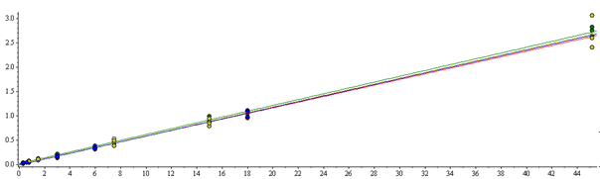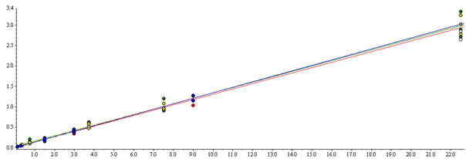

Analyte peak area/ Internal standard peak area

Analyte concentration/ Internal standard concentration

**B**

**A**

**Supplementary Figure 2:** Overlaid calibration curves for A – caffeine and B – paraxanthine extracted from Mitra™ DBS sampler and plasma with matching solvent calibration curves.

**Supplementary Figure 3:** Overlaid calibration curves for A – omeprazole and B – hydroxy-omeprazole extracted from the Mitra™ DBS sampler and plasma with matching solvent calibration curves on day three of validation.

**A**

**B**

Analyte peak area/ Internal standard peak area

Analyte concentration/ Internal standard concentration

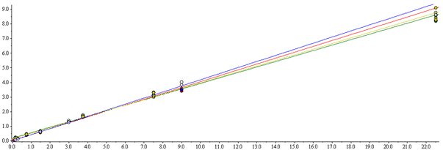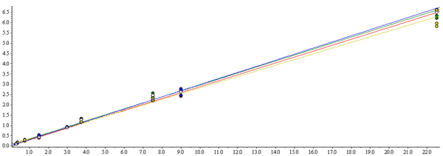

**A**

**B**