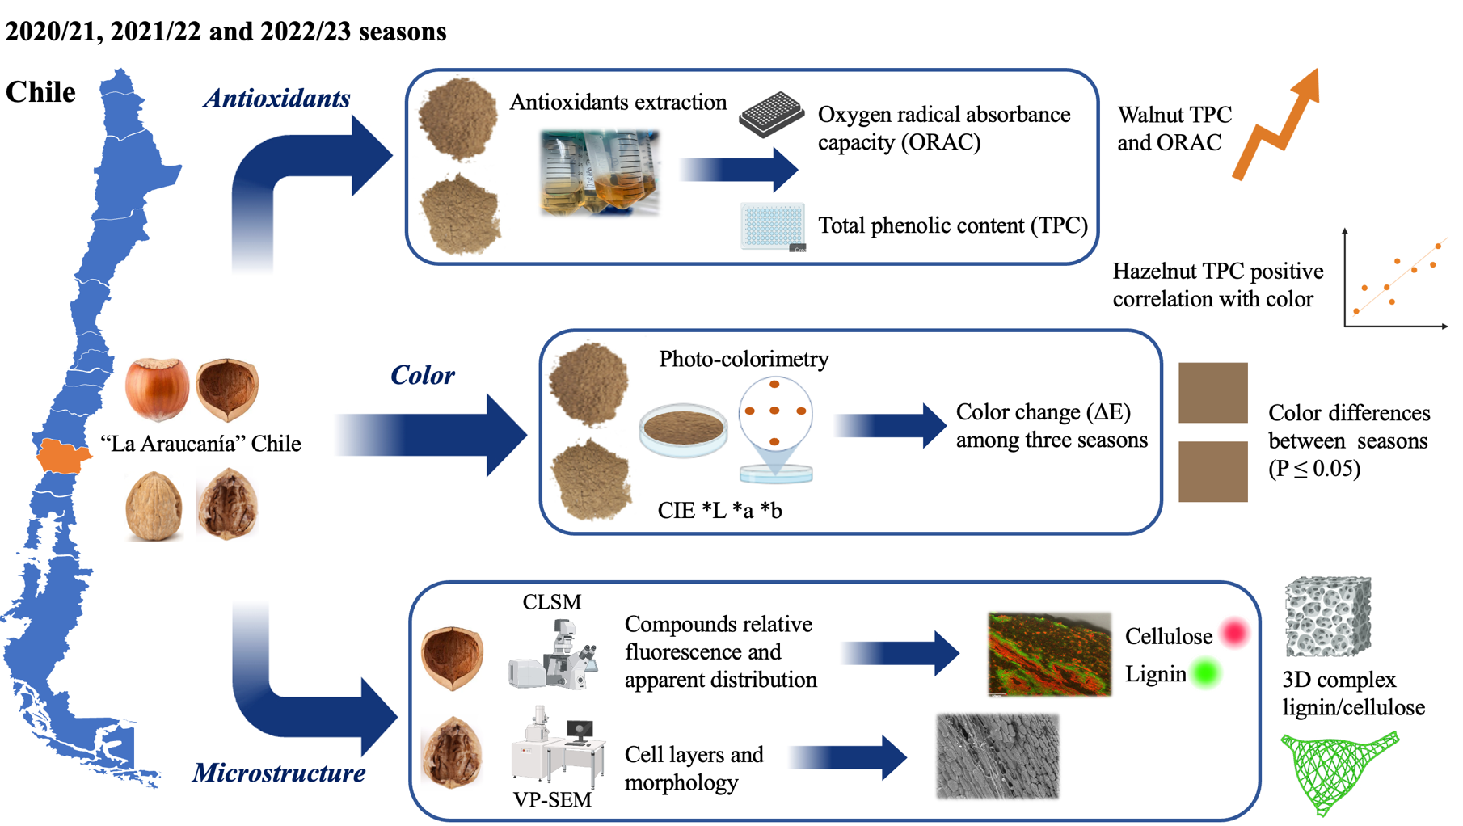

Table 1 Colorimetric parameters (L*, a*, b* and ΔE) obtained for hazelnut and walnut shell samples in relation to three productive seasons. The data was obtained in CIE L*a*b* color scale. L*=luminosity, a*= red/green coordinates (+a indicates red, −a indicates green), b*= coordinates yellow/blue (+b indicates yellow, −b indicates blue) while ΔE corresponds to the difference between colorimetric parameters. Values represent the average of five replicates ± S.E. Different low letters indicate statistical differences (P≤0.05) between the three seasons.

Species | Season | L* | a* | b* | ΔE
Hazelnut | 2020/21 | 51.33±0.35a | 7.71±0.03b | 21.59±0.12b | 54.95±0.26b
 | 2021/22 | 52.03±0.14a | 7.82±0.04b | 21.85±0.06b | 55.68±0.06b
 | 2022/23 | 52.31±0.10a | 8.32±0.05a | 22.37±0.08a | 56.84±0.12a
Walnut | 2020/21 | 46.83±0.42b | 4.58±0.03c | 23.13±2.32b | 55.65±0.27c
 | 2021/22 | 58.07±0.47a | 4.85±0.04b | 24.20±0.18b | 58.09±0.35b
 | 2022/23 | 59.15±0.50a | 5.41±0.06a | 25.32±0.06a | 60.31±0.12a

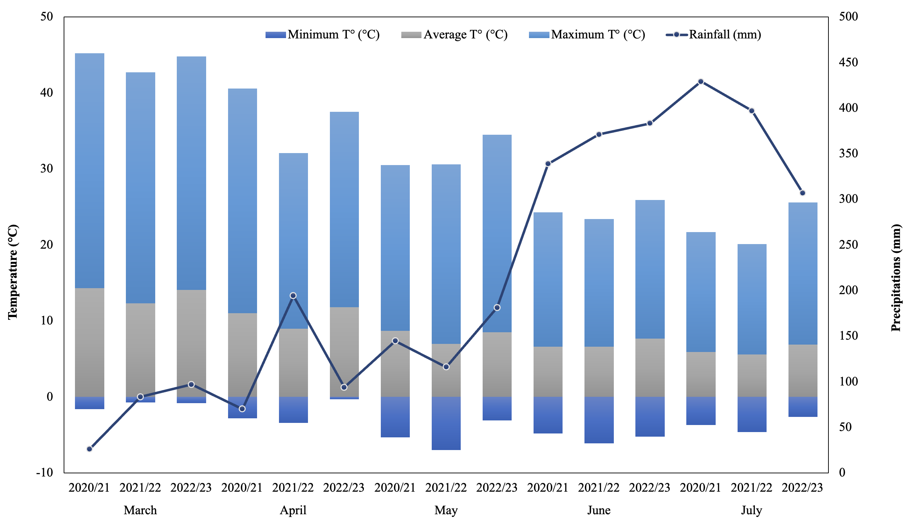
Fig. 1. Weather parameters among studied seasons in the municipality of Freire, La Araucanía region, Chile, which includes the two evaluated localities: Campo Experimental Maquehue (38° 50' 28.5" S, 72° 41' 40.4" W; Altitude: 200 m.a.s.l.) and Radal (39º 10’ 06” S, 72º 19’ 11” W; Altitude: 168 m.a.s.l.). The data was provided by Frutícola Agrichile S.A - Ferrero Hazelnut Company.

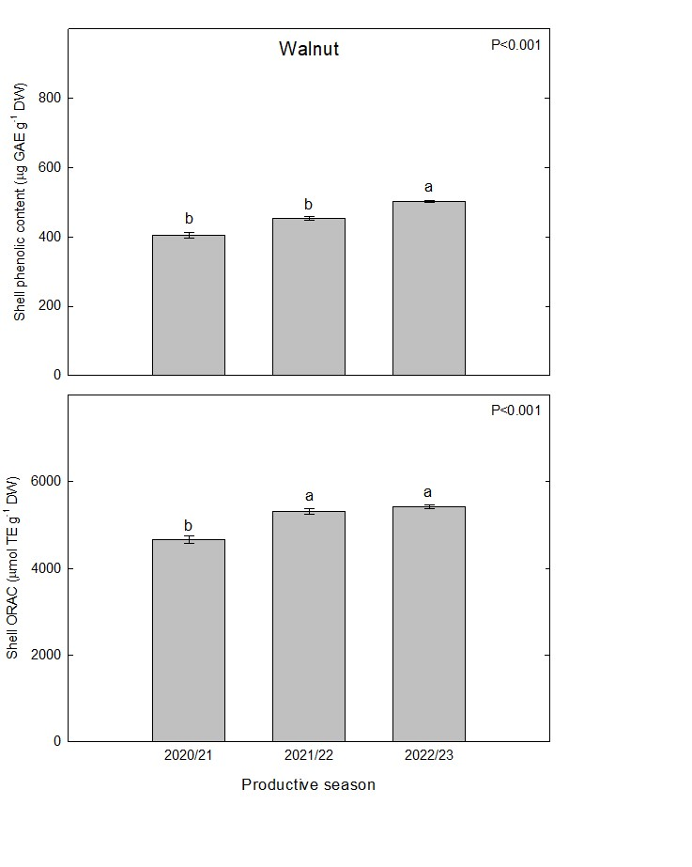
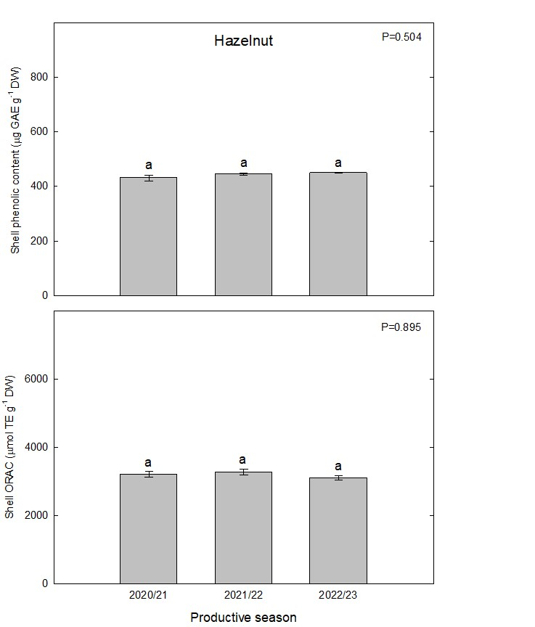

Fig. 2. The total phenolic content (µg GAE g⁻¹ DW) and ORAC (µmol TE g^{‒1} DW) in hazelnut (Tonda di Giffoni) and walnut (Franquette) shell samples from La Araucanía region orchards. Bars represent the average of five replicates ± S.E. Different letters indicate statistical differences (P≤0.05) between three different productive seasons.

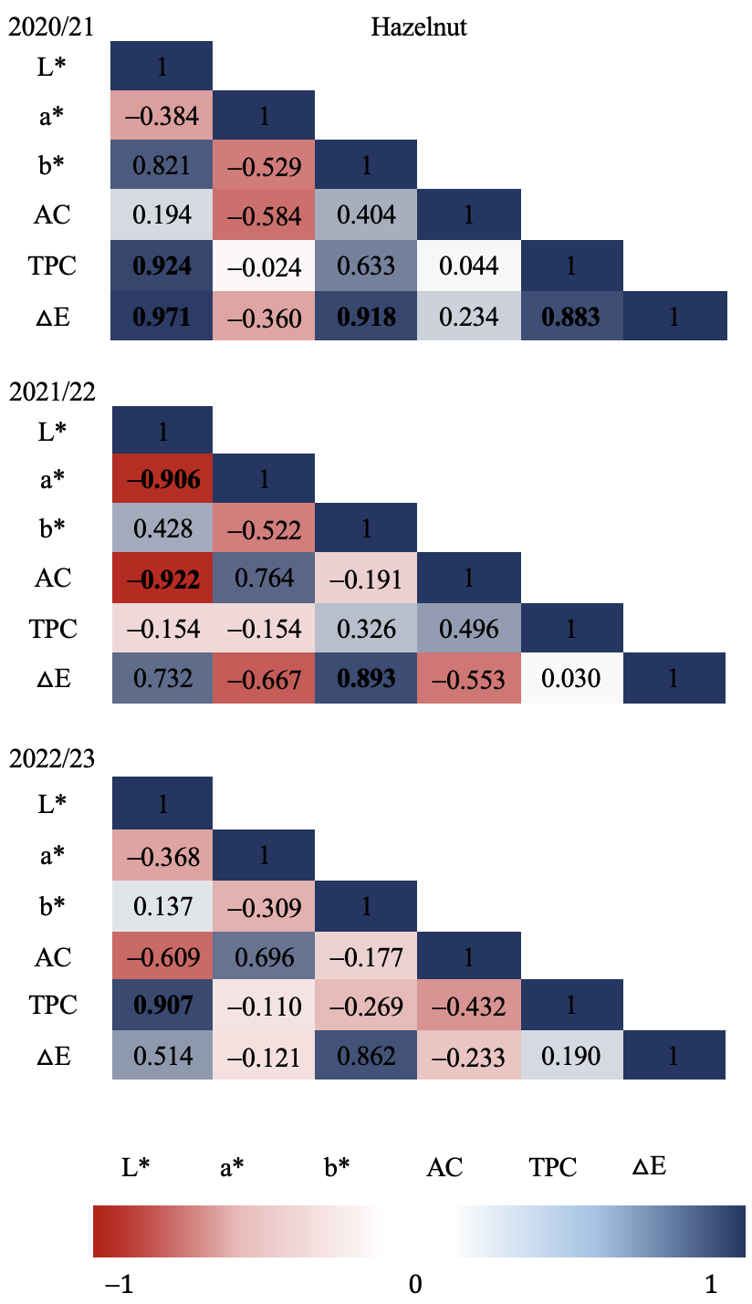
Fig. 3. Hazelnut shell Pearson’s correlation coefficient matrix among seasons and all variables. Correlation was calculated for three productive seasons (2020/21, 2021/22 and 2022/23). Where ORAC correspond to AC (antioxidant capacity) and TPC to total phenolic content. Pearson’s coefficients that are significant at P≤0.05 are indicated by bold numbers. Positive and negative correlations are distinguished by blue and red colors respectively.
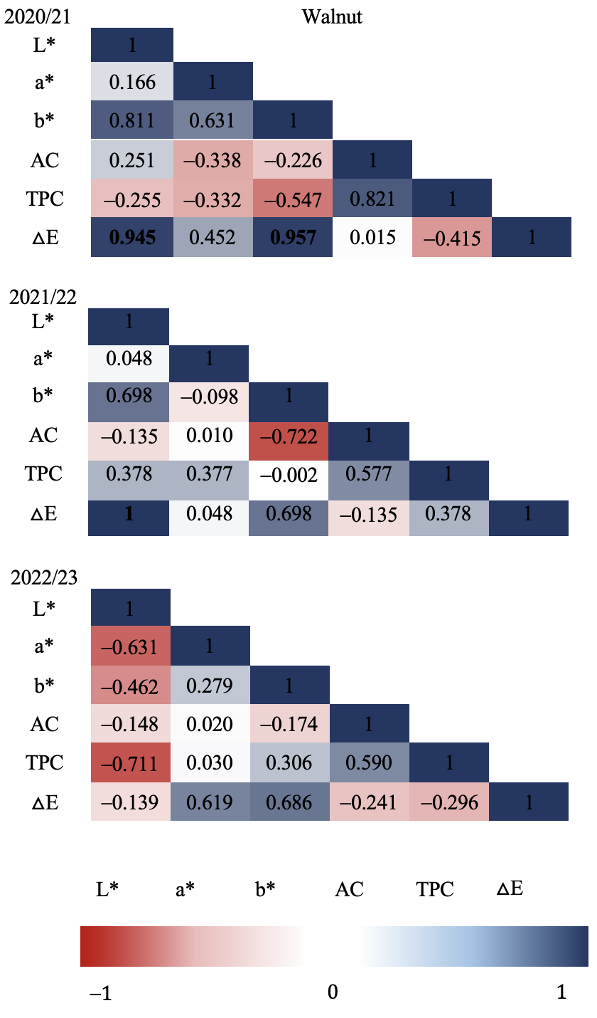
Fig. 4. Walnut shell Pearson’s correlation coefficient matrix among seasons and all variables. Correlation was calculated for three productive seasons (2020/21, 2021/22 and 2022/23). Where ORAC correspond to AC (antioxidant capacity) and TPC to total phenolic content. Pearson’s coefficients that are significant at P≤0.05 are indicated by bold numbers. Positive and negative correlations are distinguished by blue and red colors respectively.

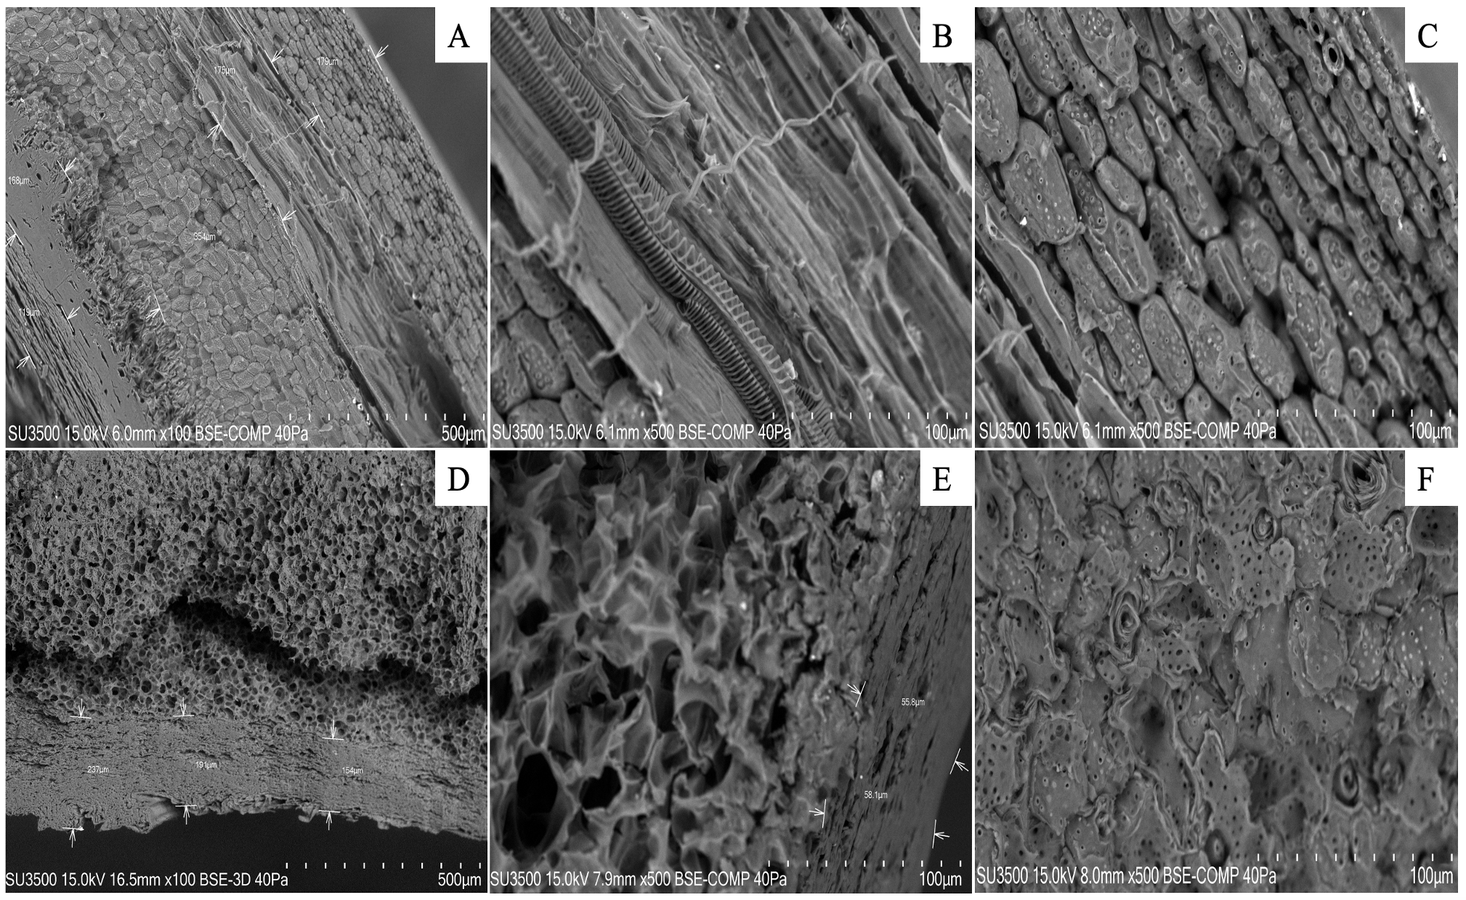
Fig. 5. Scanning electron microscopy (SEM) visualization of nutshell profiles (hazelnut A-C, and walnut D-F). Images were zoomed to 500 µm (A and D) and to 100 µm (B, C, E and F). The arrows point to different cell layers in each sample. Analyses were carried out at Microscopy and Flow Cytometry Unit, BIOREN-UFRO, Universidad de La Frontera, Temuco, Chile.

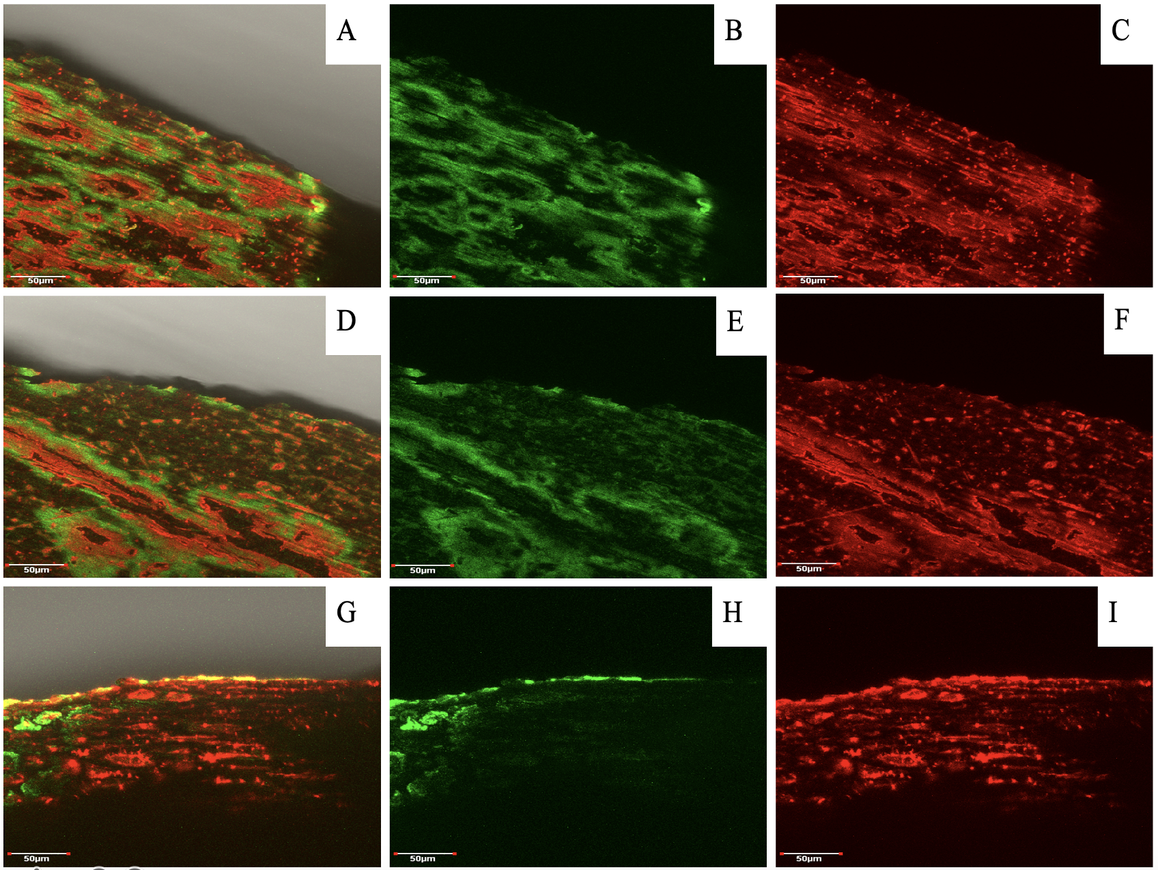
Fig. 6. Hazelnut shell profiles after staining and fluorescence visualization assay by laser confocal microscopy. Figure A, D and G correspond to a MERGE (overlap of both staining solutions) of nutshell profiles in relation to three seasons (2020/21, 2021/22 and 2022/23 respectively), while figures B, C, E, F, H and I correspond to the same picture with separate staining. Staining solutions used were “red congo” (red) for cellulose and “safranin” (green) for lignin. Analyses were carried out at Microscopy and Flow Cytometry Unit, BIOREN-UFRO, Universidad de La Frontera, Temuco, Chile.

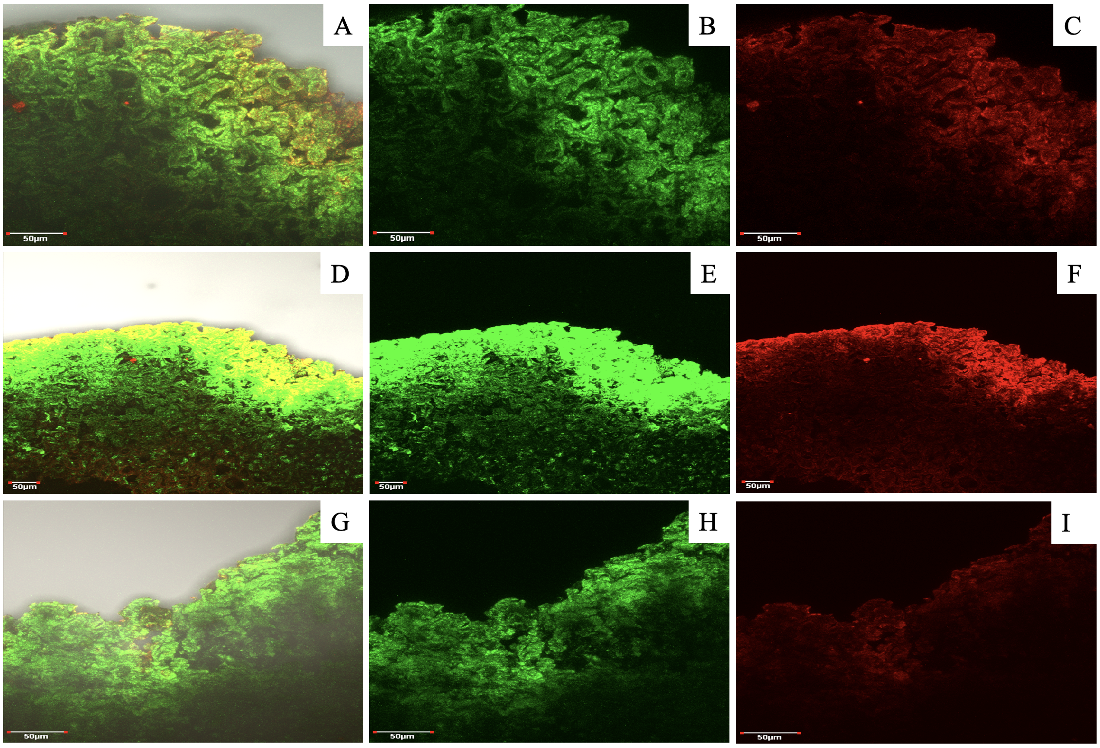
Fig. 7. Walnut shell profiles after staining and fluorescence visualization assay by laser confocal microscopy. Figures A, D and G correspond to a MERGE (overlap of both staining solutions) of nutshell profiles in relation to three seasons (2020/21, 2021/22 and 2022/23 respectively), while figures B, C, E, F, H and I correspond to the same picture with separate staining. Staining solutions used were “red congo” (red) for cellulose and “safranin” (green) for lignin. Analyses were carried out at Microscopy and Flow Cytometry Unit, BIOREN-UFRO, Universidad de La Frontera, Temuco, Chile.

Highlights

- In both hazelnut and walnut, the color change parameter (ΔE) showed a significant upward increase according to the chronology of the studied seasons.
- In terms of microstructure in both shells, the number of cell layers was determined and the cell types were described.
- In relation to the effect of seasons evaluated on ORAC and TPC it was possible to establish certain differences between the evaluated seasons.
- The results point to the high potential of hazelnut and nutshell by-products for further use, based on the stability of the features investigated.

