EMISSION ELLIPSOMETRY STUDY IN POLYMERIC INTERFACES BASED ON POLY(3-HEXYLTHIOPHENE), PCBM AND GRAPHENE
Ana Clarissa H. Kolbow ¹, Everton Crestani Rambo¹, Maria Ruth Neponucena dos Santos¹, Paulo Ernesto Marchezi ², Ana Flávia Nogueira³, Alexandre Marletta⁴, Romildo Jerônimo Ramos¹, Eralci Moreira Therézio^{1,*}
¹ Institute of Physics, Federal University of Mato Grosso, Cuiabá, MT, Brazil; ana.kolbow@fisica.ufmt.br (A.C.H.K.); everton@fisica.ufmt.br (E.C.R.); mariaruth_neponucena@hotmail.com (M.R.N.S.); romildo@fisica.ufmt.br (R.J.R.); therezio@fisica.ufmt.br (E.M.T.)
² Department of NanoEngineering, University of California San Diego, 9500 Gilman Drive, La Jolla, California 92093, United States; pauloernestom@gmail.com (P.E.M.)
³ Chemistry Institute, University of Campinas, Campinas, SP, Brazil ; anafla@unicamp.br (A.F.N.)
⁴ Institute of Physics, Federal University of Uberlândia,Uberlândia, MG, Brazil; marletta@ufu.br (A.M.)

* Correspondence: therezio@fisica.ufmt.br
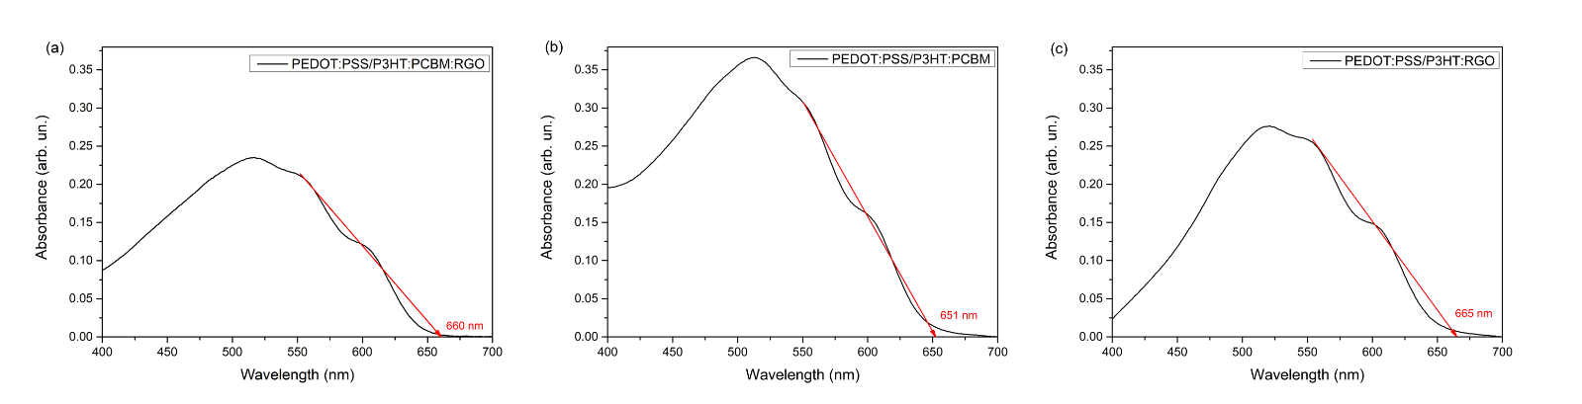
Figure S1. Absorption spectra for samples (a) PEDOT:PSS/P3HT:PCBM:RGO, (b) PEDOT:PSS/P3HT:PCBM (c) PEDOT:PSS/P3HT:RGO. Indicating cutting length.

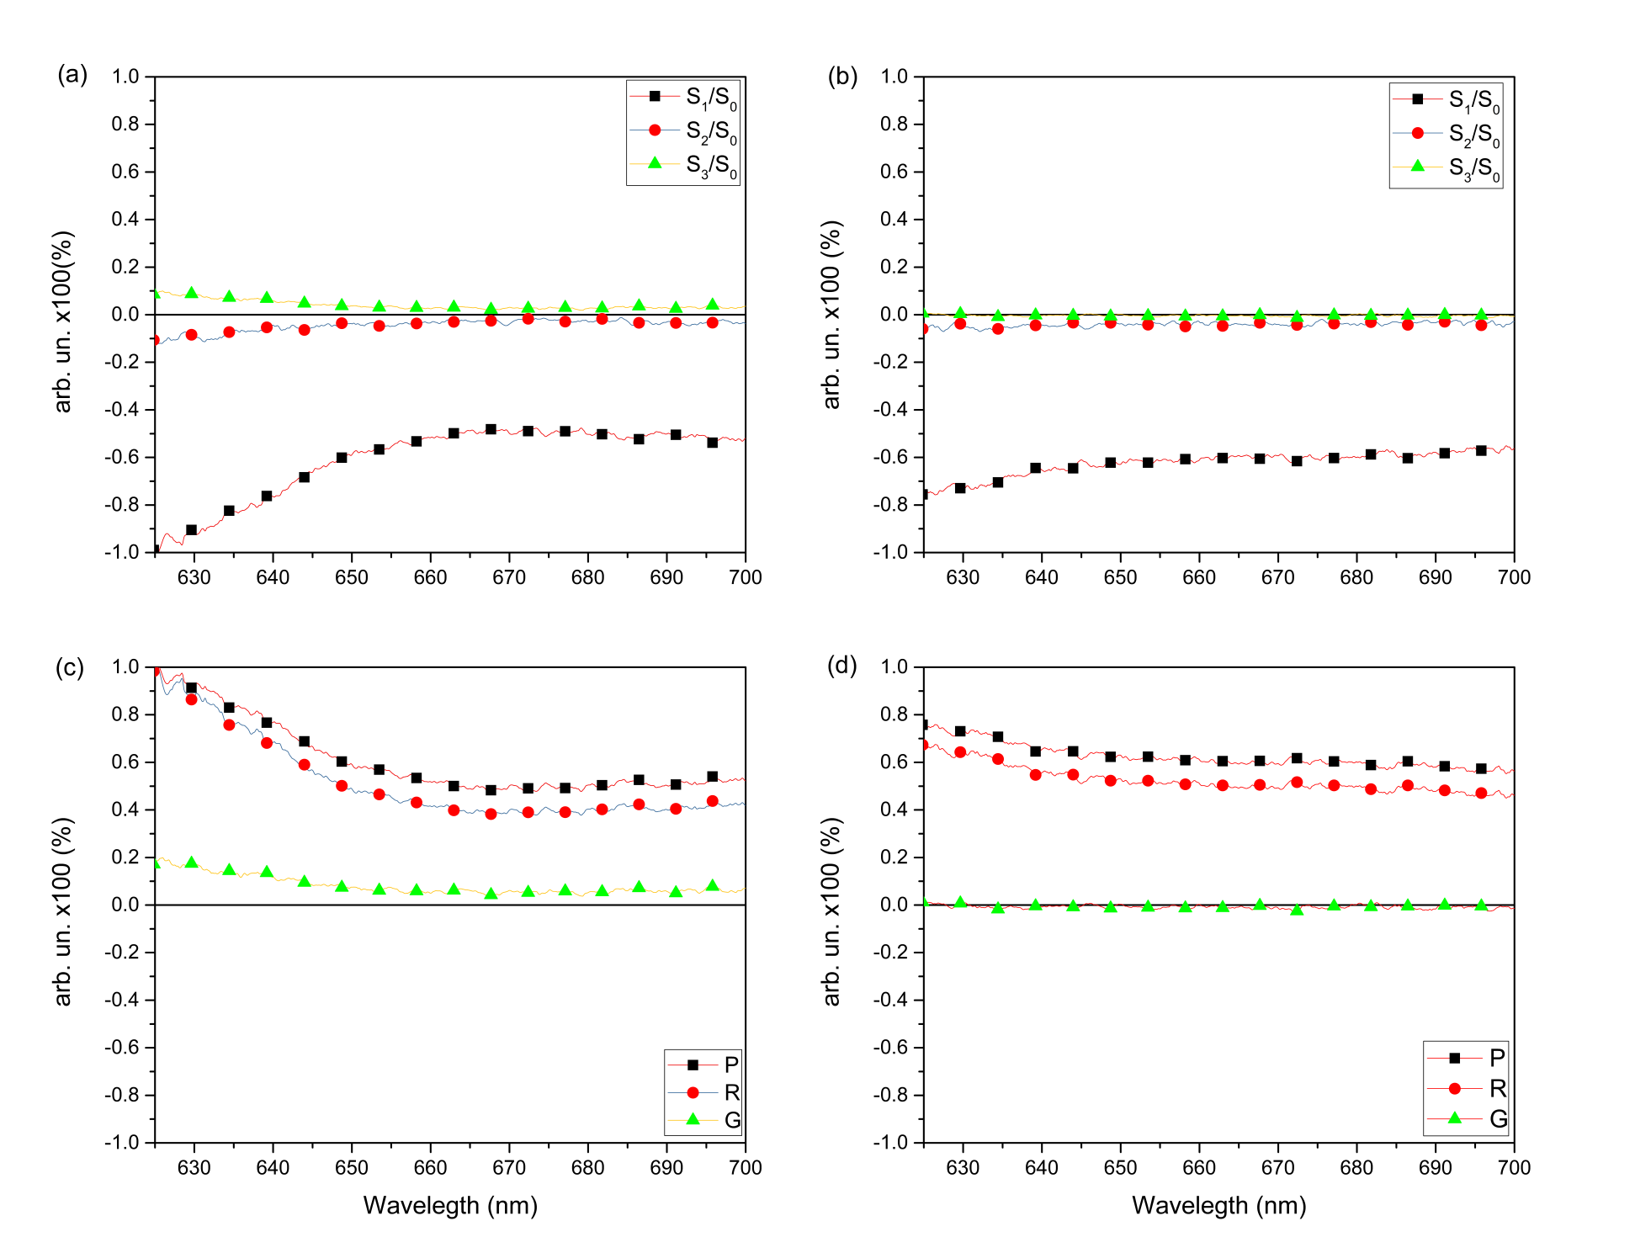
Figure S2. (a) EE spectra for sample PEDOT:PSS/P3HT:PCBM at 90 K and (b) at 300 K; (c) Polarization degree, P, anisotropy factors, r, and asymmetry, g, obtained from the Stokes parameters for sample PEDOT:PSS/P3HT:PCBM at 90 K and (d) at 300 K.
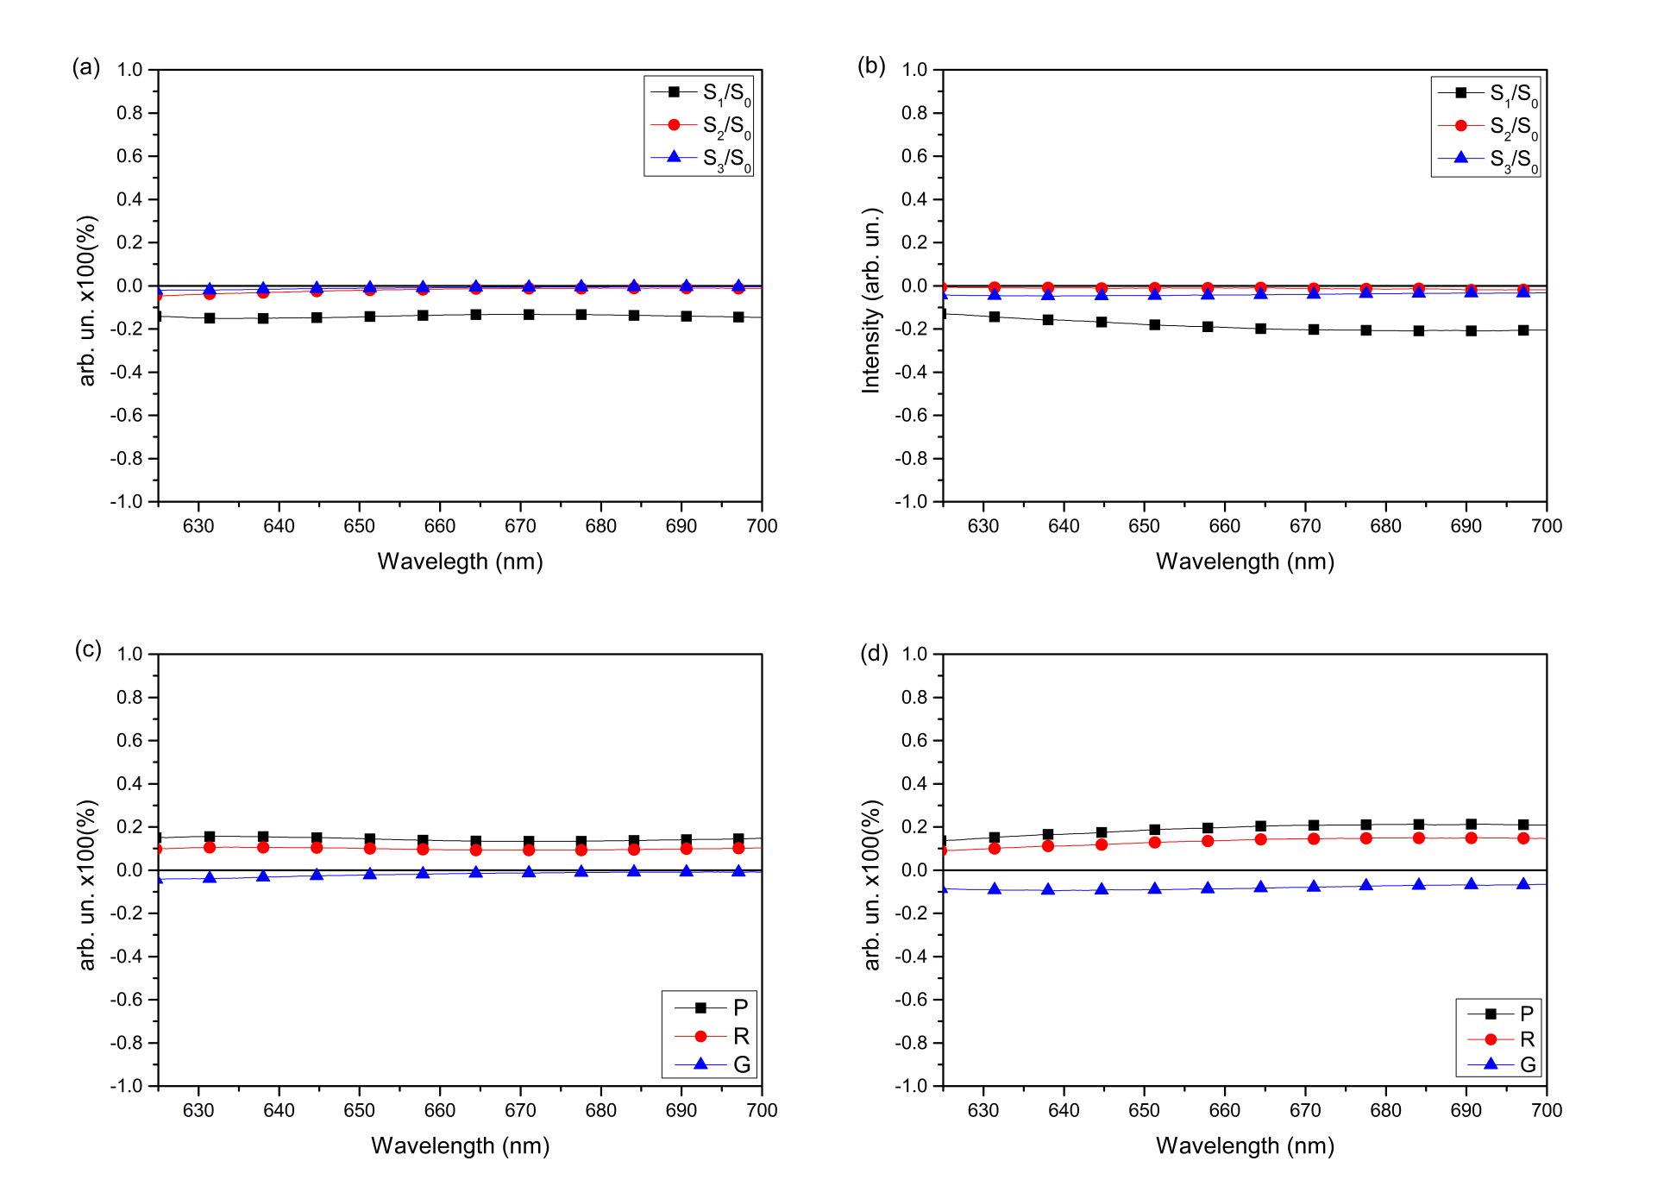
Figure S3. (a) EE spectra for sample PEDOT:PSS/P3HT:RGO at 90 K and (b) at 300 K; (c) Polarization degree, P, anisotropy factors, r, and asymmetry, g, obtained from the Stokes parameters for sample PEDOT:PSS/P3HT:RGO at 90 K and (d) at 300 K.
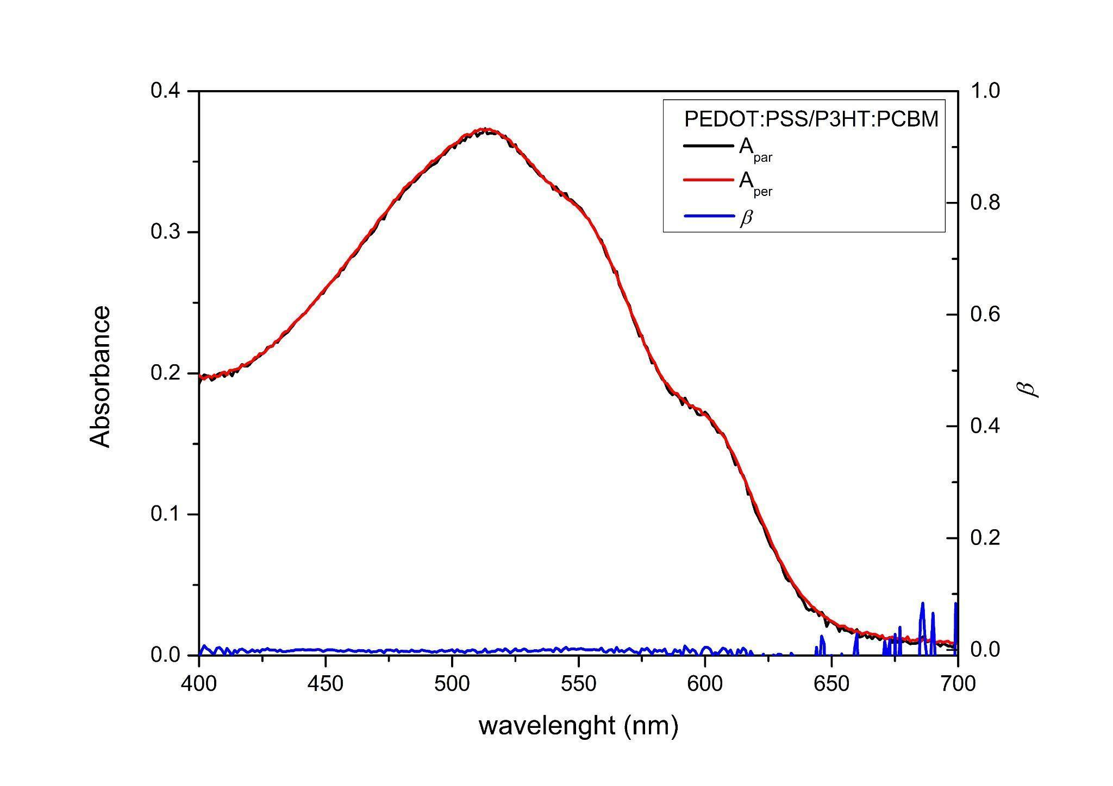
Figure S4. Parallel (A_{par}) and perpendicular (A_{per}) to the laboratory plane UV-Vis absorption spectra of sample PEDOT:PSS/P3HT:PCBM. The blue curve represents the molecular order parameter, β , in the spectral window of the absorption band.
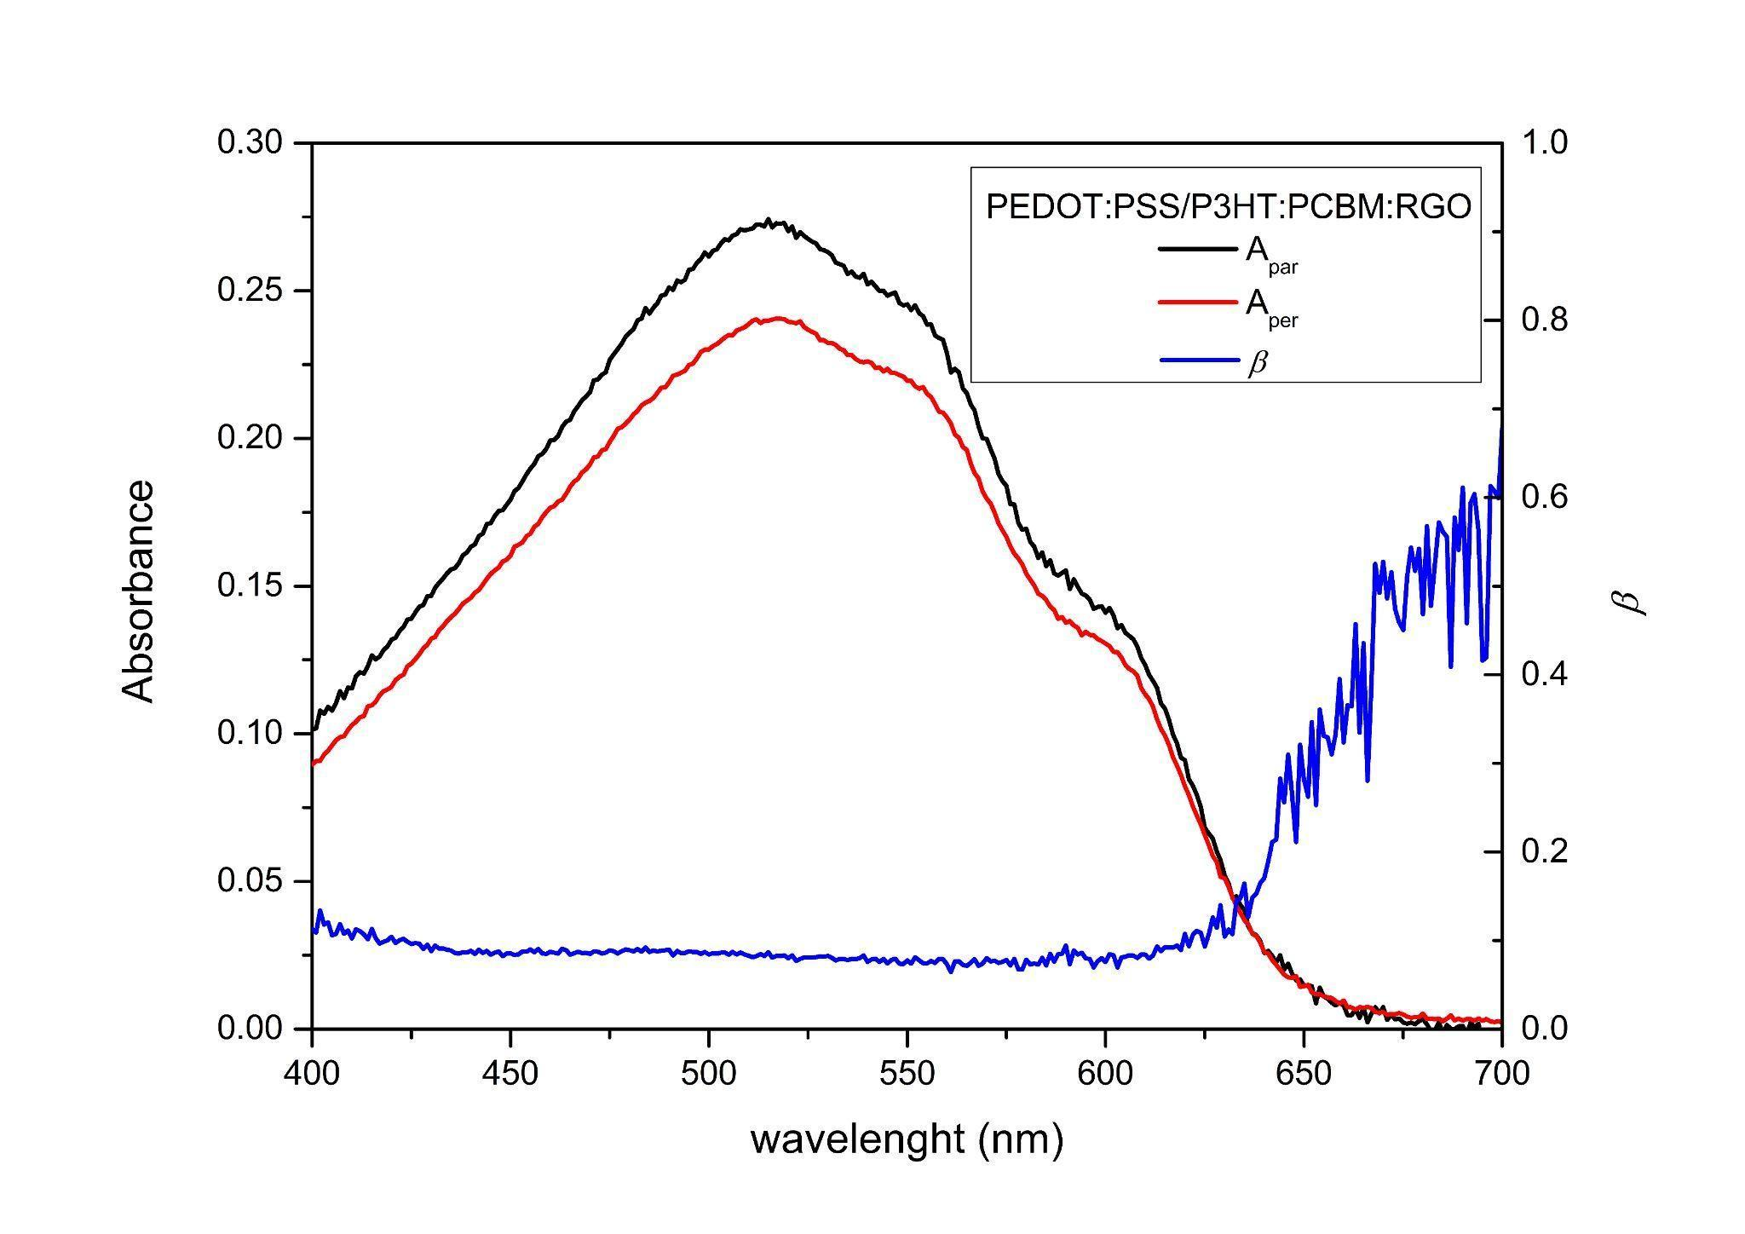
Figure S5. Parallel (A_{par}) and perpendicular (A_{per}) to the laboratory plane UV-Vis absorption spectra of sample PEDOT:PSS/P3HT:PCBM:RGO. The blue curve represents the molecular order parameter, β, in the spectral window of the absorption band.
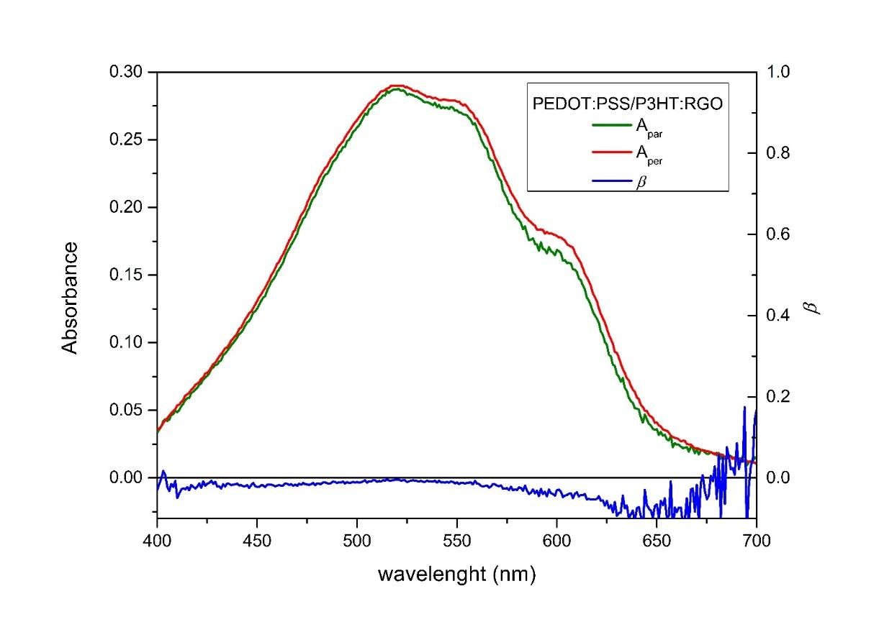
Figure S6. Parallel (A_{par}) and perpendicular (A_{per}) to the laboratory plane UV-Vis absorption spectra of sample PEDOT:PSS/P3HT:RGO. The blue curve represents the molecular order parameter, β , in the spectral window of the absorption band.

