Supplemental for
Preterm Births Attributable to Criteria Air Pollutant Exposure in Bangladesh During 2015-2019
Debatosh B. Partha^{1, *}, Sumiya Yasmin², Hrithik Nath^{2, 3}

¹ Department of Civil & Environmental Engineering, Wayne State University, Detroit, MI 48202, United States
² Department of Civil Engineering, Khulna University of Engineering & Technology (KUET), Khulna, 9203, Bangladesh
³ Department of Civil Engineering, University of Creative Technology Chittagong (UCTC), Chattogram, 4212, Bangladesh

*Corresponding author: debatosh@wayne.edu

Number of pages: 8
Number of tables: 3
Number of figures: 1

Table of Contents
1. Measurements of Odds ratio and log-linear slope for each criteria air pollutant
2. Global total gridded live births from (a) unscaled CIESIN for 2015, and scaled total gridded live births for (b) 2015, (c) 2016, (d) 2017, (e) 2018, and (f) 2019.
3. Annual mean and maximum exposure of CO, O₃, PM_{2.5}, SO₂, and NO₂ during 2015-2019 in Bangladesh.
4. Location-wise total number of PTBs attributable to individual and synergistic effect of CO, O₃, PM_{2.5}, SO₂, and NO₂ exposure during 2015-2019 in Bangladesh.
5. Total number of PTBs attributable to CO, O₃, PM_{2.5}, SO₂, NO₂, and combined exposure with 95% confidence interval (CI) during 2015-2019 in Bangladesh.

Text S1. Measurements of Odds ratio and log-linear slope for each criteria air pollutant
Eqn. (1) & (2) are used to calculate the odds ratio in each grid box and the log-linear slope for CO. With the increase of 100 $μg/m$³ CO exposure, the odds of PTB increased by 1.18 times (95CI: 1.06, 1.32) (Shanshan Li et al., 2016). For the counterfactual concentration of CO in Bangladesh, we have assumed 40 $μg/m$³ under which there may not be any health impacts associated with the exposure.

$${OR}_{i,j}=e^{\left\{γ×[C_{i,j }- 40]\right\}} [1]$$
$$γ= \left[\frac{ln(OR)}{100}\right] [2]$$

Eqn. (3) & (4) are used to calculate the odds ratio in each grid box and the log-linear slope for NO₂ exposure (in ppbv) associated with PTB. The odds of PTB increased by 1.29 times (95CI: 1.13, 1.46) when the NO₂ exposure increased by 1 $μg/m$³ ($≡$0.5 $ppbv$) (Sabrina Llop et al., 2010). Sabrina Llop et al., 2010 found the counterfactual concentration of NO₂ as 46.2 $μg/m$³ ($≡$7.6 ppbv) under which there may not be any health impacts associated with the exposure.

$${OR}_{i,j}=e^{\left\{γ×[C_{i,j }- 7.6]\right\}} [3]$$
$$γ= \left[\frac{ln(OR)}{0.5}\right] [4]$$
The odds ratio in each grid box and the log-linear slope for O₃ exposure associated with PTB are calculated using Eqn. (5) & (6). The metal analysis of Kristen M. et al., 2021 found that with the increase of 10 $ppb$ O₃ exposure, the odds of PTB increased by 1.06 times (95CI: 1.03, 1.10). For the counterfactual O₃ exposure, we have assumed 26.7 ppb similar to the study of Hunag et. al., 2021 under which there may not be any health impacts associated with the exposure.

$${OR}_{i,j}=e^{\left\{γ×[C_{i,j }- 26.7]\right\}} [5[$$
$$γ= \left[\frac{ln(OR)}{10}\right] [6]$$

The odds ratio in each grid box and the log-linear slope for PM_{2.5} and SO₂ exposure associated with PTB are calculated using Eqn. (7) & (8). The metal analysis of Xiaoli Sun et al., 2015 found that with the increase of 10 $μg/m$³ PM_{2.5} exposure, the odds of PTB increased by 1.13 times (95CI: 1.03, 1.24). On the other hand, Ying Liu et al., 2019 found that with the increase of 10 $μg/m$³ SO₂ exposure, the odds of PTB increased by 1.081 times (95CI: 1.01, 1.29). For the counterfactual PM_{2.5} and SO₂ exposure, we have assumed 2.4 $μg/m$³ similar to the study of Hunag et. al., 2021 as SO₂ is one of the vital primary organic matters that contributes to the formation of PM_{2.}

$${OR}_{i,j}=e^{\left\{γ×[C_{i,j }- 2.4]\right\}} [7]$$
$$γ= \left[\frac{ln(OR)}{10}\right] [8]$$

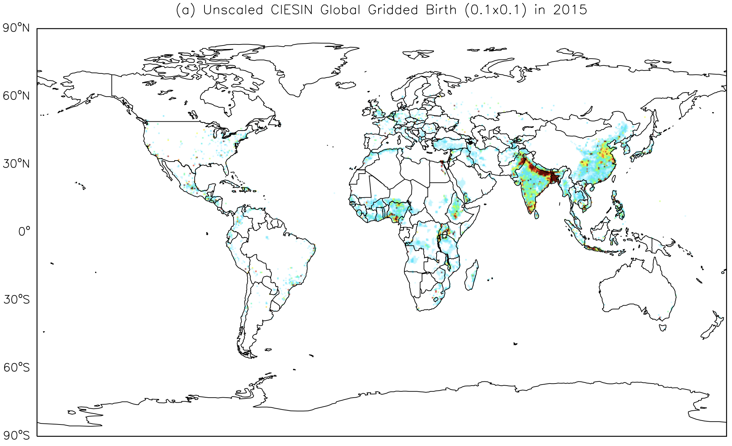
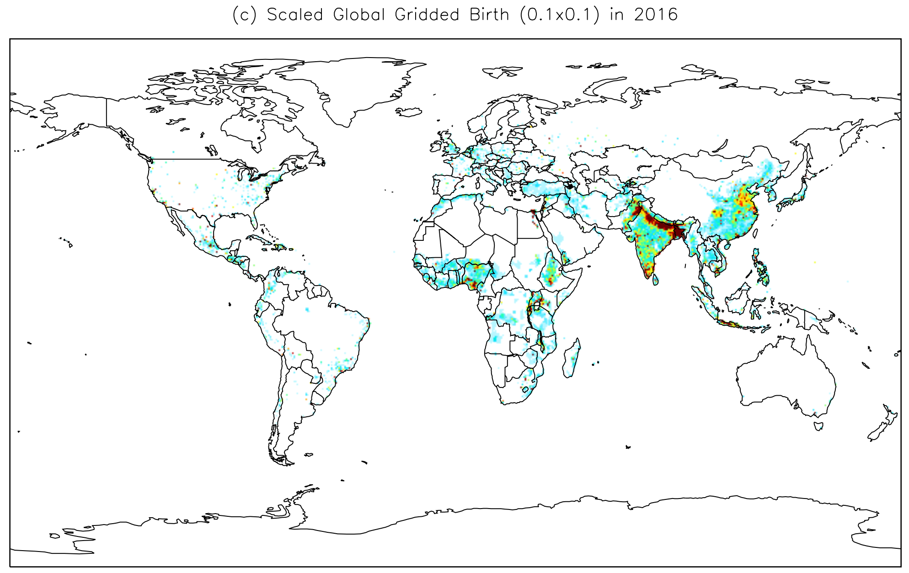
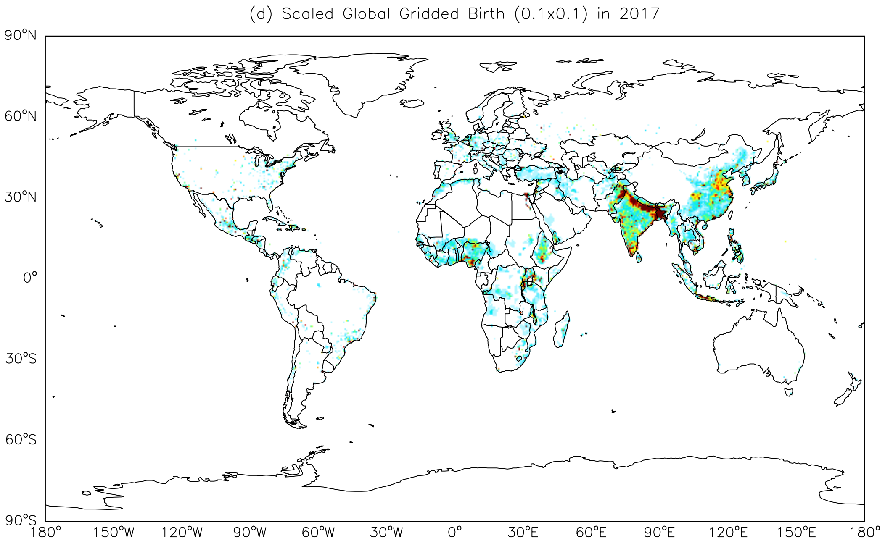
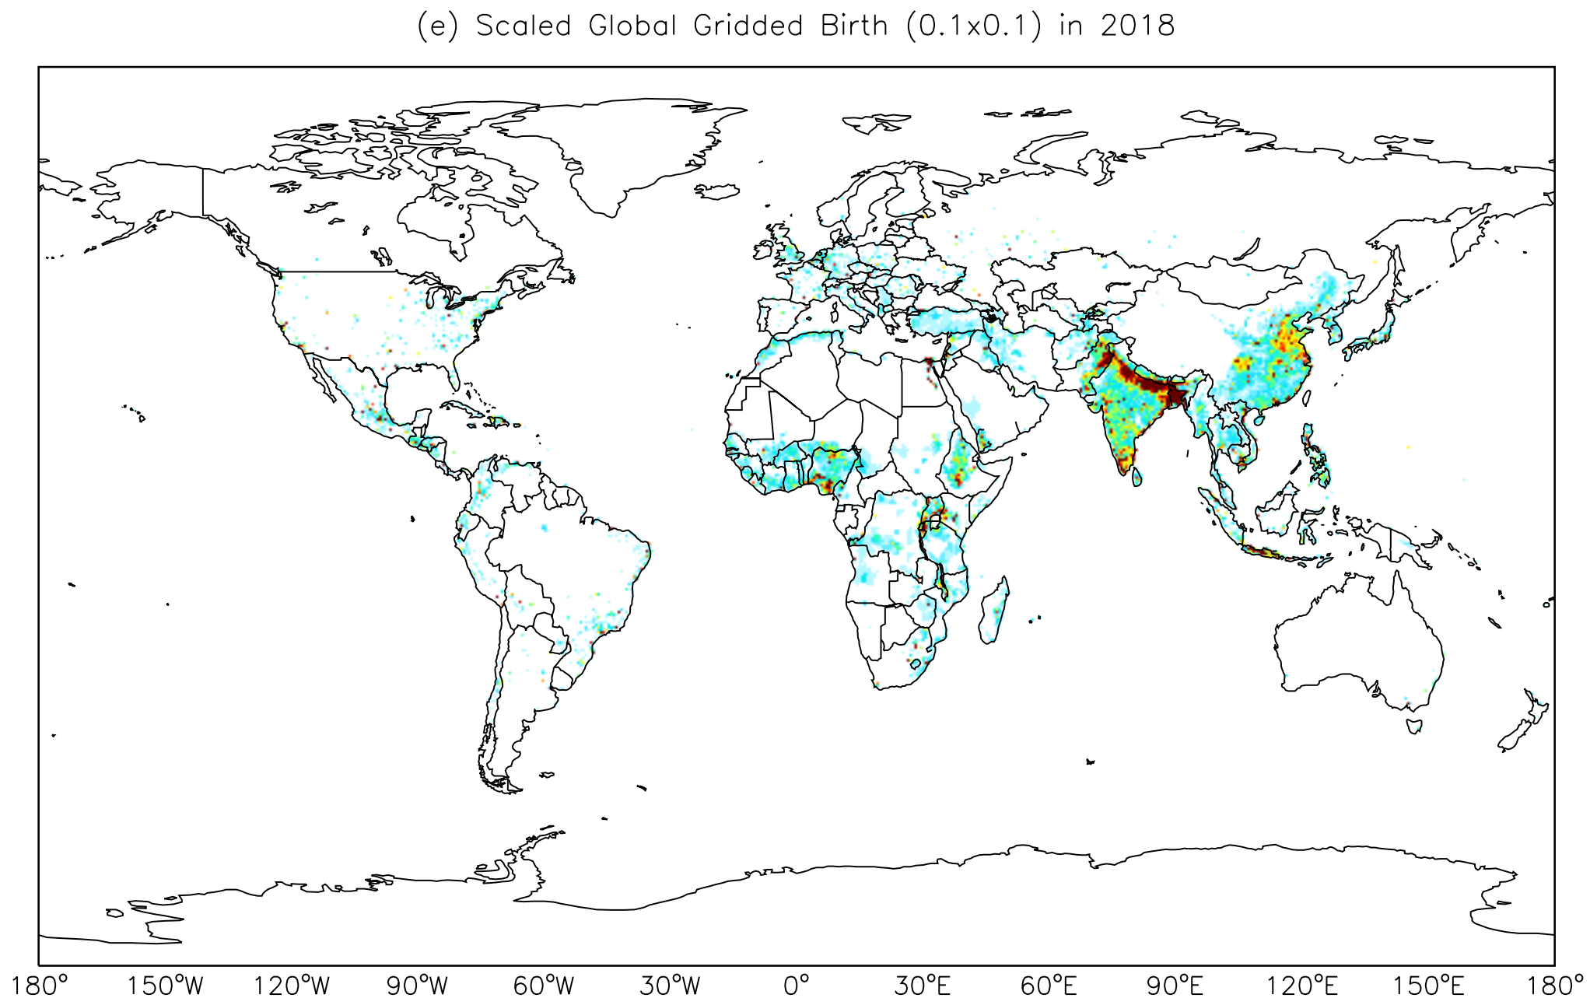
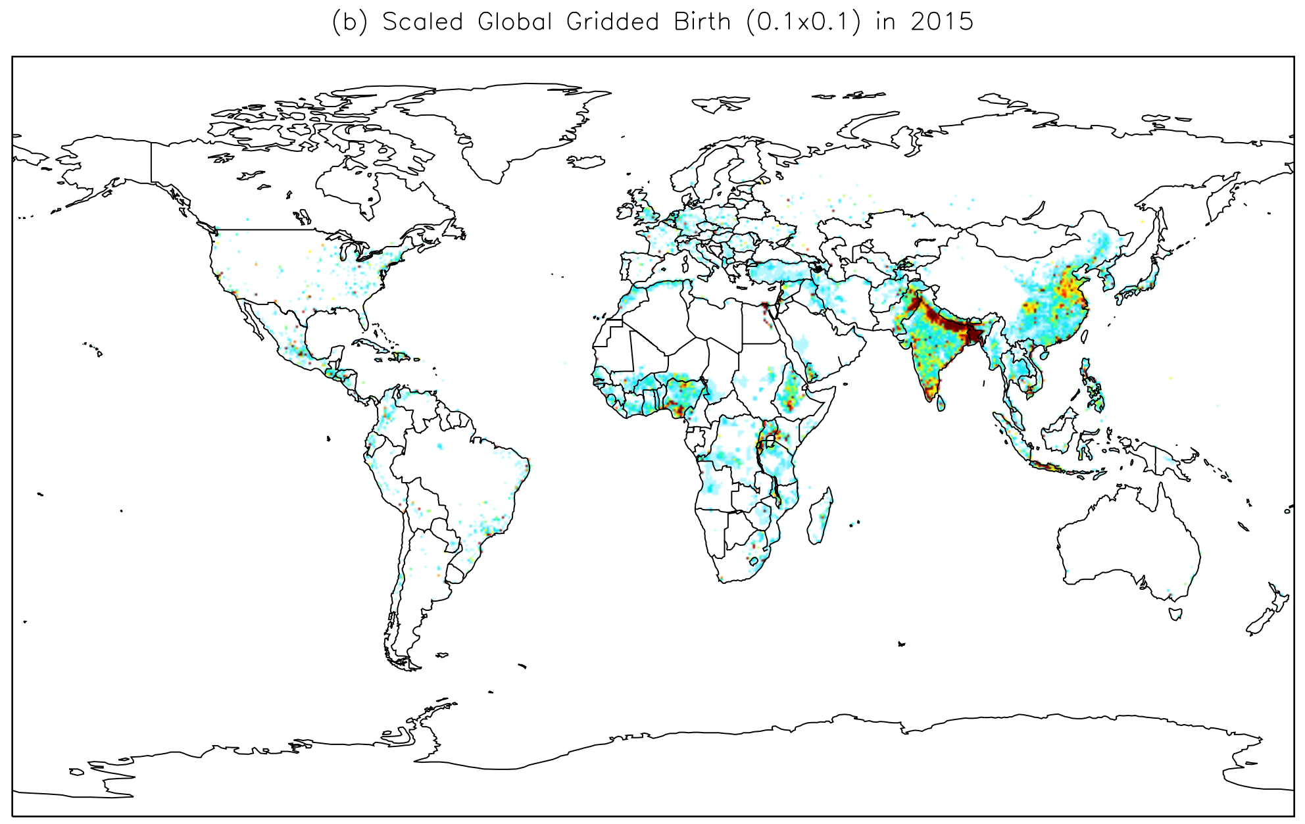
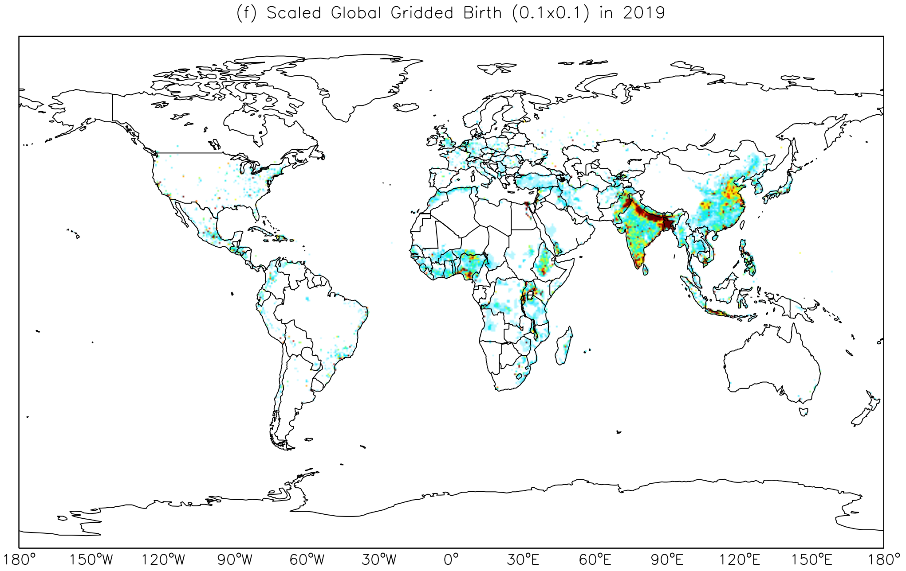
Global total live births: 127.3 Million
Global total live births: 141.6 Million
Global total live births: 141.8 Million
Global total live births: 141.9 Million
Global total live births: 142 Million
Global total live births: 141.9 Million

Figure S1. Global total gridded live births from (a) unscaled CIESIN for 2015, and scaled total gridded live births for (b) 2015, (c) 2016, (d) 2017, (e) 2018, and (f) 2019.

Table S1. Annual mean and maximum exposure of CO, O₃, PM_{2.5}, SO₂, and NO₂ during 2015-2019 in Bangladesh.

 | CO |  | O₃ |  | PM_{2.5} |  | SO₂ |  | NO₂
Year | Mean ($μ$g/m³) | Max  ($μ$g/m³) | Mean (ppbv) | Max  (ppbv) | Mean ($μ$g/m³) | Max  ($μ$g/m³) | Mean ($μ$g/m³) | Max  ($μ$g/m³) | Mean (ppbv) | Max  (ppbv)
2015 | 0.032 | 265.69 | 0.01491 | 84.47 | 0.008400 | 54.67 | 0.001 | 20.29 | 0.000627 | 10.36
2016 | 0.032 | 250.26 | 0.01481 | 84.04 | 0.008397 | 57.69 | 0.001 | 20.11 | 0.000627 | 10.38
2017 | 0.031 | 245.16 | 0.01484 | 83.95 | 0.008076 | 53.47 | 0.001 | 19.36 | 0.000664 | 11.43
2018 | 0.033 | 272.82 | 0.01506 | 88.15 | 0.009671 | 62.94 | 0.001 | 20.49 | 0.000651 | 11.60
2019 | 0.031 | 240.79 | 0.01486 | 85.66 | 0.008175 | 54.38 | 0.001 | 18.25 | 0.000632 | 11.24

Table S2. Location-wise total number of PTBs attributable to individual and synergistic effect of CO, O₃, PM_{2.5}, SO₂, and NO₂ exposure during 2015-2019 in Bangladesh.

 |  | CO |  |  |  |  | O₃ |  |  |  |  | PM_{2.5}
Area/  Region | Coordi-nates | 2015 | 2016 | 2017 | 2018 | 2019 | 2015 | 2016 | 2017 | 2018 | 2019 | 2015 | 2016 | 2017 | 2018 | 2019
Firmgate, Dhaka | 23.76, 90.39E | 268 | 263 | 248 | 268 | 250 | 361 | 350 | 345 | 343 | 338 | 562 | 545 | 538 | 601 | 520
Gazipur | 23.99, 90.42E | 54 | 53 | 50 | 54 | 51 | 77 | 75 | 74 | 73 | 72 | 114 | 111 | 109 | 122 | 105
Narayangonj | 23.63, 90.51E | 152 | 147 | 139 | 151 | 141 | 213 | 207 | 204 | 203 | 200 | 333 | 325 | 316 | 354 | 310
Khulshi, Chattogram | 22.36, 91.80E | 84 | 79 | 78 | 82 | 79 | 143 | 139 | 137 | 135 | 134 | 222 | 208 | 203 | 234 | 197
Agrabad, Chattogram | 22.32, 91.81E | 201 | 188 | 187 | 197 | 190 | 343 | 333 | 328 | 324 | 322 | 532 | 498 | 485 | 560 | 472
Red Crescent Campus, Sylhet | 24.89, 91.87E | 30 | 28 | 27 | 28 | 27 | 48 | 47 | 46 | 46 | 45 | 56 | 52 | 50 | 61 | 49
Baira, Khulna | 22.48, 89.53E | 11 | 10 | 10 | 10 | 10 | 14 | 14 | 13 | 13 | 13 | 24 | 24 | 22 | 25 | 22
Sopura, Rajshahi | 24.38, 88.61E | 49 | 48 | 48 | 48 | 46 | 58 | 57 | 56 | 57 | 55 | 96 | 99 | 91 | 100 | 91
DFO office campus, Barisal | 22.71, 90.36E | 40 | 38 | 36 | 38 | 37 | 62 | 60 | 59 | 58 | 58 | 101 | 101 | 95 | 107 | 95
 |  | SO₂ |  |  |  |  | NO₂ |  |  |  |  | Total PTBs from Combined Exposure
Area/  Region | Coordi-nates | 2015 | 2016 | 2017 | 2018 | 2019 | 2015 | 2016 | 2017 | 2018 | 2019 | 2015 | 2016 | 2017 | 2018 | 2019
Firmgate, Dhaka | 23.76, 90.39E | 36 | 34 | 30 | 41 | 25 | 0 | 0 | 0 | 0 | 0 | 1227 | 1192 | 1161 | 1253 | 1133
Gazipur | 23.99, 90.42E | 7 | 7 | 6 | 8 | 5 | 0 | 0 | 0 | 0 | 0 | 252 | 246 | 239 | 258 | 234
Narayangonj | 23.63, 90.51E | 21 | 20 | 16 | 24 | 14 | 0 | 0 | 0 | 0 | 0 | 720 | 699 | 675 | 732 | 666
Khulshi, Chattogram | 22.36, 91.80E | 0 | 0 | 0 | 0 | 0 | 0 | 0 | 0 | 0 | 0 | 450 | 426 | 418 | 452 | 411
Agrabad, Chattogram | 22.32, 91.81E | 0 | 0 | 0 | 0 | 0 | 0 | 0 | 0 | 0 | 0 | 1076 | 1019 | 1000 | 1081 | 984
Red Crescent Campus, Sylhet | 24.89, 91.87E | 1 | 1 | 1 | 2 | 1 | 0 | 0 | 0 | 0 | 0 | 135 | 128 | 125 | 137 | 121
Baira, Khulna | 22.48, 89.53E | 3 | 3 | 2 | 3 | 2 | 0 | 0 | 0 | 0 | 0 | 52 | 51 | 47 | 52 | 47
Sopura, Rajshahi | 24.38, 88.61E | 20 | 21 | 19 | 18 | 17 | 0 | 0 | 0 | 0 | 0 | 223 | 224 | 214 | 223 | 209
DFO office campus, Barisal | 22.71, 90.36E | 6 | 5 | 4 | 6 | 3 | 0 | 0 | 0 | 0 | 0 | 209 | 205 | 193 | 210 | 193

Table S3. Total number of PTBs attributable to CO, O₃, PM_{2.5}, SO₂, NO₂, and combined exposure with 95% confidence interval (CI) during 2015-2019 in Bangladesh.

Pollutants | Year | Total number of PTBs (95% CI)
CO | 2015 | 41,229 (15,570, 64,510)
 | 2016 | 39,977 (15,080, 62,623)
 | 2017 | 38,132 (14,354, 59,855)
 | 2018 | 40,197 (15,211, 62,771)
 | 2019 | 37,957 (14,299, 59,533)
O₃ | 2015 | 55,942 (30,496, 83,650)
 | 2016 | 54,551 (29,717, 81,641)
 | 2017 | 53,666 (29,239, 80,302)
 | 2018 | 53,713 (29,313, 80,214)
 | 2019 | 52,657 (28,694, 78,776)
PM_{2.5} | 2015 | 86,370 (25,222, 1,29,635)
 | 2016 | 84,696 (24,741, 1,27,121)
 | 2017 | 81,344 (23,629, 1,22,689)
 | 2018 | 91,680 (27,526, 1,34,252)
 | 2019 | 80,006 (23,268, 1,20,549)
SO₂ | 2015 | 7684 (1007, 23,568)
 | 2016 | 7375 (967, 22,611)
 | 2017 | 6538 (856, 20,121)
 | 2018 | 7645 (1002, 23,468)
 | 2019 | 5621 (734, 17,399)
NO₂ | 2015 | 1518 (852, 1985)
 | 2016 | 1794 (1003, 2353)
 | 2017 | 3157 (1785, 4109)
 | 2018 | 2460 (1391, 3205)
 | 2019 | 1782 (1007, 2322)
Combined PTBs | 2015 | 1,92,744 (77,382, 3,12,203)
 | 2016 | 1,88,395 (88,144, 3,21,213)
 | 2017 | 1,82,839 (81,397, 3,06,102)
 | 2018 | 1,95,697 (81,282, 3,16,669)
 | 2019 | 1,78,024 (75,409, 2,90,979)

References

Shanshan Li, Yuming Guo, and Gail Williams, Acute Impact of Hourly Ambient Air Pollution on Preterm Birth, doi: 10.1289/EHP200

Llop S, Ballester F, Estarlich M, Esplugues A, Rebagliato M, Iñiguez C. Preterm birth and exposure to air pollutants during pregnancy. Environ Res. 2010 Nov;110(8):778-85. doi: 10.1016/j.envres.2010.09.009. Epub 2010 Oct 6. PMID: 20932516.

Kristen M. Rappazzo *, Jennifer L. Nichols, R. Byron Rice, Thomas J. Luben, Ozone exposure during early pregnancy and preterm birth: A systematic review and meta-analysis, https://doi.org/10.1016/j.envres.2021.111317

Huang, Y., Partha, D. B., Harper, K., & Heyes, C. (2021). Impacts of global solid biofuel stove emissions on ambient air quality and human health. GeoHealth, 5, e2020GH000362. https://doi.org/10.1029/2020GH000362

Sun, X., Luo, X., Zhao, C. et al. The association between fine particulate matter exposure during pregnancy and preterm birth: a meta-analysis. BMC Pregnancy Childbirth 15, 300 (2015). https://doi.org/10.1186/s12884-015-0738-2

Ying Liu, Jihong Xu, Dian Chen, Pei Sun and Xu Ma, The association between air pollution and preterm birth and low birth weight in Guangdong, China 2019, https://doi.org/10.1186/s12889-018-6307-7

