**Supplementary data**

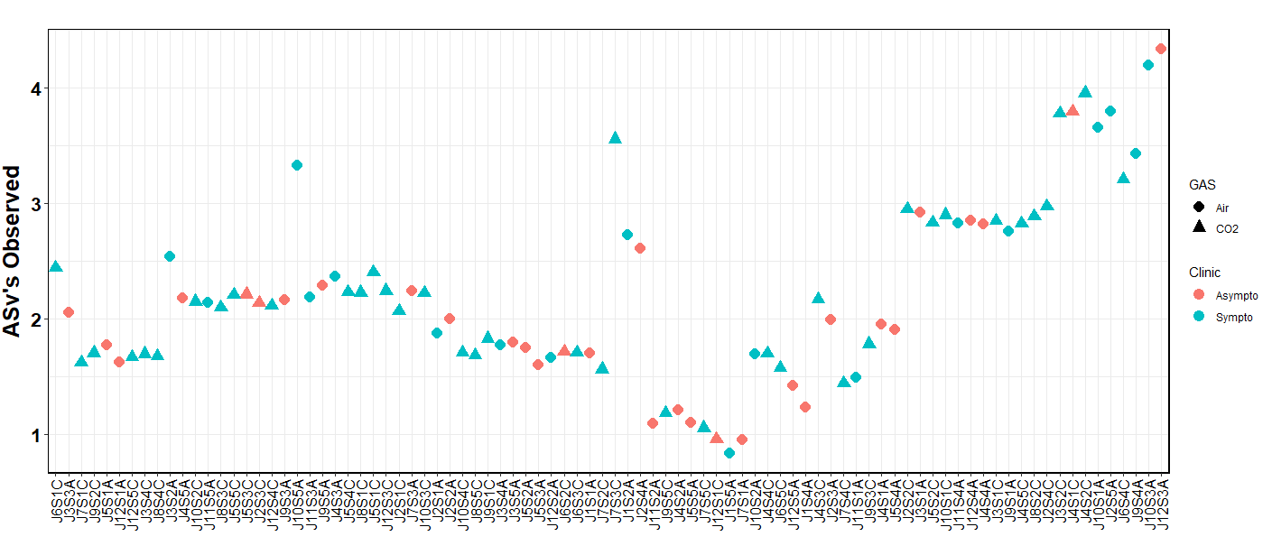

Figure 1 Distribution of Shannon diversity of microbial communities obtained with the 16 rDNA dataset. The colors represent the clinical group and the shape represents the gas group.

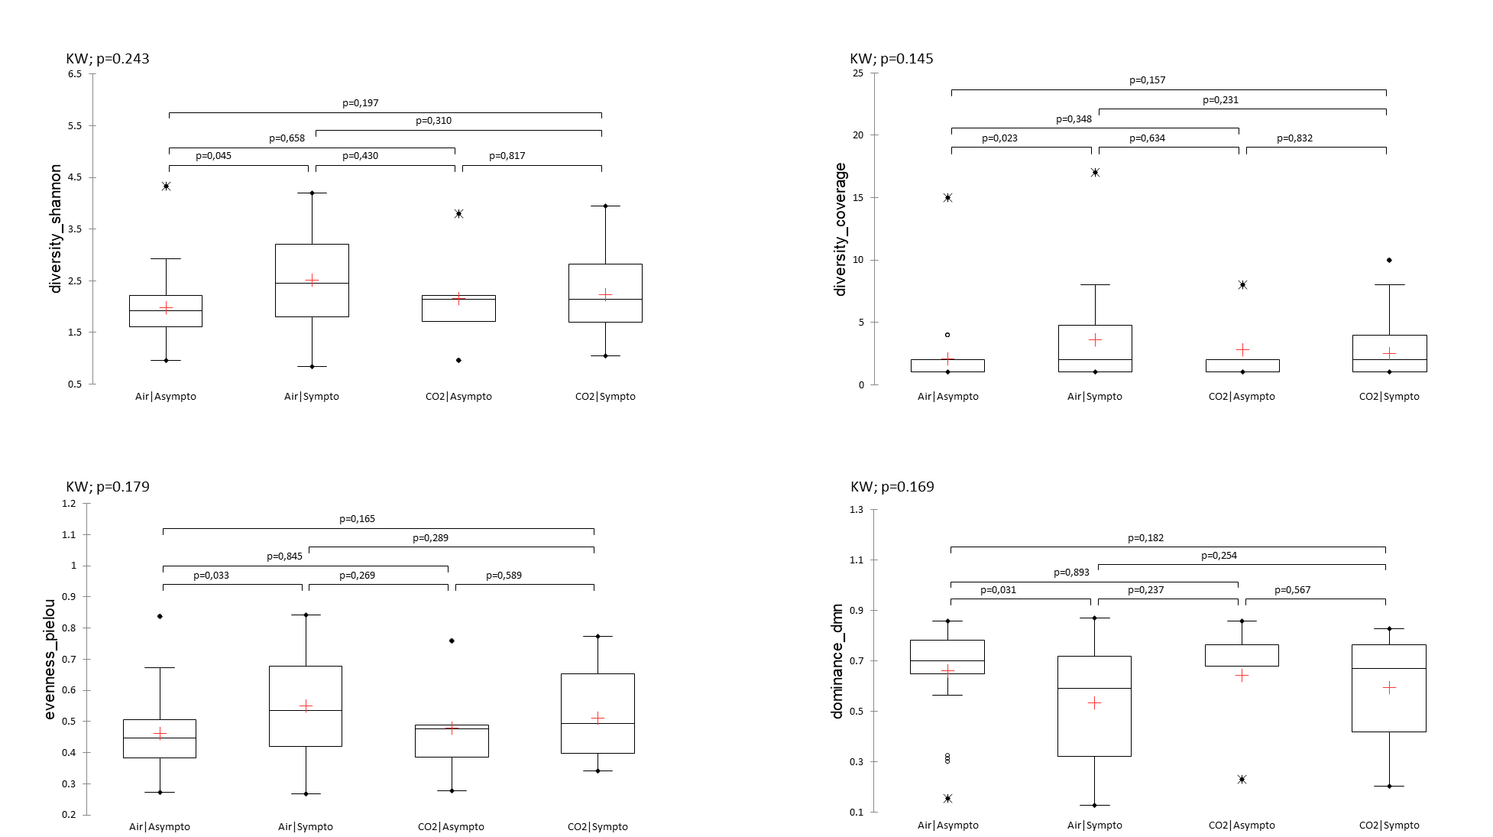

Figure 2 Diversity index. Kruskal-Wallis (KW) analysis with post-hoc dunn test (Bonferroni correction: 0,0083).

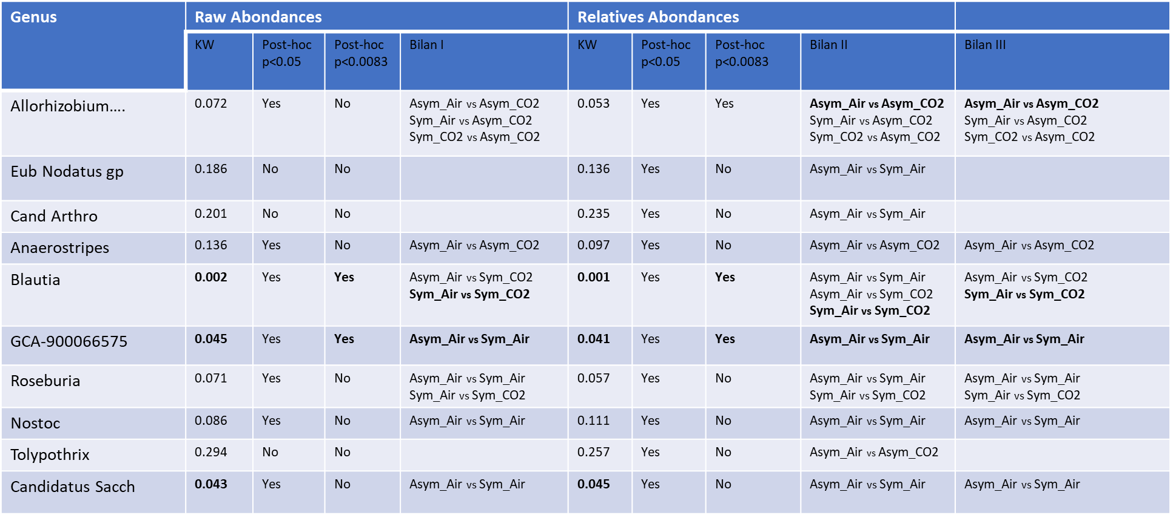

Table 1 Relative and raw abundances. Summary table according to Kruskal-Wallis (KW) analysis with post-hoc dunn test (Bonferroni correction: 0,0083).