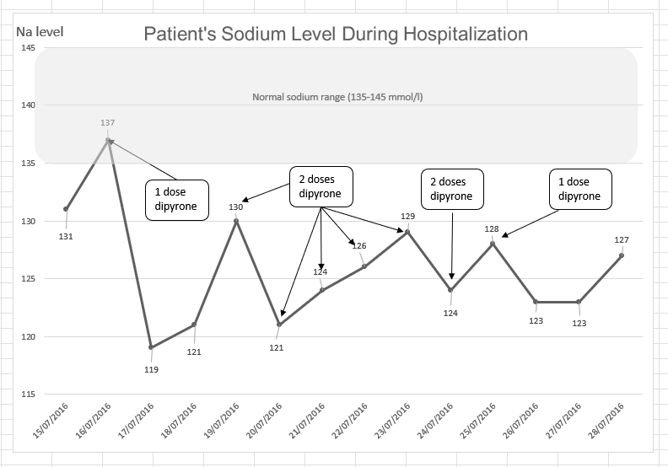
Figure 1: Patient’s sodium levels during his hospitalization per date.
.
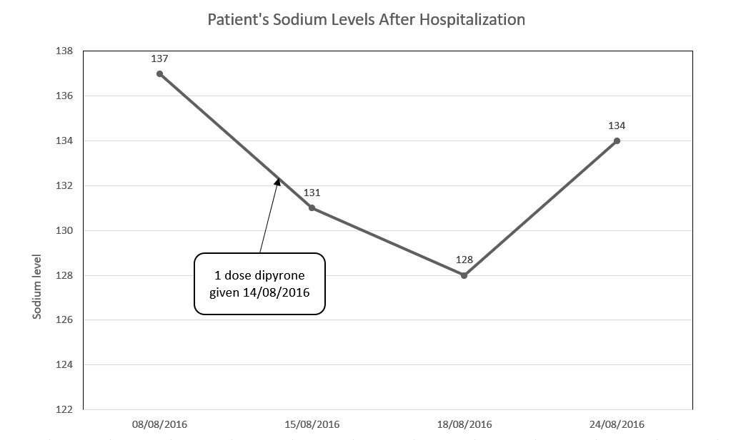
Figure 2: Dipyrone challenge test: Patient's sodium levels after hospitalization; the red arrow indicates one dose of dipyrone. Sodium levels were measured one day after the dose and day three days after the dose.

