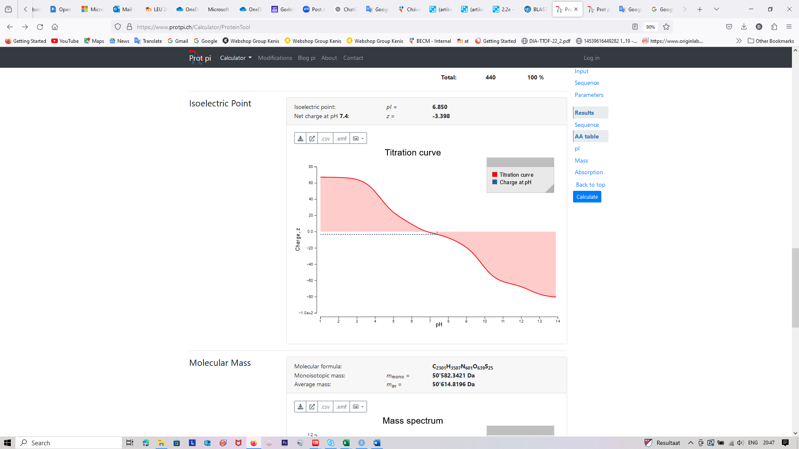
Full-length GULO
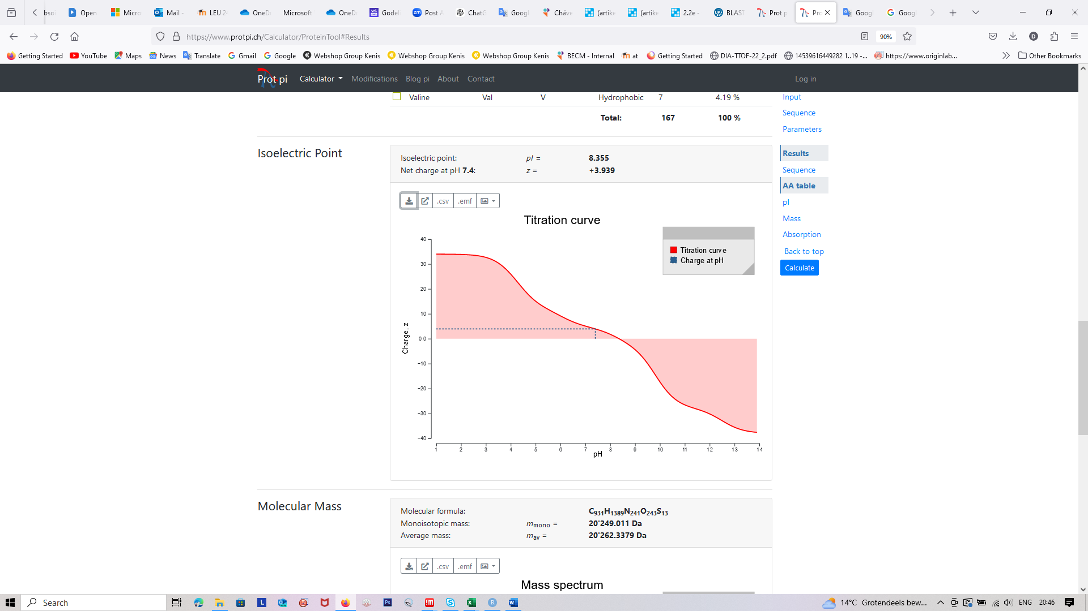
C-terminal part of GULO
Supplementary Figure 1. Comparison of selected physico-chemical properties of full length GULO and C-terminal part of GULO.

