Electronic Supplementary Material to the paper
Distribution of natural trace elements in drinking water sources of Hungary
Bálint Izsák, Katalin Hegedűs-Csondor, Petra Baják, Anita Erőss, Norbert Erdélyi, Márta Vargha

Figure S1 Dendogram of water samples by hierarchical cluster analysis
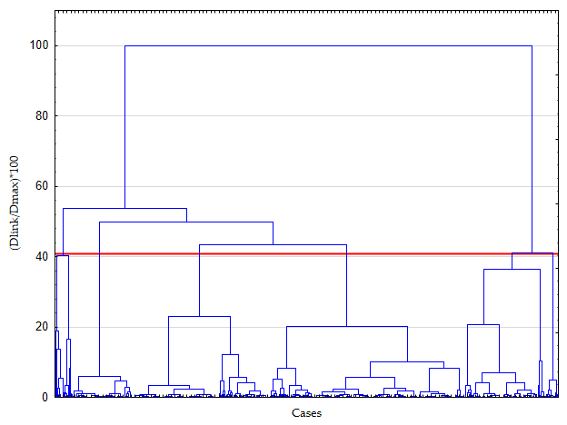

Principal component | Eigenvalues | % Total variance | Cumulative %
1 | 2,825868 | 21,73744 | 21,73744
2 | 1,887558 | 14,51968 | 36,25712
3 | 1,537639 | 11,82799 | 48,08511
4 | 1,160101 | 8,92385 | 57,00896
5 | 1,086953 | 8,36118 | 65,37014
Table S1 Eigen values of the principal component analysis

 | Loading value
Variable | PC1 | PC2 | PC3 | PC4 | PC5
B | -0.63 | 0.31 | 0.09 | 0.2 | 0.29
Ba | -0.12 | 0.35 | -0.62 | -0.32 | -0.04
Ca | 0.79 | 0.00 | -0.09 | 0.26 | 0.09
K | 0.11 | 0.65 | 0.16 | 0.38 | -0.37
Li | -0.18 | 0.66 | -0.01 | 0.24 | -0.20
Mg | 0.75 | 0.32 | -0.14 | 0.02 | 0.25
Mo | -0.42 | 0.13 | 0.22 | 0.14 | 0.50
Na | -0.75 | 0.36 | -0.06 | -0.02 | 0.19
Se | 0.28 | 0.29 | 0.51 | -0.46 | 0.18
Sr | 0.32 | 0.59 | -0.43 | -0.22 | 0.02
Ti | 0.35 | -0.06 | -0.21 | 0.55 | 0.50
U | 0.35 | 0.34 | 0.57 | -0.28 | 0.23
V | 0.11 | 0.07 | 0.46 | 0.29 | -0.36
Table S2 PC’s loading values of the elements (relevant elements with a loading value: >0.4 or <-0.4 are indicated in bold)

