**Supplementary materials**

**Appendix 1: Deployment strategies and Data Management**

**Site selection:** We pre-selected 30 sites located at the forest-village edge across the Jhargram forest division in the four forest ranges, namely Manikpara (10 sites), Lodhasuli (3), Gidhni (8) and Jhargram (9) in the study area. Selection criteria included recent elephant visitation and cell network connectivity at each location. These data were supplemented by additional information on elephant occurrence and movement over the past two years across the study area (gained primarily from local knowledge of forest staff—forest rangers, beat guards, Joint Forest Management Committee (JFMC) members, elephant trackers, and “*van sahayaks*”). These groups also constituted the Rapid Response Teams (RRTs), working under the supervision of the Jhargram forest officials. At each site, we selected trails that elephants frequented to enter croplands and villages from adjacent forests as agricultural fields and human settlements are embedded within the forests of Jhargram.

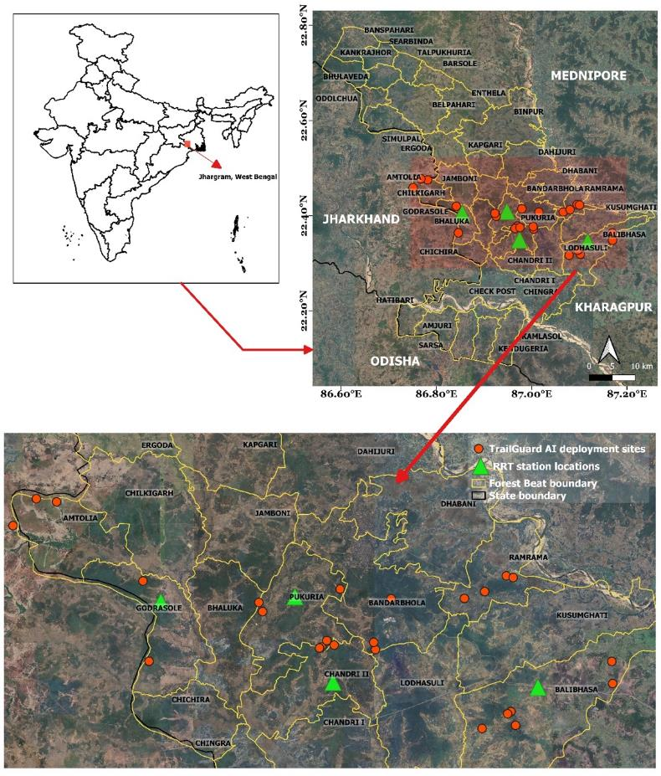

**Figure S1: Spatial locations of trails where TrailGuard AI systems were deployed in Jhargram forest division. Certain locations at the boundaries with adjacent state of Jharkhand and Kharagpur district were also selected for early detection of migrating elephants.**

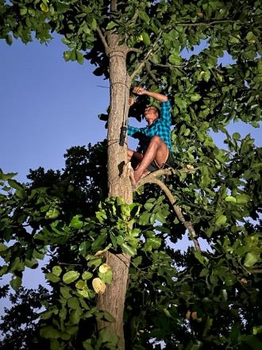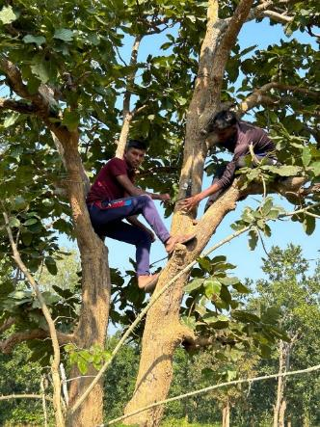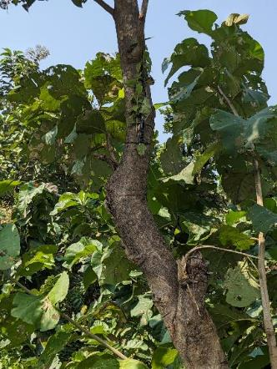

**Figure S2: TrailGuard AI camera alert systems were deployed high-up on trees overlooking the trails used by elephants in the study area with the help of local community members**

**Appendix 2: Data filtering, AI model statistics**

**Data management –**

**Elephant Detections**

In order to enhance the performance of the edge detector so as to minimize the chances of false negatives, the threshold p-value for this AI model was deliberately set very low, at 0.2. Since the major objective in this study was to minimize and even prevent any human-elephant negative interactions, it was critical to provide the frontline forest staff, the end user, with all elephant detections across all sites with minimal chances of missing any detections. Setting this low a p-value threshold for the edge detector is a trade-off where number of false positives generated by the AI model increase which is evident from low precision values for the edge detector in this paper. However, given the urgency and need in the use-case presented, it was thus essential to balance this technical aspect in the best way possible to aid the forest staff in managing human-elephant interactions efficiently. A more robust model to be used in the next deployment in Jhargram and beyond removed all false positives generated by this initial study when fed into the model.

The two statistics for the edge detector AI model were estimated by accessing and filtering the data from SD cards of each TrailGuard unit for the elephant output class. The precision of the AI model was estimated to be 0.45 and recall as 0.66. Partitioned by the time of day, the precision and recall values for day-time were estimated to be 0.13 and 0.89 respectively while for the night-time, the statistics were estimated as 0.4 and 0.7, respectively.

The deployed TrailGuard camera systems varied by background ranging from forested trails, motorable roads, water bodies and open lands in the multi-use landscape of the study area. A second goal was to partition the performance of the edge detector AI model across all such areas. We divided the deployed TrailGuard units as those along trails vs. cameras placed in more wide-open areas. The AI model statistics for both the cases are as below –

|  |  |  |  |
| --- | --- | --- | --- |
| **Deployment type** | **Accuracy (median detection probability)** | **Precision** | **Recall** |
| Along trails | 0.80 | 0.41 | 0.76 |
| Wide-open areas | 0.63 | 0.56 | 0.51 |

The model statistics for the two cases clearly indicate the better performance of the edge detector AI model along trails with higher accuracy and recall as compared to wide open areas. Model accuracy and recall statistics are more important in this particular use where the end-user wants correct detection of all elephants along villages with no false negatives. Given the ideal distance for the TrailGuard AI to perform effectively is within 15 m, the edge detector has to function beyond its capability when placed in wide-open areas thus leading to lower accuracy and recall values. Therefore, we recommend the end-users to assess the field conditions and conduct a site selection exercise with utmost attention in order to effectively deploy TrailGuard AI in their respective use cases. Again, the new AI model that replaces the initial model used in this study resulted in no false positives being transmitted while still detecting every trigger event initiated by an elephant.

**Data management – Humans**

**AI filtering and transmission of elephant alerts**: Alerts of humans and livestock greatly outnumbered those of elephants. To avoid oversaturating the recipients with non-targeted alerts, only alerts of elephant detections were transmitted; detection of other object classes (e.g. human, livestock) were stored on the camera’s SD card for future analysis but not transmitted. Senior WBFD officials and Jhargram forest officials received alerts from all deployed sites across the forest divisions. Range Officers and their respective RRTs received elephant alerts only from TrailGuard AI units deployed in their specific forest ranges and beats to channel alerts where response was practical.

**Appendix 3: Integrating real-time alerts with local forest staff management Standard Operating Procedures**

**Technology transfer and ease of use by local rangers:** We conducted a one-day training program for rangers to cover the basics of the TrailGuard AI system and aspects of camera placement on trails actively used by elephants and that also offered strong cell connectivity. Operation of the system requires the end user only to connect the battery and point the camera correctly. Assuming there is sufficient cell signal strength, 15-35 KB images arrive almost immediately to the end users’ smart phone. Installation of the 30 units was completed in 3.5 days each across the two phases. After the first round of installations, the WBFD staff carried out installation or moving units independently. Ease of deployment proved valuable because some camera-alert systems had to be shifted from the original locations to accommodate the unpredictable, frequent movements of wild elephants, especially lone bulls, across the Jhargram division during the study period. This step also included finalisation of a Rapid Response protocol with feedback from frontline forest staff along with inputs from JFMC members in devising effective mitigation strategies to prevent HEC events in the future.

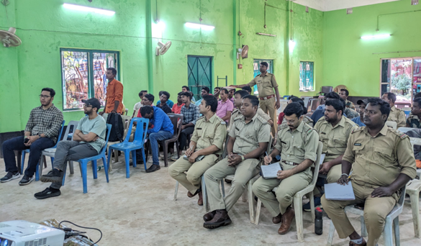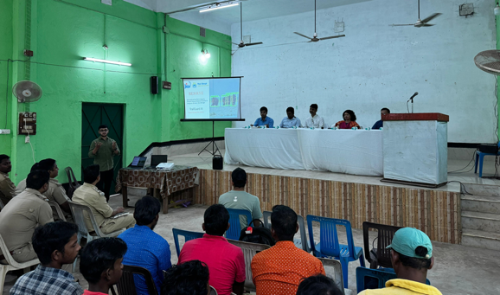

**Use of real-time Elephant alerts for planning responses by RRTs:** After receiving real-time elephant alerts, the respective RRTs relayed the information to JFMC members and the other local community members in the villages adjoining the sites of elephant detection. The response data accessed from ODK forms and RRT movement from the server indicated that RRTs responded to the elephant alerts with increased situational awareness.

**Appendix 4:**

To better assess the practicality of the AI-detection system, we examined the cost of alternative measures such as GPS-satellite collaring of problem elephants compared to the costs of the alert system and support of rapid response teams in the field. We also suggest how AI-embedded alerting systems could be integrated with other technologies to provide both autonomous detection and deterrence, thereby increasing the force-multiplier effect.

**Calculations of comparative costs of technology deployment with other conflict mitigation methods**

We define (AI+RRT)c as the total costs of deploying and maintaining TrailGuard AI systems combined with the expenditure incurred by WBFD to support four RRTs strategically assigned to guard posts closest to high elephant activity. We compared the (AI+RRT)c with the total expenditures of collaring elephants involved in conflict—these costs include capturing and fitting GPS-Satellite collars on elephants that recurrently use human locations, as well as subsequent logistical costs including monitoring and airtime costs to transmit alerts of elephants.

**Comparative costs of conflict mitigation methods**

We estimated (AI+RRT)c, the total costs of technology deployment (along hotspots of incursions for bulls and matriarch herds) as maintenance for 30 TrailGuard AI units and supporting four RRTs activities in this study. This incurred a one-time cost of ~$31,500 for hardware and ~$30,000 annually for the four RRTs compared to capturing and radio-collaring conflict-prone lone bulls (estimated at $48,000 for two bull elephants based on cost estimates from other states in India).