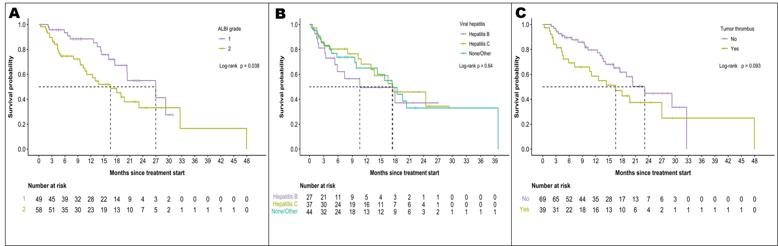
Appendix Figure 1: Overall Survival in Patients Treated with Atezolizumab with Bevacizumab Stratified by
(A) ALBI grade (B) Liver etiology and (C) Portal vein tumor thrombosis

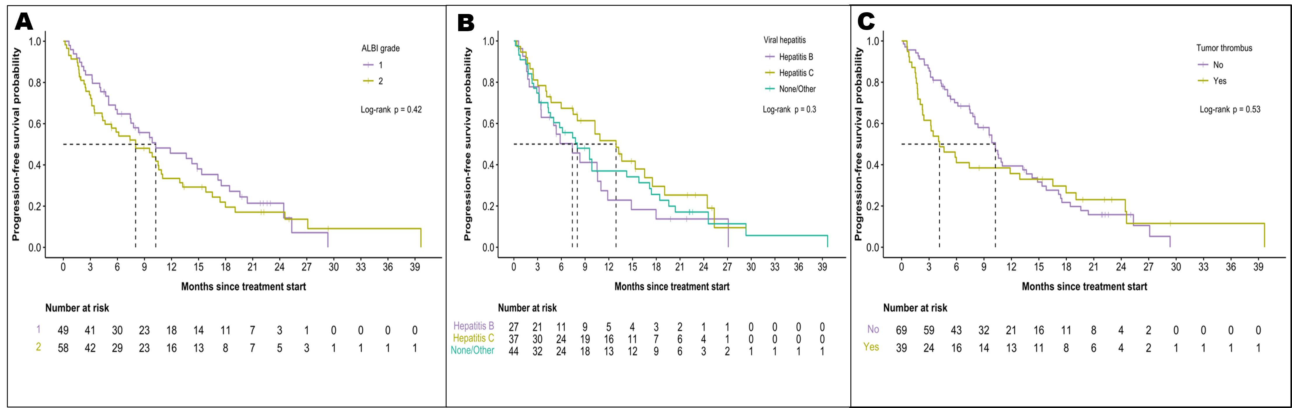Appendix Figure 2: Progression-Free Survival in Patients Treated with Atezolizumab with Bevacizumab Stratified by A) ALBI grade B) Liver etiology and C) Portal vein tumor thrombosis

Appendix Table 1: Impact of clinical characteristics on bleeding risk.
 |  | Bleeding events
Characteristic | Total included | No (n = 95) | Yes (n= 17) | p-value
Cirrhosis | 75 (67.0%) | 64 (67.4%) | 11 (64.7%) | 0.83
Hepatitis B | 28 (25.0%) | 20 (21.1%) | 8 (47.1%) | 0.03
Hepatitis C | 37 (33.0%) | 32 (33.7%) | 5 (29.4%) | 0.73
NASH | 17 (15.2%) | 13 (13.7%) | 4 (23.5%) | 0.29
Excess alcohol use | 25 (22.3%) | 24 (25.3%) | 1 (5.9%) | 0.11
Prior locoregional treatment
TACE procedures | 29
0 | 83 (74.1%) | 71 (74.7%) | 12 (70.6%)
1 | 11 (9.8%) | 10 (10.5%) | 1 (5.9%) | 1.00
2 | 14 (12.5%) | 13 (13.7%) | 1 (5.9%) | 0.72
3 | 4 (3.6%) | 1 (1.1%) | 3 (17.6%) | 0.03
Radiofrequency Ablation | 33 (29.5%) | 28 (29.5%) | 5 (29.4%) | 1.00
Stereotactic Body Radiation Therapy | 17 (21.8%) | 15 (23.1%) | 2 (15.4%) | 0.72
Liver resection | 29 (25.9%) | 22 (23.2%) | 7 (41.2%) | 0.14
Liver transplant | 1 (0.9%) | 0 (0.0%) | 1 (5.9%) | 0.15
Macrovascular invasion | 41 (36.9%) | 35 (37.2%) | 6 (35.3%) | 0.88
Unknown | 1 | 1 | 0
Tumor size | 96 |  |  | 0.56
Mean ± SD | 5.8 ± 4.7 | 5.7 ± 4.8 | 6.0 ± 4.3
Median (Range) | 3.8 (0.0, 18.0) | 3.8 (0.0, 18.0) | 6.0 (0.0, 15.6)
Unknown | 16 | 16 | 0
Tumor Histology | 76 |  |  | 0.04
HCC | 73 (96.1%) | 66 (98.5%) | 7 (77.8%)
Mixed CCA-HCC | 3 (3.9%) | 1 (1.5%) | 2 (22.2%)
Unknown | 36 | 28 | 8
NASH: non-alcoholic steatohepatitis; TACE: Transarterial Chemoembolization; SD: standard deviation; HCC: hepatocellular carcinoma; CCA: cholangiocarcinoma.

