Supplementary Material
Table S1. Demographic data collected from the sampled stores (five supermarkets and five butcheries)
Date of sample collection: __________________________________
Sample collection done by: __________________________________
Sample unique identifier: __________________________________
Store unique identifier: __________________________________

- Total number of cash registers in-store (a surrogate measure of store volume)
1 to 5 □󠇯 6 to 10 □󠇯 11 to 15 □󠇯 16 to 20 □󠇯 21 to 25 □󠇯 ≥26 □󠇯
2. “Sell-by” and packaging date of meat
“Sell-by” date: __________________________________
Packaging date: __________________________________

3. “May contain previously frozen meat” label
Yes □󠇯 No □󠇯
4. Final processing in store
Yes □󠇯 No □󠇯 Unknown □󠇯
5. Organic meat
Yes □󠇯 No □󠇯 Unknown□󠇯
6. Free range meat
Yes □󠇯 No □󠇯 Unknown □󠇯
7. Antimicrobial free meat
Yes □󠇯 No □󠇯 Unknown □󠇯

8. Price per kilogram: R __________________________________

Table S2. Captured demographic data collected from the sampled stores five supermarkets and five butcheries)
Collection date | Sample ID | Store ID | Number of cash registers | Sell-by date | Packaging date | Frozen meat label | Final processing in store | Organic meat | Free range meat | Antibiotic free meat | Price per kilogram | Other | ESCCO count | SAL spp. count | ENT spp. count | CAM spp. count
4-Jan-22 | PC1 | S1 | >= 26 | 9-Jan-22 | 31-Dec-21 | No | Yes | No | No | Unknown | ZAR 109,99 / USD 6,72 | Pork 360 quality sticker | <10 | Absent | <1 | <10
4-Jan-22 | PC2 | S2 | 6-10 | 4-Jan-22 | Unknown | No | Unknown | No | No | Unknown | ZAR 119,99 / USD 7,33 | Kinder to sows sticker | <10 | Absent | <1 | <10
4-Jan-22 | PC3 | S3 | 6-10 | 7-Jan-22 | Unknown | No | Unknown | No | No | Unknown | ZAR 99,99 / USD 6,05 | Sow friendly sticker | <10 | Absent | 16 | <10
4-Jan-22 | PC4 | S4 | 6-10 | 5-Jan-22 | 2-Jan-22 | No | Yes | No | No | Unknown | ZAR 89,99 / USD 5,50 | N/A | <10 | Absent | 1 | <10
4-Jan-22 | PC5 | S5 | 11-15 | 8-Jan-22 | Unknown | No | Yes | No | No | Unknown | ZAR 85,99 / USD 5,25 | N/A | <10 | Absent | <1 | <10
4-Jan-22 | PC6 | B1 | 1-5 | 6-Jan-22 | 2-Jan-22 | No | Yes | No | No | Unknown | ZAR 79,99 / USD 4,89 | N/A | <10 | Absent | <1 | <10
4-Jan-22 | PC7 | B2 | 6-10 | 7-Jan-22 | 2-Jan-22 | No | Yes | No | No | Unknown | ZAR 89,99 / USD 5,50 | N/A | <10 | Absent | <1 | <10
4-Jan-22 | PC8 | B3 | 1-5 | Unknown | 3-Jan-22 | No | Yes | No | No | Unknown | ZAR 90,00 / USD 5,50 | N/A | <10 | Absent | <1 | <10
4-Jan-22 | PC9 | B4 | 1-5 | Unknown | 4-Jan-22 | No | Yes | No | No | Unknown | ZAR 89,90 / USD 5,50 | N/A | 20 | Absent | <1 | <10
4-Jan-22 | PC10 | B5 | 1-5 | 10-Jan-22 | 3-Jan-22 | No | Yes | No | No | Unknown | ZAR 96,90 / USD 5,92 | N/A | <10 | Absent | 3 | <10
PC = Pork chop; S = Supermarket; B = Butchery; ESCCO = Escherichia coli; SAL = Salmonella; ENT = Enterococcus; CAM = Campylobacter; ZAR = South African Rand; USD = United States dollar. The average exchange rate for 2022 was used to convert the cost of meat per kilogram from ZAR to USD (i.e. 16.37 ZAR = 1 USD).

Table S3. Summary of antimicrobial resistance categories by number of open reading frame genes from 10 raw retail meat samples.
AMR categories | Supermarkets  (n = Annotated ORFs) | Butcheries  (n = Annotated ORFs) | Overall  (n = Annotated ORFs)
Aminoglycoside | 4 | 2 | 6
Bacitracin | 1 | 1 | 2
Beta-lactam | 14 | 1 | 15
Fluoroquinolone | 1 | 1 | 2
Fosfomycin | 0 | 1 | 1
Glycopeptide | 5 | 1 | 6
MLS | 8 | 2 | 10
Multidrug | 18 | 3 | 21
Mupirocin | 0 | 1 | 1
Peptide | 2 | 1 | 3
Phenicol | 3 | 0 | 3
Sulphonamide | 1 | 0 | 1
Tetracycline | 10 | 8 | 18
AMR = Antimicrobial resistance; ORF = Open reading frame; MLS = Macrolides, lincosamides and streptogramins.
Table S4. Summary of antimicrobial resistance mechanisms by number of ORF genes from 10 raw retail meat samples.
AMR resistance mechanisms | Supermarkets (n = Annotated ORFs) | Butcheries  (n = Annotated ORFs) | Overall  (n = Annotated ORFs)
Antibiotic efflux | 30 | 13 | 43
Antibiotic inactivation | 19 | 3 | 22
Antibiotic target alteration | 14 | 6 | 20
Antibiotic target protection | 1 | 0 | 1
Antibiotic target replacement | 3 | 0 | 3
Reduced permeability to antibiotic | 2 | 0 | 2
Resistance absence | 1 | 0 | 1
AMR = Antimicrobial resistance; ORF = Open reading frame
Table S5. Summary of virulence factor category by number of ORF genes from 10 raw retail meat samples.
VF category | Supermarkets (n = annotated ORFs) | Butcheries  (n = annotated ORFs) | Overall  (n = annotated ORFs)
Adherence | 39 | 13 | 42
Antimicrobial activity/Competitive advantage | 3 | 2 | 5
Biofilm | 6 | 1 | 7
Effector delivery system | 16 | 3 | 19
Exoenzyme | 1 | 0 | 1
Exotoxin | 2 | 0 | 2
Immune modulation | 10 | 2 | 10
Invasion | 7 | 0 | 7
Motility | 11 | 2 | 13
Nutritional/Metabolic factor | 11 | 4 | 15
Post-translational modification | 2 | 0 | 2
Regulation | 4 | 1 | 5
Stress survival | 4 | 0 | 4
VF = Virulence factor
Table S6. Summary of toxin gene description by number of ORF genes from 10 raw retail meat samples.
Toxin gene description | Supermarkets  (n = Annotated ORFs) | Butcheries  (n = Annotated ORFs) | Overall  (n = Annotated ORFs)
AcrB/AcrD/AcrF family | 5 | 4 | 9
Capsule assembly protein Wzi | 1 | 0 | 1
Dual specificity phosphatase, catalytic domain | 1 | 0 | 1
Endonuclease/Exonuclease/phophatase family | 1 | 0 | 1
Insulinase (Peptidase family M16) | 9 | 0 | 9
Outer membrane protein | 9 | 1 | 10
PapC N-terminal domain | 1 | 0 | 1
Peptidase M16 inactivate domain | 1 | 0 | 1
Presequence protease [EC:3.4.24.-] | 1 | 0 | 1
Probable enterotoxin B | 1 | 0 | 1
Probable enterotoxin D | 1 | 0 | 1
Putative toxin 46 | 1 | 0 | 1
S-type Pyocin | 1 | 0 | 1
S1/P1 Nuclease | 1 | 0 | 1
Putative hemolysin | 0 | 1 | 1
Figure S1. Mobile genetic element prediction of ARGs of all raw meat samples from both supermarket and butchery groups. Unclassified MGE predictions are genes with unknown mobile genetic element information.
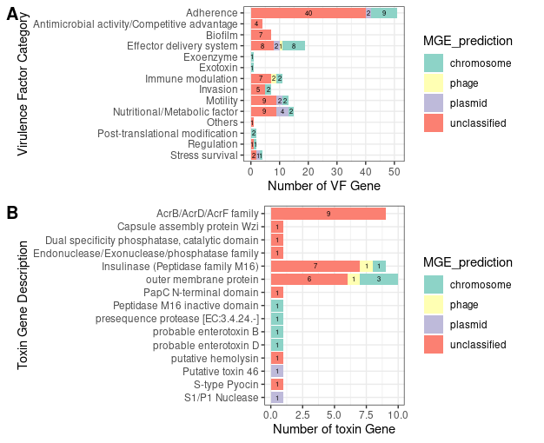
Figure S2. Mobile genetic element prediction of VF and toxin genes of all raw meat samples from both supermarket and butchery groups.

