Table S1. Data quality of transcriptome sequencing of eucalypt hybrids and their parents.
Sample | Library | Raw  Reads | Raw  Bases | Clean  Reads | Clean  Bases | Error  Rate | Q20 | Q30 | GC  pct %
EC338-1 | FRAS230192178-1A | 47515774 | 7.13G | 46484356 | 6.97G | 0.02 | 98.05 | 94.73 | 51.09
EC338-2 | FRAS230192179-1A | 42887700 | 6.43G | 41954540 | 6.29G | 0.02 | 97.93 | 94.46 | 51.19
EC338-3 | FRAS230209768-1A | 51374302 | 7.71G | 49209662 | 7.38G | 0.02 | 98 | 94.38 | 51.19
EC333-1 | FRAS230192180-1A | 39734450 | 5.96G | 38914584 | 5.84G | 0.02 | 98.06 | 94.75 | 50.58
EC333-2 | FRAS230192181-1A | 41468672 | 6.22G | 40620656 | 6.09G | 0.02 | 97.96 | 94.5 | 51.21
EC333-3 | FRAS230209769-1A | 46001662 | 6.9G | 44410908 | 6.66G | 0.03 | 97.48 | 93.53 | 51.64
W-1 | FRAS230192182-1A | 50168332 | 7.53G | 48871946 | 7.33G | 0.02 | 98.1 | 94.78 | 49.68
W-2 | FRAS230192183-1A | 44691972 | 6.7G | 43253182 | 6.49G | 0.02 | 97.95 | 94.59 | 49.8
W-3 | FRAS230192184-1A | 49434360 | 7.42G | 47975448 | 7.2G | 0.02 | 97.96 | 94.42 | 49.66
P-1 | FRAS230192185-1A | 44160454 | 6.62G | 42383048 | 6.36G | 0.02 | 97.9 | 94.39 | 50.81
P-2 | XRAS230006854-4r | 46072424 | 6.91G | 45732072 | 6.86G | 0.03 | 97.82 | 93.73 | 48.75
P-3 | FRAS230209770-1A | 40595960 | 6.09G | 38711270 | 5.81G | 0.03 | 97.54 | 93.71 | 50.63
H-1 | FRAS230209771-1A | 42113188 | 6.32G | 41014490 | 6.15G | 0.03 | 97.61 | 93.81 | 51.65
H-2 | FRAS230209812-1A | 48669912 | 7.3G | 47323484 | 7.1G | 0.03 | 97.55 | 93.82 | 52.18
H-3 | XRAS230006855-2r | 45008802 | 6.75G | 44098734 | 6.61G | 0.03 | 97.65 | 93.82 | 51.72

Notes: Sample: Sample name. Library: Library number. Raw Reads: Number of reads in the original dataset. Raw Bases: Number of bases in the original dataset(raw base=raw reads*150bp). Clean Reads：Number of reads after filtering raw data. Clean Bases：Number of reads after filtering raw data(clean base=clean reads*150bp). Error Rate: The data's overall sequencing error rate. Q20: Percentage of total bases with Phred values greater than 20. Q30: Percentage of total bases with Phred values greater than 30. GC pct%: The percentage of G versus C in clean reads is calculated for all four bases.

Table S2. Presents a comparison of eucalypt hybrids and their parents with the E. grandis reference genome.

Sample | Total map (n/%) | Unique map (n/%) | Multi map (n/%) | read1 map (n/%) | read2 map (n/%) | Positive map (n/%) | Negative map (n/%) | Splice map (n/%) | Unsplice map (n/%) | Proper map (n/%)
EC338-1 | 40159966/86.39 | 38558167/82.95 | 1601799/3.45 | 19237051/41.38 | 19321116/41.56 | 19247863/41.41 | 19310304/41.54 | 14669935/31.56 | 23888232/51.39 | 34823836/74.92
EC338-2 | 36211213/86.31 | 34796756/82.94 | 1414457/3.37 | 17370036/41.4 | 17426720/41.54 | 17363332/41.39 | 17433424/41.55 | 13227206/31.53 | 21569550/51.41 | 31446686/74.95
EC338-3 | 42338677/86.04 | 40560287/82.42 | 1778390/3.61 | 20271145/41.19 | 20289142/41.23 | 20242786/41.14 | 20317501/41.29 | 15323738/31.14 | 25236549/51.28 | 36530762/74.23
EC333-1 | 33544701/86.2 | 32214360/82.78 | 1330341/3.42 | 16070400/41.3 | 16143960/41.49 | 16078334/41.32 | 16136026/41.47 | 12578129/32.32 | 19636231/50.46 | 29221844/75.09
EC333-2 | 35104775/86.42 | 33762517/83.12 | 1342258/3.3 | 16855306/41.49 | 16907211/41.62 | 16854963/41.49 | 16907554/41.62 | 12976420/31.95 | 20786097/51.17 | 30543652/75.19
EC333-3 | 38005714/85.58 | 36545285/82.29 | 1460429/3.29 | 18276630/41.15 | 18268655/41.14 | 18226461/41.04 | 18318824/41.25 | 13812660/31.1 | 22732625/51.19 | 33019178/74.35
W-1 | 40966127/83.82 | 39255844/80.32 | 1710283/3.5 | 19577756/40.06 | 19678088/40.26 | 19604178/40.11 | 19651666/40.21 | 14318448/29.3 | 24937396/51.03 | 34911134/71.43
W-2 | 36207525/83.71 | 34720281/80.27 | 1487244/3.44 | 17359942/40.14 | 17360339/40.14 | 17341110/40.09 | 17379171/40.18 | 12643301/29.23 | 22076980/51.04 | 30911876/71.47
W-3 | 40077327/83.54 | 38354230/79.95 | 1723097/3.59 | 19151315/39.92 | 19202915/40.03 | 19153905/39.92 | 19200325/40.02 | 13988035/29.16 | 24366195/50.79 | 34094218/71.07
P-1 | 36247769/85.52 | 34844811/82.21 | 1402958/3.31 | 17394413/41.04 | 17450398/41.17 | 17388937/41.03 | 17455874/41.19 | 13905270/32.81 | 20939541/49.41 | 31567568/74.48
P-2 | 38936463/85.14 | 37274764/81.51 | 1661699/3.63 | 18811318/41.13 | 18463446/40.37 | 18635037/40.75 | 18639727/40.76 | 15579472/34.07 | 21695292/47.44 | 32493534/71.05
P-3 | 32957503/85.14 | 31624759/81.69 | 1332744/3.44 | 15797846/40.81 | 15826913/40.88 | 15783669/40.77 | 15841090/40.92 | 12584014/32.51 | 19040745/49.19 | 28631266/73.96
H-1 | 35171695/85.75 | 33842523/82.51 | 1329172/3.24 | 16892358/41.19 | 16950165/41.33 | 16891991/41.19 | 16950532/41.33 | 12644630/30.83 | 21197893/51.68 | 30650360/74.73
H-2 | 40426354/85.43 | 38905691/82.21 | 1520663/3.21 | 19384760/40.96 | 19520931/41.25 | 19405029/41.01 | 19500662/41.21 | 14155675/29.91 | 24750016/52.3 | 36117940/76.32
H-3 | 37735187/85.57 | 36327633 | 1407554/3.19 | 18204108/41.28 | 18123525/41.1 | 18141086/41.14 | 18186547/41.24 | 13587218/30.81 | 22740415/51.57 | 32718452/74.19
Notes: Total Reads: After quality control, the sequencing data yielded a specific number of clean reads. Total map: The number of reads matched to the genome and their percentage. Unique map: The percentage and count of reads that aligned to a unique position in the reference genome, for further quantitative data analysis. Multi map: The quantity of sequencing reads and the corresponding proportion that underwent alignment against various positions within the genomic reference were scrutinized. read1 map: the number of read1s compared to the reference genome and their percentage, read2_map: the number of read2s compared to the reference genome and their percentage. Positive map: The quantity of reads and their respective proportion in relation to the positive strand of the reference genome is under examination. Negative_map：The quantity of sequences and their corresponding proportion when juxtaposed with the antisense strand of the foundational genetic blueprint. Splice map: The quantity and proportion of reads demonstrating a split-matched alignment with the genomic reference sequence. Unsplice map: The quantity of reads that did not align with the genome and their respective percentage. Proper map: The alignment of read pairs (read1 and read2) was conducted concurrently with an evaluation of their frequencies and proportions within the genomic sequence.

Table S3. Genes detected in eucalypt parents and their offspring.

Gene  id | Gene  name | Gene  chr | Gene  start | Gene  end | Gene  strand | Gene  length | Gene  biotype | Gene  description | Sub-family | Family
104422107 | LOC104422107 | NC_052621.1 | 18302801 | 18304215 | + | 886 | protein_coding | ribulose bisphosphate carboxylase small chain%2C chloroplastic && sp|P24007|RBS_PYRPY Ribulose bisphosphate carboxylase small subunit, chloroplastic OS=Pyrus pyrifolia OX=3767 GN=RBCS PE=2 SV=1 && PF12338:Ribulose-1,5-bisphosphate carboxylase small subunit|PF00101:Ribulose bisphosphate carboxylase, small chain | - | -
104444821 | LOC104444821 | NC_052616.1 | 32742793 | 32743761 | - | 969 | protein_coding | chlorophyll a-b binding protein of LHCII type 1 && sp|P27493|CB22_TOBAC Chlorophyll a-b binding protein 21, chloroplastic OS=Nicotiana tabacum OX=4097 GN=CAB21 PE=2 SV=1 && PF00504:Chlorophyll A-B binding protein | - | -
104425107 | LOC104425107 | NC_052622.1 | 16631474 | 16632275 | + | 636 | protein_coding | non-specific lipid-transfer protein 1 && sp|P85894|LTP1_MORNI Non-specific lipid-transfer protein 1 OS=Morus nigra OX=85232 PE=1 SV=1 && PF00234:Protease inhibitor/seed storage/LTP family | - | -
104434692 | LOC104434692 | NC_052612.1 | 34560961 | 34562840 | - | 1068 | protein_coding | chlorophyll a-b binding protein 36%2C chloroplastic && sp|P27518|CB21_GOSHI Chlorophyll a-b binding protein 151, chloroplastic OS=Gossypium hirsutum OX=3635 GN=CAB-151 PE=2 SV=2 && PF00504:Chlorophyll A-B binding protein | - | -
Notes: Gene id: Gene count. Sample: The quantification of each sample yielded a raw READ COUNT value.Gene name: The nomenclature of the genetic entity. Gene chr：The gene is located on a specific chromosome. Gene start: The gene's location on the chromosome is determined by its starting position. Gene end: The chromosomal locus where a gene is situated terminates at a specific position on the chromosome. Gene strand: Details regarding the positive and negative strands of the chromosome harboring the gene are being discussed. Gene length: The gene length is defined as the cumulative measure of all non-overlapping exon regions spanning from the initiation to the termination of a gene. Gene biotype: Various types of genes exist, including protein-coding genes, long-chain non-coding genes, among others. Gene description: The gene function description is detailed alongside reference genome annotation information preceding the initial && symbol, Swiss-Prot database annotation following the first && symbol, and Pfam database annotation subsequent to the second && symbol. Tf family：Annotation of gene transcription factor families.

Table S4. Genes in carbohydrate binding (GO-GSEA).

 | PROBE | DESCRIPTION  (from dataset) | GENE SYMBOL | GENE_TITLE | RANK IN GENE LIST | RANK METRIC SCORE | RUNNING ES | CORE ENRICHMENT
172 | 104451739 | LOC104451739 |  |  | 26514 | -0.802 | -0.5163 | Yes
173 | 104427375 | LOC104427375 |  |  | 26517 | -0.802 | -0.514 | Yes
174 | 120296231 | LOC120296231 |  |  | 26644 | -0.819 | -0.5156 | Yes
175 | 104425265 | LOC104425265 |  |  | 26693 | -0.823 | -0.5146 | Yes
176 | 120289673 | LOC120289673 |  |  | 26739 | -0.834 | -0.5136 | Yes
177 | 120291737 | LOC120291737 |  |  | 26849 | -0.847 | -0.5145 | Yes
178 | 120296079 | LOC120296079 |  |  | 26857 | -0.847 | -0.5122 | Yes
179 | 120292471 | LOC120292471 |  |  | 26895 | -0.851 | -0.5109 | Yes
180 | 104418351 | LOC104418351 |  |  | 26948 | -0.858 | -0.51 | Yes
181 | 104442507 | LOC104442507 |  |  | 26995 | -0.859 | -0.5089 | Yes
182 | 120292993 | LOC120292993 |  |  | 27300 | -0.89 | -0.5159 | Yes
183 | 104419218 | LOC104419218 |  |  | 27326 | -0.895 | -0.514 | Yes
184 | 104428058 | LOC104428058 |  |  | 27408 | -0.913 | -0.5139 | Yes
185 | 104427280 | LOC104427280 |  |  | 27455 | -0.921 | -0.5126 | Yes
186 | 104416546 | LOC104416546 |  |  | 27523 | -0.935 | -0.5119 | Yes
187 | 120296236 | LOC120296236 |  |  | 27527 | -0.936 | -0.5093 | Yes
188 | 104437884 | LOC104437884 |  |  | 27534 | -0.937 | -0.5067 | Yes
189 | 104419425 | LOC104419425 |  |  | 27716 | -0.971 | -0.5095 | Yes
190 | 120287022 | LOC120287022 |  |  | 27847 | -0.988 | -0.5107 | Yes
191 | 120295547 | LOC120295547 |  |  | 27876 | -0.993 | -0.5086 | Yes
192 | 120289765 | LOC120289765 |  |  | 28053 | -1.033 | -0.5111 | Yes
193 | 104424490 | LOC104424490 |  |  | 28094 | -1.041 | -0.5093 | Yes
194 | 104425264 | LOC104425264 |  |  | 28144 | -1.054 | -0.5077 | Yes
195 | 104450896 | LOC104450896 |  |  | 28145 | -1.054 | -0.5046 | Yes
196 | 104427563 | LOC104427563 |  |  | 28282 | -1.087 | -0.5057 | Yes
197 | 120290470 | LOC120290470 |  |  | 28342 | -1.101 | -0.5043 | Yes
198 | 104453202 | LOC104453202 |  |  | 28611 | -1.164 | -0.5093 | Yes
199 | 104435019 | LOC104435019 |  |  | 28626 | -1.169 | -0.5063 | Yes
200 | 104442597 | LOC104442597 |  |  | 28659 | -1.177 | -0.5038 | Yes
201 | 104425585 | LOC104425585 |  |  | 28758 | -1.202 | -0.5034 | Yes
202 | 104457009 | LOC104457009 |  |  | 28782 | -1.208 | -0.5005 | Yes
203 | 104452347 | LOC104452347 |  |  | 28799 | -1.213 | -0.4974 | Yes
204 | 104455878 | LOC104455878 |  |  | 28840 | -1.226 | -0.4951 | Yes
205 | 120288503 | LOC120288503 |  |  | 28859 | -1.231 | -0.492 | Yes
206 | 104435473 | LOC104435473 |  |  | 28964 | -1.266 | -0.4915 | Yes
207 | 104420744 | LOC104420744 |  |  | 29015 | -1.284 | -0.4893 | Yes
208 | 120294558 | LOC120294558 |  |  | 29022 | -1.285 | -0.4857 | Yes
209 | 108957345 | LOC108957345 |  |  | 29054 | -1.297 | -0.4828 | Yes
210 | 104437043 | LOC104437043 |  |  | 29392 | -1.423 | -0.4893 | Yes
211 | 120291983 | LOC120291983 |  |  | 29424 | -1.436 | -0.486 | Yes
212 | 104446144 | LOC104446144 |  |  | 29432 | -1.439 | -0.4819 | Yes
213 | 120289594 | LOC120289594 |  |  | 29510 | -1.468 | -0.48 | Yes
214 | 104442589 | LOC104442589 |  |  | 29696 | -1.554 | -0.4813 | Yes
215 | 104424015 | LOC104424015 |  |  | 29716 | -1.563 | -0.4773 | Yes
216 | 104453182 | LOC104453182 |  |  | 29777 | -1.597 | -0.4744 | Yes
217 | 104414070 | LOC104414070 |  |  | 29827 | -1.622 | -0.4712 | Yes
218 | 104427371 | LOC104427371 |  |  | 29834 | -1.624 | -0.4665 | Yes
219 | 120289599 | LOC120289599 |  |  | 29986 | -1.707 | -0.4663 | Yes
220 | 120294795 | LOC120294795 |  |  | 29999 | -1.713 | -0.4616 | Yes
221 | 104416038 | LOC104416038 |  |  | 30004 | -1.716 | -0.4566 | Yes
222 | 104425283 | LOC104425283 |  |  | 30012 | -1.72 | -0.4517 | Yes
223 | 104431708 | LOC104431708 |  |  | 30124 | -1.791 | -0.45 | Yes
224 | 104431212 | LOC104431212 |  |  | 30177 | -1.823 | -0.4462 | Yes
225 | 104416068 | LOC104416068 |  |  | 30181 | -1.824 | -0.4409 | Yes
226 | 104420740 | LOC104420740 |  |  | 30192 | -1.831 | -0.4358 | Yes
227 | 104434429 | LOC104434429 |  |  | 30202 | -1.835 | -0.4306 | Yes
228 | 120296238 | LOC120296238 |  |  | 30220 | -1.844 | -0.4257 | Yes
229 | 120293387 | LOC120293387 |  |  | 30233 | -1.852 | -0.4206 | Yes
230 | 104416600 | LOC104416600 |  |  | 30282 | -1.888 | -0.4165 | Yes
231 | 104427057 | LOC104427057 |  |  | 30306 | -1.901 | -0.4116 | Yes
232 | 104452523 | LOC104452523 |  |  | 30314 | -1.907 | -0.4062 | Yes
233 | 104453353 | LOC104453353 |  |  | 30339 | -1.919 | -0.4013 | Yes
234 | 104417063 | LOC104417063 |  |  | 30396 | -1.965 | -0.3973 | Yes
235 | 104427276 | LOC104427276 |  |  | 30462 | -2.011 | -0.3934 | Yes
236 | 120294798 | LOC120294798 |  |  | 30519 | -2.059 | -0.389 | Yes
237 | 104457401 | LOC104457401 |  |  | 30538 | -2.089 | -0.3834 | Yes
238 | 104440880 | LOC104440880 |  |  | 30558 | -2.107 | -0.3778 | Yes
239 | 104455879 | LOC104455879 |  |  | 30578 | -2.127 | -0.3721 | Yes
240 | 104433328 | LOC104433328 |  |  | 30587 | -2.134 | -0.366 | Yes
241 | 104440043 | LOC104440043 |  |  | 30590 | -2.137 | -0.3598 | Yes
242 | 104451077 | LOC104451077 |  |  | 30618 | -2.158 | -0.3542 | Yes
243 | 104449039 | LOC104449039 |  |  | 30632 | -2.168 | -0.3482 | Yes
244 | 104451920 | LOC104451920 |  |  | 30766 | -2.271 | -0.3457 | Yes
245 | 120289800 | LOC120289800 |  |  | 30869 | -2.376 | -0.3419 | Yes
246 | 104452592 | LOC104452592 |  |  | 30882 | -2.395 | -0.3352 | Yes
247 | 104440029 | LOC104440029 |  |  | 30901 | -2.412 | -0.3286 | Yes
248 | 104430597 | LOC104430597 |  |  | 30985 | -2.503 | -0.3238 | Yes
249 | 104442603 | LOC104442603 |  |  | 30994 | -2.506 | -0.3166 | Yes
250 | 108960421 | LOC108960421 |  |  | 31005 | -2.511 | -0.3095 | Yes
251 | 104455436 | LOC104455436 |  |  | 31056 | -2.555 | -0.3035 | Yes
252 | 104438704 | LOC104438704 |  |  | 31057 | -2.557 | -0.296 | Yes
253 | 104440879 | LOC104440879 |  |  | 31061 | -2.563 | -0.2885 | Yes
254 | 104430169 | LOC104430169 |  |  | 31079 | -2.584 | -0.2814 | Yes
255 | 104429110 | LOC104429110 |  |  | 31085 | -2.591 | -0.2739 | Yes
256 | 104424563 | LOC104424563 |  |  | 31098 | -2.614 | -0.2665 | Yes
257 | 104451790 | LOC104451790 |  |  | 31113 | -2.631 | -0.2592 | Yes
258 | 104451714 | LOC104451714 |  |  | 31175 | -2.724 | -0.253 | Yes
259 | 104447342 | LOC104447342 |  |  | 31190 | -2.741 | -0.2454 | Yes
260 | 120291350 | LOC120291350 |  |  | 31194 | -2.753 | -0.2373 | Yes
261 | 104456007 | LOC104456007 |  |  | 31198 | -2.759 | -0.2292 | Yes
262 | 104427378 | LOC104427378 |  |  | 31211 | -2.779 | -0.2214 | Yes
263 | 104428611 | LOC104428611 |  |  | 31229 | -2.802 | -0.2136 | Yes
264 | 104446289 | LOC104446289 |  |  | 31249 | -2.835 | -0.2058 | Yes
265 | 104421788 | LOC104421788 |  |  | 31261 | -2.85 | -0.1977 | Yes
266 | 104452340 | LOC104452340 |  |  | 31274 | -2.867 | -0.1896 | Yes
267 | 104434436 | LOC104434436 |  |  | 31285 | -2.885 | -0.1814 | Yes
268 | 104427372 | LOC104427372 |  |  | 31298 | -2.902 | -0.1732 | Yes
269 | 120286921 | LOC120286921 |  |  | 31389 | -3.09 | -0.1669 | Yes
270 | 120294680 | LOC120294680 |  |  | 31401 | -3.108 | -0.1581 | Yes
271 | 104428452 | LOC104428452 |  |  | 31405 | -3.113 | -0.1489 | Yes
272 | 104427380 | LOC104427380 |  |  | 31412 | -3.12 | -0.1399 | Yes
273 | 120286632 | LOC120286632 |  |  | 31423 | -3.148 | -0.1309 | Yes
274 | 104427381 | LOC104427381 |  |  | 31430 | -3.16 | -0.1217 | Yes
275 | 104456032 | LOC104456032 |  |  | 31462 | -3.235 | -0.1131 | Yes
276 | 120286923 | LOC120286923 |  |  | 31473 | -3.259 | -0.1038 | Yes
277 | 104428449 | LOC104428449 |  |  | 31565 | -3.474 | -0.0964 | Yes
278 | 120286925 | LOC120286925 |  |  | 31584 | -3.524 | -0.0865 | Yes
279 | 104427367 | LOC104427367 |  |  | 31592 | -3.539 | -0.0763 | Yes
280 | 120291996 | LOC120291996 |  |  | 31724 | -3.959 | -0.0687 | Yes
281 | 104414044 | LOC104414044 |  |  | 31725 | -3.961 | -0.057 | Yes
282 | 104440094 | LOC104440094 |  |  | 31774 | -4.158 | -0.0462 | Yes
283 | 120289670 | LOC120289670 |  |  | 31779 | -4.173 | -0.0339 | Yes
284 | 104427055 | LOC104427055 |  |  | 31787 | -4.214 | -0.0217 | Yes
285 | 104420736 | LOC104420736 |  |  | 31794 | -4.251 | -0.0093 | Yes
286 | 104419546 | LOC104419546 |  |  | 31932 | -4.925 | 0.0009 | Yes

Table S5. Genes in terpene synthase activity (GO-GSEA).

 | PROBE | DESCRIPTION  (from dataset) | GENE SYMBOL | GENE_TITLE | RANK IN GENE LIST | RANK METRIC SCORE | RUNNING ES | CORE ENRICHMENT
1 | 104435491 | LOC104435491 |  |  | 3 | 4.995 | 0.0212 | Yes
2 | 120292023 | LOC120292023 |  |  | 9 | 4.988 | 0.0424 | Yes
3 | 104431307 | LOC104431307 |  |  | 17 | 4.981 | 0.0635 | Yes
4 | 104442026 | LOC104442026 |  |  | 21 | 4.98 | 0.0846 | Yes
5 | 104426794 | LOC104426794 |  |  | 44 | 4.965 | 0.1052 | Yes
6 | 120289312 | LOC120289312 |  |  | 60 | 4.954 | 0.1259 | Yes
7 | 104450191 | LOC104450191 |  |  | 68 | 4.948 | 0.1468 | Yes
8 | 104422073 | LOC104422073 |  |  | 77 | 4.944 | 0.1677 | Yes
9 | 104423654 | LOC104423654 |  |  | 103 | 4.93 | 0.1879 | Yes
10 | 108958990 | LOC108958990 |  |  | 207 | 4.83 | 0.2053 | Yes
11 | 120290740 | LOC120290740 |  |  | 323 | 4.667 | 0.2216 | Yes
12 | 104442836 | LOC104442836 |  |  | 472 | 4.408 | 0.2358 | Yes
13 | 104442834 | LOC104442834 |  |  | 538 | 4.308 | 0.2522 | Yes
14 | 104431518 | LOC104431518 |  |  | 648 | 4.148 | 0.2664 | Yes
15 | 104454904 | LOC104454904 |  |  | 701 | 4.045 | 0.2821 | Yes
16 | 104452558 | LOC104452558 |  |  | 743 | 3.973 | 0.2978 | Yes
17 | 104456309 | LOC104456309 |  |  | 747 | 3.963 | 0.3146 | Yes
18 | 104429381 | LOC104429381 |  |  | 792 | 3.884 | 0.3298 | Yes
19 | 104452559 | LOC104452559 |  |  | 808 | 3.867 | 0.3459 | Yes
20 | 104452556 | LOC104452556 |  |  | 839 | 3.804 | 0.3612 | Yes
21 | 104435858 | LOC104435858 |  |  | 866 | 3.757 | 0.3764 | Yes
22 | 104454860 | LOC104454860 |  |  | 921 | 3.688 | 0.3905 | Yes
23 | 104435401 | LOC104435401 |  |  | 953 | 3.649 | 0.4051 | Yes
24 | 104454882 | LOC104454882 |  |  | 954 | 3.649 | 0.4207 | Yes
25 | 120288878 | LOC120288878 |  |  | 1147 | 3.367 | 0.429 | Yes
26 | 120289974 | LOC120289974 |  |  | 1168 | 3.344 | 0.4427 | Yes
27 | 104435460 | LOC104435460 |  |  | 1374 | 3.135 | 0.4496 | Yes
28 | 120292774 | LOC120292774 |  |  | 1399 | 3.112 | 0.4621 | Yes
29 | 104427170 | LOC104427170 |  |  | 2012 | 2.53 | 0.4536 | Yes
30 | 120289357 | LOC120289357 |  |  | 2187 | 2.418 | 0.4585 | Yes
31 | 104435451 | LOC104435451 |  |  | 2191 | 2.418 | 0.4687 | Yes

Table S6. Genes in carbon-oxygen lyase activity, acting on phosphates (GO-GSEA).

 | PROBE | DESCRIPTION  (from dataset) | GENE SYMBOL | GENE_TITLE | RANK IN GENE LIST | RANK METRIC SCORE | RUNNING ES | CORE ENRICHMENT
1 | 104435491 | LOC104435491 |  |  | 3 | 4.995 | 0.021 | Yes
2 | 120292023 | LOC120292023 |  |  | 9 | 4.988 | 0.0419 | Yes
3 | 104431307 | LOC104431307 |  |  | 17 | 4.981 | 0.0627 | Yes
4 | 104442026 | LOC104442026 |  |  | 21 | 4.98 | 0.0836 | Yes
5 | 104426794 | LOC104426794 |  |  | 44 | 4.965 | 0.1039 | Yes
6 | 120289312 | LOC120289312 |  |  | 60 | 4.954 | 0.1243 | Yes
7 | 104450191 | LOC104450191 |  |  | 68 | 4.948 | 0.145 | Yes
8 | 104422073 | LOC104422073 |  |  | 77 | 4.944 | 0.1656 | Yes
9 | 104423654 | LOC104423654 |  |  | 103 | 4.93 | 0.1856 | Yes
10 | 108958990 | LOC108958990 |  |  | 207 | 4.83 | 0.2028 | Yes
11 | 120290740 | LOC120290740 |  |  | 323 | 4.667 | 0.2189 | Yes
12 | 104442836 | LOC104442836 |  |  | 472 | 4.408 | 0.2328 | Yes
13 | 104442834 | LOC104442834 |  |  | 538 | 4.308 | 0.2489 | Yes
14 | 104431518 | LOC104431518 |  |  | 648 | 4.148 | 0.263 | Yes
15 | 104454904 | LOC104454904 |  |  | 701 | 4.045 | 0.2784 | Yes
16 | 104452558 | LOC104452558 |  |  | 743 | 3.973 | 0.2939 | Yes
17 | 104456309 | LOC104456309 |  |  | 747 | 3.963 | 0.3106 | Yes
18 | 104429381 | LOC104429381 |  |  | 792 | 3.884 | 0.3256 | Yes
19 | 104452559 | LOC104452559 |  |  | 808 | 3.867 | 0.3414 | Yes
20 | 104452556 | LOC104452556 |  |  | 839 | 3.804 | 0.3565 | Yes
21 | 104435858 | LOC104435858 |  |  | 866 | 3.757 | 0.3716 | Yes
22 | 104454860 | LOC104454860 |  |  | 921 | 3.688 | 0.3854 | Yes
23 | 104435401 | LOC104435401 |  |  | 953 | 3.649 | 0.3999 | Yes
24 | 104454882 | LOC104454882 |  |  | 954 | 3.649 | 0.4153 | Yes
25 | 120288878 | LOC120288878 |  |  | 1147 | 3.367 | 0.4234 | Yes
26 | 120289974 | LOC120289974 |  |  | 1168 | 3.344 | 0.4369 | Yes
27 | 104435460 | LOC104435460 |  |  | 1374 | 3.135 | 0.4437 | Yes
28 | 120292774 | LOC120292774 |  |  | 1399 | 3.112 | 0.4561 | Yes
29 | 104427170 | LOC104427170 |  |  | 2012 | 2.53 | 0.4475 | Yes
30 | 120289357 | LOC120289357 |  |  | 2187 | 2.418 | 0.4522 | Yes
31 | 104435451 | LOC104435451 |  |  | 2191 | 2.418 | 0.4623 | Yes

Table S7. Genes in carbon-oxygen lyase activity (GO-GSEA).

 | PROBE | DESCRIPTION  (from dataset) | GENE SYMBOL | GENE_TITLE | RANK IN GENE LIST | RANK METRIC SCORE | RUNNING ES | CORE ENRICHMENT
1 | 104435491 | LOC104435491 |  |  | 3 | 4.995 | 0.0188 | Yes
2 | 120292023 | LOC120292023 |  |  | 9 | 4.988 | 0.0375 | Yes
3 | 104431307 | LOC104431307 |  |  | 17 | 4.981 | 0.0561 | Yes
4 | 104442026 | LOC104442026 |  |  | 21 | 4.98 | 0.0748 | Yes
5 | 104426794 | LOC104426794 |  |  | 44 | 4.965 | 0.0929 | Yes
6 | 120289312 | LOC120289312 |  |  | 60 | 4.954 | 0.1112 | Yes
7 | 104450191 | LOC104450191 |  |  | 68 | 4.948 | 0.1297 | Yes
8 | 104422073 | LOC104422073 |  |  | 77 | 4.944 | 0.1481 | Yes
9 | 104423654 | LOC104423654 |  |  | 103 | 4.93 | 0.166 | Yes
10 | 108958990 | LOC108958990 |  |  | 207 | 4.83 | 0.181 | Yes
11 | 120290740 | LOC120290740 |  |  | 323 | 4.667 | 0.195 | Yes
12 | 104442836 | LOC104442836 |  |  | 472 | 4.408 | 0.207 | Yes
13 | 104442834 | LOC104442834 |  |  | 538 | 4.308 | 0.2212 | Yes
14 | 104431518 | LOC104431518 |  |  | 648 | 4.148 | 0.2335 | Yes
15 | 104454904 | LOC104454904 |  |  | 701 | 4.045 | 0.2472 | Yes
16 | 104452558 | LOC104452558 |  |  | 743 | 3.973 | 0.2609 | Yes
17 | 104456309 | LOC104456309 |  |  | 747 | 3.963 | 0.2758 | Yes
18 | 104429381 | LOC104429381 |  |  | 792 | 3.884 | 0.2891 | Yes
19 | 104452559 | LOC104452559 |  |  | 808 | 3.867 | 0.3032 | Yes
20 | 104452556 | LOC104452556 |  |  | 839 | 3.804 | 0.3167 | Yes
21 | 104435858 | LOC104435858 |  |  | 866 | 3.757 | 0.33 | Yes
22 | 104454860 | LOC104454860 |  |  | 921 | 3.688 | 0.3423 | Yes
23 | 104435401 | LOC104435401 |  |  | 953 | 3.649 | 0.3551 | Yes
24 | 104454882 | LOC104454882 |  |  | 954 | 3.649 | 0.3689 | Yes
25 | 104430995 | LOC104430995 |  |  | 1018 | 3.556 | 0.3804 | Yes
26 | 120288878 | LOC120288878 |  |  | 1147 | 3.367 | 0.3891 | Yes
27 | 120289974 | LOC120289974 |  |  | 1168 | 3.344 | 0.4011 | Yes
28 | 104435460 | LOC104435460 |  |  | 1374 | 3.135 | 0.4065 | Yes
29 | 120292774 | LOC120292774 |  |  | 1399 | 3.112 | 0.4175 | Yes
30 | 104427170 | LOC104427170 |  |  | 2012 | 2.53 | 0.4077 | Yes
31 | 120289357 | LOC120289357 |  |  | 2187 | 2.418 | 0.4114 | Yes
32 | 104435451 | LOC104435451 |  |  | 2191 | 2.418 | 0.4204 | Yes
33 | 104421260 | LOC104421260 |  |  | 2578 | 2.22 | 0.4167 | Yes
34 | 104427202 | LOC104427202 |  |  | 2627 | 2.199 | 0.4235 | Yes
35 | 104423547 | LOC104423547 |  |  | 3018 | 1.985 | 0.4187 | Yes
36 | 104422552 | LOC104422552 |  |  | 3120 | 1.935 | 0.4228 | Yes
37 | 104438521 | LOC104438521 |  |  | 3481 | 1.777 | 0.4181 | Yes
38 | 104445701 | LOC104445701 |  |  | 3549 | 1.746 | 0.4226 | Yes
39 | 104456834 | LOC104456834 |  |  | 3561 | 1.742 | 0.4289 | Yes

Table S8. Genes in sesquiterpenoid and triterpenoid biosynthesis (KEGG-GSEA).

 | PROBE | DESCRIPTION  (from dataset) | GENE SYMBOL | GENE_TITLE | RANK IN GENE LIST | RANK METRIC SCORE | RUNNING ES | CORE ENRICHMENT
1 | novel.111 | - |  |  | 97 | 4.682 | 0.057 | Yes
2 | 108958990 | LOC108958990 |  |  | 135 | 4.472 | 0.1133 | Yes
3 | 104431518 | LOC104431518 |  |  | 250 | 3.819 | 0.1587 | Yes
4 | 104423654 | LOC104423654 |  |  | 273 | 3.708 | 0.2056 | Yes
5 | 104442834 | LOC104442834 |  |  | 310 | 3.49 | 0.2493 | Yes
6 | 104442836 | LOC104442836 |  |  | 418 | 3.106 | 0.2858 | Yes
7 | 104438521 | LOC104438521 |  |  | 488 | 2.911 | 0.321 | Yes
8 | 104450191 | LOC104450191 |  |  | 716 | 2.45 | 0.3453 | Yes
9 | 120289357 | LOC120289357 |  |  | 718 | 2.446 | 0.3767 | Yes
10 | 104438524 | LOC104438524 |  |  | 748 | 2.411 | 0.4067 | Yes
11 | 104431307 | LOC104431307 |  |  | 752 | 2.403 | 0.4374 | Yes
12 | 104422073 | LOC104422073 |  |  | 877 | 2.239 | 0.4623 | Yes
13 | 104450716 | LOC104450716 |  |  | 951 | 2.152 | 0.4876 | Yes
14 | 120289312 | LOC120289312 |  |  | 1114 | 1.999 | 0.5082 | Yes
15 | 104447805 | LOC104447805 |  |  | 1427 | 1.763 | 0.521 | Yes
16 | 104445174 | LOC104445174 |  |  | 1595 | 1.665 | 0.5372 | Yes
17 | 104418420 | LOC104418420 |  |  | 1763 | 1.561 | 0.552 | Yes
18 | 104454355 | LOC104454355 |  |  | 1920 | 1.494 | 0.5662 | Yes
19 | 104426794 | LOC104426794 |  |  | 2300 | 1.335 | 0.5715 | Yes
20 | 120289974 | LOC120289974 |  |  | 2304 | 1.335 | 0.5885 | Yes
21 | 104418125 | LOC104418125 |  |  | 2442 | 1.288 | 0.6008 | Yes
22 | 104449232 | LOC104449232 |  |  | 2756 | 1.184 | 0.6062 | Yes
23 | 104447373 | LOC104447373 |  |  | 3071 | 1.097 | 0.6104 | Yes

Table S9. Genes in phenylpropanoid biosynthesis (KEGG-GSEA).

 | PROBE | DESCRIPTION  (from dataset) | GENE SYMBOL | GENE_TITLE | RANK IN GENE LIST | RANK METRIC SCORE | RUNNING ES | CORE ENRICHMENT
1 | 104445601 | LOC104445601 |  |  | 4 | 4.999 | 0.0094 | Yes
2 | 104445600 | LOC104445600 |  |  | 16 | 4.997 | 0.0186 | Yes
3 | 104453856 | LOC104453856 |  |  | 31 | 4.996 | 0.0276 | Yes
4 | 104438294 | LOC104438294 |  |  | 88 | 4.986 | 0.0354 | Yes
5 | 104426975 | LOC104426975 |  |  | 146 | 4.976 | 0.0431 | Yes
6 | 104456851 | LOC104456851 |  |  | 243 | 4.954 | 0.0495 | Yes
7 | 104453855 | LOC104453855 |  |  | 349 | 4.93 | 0.0556 | Yes
8 | 104452254 | LOC104452254 |  |  | 395 | 4.914 | 0.0636 | Yes
9 | 104415687 | LOC104415687 |  |  | 400 | 4.913 | 0.0728 | Yes
10 | 104415688 | LOC104415688 |  |  | 405 | 4.91 | 0.082 | Yes
11 | 104454445 | LOC104454445 |  |  | 414 | 4.908 | 0.0911 | Yes
12 | 104455395 | LOC104455395 |  |  | 415 | 4.908 | 0.1005 | Yes
13 | 104449485 | LOC104449485 |  |  | 460 | 4.889 | 0.1084 | Yes
14 | 104444152 | LOC104444152 |  |  | 464 | 4.887 | 0.1176 | Yes
15 | 104453315 | LOC104453315 |  |  | 551 | 4.848 | 0.1242 | Yes
16 | 104443712 | LOC104443712 |  |  | 555 | 4.847 | 0.1333 | Yes
17 | 104455132 | LOC104455132 |  |  | 654 | 4.811 | 0.1394 | Yes
18 | 104455140 | LOC104455140 |  |  | 655 | 4.81 | 0.1486 | Yes
19 | 104422587 | LOC104422587 |  |  | 886 | 4.709 | 0.1504 | Yes
20 | 104430095 | LOC104430095 |  |  | 887 | 4.708 | 0.1593 | Yes
21 | 104422800 | LOC104422800 |  |  | 1016 | 4.645 | 0.1642 | Yes
22 | 104433339 | LOC104433339 |  |  | 1017 | 4.645 | 0.173 | Yes
23 | 104418455 | LOC104418455 |  |  | 1133 | 4.587 | 0.1782 | Yes
24 | 104437652 | LOC104437652 |  |  | 1156 | 4.574 | 0.1862 | Yes
25 | 104437651 | LOC104437651 |  |  | 1220 | 4.532 | 0.1929 | Yes
26 | 104433684 | LOC104433684 |  |  | 1272 | 4.507 | 0.1999 | Yes
27 | 104454440 | LOC104454440 |  |  | 1450 | 4.398 | 0.2027 | Yes
28 | 104450635 | LOC104450635 |  |  | 1506 | 4.359 | 0.2093 | Yes
29 | 104456852 | LOC104456852 |  |  | 1532 | 4.341 | 0.2168 | Yes
30 | 104441575 | LOC104441575 |  |  | 1832 | 4.185 | 0.2155 | Yes
31 | 120291593 | LOC120291593 |  |  | 1970 | 4.094 | 0.219 | Yes
32 | 104437195 | LOC104437195 |  |  | 1974 | 4.089 | 0.2267 | Yes
33 | 104450510 | LOC104450510 |  |  | 1992 | 4.08 | 0.2339 | Yes
34 | 104431840 | LOC104431840 |  |  | 2145 | 3.986 | 0.2368 | Yes
35 | 104438293 | LOC104438293 |  |  | 2173 | 3.969 | 0.2435 | Yes
36 | 120294767 | LOC120294767 |  |  | 2254 | 3.92 | 0.2484 | Yes
37 | 120296049 | LOC120296049 |  |  | 2264 | 3.913 | 0.2556 | Yes
38 | 104445602 | LOC104445602 |  |  | 2272 | 3.906 | 0.2628 | Yes
39 | 104437647 | LOC104437647 |  |  | 2332 | 3.868 | 0.2684 | Yes
40 | 120296044 | LOC120296044 |  |  | 2429 | 3.812 | 0.2726 | Yes
41 | 104417080 | LOC104417080 |  |  | 2538 | 3.744 | 0.2764 | Yes
42 | 104450451 | LOC104450451 |  |  | 2553 | 3.736 | 0.2831 | Yes
43 | 104430395 | LOC104430395 |  |  | 2563 | 3.733 | 0.2899 | Yes
44 | 104455389 | LOC104455389 |  |  | 2636 | 3.688 | 0.2947 | Yes
45 | 104441401 | LOC104441401 |  |  | 2685 | 3.655 | 0.3001 | Yes
46 | 104416462 | LOC104416462 |  |  | 2690 | 3.651 | 0.307 | Yes
47 | 104443731 | LOC104443731 |  |  | 2770 | 3.601 | 0.3114 | Yes
48 | 120294448 | LOC120294448 |  |  | 2829 | 3.564 | 0.3163 | Yes
49 | 104431976 | LOC104431976 |  |  | 2833 | 3.563 | 0.323 | Yes
50 | 120296047 | LOC120296047 |  |  | 3010 | 3.469 | 0.3241 | Yes
51 | 104419698 | LOC104419698 |  |  | 3158 | 3.389 | 0.326 | Yes
52 | 104455394 | LOC104455394 |  |  | 3198 | 3.368 | 0.3312 | Yes
53 | 104417991 | LOC104417991 |  |  | 3213 | 3.361 | 0.3372 | Yes
54 | 104456751 | LOC104456751 |  |  | 3231 | 3.352 | 0.343 | Yes
55 | 104453243 | LOC104453243 |  |  | 3268 | 3.334 | 0.3483 | Yes
56 | 104442380 | LOC104442380 |  |  | 3298 | 3.324 | 0.3537 | Yes
57 | 120294132 | LOC120294132 |  |  | 3311 | 3.316 | 0.3596 | Yes
58 | 120296045 | LOC120296045 |  |  | 3352 | 3.296 | 0.3646 | Yes
59 | 120296048 | LOC120296048 |  |  | 3518 | 3.21 | 0.3656 | Yes
60 | 104437427 | LOC104437427 |  |  | 3594 | 3.169 | 0.3693 | Yes

Table S10. Genes in plant-pathogen interaction (KEGG-GSEA).

 | PROBE | DESCRIPTION  (from dataset) | GENE SYMBOL | GENE_TITLE | RANK IN GENE LIST | RANK METRIC SCORE | RUNNING ES | CORE ENRICHMENT
177 | 104449494 | LOC104449494 |  |  | 27613 | -1.939 | -0.4521 | Yes
178 | 104416970 | LOC104416970 |  |  | 27628 | -1.945 | -0.4491 | Yes
179 | 104422137 | LOC104422137 |  |  | 27672 | -1.962 | -0.4471 | Yes
180 | 104414302 | LOC104414302 |  |  | 27711 | -1.975 | -0.4448 | Yes
181 | 120287568 | LOC120287568 |  |  | 27727 | -1.98 | -0.4418 | Yes
182 | 104414483 | LOC104414483 |  |  | 27758 | -1.99 | -0.4393 | Yes
183 | 104421232 | LOC104421232 |  |  | 27869 | -2.029 | -0.4392 | Yes
184 | 104443414 | LOC104443414 |  |  | 27960 | -2.061 | -0.4384 | Yes
185 | 104444272 | LOC104444272 |  |  | 28021 | -2.089 | -0.4366 | Yes
186 | 104433916 | LOC104433916 |  |  | 28067 | -2.105 | -0.4344 | Yes
187 | 104456380 | LOC104456380 |  |  | 28105 | -2.117 | -0.4318 | Yes
188 | 104448458 | LOC104448458 |  |  | 28180 | -2.146 | -0.4304 | Yes
189 | 104423255 | LOC104423255 |  |  | 28299 | -2.195 | -0.4303 | Yes
190 | 104443940 | LOC104443940 |  |  | 28364 | -2.22 | -0.4284 | Yes
191 | 104448722 | LOC104448722 |  |  | 28415 | -2.246 | -0.426 | Yes
192 | 104443936 | LOC104443936 |  |  | 28429 | -2.252 | -0.4225 | Yes
193 | 104419928 | LOC104419928 |  |  | 28507 | -2.288 | -0.4209 | Yes
194 | 104423668 | LOC104423668 |  |  | 28511 | -2.289 | -0.417 | Yes
195 | 104433709 | LOC104433709 |  |  | 28536 | -2.297 | -0.4138 | Yes
196 | 104445156 | LOC104445156 |  |  | 28599 | -2.331 | -0.4117 | Yes
197 | 120285870 | LOC120285870 |  |  | 28608 | -2.335 | -0.4078 | Yes
198 | 104456273 | LOC104456273 |  |  | 28656 | -2.357 | -0.4052 | Yes
199 | 104444452 | LOC104444452 |  |  | 28663 | -2.361 | -0.4013 | Yes
200 | 120286843 | LOC120286843 |  |  | 28668 | -2.362 | -0.3973 | Yes
201 | 104441710 | LOC104441710 |  |  | 28766 | -2.41 | -0.3961 | Yes
202 | 104428053 | LOC104428053 |  |  | 28767 | -2.411 | -0.3919 | Yes
203 | 104456403 | LOC104456403 |  |  | 28836 | -2.442 | -0.3898 | Yes
204 | 104419657 | LOC104419657 |  |  | 28966 | -2.51 | -0.3894 | Yes
205 | 104451514 | LOC104451514 |  |  | 28984 | -2.522 | -0.3856 | Yes
206 | 104421651 | LOC104421651 |  |  | 29059 | -2.559 | -0.3834 | Yes
207 | 104426329 | LOC104426329 |  |  | 29167 | -2.624 | -0.3822 | Yes
208 | 104422924 | LOC104422924 |  |  | 29193 | -2.64 | -0.3784 | Yes
209 | 104448798 | LOC104448798 |  |  | 29200 | -2.644 | -0.3739 | Yes
210 | 104421646 | LOC104421646 |  |  | 29251 | -2.668 | -0.3709 | Yes
211 | 120293261 | LOC120293261 |  |  | 29314 | -2.696 | -0.3681 | Yes
212 | 104441713 | LOC104441713 |  |  | 29395 | -2.738 | -0.3658 | Yes
213 | 104438492 | LOC104438492 |  |  | 29460 | -2.769 | -0.363 | Yes
214 | 104444268 | LOC104444268 |  |  | 29477 | -2.778 | -0.3586 | Yes
215 | 108960305 | LOC108960305 |  |  | 29491 | -2.785 | -0.3542 | Yes
216 | 120287703 | LOC120287703 |  |  | 29610 | -2.86 | -0.3529 | Yes
217 | 104450406 | LOC104450406 |  |  | 29634 | -2.873 | -0.3486 | Yes
218 | 104432889 | LOC104432889 |  |  | 29653 | -2.88 | -0.3442 | Yes
219 | 104419049 | LOC104419049 |  |  | 29656 | -2.881 | -0.3392 | Yes
220 | 104450465 | LOC104450465 |  |  | 29718 | -2.924 | -0.336 | Yes
221 | 104443368 | LOC104443368 |  |  | 29739 | -2.937 | -0.3315 | Yes
222 | 104429436 | LOC104429436 |  |  | 29742 | -2.938 | -0.3265 | Yes
223 | 104437953 | LOC104437953 |  |  | 29836 | -2.997 | -0.3241 | Yes
224 | 104427319 | LOC104427319 |  |  | 29870 | -3.02 | -0.3199 | Yes
225 | 120287698 | LOC120287698 |  |  | 29978 | -3.1 | -0.3178 | Yes
226 | 104425716 | LOC104425716 |  |  | 29980 | -3.101 | -0.3125 | Yes
227 | 104443369 | LOC104443369 |  |  | 30053 | -3.141 | -0.3092 | Yes
228 | 104456341 | LOC104456341 |  |  | 30127 | -3.206 | -0.3059 | Yes
229 | 104425342 | LOC104425342 |  |  | 30159 | -3.225 | -0.3013 | Yes
230 | 104456407 | LOC104456407 |  |  | 30207 | -3.257 | -0.2971 | Yes
231 | 104454049 | LOC104454049 |  |  | 30269 | -3.294 | -0.2932 | Yes
232 | 104437523 | LOC104437523 |  |  | 30271 | -3.295 | -0.2875 | Yes
233 | 120286810 | LOC120286810 |  |  | 30337 | -3.339 | -0.2837 | Yes
234 | 104426306 | LOC104426306 |  |  | 30371 | -3.378 | -0.2789 | Yes
235 | 104442385 | LOC104442385 |  |  | 30430 | -3.425 | -0.2747 | Yes
236 | 104444270 | LOC104444270 |  |  | 30451 | -3.442 | -0.2693 | Yes
237 | 104425417 | LOC104425417 |  |  | 30471 | -3.46 | -0.2639 | Yes
238 | 104449707 | LOC104449707 |  |  | 30528 | -3.507 | -0.2596 | Yes
239 | 120287409 | LOC120287409 |  |  | 30545 | -3.519 | -0.2539 | Yes
240 | 104416990 | LOC104416990 |  |  | 30572 | -3.536 | -0.2486 | Yes
241 | 104442040 | LOC104442040 |  |  | 30659 | -3.606 | -0.245 | Yes
242 | 120295517 | LOC120295517 |  |  | 30666 | -3.611 | -0.2389 | Yes
243 | 104422003 | LOC104422003 |  |  | 30690 | -3.636 | -0.2333 | Yes
244 | 104453847 | LOC104453847 |  |  | 30833 | -3.754 | -0.2311 | Yes
245 | 104448267 | LOC104448267 |  |  | 30852 | -3.77 | -0.2251 | Yes
246 | 104425834 | LOC104425834 |  |  | 30859 | -3.775 | -0.2187 | Yes
247 | 104417001 | LOC104417001 |  |  | 31014 | -3.91 | -0.2167 | Yes
248 | 104422757 | LOC104422757 |  |  | 31034 | -3.927 | -0.2105 | Yes
249 | 120294306 | LOC120294306 |  |  | 31045 | -3.937 | -0.2039 | Yes
250 | 104423509 | LOC104423509 |  |  | 31081 | -3.976 | -0.1981 | Yes
251 | 120293645 | LOC120293645 |  |  | 31096 | -3.988 | -0.1916 | Yes
252 | 104456406 | LOC104456406 |  |  | 31187 | -4.061 | -0.1873 | Yes
253 | 104444445 | LOC104444445 |  |  | 31198 | -4.07 | -0.1805 | Yes
254 | 104446729 | LOC104446729 |  |  | 31254 | -4.118 | -0.1751 | Yes
255 | 104442133 | LOC104442133 |  |  | 31304 | -4.163 | -0.1694 | Yes
256 | 104427433 | LOC104427433 |  |  | 31328 | -4.185 | -0.1628 | Yes
257 | 120294405 | LOC120294405 |  |  | 31339 | -4.197 | -0.1558 | Yes
258 | 104451769 | LOC104451769 |  |  | 31426 | -4.276 | -0.151 | Yes
259 | 104429873 | LOC104429873 |  |  | 31465 | -4.309 | -0.1447 | Yes
260 | 104444068 | LOC104444068 |  |  | 31472 | -4.313 | -0.1374 | Yes
261 | 104425137 | LOC104425137 |  |  | 31510 | -4.354 | -0.1309 | Yes
262 | 104444418 | LOC104444418 |  |  | 31521 | -4.365 | -0.1237 | Yes
263 | 104422220 | LOC104422220 |  |  | 31535 | -4.372 | -0.1164 | Yes
264 | 104428600 | LOC104428600 |  |  | 31541 | -4.383 | -0.109 | Yes
265 | 104443366 | LOC104443366 |  |  | 31568 | -4.412 | -0.1021 | Yes
266 | 104454739 | LOC104454739 |  |  | 31570 | -4.413 | -0.0944 | Yes
267 | 104425347 | LOC104425347 |  |  | 31580 | -4.416 | -0.087 | Yes
268 | 104444265 | LOC104444265 |  |  | 31586 | -4.426 | -0.0795 | Yes
269 | 120294824 | LOC120294824 |  |  | 31623 | -4.458 | -0.0728 | Yes
270 | 104453031 | LOC104453031 |  |  | 31629 | -4.461 | -0.0652 | Yes
271 | 104450370 | LOC104450370 |  |  | 31637 | -4.464 | -0.0577 | Yes
272 | 104426344 | LOC104426344 |  |  | 31639 | -4.466 | -0.0499 | Yes
273 | 120293654 | LOC120293654 |  |  | 31643 | -4.47 | -0.0422 | Yes
274 | 104448346 | LOC104448346 |  |  | 31644 | -4.47 | -0.0344 | Yes
275 | 104434125 | LOC104434125 |  |  | 31660 | -4.481 | -0.0271 | Yes
276 | 104445200 | LOC104445200 |  |  | 31701 | -4.51 | -0.0205 | Yes
277 | 104440808 | LOC104440808 |  |  | 31704 | -4.513 | -0.0127 | Yes
278 | 104426307 | LOC104426307 |  |  | 31756 | -4.559 | -0.0063 | Yes
279 | 104444267 | LOC104444267 |  |  | 32042 | -4.796 | -0.0069 | Yes
280 | 104456528 | LOC104456528 |  |  | 32073 | -4.816 | 0.0006 | Yes
281 | 104444424 | LOC104444424 |  |  | 32100 | -4.832 | 0.0082 | Yes

Table S11. Genes in flavonoid biosynthesis (KEGG-GSEA).
 | PROBE | DESCRIPTION  (from dataset) | GENE SYMBOL | GENE_TITLE | RANK IN GENE LIST | RANK METRIC SCORE | RUNNING ES | CORE ENRICHMENT
1 | 104456052 | LOC104456052 |  |  | 13 | 4.998 | 0.0227 | Yes
2 | 104426975 | LOC104426975 |  |  | 146 | 4.976 | 0.0416 | Yes
3 | 104415687 | LOC104415687 |  |  | 400 | 4.913 | 0.0565 | Yes
4 | 104415688 | LOC104415688 |  |  | 405 | 4.91 | 0.079 | Yes
5 | 104455395 | LOC104455395 |  |  | 415 | 4.908 | 0.1014 | Yes
6 | 104415137 | LOC104415137 |  |  | 470 | 4.886 | 0.1223 | Yes
7 | 104443712 | LOC104443712 |  |  | 555 | 4.847 | 0.1421 | Yes
8 | 104455132 | LOC104455132 |  |  | 654 | 4.811 | 0.1613 | Yes
9 | 104455140 | LOC104455140 |  |  | 655 | 4.81 | 0.1836 | Yes
10 | 104428803 | LOC104428803 |  |  | 666 | 4.806 | 0.2055 | Yes
11 | 120294781 | LOC120294781 |  |  | 692 | 4.794 | 0.2268 | Yes
12 | 104430095 | LOC104430095 |  |  | 887 | 4.708 | 0.2426 | Yes
13 | 120294785 | LOC120294785 |  |  | 1052 | 4.624 | 0.2589 | Yes
14 | 104432776 | LOC104432776 |  |  | 1380 | 4.441 | 0.2693 | Yes
15 | 104450635 | LOC104450635 |  |  | 1506 | 4.359 | 0.2855 | Yes
16 | 104449845 | LOC104449845 |  |  | 1884 | 4.149 | 0.293 | Yes
17 | 104431840 | LOC104431840 |  |  | 2145 | 3.986 | 0.3034 | Yes
18 | 120294767 | LOC120294767 |  |  | 2254 | 3.92 | 0.3182 | Yes
19 | 120296049 | LOC120296049 |  |  | 2264 | 3.913 | 0.336 | Yes
20 | 120296044 | LOC120296044 |  |  | 2429 | 3.812 | 0.3485 | Yes
21 | 104455389 | LOC104455389 |  |  | 2636 | 3.688 | 0.3592 | Yes
22 | 120290178 | LOC120290178 |  |  | 2737 | 3.626 | 0.3728 | Yes
23 | 104443731 | LOC104443731 |  |  | 2770 | 3.601 | 0.3885 | Yes
24 | 120294448 | LOC120294448 |  |  | 2829 | 3.564 | 0.4031 | Yes
25 | 104431976 | LOC104431976 |  |  | 2833 | 3.563 | 0.4195 | Yes
26 | 120296047 | LOC120296047 |  |  | 3010 | 3.469 | 0.4301 | Yes
27 | 104455394 | LOC104455394 |  |  | 3198 | 3.368 | 0.4399 | Yes
28 | 104453243 | LOC104453243 |  |  | 3268 | 3.334 | 0.4531 | Yes
29 | 120296045 | LOC120296045 |  |  | 3352 | 3.296 | 0.4658 | Yes
30 | 120296048 | LOC120296048 |  |  | 3518 | 3.21 | 0.4755 | Yes
31 | 104420450 | LOC104420450 |  |  | 3735 | 3.085 | 0.4831 | Yes
32 | 104432774 | LOC104432774 |  |  | 3829 | 3.031 | 0.4942 | Yes
33 | 104454463 | LOC104454463 |  |  | 3974 | 2.951 | 0.5034 | Yes
34 | 104436514 | LOC104436514 |  |  | 4301 | 2.805 | 0.5062 | Yes
35 | 104441153 | LOC104441153 |  |  | 4394 | 2.761 | 0.5161 | Yes
36 | 104441822 | LOC104441822 |  |  | 4981 | 2.521 | 0.5096 | Yes
37 | 104450636 | LOC104450636 |  |  | 4985 | 2.52 | 0.5212 | Yes

Table S12. WGCNA disease resistance related module genes.

EC338 positive correlation |  | EC333 negative correlation | EC338 negative correlation with EC333 positive correlation
MEpink | MEtan | MEgreenyellow | MEsaddlebrown
120291506 | 104453526 | 104436533 | 104448928
104449885 | 104453361 | 104430936 | 104445252
104450993 | 104424635 | 104456799 | 104424752
104437752 | 104441683 | 104425869 | 104426217
104426863 | 104438376 | 104422794 | 104419057
104414247 | 104420006 | 104438573 | 104442219
104456301 | 104436363 | 104432842 | 104450478
104448798 | 104416141 | 104448851 | 104418785
104422496 | 104421812 | 104454201 | 120285888
104453055 | 104424700 | 104433910 | 104423290
104436548 | 104453561 | 104424743 | 104421540
104432557 | 104450852 | 104418884 | 104426756
120286881 | 104426822 | 104456398 | 104440718
104438399 | 104424758 | 104425364 | 104442362
104422285 | 104433348 | 104422657 | 104426238
104426754 | 104432639 | 104453437 | 104415307
104457395 | 104422776 | 104454528 | 104448299
104449214 | 104424352 | 104422772 | 104436313
104436828 | 104424857 | 104414528 | 104437500
104437634 | 104418942 | 104450253 | 104419579
104432680 | 104448773 | 104449883 | 104444319
104449932 | 104446877 | 104448922 | 104443488
104433742 | 104415854 | 104453387 | 104442156
104445600 | 104426272 | 104421700 | 104422238
104438051 | 104438200 | 104454478 | 104418194
120286245 | 104418682 | 104422033 | 104433932
104448025 | 104445410 | 104415747 | 104422733
104453382 | 104424281 | 104434133 | 104449414
104433374 | 104425564 | 104449524 | 104449514
104427965 | 104415970 | 104449017 | 104434231
104437235 | 104449269 | 104441483 | 104443645
104424418 | 104454685 | 104453137 | 104419491
104437563 | 104449552 | 104415636 | 104445334
104442991 | 104424607 | 104418419 | 104449108
104450773 | 104450696 | 104421278 | 104414803
104415766 | 104424265 | 104418447 | 104437444
104426029 | 104436026 | 104423234 | 104437686
104418982 | 104427640 | 104419004 | 104452645
104423225 | 104438362 | 104442024 | 104439186
104454440 | 104426686 | 104423010 | 104418438
104437963 | 104448228 | 104421366 | 104418123
104433743 | 104438032 | 104445221 | 104421174
104449880 | 104436102 | 104449346 | 104448238
104443648 | 104443998 | 104457394 | 104453159
104445011 | 120295714 | 104443370 | 104445581
120290849 | 120290287 | 104444274 | 104434797
104443766 | 104447964 | 104448687 | 104415261
104436144 | 104419394 | 104449800 | 104437139
104441236 | 104432674 | 104456509 | 104424280
104436438 | 104453664 | 104450348 | 104454643
104424824 | 104419153 | 108957826 | 104422167
104453344 | 104434227 | 104422205 | 104423517
104448513 | 108953833 | 104448621 | 104433230
104441814 | 104453006 | 104449037 | 104415355
104421865 | 104438956 | 104457257 | 104440607
104441984 | 104432695 | 104440995 | 104438177
104450695 | 104442338 | 104415966 | 104432922
104418469 | 120286445 | 104457306 | 104421365
104421518 | 104419452 | 104436914 | 104425409
104440778 | 104441822 | 104454242 | 104453569
104437522 | 104449364 | 104437360 | 104454575
104422374 | 104449641 | 104435840 | novel.947
104456998 | 104425622 | 104448334 | 104426834
104419496 | 104418972 | 104441438 | 104415216
104415921 | 104433644 | 120288118 | 104419946
104421465 | 104444640 | 104456107 | 104421694
104452661 | 104456901 | 104442291 | 104437756
104437431 | 104450778 | 104427041 | 104423200
104442372 | 104441782 | 104442314 | 104438995
104456057 | 104456818 | 104414087 | 104436631
104456708 | 104445331 | 104441203 | 104423281
104419878 | 104417657 | 104425375 | 104438076
104416031 | 104457369 | 104449867 | 104447678
104444123 | 120294343 | 104423630 | 104448964
104419151 | 104449594 | 104415777 | 104445486
104441735 | 104433170 | 104438025 | 120292498
104449254 | 104448131 | novel.1622 | 104437412
104449581 | 104432980 | 104426582 | 104450743
104435040 | 104426089 | 104426164 | 104438321
104423243 | 104419274 | 104422669 | 104454500
120295464 | 104449114 | 104437575 | 104442188
104438128 | 104441118 | 104443465 | 104454956
104453990 | 108960239 | 104430240 | 104428484
104425616 | 104428535 | 104421324 | 104424701
104426317 | 104456553 | 104415502 | 104439201
104420028 | 104424445 | 104424517 | 104449028
104457015 | 104423111 | 104423871 | 120290955
104415031 | 104448335 | 104435888 | 104418598
104441401 | 104454319 | 104453630 | 104452636
104419488 | 104454512 | novel.1035 | 104438235
104456282 | 104424755 | 104423177 | 104440862
104444805 | 104450385 | 104442162 | 104421241
104423801 | 104434095 | 104450226 | 104451300
104421292 | 104453654 | novel.1162 | 120289452
104434014 | 104418676 | 104449593 | 104422226
104421714 | 104450064 | 104425022 | 108953866
120293510 | 104432967 | 104443245 | 104437180
104445843 | 104454410 | 104419880 | 120290834
104418455 | 104456827 | 104418792 | 104438221
104433138 | 104418891 | 104432593 | 104429512
104446012 | 104422779 | 104430414 | novel.1786
104421139 | 104437483 | 104433280 | 120291533
104414945 | 104422748 | 104447794 | 104423643
104418784 | 104424261 | 104436258 | 104448013
104452358 | 104445845 | 104422143 | 104431467
104433896 | 104423740 | 104422663 | 120294741
104453121 | 120289195 | 104440765 | 120288281
104435955 | 104421200 | 104419852 | 104453150
104436280 | 104450312 | 104427368 | 104438806
104450574 | 104425468 | 104419730 | 120286682
104426648 | 104424697 | 104437570 | 120286768
104456147 | 104424302 | 104452616 | 104440226
104414388 | 104425161 | 104448877 | 104435465
104447095 | 104436716 | 104442335 | 120285974
104457115 | 104425812 | 104445761 | 104418293
104449282 | 104450013 | 104414127 | 120288294
104444321 | 120294605 | 120288142 | 104448186
104419737 | 104447940 | 104448999 | 120286090
104415254 | 104442278 | 104437729 | 104448563
104421746 | 104414046 | 104433726 | 104430559
104452752 | 120291160 | 104418686 | 104420352
104421686 | 104433943 | 104448843 | 104435774
104426722 | 104450575 | 104440781 | 120292821
120293021 | 120290069 | 104426283 | 120287031
104433137 | 104441686 | 104420001 | 104425783
104443836 | 120294897 | 104426734 | 104422065
104422221 | 104438570 | 104415033 | novel.830
104432738 | 104449715 | 104453319 | 104427367
104424918 | 104428397 | 104437851 | 104438851
104421802 | 104425497 | 104445681 | 104414763
104418708 | 104416611 | 104444620 | 104448296
104421137 | 104433973 | 120296185 | 104451036
104447907 | 104434075 | 104456227 | 104436956
104424333 | 104422792 | 120292416 | 104423665
104416327 | 104453329 | 104429023 | 104430446
104454204 | 104452637 | 104416868 | 104418513
104456240 | 104456492 | 104437681 | 104451390
104433769 | 104433901 | 104435574 | 104426577
104446106 | 104438391 | 104418440 | 104453212
104448985 | 120293168 | 104425856 | 104438120
104434287 | 104426632 | 104423265 | 104428921
104441375 | 104426293 | 120288698 | 120294229
120292245 | 104436521 | 104447772 | 104456234
104456122 | 104456484 | 104414421 | 104438296
104436767 | 104443475 | 120287260 | 104456391
104425112 | 104422269 | 104427023 | 120287661
120295413 | 104449680 | 104447349 | 104437528
120289247 | 120295346 | 120289506 | 104432772
104448338 | 120288078 | 120292883 | 104422002
104442305 | 104441030 | 104415926 | 120293320
104442344 | 104448969 | 104429094 | 108953880
104442397 | 108958510 | 104449919 | 104419938
104414680 | 104418296 | 104441630 | 104436516
104441617 | 104442134 | 104421770 | 120286602
104449461 | 104439941 | 104449949 | 120291535
104433041 | 104437276 | 108960176 | novel.444
104444192 | 104432133 | 120292902 | 104418619
104454497 | 104457029 | 104450178 | 104415633
104453881 | 108958715 | 104429442 | 104437264
104453532 | 104423098 | 104418030 | novel.186
104439635 | 104424578 | 104438227 | 104449034
104443984 | 104418132 | 104420259 | 104425171
104414235 | 104425738 | 104444829 | 120288673
104436298 | 104449735 | 104453135 | 120294662
104415167 | 120288985 | 120291256 | 108960346
104444209 | 104420566 | 108955632 | 104445860
104426849 | 104418242 | novel.321 | 108953862
104445889 | 104456682 | 104448348 | 120291653
104442954 | 104437778 | 104425045 | 120289405
104450012 | novel.78 | novel.1216 | 104436777
104421048 | 104424796 | 104438632 | 104414132
104426678 | 104421655 | 104415589 | 104419000
104415826 | 104428685 | novel.1913 | 104426568
104448128 | 104441857 | 104449078 | 104445518
104433914 | 108957790 | 120289205 | novel.509
104441601 | 104427701 | 120287678 | 104423232
104436607 | 104425004 | 120294601 | 104447534
104441382 | 104422203 | 104441829 | 104438099
104415887 | 104453874 | 120288053 | 104447493
104448630 | 104429779 | 104445387 | 120291903
104449937 | 120289383 | 104456181 | 104448129
104425342 | novel.1028 | 104441042 | 104452638
104438521 | 120295332 | 104451733 | 120286762
104433925 | novel.1049 | 104418642 | 108954038
104425402 | 104419179 | 120290962 | 120286469
104418877 | 120289904 | 104422466 | 104436557
104454675 | 104422200 | 104456674 | 104451972
104449947 | 104436944 | 104443473 | 120289396
104448849 | 104432523 | 104421124 | 104441369
104433602 | 104418650 | novel.487 | 104440380
120285843 | 120291194 | 104448345 | 120289413
104436370 | 104423148 | 120294126 | 104455371
104435993 | 104425580 | 104426611 | 104434037
104454487 | 120293249 | 104429607 | 104423808
104443460 | novel.1524 | 104441501 | 104443861
104426019 | 104451346 | 104425702 | 104435980
104443714 | 104452353 | 104436735 | 104416167
120292225 | 120286157 | 104436493 | 104444677
104445742 | 104417796 | 104428899 | 104422120
104450693 | 108953817 | 104418377 | 104450674
104447214 | 104438578 | 104453837 | 104447063
104444095 | 104416959 | 104450513 | 120292471
104441673 | 104441379 | 104428618 | 120290268
104443724 | 108956857 | 104417826
104441250 | 104414781 | 104426338
104426336 | 120288966 | 104450047
104415878 | 120288914 | 104414269
104422236 | 120295478 | 104441942
104421736 | 104445185 | 104424144
104434077 | 104417002 | 104421989
104421722 | 120288220 | novel.1672
104435770 | 120289124 | 104438329
104415740 | 104433538 | 104424625
104450034 | 120294014 | 104441202
120286014 | 104454178 | 120291396
104450509 | 104445857 | 104449665
104450667 | novel.1761 | 104436867
104415531 | 104428611 | 104432193
104419485 | 120286242 | 120295748
104426286 | 104419584 | 9829715
104452930 | 104441497 | 120292926
104421829 | 104423055 | 108958880
104425651 | 120287655 | 108959091
104453024 | 104454103 | 104443967
104433607 | 108955670 | 104417187
104443684 | 108959095 | 104436198
104452428 | 104442763 | 104441101
104419602 | 120294301 | 104423023
104452456 | 120289624 | 104421669
104449958 | 104449203 | 104416625
104440726 | 120286013 | 104448288
104454001 | 104430513 | 104438524
104436406 | 108955011 | 104449546
104421249 | 104421565 | 108954914
104445265 | 104451624 | 104440282
104436736 | 120292169 | novel.1194
120287620 | 104456193 | novel.447
104420031 | 104456104 | 104434108
104421790 | 120286873 | 104453923
104444993 | 104426130 | 120288940
104418308 | 104418387 | 104437754
104436754 | 120292242 | novel.814
104421102 | novel.178 | 104424619
104422788 | 108955725 | 104441494
104441065 | 108955753 | 104420904
104441587 | 120296107 | 104431595
104424338 | 120288114 | 104437148
104436468 | 104420833 | 108955749
104438079 | 104422089 | 104457321
104453665 | 104448084 | 120292161
120294625 | 120291466 | 104414922
104438985 | 104414911 | 120296296
104426367 | 104436129 | 120291391
104414676 | 120291460 | 104430467
104441939 | 104437537 | 104420617
120289178 | 104426745 | 104437715
104421852 | 104415409 | novel.1340
104425861 | 108954913 | 108961003
104449631 | 104457045 | 104436189
104436696 | novel.1050 | 104440272
104456043 | 104423907 | 104444025
104452903 | 104443769 | 104436191
novel.1053 | 104422355 | 104424819
104441764 | 104436902 | 104421215
104447360 | 104418268 | 104438317
104420419 | 104440716 | 120291999
104431307 | 104440839 | 104438830
104444541 | 104432520 | 104449252
104424219 | 120290659 | 104437751
104432931 | 104442693 | 104414725
104425146 | 120291464 | 120287321
104421473 | 120287738 | 120292270
104421052 | 104424408 | 104418326
104448183 | 104422051 | 104426759
104456353 | novel.393 | novel.1603
104414105 | novel.1521 | 104419706
104414444 | 104436133 | 104419346
104449420 | novel.351 | 104449845
104423888 | 120292968 | 104419280
novel.348 | 104423735 | 104438794
120287701 | 120291470 | 120293988
104432545 | novel.549 | 104449082
104445018 | 104448367 | 104452449
104435133 | 104456465 | 104436062
104418180 | 104454530 | 104418187
104444649 | 120291395 | 104452308
104421173 | 120287746 | 104438328
104445134 | 104418382 | 104419635
104420021 | 104443459 | novel.245
104418841 | novel.1436 | 120291511
104444305 | 104421653 | 104452254
104457043 | novel.786 | novel.341
104453907 | 108958989 | novel.1812
104421572 | 104435778 | novel.64
104432890 | 104449425 | 108954084
104454636 | novel.1624 | 104422001
104441730 | 104451479 | 120287556
104434132 | 108958343 | 104436712
104444174 | 104415635 | 120296128
104438518 | 104445422 | 108957576
104441006 | 104452569 | 104456664
104419947 | novel.1874 | 120286586
104443232 | 120291192 | novel.1011
104438377 | 120291990 | 120286173
104422918 | 120294899 | 104431694
104454644 | 104452732 | 104425039
104444298 | 104451480 | 104438159
104440854 | 104424653 | novel.1611
104426649 | 120293202 | 104441086
104433944 | 120293244 | 104428447
104452947 | 104418306 | 104437903
104454426 | 104444641 | 104434753
104441701 | 120291890 | 104438892
104421665 | novel.790 | 104418223
104438388 | 104443095 | 104454467
104441908 | novel.1712 | 120286221
104448493 | novel.1056 | 104436809
104437443 | 104450555 | 104435768
104453930 | 120291734 | 104433582
104419527 | 104418564 | novel.1868
104421466 | 104438113 | 104433105
120286196 | 104414823 | 104446525
104421464 | 104417498 | 104450638
104433218 | 104415571 | 104435951
104453520 | 120286824 | novel.110
104442109 | 104421866 | 104431997
104421793 | 104431006 | 104436190
120293063 | novel.1117 | 104423492
104422003 | 104437776 | 104425113
104443378 | novel.838 | 104426173
104448785 | 120290470 | 120291336
104420000 | 120291458 | 104427525
104425739 | 104445275 | novel.344
104433319 | novel.209 | 108957973
104424312 | 120286195 | novel.556
104416083 | 104439993 | 120292176
104426850 | 104421906 | 120293005
104445775 | 104453364 | novel.478
120289189 | 108960054 | 104445636
104442332 | 120289508 | 104445616
104428381 | 104428756 | novel.273
104414792 | 120289785 | 104456665
108957702 | 104440953 | novel.1344
120287023 | 104425274 | 104436168
104437854 | 120288243 | 104436261
104453818 | 120293899 | 104414067
104424470 | 104448489 | 120289701
104434022 | 104451189 | 108959268
104448961 | 104441728 | 104418089
104457373 | 104431186 | 120286845
104441414 | 104418874 | 104428757
104414870 | 9829718 | 108956720
104434122 | 104421482 | novel.1539
104415957 | 104429095 | 104430701
120289670 | 104426409 | 104453062
104433820 | 104456804 | 120287761
104422587 | 104445891 | 104421443
104441087 | 104451853 | 120294041
104415462 | 104426687 | 104456918
104433227 | 104441321 | novel.304
104455844 | 104415770 | 104438421
104449120 | 120289855 | 104427055
104453097 | 104437840 | novel.281
104415806 | 104451124 | novel.1087
104416283 | 120286146 | 120289641
104454564 | 120285948 | 108956196
104429702 | 104448179 | 104449351
104436624 | 104426782 | novel.1813
104426219 | 104434494 | 104417913
120292137 | 104436311 | 120290846
104425686 | 120289139 | 120291314
104445633 | 104415624 | 120294603
104436130 | 104422689 | 120286803
104434072 | 108961066 | 104436955
104436916 | 104449614 | novel.1057
120286235 | 108958113 | novel.813
104417570 | 108958328 | 120293513
104448008 | 104455363 | 104431916
104415733 | 120295539 | 104456964
104426650 | 108960908 | 120295263
104432917 | 104449124 | 108954808
104433660 | 120291472 | novel.1602
104437863 | 104454080 | 104449330
104421170 | 104418450 | 108954120
104443716 | 104427134 | 120291497
104447761 | 104439456 | 104416376
104426098 | 104418687 | 104415403
120290966 | 104428868 | 120294815
104454031 | 120286879 | 104429379
104456931 | 120292972 | 104445488
104434789 | 104443888 | 104420034
104444812 | 104438962 | 104431986
104456021 | 104440039 | 108957177
104441398 | 120289802 | 120286418
104419905 | 108954479 | 104428528
120295973 | 120293487 | 104436885
104433722 | 104425763 | 104436884
104437847 | 108958664 | 104456081
104454591 | 120293253 | 120294600
104426860 | 120288894 | 120288421
104449938 | 120293530 | novel.476
104441851 | 120291886 | 104451225
104433415 | 104443059 | novel.514
104447927 | 104424107 | novel.617
104445723 | 104454770 | 120292669
104442249 | 104447285 | 104422019
104416416 | 120289803 | 120287599
120290847 | 120289216 | 120289537
104456120 | 104452265 | 120292007
104440593 | 120296252 | 104418420
104453371 |  | 104445238
104441055 |  | 104427189
120294132 |  | 120292057
104418892 |  | 104436517
104453855 |  | 104417854
104447787 |  | 104429424
104414614 |  | 120295501
120296357 |  | 120291392
104444291 |  | 104453756
104448832 |  | 104449002
104424892 |  | 108957080
104418167 |  | 120294042
120291930 |  | 104439207
novel.1251 |  | 104435032
104427296 |  | 104429290
104454483 |  | 104428786
104449807 |  | 120292171
104425582 |  | novel.1030
104441175 |  | 120293476
120286822 |  | 120289386
novel.1873 |  | 104440074
104442311 |  | 108954609
104423991 |  | novel.276
104422358 |  | 104418080
104448987 |  | 104424639
104434165 |  | 104423024
104433617 |  | 104445567
104437552 |  | 104419743
104421523 |  | 104437517
104417099 |  | 104427772
104444295 |  | 104450542
104438395 |  | 104423757
104416101 |  | 108954769
104441850 |  | 104437314
104449689 |  | 104440509
104419776 |  | 104438728
104454461 |  | 120293318
104454202 |  | 120286900
104419262 |  | 104432945
104453400 |  | 104422442
104418508 |  | 104430502
104432937 |  | 120286785
104421049 |  | 104436527
104440830 |  | 104426075
104449911 |  | 104421345
104451665 |  | 120286056
104433308 |  | 9829636
104429929 |  | 38466617_part1
104415336 |  | 120294442
104443386 |  | 120291920
104421894 |  | 120287733
104450596 |  | 120289160
104418818 |  | 104431333
120292999 |  | 120294800
104438098 |  | 120294576
104422332 |  | 120292277
120293851 |  | 104423350
104418252 |  | 104448450
novel.1648 |  | novel.627
104442104 |  | 104455686
108958990 |  | 104414503
104425053 |  | 104438281
104421219 |  | 104456359
104422384 |  | 104417714
104433556 |  | 104439790
108955120 |  | 104420552
104415282 |  | 104446404
104457358 |  | 120289414
104441608 |  | 104443921
104426853 |  | 104414119
104450615 |  | 104444931
104433359 |  | 104431491
104438369 |  | 104430593
104426588 |  | 104417852
104432991 |  | 104424855
104422095 |  | 104424674
104420192 |  | 104420137
120288334 |  | 120290347
104432908 |  | 120290399
104450191 |  | 104448357
104442066 |  | 104427993
104444419 |  | 104428233
104433292 |  | 104438156
104433562 |  | 108960378
108955706 |  | 120286482
104443957 |  | 104447144
104432778 |  | 120291063
104434064 |  | 104438944
104419444 |  | 104445925
104430707 |  | 104443885
104453723 |  | 104438622
104422462 |  | 104419478
108954252 |  | 104417360
104436071 |  | 104432919
104436546
104445704
104418156
104455112
104449357
104452161
104425031
104440596
novel.1142
104433092
120294896
104423699
104443606
120294471
104433826
104424992
104424656
104445315
104420857
104425649
104419006
104438398
104449842
novel.1458
novel.1504
104419790
104433614
120289601
104426308
novel.398
novel.1838
104437042
104436212
104449285
104431454
104418236
104436431
104444115
104425227
104419464
104419078
104453381
104453971
104447991
104441271
104444480
104432614
104419698
104444487
104433812
104447797
104448458
104419325
104444096
104444877
104438305
104422531
novel.1700
104442065
120295957
104452195
104436314
novel.1207
120293269
104442080
104425033
104449380
novel.1136
104430313
104456483
104433729
104416113
104442026
104441418
104445807
104433165
104418273
104451555
104445511
104443601
120287019
104441787
120291657
104433493
104422530
104421948
104429238
104456902
104442198
104425845
104422659
104447703
104425302
104449319
104423019
104440321
104450618
novel.1137
104426419
104436462
104430323
120286617
104452381
104429125
104416596
104447573
120288332
108956654
104430495
104415892
novel.1337
104441910
104425340
104414487
104420479
120293526
104445719
104419789
104432803
104448702
104445739
120291994
104419892
104455546
120295972
120287110
104438776
120289527
104420963
104415608
120290965
104449232
104456324
104456709
104425698
108956893
104455997
120291369
104456498
novel.1250
104415947
104419005
104455563
104441058
104436730
104444806
104439484
novel.887
104424974
104439611
novel.685
104414549
104453401
104441493
120292109
120288313
104440727
104417766
104438512
104419600
104438645
104420141
104437406
104433525
104418894
104437753
104457402
104443531
104453841
104423594
104451317
104454024
104436644
120286991
104441653
104417741
novel.1178
104450251
104424629
104416285
104445586
104425392
104428135
104420204
104424580
104421912
104447805
novel.1529
104429228
104449541
120286005
104438236
120288728
104433766
novel.638
104449226
104428753
104444552
104441820
120290394
104424458
120290182
104436278
104441333
104447435
104435650
120286651
104414097
104429331
104434461
104443402
104414204
104445965
104450300
104417599
104450169
novel.670
108957819
104434035
120288071
104441444
104418389
104418680
120294630
120286511
novel.106
104416785
104430475
104438083
104453420
104448116
104431439
104445476
104423654
120292677
104435526
104433646
novel.1140
104445227
104430947
104447949
120291531
120294530
104437470
120294539
novel.1654
104416486
104416040
104455704
104424640
novel.1135
108954425
104455140
104443552
104418396
120295775
104445774
104443695
120291520
104455707
novel.300
104417605
104431276
104449217
104447808
104423921
104434117
120289877
104456134
104416744
120286807
104421335
104448042
104424197
104438367
104421728
104437023
104426066
104423367
104456819
104438297
104439225
104440524
104438756
104430774
104454065
104422367
120289712
104438081
104414159
104440429
104434791
104436407
novel.1302
104425563
104448765
104447931
104422787
104423595
104420496
104426771
104451109
104451166
novel.1289
novel.928
120292733
104445296
104441995
104447227
104436152
104449155
120290273
108960381
104419801
104456945
120289612
104442374
104443691
104414515
108956789
120292110
104429511
120291515
104457131
novel.1040
104431857
104438991
104421243
104445990
104456733
104454155
104418922
104429128
120292603
novel.1191
novel.1349
120291295
104425114
104423762
104435999
104442214
104423919
104450183
108958704
104437659
104430117
104452067
108955899
120288520
104445767
104449230
120288485
120287742
104440814
120295953
104453010
120289910
120286145
104420317
120295500
104424275
104449868
120291304
104435981
novel.929
104415923
120287279
104456839
104451104
120288733
104439017
104415475
104421454
104437348
104444083
120294727
104441318
104440824
120294778
104451138
104434242
120294786
120293508
104419674
120289001
104414772
104414181
104442609
104451900
104419648
104453692
104418251
104449701
104414612
120290950
104431262
120286396
104416876
120285959
104449771
108955043
104420794
120292437
120290878
120294485
120291388
104423723
104448833
104456218
104422535
104422255
108960232
120286739
104427948
104442707
104418481
104436848
104414179
104450570
120288411
120292561
120290822
120286132
104419569
104441643
120294540
104456571
104456802
104439562
104427046
120289671
104440427
120292033
104451448
104448633
104439949
120291807
104438885
120291450
104451204
104419784
104441963
104442848
104426829
120289357
104417751
104427840
104423565
120288900
120293748
104447689
104414165
104436826
104439610
104414634
104443466
104456212
104419360
104444484
104420710
104420948
104443244
120289417
104443203
120294784
104447732
104423373
104454651
104446587
104443197
120287472
120291967
120292675
120296308
120288867
104439723
104427801
104420863
104424111
104447621
104457262
104425021
104443292
104453424
104451734
104454998
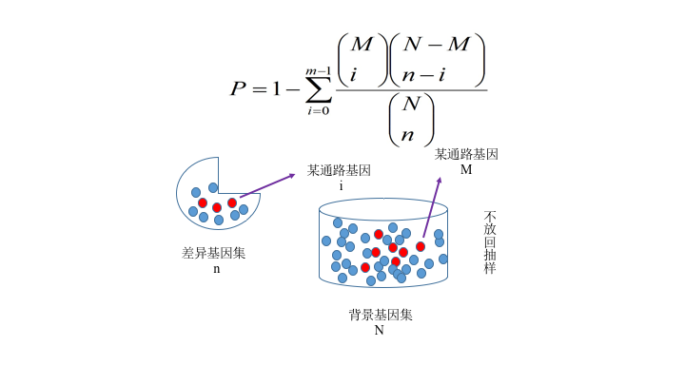

Figure S1. Schematic of differential gene enrichment analysis.

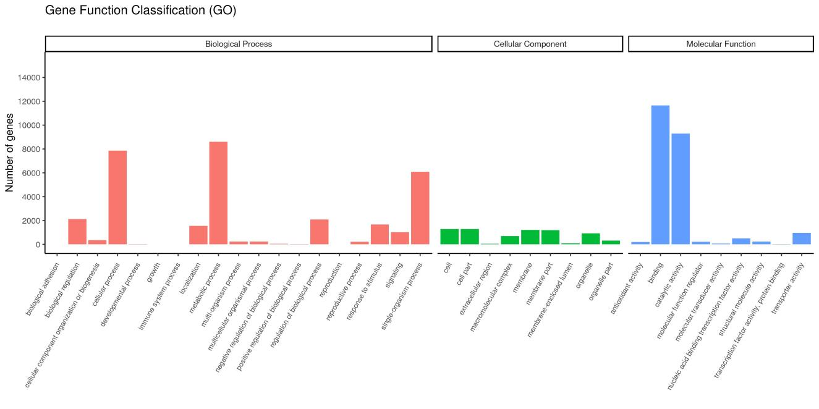
Figure S2. Statistical map of gene classification according to GO annotations for all genes annotated at level 2, png format (bitmap).

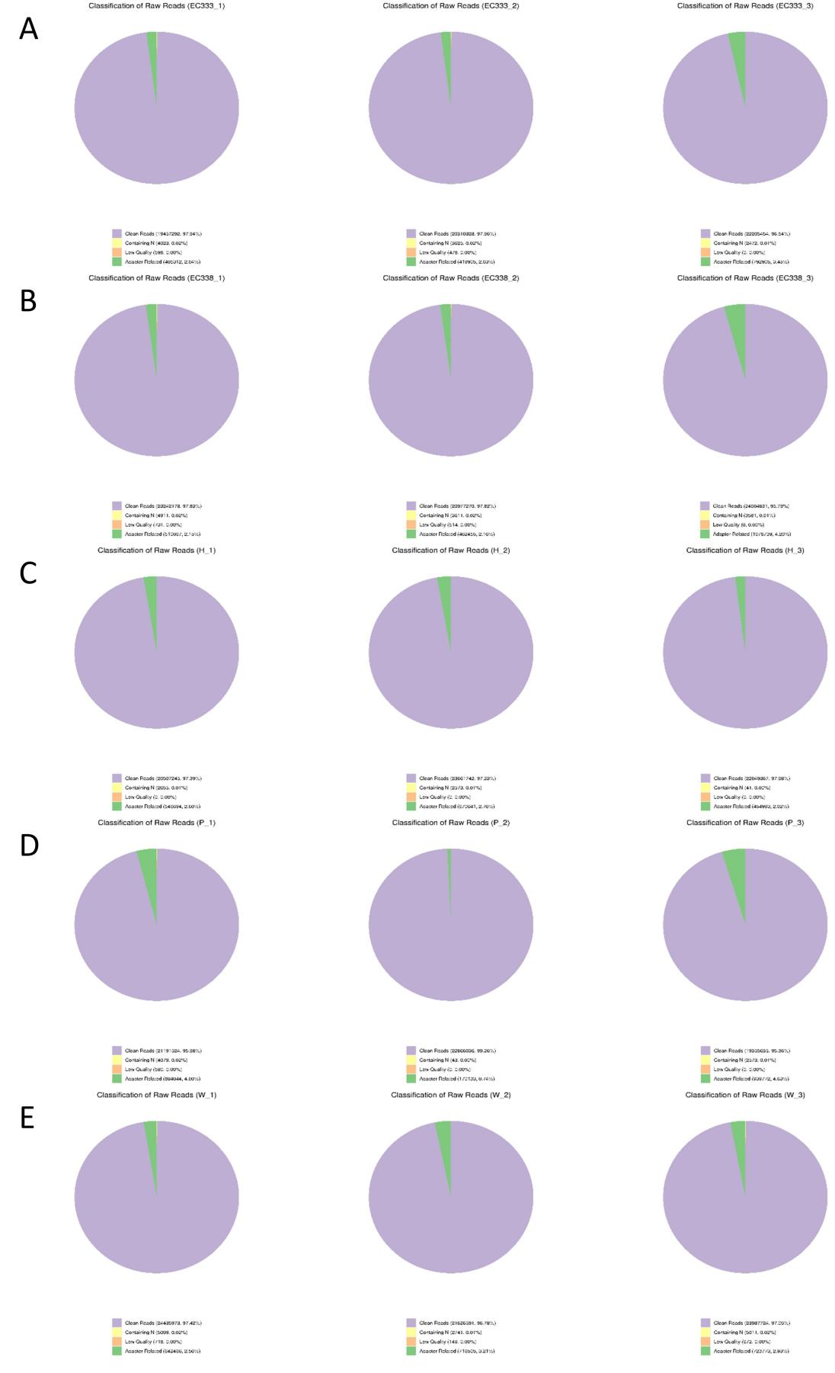
Figure S3. Sample sequencing data filtering.
Adapter related: percentage of reads with adapters, Containing N: percentage of reads with N bases, Low quality: percentage of reads with low sequencing quality, Clean reads: percentage of clean reads.

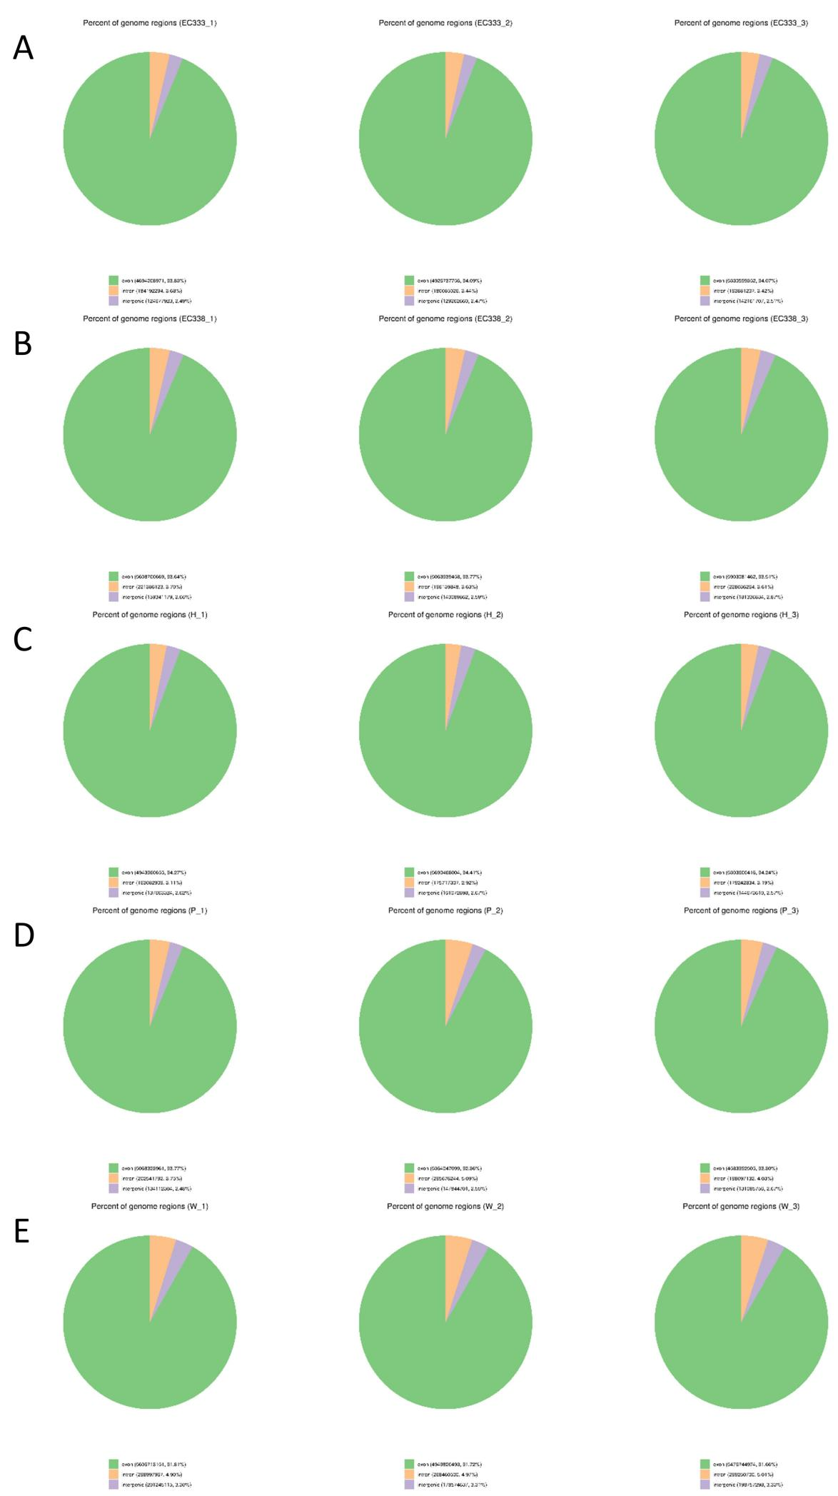
Figure S4. Distribution of sequenced reads in genomic regions of eucalypt hybrids.
Exon: the number of bases compared to the exonic region of the genome and its percentage of the number of bases compared to the reference genome, Intron: the number of bases compared to the intronic region of the genome and its percentage of the number of bases compared to the reference genome, Intergenic: the number of bases compared to the intergenic region and its percentage of the number of bases compared to the reference genome. Intergenic: the number of bases matched to intergenic regions and their percentage of the number of bases matched to the reference genome.

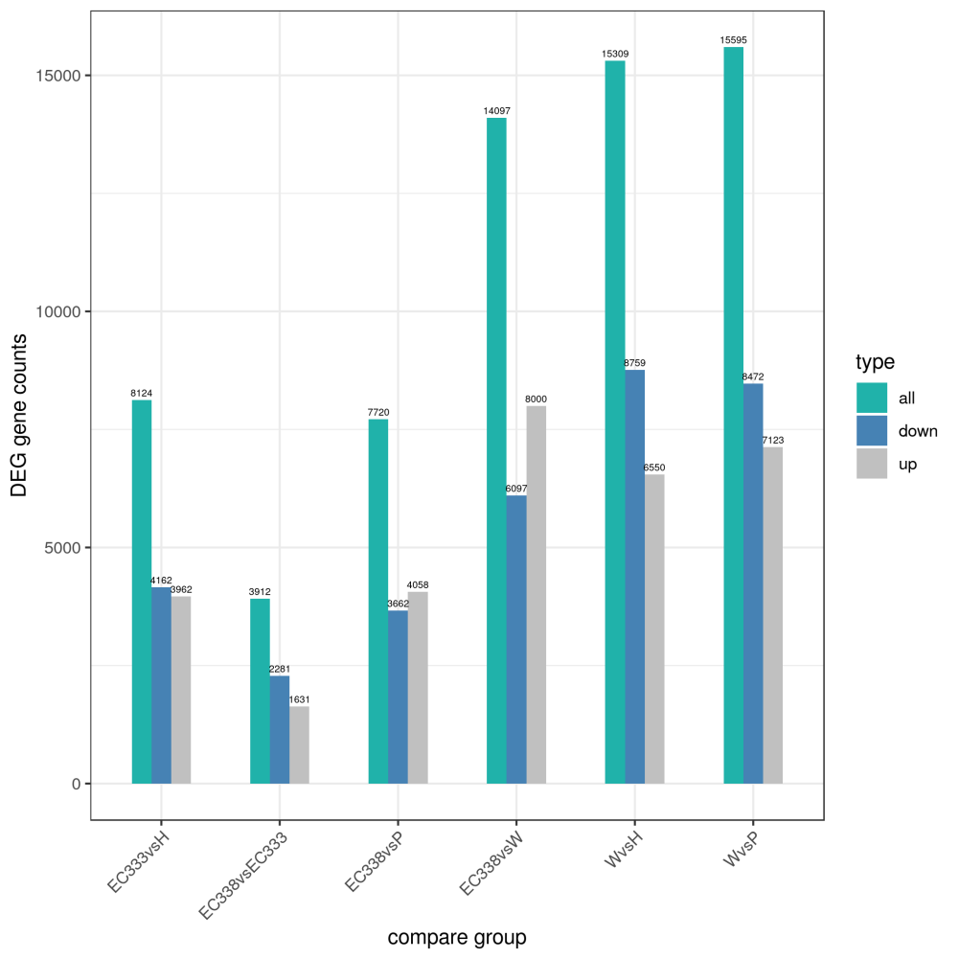

Figure S5. Histogram of the number of differential genes for each comparison combination (blue and gray indicate up- and down-regulated genes, respectively, and numbers indicate the number of genes).

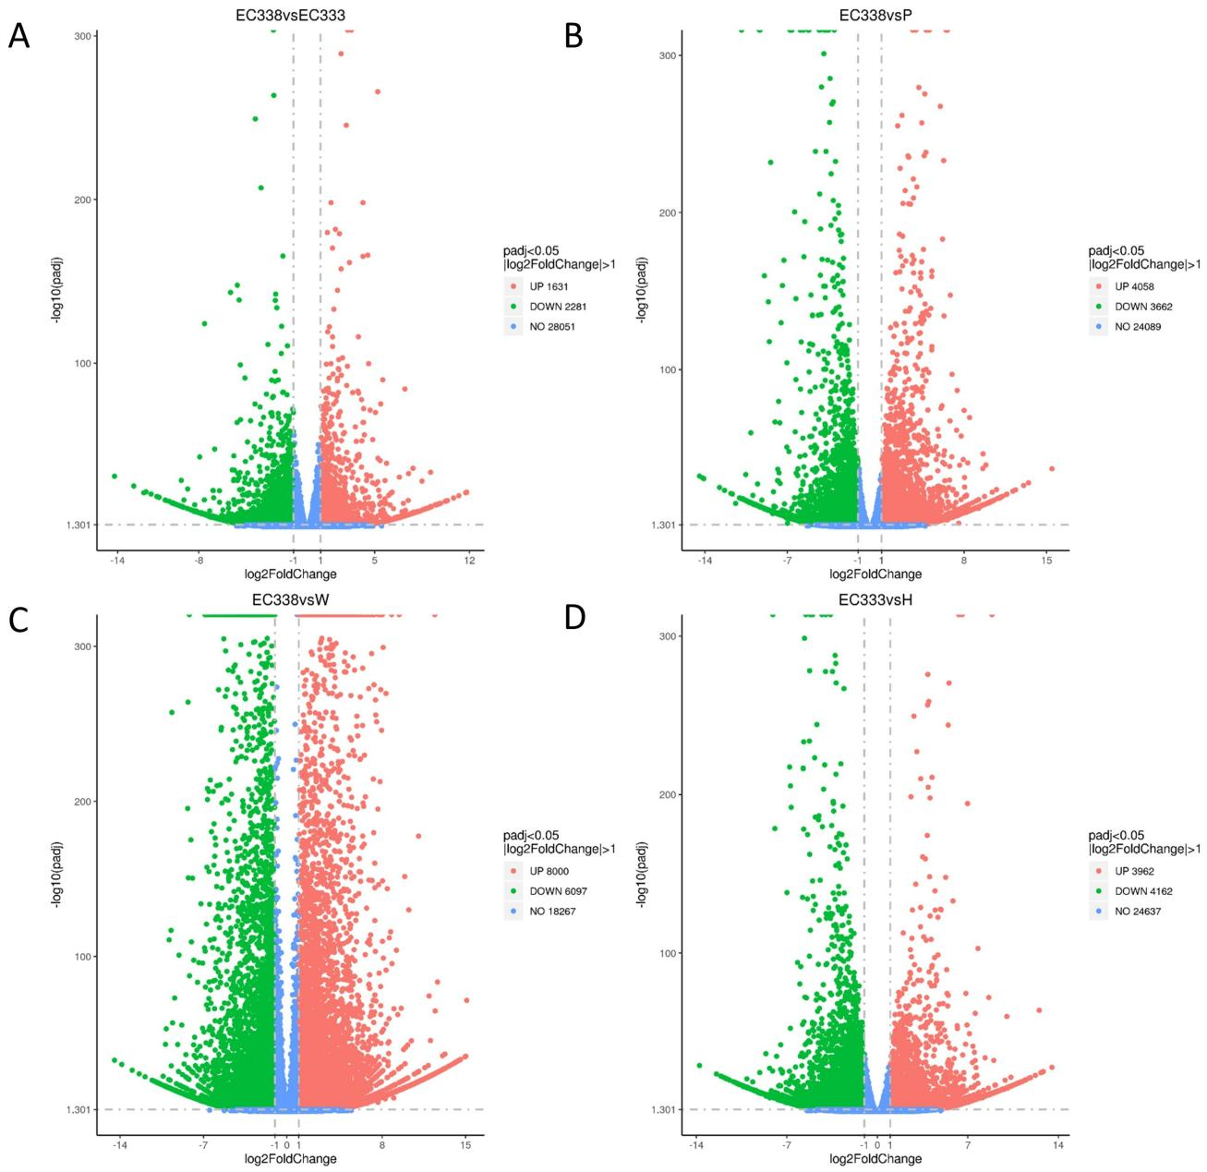
Figure S6. Volcano of differentially expressed genes for four pairs of genotypes (the more off-center the horizontal axis is, the greater the multiplicity of differences; the more the vertical axis is toward the top of the plot, the more significant the differences are; the dashed line indicates the threshold line for the differential gene screening criteria).

