Supporting information for
In search of phytoremediation candidates: Eu(III) bioassociation and root exudation in hydroponically grown plants.
Max Klotzsche ¹, Viktor Dück ¹, Björn Drobot ¹, Manja Vogel ², Johannes Raff ¹, Thorsten Stumpf ¹ and Robin Steudtner ^{1,}*
¹ Helmholtz-Zentrum Dresden-Rossendorf e.V., Institute of Resource Ecology, Bautzner Landstraße 400, 01,328 Dresden, Germany
² VKTA – Strahlenschutz,Analytik & Entsorgung Rossendorf e.V., Bautzner Landstraße 400, 01,328 Dresden, Germany
* Correspondence: r.steudtner@hzdr.de; Tel.: +49 351 260 2895

Hoagland medium composition
Table S1. Composition of the modified full-strength Hoagland medium used for plant cultivation and the phosphate-reduced Hoagland medium used for bioassociation experiments [1]. Chemicals were readily used as purchased. Before use, the medium was adjusted to pH = 5.5 ± 0.1 and autoclaved to avoid any biological contamination.
Chemical | Concentration in full-strength medium (µM) | Concentration in phosphate-reduced medium (µM)
KNO₃ | 1001 | 1001
Ca(NO₃)₂ ∙ 4 H₂O | 300 | 300
MgSO₄ ∙ 7 H₂O | 199 | 199
KH₂PO₄ | 100 | 1
FeSO₄ ∙ 7 H₂O | 2 | 2
Na₂EDTA ∙ 2 H₂O | 1 | 1
H₃BO₃ | 5 | 5
MnCl₂ ∙ 4 H₂O | 1 | 1
CuSO₄ ∙ 5 H₂O | 0.03 | 0.03
Na₂MoO₄ ∙ 2 H₂O | 0.06 | 0.06
ZnSO₄ ∙ 7 H₂O | 0.08 | 0.08

Bioassociated Eu(III) in root, stem and leave
Figure S1. Quantification of bioassociated Eu(III) in root, stem and leave after 96 h exposure of plant roots of (a) M. sativa, (b) L. corniculatus and (c) L. usitatissimum with initial concentrations of 200, 20 and 2 µM Eu(III) in the liquid medium. Bars represent the mean and error bars the standard deviation of four biological replicates.

Pictures of hydroponically grown plants
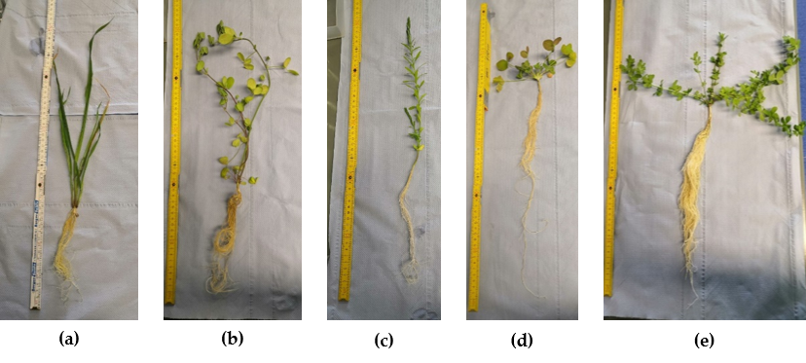
Figure S2. Photographic images of hydroponically grown plants. (a) A. strigosa, (b) M. sativa, (c) L. usitatissimum, (d) T. incarnatum, (e) L. corniculatus.

Luminescence spectra of liquid media
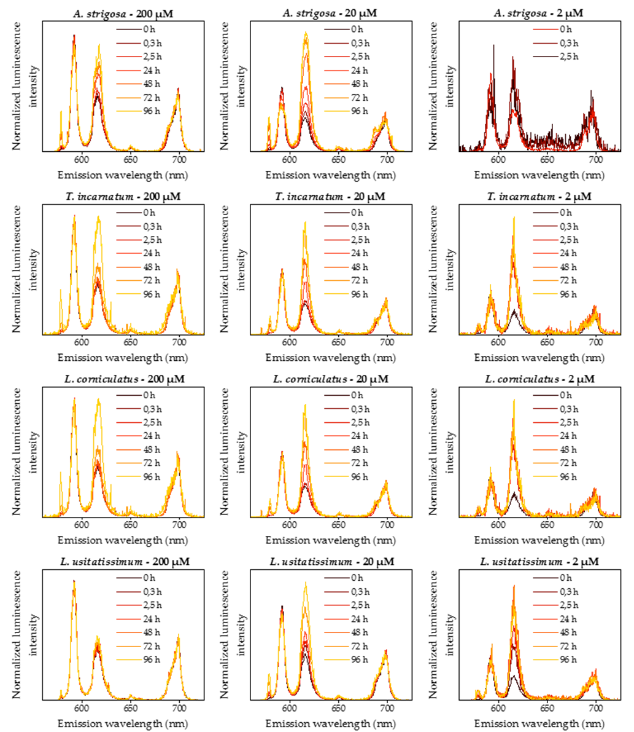
Figure S3. Normalized luminescence spectra of liquid media throughout the bioassociation experiments with A. strigosa, T. incarnatum, L. corniculatus, L. usitatissimum (top to bottom) exposed to 200, 20 and 2 µM Eu(III) (left to right). For A. strigosa, 2 µM, luminescence spectra became too noisy with time, hence only the first three spectra are shown.

Thermodynamic modelling of Eu(III) speciation in the liquid medium
Figure S4. Calculated Eu(III) speciation in low phosphate Hoagland medium (1 µM P) in dependence of the pH value for (a) 200 µM Eu(III); (b) 20 µM Eu(III) and (c) 2 µM Eu(III).

Chromatogram of liquid medium
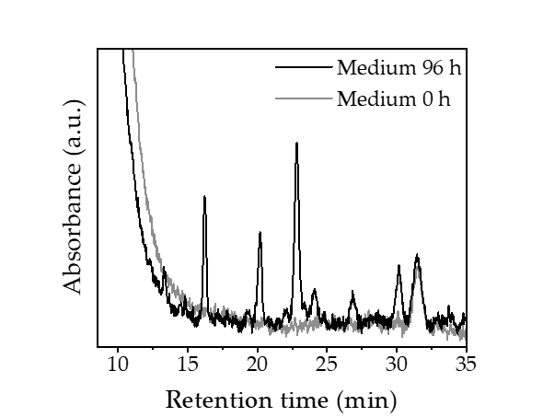
Figure S5. Chromatogram of liquid medium before (0 h) and after (96 h) contact with roots of A. strigosa.

References
1. Hoagland, D.R.; Arnon, D.I. The Water-Culture Method for Growing Plants without Soil. Circular. California Agricultural Experiment Station 1950, 347.

