Appendix A SUPPLEMENTAL DATA
S1. Questionnaire
The Centre for Multidisciplinary Studies of Coastal Zones (CEMZOC) of the University of Oriente is conducting a study on mangrove management and climate change mitigation. We are asking for your criteria on the use and benefits of mangroves in your community. We would like to thank you in advance for your cooperation and for your permission to publish the information collected and processed without revealing the identity of the participants.

GENERAL INFORMATION

1. Data
1.1 Sex______ 1.2 Age____
1.3 Marital Status ______________
1.4 Occupation_______________
1.5 people in your feeI home_____
1.5.1 Men____ 1.5.2 Women___
1.6 Where were you born? (Municipality/Province)
____________________________
1.7 How many years have you lived in this community? ___________
1.8 Family income
1.8.1 [ ] No income
1.8.2 [ ] Less than 2100 1.8.3[ ]Between 2100 and 3100
1.8.4 [ ] Between 3100 and 4100 1.8.5 [ ]Between 4100 and 5100
1.8.6 [ ] Between 5100 and 6100 1.8.7 [ ] Between 6100 and 710
    - [ ]More than 7100

Regarding “mangrove”
  - How many species of mangroves do you know? ____
  - 2.2 What are these species called?________________________________________________________________
- USE OF MANGROVE RESOURCES
Uses of the ecosystem and associated resources (Please rate how you use resources according to the following scale: 1=never, 2=sometimes, 3=always) | Frequency of use
 | 1 | 2 | 3
  - Collection of marine species for consumption or sale
a. Fish
b. Oysters, snails (Molluscs)
c. Crabs, shrimp, lobsters (Crustaceans)
d. Others:
  - Use of the resource as a colorant
  - 3. Use of parts for traditional medicine
  - 4. Decorative use
  - 5. Recreational uses:
a. Wildlife observation
b. bathing area
  - 6. Use for research or educational visits
  - 7. Spiritual use or religious practices
  - 8. Use of wood as an energy source
  - 9. Use of wood for construction

- PERCEPTION OF ECOSYSTEM SERVICES
Type of ecosystem service | (Please rate the level of importance you perceive of the resources according to the following scale: 1=not important, 2=important, 3=very important) | Importance level
 |  | 1 | 2 | 3
Support service | 1. It serves as a refuge for the juvenile stages of numerous species, feeding and engendering a large number and diversity of marine and terrestrial organisms.
 | 2. Provides habitat for a large number of marine and terrestrial fauna.
Provision service | 3. Source of food for consumption and sale
 | 4. Source of natural medicine for numerous diseases
Regulation service | 5. Protection in coastal areas against storms, cyclones and waves.
 | 6. Helps maintain seawater quality by retaining sediment.
 | 7. Helps mitigate the effect of climate change by sequestering carbon
Cultural service | 8. They can be used as recreation and educational sites.
 | 9 Local culture/heritage symbol

- THREATS TO THE MANGROVE ECOSYSTEM AND MANAGEMENT
Questions | Answers
1. Do you think that the degradation of the mangrove forest in your area affects you and your community? | [ ]1= not affected [ ]2= some are affected [ ]3 = extremely
2. What condition is the mangrove currently in? | [ ] 1 = Bad [ ] 2 = good [ ] 3 = excellent
3. What changes have you noticed in the mangrove during your life in this community? | [ ] 1 = There have been no changes [ ] 2 = completely disappeared [ ] 3 = I don't know
4. How important are mangroves to your livelihood? | [ ] 1 = not important [ ] 2 = slightly important [ ] 3 = very important
5. What institution/organism is responsible for mangrove management in your locality? | [ ] Local communities [ ] Local government [ ] Flora and Fauna  [ ] CITMA [ ] Forest Ranger Corps [ ] Others:
6. Are you aware of the interventions for mangrove management?  Scale: 1=unaware, 2=somewhat aware, 3= fully aware  You must ask and evaluate each of the following possibilities:  to. A specialised program or plan for the management  b. Various seminars/trainings that consider mangrove management.  c. Existence of legal instruments  d. penalty for violating existing environmental legislation.  and. The existence of Government employees who supervise and evaluate resources. |  | 1 | 2 | 3
7. What do you think about the current form of management implemented regarding the protection and exploitation of mangroves?
[ ]1 = not supported:
[ ]2 = supported:
[ ]3 = Supported but not effective:
[ ]4 = Supported and effective:
[ ]5 = Supported and very effective:
9. Please list the natural or anthropogenic threats that you think have the highest to lowest effect on your mangroves:

S2. Variables used in statistical analysis and types of data
Variables | Type of Data
Socio-demographic profile
Locality | Categorical
Sex | Binary | Female/male
Age | Continuous | Exact age
Occupation | Categorical | Exact occupation
Frequency of resource utilization | Ordinal (Likert scale) | 1 = never used, 2 = sometimes, 3 = always
Awareness on ecosystem services | Ordinal (Likert scale) | 1 =not important, 2 =important, 3 =very important
Perceived threats | Ordinal | 1 = first, 2 = second, 3 = third, 4 = fourth, 5 = fifth, 6 = sixth, 7 = seventh, 8 = eighth, 9 = ninth, 10 = tenth
Management
Perception of the effect of mangrove degradation on the community and responder | Ordinal (Likert scale) | 1 = not affected, 2 = some are affected, 3 = extremely
Perception of mangrove state | Ordinal (Likert scale) | 1 = bad, 2 = good, 3 = excellent
Perception of the changes that have occurred in the mangrove | Ordinal (Likert scale) | 1 = There have been no changes, 2 = completely disappeared, 3 = I don't know
Assessment of the importance of the mangrove | Ordinal (Likert scale) | 1 = not important, 2 = important, 3 = very important
Administration identity | Categorical | Exact identity (Local communities, Local government, Flora and Fauna Company, CITMA, Forest Rangers)
Awareness on ordinances, laws and penalties | Ordinal (Likert scale) | 1 = unaware 2 = somewhat aware, and 3 (fully aware

Figure S1. Frequency of mangrove resource use in the sites studied.
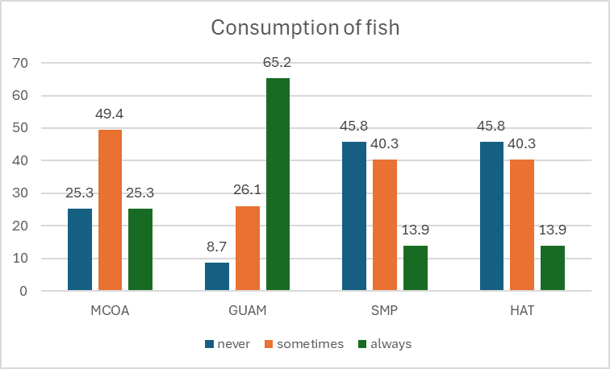  A | 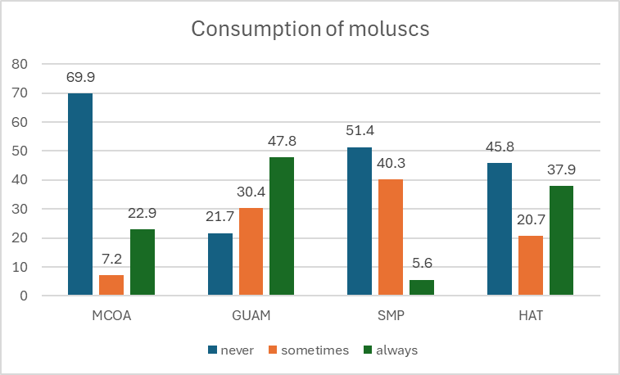  B
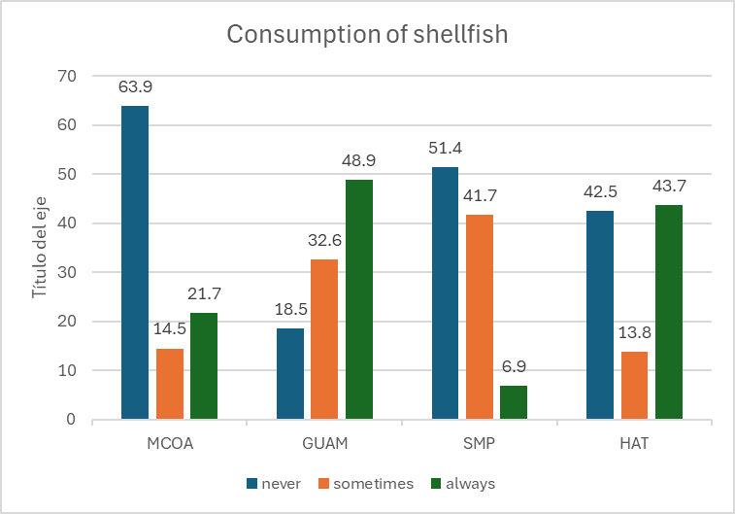  C | 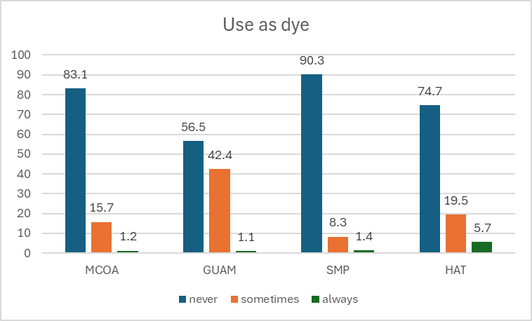  D
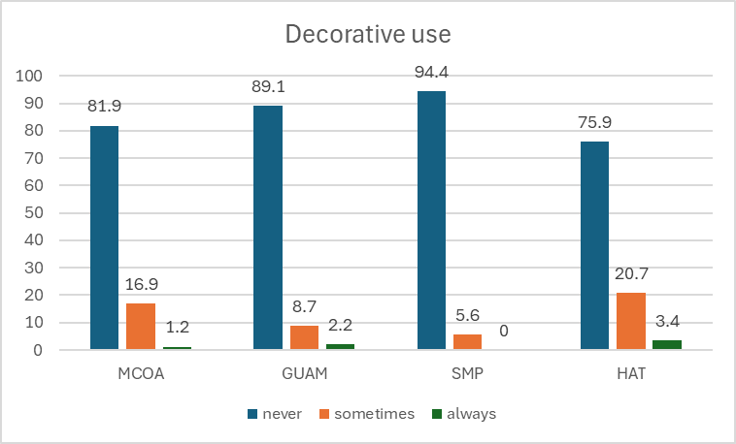  E | 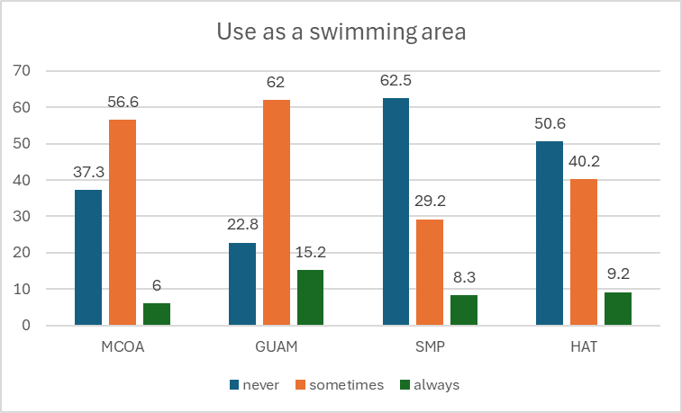  F
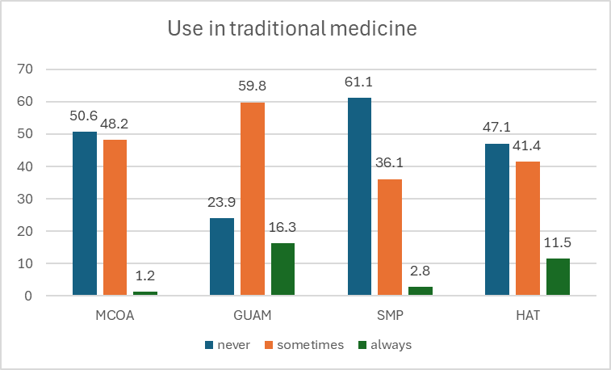  G | 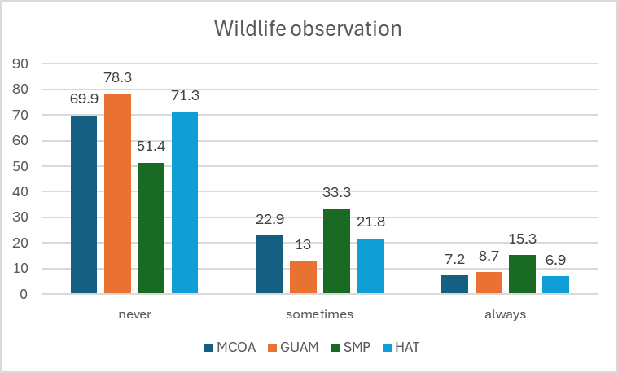  H
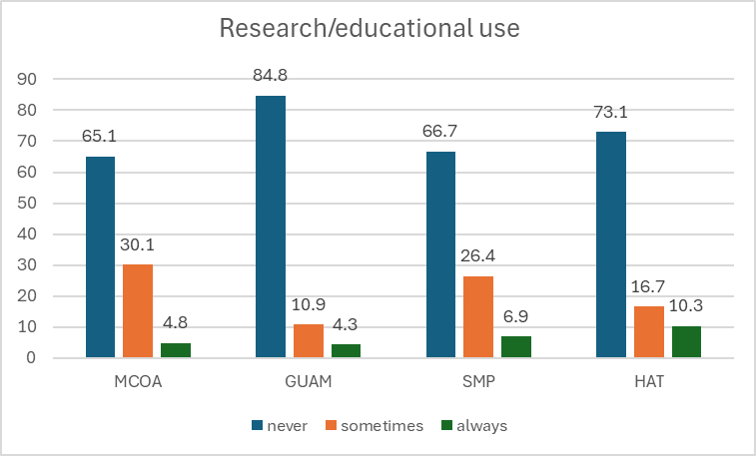  I | 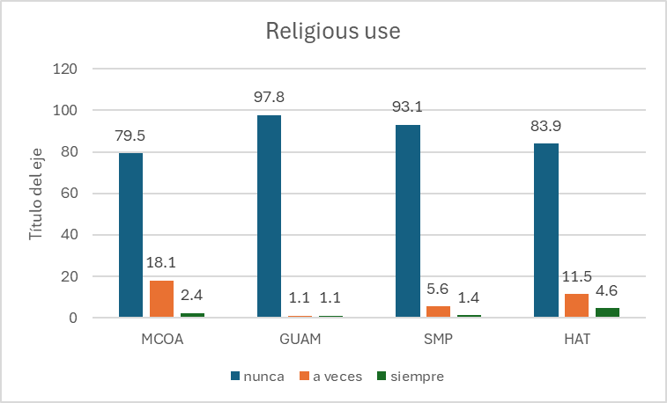  J
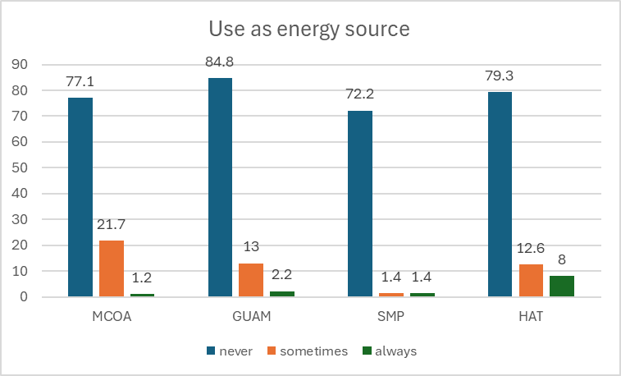  K | 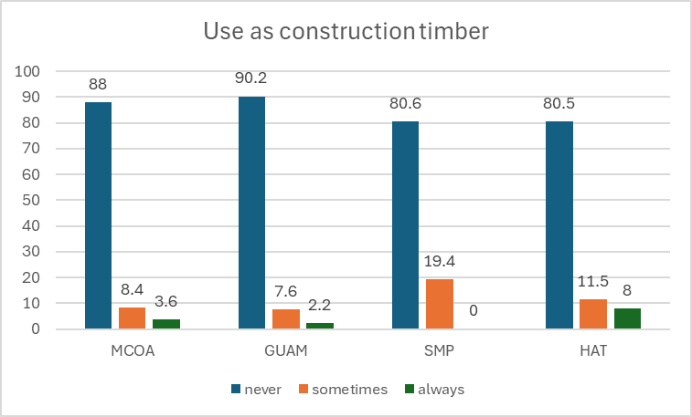  L

Figure S2. Level of specific stakeholders in the management system for the mangrove governance in Cuba (Mendelow’s Stakeholder Matrix)

Stackeholder matrix analysis

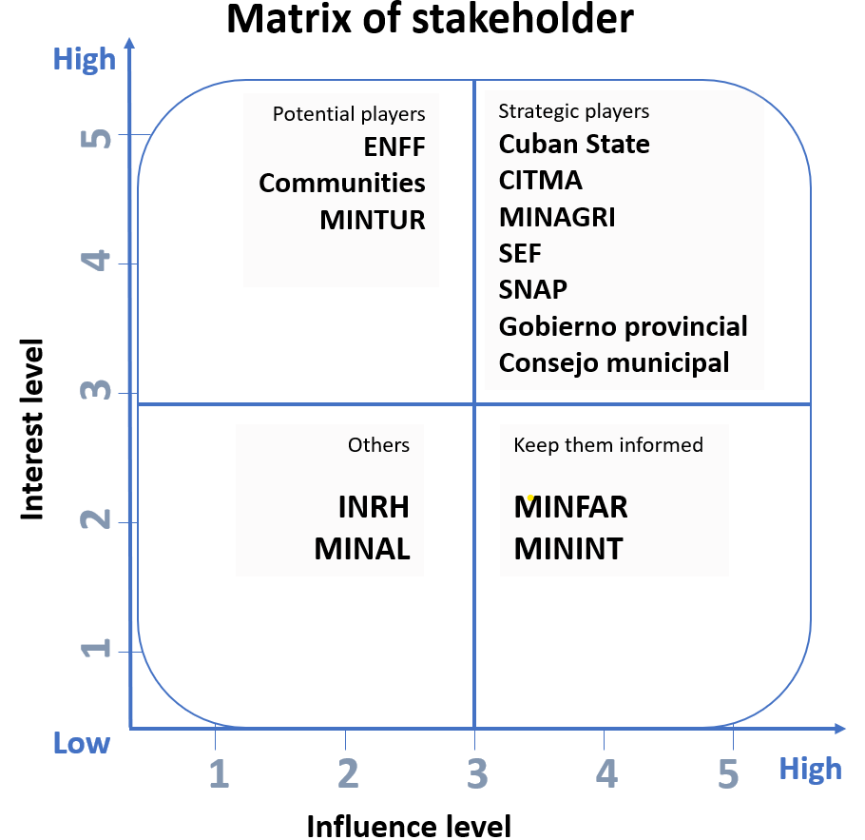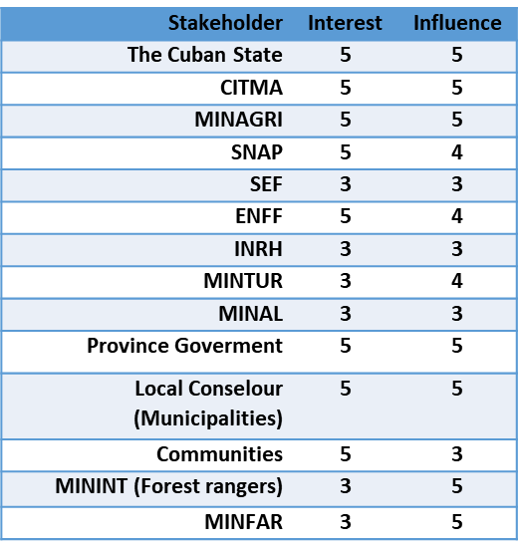
To what degree do stakeholders have a relation with mangrove management in Cuba?
low, 3- average, 5- high

List of acronyms:
CITMA: Ministry of Science and Environment
MINAGRI: Ministry of Agriculture
SNAP: National System of Protected Areas
ENFF: National Enterprise of Flora and Fauna
INRH: National Institute of Hydric Resouces
MINTUR: Ministry of Tourism
MINAL: Ministry of Food Industry
MININT: Ministry of the Interior
MINFAR: Ministry of Revolutionary Armed Forces

