Slaughterhouse wastewater properties assessment by modern and classic methods
Ramona Crainic¹ and Radu Fechete^{2,*}

The CPMG and PGSE pulse sequences
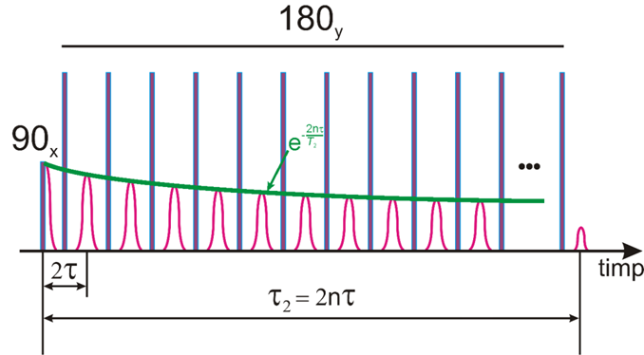
(a)

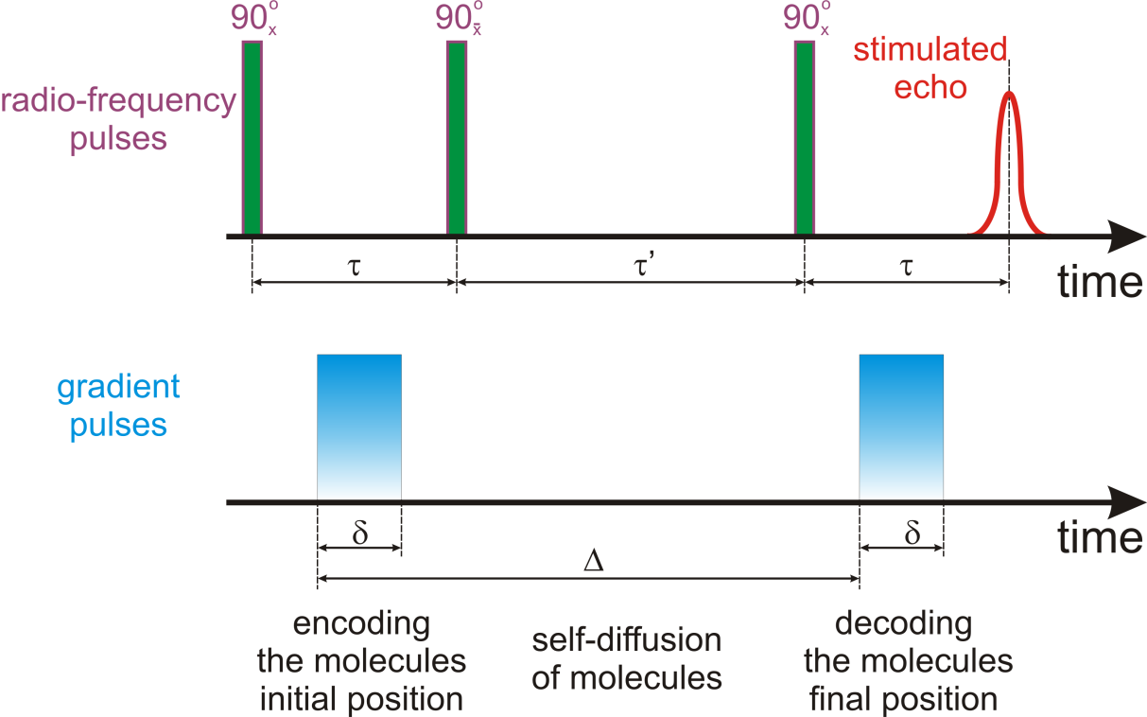
(b)
Figure SI 1. a) The CPMG (Carr-Purcell-Meiboom-Gill) pulse sequence consisting of a tipping (excitation) radiofrequency pulse and a series of n refocusing pulses generating a series of multi-exponential decay echoes, with the echo time 2τ and a total duration of 2nτ and b) The PGSE (pulsed gradient stimulated echo) pulse sequence with the echo time τ, duration of the coding/encoding grdient δ and the free diffusion period Δ.

The T₂-distributions measured for sludge
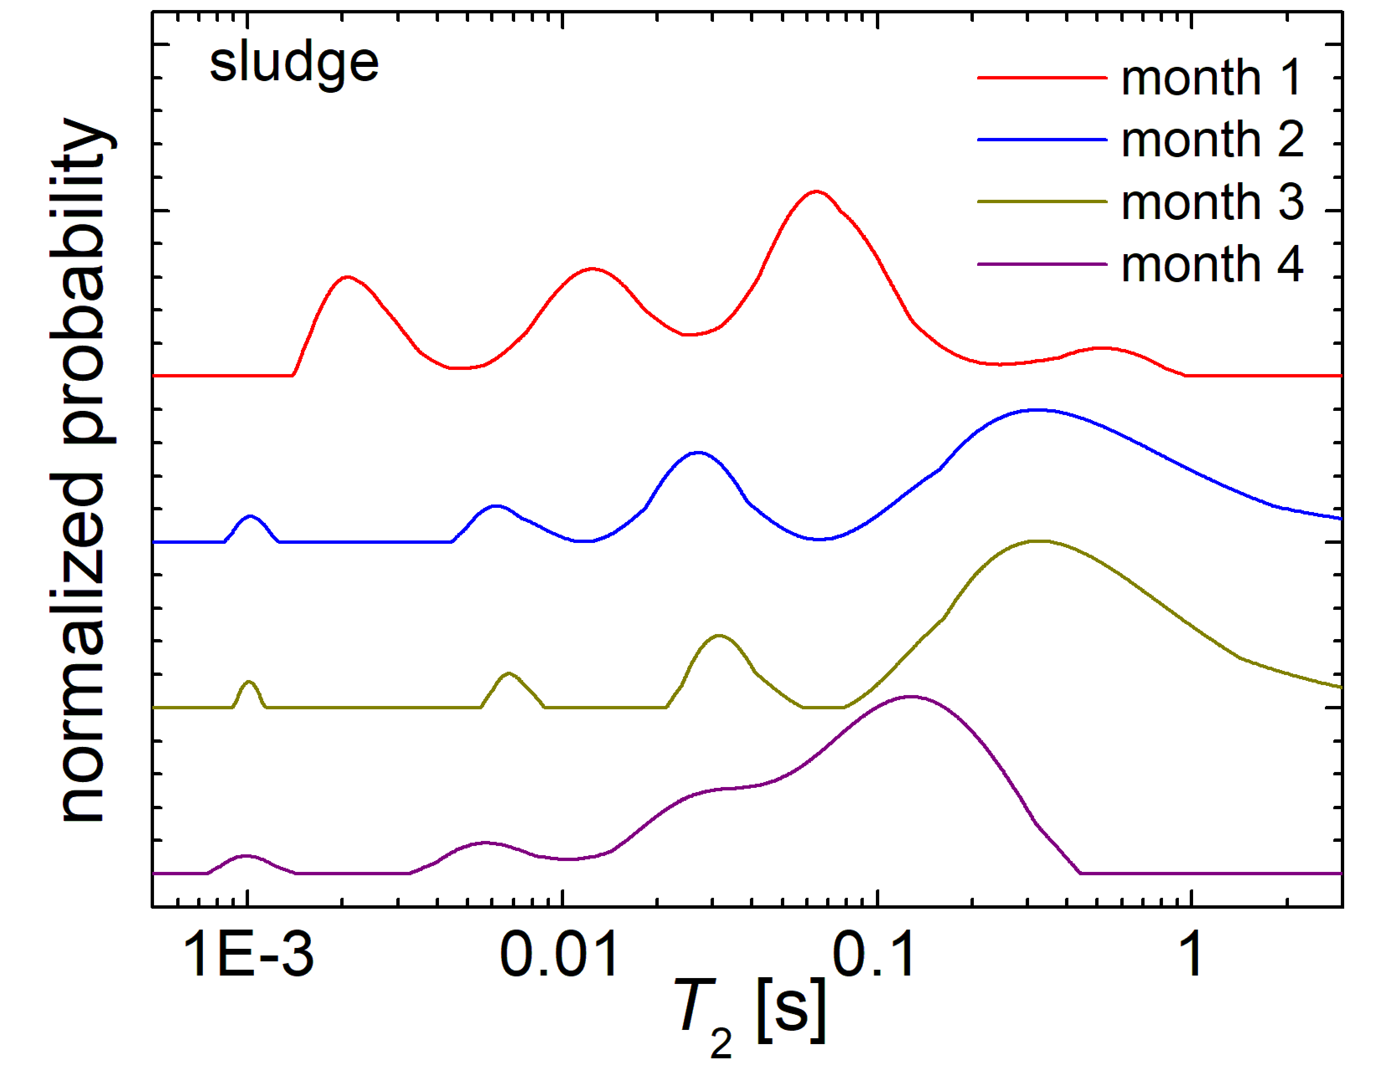
Figure SI 2. The normalized T₂ –distributions recorded for the sludge residue collected from a chicken slaughterhouse in the months 1, 2, 3 and 4 of monitoring.

The self-diffusion coefficient D distributions measured for sludge
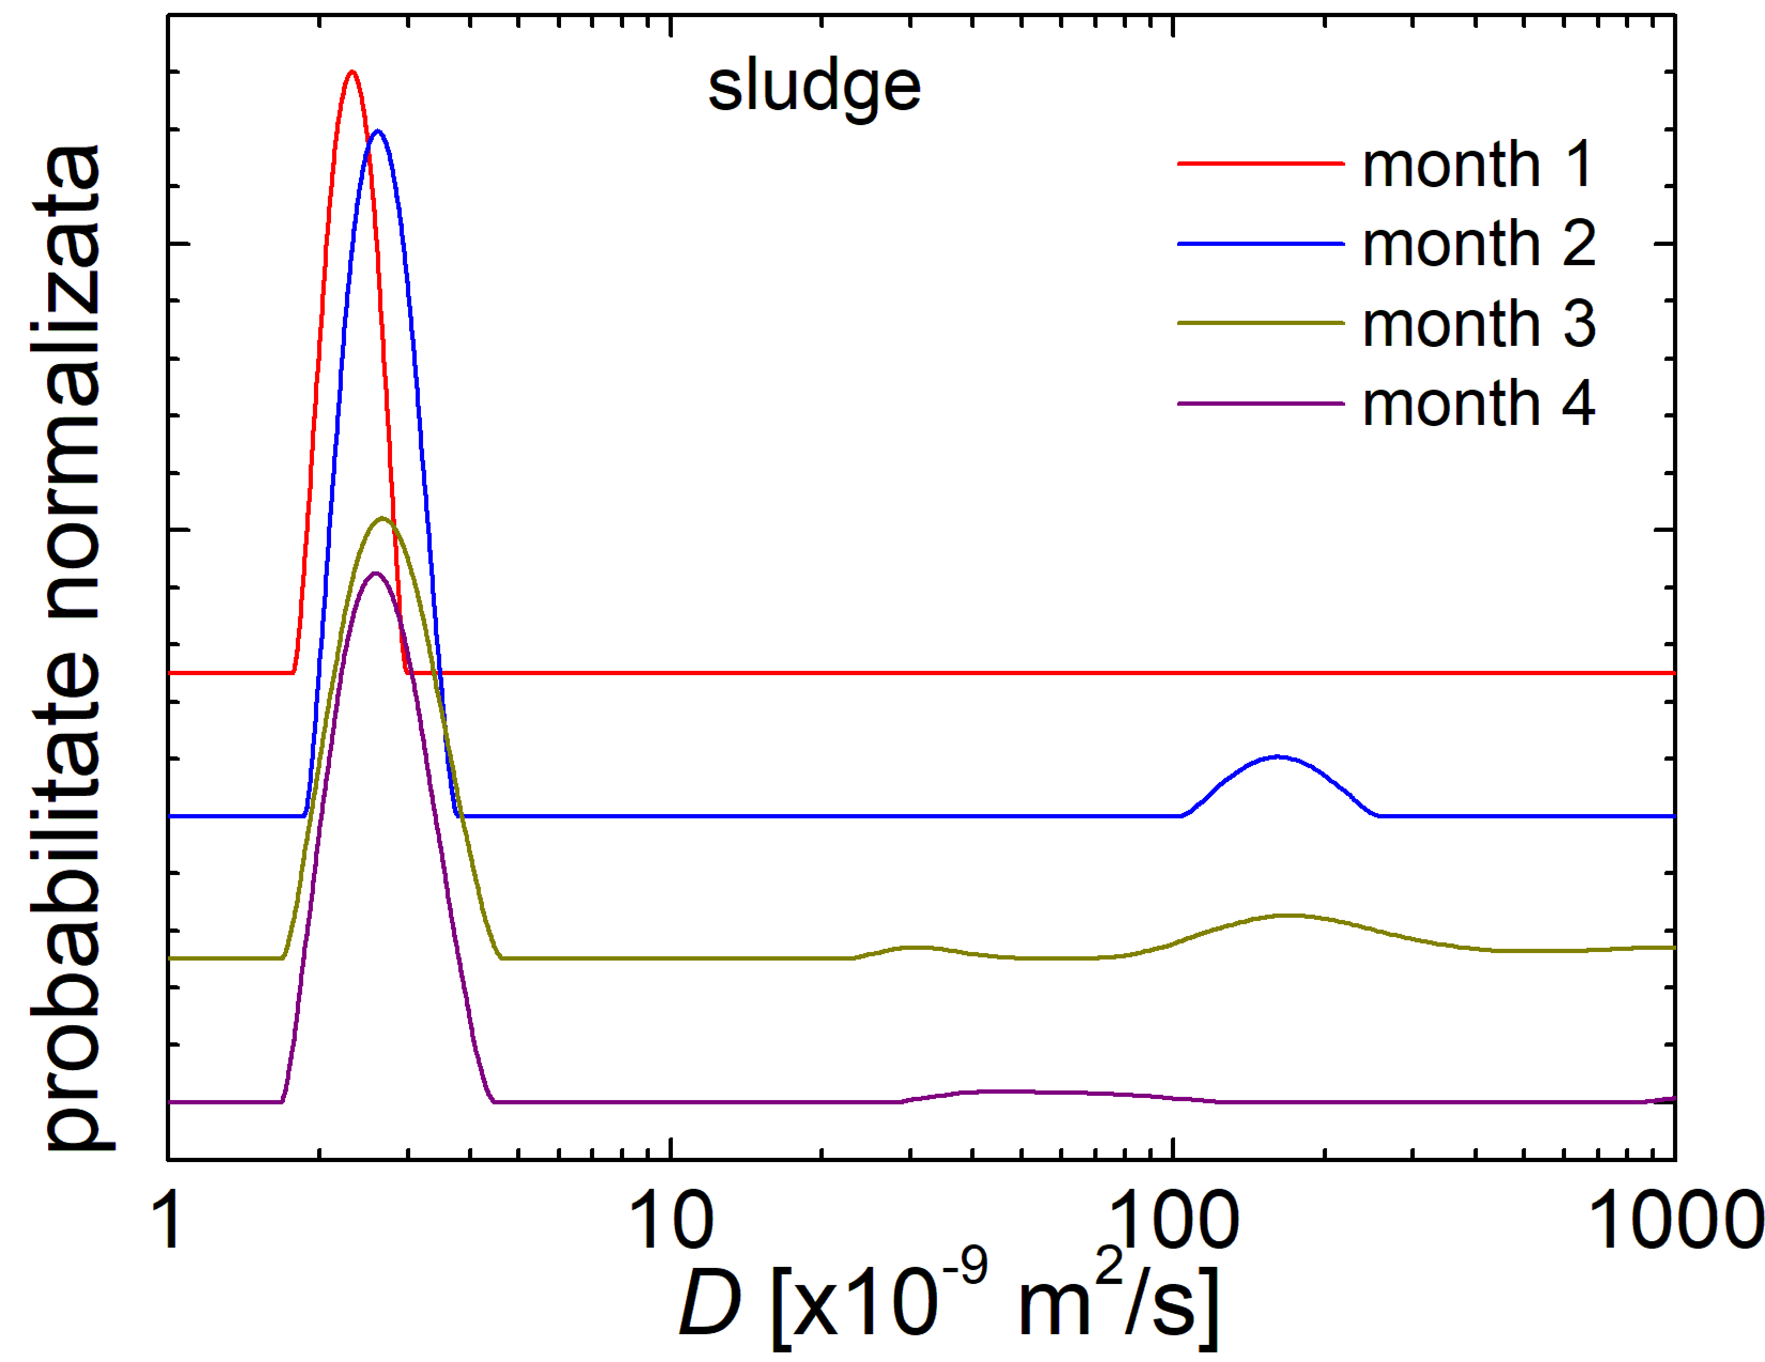
Figure SI 3. The normalized D–distributions recorded for the sludge residues collected from a chicken slaughterhouse in the months 1, 2, 3 and 4 of monitoring.

The relationship between the total absorbance in the VIS-NearIR spectra and turbidity
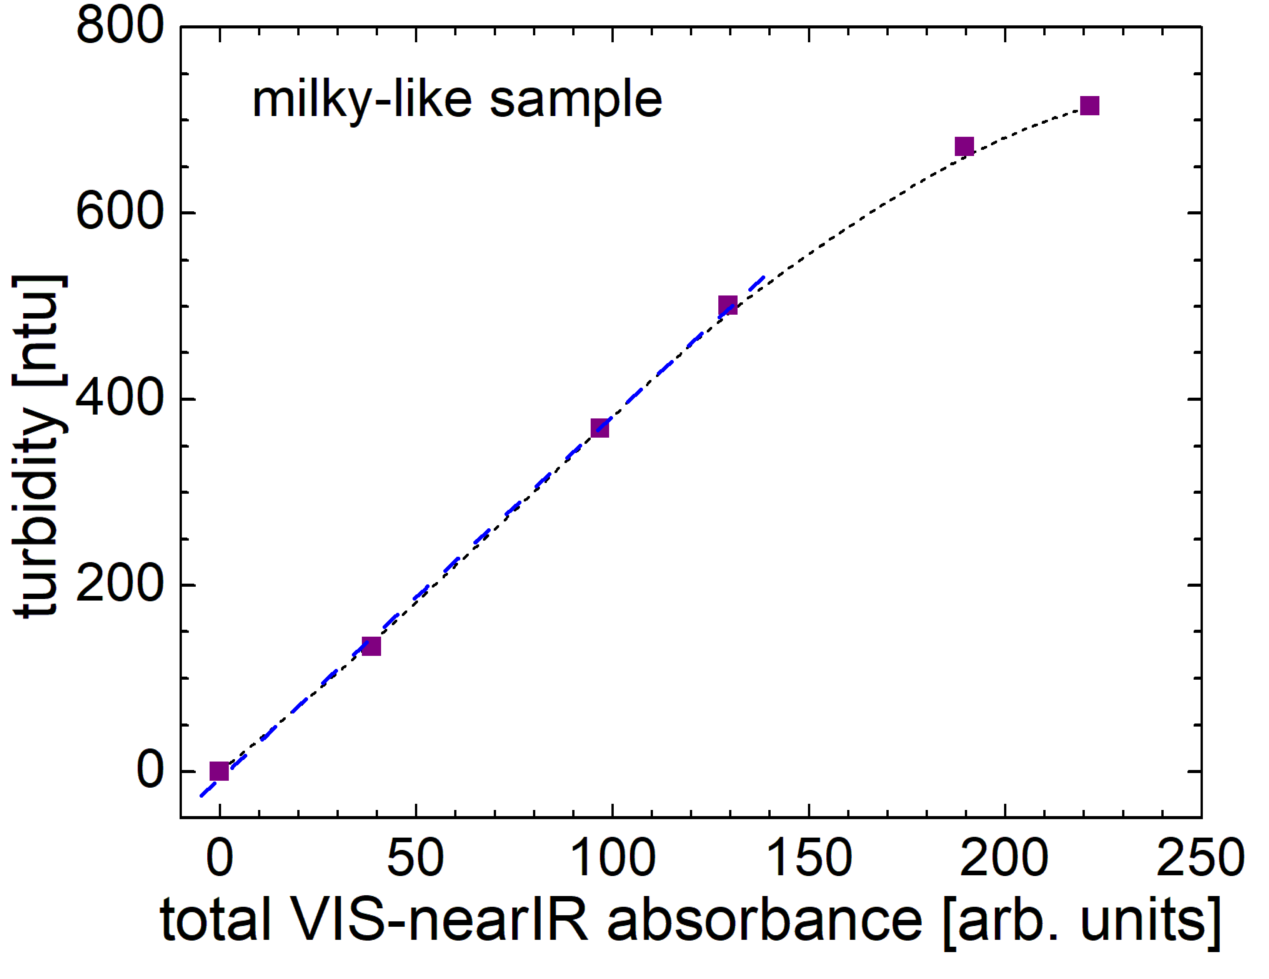
Figure SI 4. The relationship between the total absorbance in the VIS-NearIR spectra and turbidity measured for milky-like samples.

The proportions and eigenvalues resulted from PCA applied on the measured parameters of poultry slaughterhouse wastewater
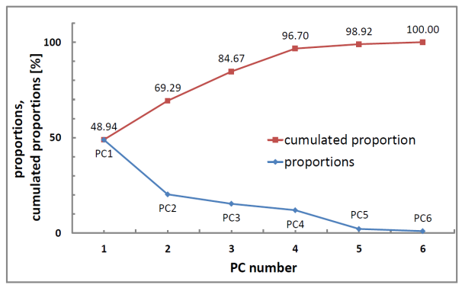  (a) | 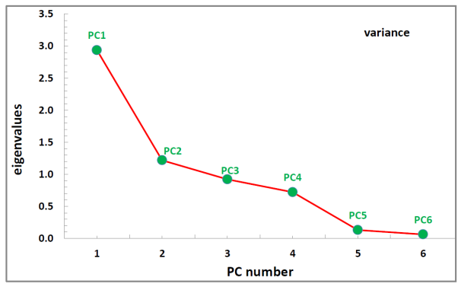  (b)
Figure SI 5. (a) The proportion and cumulated proportion function of principal component number as resulted from PCA – analysis using the input data presented in Table 1 for the wastewater and sludge collected from a chicken slaughterhouse; (b) The eigenvalues (variance) function of the principal component number PC1 – PC6.

