***Supplementary Materials***

Size uniformity of CsPbBr3 perovskite quantum dots via manganese-doping

*Mi Zhang 1, Xue Han 1, Changgang Yang 1, Guofeng Zhang 1,*, Wenli Guo 1, Jialu Li 1, Zhihao Chen 1, Bin Li 1, Ruiyun Chen 1, Chengbing Qin 1, Jianyong Hu 1, Zhichun Yang 1, Ganying Zeng 1, Liantuan Xiao 1,2,*, and Suotang Jia 1*

1 State Key Laboratory of Quantum Optics and Quantum Optics Devices, Institute of Laser Spectroscopy, Collaborative Innovation Center of Extreme Optics, Shanxi University, Taiyuan, 030006, China

2 College of Physics, Taiyuan University of Technology, Taiyuan, Shanxi 030006, China

* Corresponding Authors

Email: guofeng.zhang@sxu.edu.cn (G. Z.); xlt@sxu.edu.cn (L. X.)

**S1. Estimation of****and calculation of the absorption cross section****:**

We can estimate the average number of absorbed photons per QD per pulsefor a single perovskite QD by using the following equation:

,

whererepresents the PL count rate of the exciton, *F* is the repetition rate of the pump pulse (5 HMz), is the PLQY of the exciton, andrepresents the detection efficiency of the system.

Since the perovskite QDs are embedded in polystyrene, the environmental effects can be mitigated. Assuming aof 1 at the highest intensity level, thecan be accurately estimated based on the PL intensity trace, particularly at lower excitation powers. Subsequently, the absorption cross-sectioncan be calculated using this estimation,

,

whereis the excitation photon flux (photons/cm2), which can be calculated by the following equation:

 ,

whereis the power density of the laser excitation (W/cm2), neglecting the effect of higher order excitons, and the photoluminescence intensityis proportional to:

 .

The equation can finally be expressed as:

 .

For undoped and Mn-doped CsPbBr3 perovskite QDs, the average value ofcan be calculated to be 3.52 × 10-14 cm2 and 2.97 × 10-14 cm2, respectively.

**S2. Calculations of radiative lifetime scaling:**

The radiative lifetime scaling for the two PL intensity regions of single perovskite QDs is calculated as follows:



For a single Mn-doped CsPbBr3 perovskite QD, the radiative lifetime scaling for the two PL intensity regions is also calculated as follows:



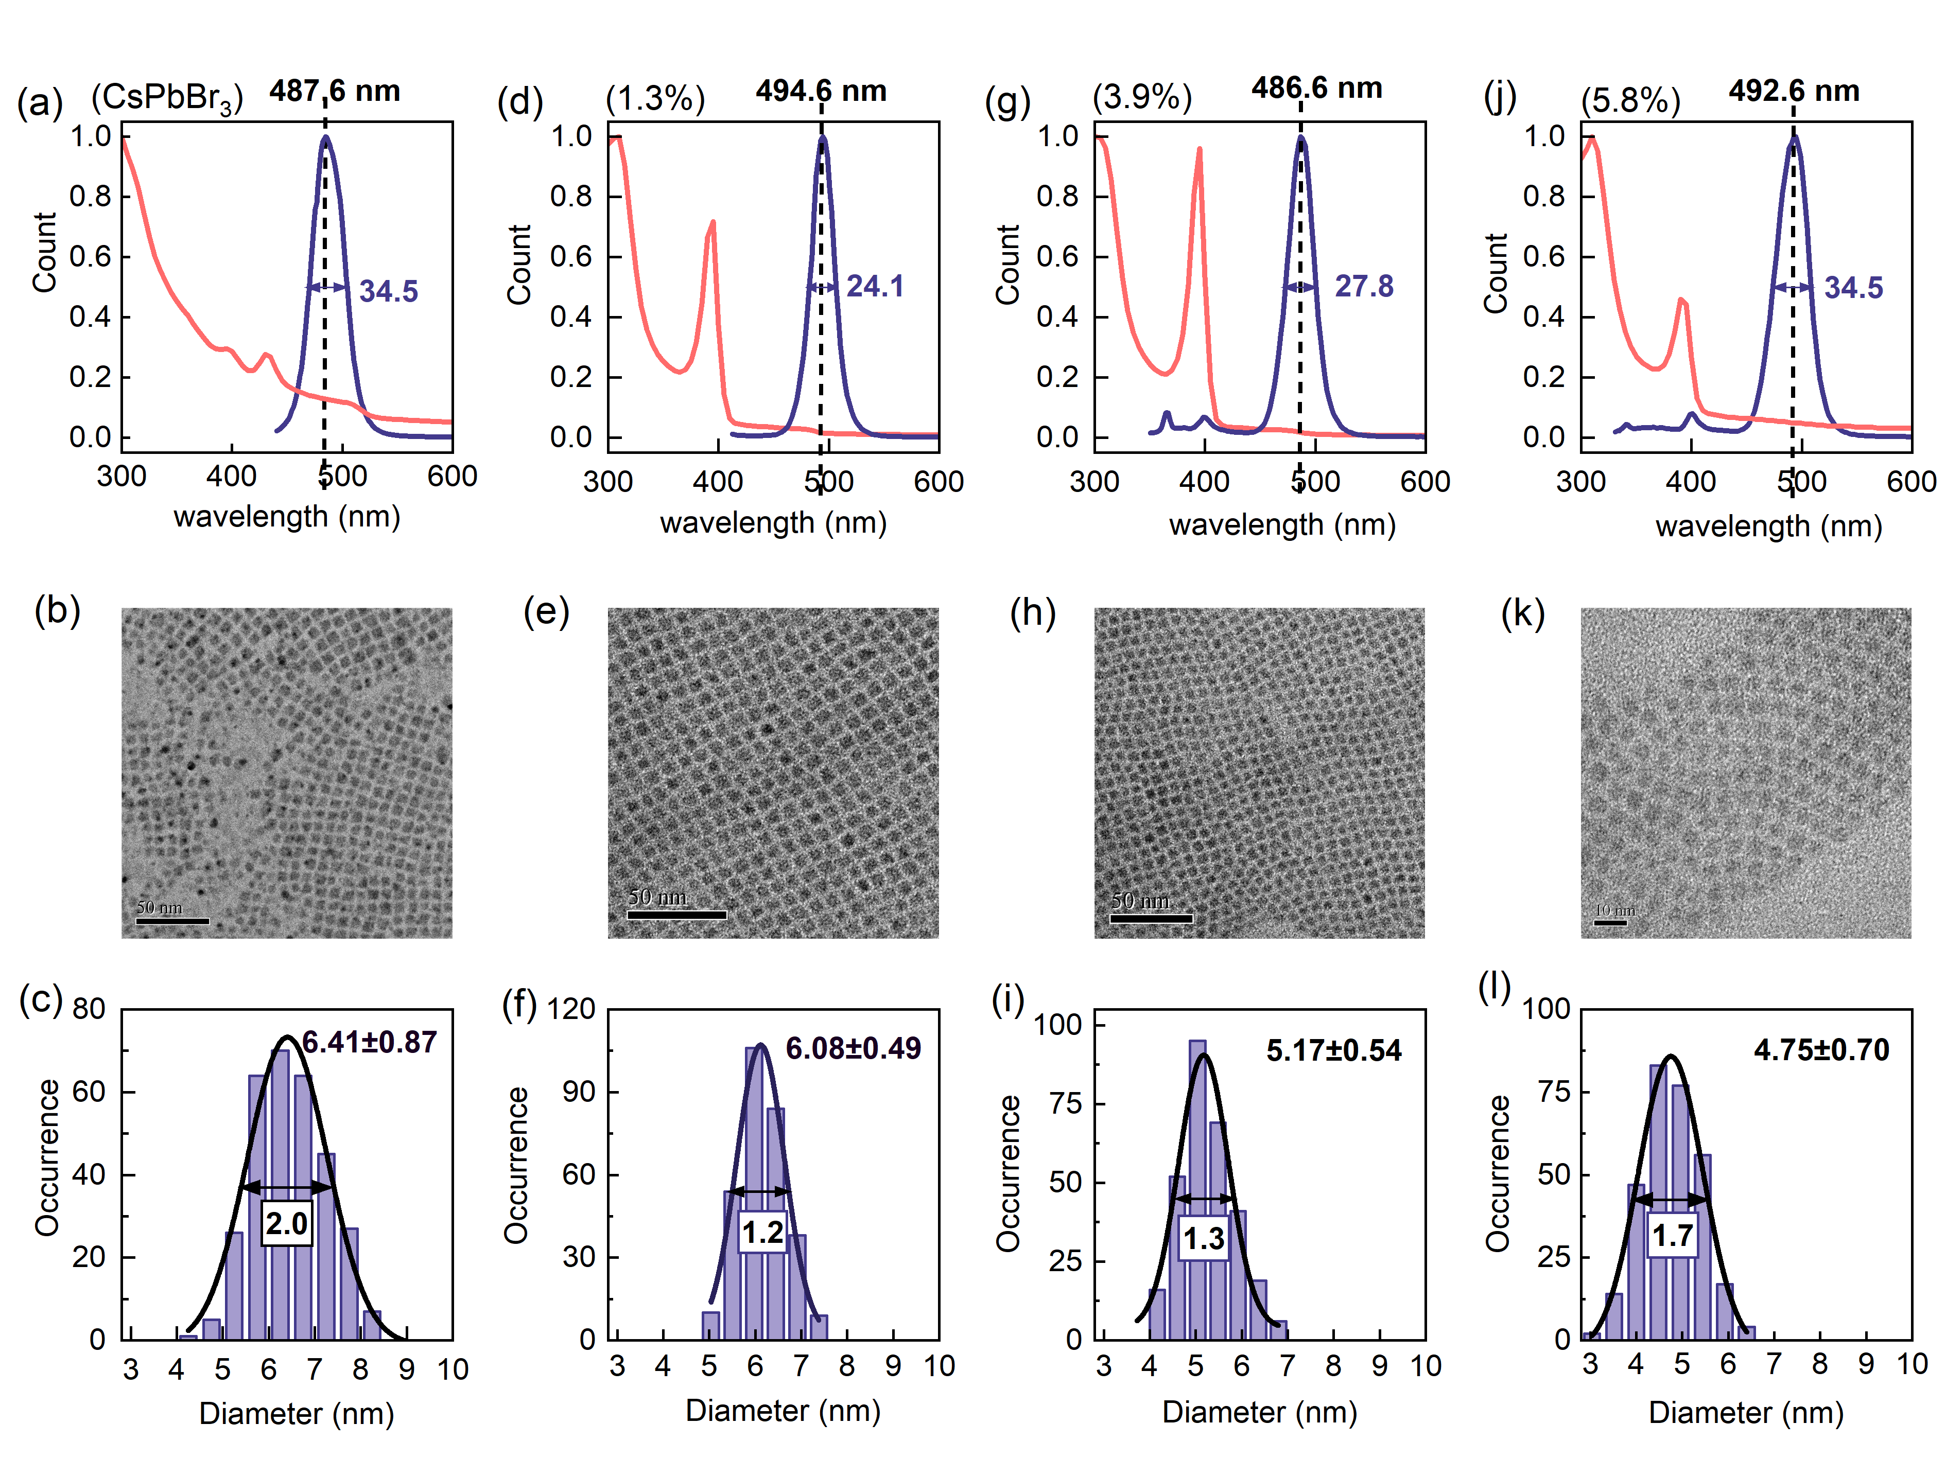

**Figure S1:** Morphological, spectral, and structural characterizations of undoped and Mn-doped CsPbBr3 perovskite QDs with various doping ratios. Absorption and emission spectra, transmission electron microscopy (TEM) images, and histograms of edge length distribution with the corresponding Gaussian fitting curve for undoped CsPbBr3 perovskite QDs (a-c), 1.3% Mn-doped CsPbBr3 perovskite QDs (d-f), 3.9% Mn-doped CsPbBr3 perovskite QDs (g-i), and 5.8% Mn-doped CsPbBr3 perovskite QDs (j-l). The doping concentration of 1.3% results in the best uniformity of the QD sizes. Excessive addition of Mn will have an adverse effect on the size distribution and stability of the QDs.

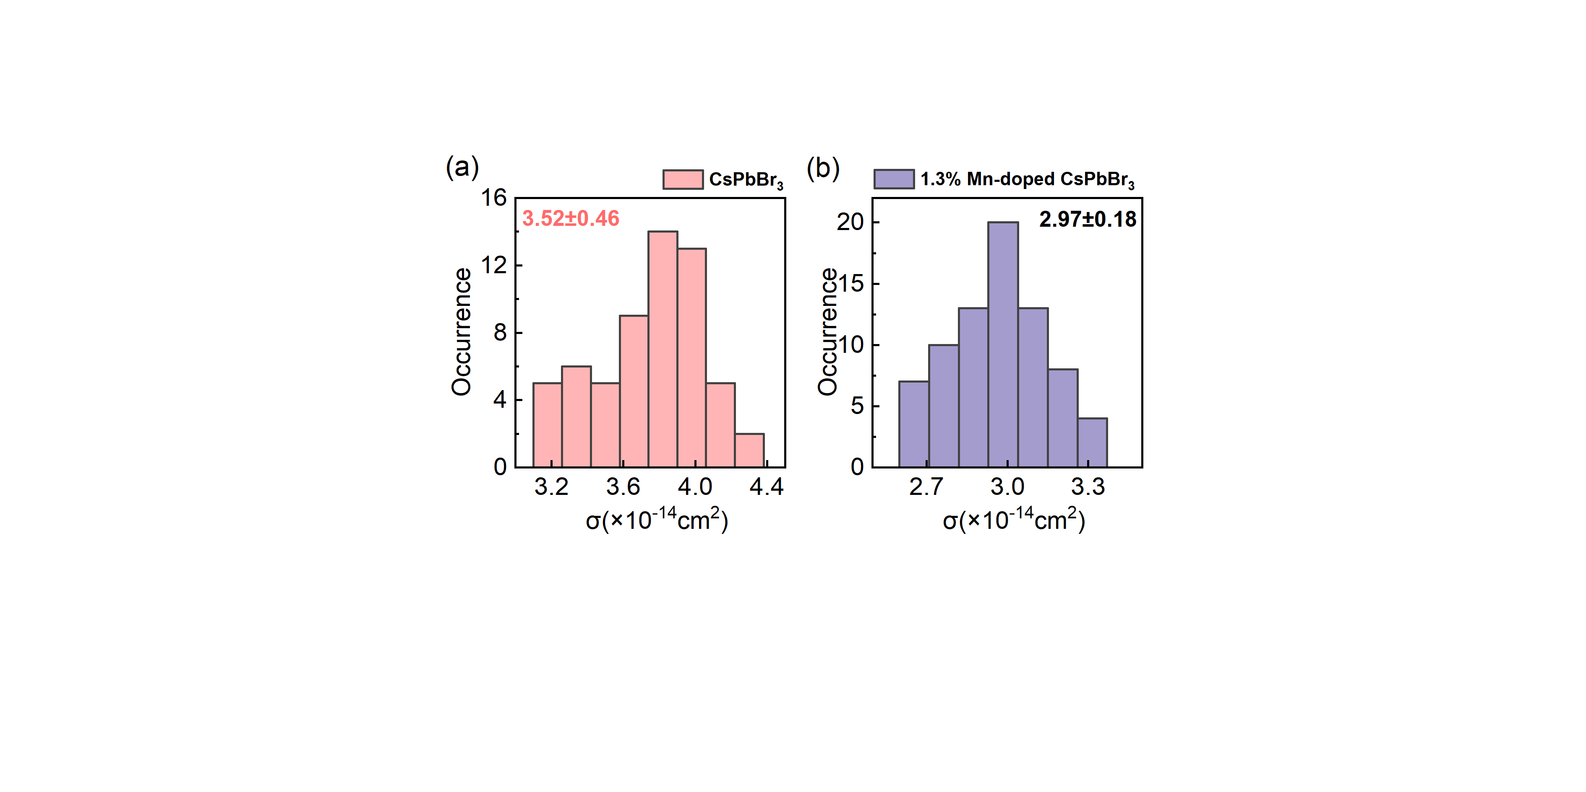

**Figure S2:** (a, b) Histograms of the absorption cross-sections () of undoped and 1.3% Mn-doped CsPbBr3 perovskite QDs.

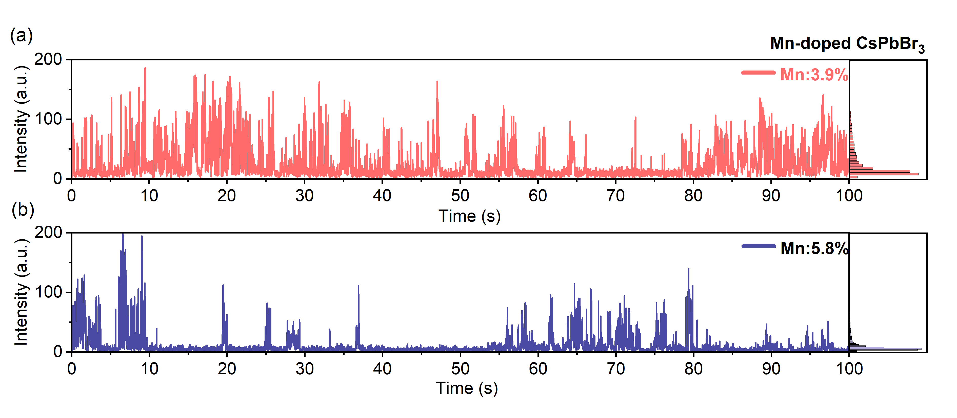

**Figure S3:** (a) A typical PL intensity time trajectory for 3.9% Mn-doped CsPbBr3 perovskite QDs. The corresponding PL intensity histogram is shown on the right panel. (b) A typical PL intensity time trajectory for 5.8% Mn-doped CsPbBr3 perovskite QDs. The corresponding PL intensity histogram is presented on the right panel.

**Table 1:** ICP-OES quantitative element scanning analysis of Mn-doped CsPbBr3 synthesized with PbBr2 as Pb2+ source and MnBr2 as doping precursor.

