Supplementary Information
Hydrogen bonding in Amorphous Indomethacin
C.J. Benmore ^{1,2,*}, J.L. Yarger², S. K. Davidowski², C. D. Shrader², P. Smith³ & S.R. Byrn^{3,4}.

(1) X-Ray Science Division, Advanced Photon Source, Argonne National Laboratory, Argonne, IL 60439, USA.
(2) Arizona State University, Tempe, AZ 85281, USA.
(3) Improved Pharma, West Lafayette, IN 47906, USA
(4) Department of Industrial and Physical Pharmacy, Purdue University, West Lafayette, IN 47906, USA.
*Correspondence: benmore@anl.gov; Tel.:1-630-2524207.

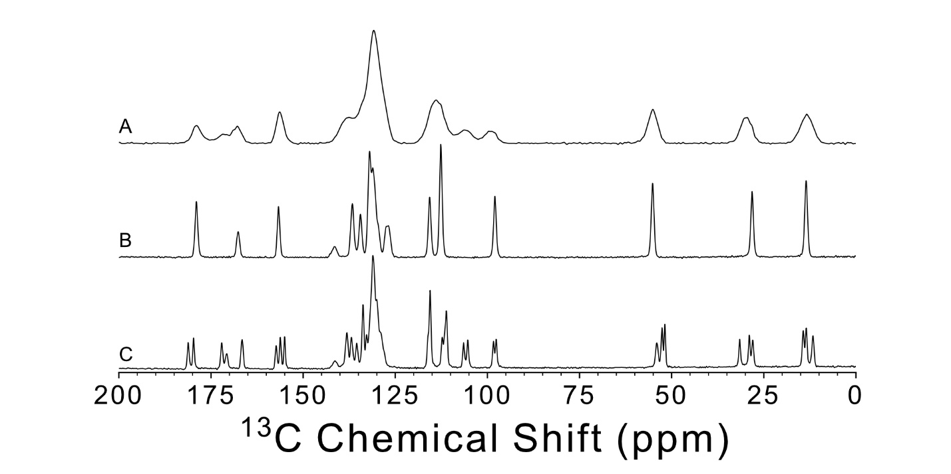
Figure S1. ¹H-¹³C CP-MAS (n_{r} = 20 kHz) ssNMR spectra for (A) amorphous indomethacin, (B) gamma indomethacin, and (C) alpha indomethacin.

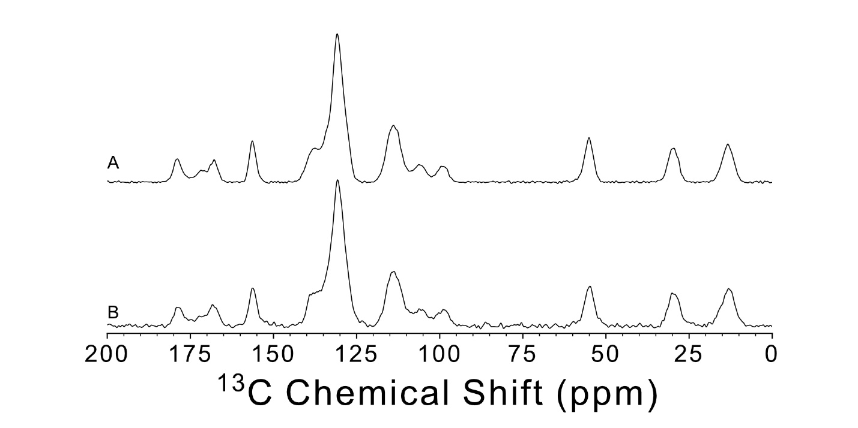
Figure S2. ¹H-¹³C CP-MAS (n_{r} = 20 kHz) ssNMR spectra for amorphous (A) indomethacin, and (B) d₁-indomethacin.

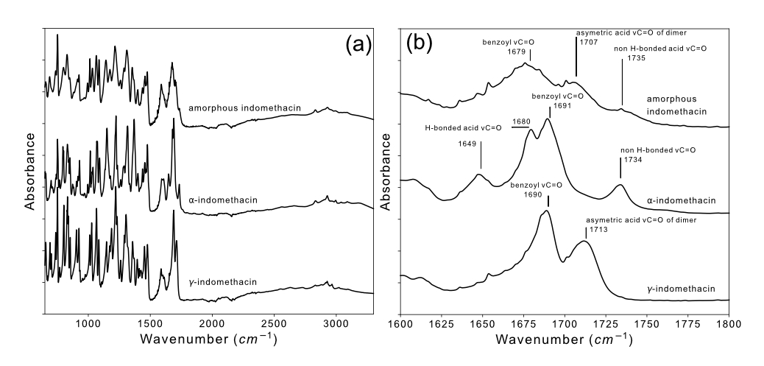
Figure S3. FT-IR spectra of Indomethacin polymorphs from 650 cm⁻¹ to 3300 cm⁻¹ (a) and the carbonyl stretching region from 1600 cm⁻¹ to 1800 cm⁻¹ (b). The carbonyl region contains assignments of characteristic stretching bands for each polymorph. These assignments are made in reference to the work of Van Duong, et al.¹ ATR-FTIR spectra were collected from 650 cm⁻¹ to 4000 cm⁻¹ using an Agilent Cary 630 FTIR spectrometer with a diamond ATR. Samples were collected using 128 background and 128 sample scans with a resolution of 2 cm⁻¹. All samples were run as a powder at room temperature (293°C) and pressed in order to have consistent contact with the diamond ATR.
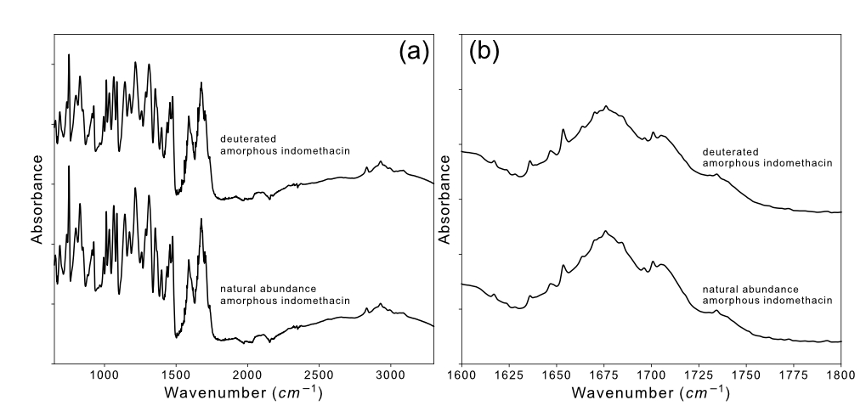
Figure S4. FT-IR spectra of deuterated vs. natural abundance gamma Indomethacin from 650 cm⁻¹ to 3300 cm⁻¹ (a) and in the carbonyl stretching region from 1600 cm⁻¹ to 1800 cm⁻¹ (b).
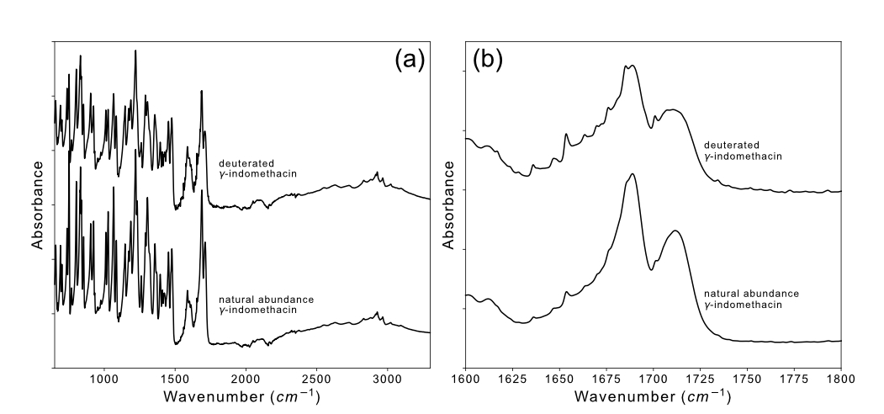
Figure S5. FT-IR spectra of deuterated vs. natural abundance amorphous Indomethacin from 650 cm⁻¹ to 3300 cm⁻¹ (a) and in the carbonyl stretching region from 1600 cm⁻¹ to 1800 cm⁻¹ (b).
Supplementary References.
[S1] Van Duong, T, et al. Polymorphism of indomethacin in semicrystalline dispersions: formation, transformation, and segregation. Mol Pharm, 2018. 15(3): p. 1037-1051.

