Figure S1. Concentration-time profiles of micafungin for (A) neonates, (B) infants, (C) preschool children, (D) school children and (E) adolescents at steady state. The solid orange lines represent the median of the simulated concentration-time profiles and the light orange shadows represent the 5th–95th percentiles of the concentration-time profiles.

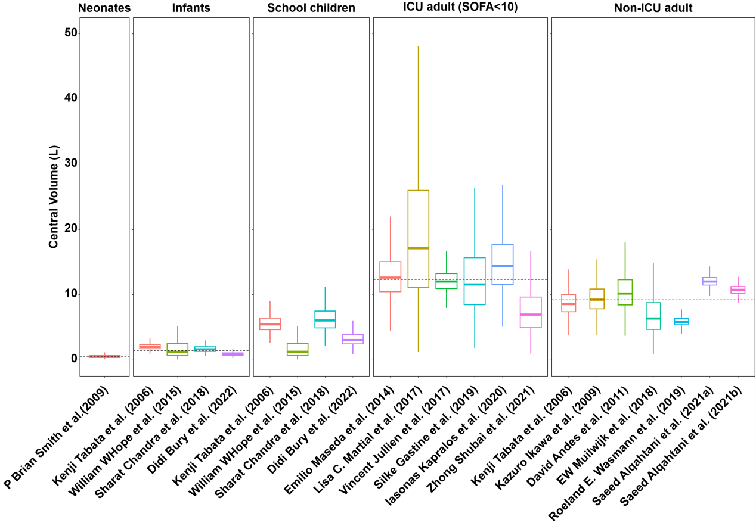
Figure S2. Distribution of the central volume of micafungin in various typical virtual populations. The typical ICU adults (SOFA<10) were set at male, 40-years-old, 70kg, and had the following demographic parameters: ALT or AST, 25 IU/L; ALB, 40 g/L; SOFA, 7; The typical Non-ICU adults were set at male, 40-years-old, 70kg, and had the following demographic parameters: ALT or AST, 25 IU/L; ALB, 40 g/L; SOFA, 0. The dashed and dotted lines in each panel represent the medians of the clearance in each corresponding population, respectively.

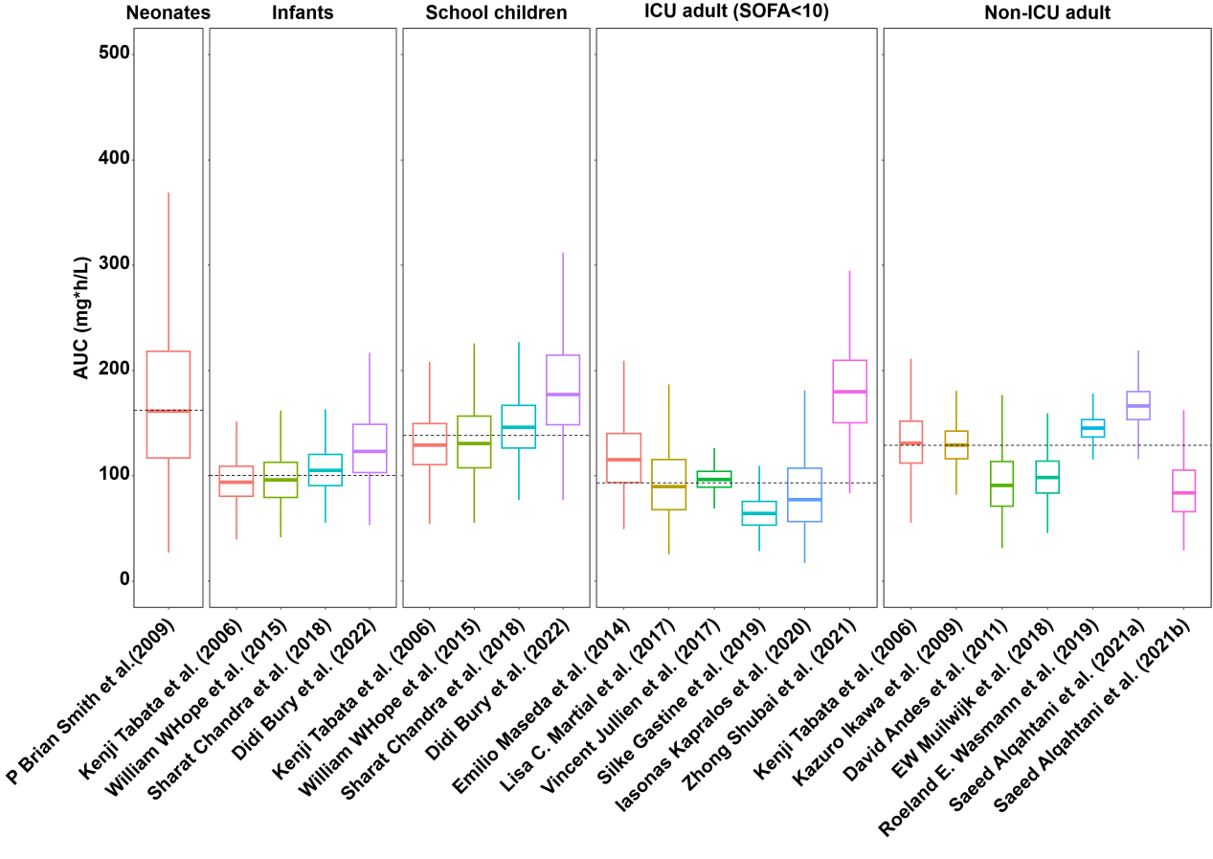
Figure S3. Distribution of the AUC24 of micafungin in various typical virtual populations. The typical ICU adults (SOFA<10) were set at male, 40-years-old, 70kg, and had the following demographic parameters: ALT or AST, 25 IU/L; ALB, 40 g/L; SOFA, 7; The typical Non-ICU adults were set at male, 40-years-old, 70kg, and had the following demographic parameters: ALT or AST, 25 IU/L; ALB, 40 g/L; SOFA, 0. The dashed and dotted lines in each panel represent the medians of the clearance in each corresponding population, respectively.

Figure S4. The histogram of the amount of investigated and identified covariates in included studies. AGE, age; HT, height; LBW or FFM, lean body weight; IBW, idea body weight; TBW or BW, Total body weight; BSA, body surface area; BMI, body mass index; ALP, alkaline phosphatase; BCHE, butyrylcholinesterase; CVVH, Continuous Veno-Venous Hemofiltration; HE, haemodialysis; RBC, red blood cell count; HCT, hematocrit; PLT, platelet count; eGFR, estimated glomerular filtration rate; CLCR, creatinine clearance; SCR, serum creatinine; CRRT, continuous renal replacement therapy; TP, total protein; ALB, albumin; BUN, blood urea nitrogen; TBILI, total bilirubin; DBIL, direct bilirubin; IBIL, indirect bilirubin; ALT, alanine amino transferase or glutamic pyruvic oxaloacetate transaminase/aspartate aminotransferase; AST, aspartate aminotransferase;γ-GTP, glutamate dehydrogenase; LDH, lactate dehydrogenase; SOFA, Sepsis-related organ failure assessment score, SAPS II, Simplifed Acute Physiology Score; CP, Child-Pugh score.

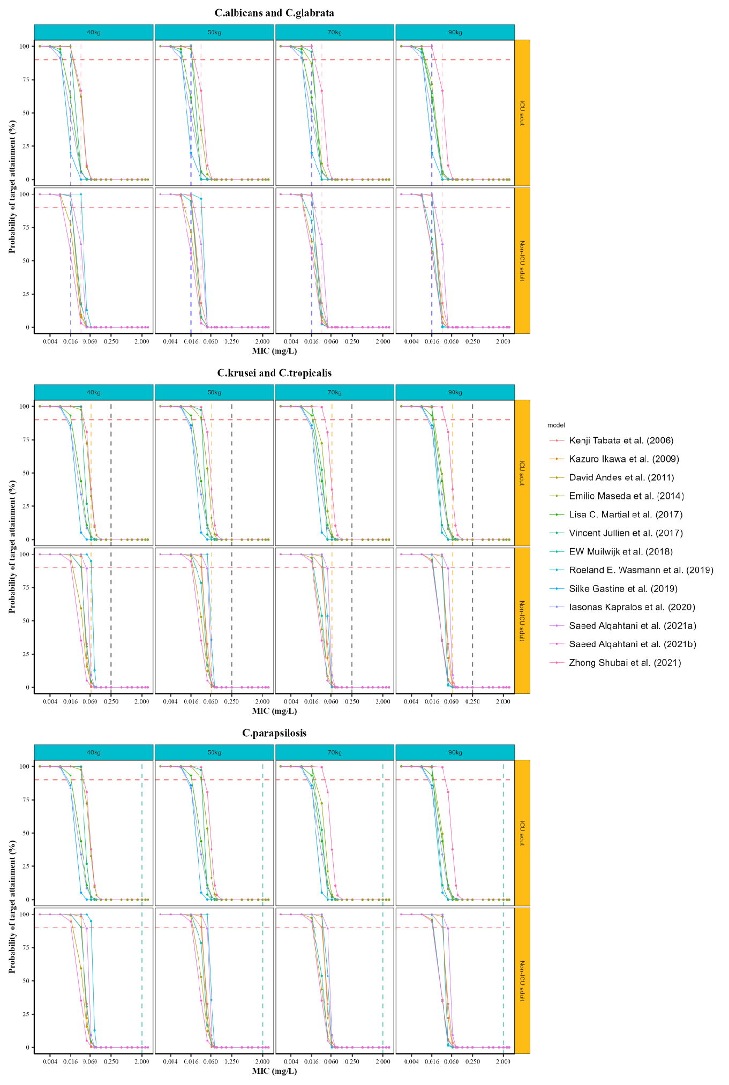
Figure S5. The probability target achievement of micafungin for ICU adults or Non-ICU adults against C. Albicans, C. glabrata, C. Krusei, C. tropicalis and C. parapsilosis in included studies. The MIC breakpoints for C. Albicans (blue), C. glabrata (pink), C. Krusei (black), C. tropicalis (orange) and C. parapsilosis (green) are marked with dashed and dotted lines in each panel, respectively. A PTA target of 90% is highlighted with red dashed and dotted lines.
Table S1. Demographic information of simulated patients.
 |  | median | min | max
Adults
Non-ICU group
 | Sex | Male
 | Age (years) | 40 | 20 | 80
 | Body weight (kg) | 70 | 40 | 150
 | Fat-free weight (kg) | 57.2 | 39.7 | 83.3
 | Height (cm) | 180 | 150 | 190
 | Body mass index (kg/m²) | 20 | 18 | 30
 | Platelet count (10⁴/μL) | 21.6 | 12.5 | 35
 | Infusion rate (mg/h) | 100
I | Non-ICU
 | Alanine aminotransferase (U/L) | 25 | 0 | 50
 | Aspartate aminotransferase (U/L) | 25 | 0 | 50
 | Total bilirubin (μmol/L) | 12 | 0 | 17.1
 | Albumin (/min) | 40 | 20 | 60
 | Sepsis related organ failure assessment score | 7 | 0 | 19
II | ICU
 | Alanine aminotransferase (U/L) | 50 | 0 | 199
 | Aspartate aminotransferase (U/L) | 50 | 0 | 340
 | Total bilirubin (μmol/L) | 70 | 0 | 100
 | Albumin (/min) | 24 | 9 | 66
 | Sepsis related organ failure assessment (SOFA) score | 11 | 0 | 19
Children
I | Neonate (≤1 month)
 | Sex | Male
 | Age (years) | 0.04 | 0.003 | 0.08
 | Body weight (kg) | 1.5 | 0.5 | 2.5
 | Fat-free weight (kg) | 1.6 | 0.63 | 2.3
 | Height (cm) | 40 | 20 | 50
 | Body mass index (kg/m²)
II | infants (4 months to 2 years)
 | Sex | Male
 | Age (years) | 1.0 | 0.6 | 1.4
 | Body weight (kg) | 8 | 6 | 10
 | Fat-free weight (kg) | 7.79 | 6.31 | 9.06
 | Height (cm) | 78 | 60 | 96
 | Body mass index (kg/m²) | 13 | 10 | 30
III | Preschool Children (2 to 6 years)
 | Sex | Male
 | Age (years) | 3.7 | 2.5 | 4.9
 | Body weight (kg) | 15 | 10 | 20
 | Fat-free weight (kg) | 13.88 | 10.41 | 16.65
 | Height (cm) | 98.5 | 87 | 110
 | Body mass index (kg/m²) | 15 | 10 | 30
IV | School Children (6 to 12 years)
 | Sex | Male
 | Age (years) | 9 | 8.5 | 10.5
 | Body weight (kg) | 30 | 20 | 40
 | Fat-free weight (kg) | 26 | 20.07 | 31.44
 | Height (cm) | 130 | 115 | 145
 | Body mass index (kg/m²) | 17 | 10 | 30
V | Adolescent (12 to 16 years)
 | Sex | Male
 | Age (years) | 14.5 | 13 | 16
 | Body weight (kg) | 50 | 37 | 70
 | Fat-free weight (kg) | 42.53 | 34.99 | 51.56
 | Height (cm) | 160 | 150 | 170
 | Body mass index (kg/m²) | 19 | 10 | 30

Table S2. Checklist for literature quality when reporting a clinical pharmacokinetic study.
 | Item | Kenji Tabata  et al.  (2006) | Kazuro Ikawa  et al.  (2009) | P Brian Smith  et al. (2009) | David Andes  et al.  (2011) | Emilio  Maseda  et al.  (2014） | William W. Hope  et al. (2015) | Lisa C. Martial et al. (2017) | Vincent Jullien et al. (2017) | E. W. Muilwijk et al. (2018) | Sharat Chandra et al. (2018) | Roeland E. Wasmann et al. (2019) | Silke Gastine et al. (2019) | Zhong Shubai et al. (2019) | Iasonas Kapralos et al. (2020) | Saeed Alqahtani et al. (2021a) | Saeed Alqahtani et al. (2021b)
1 | Drug and patient population | 1 | 1 | 1 | 1 | 1 | 1 | 1 | 1 | 1 | 1 | 1 | 1 | 1 | 1 | 1 | 1
2 | The name of the drug(s) studied, the route of administration, the population in whom it was studied, and the results of the primary objective and major clinical pharmacokinetic findings | 1 | 1 | 1 | 1 | 1 | 1 | 1 | 1 | 1 | 1 | 1 | 1 | 1 | 1 | 1 | 1
3 | Pharmacokinetic data | 1 | 1 | 1 | 1 | 1 | 1 | 1 | 1 | 1 | 1 | 1 | 1 | 1 | 1 | 1 | 1
4 | An explanation of the study rationale | 1 | 1 | 1 | 1 | 1 | 1 | 1 | 1 | 1 | 1 | 1 | 1 | 1 | 1 | 1 | 1
5 | Specific objectives or hypotheses | 1 | 1 | 1 | 1 | 1 | 1 | 1 | 1 | 1 | 1 | 1 | 1 | 1 | 1 | 1 | 1
6 | Eligibility criteria of study participants | 1 | 1 | 1 | 1 | 1 | 1 | 1 | 1 | 1 | 1 | 1 | 1 | 1 | 1 | 1 | 1
7 | Co-administration with other potentially interacting drugs or food | 0 | 0 | 0 | 0 | 1 | 1 | 1 | 0 | 1 | 0 | 0 | 0 | 0 | 0 | 0 | 0
8 | Drug preparation and administration characteristics including dose, route, formulation, infusion duration (if applicable) and frequency | 1 | 1 | 1 | 1 | 1 | 1 | 1 | 1 | 1 | 1 | 1 | 1 | 1 | 1 | 1 | 1
9 | Body fluid or tissue sampling (timing, frequency and storage) for quantitative drug measurement | 1 | 1 | 1 | 1 | 1 | 1 | 1 | 1 | 1 | 1 | 1 | 1 | 1 | 1 | 1 | 1
10 | Quantitative bioanalytical methods | 1 | 1 | 1 | 0 | 1 | 1 | 1 | 1 | 1 | 1 | 1 | 1 | 1 | 1 | 1 | 1
11 | Methods for handling missing data | 1 | 0 | 0 | 0 | 0 | 1 | 1 | 1 | 0 | 0 | 0 | 0 | 0 | 0 | 0 | 0
12 | Modelling software | 1 | 1 | 1 | 1 | 1 | 1 | 1 | 1 | 1 | 1 | 1 | 1 | 1 | 1 | 1 | 1
13 | Statistical methods and software | 1 | 1 | 1 | 1 | 1 | 1 | 1 | 1 | 1 | 1 | 1 | 1 | 1 | 1 | 1 | 1
14 | Candidate strutural models | 1 | 1 | 1 | 1 | 1 | 1 | 1 | 1 | 1 | 0 | 1 | 1 | 1 | 1 | 1 | 1
15 | Residual error struture | 1 | 1 | 1 | 1 | 1 | 1 | 1 | 1 | 1 | 1 | 1 | 1 | 1 | 1 | 1 | 1
16 | Methods for base model determination | 1 | 1 | 1 | 1 | 1 | 1 | 1 | 1 | 1 | 1 | 1 | 1 | 1 | 1 | 1 | 1
17 | Methods for base model evaluation | 1 | 1 | 1 | 0 | 1 | 1 | 1 | 1 | 1 | 1 | 1 | 1 | 1 | 1 | 1 | 1
18 | Covariates analysis strategy | 1 | 0 | 0 | 1 | 1 | 1 | 1 | 1 | 1 | 1 | 1 | 1 | 1 | 1 | 1 | 1
19 | Methods for final model evaluation | 1 | 1 | 1 | 1 | 1 | 1 | 1 | 1 | 1 | 1 | 1 | 1 | 1 | 1 | 1 | 1
20 | Distribution of individual model parameters | 0 | 1 | 1 | 1 | 1 | 1 | 1 | 1 | 1 | 1 | 1 | 1 | 1 | 1 | 1 | 1
21 | Estimation methods | 1 | 1 | 1 | 1 | 1 | 1 | 1 | 1 | 1 | 1 | 1 | 1 | 1 | 1 | 1 | 1
22 | Population characteristics | 1 | 1 | 1 | 1 | 1 | 1 | 1 | 1 | 1 | 1 | 1 | 1 | 1 | 1 | 1 | 1
23 | Schematic of the final model | 0 | 0 | 0 | 0 | 0 | 1 | 0 | 0 | 0 | 0 | 0 | 0 | 0 | 0 | 0 | 0
24 | Number of subjects and observations | 1 | 1 | 1 | 1 | 1 | 1 | 1 | 1 | 1 | 1 | 1 | 1 | 1 | 1 | 1 | 1
25 | Table of the final model parameter | 1 | 1 | 1 | 1 | 1 | 1 | 1 | 1 | 1 | 1 | 1 | 1 | 1 | 1 | 1 | 1
26 | Final model evaluation plots | 1 | 1 | 0 | 0 | 1 | 1 | 1 | 1 | 1 | 1 | 1 | 1 | 1 | 1 | 1 | 1
27 | Summary of the model-building process and the derived final model | 1 | 0 | 0 | 1 | 1 | 1 | 1 | 1 | 1 | 0 | 1 | 1 | 1 | 1 | 1 | 1
28 | Plot of concentration versus times and/or effect versus concentration | 1 | 0 | 1 | 0 | 1 | 1 | 1 | 0 | 0 | 1 | 1 | 1 | 1 | 0 | 0 | 0
29 | Study limitation | 0 | 1 | 1 | 1 | 1 | 1 | 1 | 1 | 1 | 1 | 1 | 1 | 1 | 1 | 1 | 1
30 | Study findings | 1 | 1 | 1 | 1 | 1 | 1 | 1 | 1 | 1 | 1 | 1 | 1 | 1 | 1 | 1 | 1
 | Total score | 26 | 24 | 24 | 23 | 28 | 30 | 29 | 27 | 27 | 25 | 27 | 27 | 27 | 26 | 26 | 26
 | Compliance | 86.67% | 80.00% | 80.00% | 76.67% | 93.33% | 100.00% | 96.67% | 90.00% | 90.00% | 83.33% | 90.00% | 90.00% | 90.00% | 86.67% | 86.67% | 86.67%

Table S3. List of tested and significant covariates in the included models.
Study  (publication year) | Tested covariates |  |  | Covariate selection |  | Significant covariates
 | Demographic | Laboratory tests | Co-administration | Forward inclusion | Backward elimination | CL | V
Kenji Tabata (2006) | SEX, AGE, WT, BMI | RBC, HCT, PLT, TP,  ALB, BUN, TBIL,  ALT, AST, γ-GTP,  LDH, ALP, CRCl,  SCR, | NR | P < 0.05 | P < 0.001 | AGE, WT, PLT | NR
Kazuro Ikawa （2009） | NR | NR | NR | P < 0.05 | P < 0.05 | NR | NR
P Brian Smith (2009) | NR | NR | NR | P < 0.05 | P < 0.05 | NR | NR
David Andes (2011) | BW | NR | NR | P < 0.05 | P < 0.001 | BW | NR
Emilio Maseda (2014) | AGE, SEX, BW | TBIL, SCR, BUN | vasopressor therapy | P < 0.05 | P < 0.05 | BW | NR
William W. Hope (2015) | AGE, SEX | ALB, PLT, RBC, SCR, ALT, AST, TBIL | NR | P < 0.05 | P < 0.01 | BW, AST, TBIL | BW
Lisa C. Martial (2017) | NR | ALB, CVVH, SOFA | NR | P < 0.05 | P < 0.05 | NR | NR
Vincent Jullien (2017) | AGE, SEX, BW | TP, ALT, AST, ALP, ALB, TBIL, PT, SOFA, ECMO, HE | NR | P < 0.05 | P < 0.01 | BW, ALB, SOFA | BW, ALB
E.W. Muilwijk （2018） | FFM | NR | NR | P < 0.05 | P < 0.05 | FFM | FFM
Sharat Chandra (2018) | AGE, SEX, BW  BMI | APACHE II, SCR, CRCl, ALB | NR | P < 0.05 | P < 0.01 | BW | BW
Roeland E. Wasmann (2019) | SEX, AGE, TBW, LBW, IBW, BMI | NR | NR | P < 0.05 | P < 0.001 | TBW | TBW
Silke Gastine (2019) | SEX, WT, AGE  BMI | ALB, TP, CLCR, ALT, AST, BCHE, TBIL, APACHE II, SOFA, SAPS II | NR | P < 0.05 | P < 0.01 | TBIL | SOFA
Iasonas Kapralos (2020) | AGE, BW, HT  BSA, LBW, BWI | ALB, PLT, HCT, RBC, SCR, eGFR, ALT, AST, γ-GTP, AST, ALT, GGT, ALP, TBIL, SOFA, APACHE II, CRRT | NR | P < 0.05 | P < 0.01 | NR | NR
Saeed Alqahtani (2021) | SEX, AGE, BW, HT, BMI | SCR, CRCl, SOFA, AST, AST, TBIL, ALB | NR | P < 0.05 | P < 0.05 | NR | NR
Zhong Shubai (2021) | SEX, AGE, BW, BMI | ALT, AST, TP, SCR, TP, DBIL, IBIL, etiological factors of sepsis, infection site, CP, APACHE II, SOFA, CRRT | NR | P < 0.05 | P < 0.001 | ALT | SOFA
Didi Bury (2022) | FFM | FFM | NR | P < 0.05 | P < 0.05 | FFM | FFM
SEX, sex; AGE, age; HT, height; TBW or BW, total body weight; LBW or FFM, lean body weight; IBW, idea body weight; BW, body weight; WT, weight; BSA, body surface area; BMI, body mass index; CVVH, Continuous Veno-Venous Hemofiltration; HE, haemodialysis; RBC, red blood cell count; HCT, hematocrit; PLT, platelet count; eGFR, estimated glomerular filtration rate; CL, total clearance; CLCR, creatinine clearance; SCR, serum creatinine; CRRT, continuous renal replacement therapy; TP, total protein; ALB, albumin; BUN, blood urea nitrogen; TBILI, total bilirubin; DBIL, direct bilirubin; IBIL, indirect bilirubin; ALT, alanine amino transferase or glutamic pyruvic oxaloacetate transaminase/aspartate aminotransferase; AST, aspartate aminotransferase;γ-GTP, glutamate dehydrogenase; LDH, lactate dehydrogenase; ALP, alkaline phosphatase; BCHE, butyrylcholinesterase, APACHE II, Acute Physiology and Chronic Health Evaluation II; SOFA, Sepsis-related organ failure assessment score, SAPS II, Simplifed Acute Physiology Score; CP, Child-Pugh score; Q, intercompartmental (central-peripheral) clearance; V, volume of distribution; V_{c}, volume of distribution of the central compartment; V_{p}, volume of distribution of the central compartment.

Table S4. The effect of covariates on the range of CL in each study.
Study | Covariates | Range of Covariates |  | Reference value of CL | Range of CL (Ratio*)
 |  | Minimum | Maximum |  | Minimum | Maximum
Kenji Tabata et al. (2006) | Weight (kg) | 6 | 10 | 0.17 | 0.14 (0.84) | 0.18 (1.06)
William W. Hope et al. (2015) |  | 6 | 10 | 0.16 | 0.13 (0.82) | 0.19 (1.18)
Sharat Chandra et al. (2018) |  | 6 | 10 | 0.15 | 0.12 (0.80) | 0.18 (1.17)
Didi Bury et al. (2022a)** |  | 6.31 | 9.06 | 0.13 | 0.11 (0.85) | 0.15 (1.12)
Kenji Tabata et al. (2006) |  | 10 | 20 | 0.27 | 0.19 (0.72) | 0.33 (1.22)
William W. Hope et al. (2015) |  | 10 | 20 | 0.27 | 0.20 (0.75) | 0.32 (1.19)
Sharat Chandra et al. (2018) |  | 10 | 20 | 0.25 | 0.17 (0.71) | 0.29 (1.20)
Didi Bury et al. (2022a)** |  | 10.41 | 16.65 | 0.25 | 0.20 (0.81) | 0.28 (1.15)
Kenji Tabata et al. (2006) |  | 20 | 40 | 0.47 | 0.39 (0.83) | 0.71 (1.51)
William W. Hope et al. (2015) |  | 20 | 40 | 0.48 | 0.40 (0.83) | 0.67 (1.39)
Sharat Chandra et al. (2018) |  | 20 | 40 | 0.41 | 0.35 (0.85) | 0.59 (1.42)
Didi Bury et al. (2022a)** |  | 20.07 | 31.44 | 0.38 | 0.34 (0.81) | 0.43 (1.14)
Kenji Tabata et al. (2006) |  | 37 | 70 | 0.78 | 0.57 (0.73) | 1.02 (1.31)
William W. Hope et al. (2015) |  | 37 | 70 | 0.69 | 0.55 (0.79) | 0.92 (1.33)
Didi Bury et al. (2022a)** |  | 34.99 | 51.56 | 0.54 | 0.47 (0.86) | 0.63 (1.16)
Kenji Tabata et al. (2006) |  | 40 | 150 | 0.78 | 0.78 (1) | 0.78 (1)
David Andes et al. (2011) |  | 40 | 150 | 1.07 | 0.93 (0.87) | 1.30 (1.22)
Emilio Maseda et al. (2014) |  | 40 | 150 | 0.88 | 0.58 (0.66) | 1.56 (1.77)
Vincent Jullien et al. (2017) |  | 40 | 150 | 1.20 | 0.96 (0.80) | 1.82 (1.51)
E. W. Muilwijk et al. (2018)** |  | 39.67 | 83.34 | 1.01 | 0.77 (0.76) | 1.34 (1.33)
Roeland E. Wasmann et al. (2019) |  | 40 | 150 | 0.69 | 0.46 (0.66) | 1.21 (1.76)
Didi Bury et al. (2022b)** |  | 39.67 | 83.34 | 1.02 | 0.78 (0.76) | 1.35 (1.33)
Kenji Tabata et al. (2006) | Children:PLT (10⁴/μL) | 1.8 | 48.6 | 0.16 | 0.14 (0.91) | 0.18 (1.15)
Kenji Tabata et al. (2006) | Adult:PLT (10⁴/μL) | 0.3 | 74.5 | 0.47 | 0.45 (0.95) | 0.54 (1.14)
Zhong Shubai et al. (2021) | ALT (U/L) | 8 | 200 | 0.58 | 0.22 (0.38) | 0.72 (1.24)
William W. Hope et al. (2015) | AST (U/L) | 3 | 340 | 0.48 | 0.41 (0.85） | 0.55 (1.14)
William W. Hope et al. (2015) | TBIL (μmol/L) | 4.5 | 42.2 | 0.46 | 0.43 (0.94) | 0.49 (1.05)
Silke Gastine et al. (2019) *** | TBIL≤68.4 (μmol/L) | 0 | 1 | 1.56 | 1.23 (0.79) | 1.56 (1.00)
Vincent Jullien et al. (2017)*** | ALB≤25 (g/L) | 0 | 1 | 1.37 | 1.37 (1.00) | 1.56 (1.14)
Vincent Jullien et al. (2017)*** | SOFA≥0 | 0 | 1 | 1.37 | 1.03 (0.75) | 1.37 (1.00)
*Ratio refers to the effect of the identified covariates on CL in each study, and calculated by the following equation:
$$Effect of covariate on CL=\frac{The range of calculated CL}{The reference CL}$$
** BW was transferred to FFM before calculation; *** For binary covariates like SOFA, 0 for SOFA ≥10 and 1 for SOFA<10 were used. FFM, free-fat mass; ALT, alanine amino transferase; AST, aspartate aminotransferase; PLT, platelet count; TBILI, total bilirubin; ALB, albumin; SOFA, Sepsis-related organ failure assessment score.

